Supplementary data

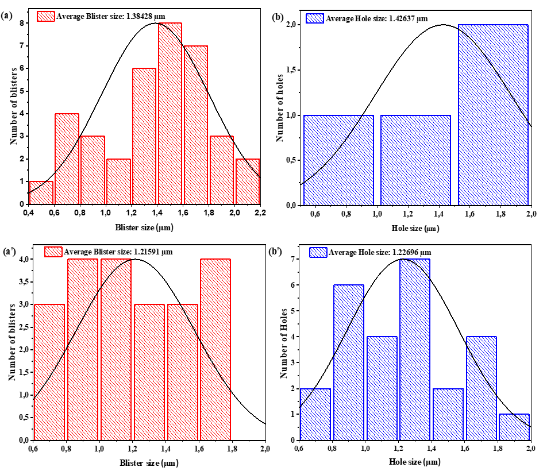
Fig. S1: Size distribution of Helium-blisters in (a) Ag+He-SiC as-implanted and (b) Ag+He-SiC annealed at 1100 °C as well as the size distribution of their Helium-induced-holes, (aʹ) and (bʹ), respectively.
Fig. S2: Elastic recoil detection analysis (ERDA) He profiles of Ag+He-SiC sample before (a) and (b) after annealing at 1100 °C for 5 h.

