Appendix

Appendix Table 1 : Epidemiology inputs
Parameter | Year 1 | Year 2 | Year 3 | References
Private health care sector population size | 8 953 076 | 8 953 076 | 8 953 076 | Council for Medical Schemes (CMS) Annexures for 2019/2020³²
Registered percentage of T2DM | 5.49% | 5.49% | 5.49% | Council for Medical Schemes (CMS) Annexures for 2019/2020³²
% T2DM patients with established CVD | 32.2% | 32.2% | 32.2% | Einarson et al. 2018³³
Uptake of empagliflozin | 6% | 8% | 10.7% | Assumption
Net population | 9 503 | 12 670 | 16 947 | Calculated

Appendix Table 2: Drug dosages
Drug class | Daily dosage [mg] | References
Empagliflozin | Weighted average of 10mg and 25mg doses | Jardiance® prescribing information
Metformin | 2 000 | WHO defined daily dose (DDD) ³⁷
Sulphonylurea
glibenclamide | 10 | WHO defined daily dose (DDD) ³⁷
chlorpropamide | 375 | WHO defined daily dose (DDD) ³⁷
glipizide | 10 | WHO defined daily dose (DDD) ³⁷
gliclazide | 60 | WHO defined daily dose (DDD) ³⁷
glimepiride | 2 | WHO defined daily dose (DDD) ³⁷
Glibenclamide/metformin combination | 2 tablets (1.25/250mg or 2.5/500mg) | WHO defined daily dose (DDD) ³⁷
Glitazones
pioglitazone | 30 | WHO defined daily dose (DDD) ³⁷
rosiglitazone | 6 | WHO defined daily dose (DDD) ³⁷
Glinides
nateglinide | 360 | WHO defined daily dose (DDD) ³⁷
repaglinide | 4 | WHO defined daily dose (DDD) ³⁷
DPP-4 inhibitors
sitagliptin | 100 | WHO defined daily dose (DDD) ³⁷
vildagliptin | 100 | WHO defined daily dose (DDD) ³⁷
saxagliptin | 5 | WHO defined daily dose (DDD) ³⁷
Vildagliptin/metformin combination | 2 tablets (50/580mg or 50/1000mg) | WHO defined daily dose (DDD) ³⁷
Sitagliptin/metformin combination | 2 tablets (50/500mg, 50/850mg or 50/1000mg) | WHO defined daily dose (DDD) ³⁷
GLP-1 agonists
exenatide | 0.02 | WHO defined daily dose (DDD) ³⁷
liraglutide | 2 | WHO defined daily dose (DDD) ³⁷

Appendix Table 3. Diagnostic and procedural codes used in data analysis to identify clinical events
Clinical event | Diagnostic and procedural codes in claim | References
Non-fatal myocardial infarction | Mean claimed amount per event for any hospitalization where at least one claim with ICD-10 codes I21.x occurred. | EMPRISE study¹³
Non-fatal stroke | Mean claimed amount per event for any hospitalization where at least one claim with any of the ICD-10 codes I60.x, I61.x, I63.x, or I67.89 occurred. | EMPRISE study¹³
Unstable angina hospitalization | Mean claimed amount per event for any hospitalization where at least one claim with ICD-10 codes I20.0, I24.0 or I24.8 occurred. | EMPRISE study¹³
Heart failure hospitalization | Mean claimed amount per event for any hospitalization where at least one claim with ICD-10 codes I50.xx, I09.81, I11.0, I13.0 or I13.2 occurred. | EMPRISE study¹³
Transient ischemic attack | Mean claimed amount per event for any hospitalization where at least one claim with ICD-10 codes G45.0, G45.1, G45.2, G45.3, G45.4, G45.8 or G45.9 occurred. | EMPRISE study¹³
Acute renal injury | Mean claimed amount per event for any hospitalization where at least one claim with ICD-10 codes N17.0, N17.1, N17.2. N17.8, N17.9 occurred, AND any of the following ICD-10, CPT4 or RPL codes: ICD-10 codes Z99.2, Z49.31 or Z49.01, CPT4 codes 90935, 90937, 90945, 90947, 90999, Medical Practitioner RPL codes 1843, 1845, 1847, 1849, 1851, 1852, Clinical Technologist RPL codes 145, 146, 148, 147, 176, 177, 149, 150, 151, 152, 154, 156, Registered Nurses RPL codes 092. | EMPRISE study¹³
Revascularization (excluding patients with NFMI as defined above) | Mean claimed amount per event for any hospitalization where at least one claim with one of the following CPT4 or RPL codes for PTCA, CABG, stenting or trans-myocardial revascularization occurred:  i. CPT codes 92973, 92982, 92984, 92995, 92996, 92920 – 92921, 92924 – 92925, 92937, 92938, 92941, 92943, 92944, 33510 – 33536, 33545, 33572, 92980, 92981, 92928 – 92929, 92933 – 92934, 33140, 33141  ii. RPL codes Medical Practitioners: 1252-1254, 1276-1281, 1286, 1287, 1346-1350, 1358  iii. RPL codes Clinical Technologist: 012. | EMPRISE study¹³

Appendix Table 4. Incremental costs

 | Total cost (USD) |  |  | Total cost (USD) |  |  | Net budget impact (USD)
 | Usual care |  |  | Usual care + empagliflozin |  |  | Usual care + empagliflozin arm minus usual care arm
 | Year 1 | Year 2 | Year 3 | Year 1 | Year 2 | Year 3 | Year 1 | Year 2 | Year 3
Drug acquisition costs | 1 667 788 | 2 324 451 | 3 249 789 | 4 670 731 | 6 509 754 | 9 101 213 | 3 002 944 | 4 185 303 | 5 851 424
Clinical event management costs | 7 459 390 | 10 433 201 | 14 638 172 | 5 728 744 | 8 012 603 | 11 241 982 | -1 730 647 | -2 420 598 | -3 396 189
Total budget | 9 127 178 | 12 757 652 | 17 887 961 | 10 399 475 | 14 522 357 | 20 343 196 | 1 272 297 | 1 764 705 | 2 455 235

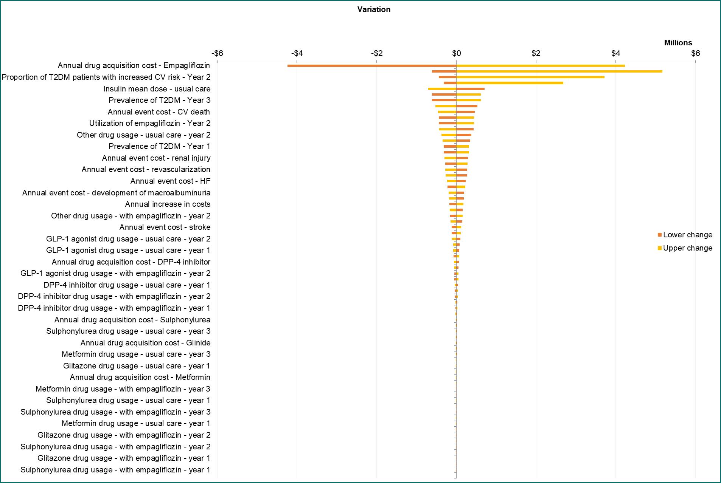
Appendix Fig 1. One-way sensitivity analysis results

