Supplemental Information for manuscript titled:

Predictive Blood Chemistry Parameters for Pansteatitis-Affected Mozambique Tilapia (Oreochromis mossambicus)

*John A. Bowden, Theresa M. Cantu, Robert W. Chapman, Stephen E. Somerville, Matthew P. Guillette, Hannes Botha, Andre Hoffman, Wilmien J. Luus-Powell, Willem J. Smit, Jeffrey Lebepe, Jan Myburgh, Danny Govender, Jonathan Tucker, Ashley S. P. Boggs, and Louis J. Guillette, Jr.

*author to whom correspondence should be addressed

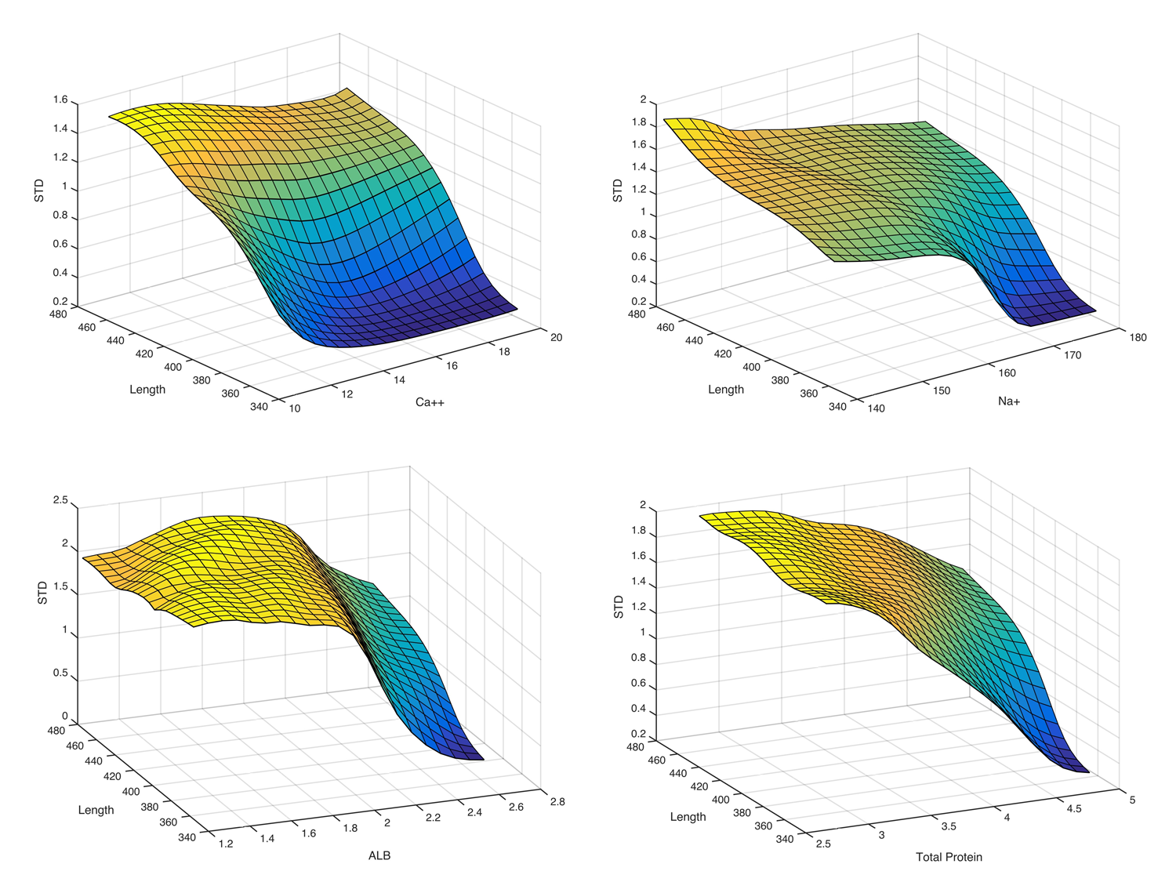
S1 Fig. Surface plots for the top four predictive parameters (Ca²⁺, Na⁺, ALB, and TP) in relation to standard deviation and total length (with the other three parameters were clamped). TP (g/dL), ALB (g/dL), Na⁺ (mmol/L), and Ca²⁺ (mg/dL).

