Evidence for transient deleterious thermal acclimation in field recapture rates of an invasive tropical species, Bactrocera dorsalis (Diptera: Tephritidae)

Kevin Malodª, Anandi Biermanª, Minette Karstenª, Aruna Manrakhan^{a,b}, Christopher W. Weldon^{c}, John S. Terblanche^{a*}

ªDepartment of Conservation Ecology and Entomology, Stellenbosch University, Stellenbosch, South Africa
^{b}Citrus Research International, PO Box 28, Mbombela, South Africa
^{c}Department of Zoology and Entomology, University of Pretoria, Private Bag X20, Hatfield 0028, South Africa
*Corresponding author: E-mail: jst@sun.ac.za

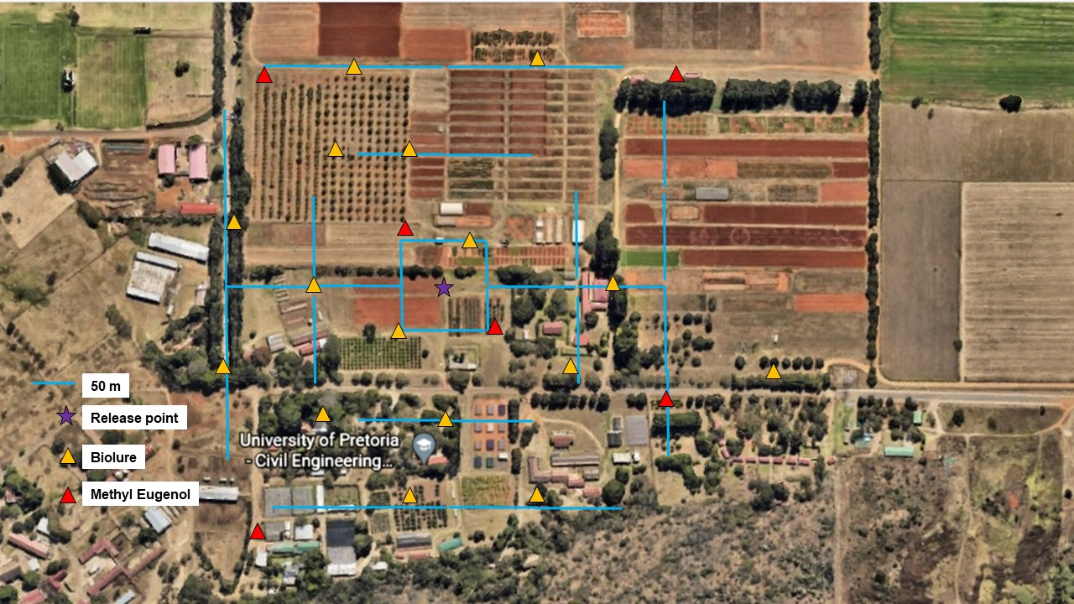
Figure S1. Grid array with the location of the methyl eugenol (red triangles) and BioLure (yellow triangles) baited traps. Traps were placed depending on the available vegetation.

Table S1. Irradiation dose rates for each replicate calculated on the irradiation time needed to reach a 100 Gy dose. NAs indicate that the time is missing but the 100 Gy dose was applied and the dose rate would be slightly higher than in the following replicate.
Replicate | Dose rate (Gy / min) | Dose (Gy)
1 | NA | 100
2 | 52.2 | 100
3 | NA | 100
4 | 25.5 | 100
5 | 25.1 | 100
6 | 23.1 | 100
7 | 22.4 | 100

Table S2. The number of flies released into the field and the proportion released (percentage of flies leaving the container) for each replicate and acclimation treatment. Females and males were not separated, and the sex ratio is assumed to be 50/50.
 | Adults released |  |  | Proportion released (%)
 | Acclimation treatment (ºC)
Release | 20 | 25 | 30 | 20 | 25 | 30
1 | 784 | 747 | 876 | 61.3 | 63.3 | 72.5
2 | 1818 | 1858 | 1750 | 93 | 92.6 | 90.6
3 | 554 | 620 | 746 | 90.1 | 86.8 | 89.6
4 | 344 | 629 | 633 | 86.8 | 93.6 | 92.5
5 | 1220 | 1643 | 1357 | 88.9 | 94.8 | 90.8
6 | 1525 | 1487 | 1377 | 88.1 | 89.9 | 85.1
7 | 714 | 828 | 1327 | 81.3 | 79.1 | 85.1

Table S3. Temperature (°C) and relative humidity (%) summary of the weather conditions experienced by the flies in the first 24 hours following release.
Release | Mean Temp | Maximum Temp | Minimum Temp | Mean humidity | Maximum humidity | Minimum humidity
1 | 23.41 | 35.78 | 13.58 | 51.61 | 86.69 | 19.39
2 | 22.20 | 30.74 | 16.54 | 76.00 | 96.44 | 48.16
3 | 17.08 | 30.11 | 7.53 | 66.16 | 99.36 | 39.22
4 | 20.69 | 35.66 | 15.10 | 84.36 | 106.59 | 52.59
5 | 22.08 | 36.82 | 13.56 | 64.86 | 97.37 | 23.97
6 | 20.03 | 31.18 | 16.11 | 80.34 | 104.14 | 41.30
7 | 15.53 | 28.41 | 9.12 | 93.81 | 104.22 | 53.88

Table S4. Temperature (°C) and relative humidity (%) summary of the weather conditions experienced by the flies over the 21 days release period. The colors indicate if the average daily temperature corresponds to benign (yellow) or cool (blue) environmental conditions.

Release | Mean Daily Temp | Maximum Temp | Minimum Temp | Mean daily humidity | Maximum humidity | Minimum humidity
1 | 21.77 | 35.29 | 14.50 | 62.46 | 88.54 | 29.17
2 | 20.84 | 38.01 | 14.32 | 71.73 | 95.71 | 36.12
3 | 19.67 | 34.04 | 11.14 | 56.14 | 86.27 | 28.42
4 | 19.98 | 36.28 | 14.07 | 85.30 | 105.35 | 49.14
5 | 21.37 | 37.86 | 15.11 | 81.15 | 101.82 | 43.33
6 | 22.08 | 39.73 | 14.66 | 69.23 | 97.83 | 24.01
7 | 16.47 | 31.74 | 10.46 | 83.16 | 103.24 | 41.41

Table S5. Total number of flies captured in each replicate as a function of the type of trap. The combined traps contained both lures and were placed the furthest from the release point.

 | Lure
Replicate | BioLure | Methyl eugenol | Combined
1 | 9 | 153 | 4
2 | 24 | 315 | 43
3 | 12 | 227 | 8
4 | 11 | 110 | 4
5 | 27 | 252 | 11
6 | 37 | 120 | 0
7 | 6 | 46 | 4

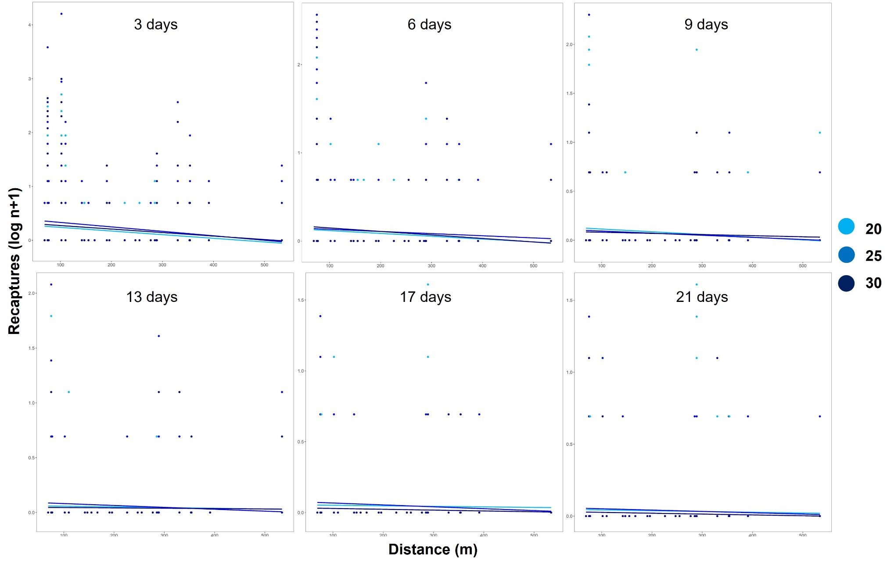
Figure S2. Distance of recapture (log n+1) at different time intervals in flies acclimated at either 20, 25 or 30ºC. Each temperature group has 7 replicates plotted.

