COMBINATIONS OF BASIC MOVEMENTS

Free-fall, Float-off and Staccato

The combination of these three movements is a test of:
- the flexibility of the wrist
- the relaxed Free-Fall and Float-Off movement of the whole arm (initiated by the wrist), and
- movement of the hand as a unit.

In the following exercise “Duckling” these three movements are practised simultaneously with both hands, the succession of movements being slow and calculated. Although the aim is to be able to perform these movements in quick succession, one after another, at first beginners should do them in slow succession.

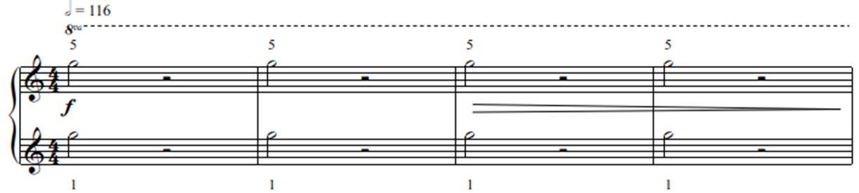

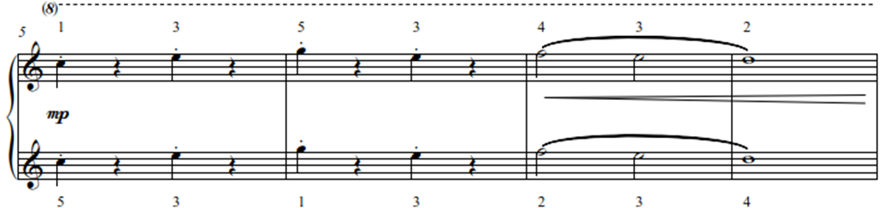

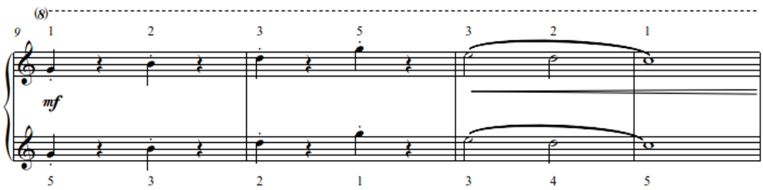

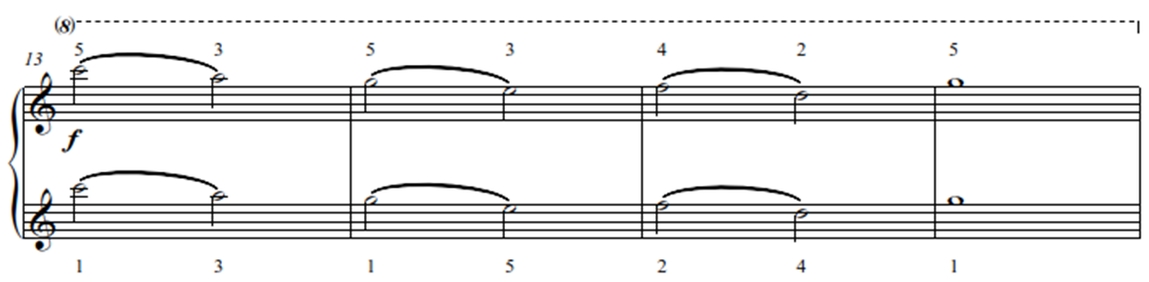

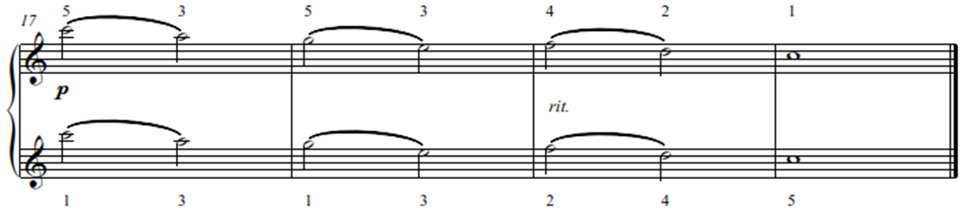

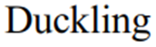
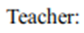
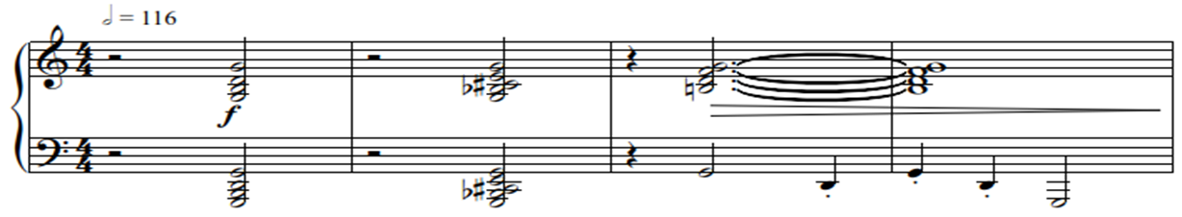

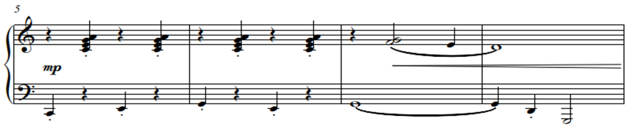

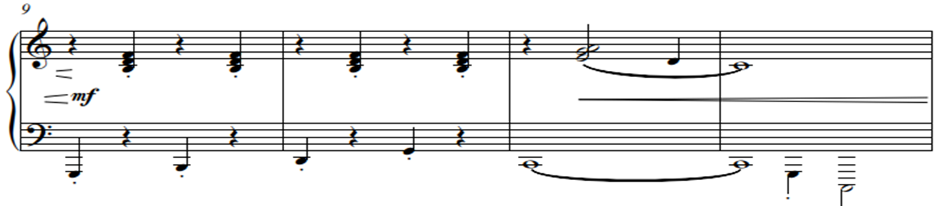

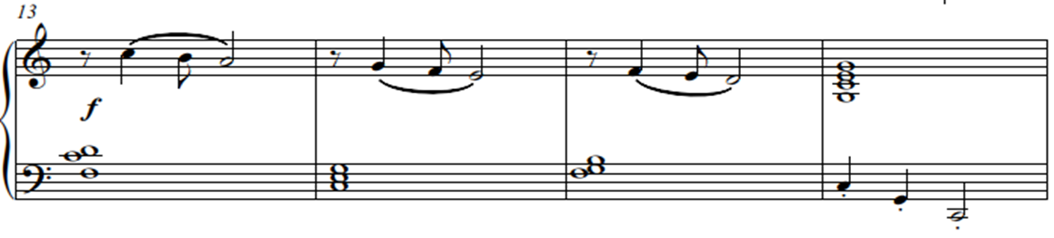

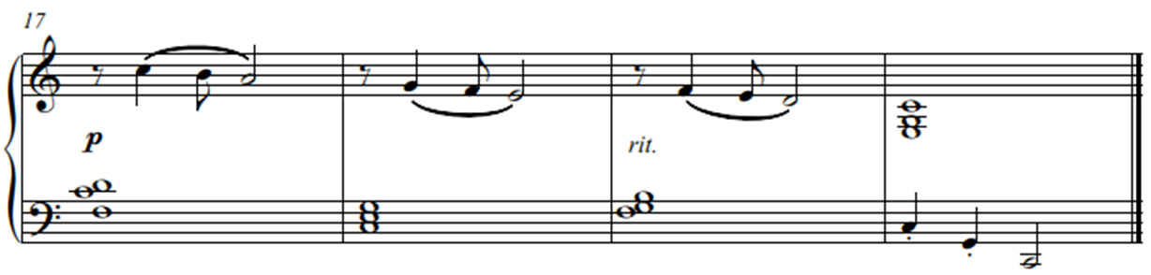

“Swinging”, the piece that follows, is an example of a composition where one would use these three movements in quick succession. It is challenging to execute different articulations simultaneously. A slow tempo at the beginning is always recommended, but once coordination is nurtured and settled, speed can be increased.

“Galloping” and “A Little Bird” came to me are short solo exercise of another combination of these movements executed independently in both hands.

Shosholoza is a duet to practise the same movements using an interesting, syncopated rhythm.

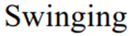
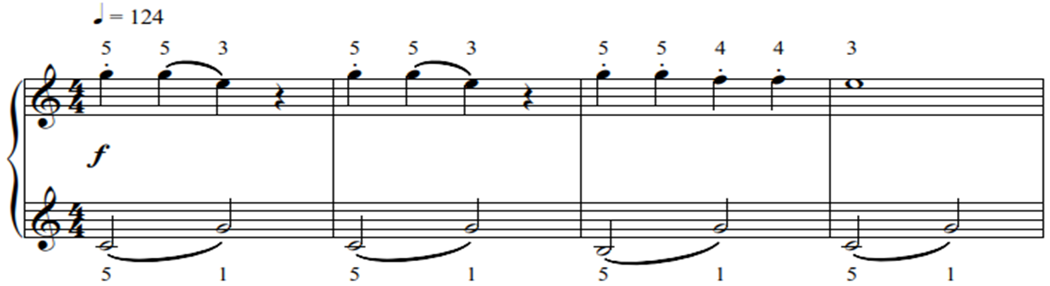

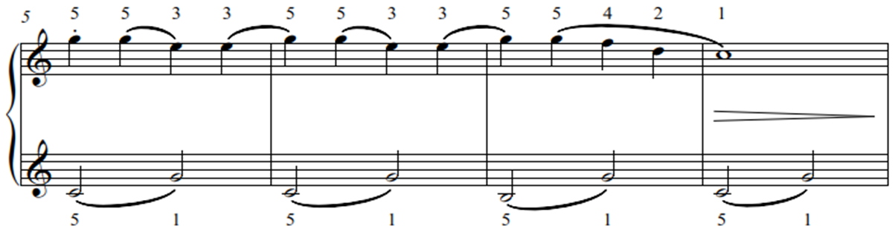

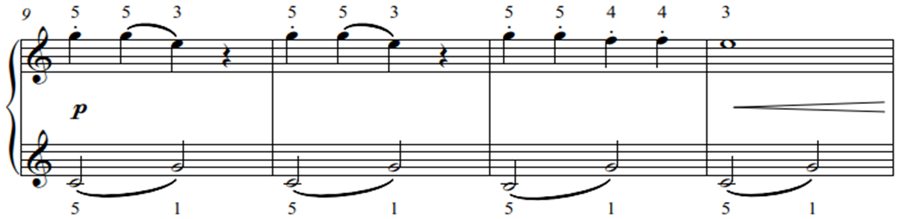

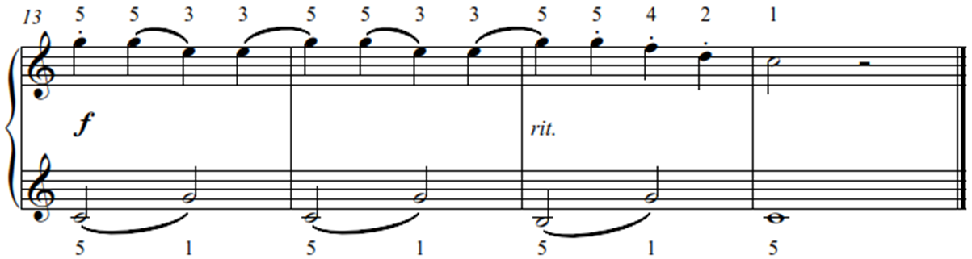

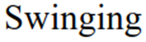
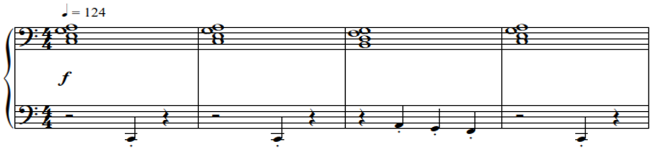

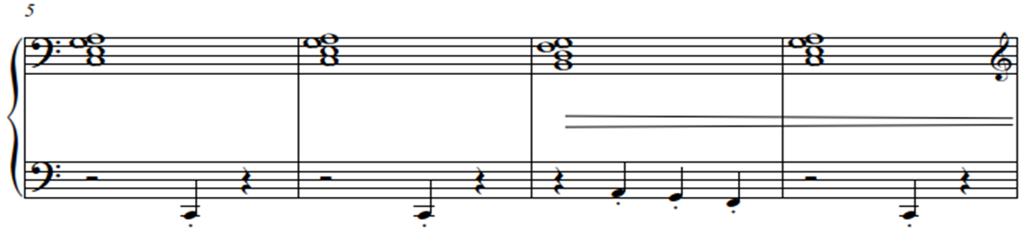

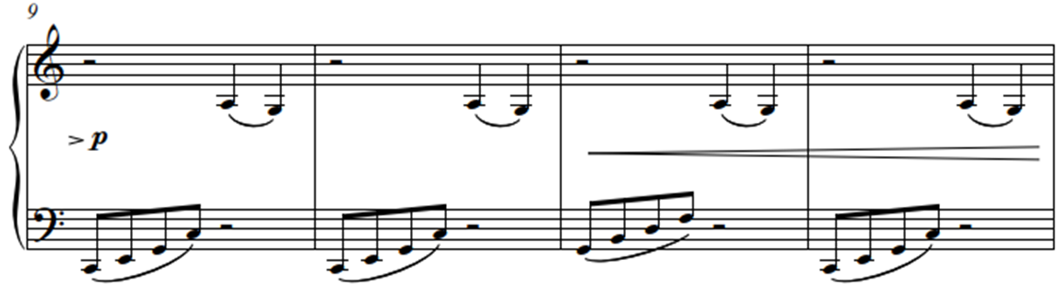

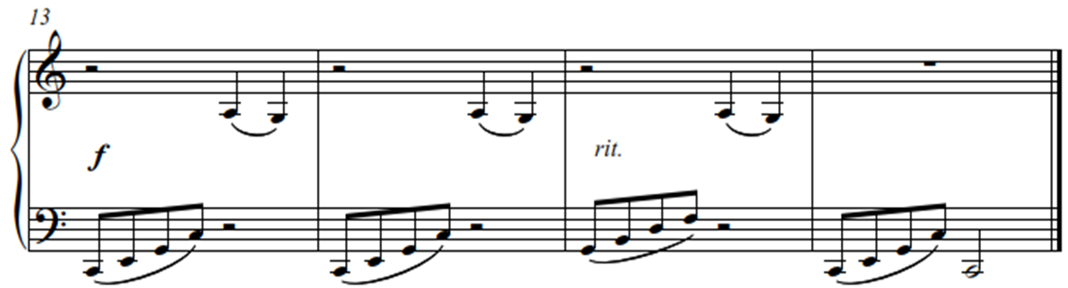

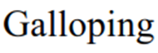
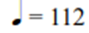
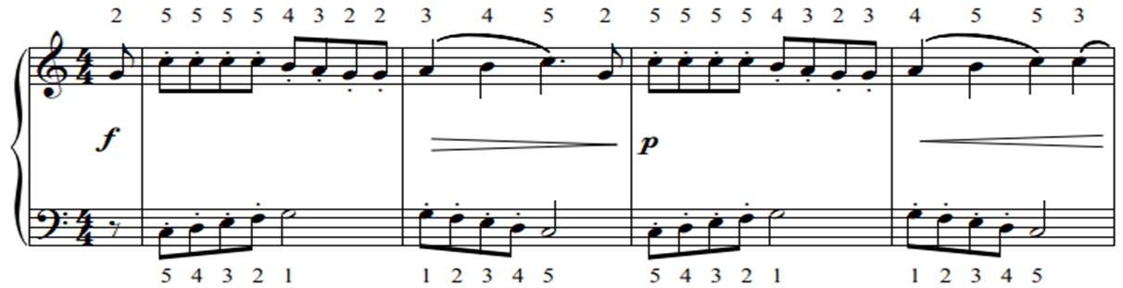

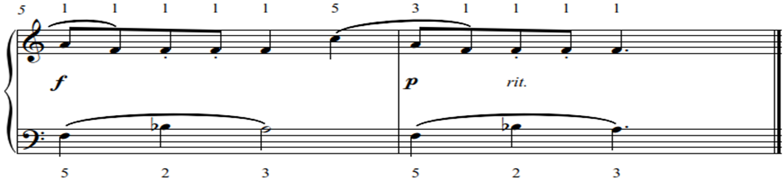

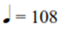
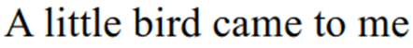
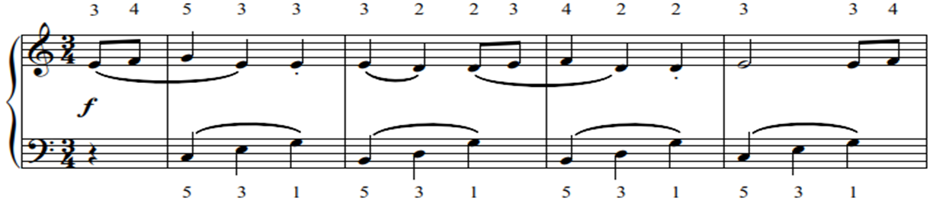

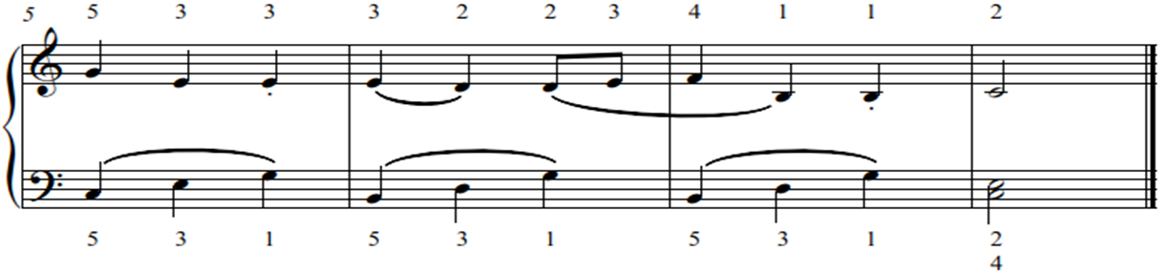

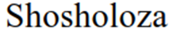
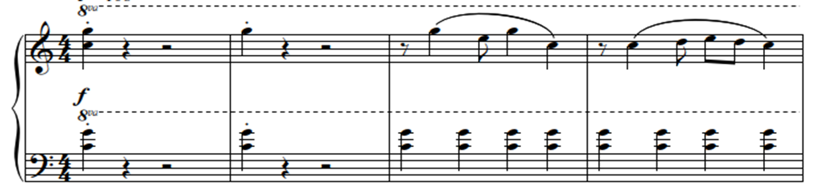
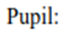

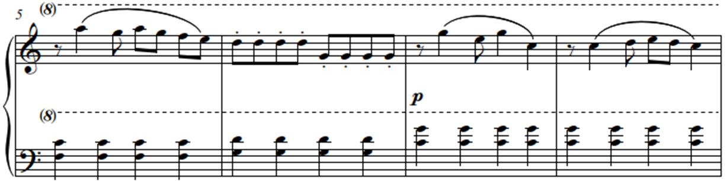

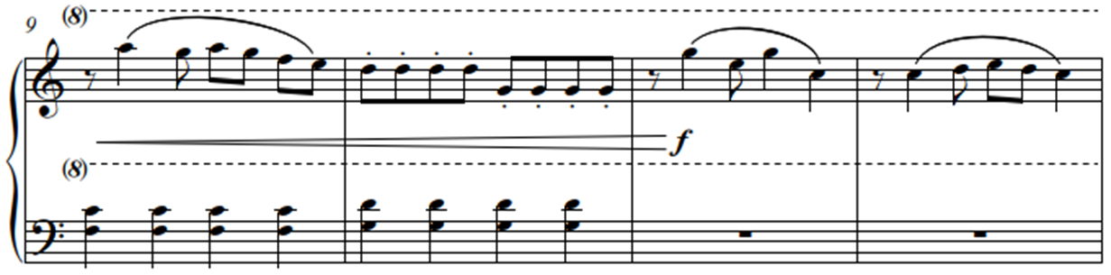

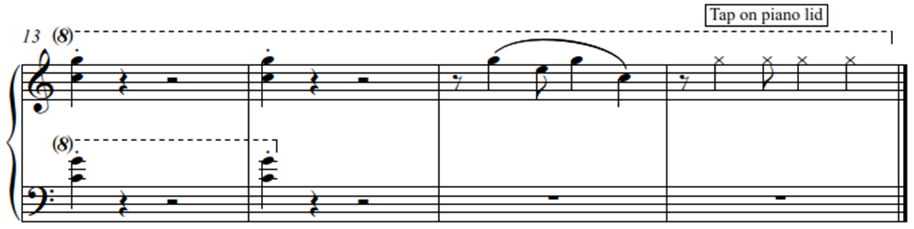

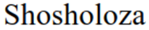
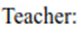
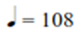
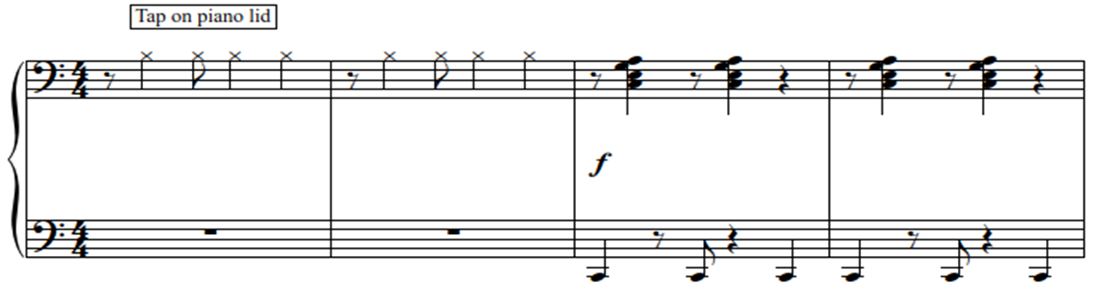

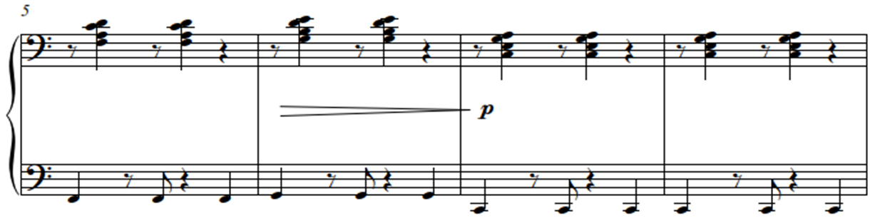

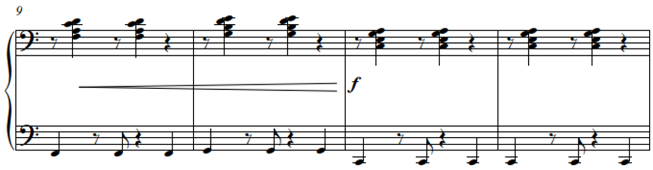

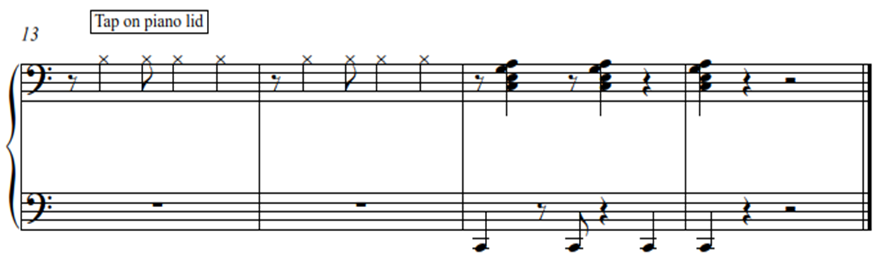

5.1.1 Free-fall, Float-off, Staccato and Alberti bass

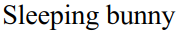
“Sleeping Bunny”, “Baa Baa Black Sheep” and “The Little Frog” are duets that combine all of the above movements. They should be practised hands separately at first to ensure settled articulation and movement.
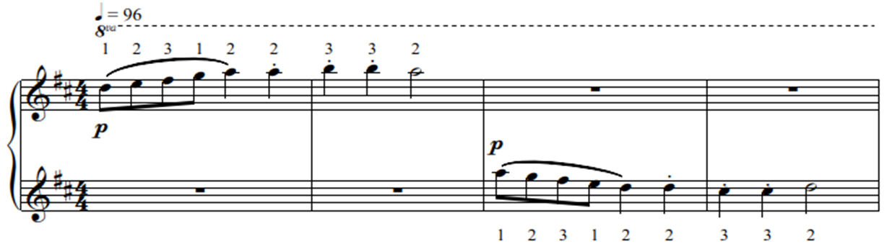

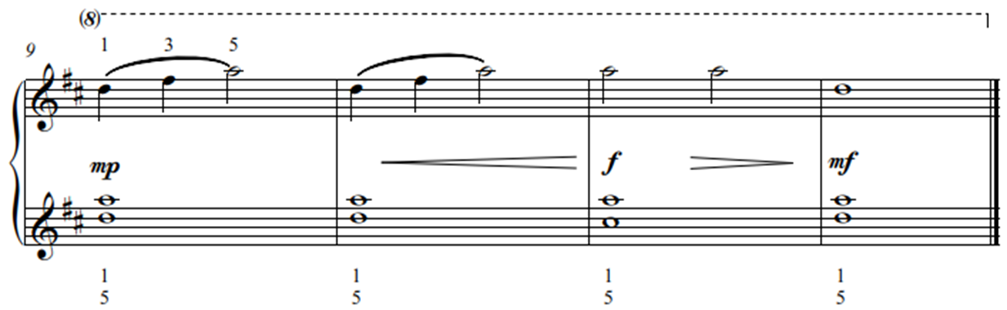

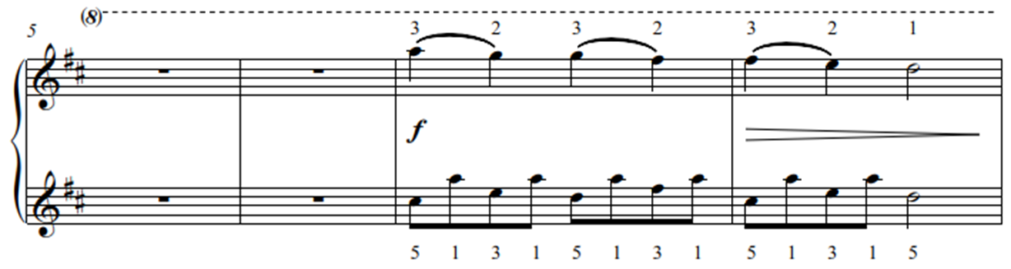

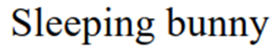
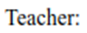
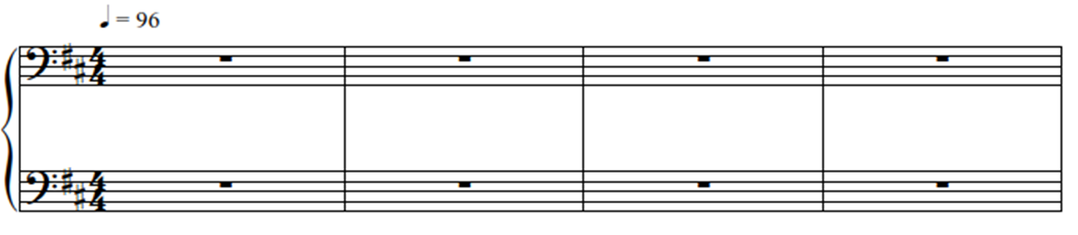

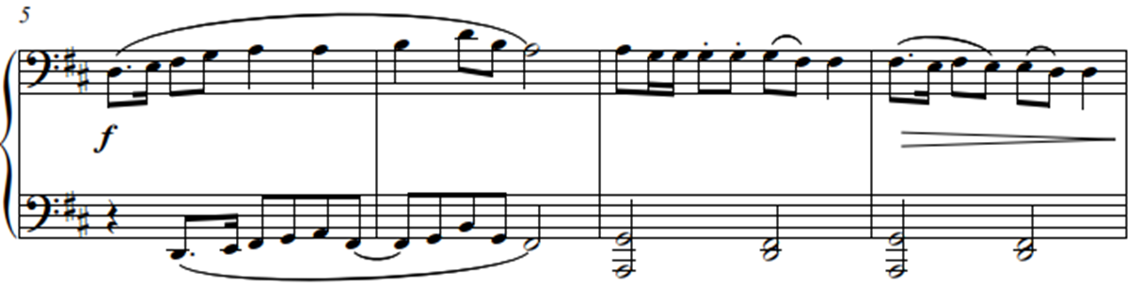

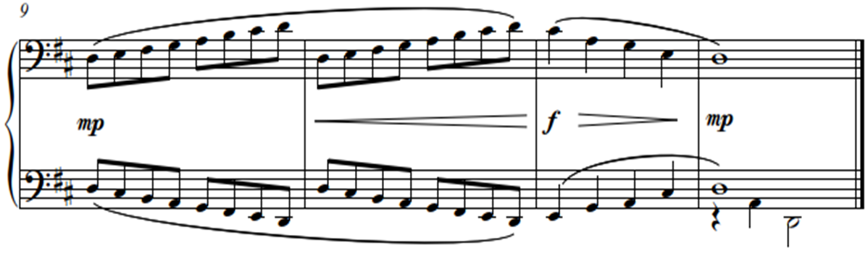

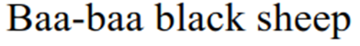
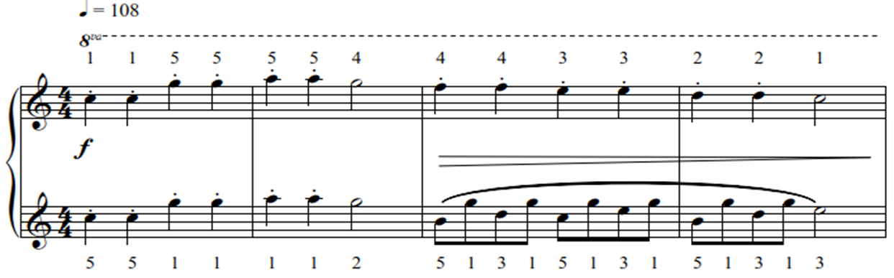

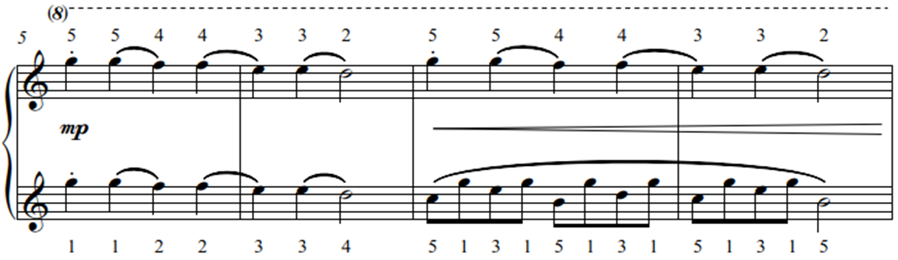

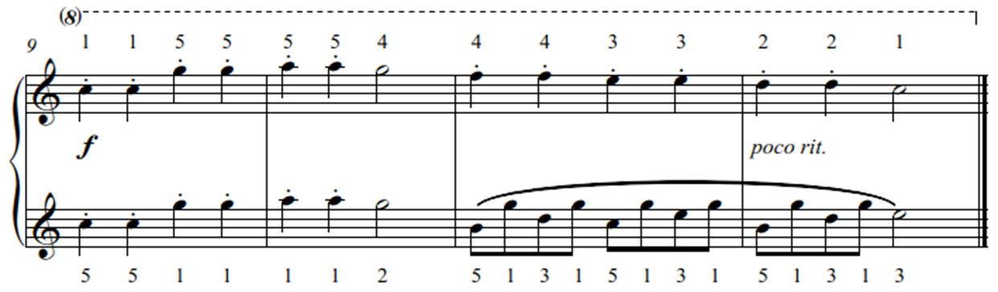

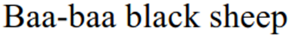
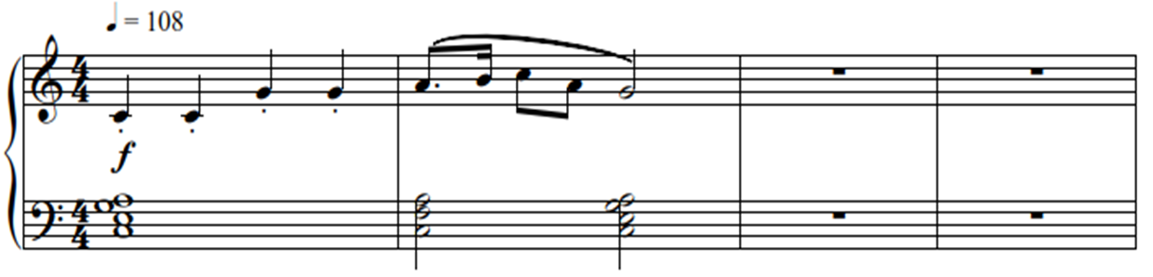

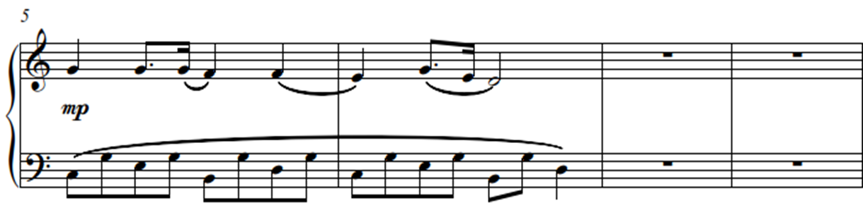

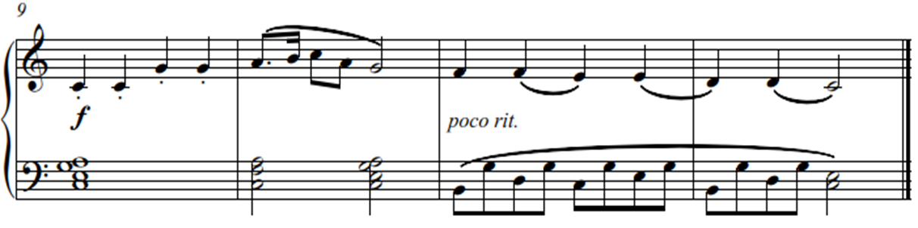

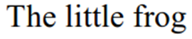
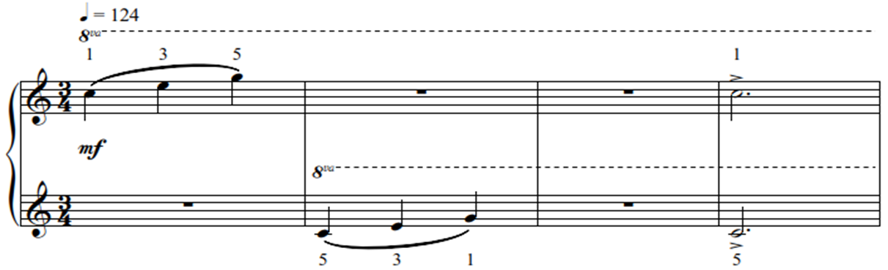

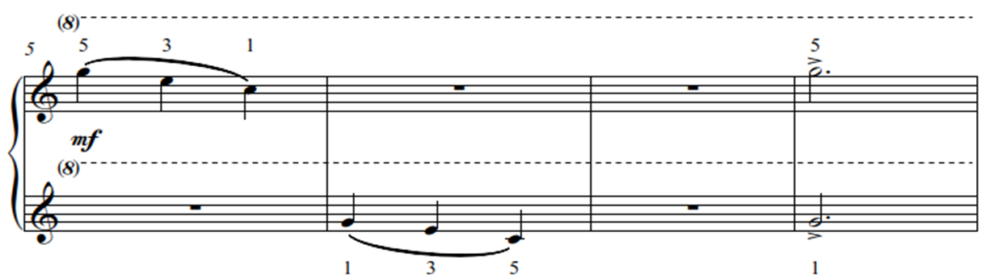

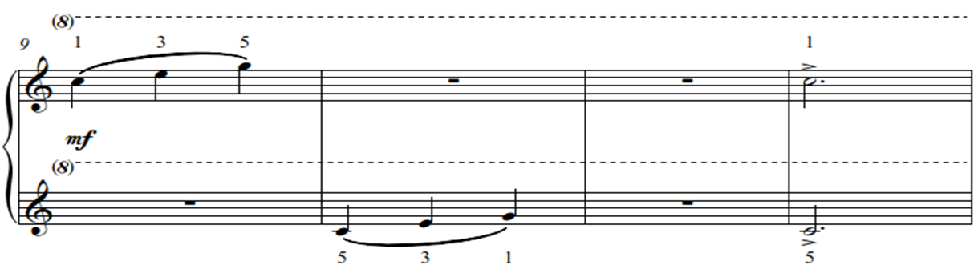

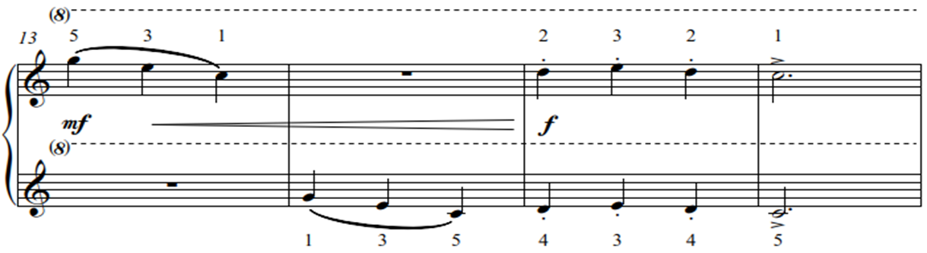

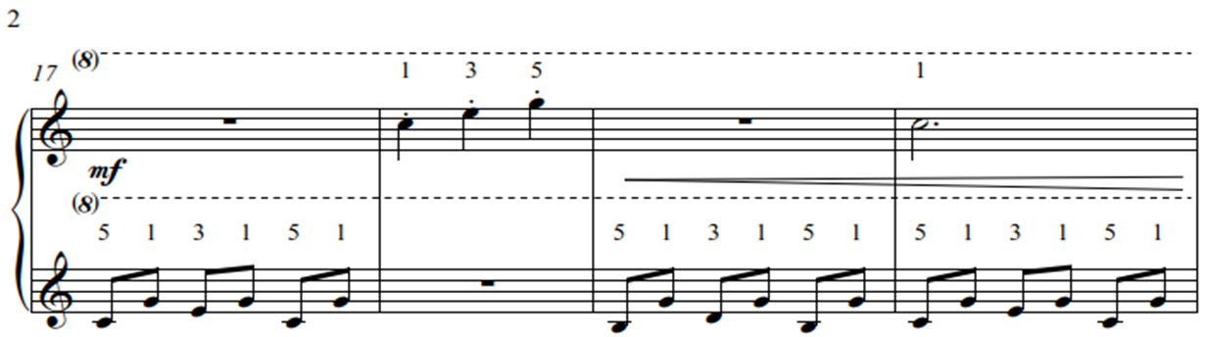

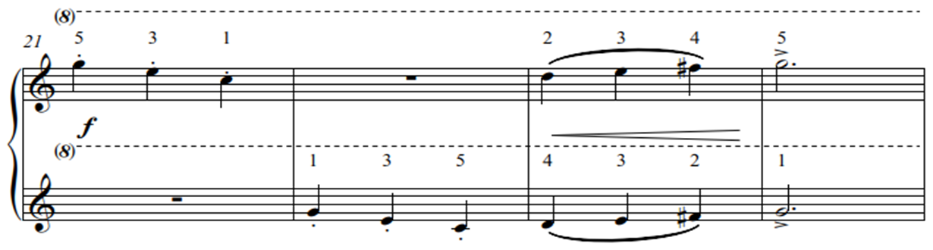

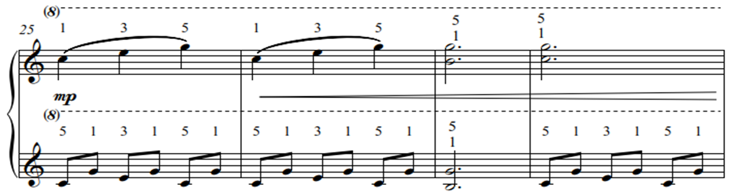

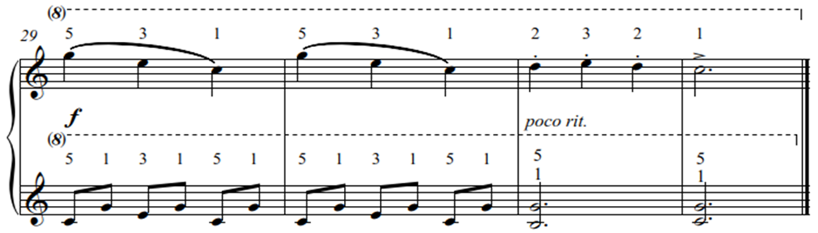

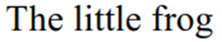
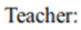
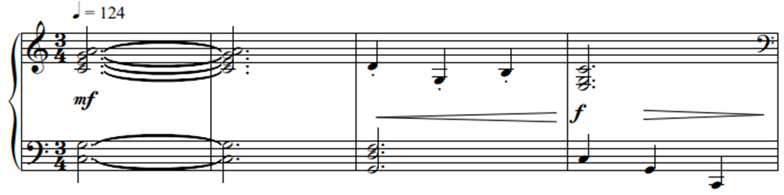

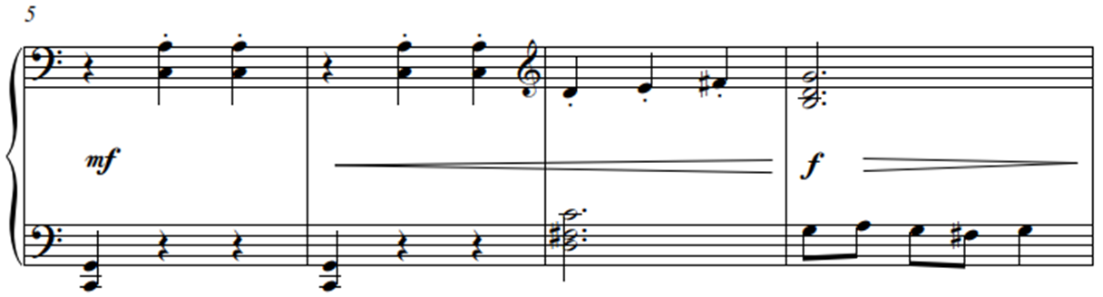

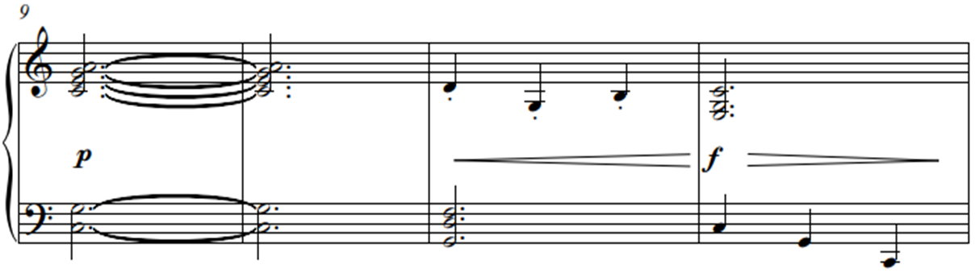

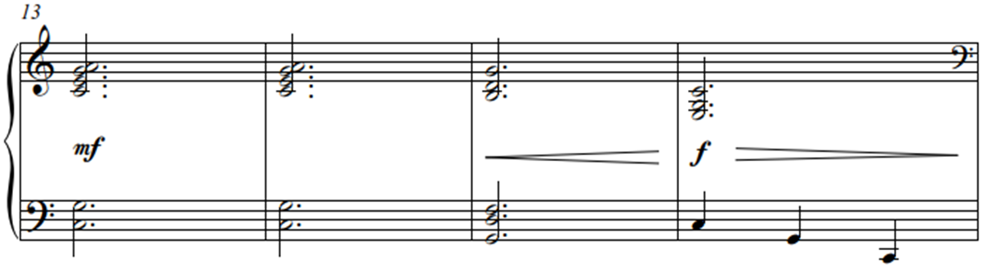

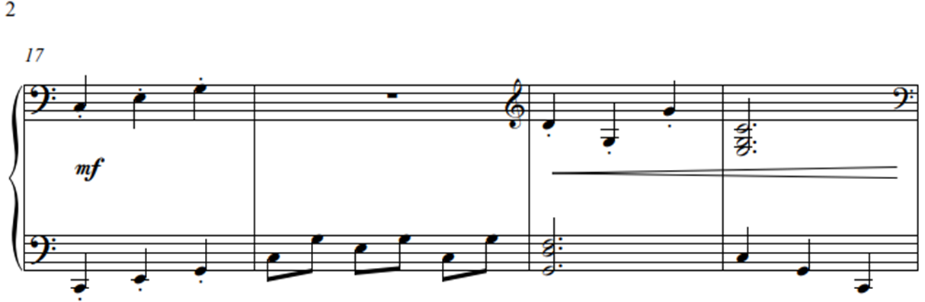

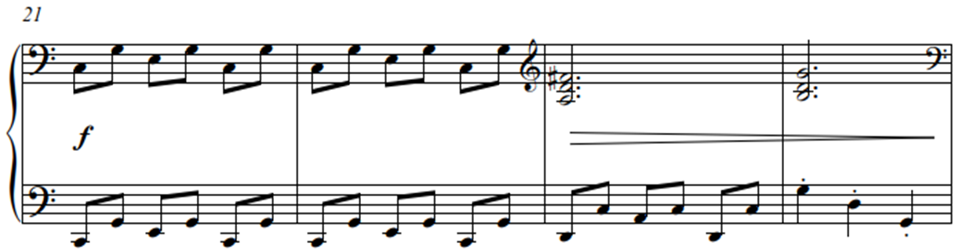

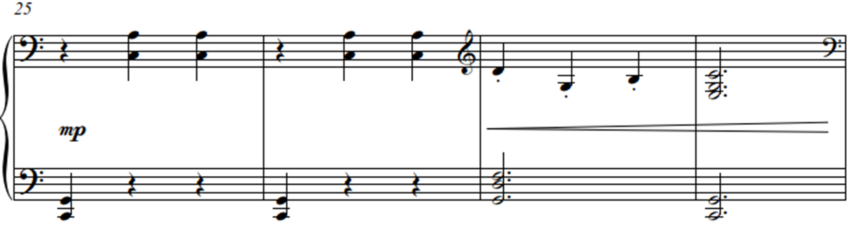

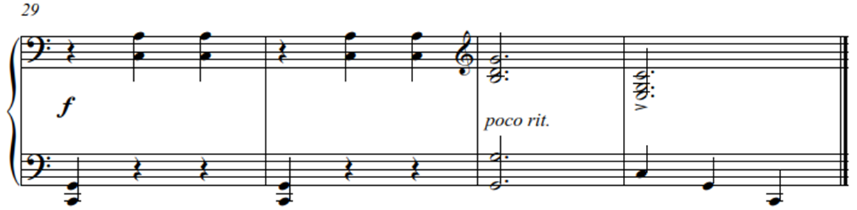

CONCLUSION

Behind this study on the movements of beginner pianists lies many years of teaching and the variety of possible approaches to teaching beginner pianists is extensive. Some teachers prioritise the reading process, some prioritise theory, while some prioritise finger technique. That said, there are two constant factors affecting beginner piano technique on the modern piano. These are:
- the movement of the entire body, i.e. ten fingers, two hands, two arms, torso and both legs
- the instrument and its characteristics

The debate on the foundational years of piano teaching and learning is an ongoing one, but the guidelines suggested here can be applied within all teaching styles. Whatever the approach, teaching relaxed and structurally sound movements remains forever crucial for the development of a beginner’s piano technique on the modern piano.

The overall aim is to educate students, support teachers in developing beginner technique, and provide joy for the young pupils and teachers performing the pieces.

