Supplementary data
In vitro Antiproliferative, Anti-inflammatory Effects and Molecular Docking Studies of Natural Compounds Isolated from Sarcocephalus pobeguinii (Hua ex Pobég).
Emmanuel Mfotie Njoya ^{1,2,}*, Brigitte Ndemangou⁴, Jude Akinyelu ⁵, Aristide M. Munvera ³, Chika. I. Chukwuma ¹, Yves M. Nguekeu Mba ¹, Pierre Mkounga ³, Samson S. Mashele ¹, Tshepiso J. Makhafola ¹*, and Lyndy J. McGaw ²
¹ Centre for Quality of Health and Living, Faculty of Health and Environmental Sciences, Central University of Technology, Bloemfontein 9301, South Africa; cchukwuma@cut.ac.za (C.I.C.); smashele@cut.ac.za (S.S.M.), ynguekeu@cut.ac.za (Y.M.N.M.)
² Department of Paraclinical Sciences, Faculty of Veterinary Science, University of Pretoria, Onderstepoort, Pretoria 0110, South Africa; lyndy.mcgaw@up.ac.za (L.J.M.)
³ Department of Organic Chemistry, Faculty of Science, University of Yaoundé I, Yaoundé 812, Cameroon; mfifena@hotmail.fr (A.M.M.); mpierrendi@yahoo.fr (P.M.)
⁴ University Institute of Technology of Wood Technology, Mbalmayo 306, Cameroon; ndemangou@yahoo.fr (B.N.)
⁵ Department of Biochemistry, Federal University Oye-Ekiti, Ekiti State, Nigeria; jude.akinyelu@fuoye.edu.ng (J.A.)
* Correspondence: mfotiefr@yahoo.fr or enjoya@cut.ac.za (E.M.N.); jmakhafola@cut.ac.za (T.J.M.)

Table of Contents:

Figure S1: Mass spectrum of mixture Nauclealatifoline G and Naucleofficines D (1).
Figure S2: ¹H NMR spectrum (DMSO-d₆, 400 MHz) of mixture Nauclealatifoline G and Naucleofficines D (1).
Figure S3: ¹³C NMR spectrum (DMSO-d₆, 100 MHz) of mixture Nauclealatifoline G and Naucleofficines D (1).
Figure S4: ¹H NMR spectrum (DMSO-d₆, 400 MHz) of hederagenin (2).
Figure S5: ¹³C NMR spectrum (DMSO-d₆, 100 MHz) of hederagenin (2).
Figure S6: ¹H NMR spectrum (MeOH-d₄, 400 MHz) of chletric acid (3)
Figure S7: ¹³C NMR spectrum (MeOH-d₄, 100 MHz) of chletric acid (3)
Figure S8: ¹H NMR spectrum (pyridine-_{d5}, 400 MHz) of taraxerol (4)
Figure S9: ¹³C NMR spectrum (pyridine-_{d5}, 100 MHz) of taraxerol (4)
Figure S10: ¹H NMR spectrum (CDCl₃, 400 MHz) of α-amyrin (3β-hydroxy-urs-12-en-3-ol) (5)
Figure S11: ¹³C NMR spectrum (CDCl₃, 100 MHz) of α-amyrin (3β-hydroxy-urs-12-en-3-ol) (5)
Figure S12-1: ¹H NMR spectrum (DMSO-d₆, 400 MHz) of quinovic acid 3-O-[α-D-quinovopyranoside] (6).
Figure S12-2: ¹H NMR spectrum (DMSO-d₆, 400 MHz) of quinovic acid 3-O-[α-D-quinovopyranoside] (6).
Figure S13: ¹³C NMR spectrum (DMSO-d₆ , 100 MHz) of quinovic acid 3-O-[α-D-quinovopyranoside] (6).
Figure S14: ¹H NMR spectrum (CDCl₃, 400 MHz) of erythrodiol (7).
Figure S15: ¹³C NMR spectrum (CDCl₃, 100 MHz) of erythrodiol (7).
Figure S16: ¹H NMR spectrum (DMSO-d₆, 400 MHz) of quinovic acid (8).
Figure S17: ¹³C NMR spectrum (DMSO-d₆, 100 MHz) of quinovic acid (8).
Figure S18: Mass spectrum of quinovic acid 3-O-[β-D-quinovopyranoside] (9).
Figure S19: ¹H NMR spectrum (MeOH-d₄, 500 MHz) of quinovic acid 3-O-[β-D-quinovopyranoside] (9).
Figure S20: ¹³C NMR spectrum (MeOH-d_{4,} 125MHz) of quinovic acid 3-O-[β-D-quinovopyranoside] (9).
Figure S21: ¹H NMR spectrum (CD3OD, 400 MHz) of latifoliamide C (10).
Figure S22: ¹³C NMR spectrum (CD3OD, 100 MHz) of latifoliamide C (10).

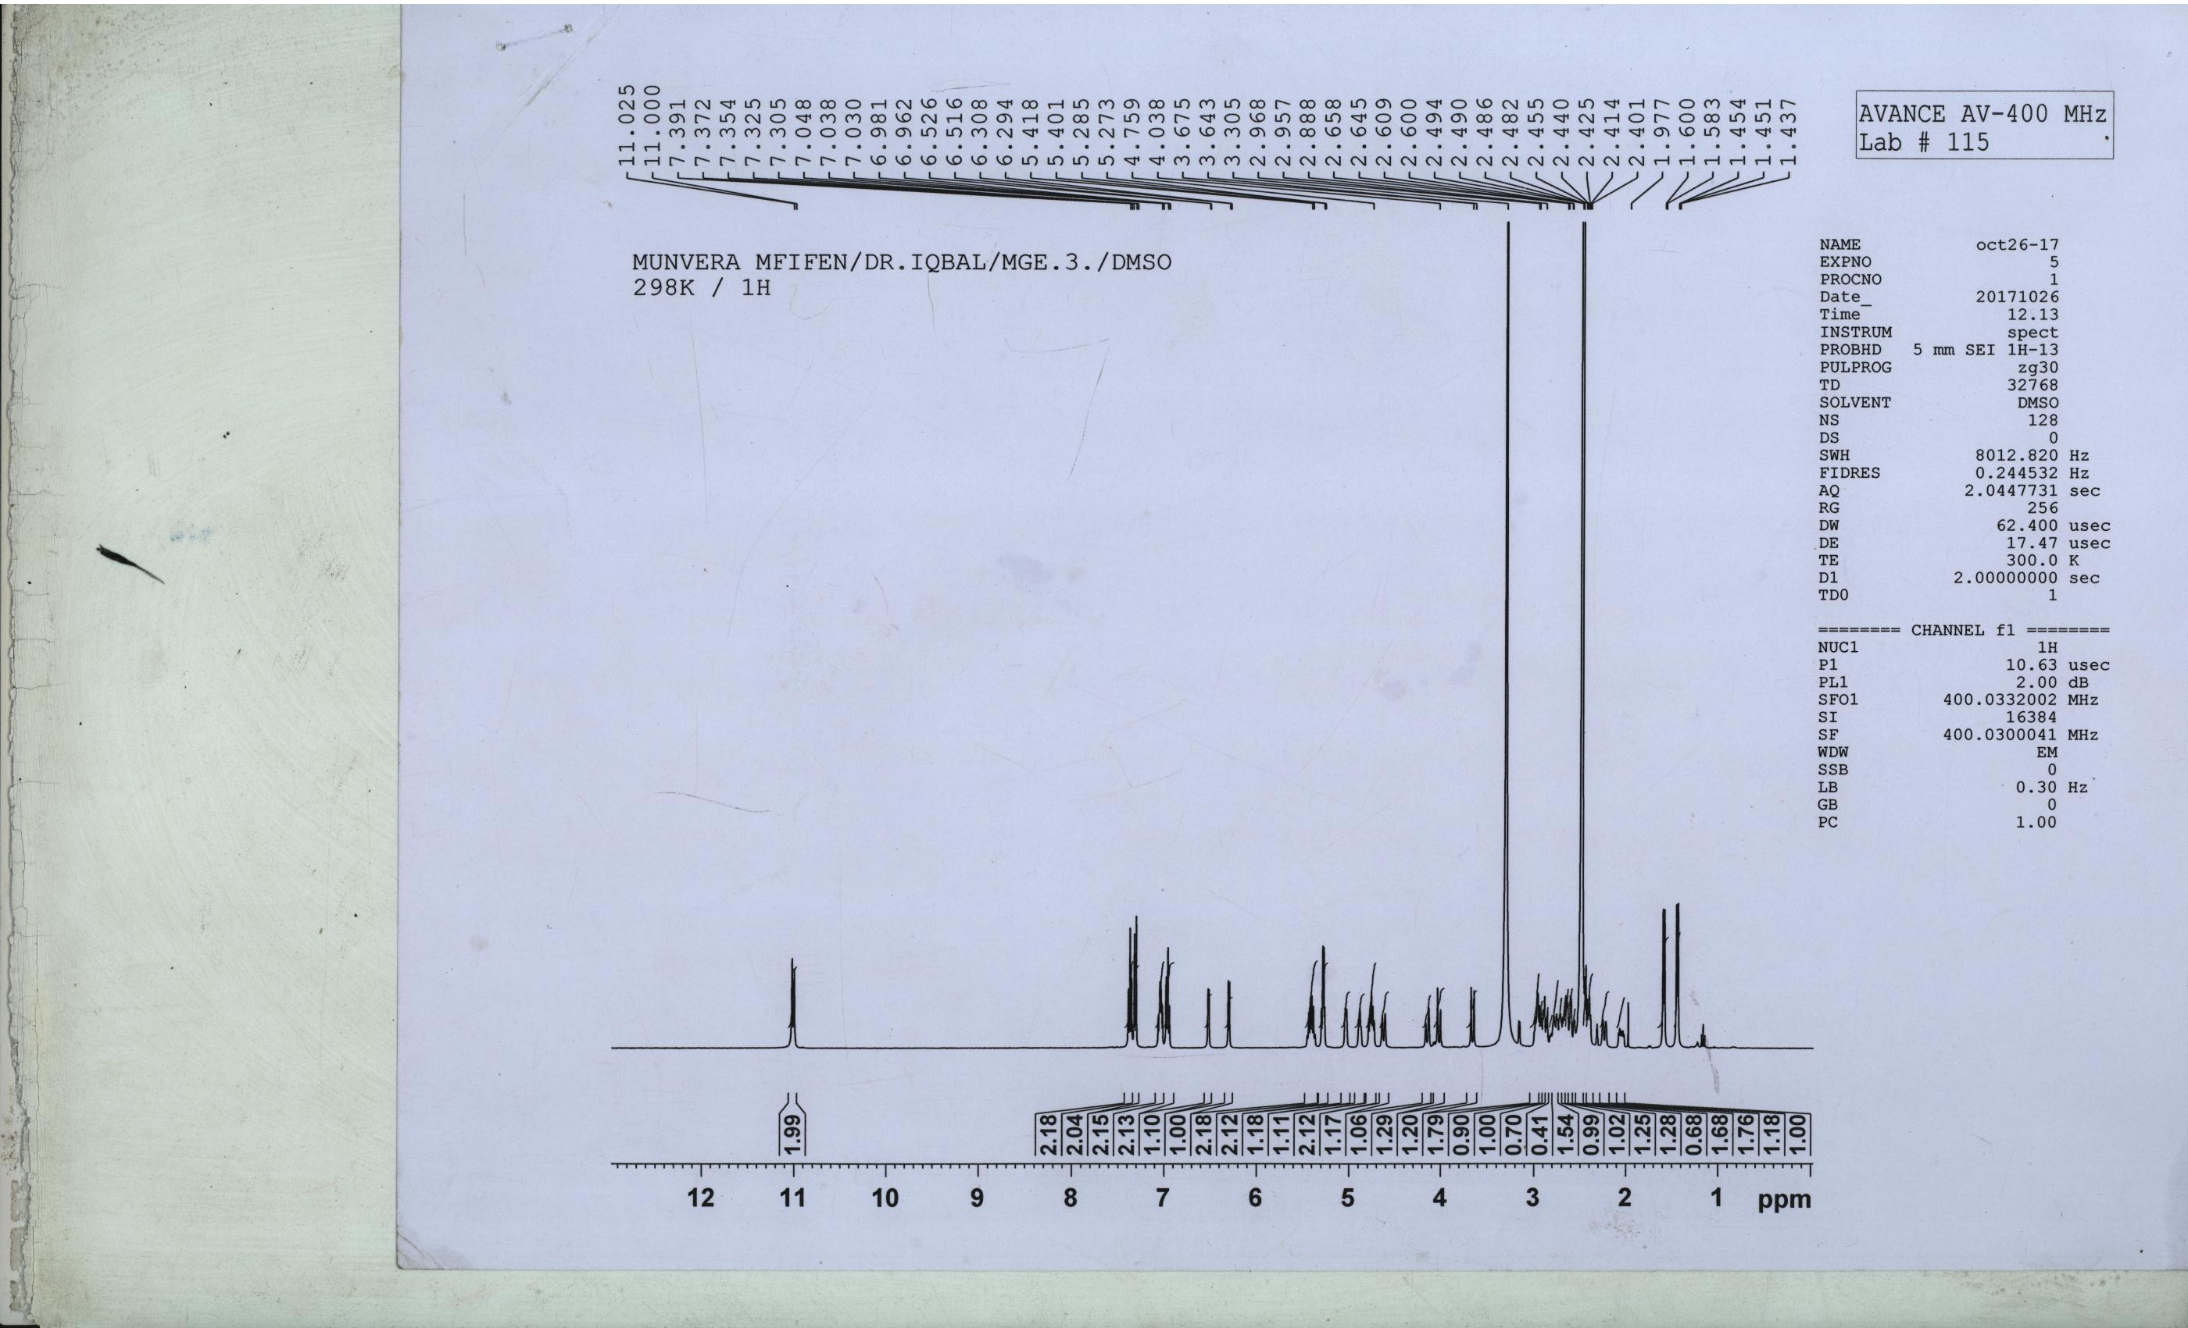
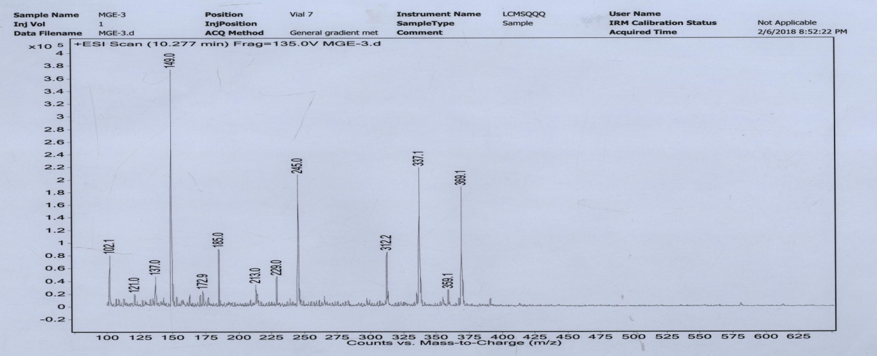

Figure S1: Mass spectrum of mixture Nauclealatifoline G and Naucleofficines D (1).

Figure S2: ¹H NMR spectrum (DMSO-d₆, 400 MHz) of mixture Nauclealatifoline G and Naucleofficines D (1).
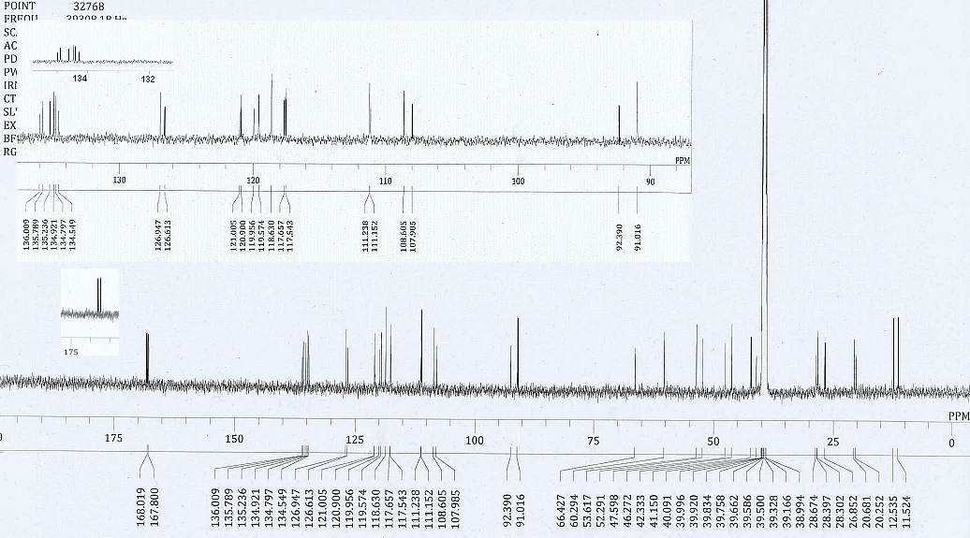
Figure S3: ¹³C NMR spectrum (DMSO-d₆, 100 MHz) of mixture Nauclealatifoline G and Naucleofficines D (1).

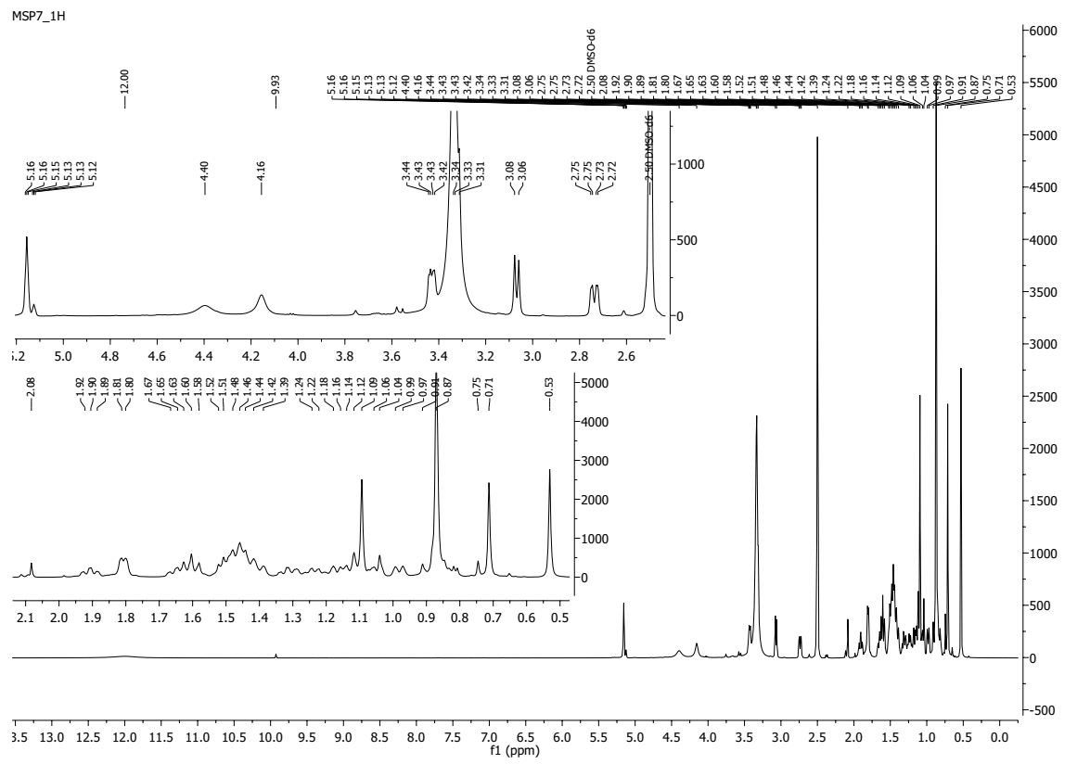
Figure S4: ¹H NMR spectrum (DMSO-d₆, 400 MHz) of hederagenin (2).

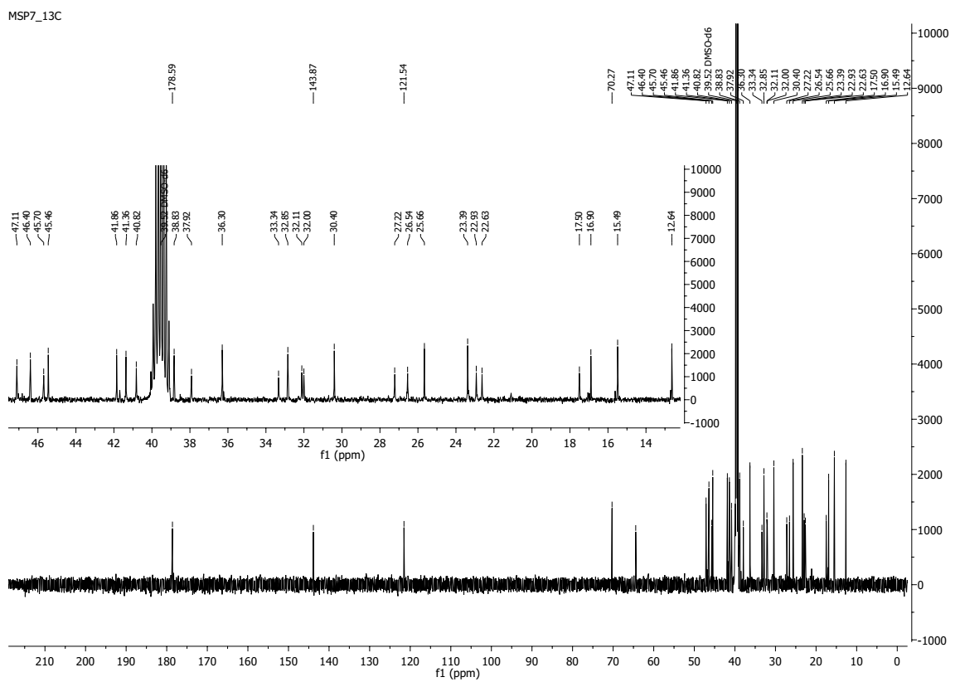
Figure S5: ¹³C NMR spectrum (DMSO-d₆, 100 MHz) of hederagenin (2).

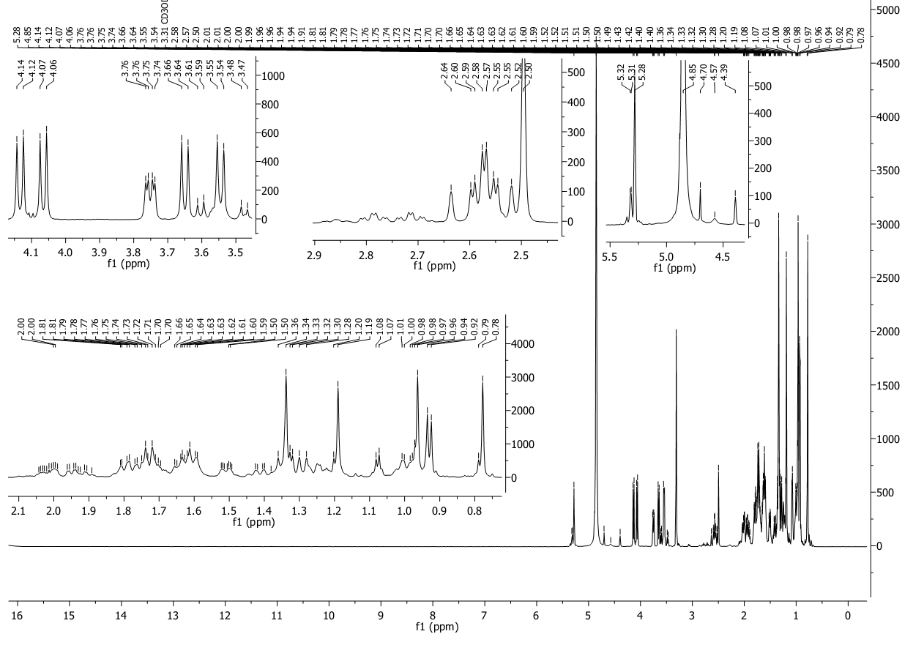
Figure S6: ¹H NMR spectrum (MeOH-d₄, 400 MHz) of chletric acid (3)

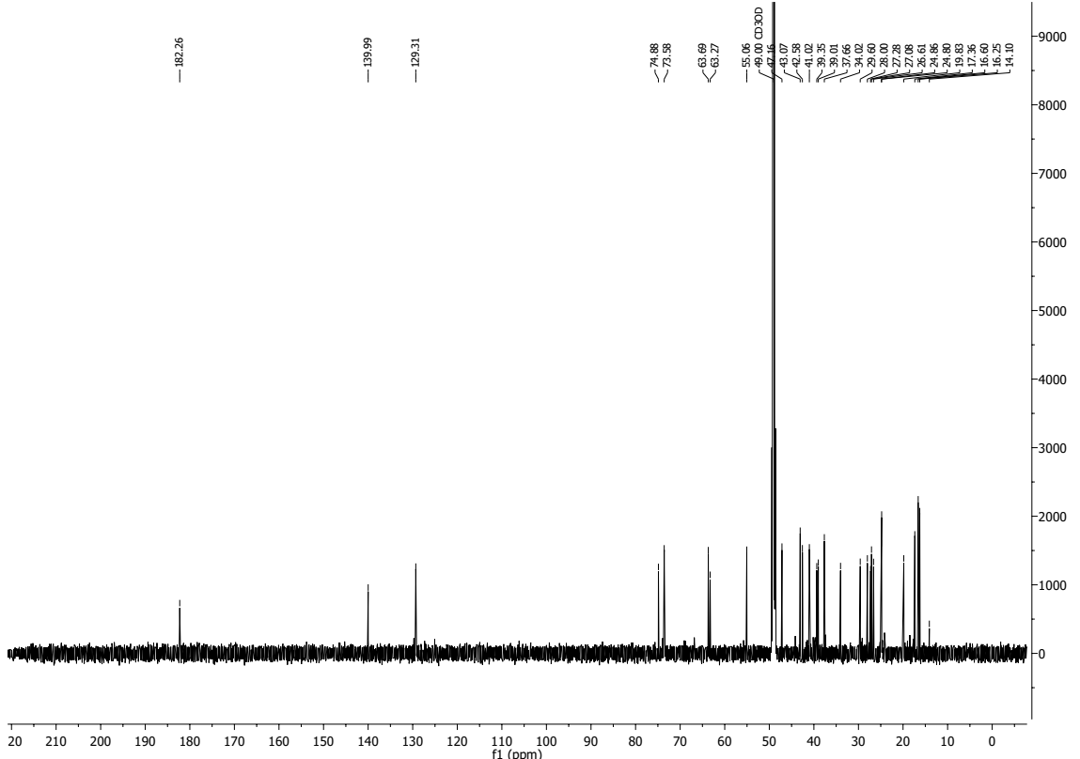
Figure S7: ¹³C NMR spectrum (MeOH-d₄, 100 MHz) of chletric acid (3)

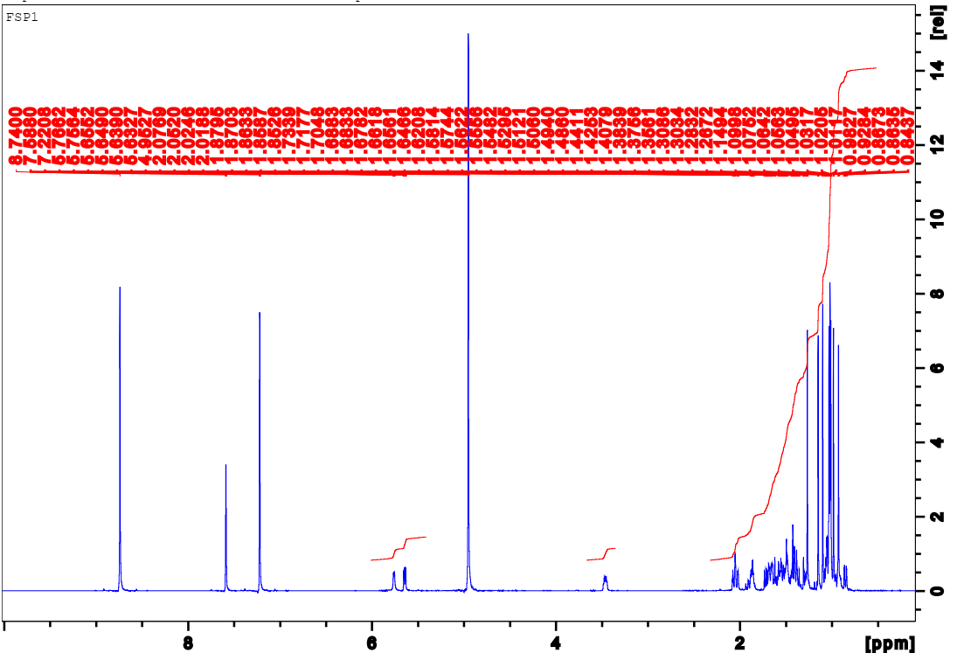
Figure S8: ¹H NMR spectrum (pyridine-_{d5}, 400 MHz) of taraxerol (4)

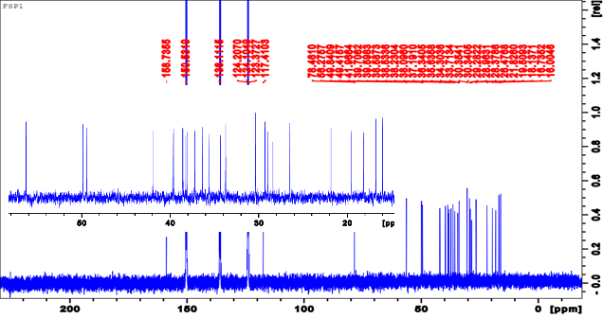
Figure S9: ¹³C NMR spectrum (pyridine-_{d5}, 100 MHz) of taraxerol (4)
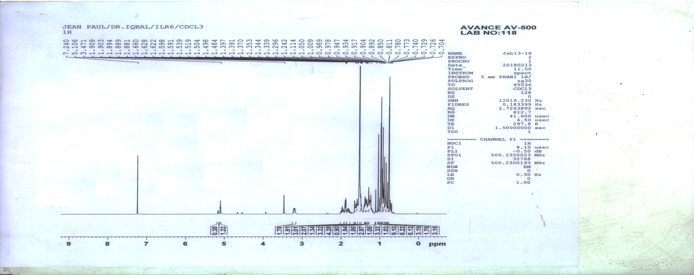
Figure S10: ¹H NMR spectrum (CDCl₃, 400 MHz) of α-amyrin (3β-hydroxy-urs-12-en-3-ol) (5)

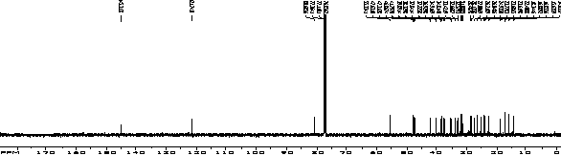
Figure S11: ¹³C NMR spectrum (CDCl₃, 100 MHz) of α-amyrin (3β-hydroxy-urs-12-en-3-ol) (5)

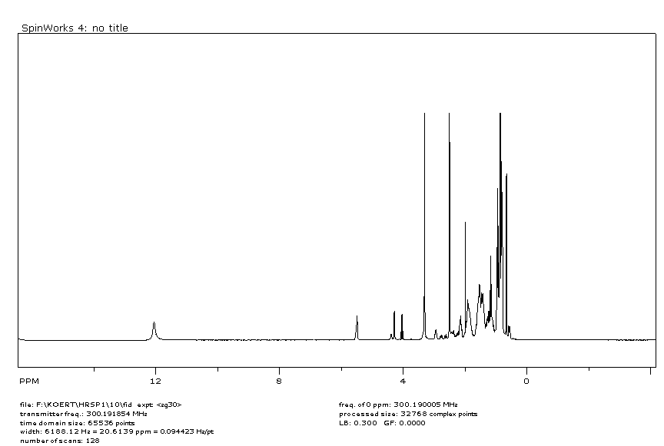 Figure S12-1: ¹H NMR spectrum (DMSO-d₆, 400 MHz) of quinovic acid 3-O-[ α-D-quinovopyranoside] (6).
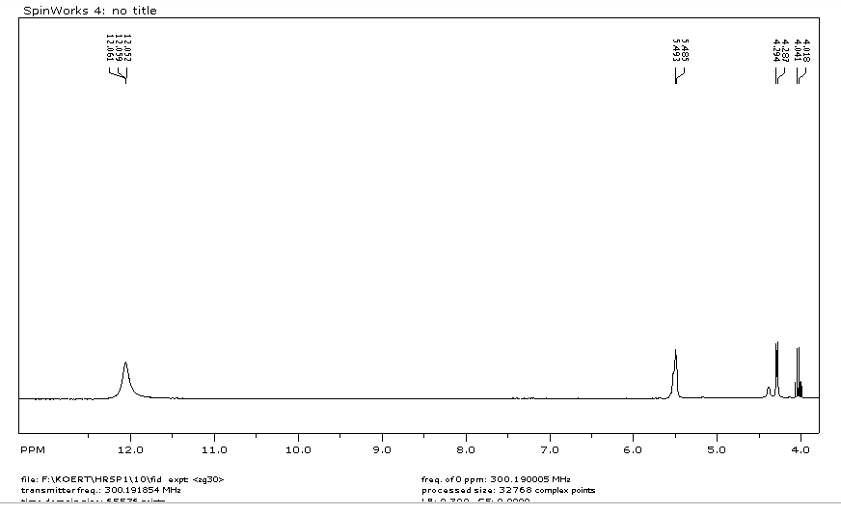
Figure S12-2: ¹H NMR spectrum (DMSO-d₆, 400 MHz) of quinovic acid 3-O-[ α-D-quinovopyranoside] (6).
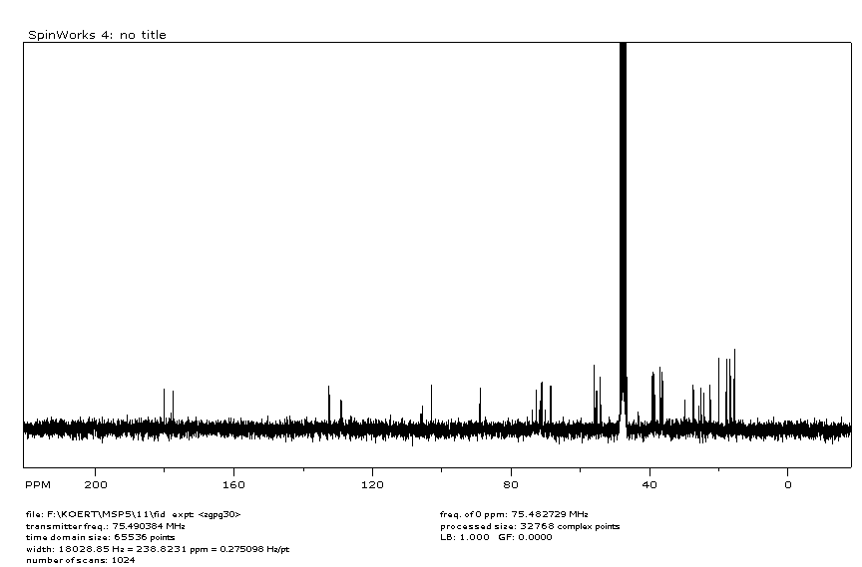
Figure S13: ¹³C NMR spectrum (DMSO-d₆ , 100 MHz) of quinovic acid 3-O-[ α-D-quinovopyranoside] (6).

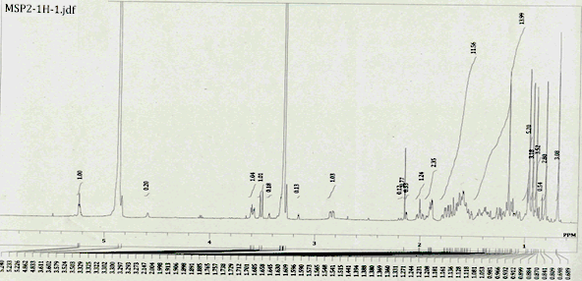
Figure S14: ¹H NMR spectrum (CDCl₃, 400 MHz) of erythrodiol (7).

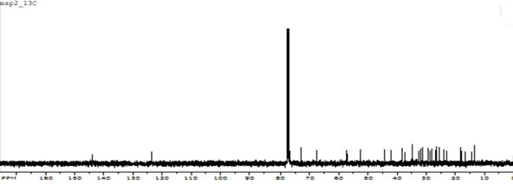
Figure S15: ¹³C NMR spectrum (CDCl₃, 100 MHz) of erythrodiol (7).

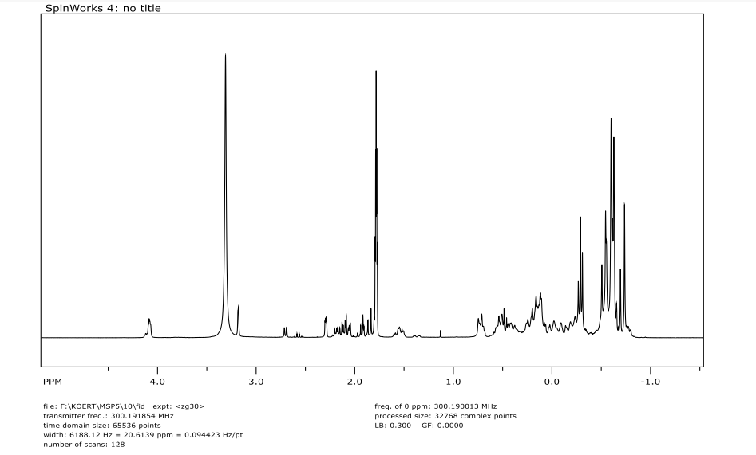
Figure S16: ¹H NMR spectrum (DMSO-d₆, 400 MHz) of quinovic acid (8).
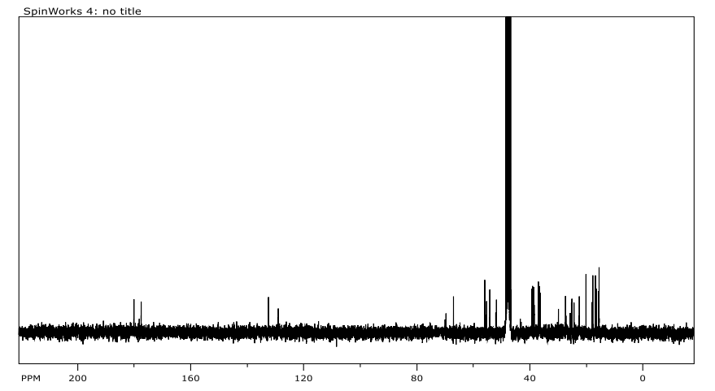
Figure S17: ¹³C NMR spectrum (DMSO-d₆, 100 MHz) of quinovic acid (8).

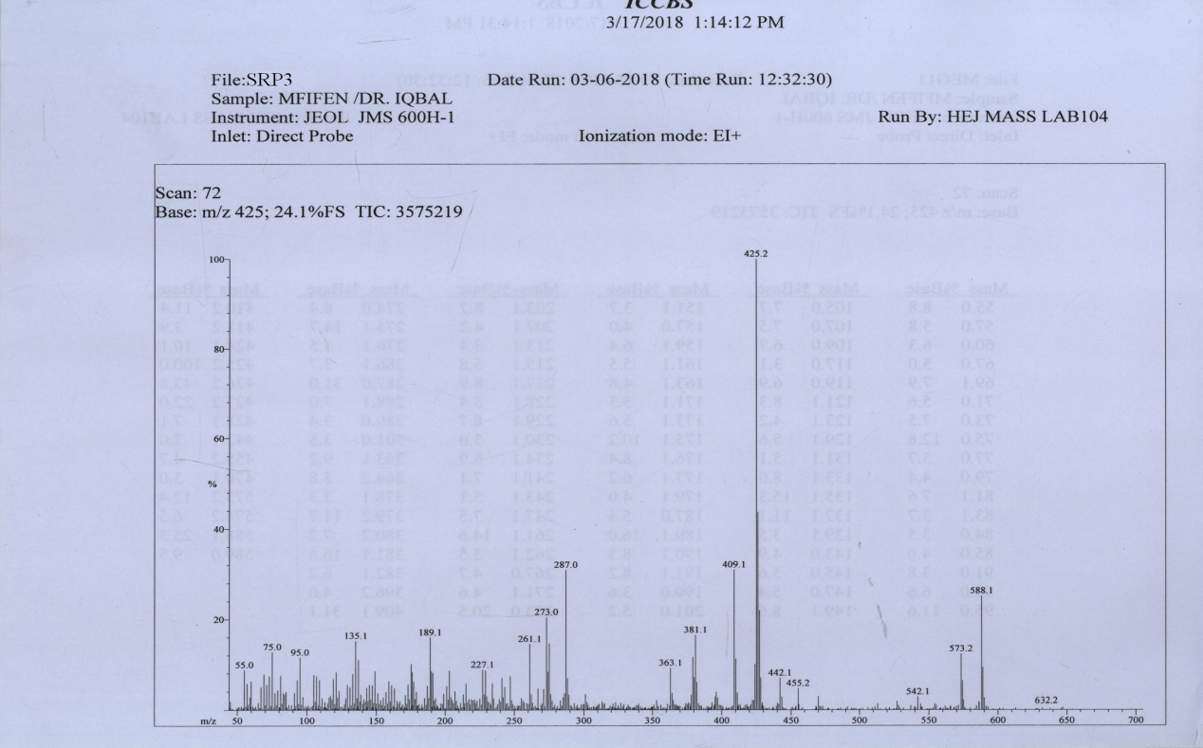
Figure S18: Mass spectrum of quinovic acid 3-O-[β-D-quinovopyranoside] (9).
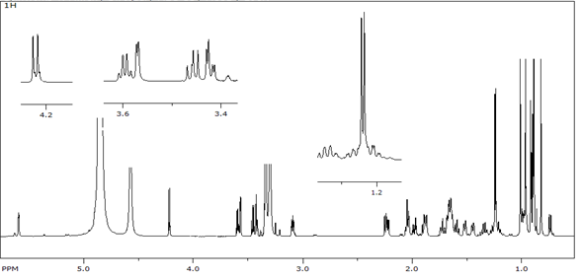
Figure S19: ¹H NMR spectrum (MeOH-d₄, 500 MHz) of quinovic acid 3-O-[β-D-quinovopyranoside] (9).
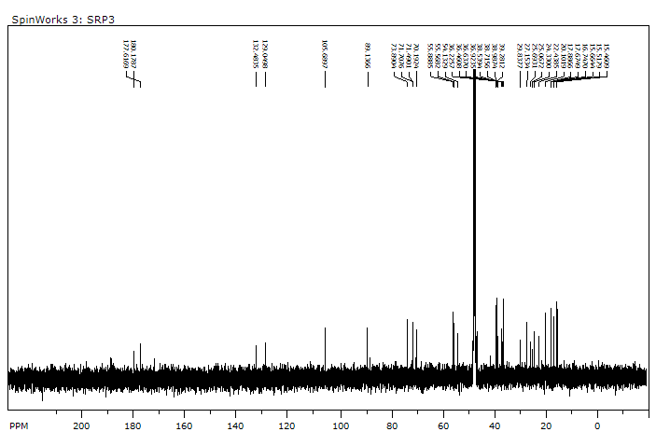
Figure S20: ¹³C NMR spectrum (MeOH-d_{4,} 125MHz) of quinovic acid 3-O-[β-D-quinovopyranoside] (9).

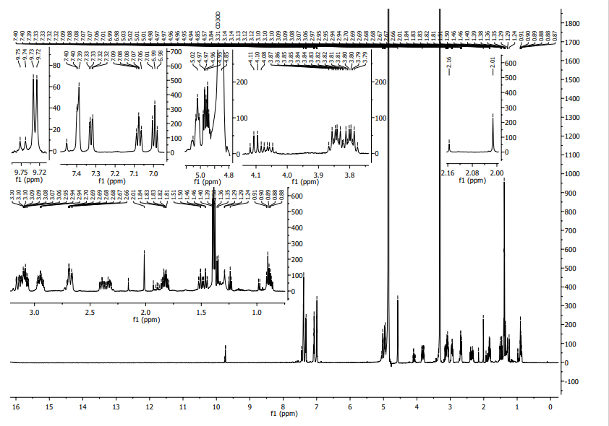
Figure S21: ¹H NMR spectrum (CD3OD, 400 MHz) of latifoliamide C (10).

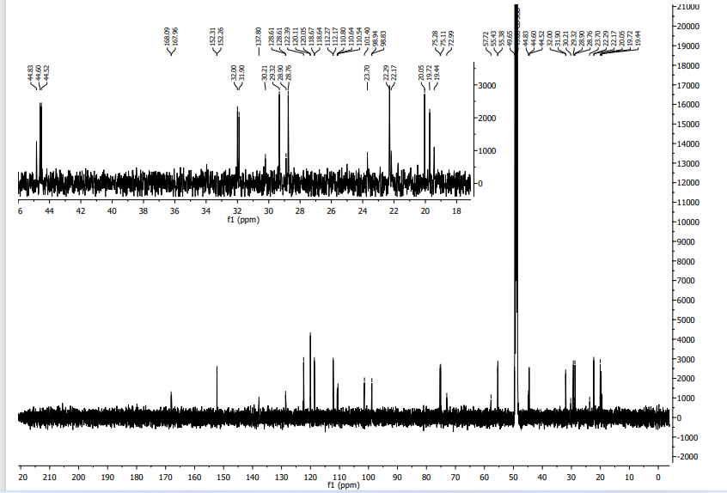
Figure S22: ¹³C NMR spectrum (CD3OD, 100 MHz) of latifoliamide C (10).

