Additional file 1

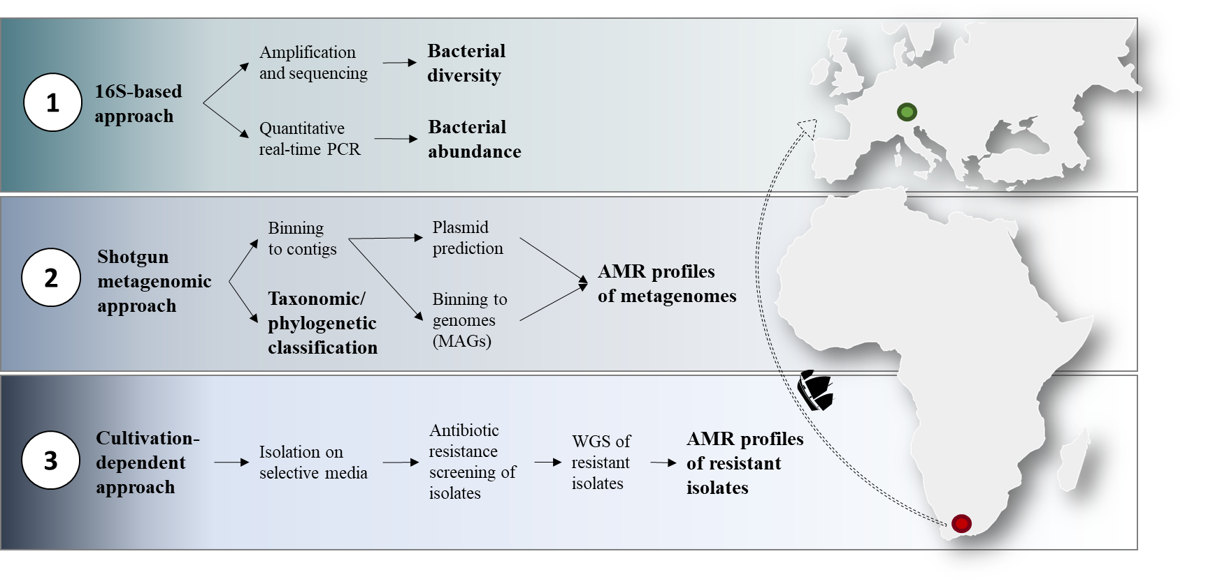Supplementary Figure 1: Overview of applied methods and workflow to analyze the microbiome and resistome of apple fruits from two different cultivars (Braeburn and Royal Gala) and sources (fresh from the tree and after storage and intercontinental transport).

Supplementary Table 1: Short read-based resistome analysis
 | Braeburn stored | Royal Gala stored | Braeburn fresh | Royal Gala fresh
Drug class | Counts of resistance genes
aminoglycoside | 81 | 143 | 29 | 21
bacitracin | 337 | 385 | 310 | 303
beta_lactam | 314 | 525 | 261 | 328
fosfomycin | 3 | 2 | 0 | 0
fosmidomycin | 142 | 31 | 43 | 18
glycopeptide | 6 | 2 | 36 | 65
kasugamycin | 67 | 23 | 26 | 10
macrolide-lincosamide-streptogramin | 16 | 46 | 18 | 4
multidrug | 1863 | 1607 | 1671 | 1788
mupirocin | 67 | 115 | 748 | 1297
polymyxin | 954 | 1156 | 787 | 1063
quinolone | 802 | 701 | 270 | 109
rifampin | 3 | 8 | 6 | 3
sulfonamide | 3 | 19 | 5 | 5
tetracycline | 10 | 179 | 7 | 13
triclosan | 3 | 8 | 13 | 13
trimethoprim | 0 | 2 | 0 | 0
Total | 4671 | 5128 | 4257 | 5045

Supplementary Table 2: Assembly results of apple metagenomes.
 | Braeburn fresh | Royal Gala fresh | Braeburn stored | Royal Gala stored
# number of contigs | 1483942 | 1458819 | 2031535 | 2072091
# total contigs length | 1027121064 | 1020881298 | 1266555057 | 1241053195
# mean contig size | 692,16 | 699,8 | 623,45 | 598,94
# contig size first quartile | 283 | 286 | 315 | 276
# median contig size | 352 | 373 | 379 | 337
# contig size third quartile | 526 | 605 | 530 | 475
# longest contig | 859584 | 361703 | 859491 | 395011
# shortest contig | 200 | 200 | 200 | 200
# contigs > 500 nt* | 396629 (26.73 %) | 458831 (31.45 %) | 555329 (27.34 %) | 475832 (22.96 %)
# contigs > 1K nt | 173181 (11.67 %) | 203072 (13.92 %) | 206949 (10.19 %) | 188404 (9.09 %)
# contigs > 10K nt | 6249 (0.42 %) | 3829 (0.26 %) | 3413 (0.17 %) | 6538 (0.32 %)
# contigs > 100K nt | 68 (0.00 %) | 33 (0.00 %) | 19 (0.00 %) | 44 (0.00 %)
# contigs > 1M nt | 0 (0.00 %) | 0 (0.00 %) | 0 (0.00 %) | 0 (0.00 %)
# N50 | 1079 | 1040 | 693 | 737
# L50 | 159218 | 193919 | 340259 | 276931
# N80 | 352 | 368 | 356 | 324
# L80 | 744903 | 747979 | 1174382 | 1130450
*Contigs with a minimum length of 500 nt were used for downstream analyses

Supplementary Table 3: Summary of binned genomes from apple metagenomics dataset
Sample | bin No. | Marker lineage CheckM | Taxonomy AMPHORA2 | # genomes | # markers | # marker sets | 0 | 1 | 2 | 3 | 4 | 5+ | Completeness | Contamination | Strain heterogeneity | binID
Braeburn fresh | 1 | k__Bacteria | Rhizobiales | 5449 | 104 | 58 | 0 | 82 | 18 | 4 | 0 | 0 | 100 | 14,03 | 6,67 | 5,011
Braeburn fresh | 2 | f__Enterobacteriaceae | Rahnella | 223 | 875 | 305 | 0 | 857 | 18 | 0 | 0 | 0 | 100 | 2,49 | 16,67 | 5,005
Braeburn fresh | 3 | k__Bacteria | Pseudomonas | 5449 | 103 | 57 | 0 | 83 | 18 | 2 | 0 | 0 | 100 | 12,28 | 4,17 | 5,003
Braeburn fresh | 4 | f__Xanthomonadaceae | Xanthomonadaceae | 55 | 659 | 290 | 21 | 634 | 4 | 0 | 0 | 0 | 99,57 | 0,51 | 0 | 5,004
Braeburn fresh | 5 | o__Rhizobiales | Bradyrhizobiaceae | 107 | 485 | 316 | 3 | 466 | 16 | 0 | 0 | 0 | 99,26 | 3,49 | 12,5 | 5,006
Braeburn fresh | 6 | o__Actinomycetales | Microbacterium testaceum | 69 | 399 | 197 | 3 | 325 | 67 | 4 | 0 | 0 | 98,92 | 15,97 | 16,46 | 5,009
Braeburn fresh | 7 | o__Sphingomonadales | Sphingomonadaceae | 26 | 569 | 293 | 17 | 524 | 26 | 2 | 0 | 0 | 97,97 | 5,48 | 15,62 | 5,01
Braeburn fresh | 8 | f__Enterobacteriaceae | Pantoea vagans | 223 | 875 | 305 | 132 | 703 | 38 | 2 | 0 | 0 | 84,24 | 6,25 | 25 | 5,015
Braeburn fresh | 9 | o__Rhizobiales | Alphaproteobacteria | 92 | 481 | 319 | 108 | 281 | 78 | 12 | 2 | 0 | 80,41 | 23,42 | 1,59 | 5,018
Royal Gala fresh | 10 | g__Pseudomonas | Pseudomonas | 78 | 1044 | 368 | 2 | 1035 | 7 | 0 | 0 | 0 | 99,86 | 0,63 | 14,29 | 6,002
Royal Gala fresh | 11 | f__Xanthomonadaceae | Xanthomonadaceae | 55 | 659 | 290 | 38 | 560 | 59 | 2 | 0 | 0 | 96,69 | 9,92 | 3,08 | 6,009
Royal Gala fresh | 12 | k__Bacteria | Brucellaceae | 5449 | 104 | 58 | 4 | 71 | 29 | 0 | 0 | 0 | 94,83 | 18,35 | 0 | 6,005
Royal Gala fresh | 13 | f__Enterobacteriaceae | Rahnella | 223 | 875 | 305 | 87 | 605 | 179 | 4 | 0 | 0 | 92,03 | 24,27 | 17,28 | 6,006
Braeburn stored | 14 | f__Enterobacteriaceae | Rahnella sp. Y9602 | 223 | 875 | 305 | 0 | 865 | 10 | 0 | 0 | 0 | 100 | 0,73 | 10 | 3,003
Braeburn stored | 15 | c__Deltaproteobacteria | Myxococcales | 83 | 247 | 155 | 89 | 155 | 3 | 0 | 0 | 0 | 70,18 | 1,61 | 33,33 | 3,005
Braeburn stored | 16 | f__Xanthomonadaceae | Xanthomonadaceae | 55 | 659 | 290 | 167 | 386 | 87 | 16 | 2 | 1 | 75,55 | 22,08 | 4,46 | 3,016
Royal Gala stored | 17 | f__Enterobacteriaceae | Pantoea vagans | 223 | 875 | 305 | 1 | 860 | 14 | 0 | 0 | 0 | 99,84 | 1,25 | 14,29 | 4,002
Royal Gala stored | 18 | c__Alphaproteobacteria | Ochrobactrum | 564 | 349 | 230 | 6 | 320 | 23 | 0 | 0 | 0 | 98,26 | 5,08 | 4,35 | 4,005
Royal Gala stored | 19 | o__Rhizobiales | Bradyrhizobiaceae | 107 | 484 | 316 | 13 | 455 | 15 | 1 | 0 | 0 | 97,68 | 3,23 | 16,67 | 4,004

bin No. | Marker lineage | # genomes | # markers | # marker sets | 0 | 1 | 2 | 3 | 4 | 5+ | Completeness | Contamination | Strain heterogeneity | binID
1 | f__Enterobacteriaceae (UID5054) | 223 | 875 | 305 | 0 | 872 | 3 | 0 | 0 | 0 | 100 | 0,36 | 0 | S01_scaffoldsMinLen1T
4 | o__Actinomycetales (UID1593) | 69 | 400 | 198 | 1 | 398 | 1 | 0 | 0 | 0 | 99,49 | 0,51 | 0 | S04_scaffoldsMinLen1T
5 | o__Actinomycetales (UID1815) | 120 | 574 | 266 | 1 | 569 | 3 | 1 | 0 | 0 | 99,94 | 1,69 | 0 | S05_scaffoldsMinLen1T
19 | f__Enterobacteriaceae (UID5054) | 223 | 875 | 305 | 0 | 871 | 4 | 0 | 0 | 0 | 100 | 0,41 | 0 | S19_scaffoldsMinLen1T
21 | o__Actinomycetales (UID1593) | 69 | 400 | 198 | 3 | 397 | 0 | 0 | 0 | 0 | 98,99 | 0 | 0 | S21_scaffoldsMinLen1T
24 | o__Actinomycetales (UID1593) | 69 | 400 | 198 | 2 | 393 | 4 | 1 | 0 | 0 | 98,99 | 1,39 | 0 | S24_contigsMinCov150minLen1T
28 | f__Enterobacteriaceae (UID5054) | 223 | 875 | 305 | 1 | 872 | 2 | 0 | 0 | 0 | 99,67 | 0,25 | 0 | S28_scaffoldsMinCov100MinLen1T
31 | o__Actinomycetales (UID1593) | 69 | 400 | 198 | 3 | 392 | 4 | 1 | 0 | 0 | 98,74 | 1,39 | 0 | S31_scaffoldsMinCov150MinLen1T
36 | f__Rhizobiaceae (UID3564) | 78 | 840 | 354 | 17 | 811 | 12 | 0 | 0 | 0 | 97,17 | 1,59 | 0 | S36_scaffoldsMinCov100MinLen500
40 | f__Enterobacteriaceae (UID5054) | 223 | 875 | 305 | 0 | 873 | 2 | 0 | 0 | 0 | 100 | 0,19 | 0 | S40_scaffoldsMinCov100MinLen500
53 | f__Enterobacteriaceae (UID5054) | 223 | 875 | 305 | 0 | 872 | 3 | 0 | 0 | 0 | 100 | 0,36 | 0 | S53_scaffoldsMinLen1T
56 | g__Bacillus (UID864) | 93 | 711 | 241 | 1 | 710 | 0 | 0 | 0 | 0 | 99,59 | 0 | 0 | S56_scaffoldsMinLen500
Supplementary Table 4: Quality results of assembled genomes of apple isolated bacteria
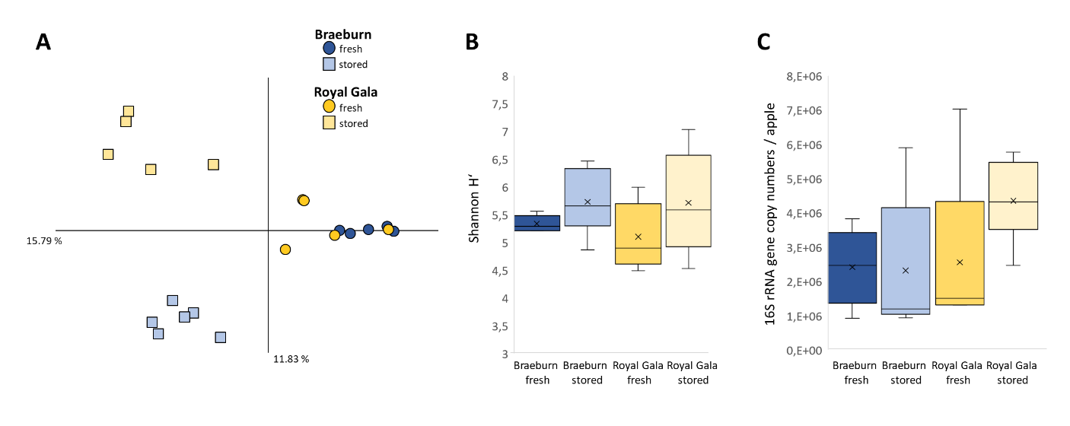
Supplementary Figure 2: Bacterial diversity and abundance estimates of fresh and stored/transported apple fruits from two cultivars. (A) PCoA plot visualizing Bray-Curtis distance matrix and (B) Shannon H’ index estimates for alpha diversity are based on 16S rRNA gene amplicon analysis. (C) shows 16S rRNA gene copy numbers per one apple, determined via quantitative real-time PCR.

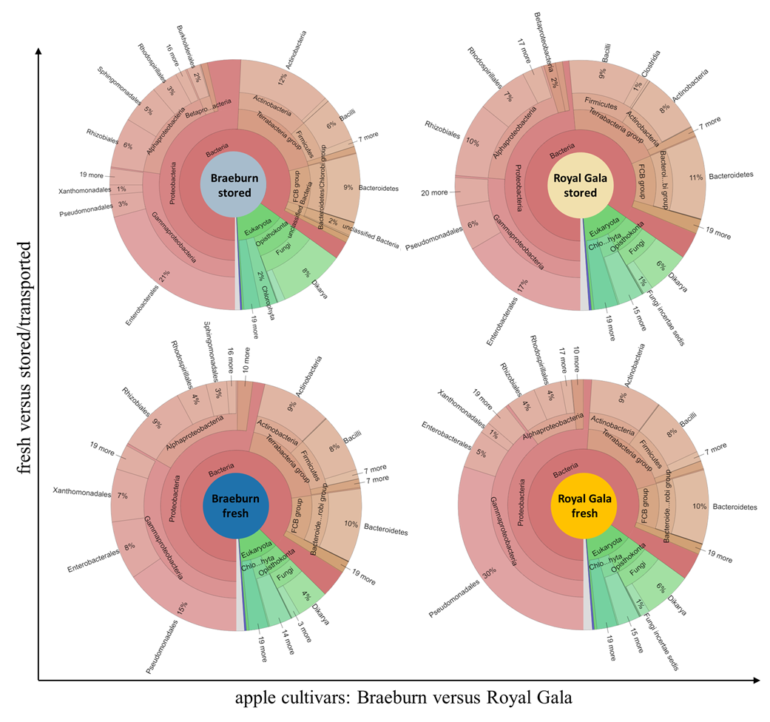
Supplementary Figure 3: Krona charts visualizing the overall microbial composition of fresh and stored apples from both cultivars. Taxonomy is resolved up to order level and assignment was done using metagenome classifier Kaiju.

Supplementary Table 5: Relative abundance of the 18 most abundant bacterial core genera.
 | Braeburn |  | Royal Gala
 | fresh (%) | stored (%) | fresh (%) | stored (%)
Pseudomonas | 15 | 3 | 32 | 4
Rahnella | 4 | 18 | 2 | 1
Acetobacter | 4 | 3 | 3 | 6
Frankia | 4 | 2 | 4 | 4
Solibacillus | 3 | 3 | 3 | 5
Pantoea | 0,8 | 0,5 | 0,4 | 12
Staphylococcus | 3 | 2 | 3 | 3
Stenotrophomonas | 7 | 1 | 1 | 0,6
Sphingomonas | 3 | 4 | 0,5 | 0,5
Bradyrhizobium | 3 | 0,9 | 0,8 | 2
Microbacterium | 2 | 0,5 | 2 | 0,4
Paenanthrobacter | 2 | 0,9 | 1 | 1
Escherichia | 0,9 | 0,9 | 1 | 2
Methylobacterium | 0,4 | 3 | 0,07 | 0,8
Acinetobacter | 0,7 | 0,7 | 0,8 | 2
Ochrobactrum | 1 | 0,08 | 0,9 | 2
Klebsiella | 1 | 0,9 | 1 | 1
Bacillus | 0,6 | 0,6 | 0,7 | 1

Supplementary Table 6: ARGs constituting the ‘shared apple resistome’ and the ‘storage-specific resistome’
Shared apple resistome
ARG | resistance mechanism | target drug class | BR fresh | RG fresh | BR  stored | RG  stored | % to annotated ARGs
mfd | target protection | quinolone | 237 | 99 | 862 | 551 | 7,65
oqxB | efflux pump | quinolone | 242 | 93 | 919 | 470 | 7,54
arnA | target alteration | polymyxin | 244 | 541 | 531 | 306 | 7,1
ileS1 | target alteration | mupirocin | 458 | 882 | 75 | 106 | 6,65
mexK | efflux pump | multidrug | 452 | 871 | 85 | 48 | 6,37
MexB | efflux pump | multidrug | 435 | 894 | 54 | 52 | 6,28
MexF | efflux pump | multidrug | 403 | 834 | 46 | 25 | 5,72
acrB | efflux pump | multidrug | 36 | 50 | 789 | 413 | 5,64
msbA | efflux pump | multidrug | 123 | 33 | 516 | 297 | 4,24
cpxA | efflux pump | multidrug | 133 | 55 | 474 | 274 | 4,1
tolC | efflux pump | multidrug | 123 | 48 | 493 | 31 | 3,04
CRP | efflux pump | multidrug | 79 | 35 | 306 | 165 | 2,56
mdtb | efflux pump | multidrug | 33 | 24 | 68 | 397 | 2,28
cpxr | efflux pump | multidrug | 141 | 263 | 18 | 28 | 1,97
KsgA | target alteration | kasugamycin | 81 | 35 | 256 | 24 | 1,73
emrB | efflux pump | multidrug | 25 | 49 | 7 | 279 | 1,58
mrdA | efflux pump | beta_lactam | 27 | 7 | 12 | 312 | 1,57
uppP | inactivation | bacitracin | 14 | 271 | 7 | 7 | 1,31
H-NS | efflux pump | multidrug | 32 | 7 | 167 | 13 | 0,96
bepE | efflux pump | multidrug | 65 | 38 | 3 | 57 | 0,71
ampC | inactivation | beta_lactam | 31 | 11 | 3 | 22 | 0,29
BacA | target alteration | bacitracin | 17 | 20 | 8 | 16 | 0,27
rosB | efflux pump | polymyxin | 8 | 3 | 12 | 32 | 0,24
ceoB | efflux pump | multidrug | 3 | 2 | 31 | 1 | 0,16
acrD | efflux pump | aminoglycoside | 4 | 16 | 12 | 3 | 0,15
Storage-specific apple resistome
ARG | resistance mechanism | target drug class | BR fresh | RG fresh | BR  stored | RG  stored | % to annotated ARGs
mdfA | efflux pump | multidrug | 0 | 0 | 472 | 7 | 2,1
mexW | efflux pump | multidrug | 0 | 0 | 32 | 40 | 0,32
arpB | efflux pump | multidrug | 0 | 0 | 34 | 34 | 0,3
MuxB | efflux pump | multidrug | 0 | 0 | 47 | 4 | 0,22
mtrA | efflux pump | multidrug | 0 | 0 | 39 | 4 | 0,19
arpC | efflux pump | multidrug | 0 | 0 | 20 | 9 | 0,13
murA | target alteration | fosfomycin | 0 | 0 | 21 | 4 | 0,11
RbpA | target alteration | rifampin | 0 | 0 | 22 | 2 | 0,11
mexi | efflux pump | multidrug | 0 | 0 | 18 | 5 | 0,1
mepA | efflux pump | multidrug | 0 | 0 | 13 | 7 | 0,09
RosA | efflux pump | fosmidomycin | 0 | 0 | 4 | 14 | 0,08
ttgC | efflux pump | multidrug | 0 | 0 | 13 | 3 | 0,07
APH(6)-Id | inactivation | aminoglycoside | 0 | 0 | 5 | 10 | 0,07
arnC | target alteration | polymyxin | 0 | 0 | 5 | 5 | 0,04
arnD | target alteration | glycopeptide | 0 | 0 | 6 | 2 | 0,04
MexD | efflux pump | multidrug | 0 | 0 | 3 | 5 | 0,04
pbp2 | target replacement | beta_lactam | 0 | 0 | 4 | 3 | 0,03
* ARGs are listed in descending order according to their total abundance in contigs of all apple samples.

