“Human subtlety will never devise an invention more beautiful, more simple or more direct than does Nature, because in her inventions, nothing is lacking and nothing is superfluous.”
Leonardo da Vinci (1452–1519)

SUPPORTING INFORMATION FOR

Nanohaloarchaea as beneficiaries of xylan degradation by haloarchaea

Violetta La Cono¹, Enzo Messina², Oleg Reva³, Francesco Smedile¹, Gina La Spada¹, Francesca Crisafi¹, Laura Marturano¹, Manuel Ferrer⁴, Noa Miguez⁴, Elena A. Selivanova⁵, Olga V. Golyshina⁶, Peter N. Golyshin⁶, Manfred Rohde⁷, Mart Krupovic⁸, Alexander Y. Merkel⁹, Dimitry Y. Sorokin^{9,10}, John E. Hallsworth¹¹, Michail M. Yakimov¹*

Corresponding author. Email: mikhail.iakimov@cnr.it

This PDF file includes:
Supporting Information: Tables S1 to S5 2
Supporting Information: Figures S1 to S8 15
Legends for SI Extended Datasets S1 to S3* 16
*SI Extended Datasets S1, S2 and S3 (provided as separated files)

Table S1. General characteristic of the SVX genomes.

Attribute | Ca. Nanohalococcus SVXNc | Haloferax sp. SVX82 Chromosome | Haloferax sp. SVX82 Plasmid 1 | Haloferax sp. SVX82 Plasmid 2 | Haloferax sp. SVX82 Plasmid 3 | Halorhabdus sp. SVX81
Chromosome/plasmid size | 948,351 bp | 2,776,760 bp | 577,800 bp | 285,035 bp | 145,200 bp | 2,923,675 bp
GC content | 47.4% | 67.0% | 62.8% | 66.7% | 55.3% | 63.3%
DNA coding region (%) | 874,194 bp (92.2%) | 2,437,441 bp (87.8%) | 488,370 bp (84.5%) | 245,835 bp (86.2%) | 121,968 bp (84.0%) | 2,569,412 bp (87.9%)
Total genes | 1,088 | 2,934 | 544 | 264 | 118 | 2,897
tRNA genes | 39 (15 introns) | 55 (3 introns) | - | - | - | 46 (2 introns)
rRNA genes (5S-16S-23S) | 3 (separated genes) | 6 (2 operons) | - | - | - | 3 (1 operon)
Protein-coding genes | 1,046 | 2,873 | 544 | 264 | 118 | 2,848
Proteins assigned to COGs (%) | 620 (59.3%) | 2,097 (73.0%) | 373 (68.6%) | 207 (78.4%) | 55 (46.6%) | 2,090 (73.4%)
Proteins assigned to arCOGs (%) | 667 (63.8%) | 2,739 (95.3%) | 498 (91.5%) | 257 (97.3%) | 101 (85.6%) | 2,716 (95.4%)
Average gene length | 828.5 bp | 843.8 bp | 897.7 bp | 931.2 bp | 1033.6 bp | 899.4 bp
Max gene length | 28,230 bp | 6,780 bp | 5,211 bp | 3,345 bp | 4,164 bp | 5,607 bp
ATG initiation codon proteins | 869 | 2,543 | 486 | 234 | 107 | 2,311
GTG initiation codon proteins | 141 | 324 | 54 | 29 | 10 | 499
TTG initiation codon proteins | 36 | 6 | 4 | 1 | 1 | 38
CRISPR-repeat regions | 2 | 2 | - | 1 | - | 3

Table S2. General characteristic of the BNX genomes.

Attribute | Ca. Nanohalovita BNXNv | Haloferax sp. BNX82 Chromosome | Haloferax sp. BNX82 Plasmid 1 | Haloferax sp. BNX82 Plasmid 2 | Haloferax sp. BNX82 Plasmid 3 | Haloferax sp. BNX82 Plasmid 4 | Halorhabdus sp. BNX81
Chromosome/plasmid size | 1,046,959 bp | 2,845,766 bp | 540,216 bp | 296,688 bp | 137,009 bp | 101,276 bp | 2,828,981 bp
GC content | 45.0% | 66.9% | 63.3% | 66.4% | 57.2% | 55.3% | 63.4%
DNA coding region (%) | 967,718 bp (92.4%) | 2,492,245 bp (87.6%) | 465,633 bp (86.2%) | 255,906 bp (86.3%) | 112,290 bp (82.0%) | 88,233 bp (87.1%) | 2,483,429 bp (87.8%)
Total genes | 1,211 | 3,043 | 480 | 277 | 159 | 86 | 2,833
tRNA genes | 38 (4 introns) | 56 (3 introns) | - | - | - | - | 46 (2 introns)
rRNA genes (5S-16S-23S) | 3 (separated genes) | 6 (2 operons) | - | - | - | - | 3 (1 operon)
Protein-coding genes | 1,170 | 2,981 | 480 | 277 | 159 | 86 | 2,784
Proteins assigned to COGs (%) | 675 (57.7%) | 2,109 (70.7%) | 340 (70.8%) | 214 (77.3%) | 96 (60.4%) | 38 (44.2%) | 2,053 (73.7%)
Proteins assigned to arCOGs (%) | 738 (63.1%) | 2,769 (92.9%) | 440 (91.7%) | 265 (95.7%) | 140 (88.1%) | 73 (84.9%) | 2,653 (95.3%)
Average gene length | 820.4 bp | 831.5 bp | 970.1 bp | 923.8 bp | 706.2 bp | 1026.0 bp | 889.1 bp
Max gene length | 26,643 bp | 6,777 bp | 4,794 bp | 2,733 bp | 2,883 bp | 5,523 bp | 7,500 bp
ATG initiation codon proteins | 1,011 | 2,459 | 370 | 237 | 124 | 67 | 2,289
GTG initiation codon proteins | 122 | 488 | 95 | 39 | 26 | 9 | 466
TTG initiation codon proteins | 37 | 34 | 15 | 1 | 9 | 10 | 29
CRISPR-repeat regions | - | 2 | - | 2 | - | - | 2

Table S3. Full genome comparison of the Halorhabdus sp. BNX81 and SVX81 isolates and the type strains of the Halorhabdus thiamatea and Halorhabdus utahensis species.

#ANIb and aligned percentage | Halorhabdus sp. SVX81 (CP104322) | Halorhabdus sp. BNX81 (CP107254) | Hrd. utahensis DSM 12940 (CP001687) | Hrd. tiamatea SARL4B (HF571520)
Halorhabdus sp. SVX81 (CP104322) | * | 97.23 [88.92] | 87.75 [74.89] | 84.09 [65.28]
Halorhabdus sp. BNX81 (CP107254) | 97.23 [91.77] | * | 87.81 [75.27] | 84.13 [66.82]
Hrd. utahensis DSM 12940 (CP001687) | 87.65 [70.01] | 87.53 [68.79] | * | 83.74 [59.61]
Hrd. tiamatea SARL4B (HF571520) | 84.32 [66.42] | 84.24 [66.00] | 83.94 [64.85] | *
#ANIm and aligned percentage | Halorhabdus sp. SVX81 (CP104322) | Halorhabdus sp. BNX81 (CP107254) | Hrd. utahensis DSM 12940 (CP001687) | Hrd. tiamatea SARL4B (HF571520)
Halorhabdus sp. SVX81 (CP104322) | * | 97.56 [90.58] | 90.70 [69.32] | 87.55 [57.36]
Halorhabdus sp. BNX81 (CP107254) | 97.56 [93.55] | * | 90.58 [70.32] | 87.55 [58.49]
Hrd. utahensis DSM 12940 (CP001687) | 90.71 [64.96] | 90.57 [63.89] | * | 87.27 [51.60]
Hrd. tiamatea SARL4B (HF571520) | 87.55 [59.51] | 87.55 [58.96] | 87.27 [57.17] | *
#GGDC (DDH formula 2) percentage | Halorhabdus sp. SVX81 (CP104322) | Halorhabdus sp. BNX81 (CP107254) | Hrd. utahensis DSM 12940 (CP001687) | Hrd. tiamatea SARL4B (HF571520)
Halorhabdus sp. SVX81 (CP104322) | * | 76.90 [73.9 - 79.6] | 35.60 [33.2 - 38.2] | 28.90 [26.5 - 31.4]
Halorhabdus sp. BNX81 (CP107254) | 76.90 [73.9 - 79.6] | * | 35.40 [32.9 - 37.9] | 28.80 [26.4 - 31.3]
Hrd. utahensis DSM 12940 (CP001687) | 35.60 [33.2 - 38.2] | 35.40 [32.9 - 37.9] | * | 28.30 [26 - 30.8]
Hrd. tiamatea SARL4B (HF571520) | 28.90 [26.5 - 31.4] | 28.80 [26.4 - 31.3] | 28.30 [26 - 30.8] | *
#AAI (Two-way) percentage | Halorhabdus sp. SVX81 (CP104322) | Halorhabdus sp. BNX81 (CP107254) | Hrd. utahensis DSM 12940 (CP001687) | Hrd. tiamatea SARL4B (HF571520)
Halorhabdus sp. SVX81 (CP104322) | * | 97.55 (SD: 6.02) | 88.41 (SD: 12.91) | 85.13 (SD: 12.45)
Halorhabdus sp. BNX81 (CP107254) | 97.55 (SD: 6.02) | * | 88.28 (SD: 12.87) | 85.31 (SD: 12.05)
Hrd. utahensis DSM 12940 (CP001687) | 88.41 (SD: 12.91) | 88.28 (SD: 12.87) | * | 84.14 (SD: 13.37)
Hrd. tiamatea SARL4B (HF571520) | 85.13 (SD: 12.45) | 85.31 (SD: 12.05) | 84.14 (SD: 13.37) | *

Table S4. Full genome comparison of the Haloferax lucetense BNX82 and SVX82 isolates and the type strains of the Haloferax lucetense and Haloferax alexandrinus species.

#ANIb and aligned percentage | Hfx. lucentense SVX82 (CP104741) | Hfx. alexandrinus BNX82 (CP106966) | Hfx. lucentense DSM 14919 (AOLH01.1) | Hfx. alexandrinus wsp1 (CP048738)
Hfx. lucetense SVX82 (CP104741) | * | 99.07 [93.81] | 98.79 [92.80] | 98.81 [93.19]
Hfx. lucetense BNX82 (CP106966) | 99.05 [91.73] | * | 98.61 [91.38] | 98.69 [92.23]
Hfx. lucentense DSM 14919 (AOLH01.1) | 97.04 [74.06] | 97.03 [74.08] | * | 98.98 [92.47]
Hfx. alexandrinus wsp1 (CP048738) | 97.05 [72.08] | 97.09 [72.62] | 99.10 [89.81] | *
#ANIm and aligned percentage | Hfx. lucentense SVX82 (CP104741) | Hfx. alexandrinus BNX82 (CP106966) | Hfx. lucentense DSM 14919 (AOLH01.1) | Hfx. alexandrinus wsp1 (CP048738)
Hfx. lucetense SVX82 (CP104741) | * | 99.11 [96.46] | 98.84 [96.22] | 98.87 [96.05]
Hfx. lucetense BNX82 (CP106966) | 99.11 [94.21] | * | 98.83 [93.99] | 98.86 [94.67]
Hfx. lucentense DSM 14919 (AOLH01.1) | 98.84 [74.34] | 98.83 [74.40] | * | 99.14 [94.80]
Hfx. alexandrinus wsp1 (CP048738) | 98.87 [72.34] | 98.86 [73.04] | 99.16 [92.58] | *
#GGDC (DDH formula 2) percentage | Hfx. lucentense SVX82 (CP104741) | Hfx. alexandrinus BNX82 (CP106966) | Hfx. lucentense DSM 14919 (AOLH01.1) | Hfx. alexandrinus wsp1 (CP048738)
Hfx. lucetense SVX82 (CP104741) | * | 92.30 [90.2 - 93.9] | 89.00 [86.6 - 91] | 89.30 [86.9 - 91.3]
Hfx. lucetense BNX82 (CP106966) | 92.30 [90.2 - 93.9] | * | 88.50 [86.1 - 90.6] | 89.10 [86.7 - 91.1]
Hfx. lucentense DSM 14919 (AOLH01.1) | 89.00 [86.6 - 91] | 88.50 [86.1 - 90.6] | * | 92.70 [90.8 - 94.3]
Hfx. alexandrinus wsp1 (CP048738) | 89.30 [86.9 - 91.3] | 89.10 [86.7 - 91.1] | 92.70 [90.8 - 94.3] | *
#AAI (Two-way) percentage | Hfx. lucentense SVX82 (CP104741) | Hfx. alexandrinus BNX82 (CP106966) | Hfx. lucentense DSM 14919 (AOLH01.1) | Hfx. alexandrinus wsp1 (CP048738)
Hfx. lucetense SVX82 (CP104741) | * | 99.05 (SD: 3.65) | 98.46 (SD: 5.97) | 98.51 (SD: 6.10)
Hfx. lucetense BNX82 (CP106966) | 99.05 (SD: 3.65) | * | 98.35 (SD: 6.35) | 98.54 (SD: 5.88)
Hfx. lucentense DSM 14919 (AOLH01.1) | 98.46 (SD: 5.97) | 98.35 (SD: 6.35) | * | 99.06 (SD: 4.57)
Hfx. alexandrinus wsp1 (CP048738) | 98.51 (SD: 6.10) | 98.54 (SD: 5.88) | 99.06 (SD: 4.57) | *

Table S5. Amount of intracellular glucose-6-phosphate (G-6-P) in lysed cell extracts (the same used for proteomic analysis) detected after cultivation for 60h

Sample | Concentration of G-6-P, mM
Axenic culture of Haloferax (1) | 0.41 ± 0.05
Axenic culture of Haloferax (2) | 0.39 ± 0.08
Binary culture of Haloferax–Ca. Nanohalococcus (1) | 16.05 ± 0.21
Binary culture of Haloferax–Ca. Nanohalococcus (2) | 22.25 ± 0.57

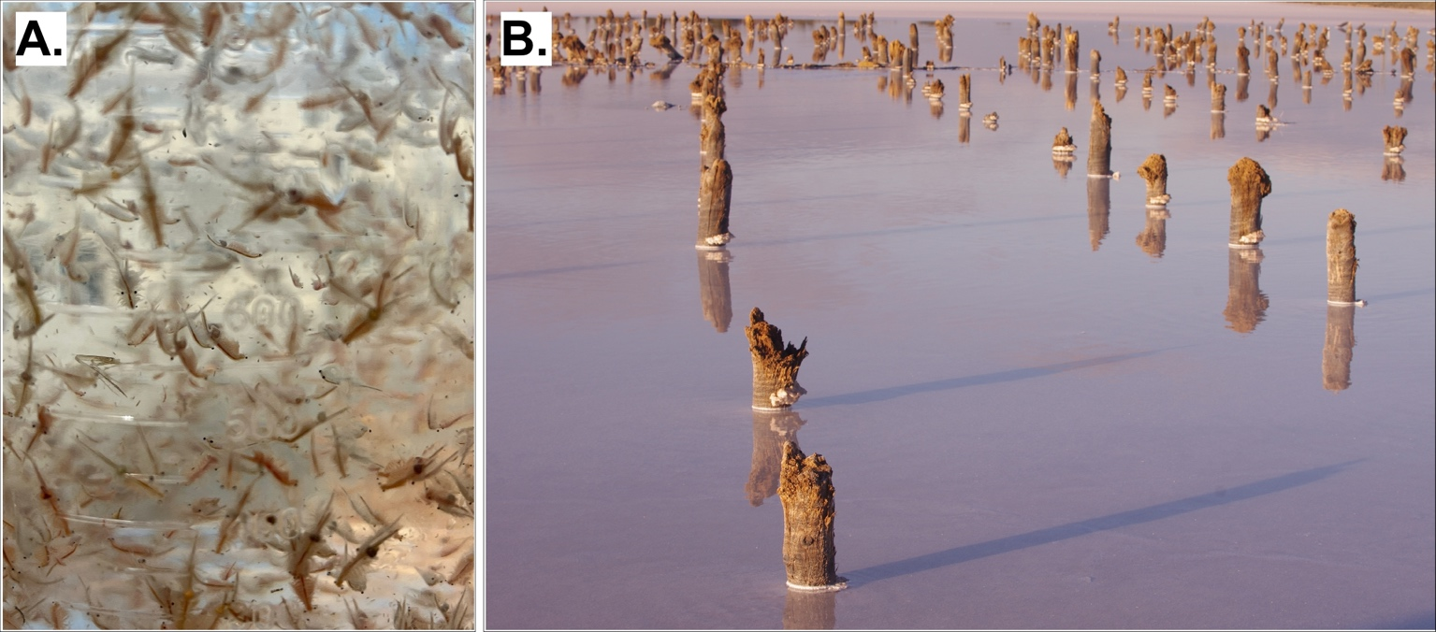

Figure S1. Abundant presence in the brine of chitin-rich crustaceans Artemia salina (A.) and wood remains in the form of partitions, scaffoldings and piles (B.), often present in solar salterns.

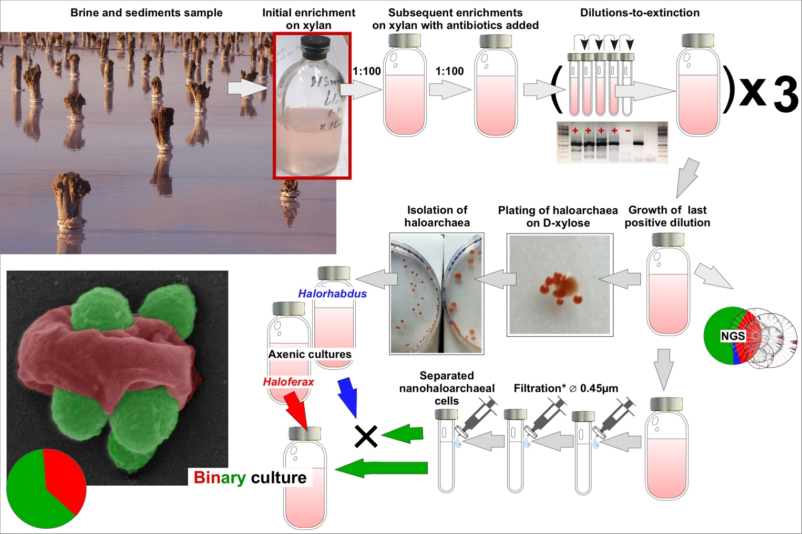

Figure S2. Flowchart of the laboratory-based strategy to obtain binary co-cultures of Ca. Nanohalococcus occultus SVXNc, Ca. Nanohalovita haloferavicina BNXNv and their xylose-utilizing hosts, Hfx. lucertense SVX82 and BNX82 respectively. Both last positive dilutions and the binary co-cultures were checked for the presence of nanohaloarchaea by taxon-specific PCR and by an Illumina NGS metabarcoding procedure. Further details of cultivation and dilution-to-extinction experiments are given in Experimental procedures and Results & Discussion sections of the main text.

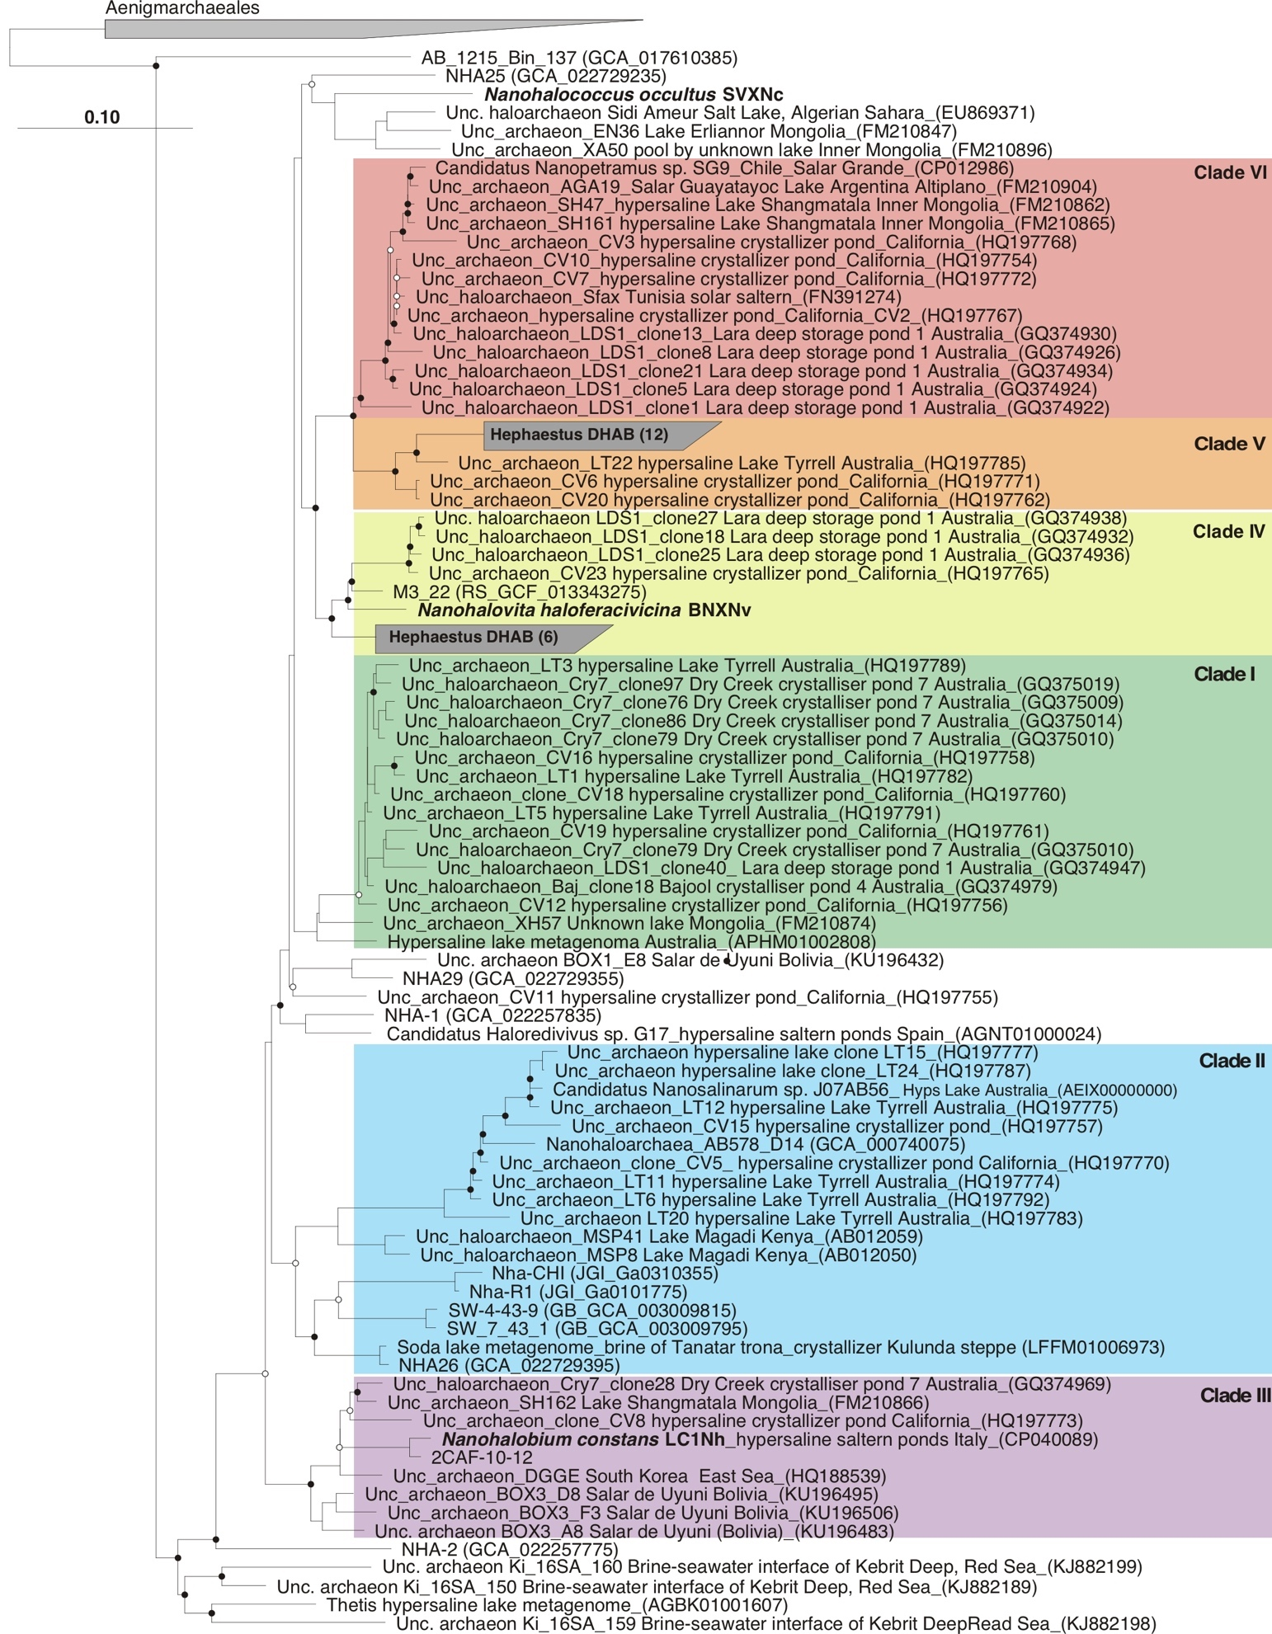

Figure S3. Phylogenetic position of Ca. Nanohalobium constans LC1Nh, Ca. Nanohalococcus occultus SVXNc and Ca. Nanohalovita haloferavicina BNXNv (indicated in bold) within the Candidate phylum Nanohaloarchaeota. Ten 16S rRNA gene sequences of Aenigmarchaeota were used for out-grouping. The black and white circles at nodes represent bootstrap support calculated on 1000 resampling. Black circles at the nodes indicate a percentage of bootstrap support of ≥ 70% and the white ones of < 70%. Values less than 60% are not shown. Scale bar corresponds to 10% estimated difference in nucleotide sequence positions.

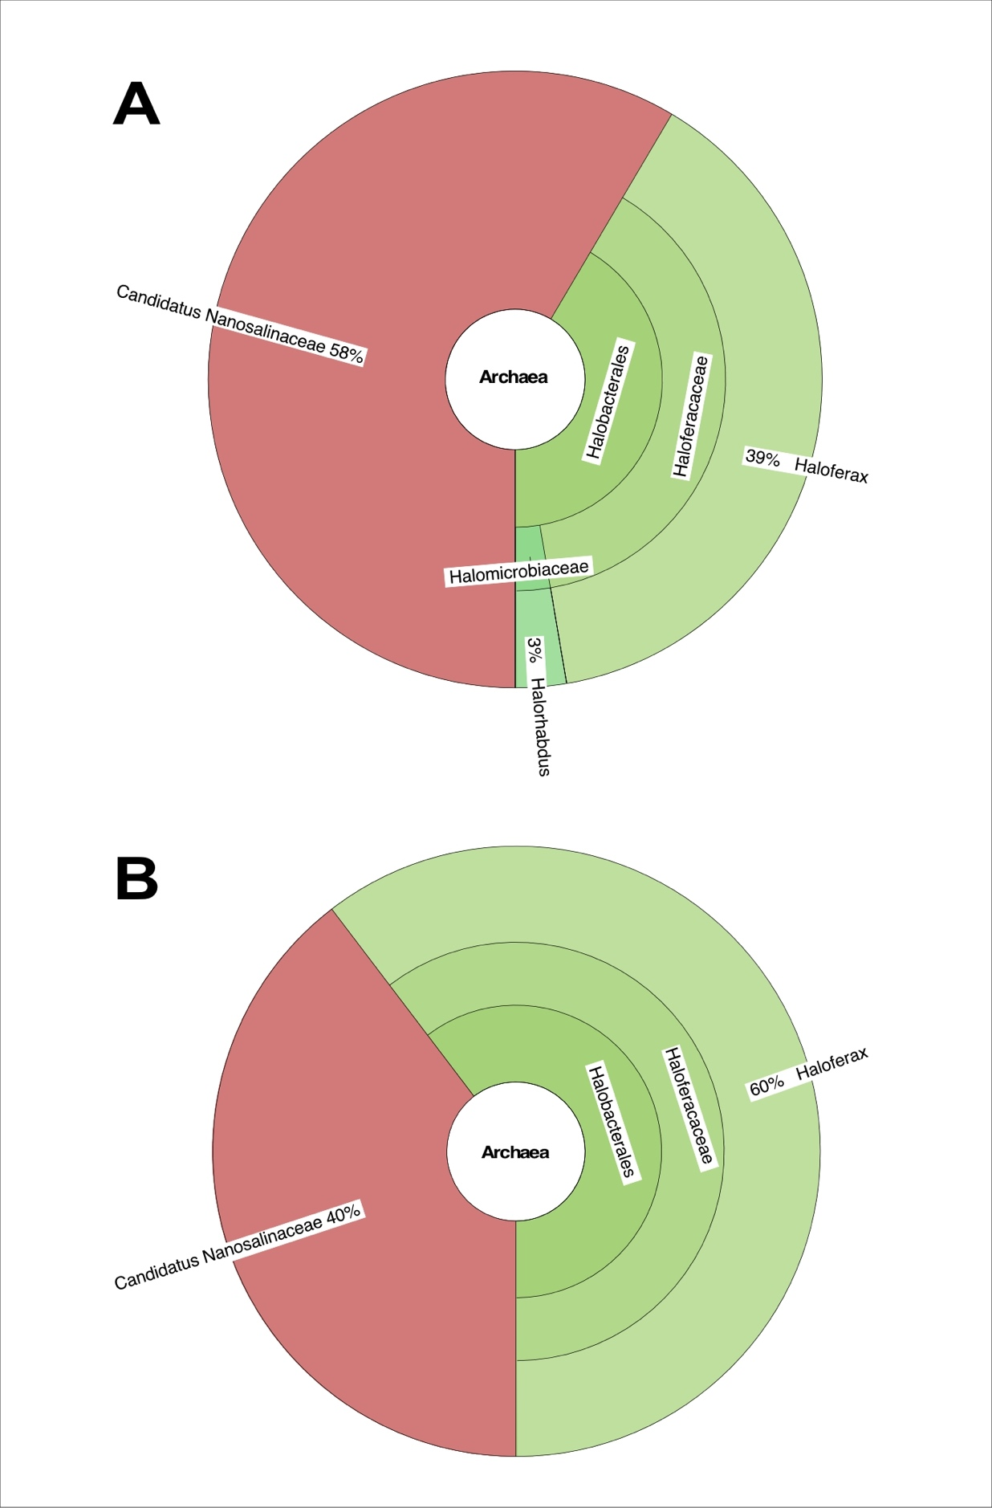
Figure S4. Taxonomic assignment of trinary (A) and binary (B) cultures analyzed after 168 h of growth on xylan and D-xylose, respectively, and displayed using Krona.

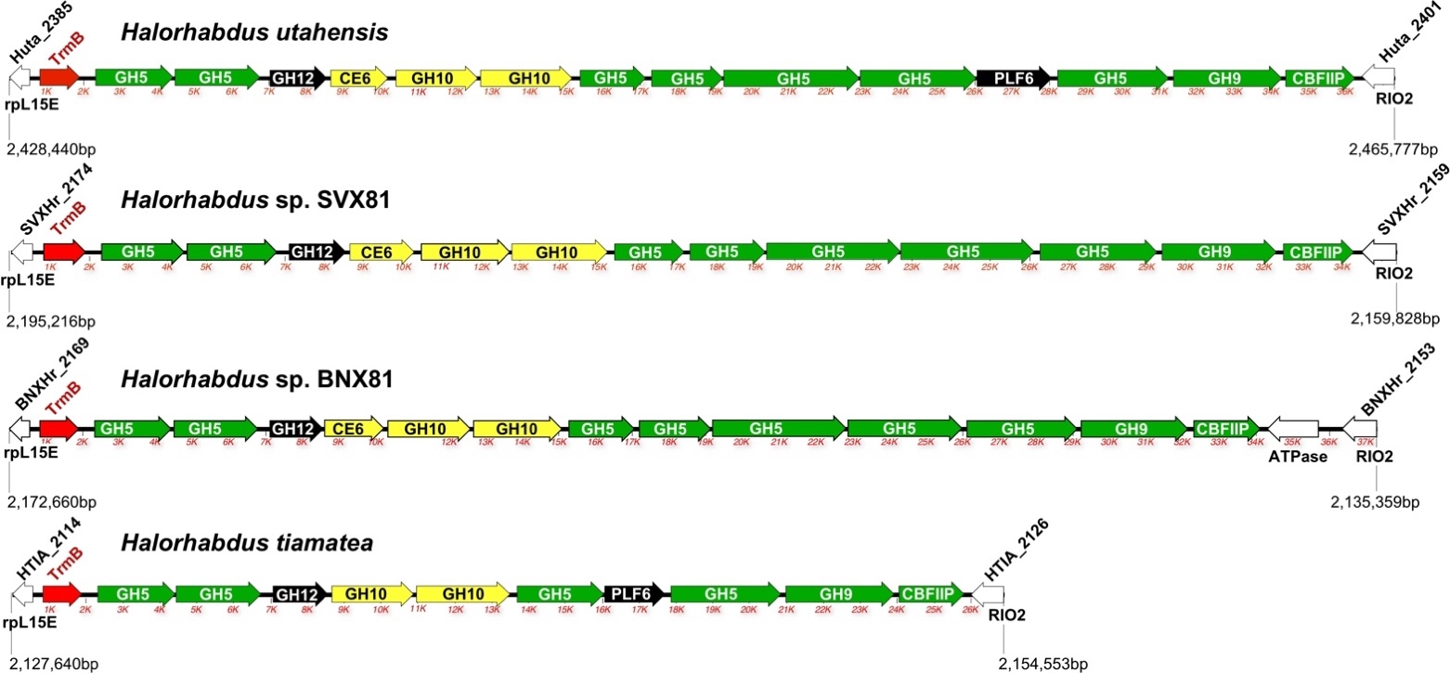

Figure S5. Genetic organization of so-called polysaccharide utilization locus (PUL) in the experimentally-proved xylanolytic species of the genera Halorhabdus. The PUL transcriptional regulator (TrmB) is depicted in red, while CAZymes involved in degradation of xylan and cellulose are shown in yellow and green, respectively. Both enzymes not involved in glucose and xylan cleavage and genes outside the operon are shown in black and white, respectively. Abbreviations and acronyms used: CBFIIP - cellulose-binding family II protein; CE6 – carboxyl esterase family 6, acetyl xylan esterase (EC 3.1.1.72); GH5 – endo-β-1,4-glucanase / cellulase (EC 3.2.1.4); GH9 - endoglucanase (EC 3.2.1.4); GH10 - endo-1,4-β-xylanase (EC 3.2.1.8); GH12 – xyloglucan hydrolase (EC 3.2.1.151); PLF6 - Polysaccharide Lyase Family 6 (indefinite KEGG affiliation); RIO2 - RIO-like serine/threonine protein kinase; rpL15E - 50S ribosomal protein L15e.

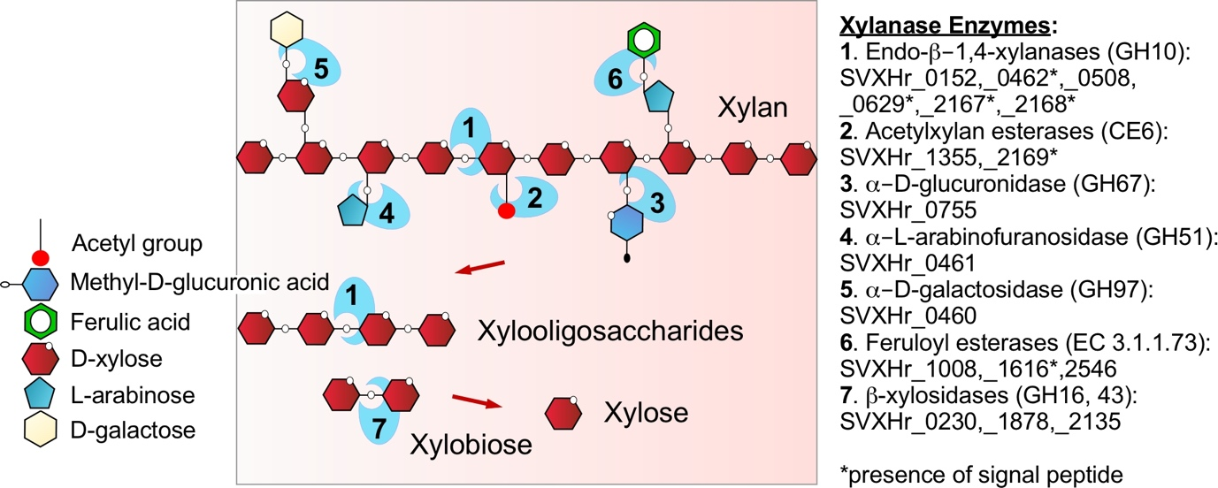

Figure S6. Genomic repertoire of Halorhabdus sp. SVX81 is capable of complete enzymatic hydrolysis of various xylans. A complex set of hydrolytic enzymes includes: endo-β-1,4-xylanase (GH10 family; EC 3.2.1.8), acetylxylan esterases (carboxyl esterase of CE6 family; EC 3.1.1.72), α-D-glucuronidase (GH67 family; EC 3.2.1.139), α-L-arabinofuranosidase (GH51 family; EC 3.2.1.55), α-D-galactosidase (GH97 family; EC 3.2.1.20), feruloyl esterases (EC 3.1.1.73) and β-xylosidase (GH16 and 43 families; EC 3.2.1.37).

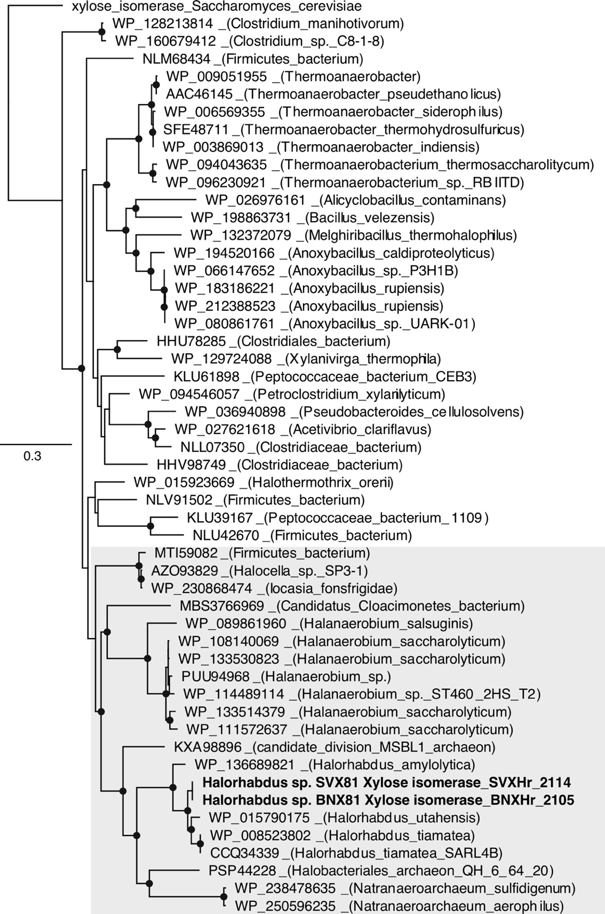

Figure S7. Phylogenetic relationship of xylose isomerases from Halorhabdus species and class II xylose isomerases from bacteria. Phylogenetic trees are based upon a multiple-amino-acid sequence alignment that was generated with ClustalX (63). Bootstrap values were obtained by inferring 1000 bootstrap trees. Black circles at the nodes indicate a percentage of bootstrap support of ≥50%. Values less than 50% were omitted. Cluster of xylose isomerase from Halorhabdus species and anaerobic firmicutes is highlighted in grey.

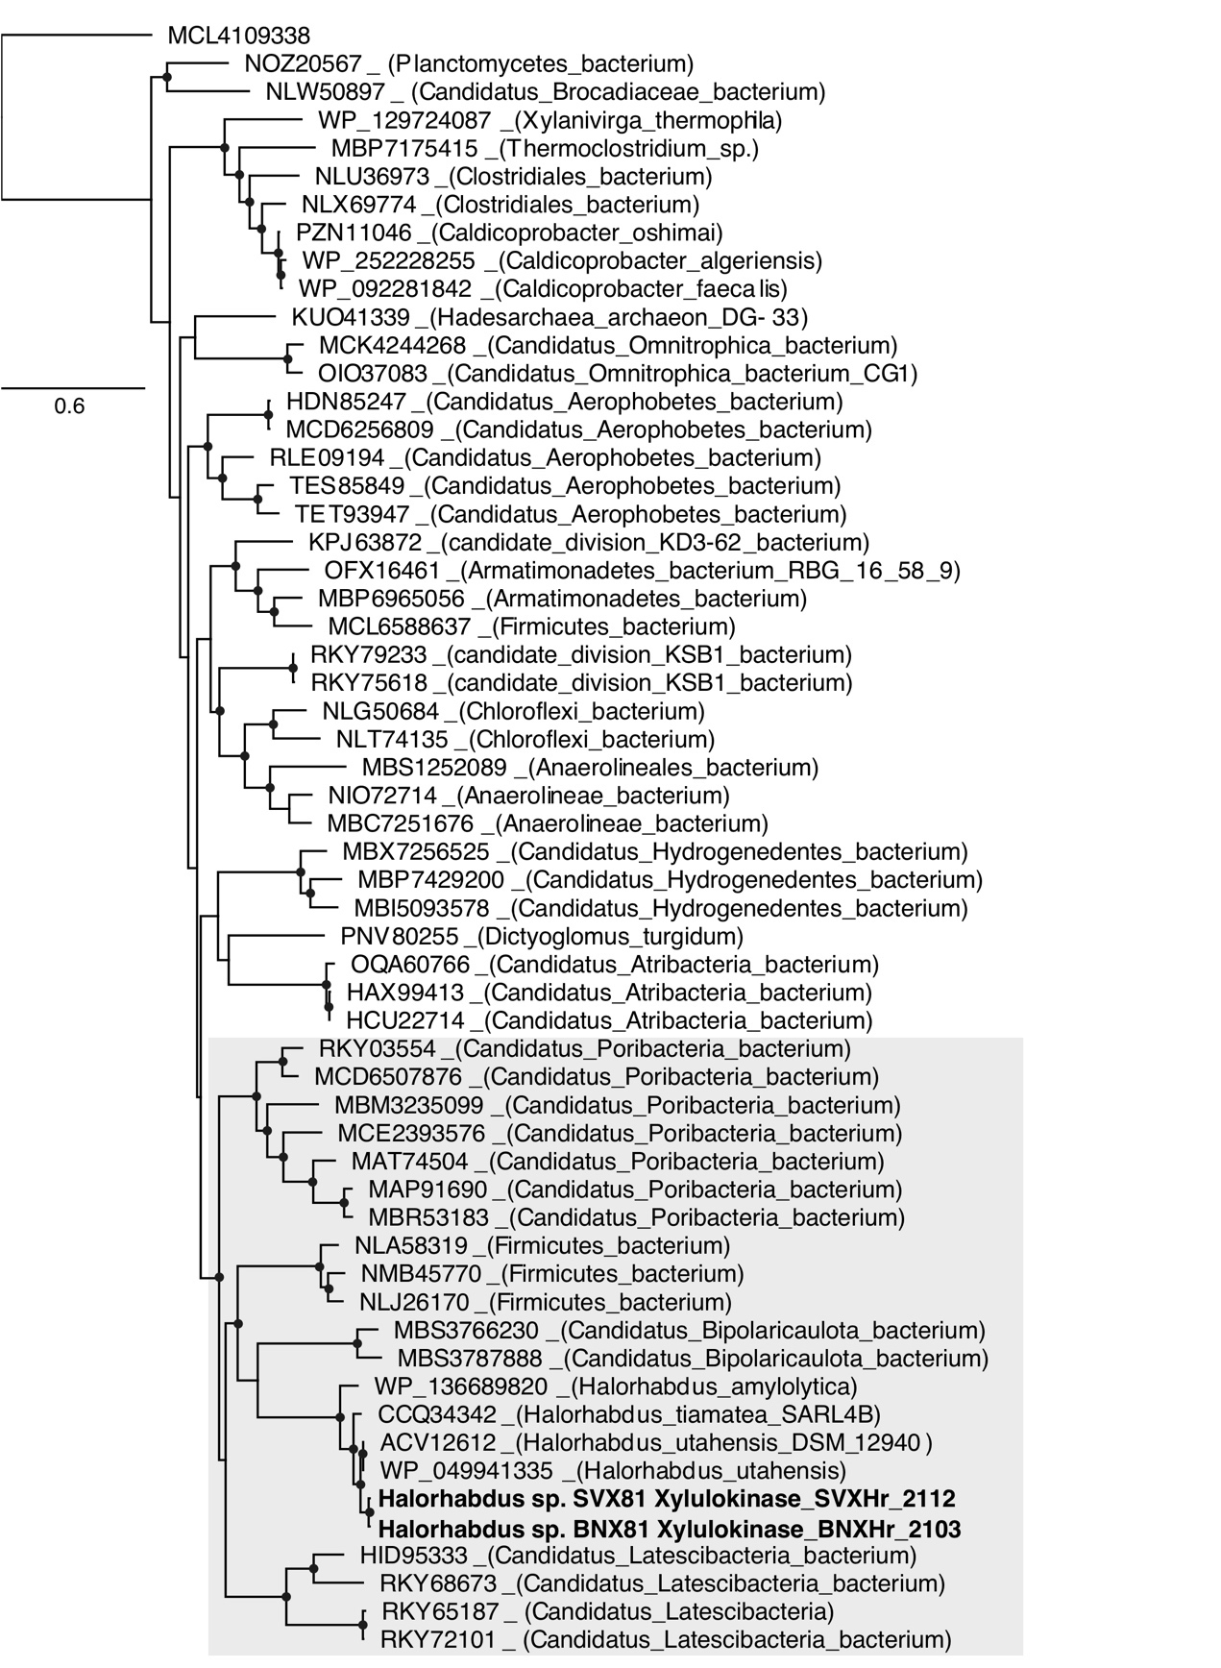

Figure S8. Phylogenetic relationship of xylulokinases from Halorhabdus species and xylulokinases from bacteria. Phylogenetic trees are based upon a multiple-amino-acid sequence alignment that was generated with ClustalX (63). Bootstrap values were obtained by inferring 1000 bootstrap trees. Black circles at the nodes indicate a percentage of bootstrap support of ≥50%. Values less than 50% were omitted. Cluster of xylulokinases from Halorhabdus species and anaerobic firmicutes is highlighted in grey.

Legends for SI Extended Datasets S1 to S3

SI Extended Dataset S1 (separate file)
S1a – BlastKOALA annotations list of Ca. Nanohalococcus occultus SVXNc chromosome;
S1b-e – BlastKOALA annotations list of Haloferax lucertense SVX82 chromosome and three plasmids;
S1f – BlastKOALA annotations list of Halorhabdus sp. SVX81 chromosome;
S1g – Transcriptome of Ca. Nanohalococcus occultus SVXNc, grown on xylose in binary culture with the host, Halferax lucertense SVX81.

SI Extended Dataset S2 (separate file)
S2a – BlastKOALA annotations list of Ca. Nanohalovita haloferacivicina BNXNv chromosome;
S2b-f – BlastKOALA annotations list of Haloferax lucertense BNX82 chromosome and four plasmids;
S2f – BlastKOALA annotations list of Halorhabdus sp. BNX81 chromosome.

SI Extended Dataset S3 (separate file)
S4a – Proteome of Haloferax lucertense SVX82 grown on xylose in co-culture with Ca. Nanohalococcus occultus SVXNc;
S4b – Proteome of Ca. Nanohalococcus occultus SVXNc grown on xylose in co-culture with Haloferax lucertense SVX82.

