Supplementary figures (Appendix D) to “Genetic and species diversity of the largest African mole-rat genus, Bathyergus. One, two or four species?” (Šumbera et al. 2024)
Figure D.1. Determination of the best number of clusters in STRUCTURE by $Δ\text{K}$ method (Evanno et al. 2005). The figure was created by StructureSelector (Li and Liu 2018).
Figure D.2. The result of STRUCTURE clustering with K=4. The color code is the same as in Fig. 4 except for the orange color indicating ancestry contribution of suillus-Cape Town gene pool. The result for K=5 was similar, just with higher uncertainty about ancestry proportions of the Cape Town individual (GM042).
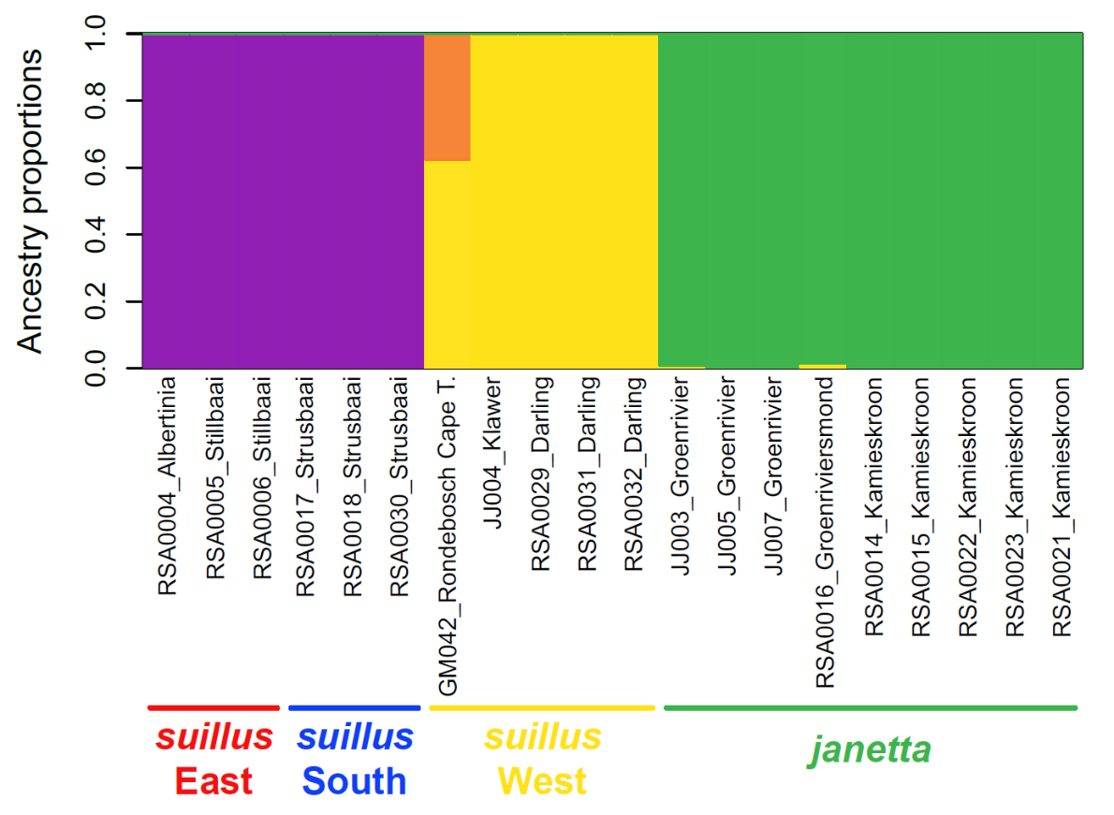
Figure D.3. The first two principal components of nuclear genomic variation.
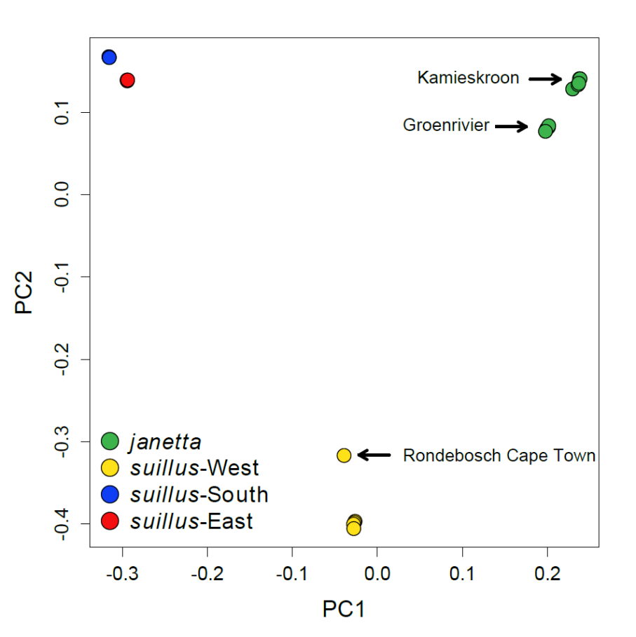

Figure D.4. The maximum clade credibility species tree and the maximum a posteriori species delimitation obtain from multispecies coalescent in BPP. Tree branches are represented by rectangles, whose dimensions are proportional to branch length (x axis) and half of the population size (y axis) so they are directly comparable.
Figure D.5. The final species tree obtained by iterative merging of little distinctive species (terminal branches). Branch labels show values of gdi (genealogical divergence index).

Figure D.6. Species tree estimated from five Sanger-sequenced loci with species delimitation and topology fixed to that of the final species tree from ddRAD sequence analysis. Branch labels show values of gdi.

Figure D.7. Time-calibrated tree of African mole-rats (Bathyergidae). Times are in units of Ma before present.
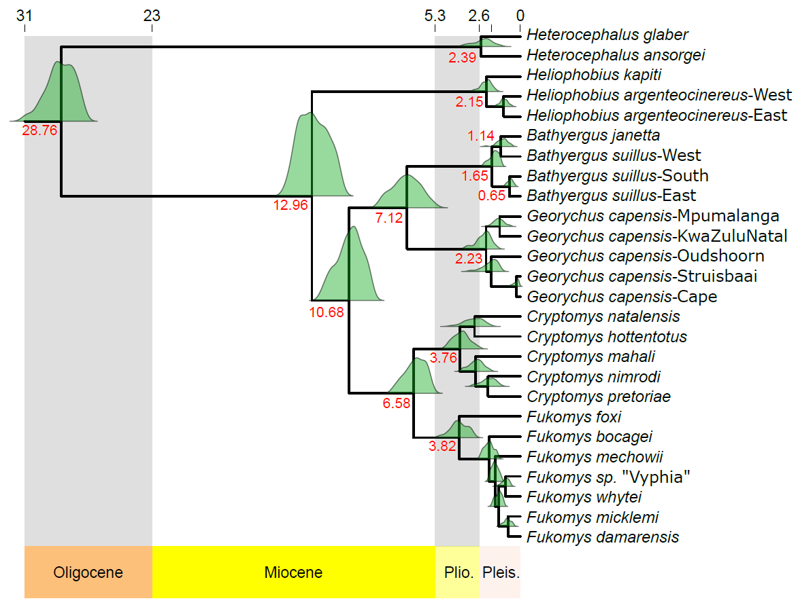

Figure D.8. Species tree of ten lineages found in two sister genera, Bathyergus and Georychus.
Figure D.9. Importance of climatic variables used as predictors in MaxEnt species distribution model. The ROR-weighted probability density is shown in red, while the unweighted probability density in grey.
Figure D.10. Importance of soil variables used as predictors in MaxEnt species distribution model. The ROR-weighted probability density is shown in red, while the unweighted probability density in grey.

