Additional files
Table S1. Attributes of de novo assemblers used in this study. Included in this table are the versions of each assembler used in this study, along with the release date of each version. We provide a link to each assemblers’ website accompanied by its reference and number of citations. We gauge ease of use by providing the programming language and MPI compatibility of each tool as well as assessing the completeness of each tools’ available documentation.
Table S2. Characteristics of the metagenomic datasets used in this study. Three metagenomes from three distinct environments (Soil, Aquatic and Human gut) were selected, and we provide accession numbers, sequencing platforms used and basic sequence characteristics (pre- and post-filtering) of each metagenome.
Table S3. Assembly statistics for the assembled aquatic metagenomes.
Table S4. Assembly statistics for the assembled soil metagenomes.
Table S5. Assembly statistics for the assembled human gut metagenomes.
Table S6. Assembly statistics for the assembled synthetic metagenomes.
Figure S1. Nonpareil estimates of sequence coverage (redundancy) for the 3 synthetic metagenomes studied.
Figure S2. Computational requirements for the Tara Ocean metagenome. A) Total assembly span proportional to wall time required. B) Total assembly span in relation to peak memory usage.
Figure S3. Correlation between assembly span and mapping rate. The exponential trendline indicates a very strong positive correlation between the amount of data utilized and the size of the generated assembly (R² = 0.83).

Table S1. Attributes of de novo assemblers used in this study. Included in this table are the versions of each assembler used in this study, along with the release date of each version. We provide a link to each assemblers’ website accompanied by its reference and number of citations. We gauge ease of use by providing the programming language and MPI compatibility of each tool as well as assessing the completeness of each tools’ available documentation.
Assembler | Version | Release Date | Language | MPI Compatibility | Reference | Citations | URL
CLC | v.8.5.1 | October 2015 | Java | No |  | - | https://www.qiagenbioinformatics.com/products/clc-genomics-workbench/
IDBA-UD | v.1.1.2 | Jun 2014 | C++ | No | ¹ | 627 | http://i.cs.hku.hk/~alse/hkubrg/projects/idba_ud/
MEGAHIT | v.1.0.6 | October 2016 | CUDA | Yes | ² | 114 | https://github.com/voutcn/megahit
metaSPAdes | v.3.9.0 | July 2016 | Python | No | ³ | 18 | http://cab.spbu.ru/software/spades/
MetaVelvet | v.1.2.02 | September 2012 | C | Yes | ⁴ | 339 | http://metavelvet.dna.bio.keio.ac.jp/
Omega | v.1.4 | August 2016 | C++ | Yes | ⁵ | 29 | http://omega.omicsbio.org/
Ray Meta | v.2.3.1 | February 2014 | C++ | Yes | ⁶ | 245 | http://denovoassembler.sourceforge.net/
SPAdes | v.3.9.0 | July 2016 | Python | No | ⁷ | 1994 | http://cab.spbu.ru/software/spades/
Velvet | v.1.2.10 | April 2011 | C | Yes | ⁸ | 5974 | https://www.ebi.ac.uk/~zerbino/velvet/

Table S2. Characteristics of the metagenomic datasets used in this study. Three metagenomes from three distinct environments (Soil, Aquatic and Human gut) were selected, and we provide accession numbers, sequencing platforms used and basic sequence characteristics (pre- and post-filtering) of each metagenome.
System | Metagenome | Accession No. | Reference | Platform | No. reads pre-QC | Mean read length (bp) | No. reads post-QC
Soil | Iowa | SRR351474 | ⁹ | HiSeq 2000 | 822,282,876 | 100 | 470,688,764
 | Permafrost | 4470009.3 - 4470010.3 | ¹⁰ | Genome Analyzer II | 35,337,078 | 114 | 25,860,604
 | Oklahoma | SRR958082 | ¹¹ | HiSeq 2000 | 113,445,350 | 101 | 91,465,330
Aquatic | Kolkata Lake | 4673644.3 - 4673645.3 | Unpublished data | MiSeq | 55,969,488 | 151 | 36,376,806
 | Tara Ocean | ERR598950 | ¹² | HiSeq 2000 | 62,109,422 | 100,01 | 54,081,014
 | Arctic Frost Flower | 4537104.3 - 4537105.3 | ¹³ | HiSeq 2000 | 42,024,360 | 101 | 37,690,670
Human gut | Infant Gut | ERR526087 | ¹⁴ | HiSeq 2000 | 47,653,548 | 100 | 46,840,928
 | European Gut | SRR341725 | ¹⁵ | HiSeq 2000 | 35,680,006 | 101 | 23,069,870
 | Scandinavian Gut | ERR732914 | ¹⁶ | HiSeq 2000 | 26,730,558 | 101 | 21,820,314
Simulated | Low Complexity | RL_S001__insert_270 | https://data.cami-challenge.org/ | Simulated | 100,000,000 | 150 | 99,771,962
 | Mid Complexity | RM2_S001__insert_270 | https://data.cami-challenge.org/ | Simulated | 100,000,000 | 150 | 99,797,512
 | High Complexity | RH_S001__insert_270 | https://data.cami-challenge.org/ | Simulated | 100,000,000 | 150 | 99,748,632

Table S3. Assembly statistics for the assembled soil metagenomes.
 | Permafrost
 | CLC | IDBA-UD | MEGAHIT | metaSPAdes | MetaVelvet | Omega | Ray Meta | SPAdes | Velvet
Number of contigs (≥ 500 bp) | 7,471 | 37,100 | 42,893 | 27,964 | 2,512 | 319 | 612 | 45,825 | 2,512
Total length | 6,368,740 | 35,345,296 | 38,460,071 | 26,197,278 | 1,861,803 | 510,449 | 563,997 | 47,250,172 | 1,861,803
No. of long contigs (≥ 1 kbp) | 1,484 | 8,992 | 8,732 | 6,080 | 315 | 315 | 143 | 12,488 | 315
No. of ultra-long contigs (≥ 50 kbp) | 0 | 0 | 0 | 1 | 0 | 0 | 0 | 4 | 0
Largest contig | 12,914 | 35,547 | 46,328 | 80,920 | 3,975 | 16,034 | 14,465 | 94,431 | 3,975
N50 | 816 | 949 | 862 | 910 | 716 | 1,544 | 898 | 1,060 | 716
L50 | 2,243 | 10,020 | 12,224 | 7,460 | 917 | 101 | 174 | 11,134 | 917
 | Oklahoma
 | CLC | IDBA-UD | MEGAHIT | metaSPAdes | MetaVelvet | Omega | Ray Meta | SPAdes | Velvet
Number of contigs (≥ 500 bp) | 1,151 | 21,577 | 27,650 | 17,886 | 1,905 | 14 | 37 | 71,750 | 1,901
Total length | 735,000 | 17,162,595 | 20,203,737 | 12,891,907 | 1,169,206 | 15,885 | 29,400 | 54,292,998 | 1,166,416
No. of long contigs (≥ 1 kbp) | 54 | 3,828 | 3,416 | 2,065 | 24 | 11 | 9 | 9,548 | 23
No. of ultra-long contigs (≥ 50 kbp) | 0 | 0 | 0 | 0 | 0 | 0 | 0 | 0 | 0
Largest contig | 3,546 | 10,253 | 7,753 | 8,247 | 1,995 | 1,646 | 1,480 | 9,671 | 1,995
N50 | 599 | 776 | 697 | 683 | 594 | 1,084 | 828 | 723 | 594
L50 | 472 | 7,313 | 10,085 | 6,622 | 819 | 7 | 14 | 25,689 | 817
 | Iowa
 | CLC | IDBA-UD | MEGAHIT | metaSPAdes | MetaVelvet | Omega | Ray Meta | SPAdes | Velvet
Number of contigs (≥ 500 bp) | 408,385 | N/A | 984,964 | 727,092 | 5,211 | 47 | 36,990 | N/A | 2,627
Total length | 432,703,575 | N/A | 1,036,490,541 | 873,829,053 | 3,997,155 | 114,251 | 44,856,058 | N/A | 1,860,815
No. of long contigs (≥ 1 kbp) | 114,196 | N/A | 277,623 | 225,046 | 727 | 31 | 14,774 | N/A | 228
No. of ultra-long contigs (≥ 50 kbp) | 4 | N/A | 11 | 100 | 0 | 0 | 0 | N/A | 0
Largest contig | 70,207 | N/A | 104,841 | 188,499 | 15,640 | 15,697 | 48,390 | N/A | 15,640
N50 | 1,107 | N/A | 1,096 | 1,339 | 741 | 5,820 | 1,389 | N/A | 663
L50 | 95,222 | N/A | 235,226 | 138,932 | 1,842 | 7 | 8,781 | N/A | 973
* N/A – Assembly could not be performed with these tools under the available resources.
Table S4. Assembly statistics for the assembled aquatic metagenomes.
 | Kolkata Lake
 | CLC | IDBA-UD | MEGAHIT | metaSPAdes | MetaVelvet | Omega | Ray Meta | SPAdes | Velvet
Number of contigs (≥ 500 bp) | 181,128 | 221,734 | 324,600 | 5,927 | 147,420 | 28,201 | 19,945 | 6,388 | 138,176
Total length | 176,334,760 | 239,616,234 | 330,771,089 | 5,695,829 | 133,768,764 | 51,164,188 | 32,776,885 | 6,378,576 | 106,649,169
No. of long contigs (≥ 1 kbp) | 42,183 | 68,266 | 89,812 | 1,517 | 34,891 | 23,966 | 9,408 | 1,808 | 20,287
No. of ultra-long contigs (≥ 50 kbp) | 2 | 2 | 4 | 1 | 0 | 0 | 0 | 0 | 0
Largest contig | 58,518 | 67,794 | 81,287 | 71,858 | 37,935 | 49,562 | 49,052 | 47,837 | 12,417
N50 | 961 | 1,144 | 1,049 | 965 | 900 | 1,924 | 2,347 | 1,028 | 737
L50 | 45,488 | 53,482 | 81,952 | 1,618 | 43,665 | 6,179 | 3,279 | 1,696 | 47,957
 | Tara Ocean
 | CLC | IDBA-UD | MEGAHIT | metaSPAdes | MetaVelvet | Omega | Ray Meta | SPAdes | Velvet
Number of contigs (≥ 500 bp) | 50,716 | 163,815 | 216,938 | 185,419 | 67,161 | 15,982 | 6,128 | 220,178 | 57,816
Total length | 46,069,409 | 179,686,756 | 210,621,485 | 202,770,058 | 55,972,515 | 34,861,819 | 7,277,214 | 275,920,632 | 45,425,460
No. of long contigs (≥ 1 kbp) | 10,720 | 50,498 | 56,243 | 48,640 | 12,590 | 13,305 | 2,179 | 70,711 | 8,802
No. of ultra-long contigs (≥ 50 kbp) | 0 | 2 | 1 | 37 | 0 | 9 | 0 | 54 | 0
Largest contig | 39,748 | 101,400 | 62,649 | 141,519 | 30,177 | 102,255 | 41,443 | 197,381 | 21,980
N50 | 880 | 1,166 | 982 | 1,124 | 805 | 2,691 | 1,329 | 1,415 | 749
L50 | 14,113 | 38,236 | 58,246 | 39,033 | 21,544 | 2,737 | 1,345 | 39,617 | 19,631
 | Arctic Frost Flower
 | CLC | IDBA-UD | MEGAHIT | metaSPAdes | MetaVelvet | Omega | Ray Meta | SPAdes | Velvet
Number of contigs (≥ 500 bp) | 3,645 | 10,024 | 7835 | 5,750 | 4,840 | 71 | 3,906 | 14,058 | 4,147
Total length | 6,214,696 | 12,554,320 | 10,702,435 | 9,367,300 | 5,297,757 | 57,772 | 3,985,954 | 16,431,291 | 3,260,116
No. of long contigs (≥ 1 kbp) | 2,112 | 1,650 | 1172 | 1,238 | 1,980 | 22 | 1,532 | 2,251 | 731
No. of ultra-long contigs (≥ 50 kbp) | 0 | 0 | 0 | 5 | 0 | 0 | 0 | 15 | 0
Largest contig | 35,081 | 37,705 | 48,918 | 73,164 | 6,410 | 2,960 | 6,355 | 142,838 | 3,321
N50 | 2,236 | 1,551 | 4,142 | 5,113 | 1,241 | 1,010 | 1,091 | 1,137 | 784
L50 | 758 | 896 | 500 | 407 | 1,373 | 22 | 1,256 | 1,670 | 1,479

Table S5. Assembly statistics for the assembled human gut metagenomes.
 | Infant Gut
 | CLC | IDBA-UD | MEGAHIT | metaSPAdes | MetaVelvet | Omega | Ray Meta | SPAdes | Velvet
Number of contigs (≥ 500 bp) | 78,374 | 74,480 | 82,679 | 69,064 | 32,616 | 2 | 22,985 | 66,893 | 74,601
Total length | 155,498,363 | 168,421,610 | 195,409,115 | 199,621,178 | 88,068,229 | 1,988 | 57,640,536 | 203,097,710 | 114,330,088
No. of long contigs (≥ 1 kbp) | 37,980 | 37,139 | 37,983 | 35,394 | 20,258 | 1 | 13,845 | 34,196 | 30,098
No. of ultra-long contigs (≥ 50 kbp) | 110 | 117 | 273 | 333 | 33 | 0 | 77 | 400 | 12
Largest contig | 207,124 | 147,767 | 286,478 | 250,614 | 105,275 | 1,145 | 165,582 | 476,171 | 71,403
N50 | 3,250 | 4,576 | 5,779 | 8,543 | 5,237 | 1,145 | 4,286 | 9,698 | 2,093
L50 | 8,657 | 7,115 | 5,858 | 4,327 | 3,694 | 1 | 2,236 | 3,839 | 10,967
 | European Gut
 | CLC | IDBA-UD | MEGAHIT | metaSPAdes | MetaVelvet | Omega | Ray Meta | SPAdes | Velvet
Number of contigs (≥ 500 bp) | 53,031 | 58,129 | 64,422 | 62,668 | 33,649 | 2,285 | 11,814 | 67,067 | 61,429
Total length | 89,451,760 | 132,103,940 | 87,777,313 | 140,509,146 | 78,332,430 | 3,363,693 | 21,606,086 | 149,369,596 | 87,676,277
No. of long contigs (≥ 1 kbp) | 21,434 | 26,451 | 24,709 | 24,355 | 19,494 | 1,971 | 5,123 | 26,175 | 24,838
No. of ultra-long contigs (≥ 50 kbp) | 63 | 132 | 13 | 241 | 53 | 0 | 8 | 247 | 1
Largest contig | 335,572 | 159,241 | 106,293 | 781,723 | 332,038 | 23,809 | 84,884 | 454,757 | 58,034
N50 | 2,571 | 5,166 | 1,651 | 6,273 | 3,980 | 1,416 | 3,045 | 6,459 | 1,819
L50 | 6,176 | 4,836 | 11,487 | 3,532 | 3,795 | 769 | 1,267 | 3,811 | 10,640
 | Scandinavian Gut
 | CLC | IDBA-UD | MEGAHIT | metaSPAdes | MetaVelvet | Omega | Ray Meta | SPAdes | Velvet
Number of contigs (≥ 500 bp) | 54,768 | 75,394 | 82,546 | 77,794 | 59,108 | 14,936 | 8,567 | 79,226 | 58,981
Total length | 84,303,852 | 130,334,592 | 144,527,440 | 147,859,250 | 75,699,080 | 36,770,655 | 15,764,885 | 153,777,699 | 73,276,966
No. of long contigs (≥ 1 kbp) | 20,244 | 31,372 | 32,317 | 30,450 | 20,361 | 13,943 | 4,567 | 32,194 | 20,168
No. of ultra-long contigs (≥ 50 kbp) | 90 | 75 | 140 | 217 | 7 | 12 | 2 | 202 | 0
Largest contig | 216,892 | 159,248 | 313,634 | 268,823 | 66,119 | 81,480 | 83,243 | 317,289 | 48,882
N50 | 2,113 | 2,720 | 2,897 | 3,615 | 1,496 | 2,900 | 2,784 | 3,720 | 1,434
L50 | 6,877 | 8,744 | 8,115 | 5,998 | 10,785 | 2,847 | 1,428 | 6,356 | 11,425

Table S6. Assembly statistics for the assembled synthetic metagenomes.
 | Low Complexity Synthetic Metagenome
 | CLC | IDBA-UD | MEGAHIT | metaSPAdes | MetaVelvet | Omega | Ray Meta | SPAdes | Velvet
Number of contigs (>= 500 bp) | 22,03 | 25,37 | 34,397 | 17,262 | 18,693 | 514,919 | 10,221 | 15,426 | 24,719
Total length | 82,906,659 | 84,760,377 | 85,371,336 | 94,237,845 | 17,976,720 | 319,705,390 | 58,171,311 | 99,869,764 | 23,035,683
Number of contigs (>= 1000 bp) | 11,732 | 13,129 | 16,071 | 6,935 | 5,837 | 4,924 | 8,560 | 7,211 | 19,086
Total bases (in contigs >= 1000 bp) | 75,346,850 | 76,305,826 | 73,014,567 | 87,195,256 | 9,172,593 | 22,330,416 | 54,472,631 | 95,004,922 | 11,073,683
Largest contig | 1,363,103 | 601,708 | 475,109 | 1,362,249 | 6,241 | 5,027 | 960,879 | 1,299,913 | 6,241
N50 | 31,952 | 11,06 | 6,283 | 62,213 | 1,016 | 622 | 74,091 | 64,229 | 970
L50 | 309 | 1,387 | 2,348 | 283 | 5,655 | 210,063 | 119 | 280 | 7,663
Genome Fraction | 64.919 | 64.98 | 60.903 | 69.883 | 11.492 | 48.674 | 44.475 | 71.244 | 14.703
Number of Misassemblies | 241 | 1,314 | 360 | 272 | 8 | 674 | 227 | 643 | 10
Unaligned length | 589,665 | 141,354 | 86,957 | 24,456 | 541 | 179,313 | 2,734 | 46,489 | 604
Number of N's per 100 kbp | 286.22 | 0 | 0 | 30.92 | 0 | 0 | 209.7 | 119.96 | 0
Number of mismatches per 100 kbp | 183.59 | 116.87 | 310.63 | 211.39 | 150.44 | 1,804.9 | 155.05 | 221.71 | 131.95
Number of indels per 100 kbp | 9.87 | 0.83 | 0.9 | 1.63 | 0.23 | 2.51 | 1.33 | 1.49 | 0.19

 | Medium Complexity Synthetic Metagenome
 | CLC | IDBA-UD | MEGAHIT | metaSPAdes | MetaVelvet | Omega | Ray Meta | SPAdes | Velvet
Number of contigs (>= 500 bp) | 80,528 | 84,037 | 119,591 | 71,191 | 77,767 | 209,183 | 7,771 | 64,224 | 77,663
Total length | 185,168,654 | 222,289,879 | 257,341,686 | 238,619,539 | 68,674,229 | 141,462,232 | 85,654,354 | 262,581,596 | 68,600,419
Number of contigs (>= 1000 bp) | 38,962 | 40,724 | 52,606 | 30,280 | 19,205 | 21,662 | 5,368 | 30,840 | 19,195
Total bases (in contigs >= 1000 bp) | 154,074,665 | 192,559,057 | 211,591,582 | 210,833,358 | 29,287,685 | 26,259,657 | 84,075,855 | 239,673,252 | 29,276,578
Largest contig | 1,122,639 | 286,805 | 352,739 | 1,046,380 | 9,610 | 5,188 | 974,677 | 1,626,065 | 9,610
N50 | 4,590 | 6,857 | 4,824 | 17,027 | 894 | 661 | 45,663 | 32,692 | 894
L50 | 4,628 | 6,114 | 9,068 | 2,354 | 24,555 | 81,165 | 286 | 1,316 | 24,516
Genome Fraction | 41.529 | 51.511 | 57.678 | 49.997 | 15.016 | 13.729 | 19.508 | 51.722 | 15.007
Number of Misassemblies | 445 | 3,362 | 1,468 | 729 | 33 | 376 | 289 | 4,928 | 33
Unaligned length | 1,232,136 | 470,585 | 456,588 | 244,737 | 37,279 | 68,470 | 882 | 891,242 | 13,210
Number of N's per 100 kbp | 157.11 | 0 | 0 | 41.76 | 0.81 | 0 | 122.19 | 16.04 | 0
Number of mismatches per 100 kbp | 246.46 | 136.46 | 394.19 | 272.13 | 248.38 | 1,538.1 | 112.91 | 338.47 | 247.94
Number of indels per 100 kbp | 11.98 | 2.47 | 2.42 | 3.34 | 0.8 | 2.65 | 1.94 | 4.07 | 0.8
 | High Complexity Synthetic Metagenome
 | CLC | IDBA-UD | MEGAHIT | metaSPAdes | MetaVelvet | Omega | Ray Meta | SPAdes | Velvet
Number of contigs (>= 500 bp) | 266,055 | 461,372 | 787,673 | 631,776 | 279,516 | 7,577 | 28,925 | 570,793 | 294,268
Total length | 373,238,950 | 725,516,659 | 1,067,622,317 | 908,158,293 | 368,586,285 | 7,035,938 | 34,533,650 | 1,106,296,159 | 243,613,789
Number of contigs (>= 1000 bp) | 99,638 | 180,549 | 281,359 | 210,180 | 99,149 | 4,336 | 8,391 | 256,527 | 59,437
Total bases (in contigs >= 1000 bp) | 250,047,413 | 532,985,992 | 721,217,607 | 622,465,729 | 245,505,326 | 4,984,746 | 20,682,392 | 887,607,518 | 88,162,814
Largest contig | 619,843 | 209,198 | 297,972 | 1,474,910 | 233,272 | 2,777 | 52,656 | 917,112 | 8,911
N50 | 1,523 | 2,204 | 1,613 | 1,850 | 1,553 | 1,057 | 1,279 | 3,266 | 815
L50 | 47,109 | 60,407 | 130,896 | 81,827 | 49,213 | 2,909 | 5,345 | 54,673 | 96,915
Genome Fraction | 22.031 | 36.972 | 52.289 | 44.158 | 22.501 | 0.492 | 2.387 | 47.787 | 13.601
Number of Misassemblies | 1,420 | 52,099 | 14,106 | 4,521 | 581 | 18 | 30 | 77,264 | 227
Unaligned length | 4,717,919 | 8,695,557 | 8,236,381 | 4,583,659 | 558,470 | 12,659 | 961 | 19,523,496 | 230,175
Number of N's per 100 kbp | 145.08 | 0 | 0 | 28.37 | 0.68 | 0 | 162.2 | 0.95 | 0
Number of mismatches per 100 kbp | 619.25 | 402.97 | 811.83 | 665.82 | 418.32 | 1,509.26 | 129.65 | 810.46 | 394.53
Number of indels per 100 kbp | 20.93 | 8.07 | 5.08 | 5.93 | 2.75 | 3.23 | 1.81 | 10.55 | 1.62

Figure S1. Nonpareil estimates of sequence coverage (redundancy) for the 3 synthetic metagenomes studied.
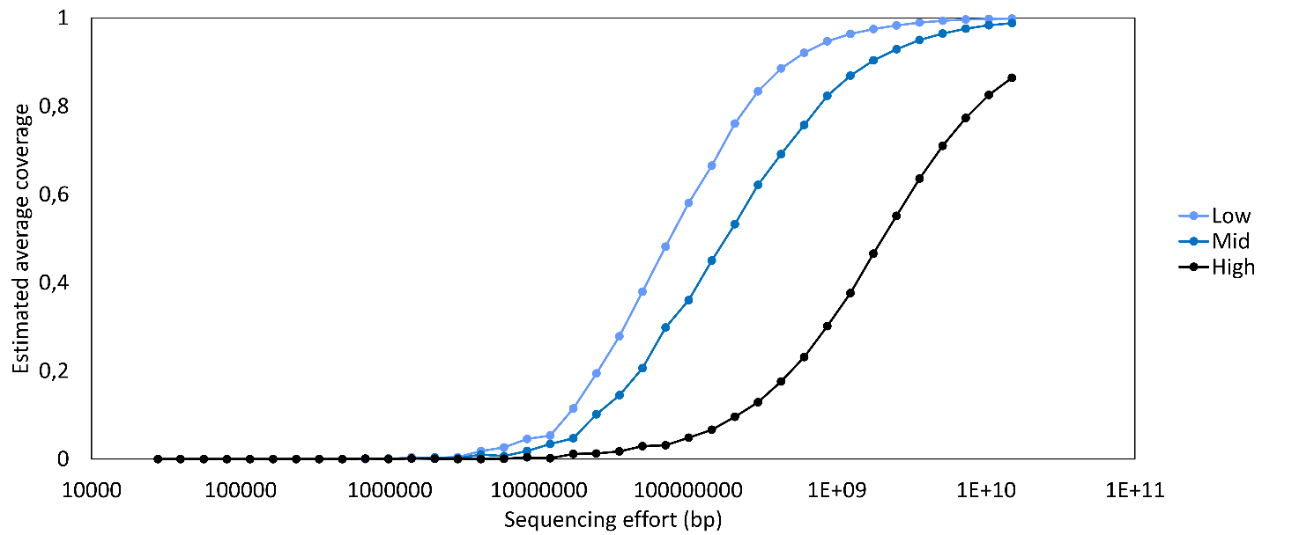
Figure S2. Computational requirements of a Tara Ocean metagenome. A) Total assembly span proportional to wall time required. B) Total assembly span in relation to peak memory usage.
A
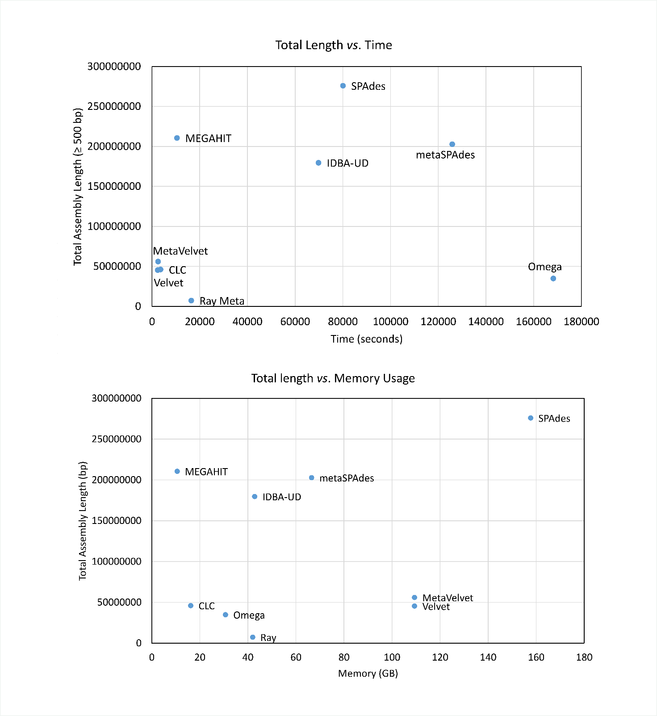
B
Figure S3. Correlation between assembly span and mapping rate. The exponential trendline indicates a very strong positive correlation between the amount of data utilized and the size of the generated assembly (R² = 0.83).
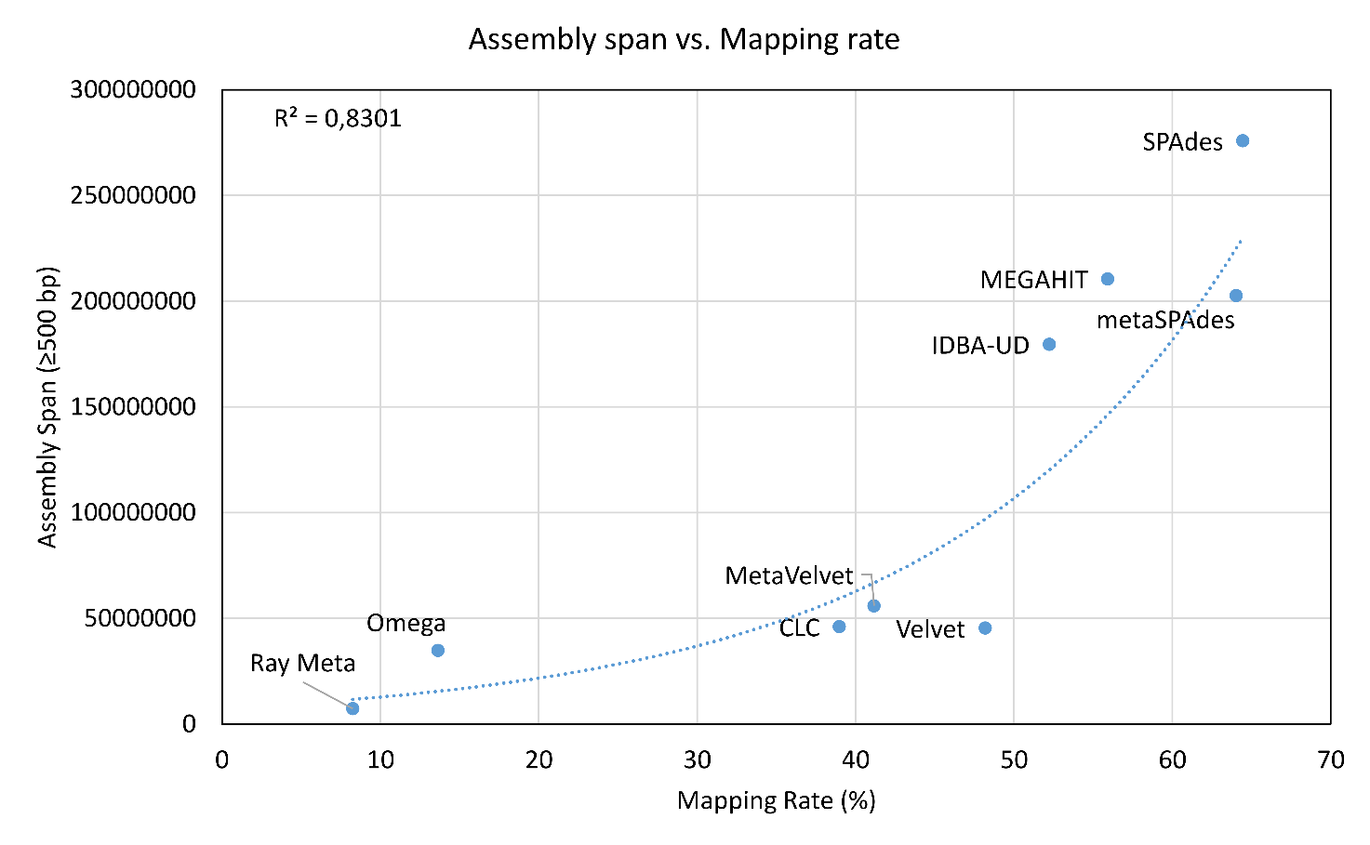

References
1 Peng, Y., Leung, H. C., Yiu, S.-M. & Chin, F. Y. IDBA-UD: a de novo assembler for single-cell and metagenomic sequencing data with highly uneven depth. Bioinformatics 28, 1420-1428 (2012).
2 Li, D., Liu, C.-M., Luo, R., Sadakane, K. & Lam, T.-W. MEGAHIT: an ultra-fast single-node solution for large and complex metagenomics assembly via succinct de Bruijn graph. Bioinformatics, btv033 (2015).
3 Nurk, S., Meleshko, D., Korobeynikov, A. & Pevzner, P. metaSPAdes: a new versatile de novo metagenomics assembler. arXiv preprint arXiv:1604.03071 (2016).
4 Namiki, T., Hachiya, T., Tanaka, H. & Sakakibara, Y. MetaVelvet: an extension of Velvet assembler to de novo metagenome assembly from short sequence reads. Nucleic acids research 40, e155-e155 (2012).
5 Haider, B. et al. Omega: an Overlap-graph de novo Assembler for Metagenomics. Bioinformatics, btu395 (2014).
6 Boisvert, S., Raymond, F., Godzaridis, É., Laviolette, F. & Corbeil, J. Ray Meta: scalable de novo metagenome assembly and profiling. Genome biology 13, 1 (2012).
7 Bankevich, A. et al. SPAdes: a new genome assembly algorithm and its applications to single-cell sequencing. Journal of Computational Biology 19, 455-477 (2012).
8 Zerbino, D. R. & Birney, E. Velvet: algorithms for de novo short read assembly using de Bruijn graphs. Genome research 18, 821-829 (2008).
9 Howe, A. C. et al. Tackling soil diversity with the assembly of large, complex metagenomes. Proceedings of the National Academy of Sciences 111, 4904-4909 (2014).
10 Hultman, J. et al. Multi-omics of permafrost, active layer and thermokarst bog soil microbiomes. Nature (2015).
11 Luo, C. et al. Soil microbial community responses to a decade of warming as revealed by comparative metagenomics. Applied and environmental microbiology 80, 1777-1786 (2014).
12 Sunagawa, S. et al. Structure and function of the global ocean microbiome. Science 348, 1261359 (2015).
13 Bowman, J. S., Berthiaume, C. T., Armbrust, E. V. & Deming, J. W. The genetic potential for key biogeochemical processes in Arctic frost flowers and young sea ice revealed by metagenomic analysis. FEMS microbiology ecology 89, 376-387 (2014).
14 Bäckhed, F. et al. Dynamics and stabilization of the human gut microbiome during the first year of life. Cell host & microbe 17, 690-703 (2015).
15 Karlsson, F. H. et al. Gut metagenome in European women with normal, impaired and diabetic glucose control. Nature 498, 99-103 (2013).
16 Tremaroli, V. et al. Roux-en-Y gastric bypass and vertical banded gastroplasty induce long-term changes on the human gut microbiome contributing to fat mass regulation. Cell metabolism 22, 228-238 (2015).

