Supplementary Information

S1 Table 1: Primers used for cloning and sequencing recombinant gene fragments
Name of primer | Primer sequence (5’…3’)
pGEX-6P-1_cbm36-1 Fd (BamHI) | ACTTGGGGATCCGGCAACACCGGTAGTCAAACG
pGEX-6P-1_cbm36-1 Rv (NotI) | AATTAGCGGCCGCTCACGATGATTCATTGCCACCAAC
pGEX-6P-1_cbm36-2 Fd (BamHI) | ACTTGGGGATCCGGTGGCCAGGCTCAAAGC
pGEX-6P-1_cbm36-2 Rv (NotI) | AATTAGCGGCCGCTCACGTTTGAACCGGCATTGTTGC
pET28a_ce4 Fd (NcoI) | ACTACCCATGGGCAATGAAAAACTGATCG
pET28a_ce4 Rv (XhoI) | TATACCTCGAGTTGACCGTTAGCGTTTGAC
T7 sequencing primer Fd | TAATACGACTCACTATAGGG
T7 sequencing primer Rv | GCTAGTTATTGCTCAGCGG

S1 Table 2: Concentration of proteins used for ITC experiments
Titrant (Protein in syringe) | Titrand (protein in vessel)
CBM36-1 (10 mg/ml) = 714 µM | GH11 (1 mg/ml) = 38.5µM
CE4 (10 mg/ml) = 437.8 µM | CBM36-1 (0.6 mg/ml) = 42.8 µM
CE4 (10 mg/ml) = 437.8 µM | GH11 (1.1 mg/ml) = 42 µM

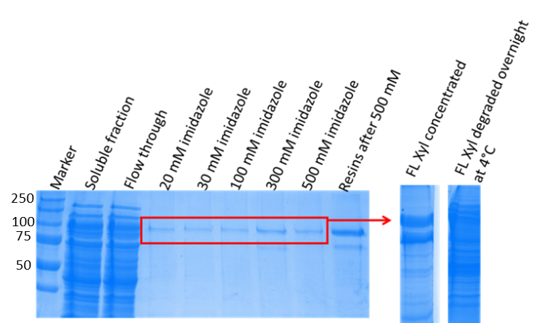
S1 Fig 1: Production and Co²⁺-NTA purification of Xyl. Xyl was eluted with increasing concentration of imidazole and elution fractions pulled and concentrated. Concentrated protein showed two major bands and degraded completely with overnight storage even in the presence of protease inhibitor cocktails.
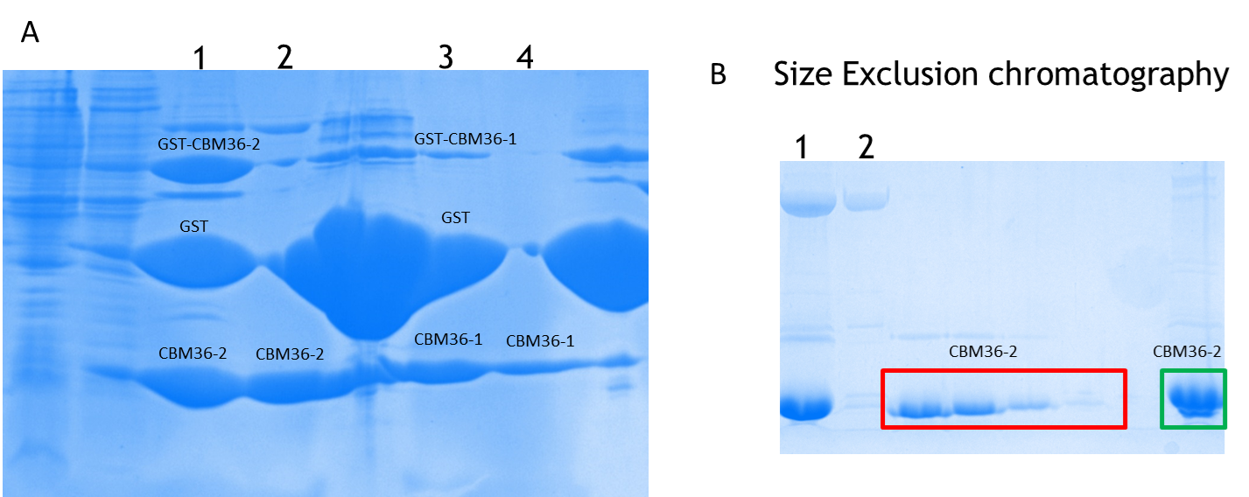
S1 Fig 2: GST-fusion and size exclusion chromatography purification of CBM36-2. A) GST- CBM36-1 and GST-CBM36-2 treated with 3C protease. Lanes 1 and 3: Protein samples after overnight treated with 3C protease at 4 °C. Lanes 2 and 4 show eluted protein from overnight cleavage. Lanes R, represents GS resins after elution. The large blob of protein is the GST tag left on the resins. Protein samples from lanes 2 and 4 were separately concentrated and further purified by size exclusion chromatography. B). CBM36-2 purified from size exclusion chromatography. Lane 1 is concentrated protein before loading on GS column. Lane 2 shows separated impurity. The read boxes represent protein on chromatogram peaks corresponding to the size of CBM36-2. The green box represents CBM36-2 concentrated for crystallization.

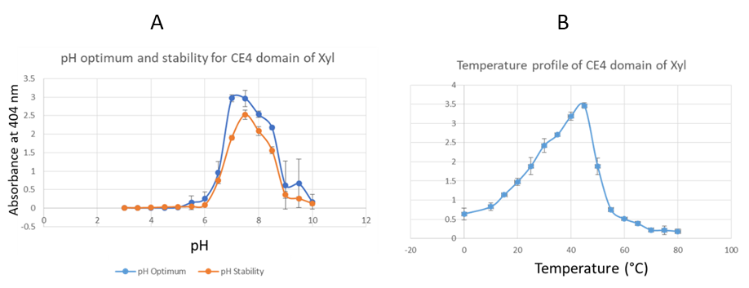
S1 Fig 3: Activity of Xyl-CE4 with increasing pH and temperature identifies optimum pH and temperature at 7.5 and 45 °C respectively. A) pH activity measured from the release of para-nitrophenol (p-NP) from 200 μL of 0.5 mM p-NPA at 405 nm and 30 °C. Blue curve optimum activity assay and orange curve is activity of enzyme after 72 h of incubation. B) Temperature profile of Xyl-CE4 at increasing temperature measured from the release of p-NP from 200 μL of 0.5 mM p-NPA at 405 nm and pH 7.5. Both pH and temperature assays were performed in triplicates and standard deviation error bars plotted.

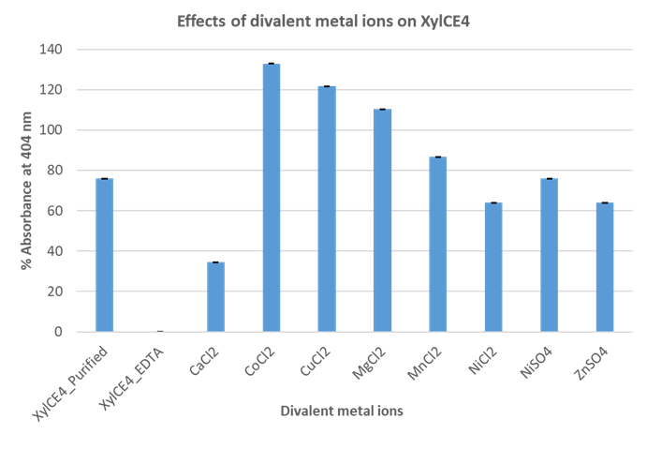
S1 Fig 4: Effect of divalent metal ions on Xyl-CE4 catalysis assayed at 30 °C by removing metal ions with 1 mM EDTA and adding divalent ions before assessing enzyme activity. EDTA treatment reduced enzyme activity to 0 % of the untreated sample (XylCE4_purified: 0.2 μg Xyl-CE4 in 50 mM Tris pH 8.0). Co²⁺ is most highly activating. All assays were performed in triplicate and standard deviation error bars indicated.

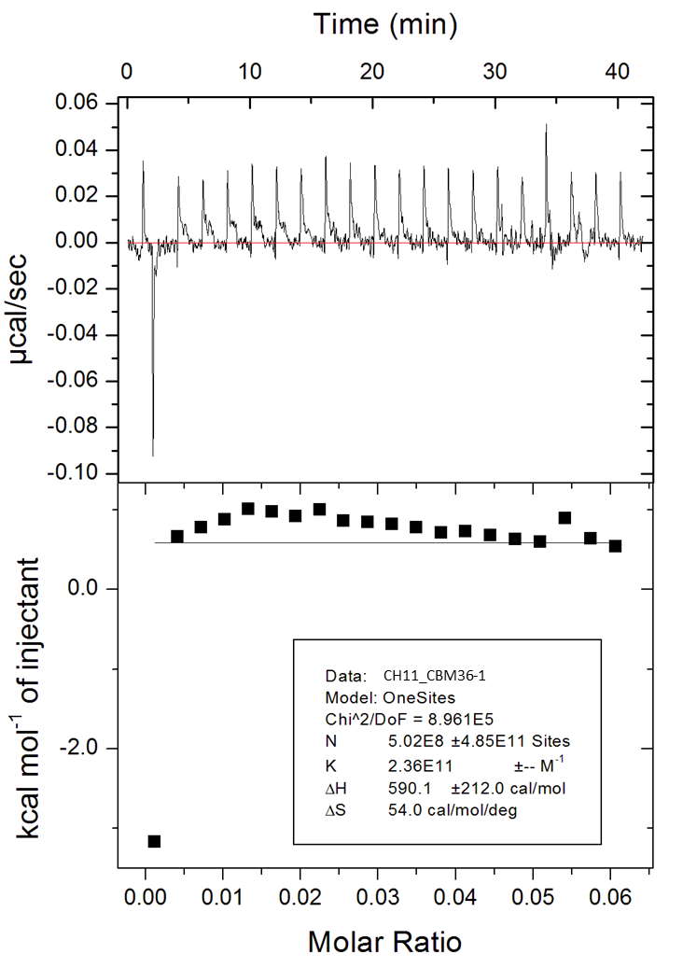
S1 Fig 5: Analysis of GH11/CBM36-1 interaction by ITC using an ITC200 microcalorimeter (Microcal/GE Healthcare, USA). 10 µM CBM36-1 in the syringe, was titrated into 1 µM GH11 at 25 °C in PBS buffer. No heats of interactions are observed.

