Supplemental Materials
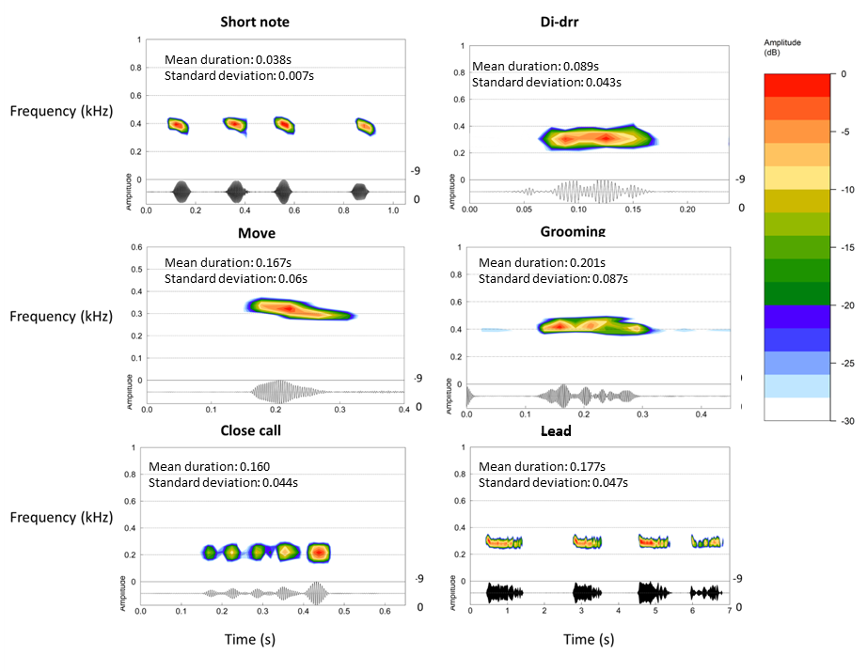
Figure S1. Spectrograms of examples of each of the call-types found in submissive calling bouts. Spectrograms produced using an FFT size of 1024 points, Hanning window and 50% window overlap in the R package ‘seewave’[32]. Medians and standard durations refer to all calls of that type.

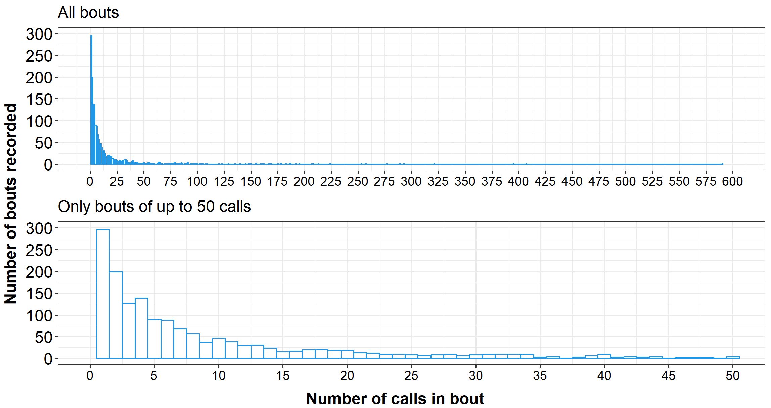
Figure S2. Sampling distribution for bouts consisting of different numbers of calls. Top: All data. Bottom: Only bouts of up to 50 calls.
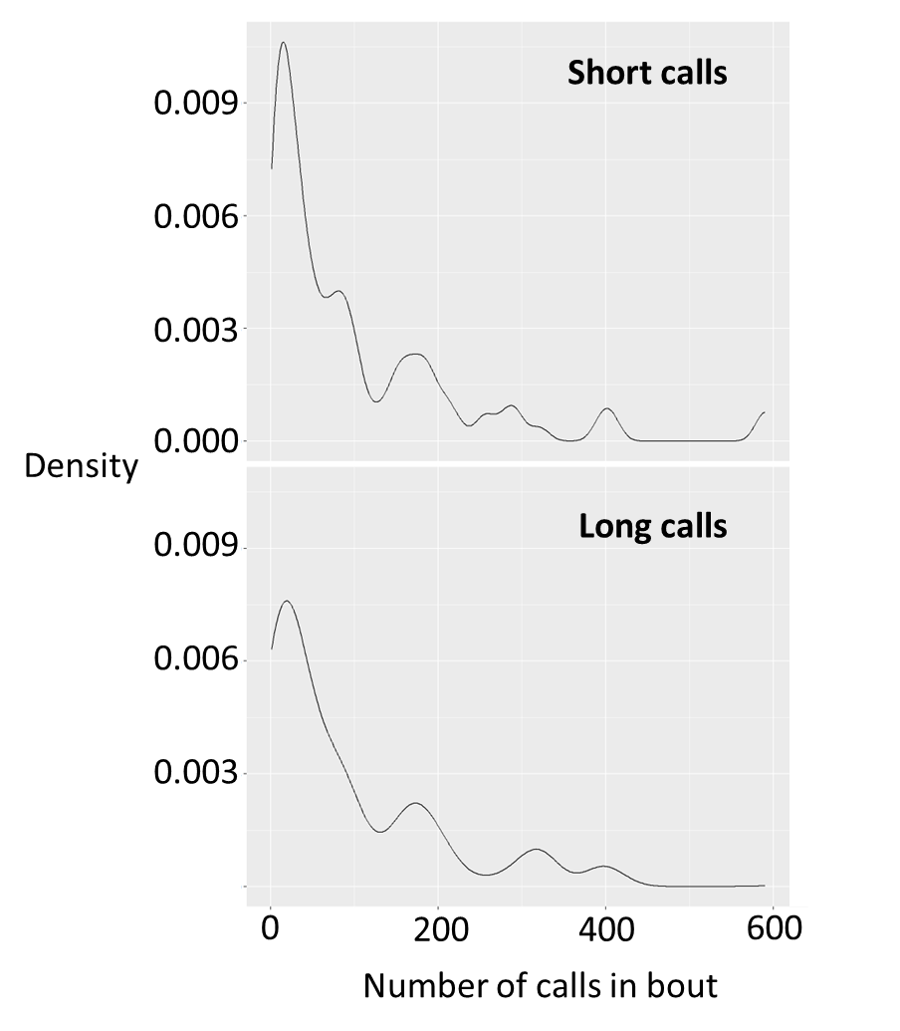
Figure S3. Proportional sampling distribution for long and short calls. Proportions provided rather than raw numbers to facilitate comparisons between call-types.

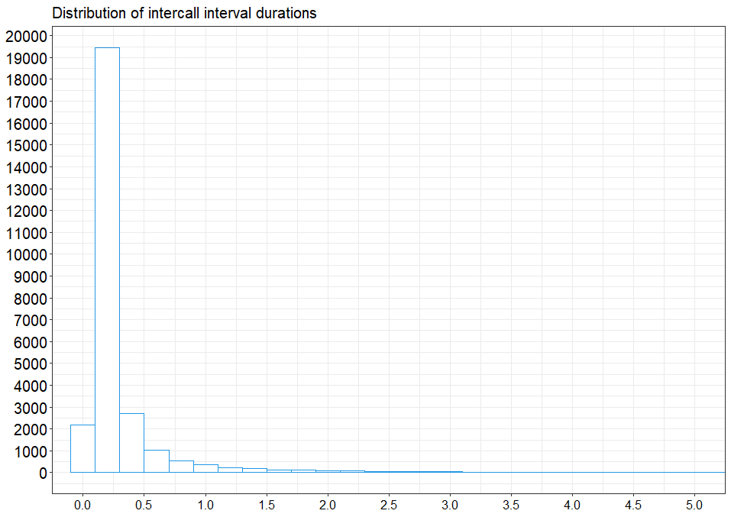
Figure S4. Sampling distribution for inter-call intervals in raw recordings, before bout-assignment procedure carried out. X-axis restricted to 5s for readability, accounting for ~95% of the data.

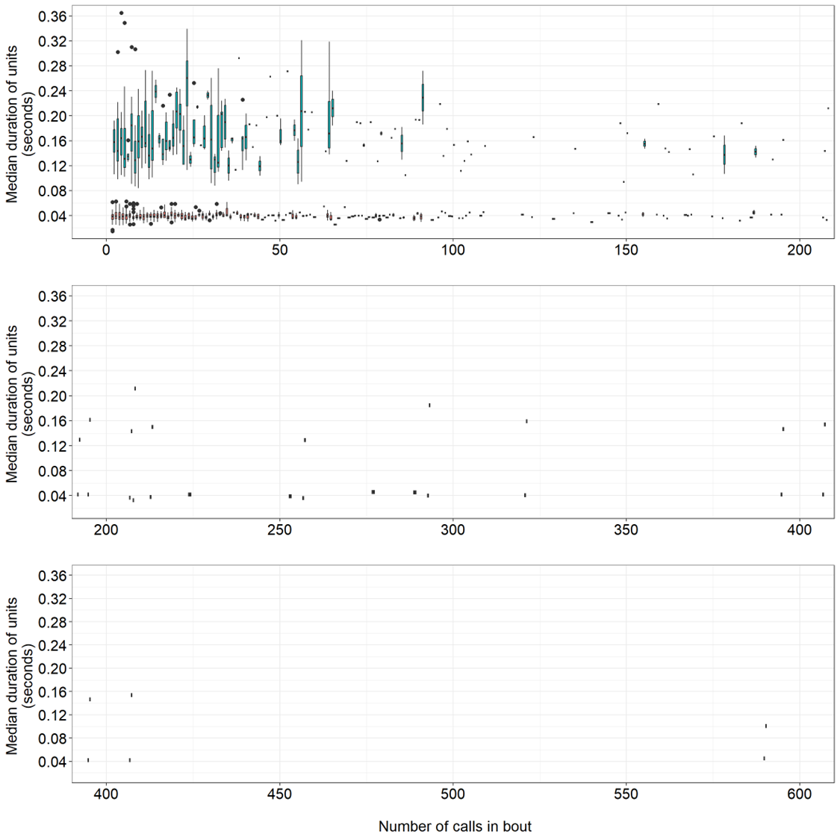
Figure S5. Overall median duration of calls in a bout, for all bout sizes. Red: Short call-types. Blue: Long call-types. In second and third row of plots, no short-call boxes are higher than 0.08s.

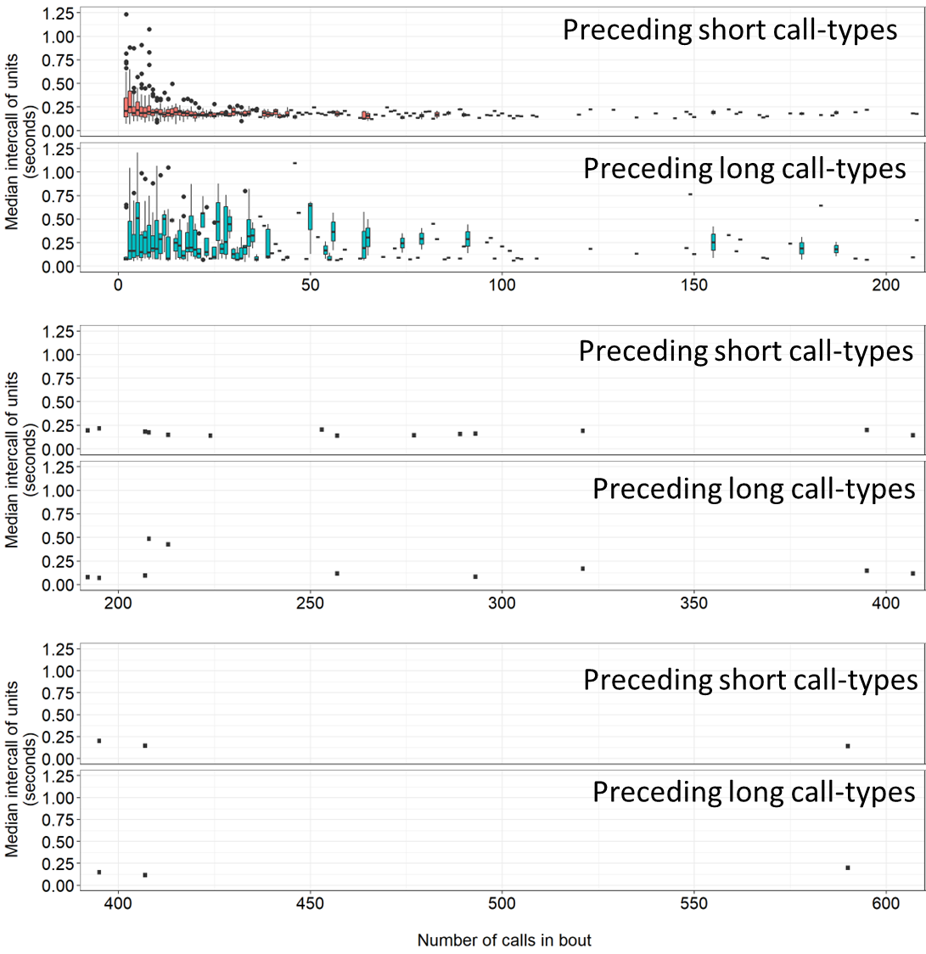
Figure S6. Overall median duration of inter-call interval preceding short (red boxes/top row) and long (blue boxes/bottom row) call-types in a bout, for all bout sizes.

Table S1. Summary of previous evidence for and against Menzerath’s law in animal communication systems.
Species tested | Signal type | Evidence for Menzerath's law? | Citation
15 songbird species | Song | Yes | James et al. 2021²
16 Baleen whale species | Song | Yes in 11 of 16 | Youngblood 2024a¹³ (preprint)
African penguin | Display song | Yes | Favaro et al. 2020⁵
Asian parti-colored bat (Vespertilio sinensis) | Aggressive vocalisations | Yes | Zhang et al. 2024 ¹
Bottlenosed dolphins | Click sequences | Yes | Stepanov et al. 2023 ³ (preprint)
Cao vit gibbon (Nomascus nasutus) | Morning calls | Yes | Huang et al. 2020⁹
Chimpanzees (Pan troglodytes) | Pant-hoots (long distance contact call) | Yes | Fedurek et al. 2017⁸
Chimpanzees (Pan troglodytes) | Play-based gestures | Yes | Heesen et al. 2019¹²
Chimpanzees (Pan troglodytes) | Sexual solicitation gestures | Yes in 11 of 16 | Safryghin et al. 2022¹⁵
Geladas | Contact call sequences | Yes | Gustison et al. 2016⁴
Gibbons (Hylobates funereus) | Duets | Partial (in some call-types) | Clink & Lau 2020⁷
Hainan frilled treefrogs (Kurixalus hainanus) | Various calls | Partial | Deng et al. 2024⁶
House finch (Haemorhous mexicanus) | Song | Yes | Youngblood 2024b¹⁴
Java sparrow (Padda oryzivora) | Song | Yes | Lewis et al. 2023¹¹ (preprint)
Mountain gorillas (Gorilla beringei beringei) | Food calls | Partial (only if including bouts of n calls = 1) | Watson et al. 2020¹⁰
Tarsiers (Tarsius spectrumgurskyae) | Duets | Partial (some call-types) | Clink & Lau 2020⁷
Titi monkeys (Plecturocebus cupreus) | Duets | Partial (in some call-types) | Clink & Lau 2020⁷
Western black-crested gibbon (Nomascus concolor) | Morning calls | Yes | Huang et al. 2020⁹

Table S2. Model comparison table for analysis rerun without the first bout in each recording.
Data | Model | ELPD Difference from best model | SE Difference from best model
All data | Full | - | -
 | Null | -16.46 | 7.38
Only bouts > 1 call | Full | - | -
 | Null | -13.26 | 6.15
Bouts < 32 calls | Full | - | -
 | Null | -21.73 | 5.54
Bouts > 1 and > 42 calls | Full | - | -
 | Null | -10.20 | 4.42

Table S3. Model outputs for Full models from Table S2.
Data | Parameter | Estimate | Estimate Error | Lower 95% credible interval | Upper 95% credible interval
All data | Intercept | -3.3026 | 0.0171 | -3.337 |  | -3.2697
 | Number of calls in bout | 0.0009 | 0.0002 | 0.0006 |  | 0.0012
 | Call-length category (Long/Short) | 1.5008 | 0.0108 | 1.4794 |  | 1.522
 | Logged position of call in bout | 0.0192 | 0.0019 | 0.0155 |  | 0.0229
 | Number of calls in bout * Call-length category | -0.0004 | 0.0001 | -0.0006 |  | -0.0003
Bouts > 1 | Intercept | -3.2831 | 0.0169 | -3.3154 |  | -3.2501
 | Number of calls in bout | 0.0007 | 0.0001 | 0.0004 |  | 0.001
 | Call-length category (Long/Short) | 1.4889 | 0.0111 | 1.4673 |  | 1.5111
 | Logged position of call in bout | 0.0203 | 0.0019 | 0.0167 |  | 0.0238
 | Number of calls in bout * Call-length category | -0.0004 | 0.0001 | -0.0006 |  | -0.0002
Bouts < 35 | Intercept | -3.3331 | 0.0185 | -3.3693 |  | -3.2964
 | Number of calls in bout | 0.0059 | 0.0006 | 0.0048 |  | 0.0071
 | Call-length category (Long/Short) | 1.5252 | 0.0202 | 1.4857 |  | 1.5636
 | Logged position of call in bout | 0.034 | 0.0033 | 0.0274 |  | 0.0406
 | Number of calls in bout * Call-length category | -0.0015 | 0.0012 | -0.0038 |  | 0.0008
Bouts > 1 and < 42 | Intercept | -3.3058 | 0.0171 | -3.3387 |  | -3.2719
 | Number of calls in bout | 0.0044 | 0.0005 | 0.0035 |  | 0.0054
 | Call-length category (Long/Short) | 1.4966 | 0.0199 | 1.459 |  | 1.5353
 | Logged position of call in bout | 0.0349 | 0.0031 | 0.0289 |  | 0.0409
 | Number of calls in bout * Call-length category | -0.0009 | 0.0009 | -0.0028 |  | 0.0009

References
1. Zhang, C., Zheng, Z., Lucas, J.R., Wang, Y., Fan, X., Zhao, X., Feng, J., Sun, C., and Jiang, T. (2024). Do bats’ social vocalizations conform to Zipf’s law and the Menzerath-Altmann law? iScience 27. https://doi.org/10.1016/j.isci.2024.110401.
2. James, L.S., Mori, C., Wada, K., and Sakata, J.T. (2021). Phylogeny and mechanisms of shared hierarchical patterns in birdsong. Curr. Biol. 31, 2796-2808.e9. https://doi.org/10.1016/j.cub.2021.04.015.
3. Stepanov, A., Zhivomirov, H., Nedelchev, I., and Stateva, P. (2023). Bottlenose dolphins’ broadband clicks are structured for communication. Preprint at bioRxiv, https://doi.org/10.1101/2023.01.11.523588 https://doi.org/10.1101/2023.01.11.523588.
4. Gustison, M.L., Semple, S., Ferrer-i-Cancho, R., and Bergman, T.J. (2016). Gelada vocal sequences follow Menzerath’s linguistic law. Proc. Natl. Acad. Sci. 113, E2750–E2758. https://doi.org/10.1073/pnas.1522072113.
5. Favaro, L., Gamba, M., Cresta, E., Fumagalli, E., Bandoli, F., Pilenga, C., Isaja, V., Mathevon, N., and Reby, D. (2020). Do penguins’ vocal sequences conform to linguistic laws? Biol. Lett. 16, 20190589. https://doi.org/10.1098/rsbl.2019.0589.
6. Deng, K., He, Y.-X., Wang, X.-P., Wang, T.-L., Wang, J.-C., Chen, Y.-H., and Cui, J.-G. (2024). Hainan frilled treefrogs’ calls partially conform to Menzerath–Altmann’s law, but oppose Zipf’s law of abbreviation. Anim. Behav. 213, 51–59. https://doi.org/10.1016/j.anbehav.2024.04.011.
7. Clink, D.J., and Lau, A.R. (2020). Adherence to Menzerath’s Law is the exception (not the rule) in three duetting primate species. R. Soc. Open Sci. 7.
8. Fedurek, P., Zuberbühler, K., and Semple, S. (2017). Trade-offs in the production of animal vocal sequences: insights from the structure of wild chimpanzee pant hoots. Front. Zool. 14, 50. https://doi.org/10.1186/s12983-017-0235-8.
9. Huang, M., Ma, H., Ma, C., Garber, P.A., and Fan, P. (2020). Male gibbon loud morning calls conform to Zipf’s law of brevity and Menzerath’s law: insights into the origin of human language. Anim. Behav. 160, 145–155. https://doi.org/10.1016/j.anbehav.2019.11.017.
10. Watson, S.K., Heesen, R., Hedwig, D., Robbins, M.M., and Townsend, S.W. (2020). An exploration of Menzerath’s law in wild mountain gorilla vocal sequences. Biol. Lett. 16, 20200380. https://doi.org/10.1098/rsbl.2020.0380.
11. Lewis, R.N., Kwong, A., Soma, M., Kort, S.R. de, and Gilman, R.T. (2023). Java sparrow song conforms to Menzerath’s Law but not Zipf’s Law of Abbreviation. Preprint at bioRxiv, https://doi.org/10.1101/2023.12.13.571437 https://doi.org/10.1101/2023.12.13.571437.
12. Heesen, R., Hobaiter, C., Ferrer-i-Cancho, R., and Semple, S. (2019). Linguistic laws in chimpanzee gestural communication. Proc. R. Soc. B Biol. Sci. 286, 20182900. https://doi.org/10.1098/rspb.2018.2900.
13. Youngblood, M. (2024). Language-like efficiency in whale communication. Preprint at OSF, https://doi.org/10.31234/osf.io/tduab https://doi.org/10.31234/osf.io/tduab.
14. Youngblood, M. (2024). Language-like efficiency and structure in house finch song. Proc. R. Soc. B Biol. Sci. 291, 20240250. https://doi.org/10.1098/rspb.2024.0250.
15. Safryghin, A., Cross, C., Fallon, B., Heesen, R., Ferrer-i-Cancho, R., and Hobaiter, C. (2022). Variable expression of linguistic laws in ape gesture: a case study from chimpanzee sexual solicitation. R. Soc. Open Sci. 9, 220849. https://doi.org/10.1098/rsos.220849.

