University of Pretoria: Creative Outputs
Declaration Form
The DHET’s policy requires that creators submitting creative work outputs, submit a number of declarations i.e.: a declaration: of originality; non-plagiarism and creatorship / co-creatorship.

Note: this form is NOT for the Academic Annotation/Framework/Motivation, which must be completed in the relevant template Spreadsheet accompanying the submission.

Name of primary contributor: Ben Schoeman

UP Staff number: 22223160
Title of Creative output: The Immortal Beloved – Trios for Clarinet, Cello and Piano performed at the Odeion School of Music by Danrè Strydom, Anmari van der Westhuizen and Ben Schoeman
Category (circle one):
Design | Film | Fine Arts | Literary Arts | Music | Television | Theatre, Performance and Dance

Sub-category (see list in guidelines):
Approval granted by Faculty HOD/Creative Outputs committee to submit this CO for subsidy. | This creative output was evaluated by the HOD/Creative outputs committee and approval is granted to submit it for subsidy. YES / NO
Declaration of originality | We declare that the creative output has not been published in a peer reviewed journal or a book and has not been submitted for subsidy before
Declaration that this creative work generated has not been copied from elsewhere and that the ideas are those of the claiming creator/s. | We declare that the creative output has not been plagiarized and that the ideas are those of the claiming creator(s).
Declaration of creator/co-creatorship  A declaration of creator/co-creatorship and disclosure of other active participants in the creation of the work  (use an additional form if more space needed) | We declare that we are the co-creators of this creative work.  If co-creator/s, print names:  Danrè Strydom  Anmari van der Westhuizen  Ben Schoeman
Signatures of all creators:  (use an additional form if more space needed) | Signature(s):  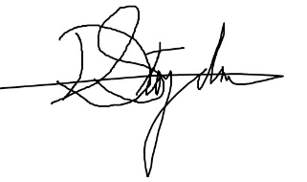  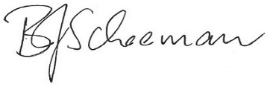  Date: 07/08/2020
Signature HOD/Creative outputs panel: | Print Name: Alexander Johnson  Signature: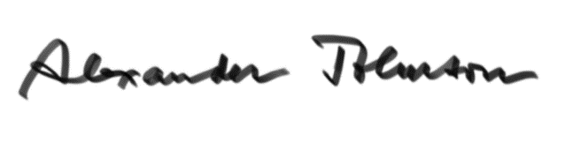  Date:08-08-2020

