Supplementary Material

The potential area of occupancy of non-native plants across a warming high-Arctic archipelago: Implications for strategic biosecurity management

James D. M. Speed^{1*}, Luis R. Pertierra^{2,3}, Kristine B. Westergaard¹

- Department of Natural History, NTNU University Museum, Norwegian University of Science and Technology, Trondheim, Norway
- Department of Plant and Soil Sciences. University of Pretoria, Pretoria, South Africa.
- Millennium Institute Biodiversity of Antarctic and Sub-Antarctic Ecosystems (BASE), Santiago, Chile
* Corresponding author: james.speed@ntnu.no

Table S1. References with species-specific strings and permanent links for each of the studied 27 non-native plant species’ ecological impact assessments. All follow a common reference structure: Westergaard KB, Hegre H, Solstad H, Alm T, Fløistad IS, Pedersen O, Schei FH, Vandvik V, Vollering J & Skarpaas O (2023). Karplanter [Vascular plants]: Vurdering av (art) for Svalbard med kystsone [Assessment of (species) for Svalbard with coastal zone]. Fremmedartslista 2023 [Alien species list 2023]. Artsdatabanken [Norwegian Biodiversity Information Centre]. (permanent link).
Assessments followed the Generic Ecological Impact Assessment of Alien Species (GEIAA) protocol using a fully quantitative set of criteria (Norwegian Biodiversity Information Centre, 2022; Sandvik et al., 2019), and are published online (in Norwegian) and searchable at https://artsdatabanken.no/lister/fremmedartslista/2023.

Species-specific strings and permanent links
Vurdering av ryllik Achillea millefolium for Svalbard med kystsone. https://www.artsdatabanken.no/lister/fremmedartslista/2023/3156
Vurdering av engmarikåpe Alchemilla subcrenata for Svalbard med kystsone. https://www.artsdatabanken.no/lister/fremmedartslista/2023/3180
Vurdering av skarmarikåpe Alchemilla wichurae for Svalbard med kystsone. https://www.artsdatabanken.no/lister/fremmedartslista/2023/3166
Vurdering av hundekjeks Anthriscus sylvestris for Svalbard med kystsone. https://www.artsdatabanken.no/lister/fremmedartslista/2023/3170
Vurdering av vinterkarse Barbarea vulgaris for Svalbard med kystsone. https://www.artsdatabanken.no/lister/fremmedartslista/2023/3153
Vurdering av gjetertaske Capsella bursa-pastoris for Svalbard med kystsone. https://www.artsdatabanken.no/lister/fremmedartslista/2023/3152
Vurdering av sølvbunke Deschampsia cespitosa subsp. cespitosa for Svalbard med kystsone. https://www.artsdatabanken.no/lister/fremmedartslista/2023/3126
Vurdering av markrødsvingel Festuca rubra subsp. rubra for Svalbard med kystsone. https://www.artsdatabanken.no/lister/fremmedartslista/2023/3125
Vurdering av tunbalderbrå Lepidotheca suaveolens for Svalbard med kystsone. https://www.artsdatabanken.no/lister/fremmedartslista/2023/3113
Vurdering av tunrapp Poa annua for Svalbard med kystsone. https://www.artsdatabanken.no/lister/fremmedartslista/2023/3158
Vurdering av smårapp Poa humilis for Svalbard med kystsone. https://www.artsdatabanken.no/lister/fremmedartslista/2023/3112
Vurdering av myrrapp Poa palustris for Svalbard med kystsone. https://www.artsdatabanken.no/lister/fremmedartslista/2023/3157
Vurdering av engrapp Poa pratensis for Svalbard med kystsone. https://www.artsdatabanken.no/lister/fremmedartslista/2023/3162
Vurdering av parksoleie Ranunculus acris subsp. friesianus for Svalbard med kystsone. https://www.artsdatabanken.no/lister/fremmedartslista/2023/3134
Vurdering av krypsoleie Ranunculus repens for Svalbard med kystsone. https://www.artsdatabanken.no/lister/fremmedartslista/2023/3061
Vurdering av kystsoleie Ranunculus subborealis subsp. villosus for Svalbard med kystsone. https://www.artsdatabanken.no/lister/fremmedartslista/2023/3132
Vurdering av ugrasløvetann-gruppa Ruderalia for Svalbard med kystsone. https://www.artsdatabanken.no/lister/fremmedartslista/2023/3169
Vurdering av matsyre Rumex acetosa for Svalbard med kystsone. https://www.artsdatabanken.no/lister/fremmedartslista/2023/3120
Vurdering av høymol Rumex longifolius for Svalbard med kystsone. https://www.artsdatabanken.no/lister/fremmedartslista/2023/3119
Vurdering av fjelltistel Saussurea alpina for Svalbard med kystsone. https://www.artsdatabanken.no/lister/fremmedartslista/2023/3129
Vurdering av vassarve Stellaria media for Svalbard med kystsone. https://www.artsdatabanken.no/lister/fremmedartslista/2023/3159
Vurdering av reinfann Tanacetum vulgare for Svalbard med kystsone. https://www.artsdatabanken.no/lister/fremmedartslista/2023/3186
Vurdering av rødkløver Trifolium pratense for Svalbard med kystsone. https://www.artsdatabanken.no/lister/fremmedartslista/2023/3204
Vurdering av hvitkløver Trifolium repens for Svalbard med kystsone. https://www.artsdatabanken.no/lister/fremmedartslista/2023/3171
Vurdering av strandbalderbrå Tripleurospermum maritimum for Svalbard med kystsone. https://www.artsdatabanken.no/lister/fremmedartslista/2023/3182
Vurdering av brennesle Urtica dioica subsp. dioica for Svalbard med kystsone. https://www.artsdatabanken.no/lister/fremmedartslista/2023/3127
Vurdering av storveronika Veronica longifolia for Svalbard med kystsone. https://www.artsdatabanken.no/lister/fremmedartslista/2023/3163

Table S2 The total area of potential occupancy (km²) of the 27 non-native species across the Svalbard archipelago under current and future (SSP 2-45 and 5-85) climate scenarios (data from Figure 2, also see Figures S8, S11 and S12 for the corresponding maps). These are estimated using 30’ second rasters. The total ice-free area of non-glaciated land available using this dataset is 24 210 km². The percent of the total area is shown in parantheses. Species are ranked by the current potential area.

Species | Current potential area (km²) | Future potential area SSP 2-45 (km²) | Future potential area SSP5-85 (km²)
Ranunculus subborealis villosus | 24210 (100%) | 24210 (100%) | 24210 (100%)
Deschampsia cespitosa cespitosa | 24210 (100%) | 24138 (99.7%) | 24129 (99.7%)
Saussurea alpina | 18209 (75.2%) | 23302 (96.2%) | 14939 (61.7%)
Alchemilla wichurae | 12336 (51%) | 24190 (99.9%) | 21944 (90.6%)
Alchemilla subcrenata | 11284 (46.6%) | 22088 (91.2%) | 20471 (84.6%)
Tripleurospermum maritimum | 10479 (43.3%) | 24170 (99.8%) | 24139 (99.7%)
Festuca rubra rubra | 9923 (41%) | 24210 (100%) | 24191 (99.9%)
Veronica longifolia | 5291 (21.9%) | 185 (0.8%) | 327 (1.4%)
Poa humilis | 2948 (12.2%) | 24177 (99.9%) | 23963 (99%)
Urtica dioica dioica | 2560 (10.6%) | 14593 (60.3%) | 17305 (71.5%)
Taraxacum sect. Ruderalia | 1211 (5%) | 12143 (50.2%) | 12426 (51.3%)
Lepidotheca suaveolens | 652 (2.7%) | 24209 (100%) | 24199 (100%)
Rumex acetosa | 474 (2%) | 24210 (100%) | 24183 (99.9%)
Rumex longifolius | 164 (0.7%) | 24202 (100%) | 23989 (99.1%)
Trifolium pratense | 46 (0.2%) | 23134 (95.6%) | 24059 (99.4%)
Ranunculus repens | 0 (0%) | 24210 (100%) | 24186 (99.9%)
Poa pratensis | 0 (0%) | 24210 (100%) | 24186 (99.9%)
Anthriscus sylvestris | 0 (0%) | 24149 (99.7%) | 24184 (99.9%)
Achillea millefolium | 0 (0%) | 24136 (99.7%) | 24126 (99.7%)
Poa annua | 0 (0%) | 24008 (99.2%) | 24087 (99.5%)
Trifolium repens | 0 (0%) | 22459 (92.8%) | 23206 (95.9%)
Stellaria media | 0 (0%) | 17541 (72.5%) | 21966 (90.7%)
Capsella bursa-pastoris | 0 (0%) | 21782 (90%) | 20886 (86.3%)
Tanacetum vulgare | 0 (0%) | 13465 (55.6%) | 16632 (68.7%)
Barbarea vulgaris | 0 (0%) | 7619 (31.5%) | 11141 (46%)
Poa palustris | 0 (0%) | 0 (0%) | 0 (0%)
Ranunculus acris friesianus | 0 (0%) | 0 (0%) | 0 (0%)

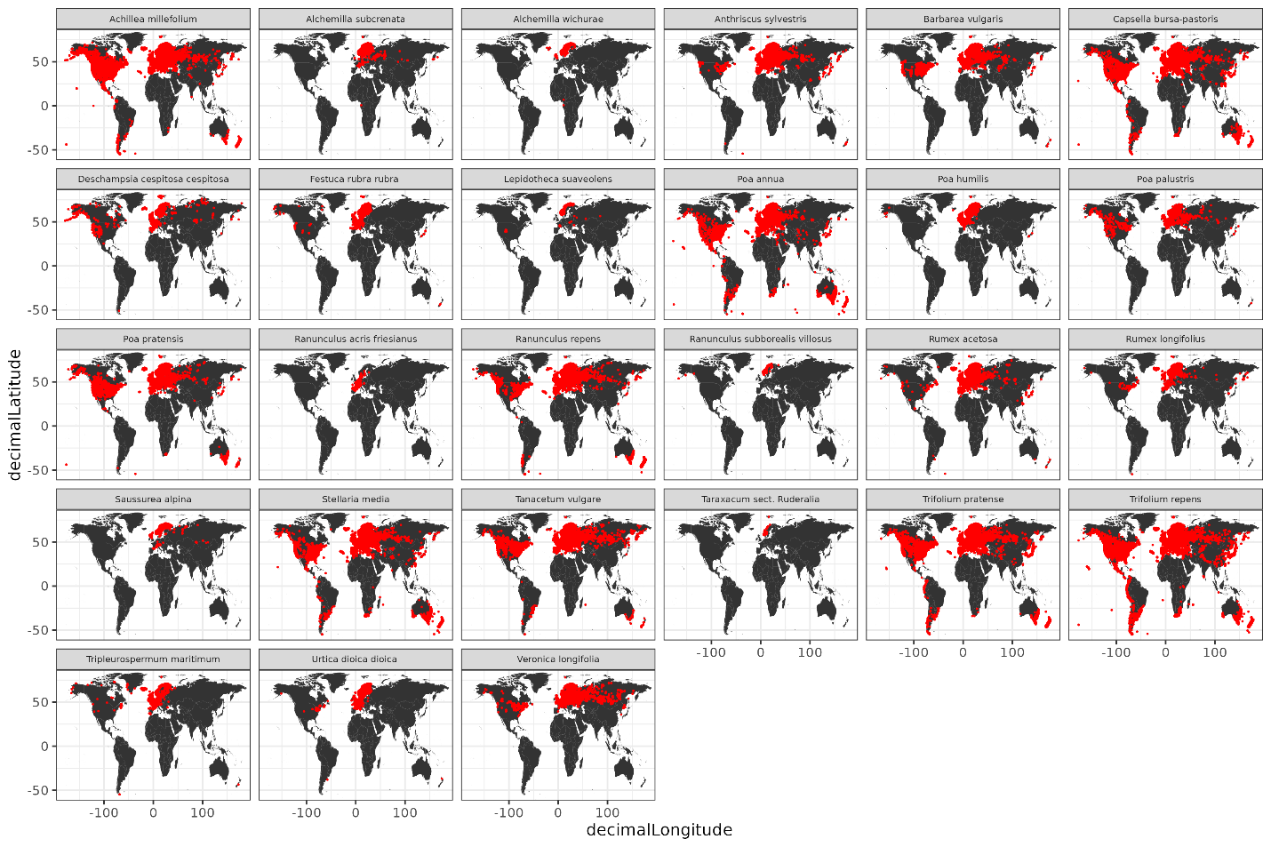
Figure S1: GBIF spatial occurrence records downloaded for the plant species used in the study (GBIF.org, 2023a).

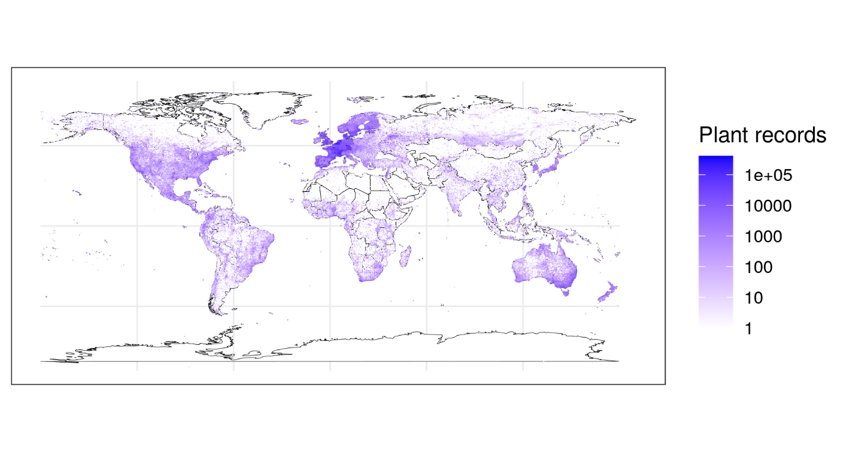
Figure S2: The number of GBIF spatial occurrence records across the world for vascular plants (Tracheophyta) per 2.5’ grid cell, used as a bias weighting in sampling pseudo-absences (GBIF.org, 2023b).

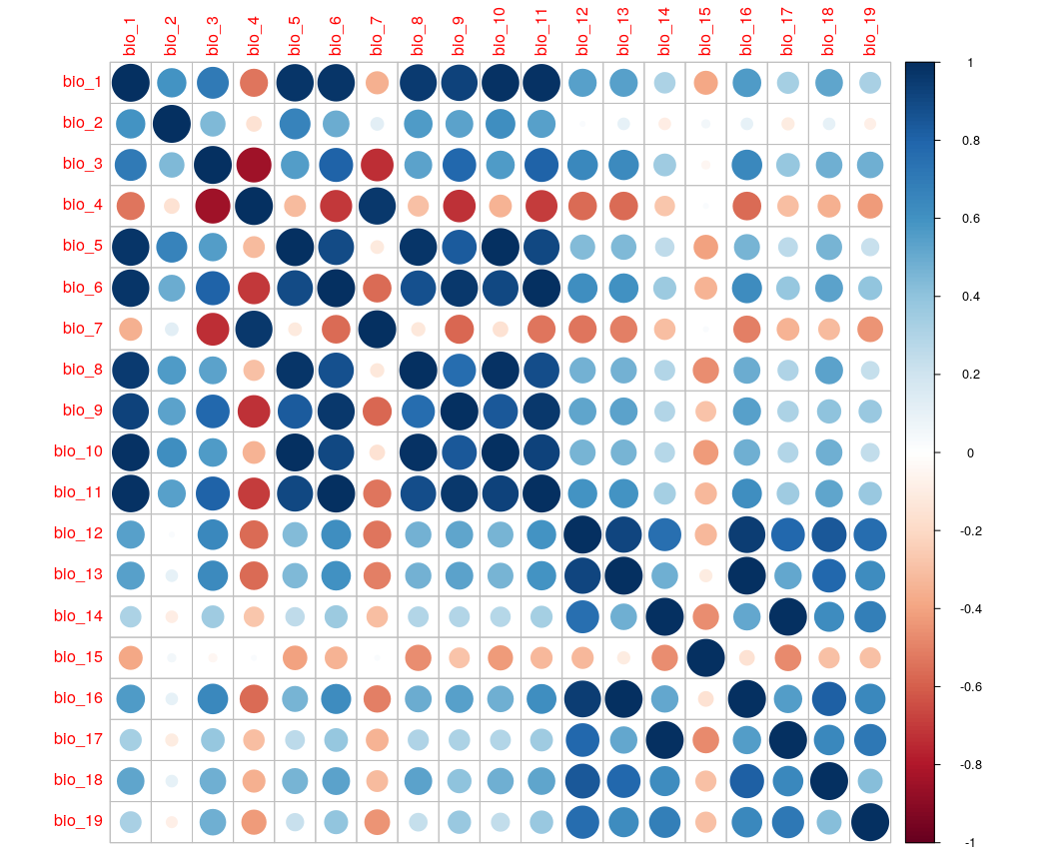Figure S3 Pearson correlation matrix used to evaluate the colinearity of the 19 global bioclimate variables and select the five representative macroclimate variables used for the distribution modelling. The size of symbols denotes the absolute correlation coefficient between each pair of variables and the colour the direction and magnitude of the correlation coefficient (red negative, blue positive).

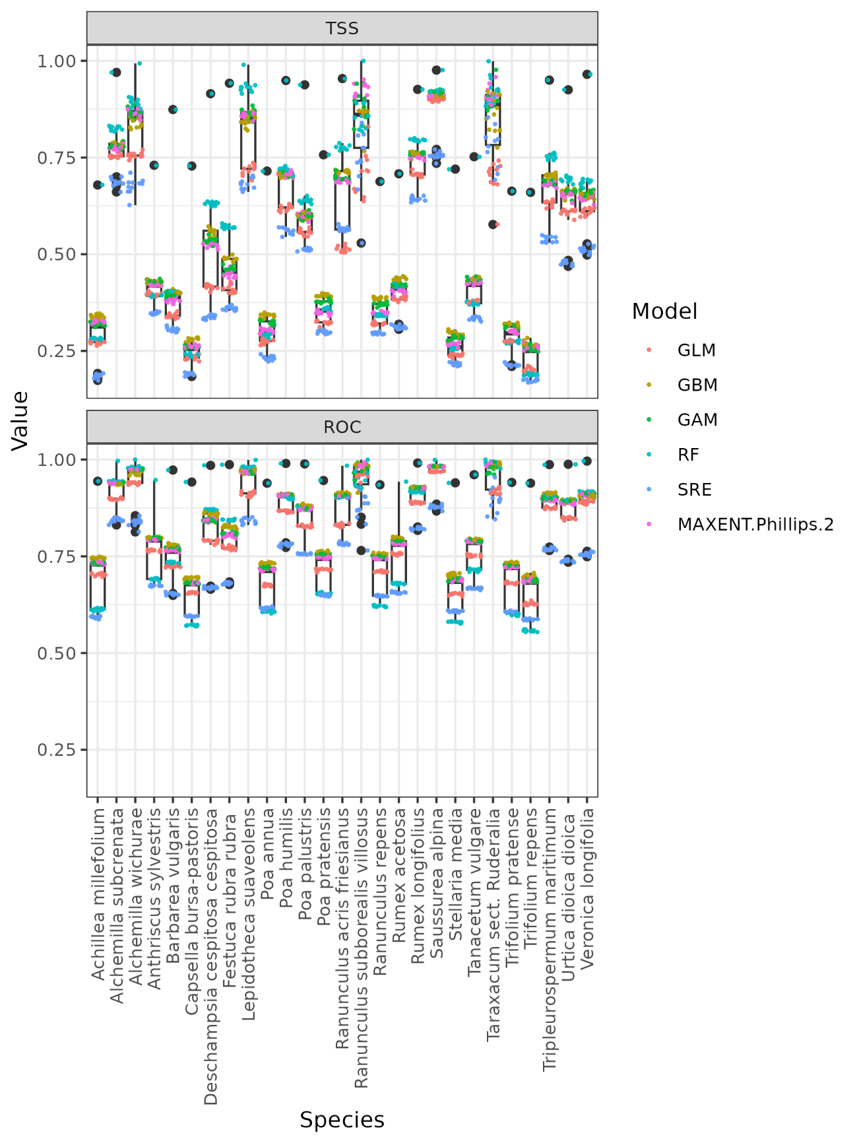
Figure S4 Evaluation statistics of the models predictive performance across all species. True skill statistic (TSS) and area under the receiver operator characteristic curve (AUC) are shown. Boxplots show statistics across all models. Points show the values per model method.

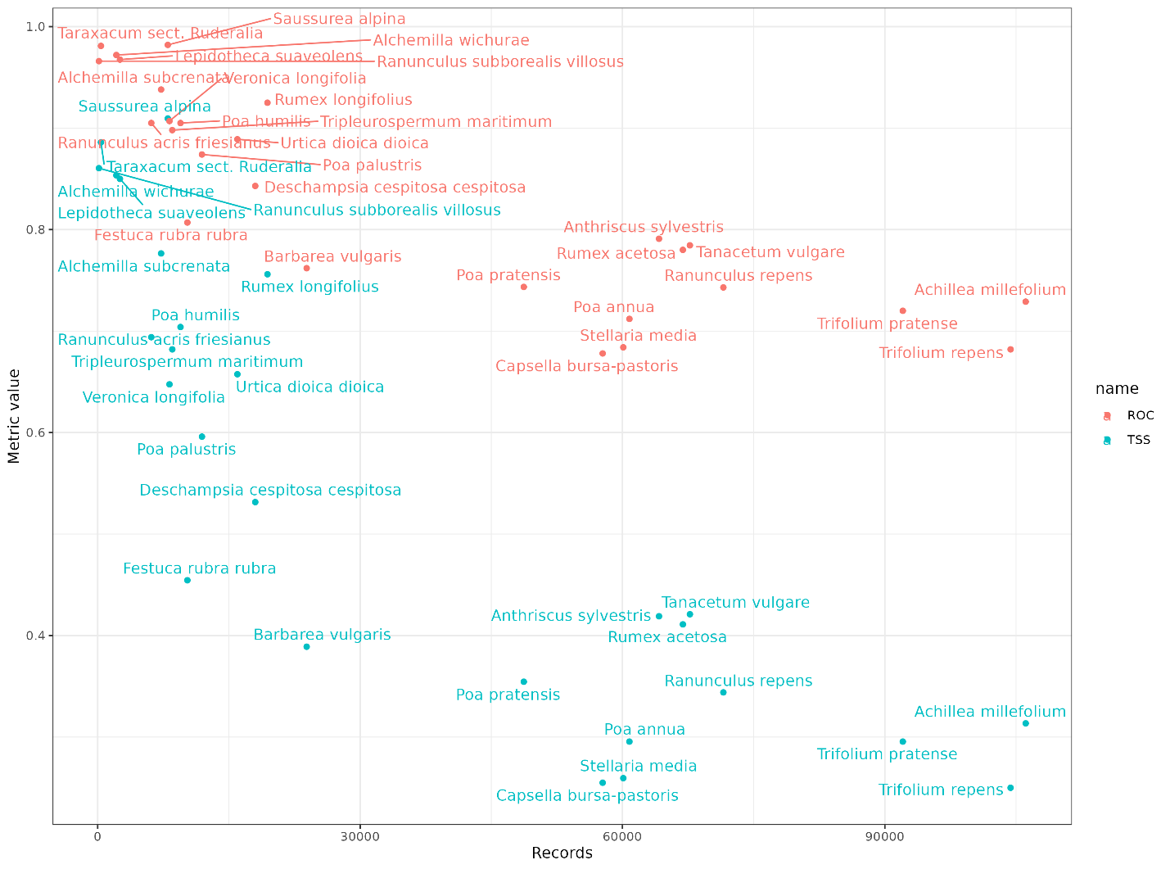
Figure S5. Evaluation statistics (TSS and ROC) of the models predictive performance plotted against the number of occurrence records per species. The median values per species across runs and modelling methods are shown.

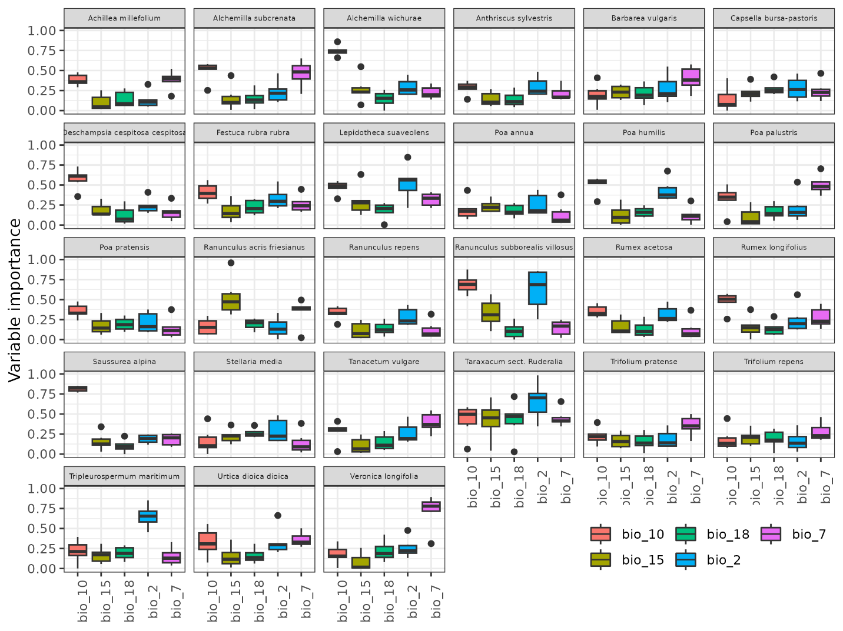
Figure S6 Variable importances of the macroenvironmental predictors estimated across modelling methods and replicates for each species and bioclimatic variable.

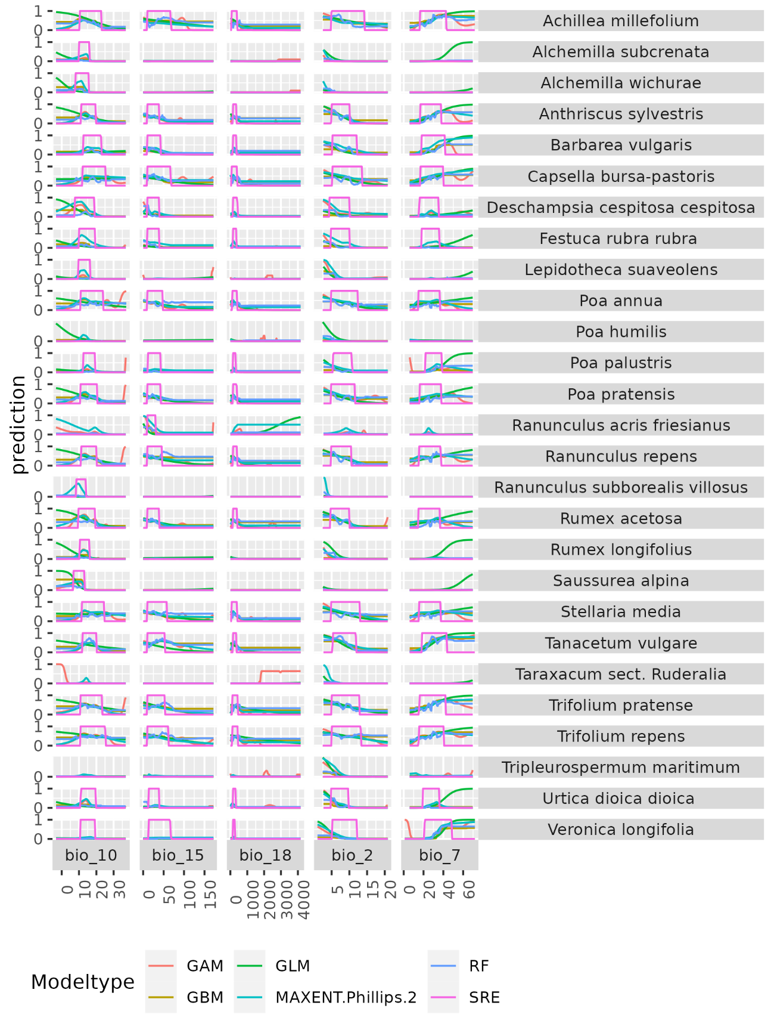
Figure S7 Response curves to the five macroenvironmental predictors per species and model algorithm.
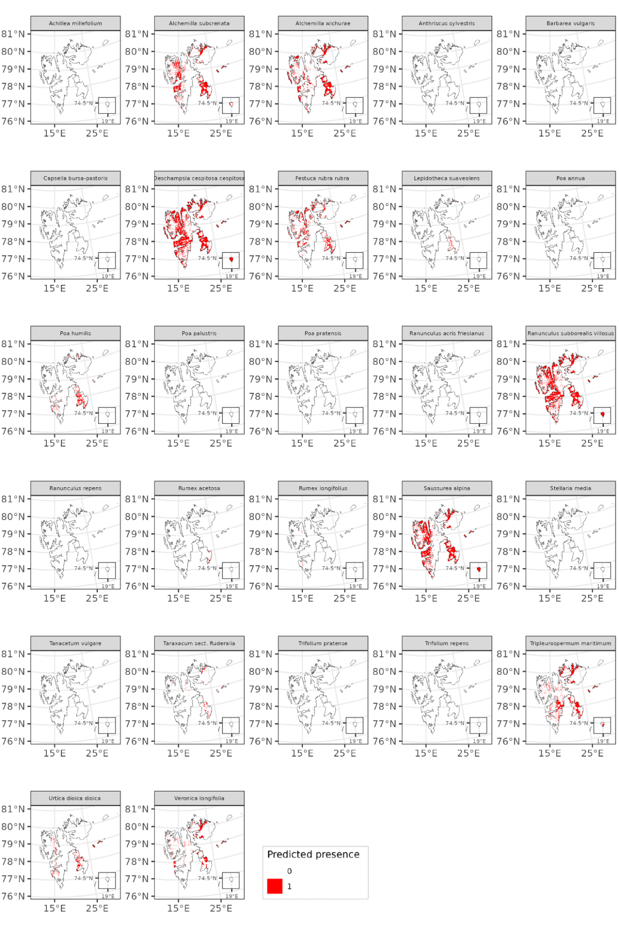
Figure S8: Thresholded binary species predictions of potential distribution under the current climate conditions.
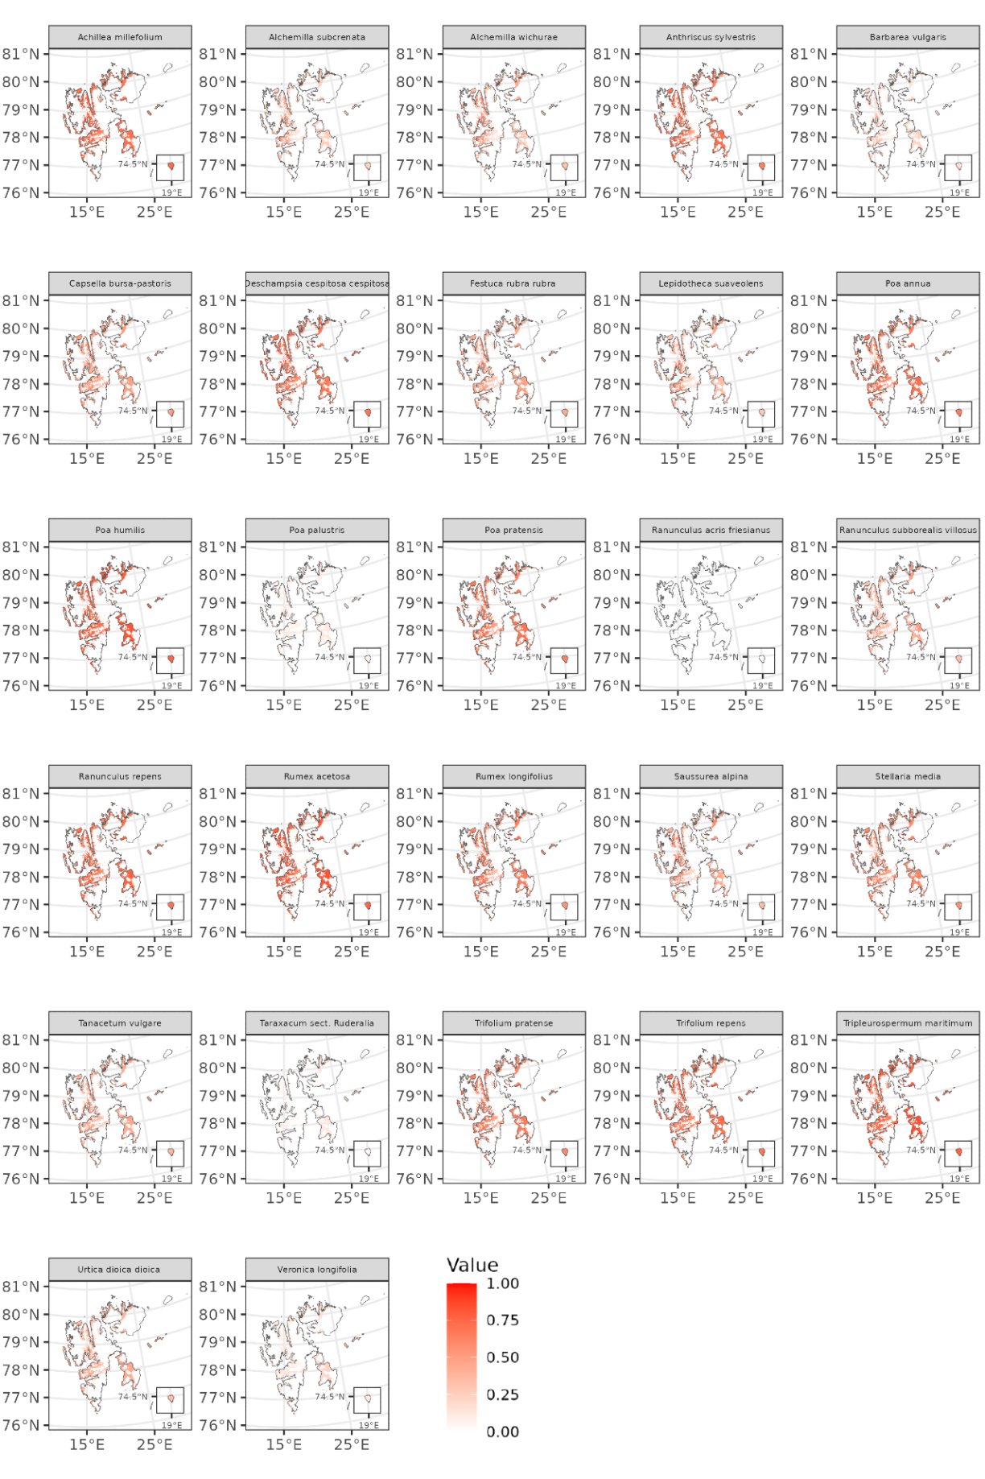
Figure S9 Model predictions for each species potential distribution under future climate (SSP2-45, 2061-2080).
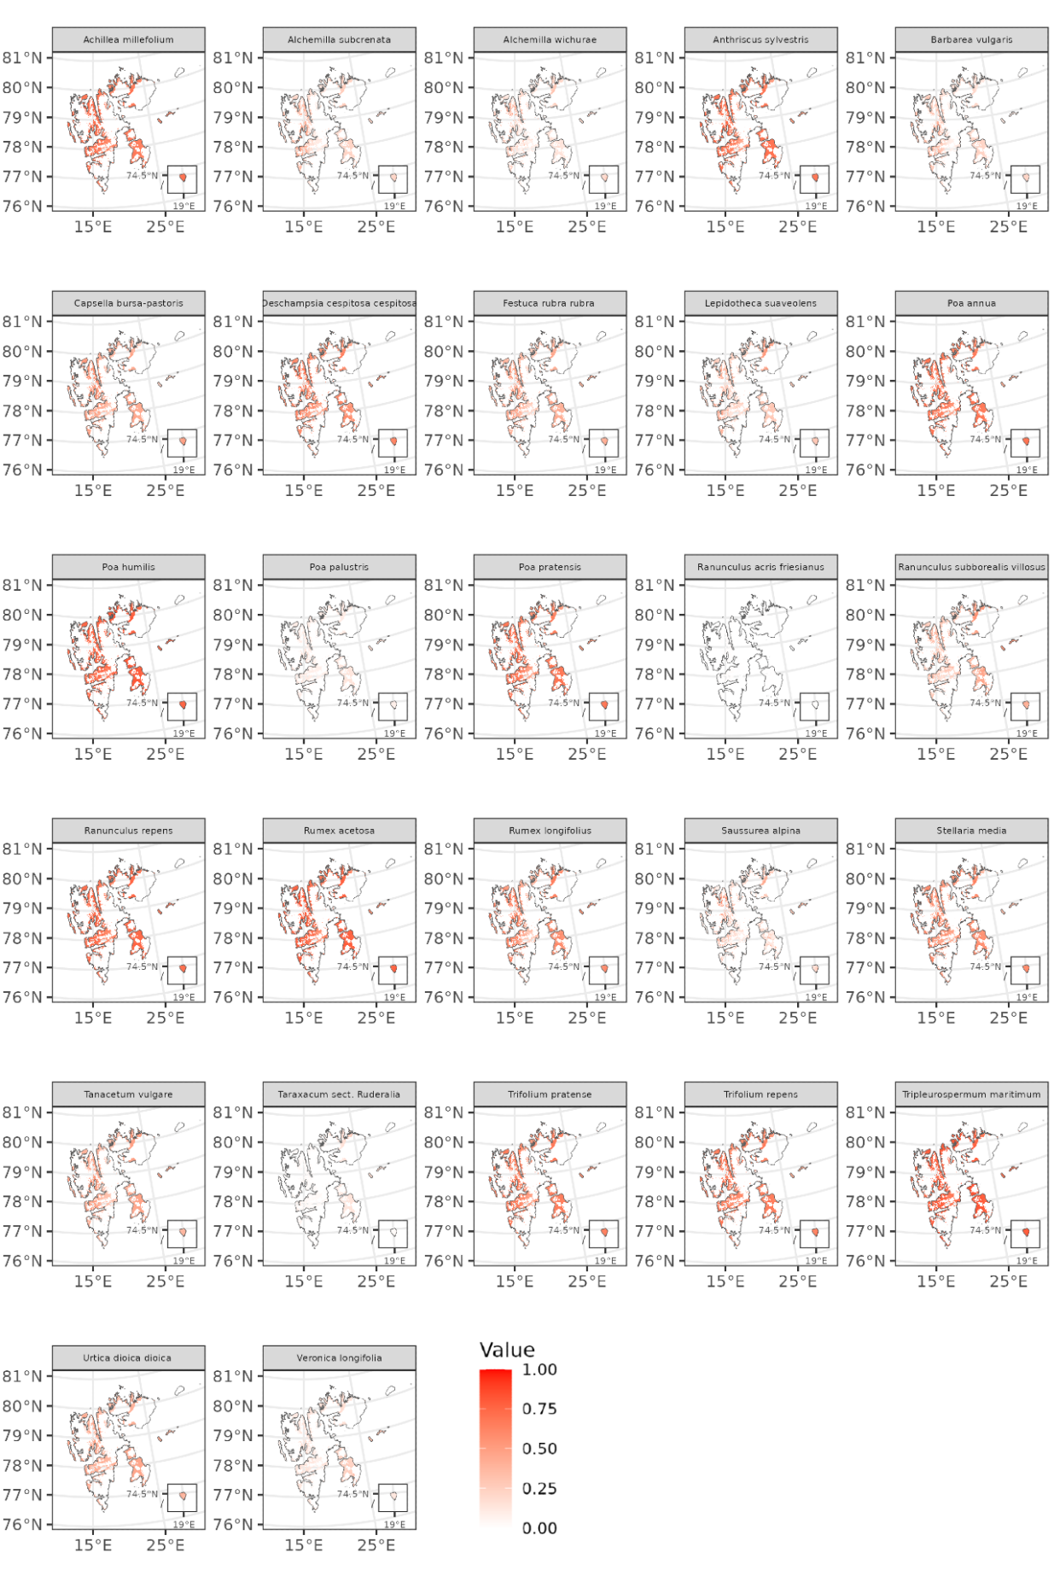
Figure S10 Model predictions for each species potential distribution under future climate (SSP5-85, 2061-2080).
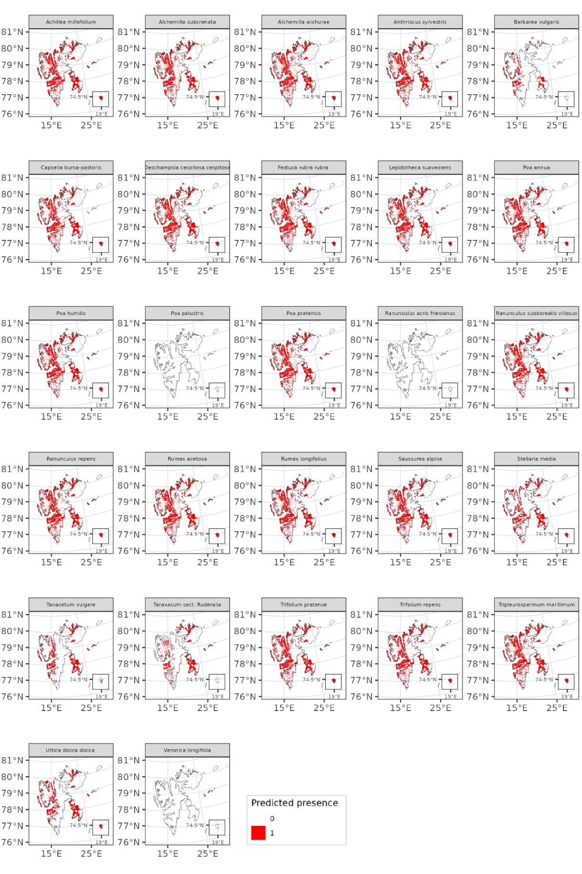
Figure S11 Thresholded model predictions for each species local potential distribution under future climate (SSP5-45, 2061-2080).
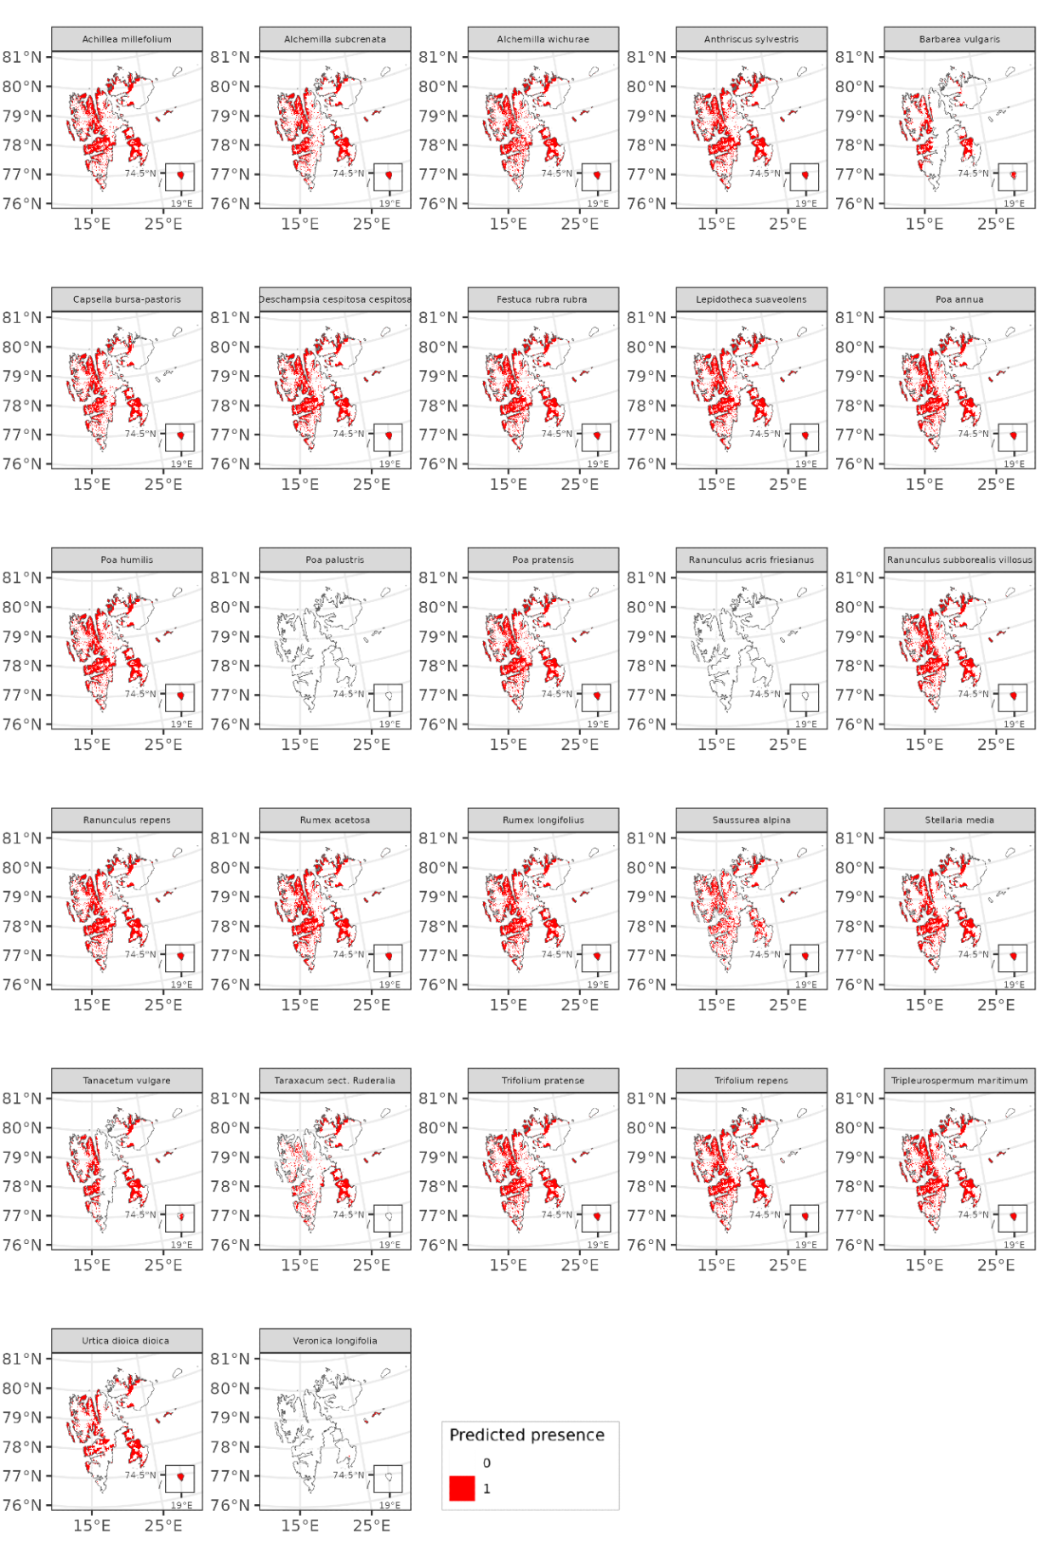
Figure S12 Thresholded model predictions for each species local potential distribution under future climate (SSP5-85, 2061-2080).
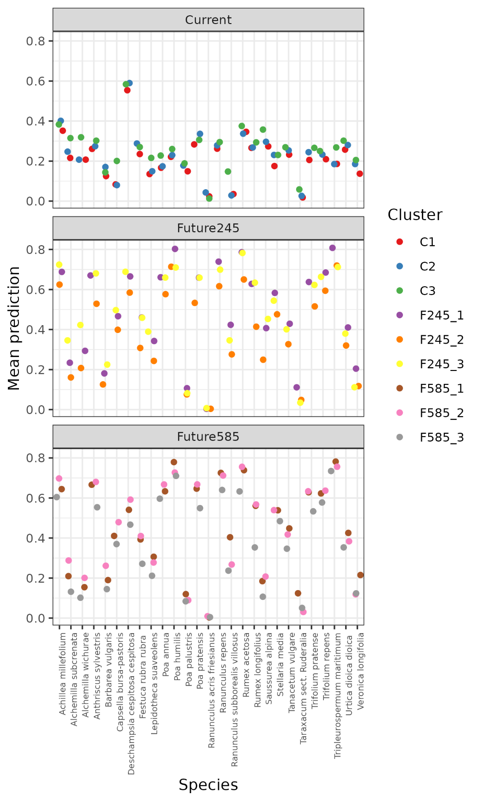
Figure S13 Species associations within the assemblage clusters under current and future scenarios (the clustering was independent within each time period so the cluster number is not comparable between scenarios). Mean weighted model predictions are shown for each species within each cluster cell. Points are jittered to facilitate visualization of overlaps.
Supplementary References
GBIF.org. (2023a). Occurrence Download (selected species) The Global Biodiversity Information Facility. https://doi.org/10.15468/DL.UWQRYF
GBIF.org. (2023b). Occurrence Download (Trachaeophyta) The Global Biodiversity Information Facility. https://doi.org/10.15468/DL.CEENQX
Norwegian Biodiversity Information Centre. (2022). Guidelines for the generic ecological impact assessment of alien species. Artsdatabanken, Norge, 4.4.
Sandvik, H., Hilmo, O., Finstad, A. G., Hegre, H., Moen, T. L., Rafoss, T., Skarpaas, O., Elven, R., Sandmark, H., & Gederaas, L. (2019). Generic ecological impact assessment of alien species (GEIAA): the third generation of assessments in Norway. Biological invasions, 21, 2803-2810.

