Supplementary information (SI)

Kisspeptin fiber and receptor distribution analysis suggests its potential role in central sensorial processing and behavioral state control

Running title: Kiss1r and KP fiber mapping in rodent brain

Limei Zhang^{1,2,*c}, Vito S. Hernández^{1,2,*c}, Mario A. Zetter^{1,5}, Oscar R. Hernández-Pérez¹, Rafael Hernández-González⁶, Ignacio Camacho-Arroyo⁷, Lee E. Eiden^{2,c}, Robert P. Millar^{1,3,4}

¹Dept. Physiology, School of Medicine, National Autonomous University of Mexico, Mexico City, Mexico
²Section on Molecular Neuroscience, NIMH-IRP, NIH, Bethesda, MD, USA
³Centre for Neuroendocrinology, University of Pretoria
⁴Dept. of Integrative Biomedical Sciences, Institute of Infectious Disease and Molecular Medicine, University of Cape Town, South Africa
⁵Department of Medicine and Health, University of La Salle, Mexico City, Mexico
⁶Vivarium, School of Medicine, National Autonomous University of Mexico, Mexico City, Mexico
⁷Research Unit in Human Reproduction, National Institute of Perinatology-Faculty of Chemistry, National Autonomous University of Mexico, Mexico City, Mexico
*These authors share first authorship.
^{c} Correspondence: limei@unam.mx, vitohdez@unam.mx, eidenl@mail.nih.gov

Supplementary Figures 1-3 and legends

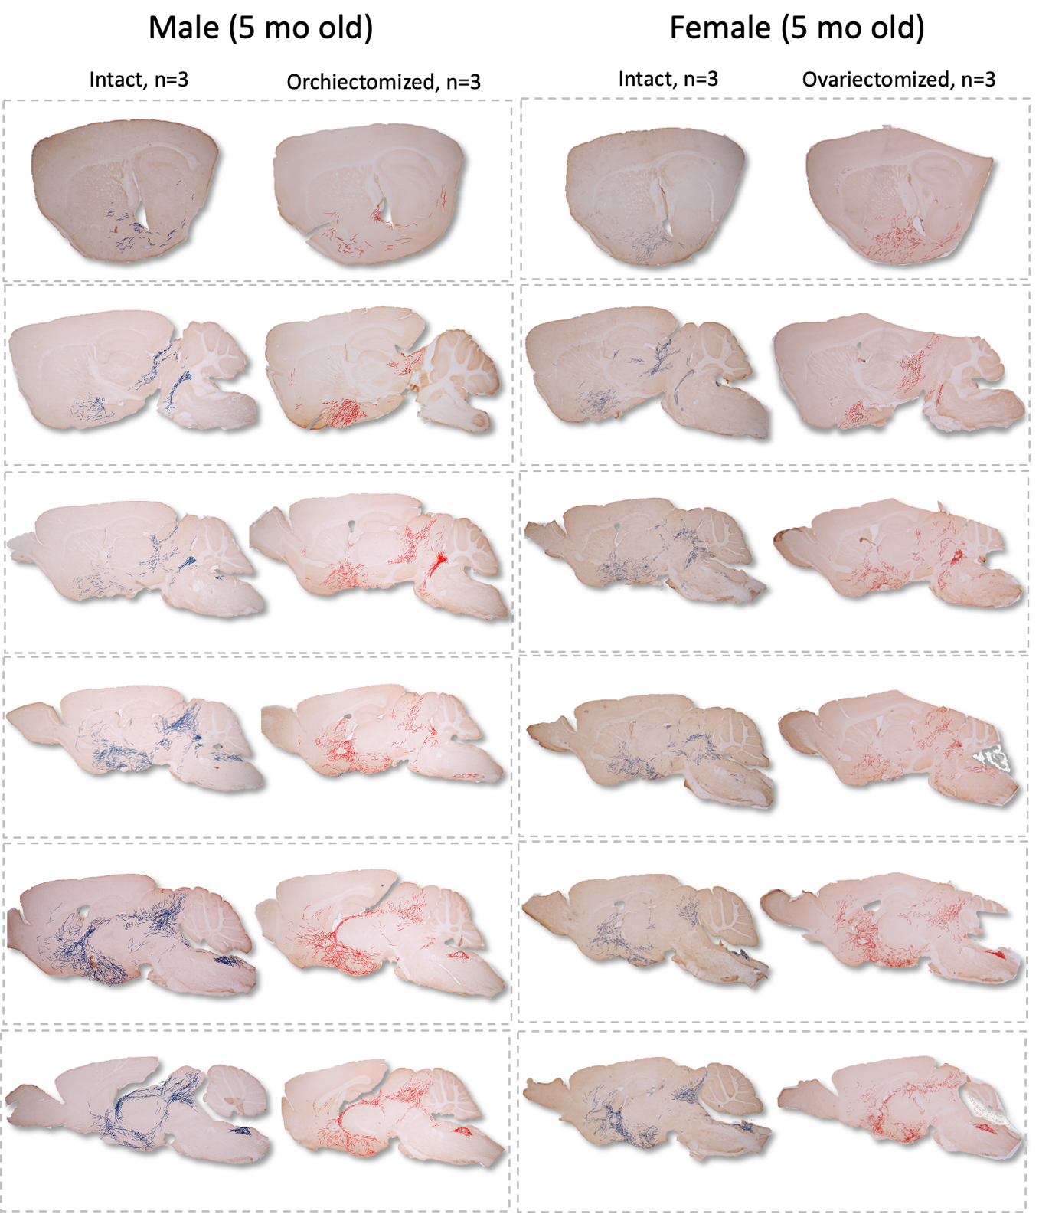
Supplementary Figure 1. The cumulative (summed) fiber density was charted for three young adult animals from each of the four experimental groups (male/female and intact/gonadectomized, N=12). These distributions are represented across six different parasagittal levels. Hand-drawn illustrations, created under microscope observation, highlight the fiber distributions abstracted from the three subjects within the same group. For visualization purposes, the thickness of the lines representing KP-ir fibers is exaggerated relative to the section area. Control groups are depicted in blue, while gonadectomized (GNX) groups are shown in red.

Supplementary Figure 2. Projection Targets of R3PV and Arcuate Kiss1-Cre Neurons Transfected with AAV. Data from two Kiss1-Cre mice injected in the arcuate nucleus (Arc; experiments 232311236 and 232310521) and two Kiss1-Cre mice injected in the rostral periventricular region (RP3V); experiments 299247009 and 301989585) with Cre-dependent tracers are displayed using the Allen Mouse Brain Connectivity Atlas. A. 3-D Representation of Innervation Patterns. Sagittal (A1), coronal (A2), and horizontal (A3) views of a 3-D reconstruction using the 3-D Brain Explorer illustrate the innervation patterns of the two major populations of Kiss1 neurons: The VGAT-expressing R3PV neuronal population and its projections are represented in red. The VGLUT2-expressing Arc population and its projections are represented in green. These views reveal a reciprocal dense innervation between the Arc and RP3V. Additionally, most regions in the striatum, septum, BNST, thalamus, hypothalamus, and amygdala receive overlapping innervation from both populations. The ponto-mesencephalic region is predominantly innervated by the RP3V. B. Coronal Sections at 17 Rostro-Caudal Bregma Coordinates. For each level, the left section from an R3PV-injected mouse was paired with a section from an Arc-injected mouse, selecting the animal with the best labeling for each level. Some regions of interest are labeled in the R3PV sections, while green-numbered arrows in the Arc sections indicate regions with differences in innervation patterns between R3PV and Arc injections: Arrow #1: Fibers were observed in the main stria terminalis and fimbria in RP3V-injected mice but not in Arc-injected mice. Arrow #2: Fibers were observed in the stria medullaris in R3PV-injected mice but not in Arc-injected mice. Arrow #3: The paraventricular hypothalamic nucleus (PVN) shows distinct innervation patterns: RP3V-labeled axons innervate both the magnocellular and parvocellular divisions. Arc-labeled axons preferentially innervate the parvocellular region. At this level (and Bregma -1.06), axons from both injection sites travel laterally to reach the central medial thalamic nucleus (CeM). Arrow #4: R3PV-injected mice show innervation of the medial part of the lateral habenula (LHbm), particularly the rostral region, with fibers traveling via the stria medullaris (see Arrow #2). No LHb fibers were observed in Arc-injected mice. Arrow #5: A plexus of labeled fibers is observed in the CA1 pyramidal layer of the ventral hippocampus in R3PV-injected mice, with fibers traveling through the stria terminalis (see Arrow #1). No fibers were found in this location in Arc-injected mice. Arrow #6: RP3V fibers innervate the mesencephalic region, including the periaqueductal gray (PAG), interfascicular nucleus (IF), ventral tegmental area (VTA), and median raphe (MnR). Arc-injected mice show sparse axons, primarily innervating the PAG.
Supplementary Figure 3.. KP fiber density and KP innervation pathways to regions involved in brain state control, as well as motor and sensorial processing. The maximum KP fiber density observed in males or females across all gonadal states is represented as relative fiber density, color-coded in two horizontal planes of the rat brain, Top panel: Modified from Simerly and Swanson, 1988 (JCN: 270, 209-242). Bottom panel: Modified from Paxinos & Watson, The Rat Brain, 2007 (interaural 5.26 mm). These planes highlight some of the most densely innervated regions related to brain state control, sensory processing, and motor integration. The bottom halves of the two panels illustrate the KP innervation pathways identified through: analysis of several consecutive immunoreacted slices in different planes together with data from four experiments published in the Allen Brain Atlas. The seven KP neuronal populations are symbolized with colored circles, based on Reference 1 of this paper.

