Supplementary Table 1: Tests of association between HIV-infected (treatment naïve versus virally-suppressed) tobacco users and non-users and HIV-uninfected controls
sCD40L
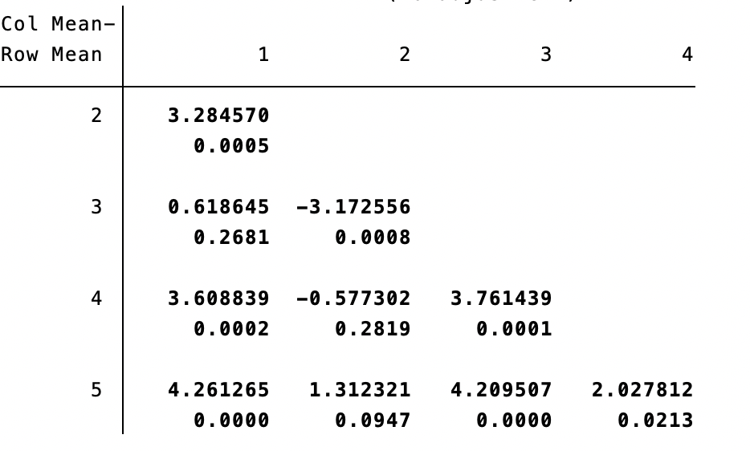
sCD62P
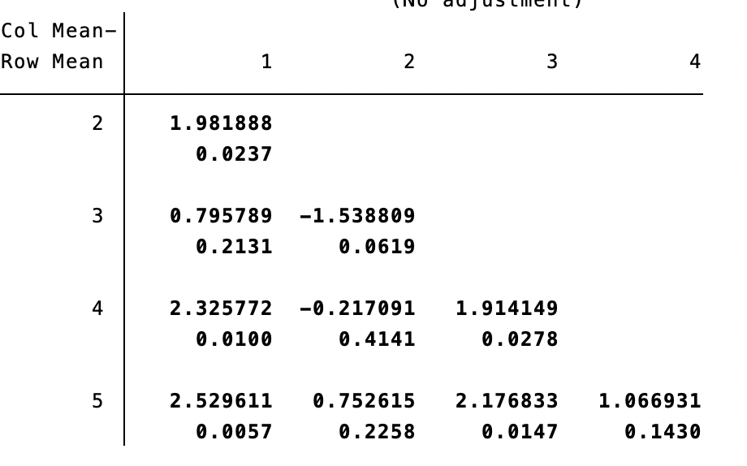
PDGF-BB
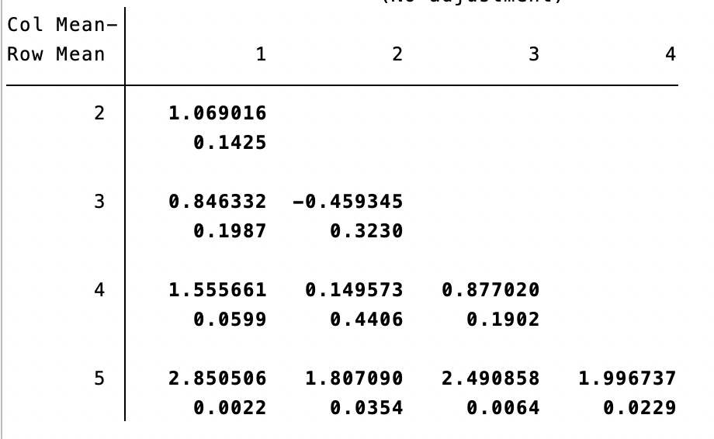
Groups: 1 = ART-naïve tobacco user (n=32); 2 = Virally suppressed tobacco user (n=23); 3 = ART-naïve non-tobacco user (n=68); 4 = Virally suppressed non-tobacco user (n=76); 5 = HIV-uninfected controls (n=15)

