Functional Ecology
Effects of past and current temperatures on the flight performance of invasive pest fruit flies (Diptera: Tephritidae): Climate change may facilitate movements by tropical species to higher latitudes
Kevin Malodª, Eleftheria-Maria D. Bali^{b}, Corentin Gledel^{c}, Emma Dieudonne^{c}, Laura Moquet^{c}, Anandi Biermanª, Evmorfia Bataka^{b}, Vassilis Rodovitis^{b}, Christopher W. Weldon^{d}, Minette Karstenª, Hélène Delatte^{c}, Nikos T. Papadopoulos^{b}, John S. Terblanche^{a*}

ªDepartment of Conservation Ecology and Entomology, Faculty of AgriSciences, Stellenbosch University, Stellenbosch, South Africa
^{b}Laboratory of Entomology and Agricultural Zoology, Department of Agriculture Crop Production and Rural Environment, University of Thessaly, Volos, Greece
^{c}CIRAD, UMR PVBMT, F-97410, Saint-Pierre, La Réunion, France
^{d}Department of Zoology and Entomology, University of Pretoria, Private Bag X20, Hatfield 0028, South Africa
*Corresponding author: E-mail: jst@sun.ac.za

Supplementary methods
FLY HUSBANDRY
Ceratitis capitata
Cultures of C. capitata were established from pupae collected from field infested fruits (oranges, mandarins and apples) from the area of Volos (Greece) and reared at the Laboratory of Entomology and Agricultural Zoology at the University of Thessaly under constant conditions (temperature: 25±2°C and RH: 55±5% 14L: 10D). The fruits were placed on sterile sand in plastic containers and sifted at regular intervals (at least once a week) to retrieve the pupae. Pupae (ca. 300) were then placed in wooden cages 30×30×30cm (custom made) and remained in the same conditions until adult emergence. Upon emergence, adults had ad libitum access to water and standard adult diet (sugar: yeast hydrolysate and water in ratio 4:1:5). Females were allowed to oviposit into artificial oviposition substrates (domes) that consisted of a red, plastic, hollow hemisphere 5 cm in diameter (Euro-matik kfc, Budapest, Hungary) with 40 to 50 evenly distributed holes (diameter 0.7 mm). Each dome was fitted into a 5 cm diameter hole cut on the lid of a 5.5 cm diameter plastic Petri dish. Water was placed into the Petri dish to maintain humidity levels in the dome. To stimulate oviposition, a plastic container with 0.5 ml of orange juice was placed in the base of the Petri dish. Eggs were collected from the inner surface of the dome, and larvae were reared on a standard artificial diet. Rearing of the experimental generations was conducted following the same methodology but after emergence, C. capitata adults were sexed and placed in Plexiglas cages 20×20×20 (Plastil, Thessaloniki, Greece) in groups of 10 (one per temperature group/sex) with ad libitum access to food (hydrolyzed yeast and sugar) and water. The same 14L: 10D light cycle was used in the incubators for acclimation treatment. Experimental flies were from the third laboratory generation.
Bactrocera dorsalis
Cultures of B. dorsalis were established from wild pupae provided by Citrus Research International (Nelspruit, South Africa) from which the females were mated with laboratory adapted males (less than 15 generations). Pupae (ca. 400) were placed in insect cages (32.5 × 32.5 × 32.5 cm, BugDorm43-030, MegaView Science, Taichung, Taiwan) with unrestricted access to food (hydrolysed yeast and sugar in separate dishes) and water (water-soaked cotton wool). The cultures were maintained at ~ 25° C in a climate room (University of Pretoria, Pretoria, South Africa) with a 14:10 light:dark photocycle. To create optimal mating conditions, the first and last hour of the light phase simulated dawn and dusk with 8 W fluorescent tubes (T4, Eurolux, Sandton, South Africa) that were placed obliquely to the fly culture and turned on before, and turned off after, the main room lights. The remaining room lights, comprising a combination of 20 W (G5, Eurolux, Sandton, South Africa) and 58 W (58W/840, Osram, Germany) fluorescent tubes were also turned on for the remainder of the light period. Each new generation was obtained by allowing females of 20-40 days of age to lay eggs on a 125 mL plastic container (Plastilon, South Africa) covered with a layer of laboratory film (Parafilm M, Bemis, USA) pierced several times with a pin. Tissue paper soaked with 3 mL of guava juice concentrate (Hall’s, Tiger Consumer Brands Limited, Bryanston, South Africa) and a slice of guava fruit were placed in the plastic container to encourage females to oviposit through the film. Eggs were then washed out of the artificial substrate with water and placed on 125 mL of a carrot-based larval rearing medium (Citrus Research International, Nelspruit, South Africa) in a plastic container at an approximate density of 2.5 eggs/mL of medium. The container of larval rearing medium was then placed in a 2 L plastic box with a layer of sand and a ventilated lid. After 15 days, during the pupal phase, the sand was sifted and pupae placed in a Petri-dish (ø 65 mm) and transferred into an insect cage (32.5 × 32.5 × 32.5 cm) with unrestricted access to food and water for emerging adults. Experimental flies were produced in the same manner, except that before one week of age (prior sexual maturity), females and males were separated and transferred to a 2 L transparent plastic cage (ca. 50 individuals per cage) with unrestricted access to food and water. The same 14L: 10D light cycle was used in the incubators for acclimation treatment. Experimental flies were produced 2 to 13 generations after crossing laboratory cultures with the wild flies provided by Citrus Research International.
Bactrocera zonata
Cultures of B. zonata were established from pupae retrieved from fruits (Terminalia catappa) in La Réunion. Laboratory rearing was conducted in insect cages (37.5 × 37.5 × 37.5 cm, BugDorm 4S4545, MegaView Science, Taichung, Taiwan) with unrestricted access to food (hydrolysed yeast and sugar) and water (water-soaked sponge). The cultures were maintained at ~ 25° C in a climate room (CIRAD, Saint-Pierre, La Réunion, France) with natural light supplemented with artificial white light from 6 a.m. to 5 p.m. Each new generation was obtained by allowing females of 10-40 days of age to lay eggs on an artificial oviposition device (perforated tennis ball) with a small piece of fruit inside to encourage females to oviposit. Eggs were washed out with 0.2 % Nipagin/sodium benzoate solution and were transferred in a carrot-based larval-rearing medium (Duyck and Quilici, 2002) in a plastic container. The container of larval rearing medium was then placed in a 3L plastic box with a layer of sand and a ventilated lid. After 15 days, during the pupal phase, the sand was sifted, and the retrieved pupae (ca. 1000 individuals per cage) were placed into a new insect cage with unrestricted access to food and water for emerging adults. Experimental flies come from generations 176 to 189 of the laboratory cultures. They were produced in the same manner, except that before one week of age (prior sexual maturity), females and males were separated and transferred in a 2 L transparent plastic cage (ca. 50 individuals per cage) with unrestricted access to food and water. The same 11L: 13D light cycle was used in the incubators for acclimation treatment.

TETHERED FLIGHT PROCEDURE
For C. capitata, the flight mill assays were conducted at the University of Thessaly in a room with average test temperatures of 20±2°C, 25±2°C or 30±2°C. To record flight performance, 8 flight mills were constructed in the laboratory according to Attisano et al. (2015). The flight mills were connected to an 8-channels flight mill data acquisition system and a free proprietary software (WinDaq/Lite, DATAQ Instruments, Ohio, USA) was used to record the data. We followed Attisano et al. (2015) and used Python (version 3.7.9), to extract the data. In preparation for the flight mill assays, the mass of 1.5 mL empty microcentrifuge tubes (ScientAct, Greece) was recorded using an analytical balance (accurate to 0.0001g, Precisa 40 SM-200A, SWISSQUALITY, Switzerland). Then the acclimated flies were individually placed in the microcentrifuge tube from the cages using an aspirator and the mass of the fly plus the tube was measured to determine the body mass of the fly. Flies were then briefly chilled (ca. 2 min) by placing the microcentrifuge tubes on fine ice shavings. Once chilled, the fly was placed on a paper towel, and a small drop of hot melted glue collected on the tip of a #1 entomological pin was immediately applied to the center of the thorax in a perpendicular and upright position. After receiving the pin, each fly placed on a Styro-foam board by sticking the pointed end of the pin into it. Flies were allowed to recover until the last fly (8 flies per session) was pinned. Starting with the first fly to be pinned, flies were attached to the flight apparatus by inserting the pin into the opening of the hypodermic tube of the arm of the flight mill and secured with a small piece of Patafix white glue pad (UHU, Greece) to ensure that the pin would not slip out of the tube. A small foil flag of the same weight as the fly was placed with a piece of Patafix on a pin inserted in the opposite arm of the flight mill to balance the mass and maximize disruption of the infrared beam in the sensor. One to two flies from each temperature group were flown per session, and two sessions a day were run.
For B. dorsalis, the flight mill assays were conducted in a climate room at the University of Pretoria, with average test temperatures of 19.4 ± 0.6 °C, 25.4 ± 0.4 °C or 28.6 ± 0.8 °C. To record flight performance, we used computerized flight mills connected to a 15-channels flight mill data acquisition (DAQ) system that was controlled from a laptop. The DAQ was built by the Vehicle Dynamics Group at the University of Pretoria using the design developed by the USDA-ARS Arid Land Agricultural Research Centre in Mariscopa, Arizona (Naranjo, 1990). In preparation for the flight mill assays, the mass of 1.5 mL empty microcentrifuge tubes (Plastpro Scientific, South Africa) was recorded using an analytical balance (accurate to 0.0001g, NewCLassic MF model #MS204S, Mettler-Toledo, Greifensee, Switzerland). The flies were then individually captured from the 2 L plastic cages using the microcentrifuge tube and the mass of the fly plus the tube was measured to determine the body mass of the fly. Flies were then briefly chilled (ca. 2 min) by placing the microcentrifuge tubes on fine ice shavings. Once chilled, the fly was placed on a paper towel, and a small drop of hot melted glue collected on the tip of a #1 entomological pin was immediately applied to the center of the thorax in a perpendicular and upright position. After receiving the pin, each fly was placed on a Styro-foam board by sticking the pointed end of the pin into it. Flies were allowed to recover until the last fly (9 flies per session) was pinned. Starting with the first fly to be pinned, flies were attached to the flight apparatus by inserting the pin into the opening of the hypodermic tube of the arm of the flight mill and secured with a small piece of pressure-sensitive non-permanent adhesive (Bostik, South Africa) to ensure that the pin would not slip out of the tube. A small piece of adhesive of the same size was placed on a pin inserted in the opposite arm of the flight mill to balance the mass. Three flies of the same sex from each temperature group were flown per session, and two sessions a day were run.
For B. zonata, the flight mill assays were conducted in a climate room at the CIRAD Réunion, with average test temperatures of 21.6 ± 0.5°C, 25.2 ± 1.3°C or 28.7 ± 0.9°C. We used an 8-channels flight mill connected to a data acquisition system controlled by a Rasberry Pi 3 B+ (Rasberry Pi, United Kingdom) to record flight performance. The flight mill was built by the CIRAD Réunion using the design developed by Attisano et al. (2015). Flies were individually weighed before each flight session. The flies were individually captured from the 2 L plastic cages, and a #1 entomological pin was glued to the center of the thorax in a perpendicular and upright position with a small drop of the hot melted glue. After receiving the pin, each fly was placed on a Styro-foam board by sticking the pointed end of the pin into it until the last fly was pinned. Flies were attached to the flight apparatus by inserting the pin into the opening of the hypodermic tube of the arm of the flight mill. Eight flies were flown per session, chosen randomly according to sex and temperature group. Each session started 2 minutes after the last fly was attached to the flight mill and recorded for precisely 2 hours.

STATISTICAL ANALYSES
Variables reduction and selection
The flight-related traits measured were: distance (distance in meters flown over 2 hours), average speed (the average speed in m/s for the 2 hours session), maximum speed (the highest speed recorded during the 2 hours session), flight events (the number of times for which flight was initiated for at least 4s before completely stopping) and total flight duration (the sum of the duration for each flight event). A principal components analysis (PCA) was performed on the flight-related traits of all species and sexes at the same time. The PCA was run by using the built-in prcomp function. To visualize the data we used the functions fviz_eig (screeplot for the variance of the dimensions) and fviz_biplot (biplot) from the factoextra package (Kassambara and Mundt, 2020), as well as the corrplot function (correlation matrix) from the package of the same name (Wei, 2024). We decided to retain the principal components (PC) that represent at least 75% of the variance. Principal components scores for the retained PCs were then extracted for each species, and used in subsequent analyses for flight-related traits.
Intraspecific comparisons of flight performance
Data for body mass and flight performance traits were analyzed using generalized mixed effects models with a Gaussian distribution when residuals of the models were normally distributed. When residuals of the model were not normally distributed, a cubic root transformation was used. The models were built using the glmmTMB function from the package of the same name (Brooks et al., 2017). Acclimation temperature, flight temperature and their interaction were entered as fixed effects, body mass as a covariate (not included in the model for body mass) and flight mill channel as a random effect. Based on the lowest Aikaike information criterion, if the random effect did not improve the fit of the model it was removed from the model. For models with random effects, reduction was performed by removing the interaction term if it was not significant, and models (full and reduced) were compared using the anova function to determine the best one based on the lowest AIC. For models without random effects, the step() function was used to perform a stepwise selection of the minimum adequate model. If a significant main effect or interaction was detected, post hoc pairwise comparison tests of the estimated marginal means were performed using the emmeans function from the package of the same name (Lenth, 2019). The pairwise comparisons from the emmeans function returns an estimate that is the difference between the estimated marginal means of the two compared groups and indicates the direction of the difference.

Supplementary results
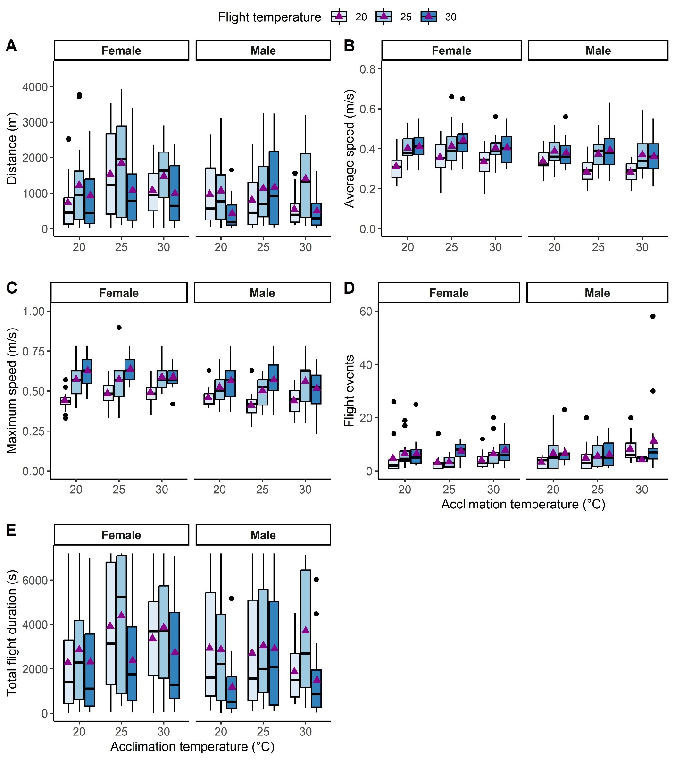
Figure S1. Flight performance traits of females and males C. capitata acclimated at either 20, 25 or 30°C and tested at either 20, 25 or 30°C. Total distance flown (a), average speed (b), maximum speed (c), number of flight events (d) and the total time spent flying (e). Each purple triangle represents the means from 15 to 17 individuals.
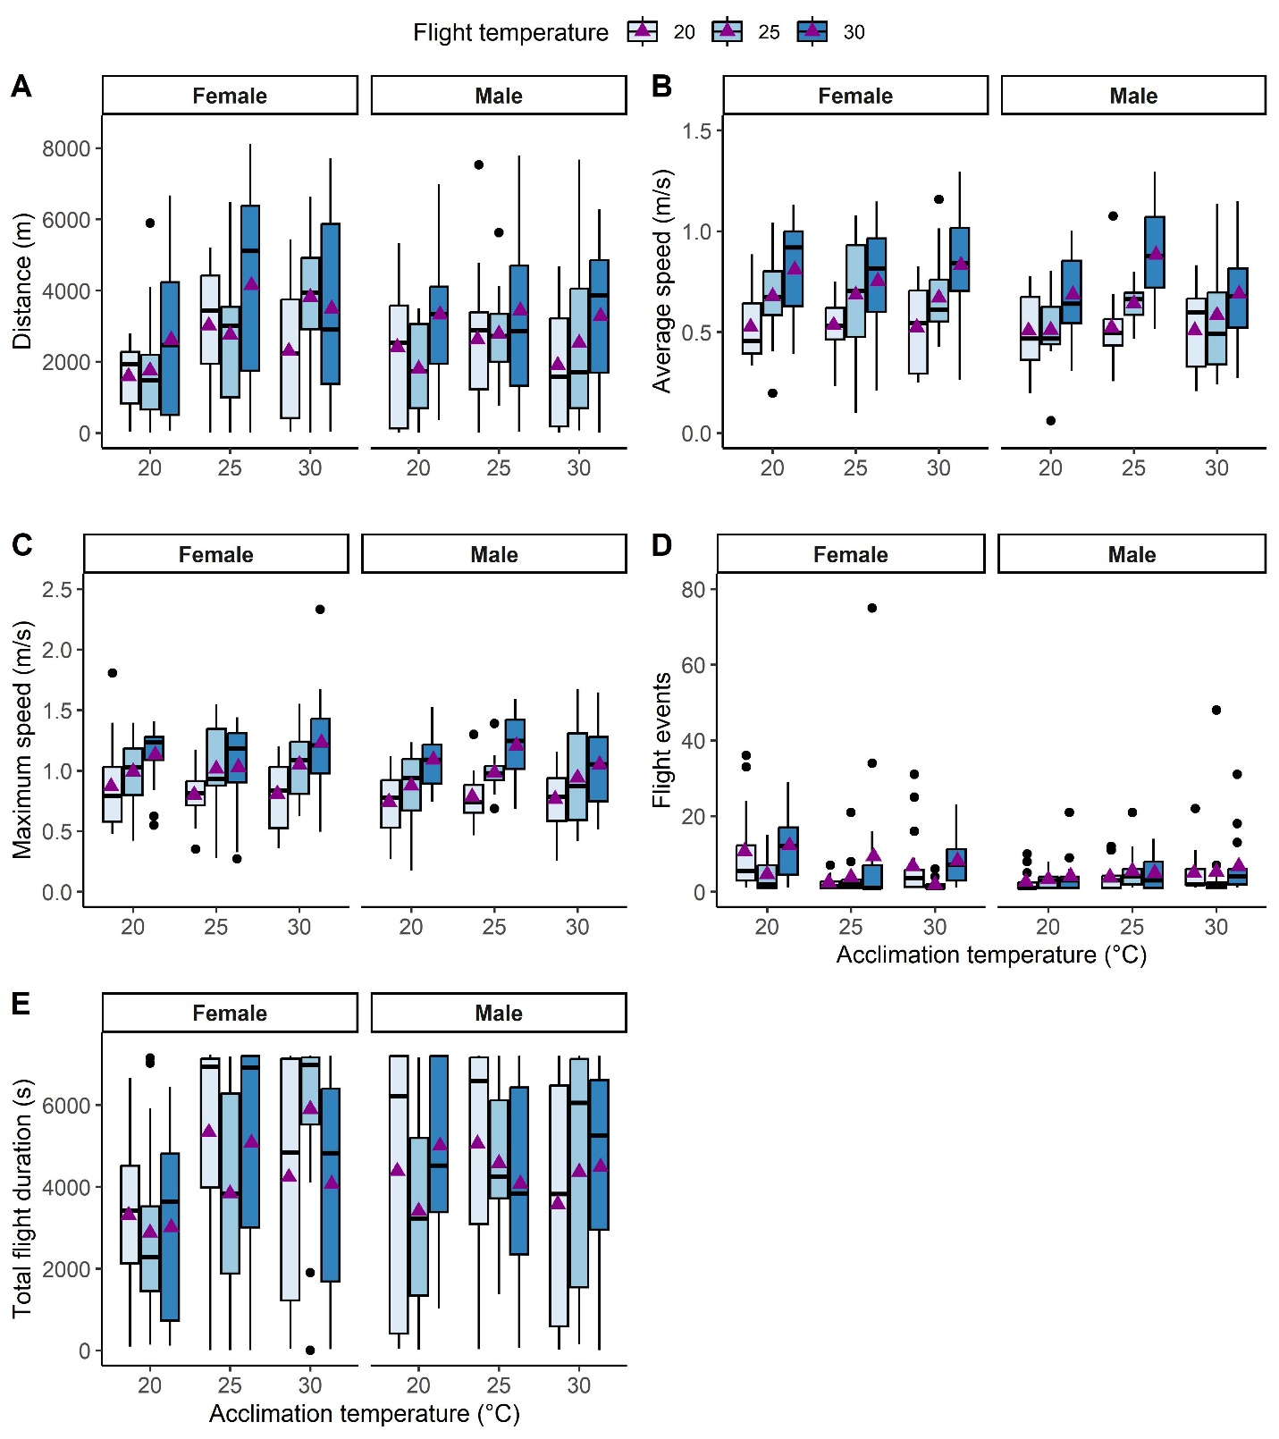
Figure S2. Flight performance traits of females and males B. dorsalis acclimated at either 20, 25 or 30°C and tested at either 20, 25 or 30°C. Total distance flown (a), average speed (b), maximum speed (c), number of flight events (d) and the total time spent flying (e). Each purple triangle represents the means from 12 to 18 individuals.
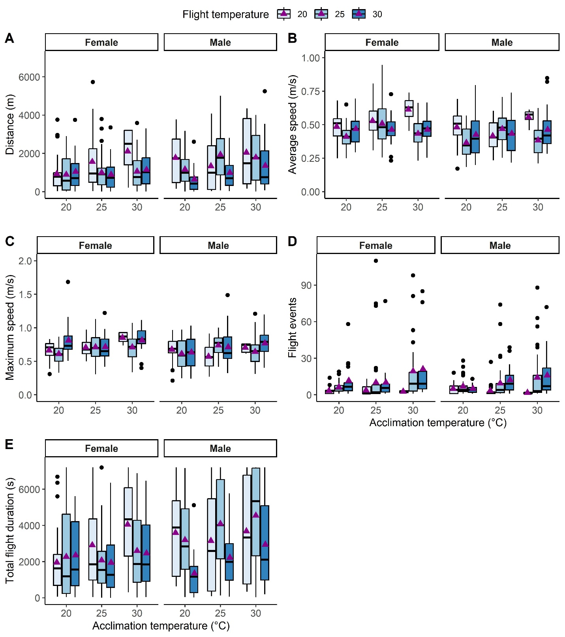
Figure S3. Flight performance traits of females and males B. zonata acclimated at either 20, 25 or 30°C and tested at either 20, 25 or 30°C. Total distance flown (a), average speed (b), maximum speed (c), number of flight events (d) and the total time spent flying (e). Each purple triangle represents the means from 4 (flies acclimated at 30°C and tested at 20°C) to 44 individuals.
Body mass
In C. capitata, body mass was significantly affected by acclimation, sex and their interaction (Table S1). Females acclimated at 20°C were lighter than females acclimated at 25°C (estimate = -0.08, p = 0.019) or 30°C (estimate = - 0.08, p = 0.006) and there was no difference between acclimation temperatures in males (Fig. S1). Overall, C. capitata males weighed less than females (coefficient = 0.22, p < 0.001). For B. dorsalis, only sex affected body mass (Table S1), with males weighing less than females (coefficient = -2.87, p < 0.001). In B. zonata, acclimation, sex, and their interaction affected body mass (Table S1). Females acclimated at 20°C were lighter than females acclimated at 25°C (estimate = -1.02, p = 0.012) or 30°C (estimate = - 2.16, p < 0.001), and females acclimated at 25°C were lighter than those acclimated at 30°C (estimate = -1.13, p = 0.071) (Fig. S1). There was no difference between acclimation temperatures in males, and overall males weighed less than females (coefficient = -3.28, p < 0.001).

Table S1. Intraspecific comparisons of body mass in Ceratitis capitata, Bactrocera dorsalis and Bactrocera zonata acclimated at either 20, 25 or 30ºC. Significant p values are indicated in bold and Robust Effect Size Indexes (RESI) are reported with 95% confidence intervals.
 |  | χ2 | df | p | RESI [CI]
C. capitata | Acclimation | 11.21 | 2 | 0.003 | 0.09 [0, 0.24]
C. capitata | Sex | 66.8 | 1 | < 0.001 | 1.03 [0.90, 1.20]
C. capitata | Acclimation × Sex | 6.41 | 2 | 0.041 | 0.12 [0, 0.26]
B. dorsalis | Acclimation | 2.35 | 2 | 0.308 | 0.12 [0, 0.27)
B. dorsalis | Sex | 23.55 | 1 | < 0.001 | 0.47 [0.35, 0.60]
B. dorsalis | Acclimation × Sex | 0.29 | 2 | 0.862 | 0 [0, 0.14]
B. zonata | Acclimation | 10.64 | 2 | 0.005 | 0.15 [0.05, 0.26]
B. zonata | Sex | 62.48 | 1 | < 0.001 | 0.76 [0.65, 0.89]
B. zonata | Acclimation × Sex | 7.43 | 2 | 0.024 | 0.12 [0, 0.23]

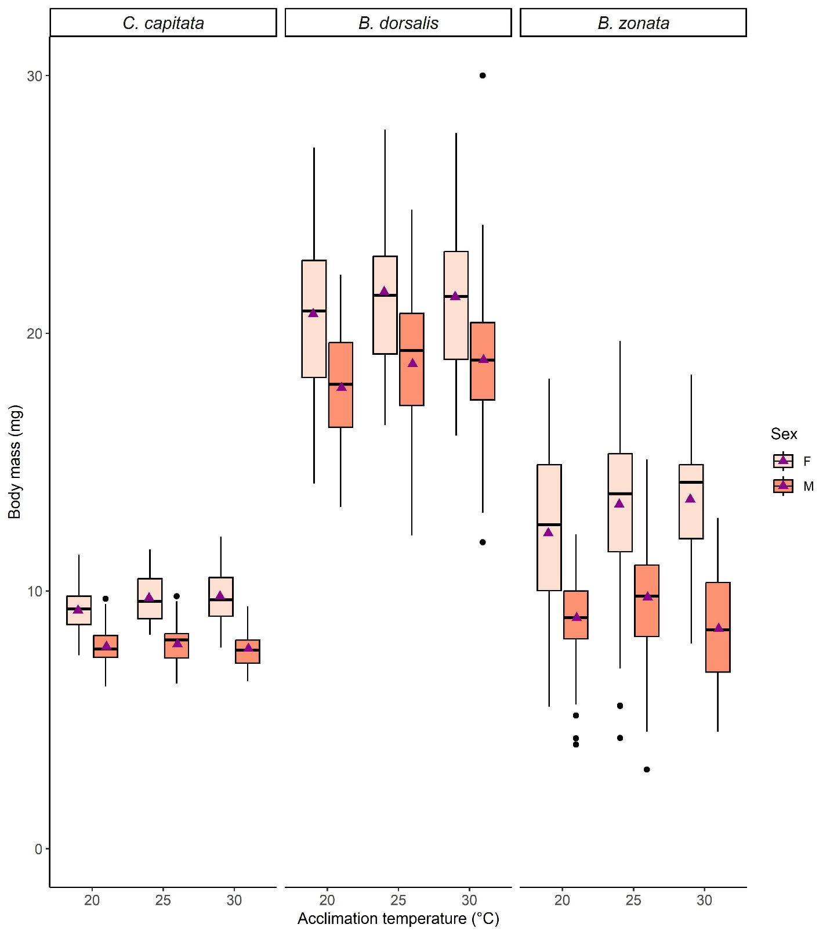
Figure S4. Body mass of females and males from three tephritid species acclimated at either 20, 25 or 30°C. Each purple triangle represents the means from 45 to 92 individuals.

Table S2. Interspecific comparisons of body mass in Ceratitis capitata, Bactrocera dorsalis and Bactrocera zonata acclimated at either 20, 25 or 30ºC. Significant p values are indicated in bold and Robust Effect Size Indexes (RESI) are reported with 95% confidence intervals.

 | χ2 | df | p | RESI [CI]
Body Mass
Species | 1957.53 | 2 | < 0.001 | 2.01 [1.86, 2.21]
Acclimation | 15.97 | 2 | < 0.001 | 0.13 [0.07, 0.19]
Sex | 17.02 | 1 | < 0.001 | 0.72 [0.65, 0.80]
Species × Sex | 37.27 | 2 | < 0.001 | 0.25 [0.19, 0.32]
Acclimation × Sex | 4.24 | 2 | 0.119 | 0.05 [0, 0.13]

Body mass differed between species, acclimation treatments and sexes, and was affected by an interaction between species and sex (Table S2). In all species males were lighter than females (coefficient = -1.42, p < 0.001). However, sexual dimorphism was more important in B. zonata, although C. capitata males were lighter than B. zonata ones (estimate = -1.23, p < 0.001), the difference between species was stronger in females C. capitata compared to females B. zonata (estimate = -3.46, p < 0.001). Overall, B. dorsalis was the heaviest species as C. capitata was lighter (estimate = -11.19, p < 0.001) and B. dorsalis heavier than B. zonata (estimate = 8.84, p < 0.001) (Fig. S1). Regardless of the species, flies acclimated at 20°C were overall lighter than those acclimated at 25°C (estimate = -0.71, p < 0.001) or 30°C (estimate = -0.51, p = 0.016).

References
Attisano, A., Murphy, J. T., Vickers, A. & Moore, P. J. 2015. A simple flight mill for the study of tethered flight in insects. JoVE, e53377.
Brooks, M. E., Kristensen, K., Van Benthem, K. J., Magnusson, A., Berg, C. W., Nielsen, A., Skaug, H. J., Mächler, M. & Bolker, B. M. 2017. glmmTMB Balances Speed and Flexibility Among Packages for Zero-inflated Generalized Linear Mixed Modeling The R Journal, 9:2, 378-400.
Duyck, P. F. & Quilici, S. 2002. Survival and development of different life stages of three Ceratitis spp. (Diptera: Tephritidae) reared at five constant temperatures. Bulletin of Entomological Research, 92, 461-469.
Kassambara, A. & Mundt, F. 2020. Extract and Visualize the Results of Multivariate Data Analyses.
Lenth, R. 2019. emmeans: Estimated Marginal Means, aka Least-Squares Means. R package version 1.3.3.
Naranjo, S. E. 1990. Comparative flight behavior of Diabrotica virgifera virgifera and Diabrotica barberi in the laboratory. Entomologia Experimentalis et Applicata, 55, 79-90.
Wei, T. 2024. Visualization of a Correlation Matrix.

