Supplementary data, Ijaz et al.

Human ----MMSASRLAGTLIPAMAFLSCVRPESWEPCVEVVPNITYQCMELNFYKIPDNLPFST
Mouse -----MMPPWLLARTLIMALFFSCLTPGSLNPCIEVVPNITYQCMDQKLSKVPDDIPSST
Chicken MPSRAAPTALTLGVLLQLLLVLSLLAGCIPSPCLEVIPSTAFRCTGQNISGVPAEIPNTT
.. . : .:* : .**:**:*. :::* :: :* ::* :*

Human KNLDLSFNPLRHLGSYSFFSFPELQVLDLSRCEIQTIEDGAYQSLSHLSTLILTGNPIQS
Mouse KNIDLSFNPLKILKSYSFSNFSELQWLDLSRCEIETIEDKAWHGLHHLSNLILTGNPIQS
Chicken LDLDLSFNSLKLLSSNYFSSVPELQFLDLSRCHIHTIEDNSFVDLYNLSTLILTANSLQH
::*****.*: * * * ...*** ******.*.**** :: .* :**.****.*.:*

Human LALGAFSGLSSLQKLVAVETNLASLENFPIGHLKTLKELNVAHNLIQSFKLPEYFSNLTN
Mouse FSPGSFSGLTSLENLVAVETKLASLESFPIGQLITLKKLNVAHNFIHSCKLPAYFSNLTN
Chicken LGLAAFHGLTSLKKLVLVETSISSLSDLPIGHLNTLQELNLGHNNIASLKLPKYFANLTS
:. .:* **:**::** ***.::**..:***:* **::**:.** * * *** **:***.

Human LEHLDLSSNKIQSIYCTDLRVLHQMPLLNLSLDLSLNPMNFIQPGAFKEIRLHKLTLRNN
Mouse LVHVDLSYNYIQTITVNDLQFLRENPQVNLSLDMSLNPIDFIQDQAFQGIKLHELTLRGN
Chicken LRHLSFSSNNITYISKGDLDALRETNRLNLTLVLSLNNIKYIQSGSFAKIHLGELILRSS
* *:.:* * * * ** *:: :**:* :*** :.:** :* *:* :* **..

Human FDSLNVMKTCIQGLAGLEVHRLVLGEFRNEGNLEKFDKSALEGLCNLTIEEFRLAYLDYY
Mouse FNSSNIMKTCLQNLAGLHVHRLILGEFKDERNLEIFEPSIMEGLCDVTIDEFRLTYTNDF
Chicken FENLNAMHSSLQGLAGLQVNRLIVGEFTNILKITAFQNGLLSGLCQVQMQEFVLMCFREF
*:. * *::.:*.****.*:**::*** : :: *: . :.***:: ::** * :

Human LDDIIDLFNCLTNVSSFSLVSVTIERVKDFSYNFGWQHLELVNCKFGQFPTLKLKSLKRL
Mouse SDDIVKFH-CLANVSAMSLAGVSIKYLEDVPKHFKWQSLSIIRCQLKQFPTLDLPFLKSL
Chicken ENDTDTLFDCIGNVTTIRLVDLNLETLSEVPMFSQVKHLEWKRCKFQELPAEKLSLFKEL
:* :. *: **::: *..:.:: :.:.. : *. .*:: ::*: .* :* *

Human TFTSNK-----GGNAFSEVDLPSLEFLDLSRNGLSFKGCCSQSDFGTTSLKYLDLSFNGV
Mouse TLTMNK-----GSISFKKVALPSLSYLDLSRNALSFSGCCSYSDLGTNSLRHLDLSFNGA
Chicken RVLRITKSKDLNGFEQKFGSLTHLEVVDLSENRLSFLTCCSPKFPRSPNLKHLNLSFNSD
. . .. . *. *. :***.* *** *** . : .*::*:****.

Human ITMSSNFLGLEQLEHLDFQHSNLKQMSEFSVFLSLRNLIYLDISHTHTRVAFNGIFNGLS
Mouse IIMSANFMGLEELQHLDFQHSTLKRVTEFSAFLSLEKLLYLDISYTNTKIDFDGIFLGLT
Chicken ISLTGEFANLRNLLYLDLQHTKLIHHGTYPVFLLLQKLIYLDISYTKTHVMSHLIFHGLN
* ::.:* .*.:* :**:**:.* : :..** *.:*:*****:*:*:: . ** **.

Human SLEVLKMAGNSFQENFLPDIFTELRNLTFLDLSQCQLEQLSPTAFNSLSSLQVLNMSHNN
Mouse SLNTLKMAGNSFKDNTLSNVFANTTNLTFLDLSKCQLEQISWGVFDTLHRLQLLNMSHNN
Chicken SLQVLKMAGNSFENNTLTNNFENVRRLRILDISSCKLVWVDQSTFNALSELKELIISNNK
**:.********::* *.: * : .* :**:*.*:* :. .*::* *: * :*:*:

Human FFSLDTFPYKCLNSLQVLDYSLNHIMTSKKQELQHFPSSLAFLNLTQNDFACTCEHQSFL
Mouse LLFLDSSHYNQLYSLSTLDCSFNRIETSKG-ILQHFPKSLAFFNLTNNSVACICEHQKFL
Chicken LLTFDPVTYKPLQALTALDFSNNQMSFLSDSALEILPDSLVLLDISHNLFECSCTHLNFL
:: :*. *: * :* .** * *:: . *: :*.**.::::::* . * * * .**

Human QWIKDQRQLLVEVERMECATPSDKQGMPVLSLN-ITCQMNKTIIGVSVLSVLVVSVVAVL
Mouse QWVKEQKQFLVNVEQMTCATPVEMNTSLVLDFNNSTCYMYKTIISVSVVSVIVVSTVAFL
Chicken KWVKEKQDLLRNKHSMICHTPAYMKNMSLSNFDMSSCHPNPTTVACSVTVLLAAGVFLFL
:*:*:::::* : . * * ** : : .:: :* * :. ** ::..... .*

Human VYKFYFHL----MLLAGCIKYGRGENIYDAFVIYSSQDEDWVRNELVKNLEEGVPPFQLC
Mouse IYHFYFHL----ILIAGCKKYSRGESIYDAFVIYSSQNEDWVRNELVKNLEEGVPRFHLC
Chicken IYKYYFQLYYSLVLLSGCKHSAERGDIYDAFVIHSSKDQEWVMKELVEPLEEGKPPFQLC
:*::**:* :*::** : .. .*******:**::::** :***: **** * *:**

Human LHYRDFIPGVAIAANIIHEGFHKSRKVIVVVSQHFIQSRWCIFEYEIAQTWQFLSSRAGI
Mouse LHYRDFIPGVAIAANIIQEGFHKSRKVIVVVSRHFIQSRWCIFEYEIAQTWQFLSSRSGI
Chicken LYFRDFLPGVPIVTNIIQEGFLSSRNVIAVISADFLESKWCSFEFDIARSWQLVEGKAGI
*::***:***.*.:***:*** .**:**.*:* .*::*:** **::**::**::..::**

Human IFIVLQKVEKTLLRQQVELYRLLSRNTYLEWEDSVLGRHIFWRRLRKALLDGKSWNPEGT
Mouse IFIVLEKVEKSLLRQQVELYRLLSRNTYLEWEDNPLGRHIFWRRLKNALLDGKASNPEQT
Chicken IMIILGEVDKTLLRQRLGLSRYLRRNTYLEWKNKEISRHIFWRQLTSVLLEGKKWNHEEI
*:*:* :*:*:****:: * * * *******::. :.******:* ..**:** * *

Human VGTGCNWQEATSI
Mouse AEEEQETATWT--
Chicken KLM----------

B
Domain | human vs chicken | human vs mouse | chicken vs mouse
TLR4 | 46% | 67% | 44%
ECD | 32% | 62% | 33%
ICD | 57% | 87% | 53%
TIR | 60% | 92% | 57%

Supplementary Fig. S1. A: Sequence alignment and Identity matrix of human, mouse, chicken TLR4 protein. Asterisk (*) shows fully conserved residues, colon (:) shows conservation between groups of strongly similar properties, dot (.) indicates conservation of groups of weakly similar properties. Cysteine residue 747 of the human TLR4 sequence, and its homologue residue in mouse and chicken TLR4, which is the binding target of TAK-242 is indicated in red/bolt. The extracellular domain of hTLR4 is highlighted in yellow, the transmembrane domain in green, the intracellular domain in light blue which contains the TIR domain (Grey). B: matrix indicating sequence homology of human, mouse and chicken TLR4 and its domains.

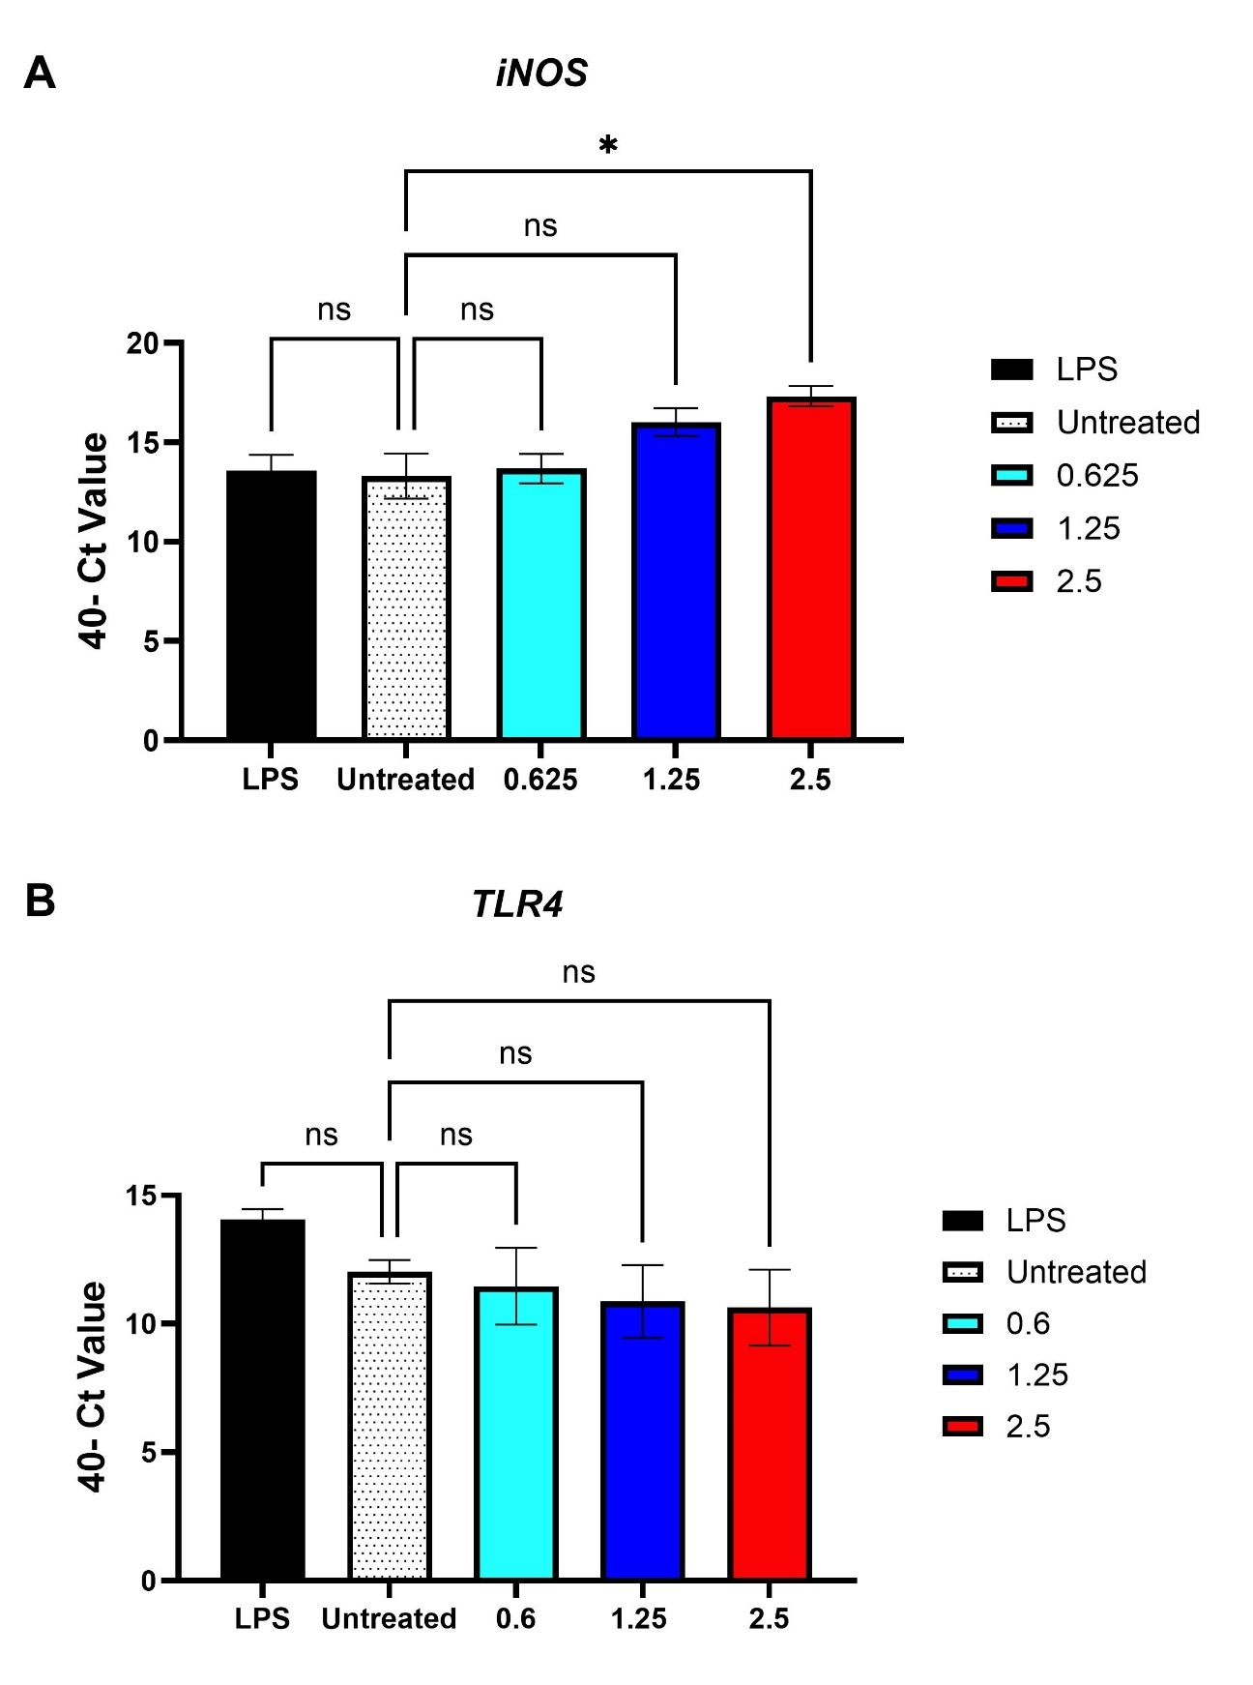
Supplementary Fig. S2.IMMP Induced gene expression of iNOS but not TLR4.
HD11 cells were incubated with 100 ng/mL LPS of IMMP (0-2.5 mg/mL) after which mRNA was extracted using Trizol. Gene expression of iNOS and TLR4 were determined using GAPDH as reference gene. (A) iNOS , (B) TLR4.Shown are average + St.Dev of 3 independent experiments performed in duplicate.

