What do you mean, 'megafire'?
Linley, Jolly, Doherty, Geary, Armenteras-Pascual, Belcher, Bliege Bird, Duane, Fletcher, Giorgis, Haslem, Jones, Kelly, Lee, Nolan, Parr, Pausas, Price, Regos, Ritchie, Ruffault, Williamson, Wu & Nimmo

SUPPORTING INFORMATION
Appendix S1: Literature search information

S1.1. Search expression used in structured review of the peer-reviewed scientific literature (English)

TS=(megafir* OR mega-fir* OR mega AND fire*)

Scopus and Web of Science (English) were searched on 20th January 2022. This search of Scopus and Web of Science produced 697 results.

Searches using Google Scholar and Google Scholar Alerts uncovered an additional seven references.

S1.2. Search expression used in structured review of the peer-reviewed scientific literature (Catalan, Galician, Italian, Portuguese, and Spanish)

TS=(megaincendi* OR mega-incendi* OR mega AND incendi*)
TS=(megafogo* OR mega-fogo* OR mega AND fogo*)

Scopus and Web of Science (Catalan, Galician, Italian, Portuguese, and Spanish) were searched on 28th January 2022. This search of Scopus and Web of Science produced seven results.

S1.3. Search expression used in structured review of the peer-reviewed scientific literature (French)

TS=(mégafeu*)

Scopus and Web of Science (French) were searched on 28th January 2022. This search of Scopus and Web of Science produced zero results.

S1.3 Search expression used in structured review of the peer-reviewed scientific literature (Chinese)

TS=(大火 AND 火) ('big fire' AND 'fire' in English)

Scopus and Web of Science (Chinese) were searched in January 2022, however, neither search engine supported searching with Chinese characters.

China National Knowledge Infrastructure (CNKI) was searched in January 2022, however, this search did not yield any Chinese research regarding fires described as the equivalent of the English term 'megafire'.

After duplicates were removed, we retained 556 results from these structured searches of CNKI, Scopus and Web of Science.

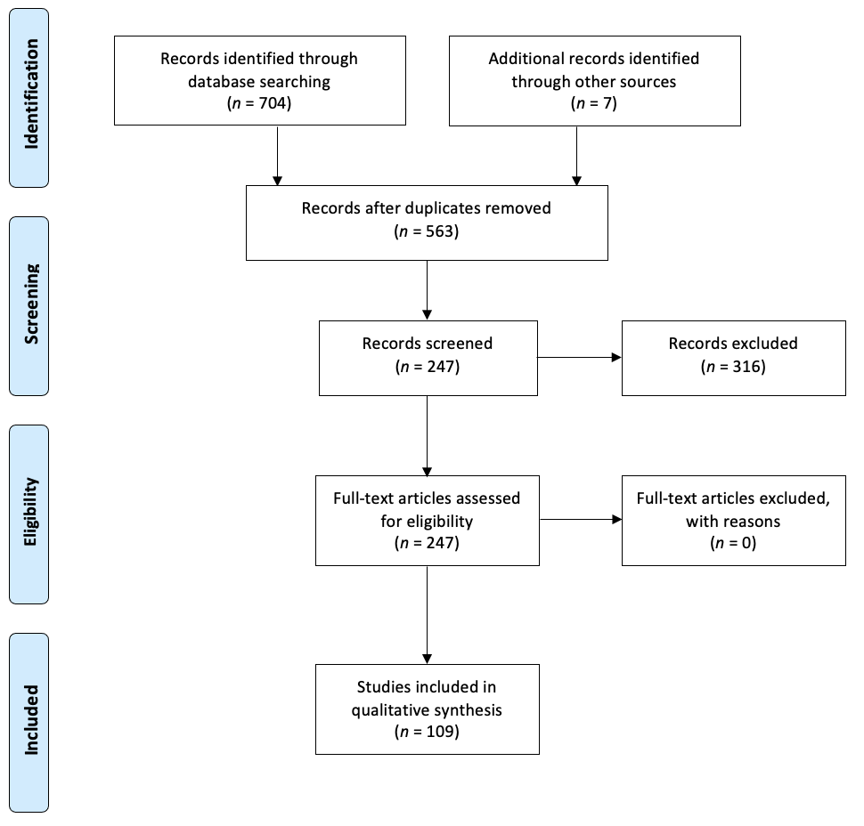
Appendix S2. PRISMA flow diagram for systematic review (Moher et al., 2009) showing the process of literature exclusion and the number of included studies.
Appendix S3. (a) Map of the smallest reported megafire from each study and their corresponding size and location as reported in the literature; and (b) number of instances of the smallest reported megafire events from each study, and their size and corresponding continent. Size ranges used were 0–10,000 ha, 10,001–100,000 ha, 100,001–1,000,000 ha, 1,000,001–10,000,000 ha and >10,000,000 ha.
Appendix S4. The number of instances of a reported megafire event, its reported size and the corresponding biome in which it burned, according to Olson et al., (2001). Size ranges used were 0–10,000 ha, 10,001–100,000 ha, 100,001–1,000,000 ha, 1,000,001–10,000,000 ha and >10,000,000 ha.
Appendix S5. The fire type of each reported megafire event uncovered during the literature search. Continent was assigned to the location of each fire. Megafires were categorised as; a single, discrete fire event from a specific ignition source (single ignition fires), 2) multiple fire events that were clustered in space and time and typically arose from a common ignition source, whilst having different ignition points (multiple ignition fires), or 3) multiple fire events that arose from separate ignition sources and were typically spatially or temporally discontinuous (separate ignition fires).
REFERENCES
Moher, D., Liberati, A., Tetzlaff, J., Altman, D.G. & PRISMA Group (2009) Preferred reporting items for systematic reviews and meta-analyses: the PRISMA statement. Annals of Internal Medicine, 151, 264–269.
Olson, D.M., Dinerstein, E., Wikramanayake, E.D., Burgess, N.D., Powell, G.V.N., Underwood, E.C., D’amico, J.A., Itoua, I., Strand, H.E., Morrison, J.C., Loucks, C.J., Allnutt, T.F., Ricketts, T.H., Kura, Y., Lamoreux, J.F., Wettengel, W.W., Hedao, P. & Kassem, K.R. (2001) Terrestrial ecoregions of the World: A new map of Life on Earth. BioScience, 51, 933.

