Supplementary files

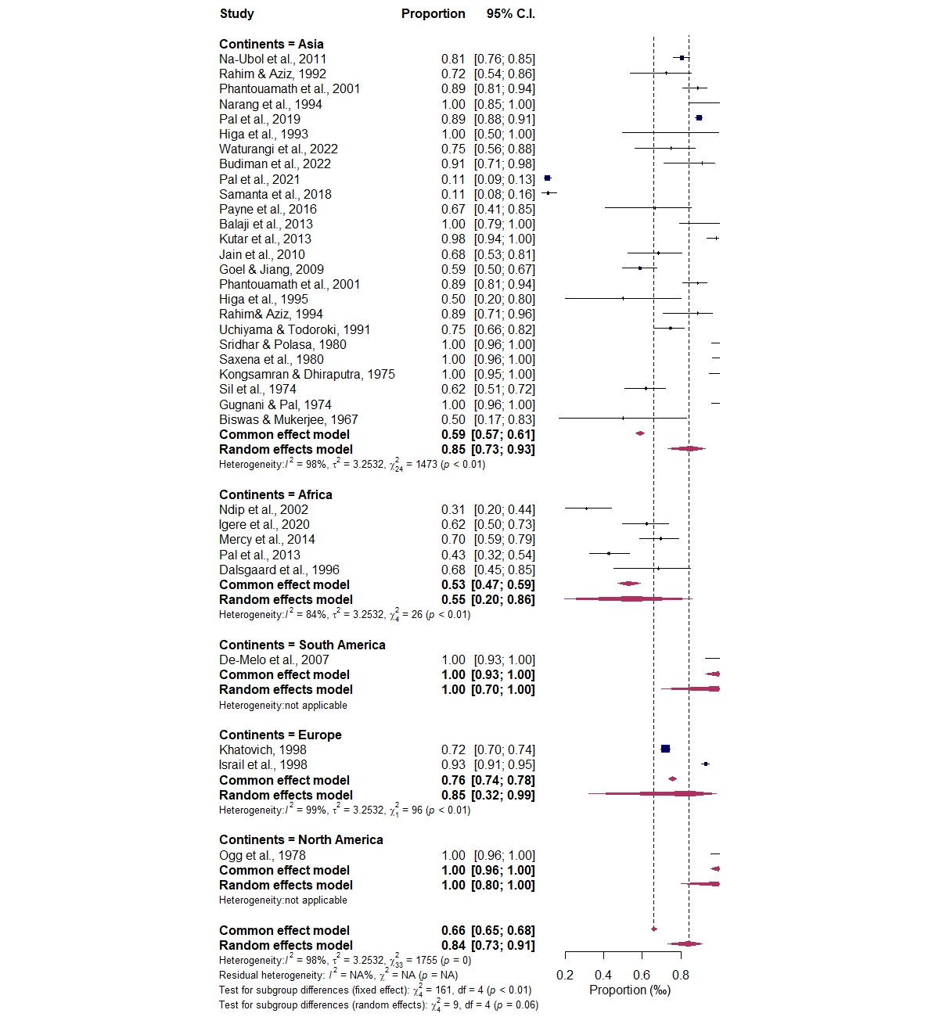
Figure S1. Continent subgroup analysis on prevalence of polymyxin resistance in V. cholerae

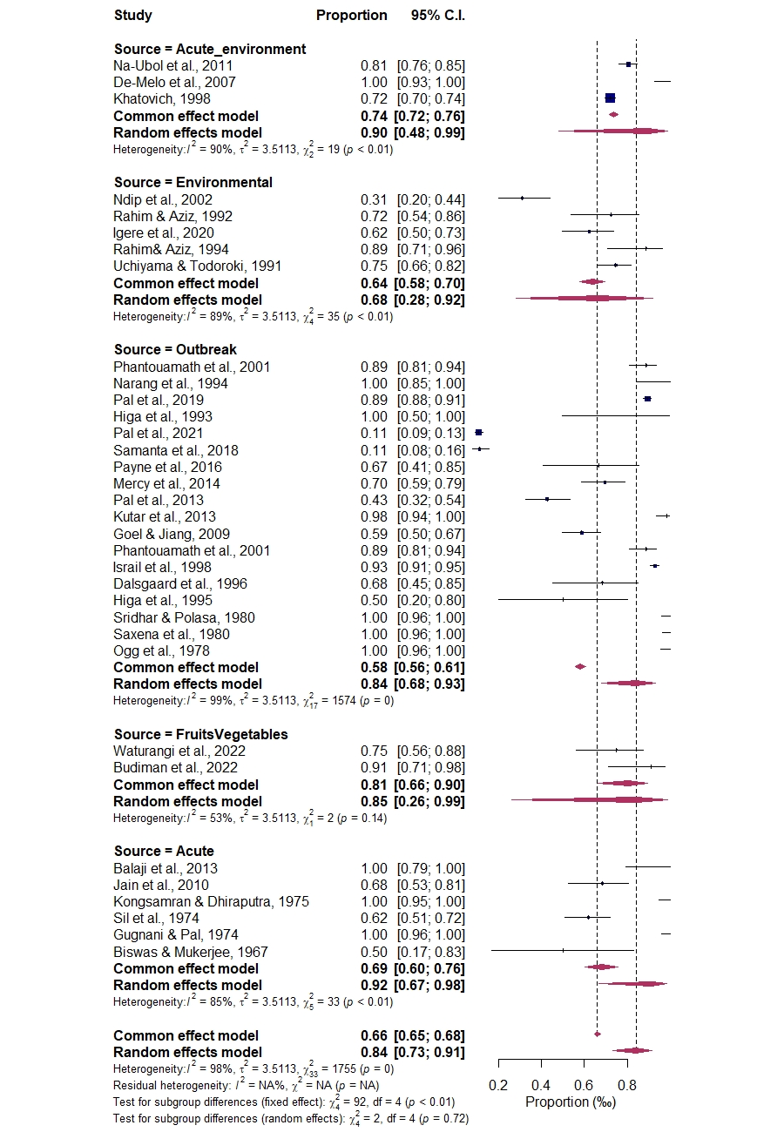
Figure S2. Sources subgroup analysis on prevalence of polymyxin resistance in V. cholerae.

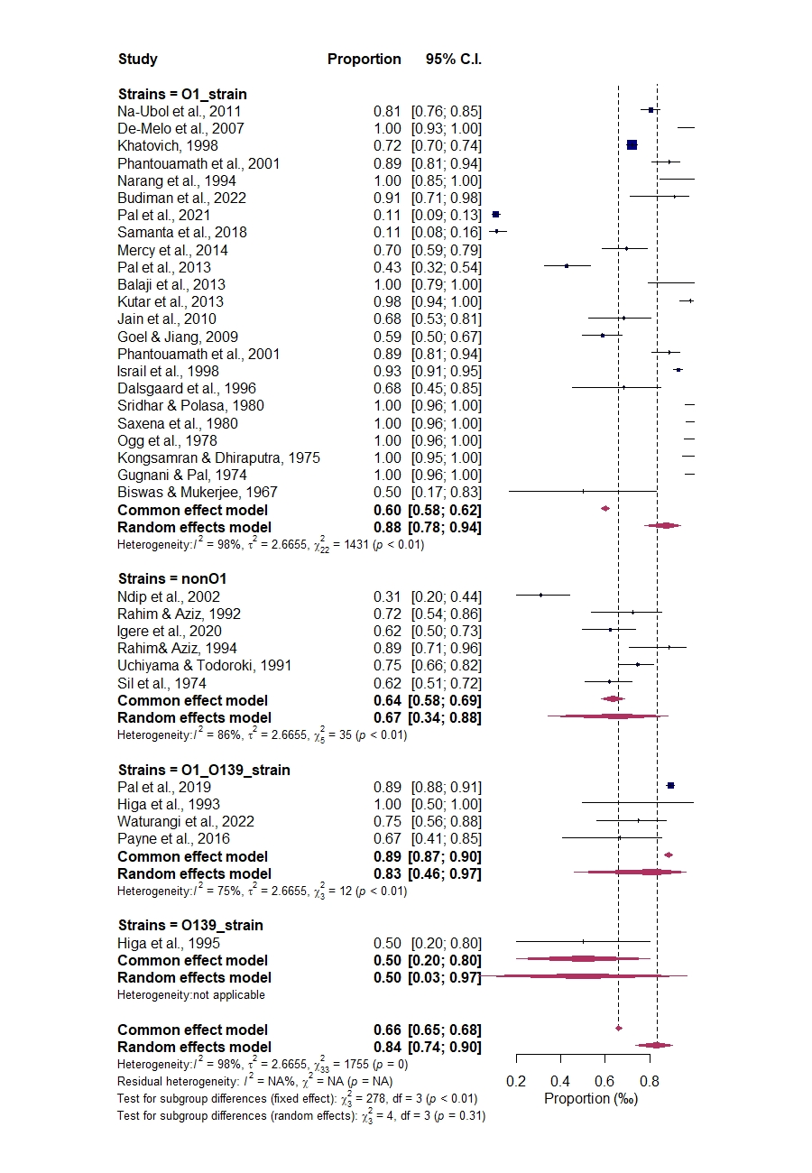
Figure S3. Strains subgroup analysis on prevalence of polymyxin resistance in Vibrio cholerae.

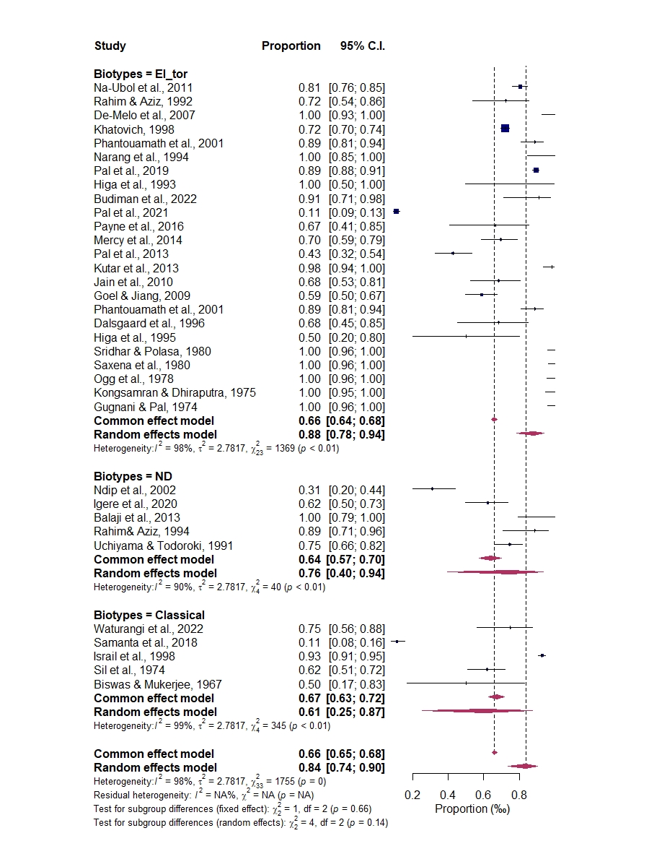

Figure S4. Biotypes subgroup analysis on prevalence of polymyxin resistance in Vibriocholerae.

Table S1a: Quality assessment of the included studies based on Newcastle-Ottawa Scale (NOS)
Authors | Year of Isolation /reporting | Item 1 | Item 2 | Item 3 | Item 4 | Item 5 | Item 6 | Item 7 | Item 8 | Item 9 | Item 10 | Item 11 | Total score | Level of bias
NA-UBOL et al. | 2011 | 2 | 2 | 2 | 2 | 2 | 2 | 1 | 2 | 2 | 2 | 2 | 21 | low
NDIP Rnet al. | 2002 | 2 | 2 | 2 | 2 | 1 | 1 | 2 | 2 | 2 | 2 | 2 | 20 | low
RAHIM & AZIZ | 1994 | 2 | 2 | 2 | 1 | 1 | 1 | 2 | 2 | 2 | 2 | 2 | 19 | low
DE MELO et al. | 2007 | 1 | 2 | 2 | 2 | 1 | 1 | 1 | 1 | 1 | 1 | 1 | 14 | Moderate
KHATOVICH | 1998 | 2 | 2 | 1 | 2 | 1 | 1 | 2 | 2 | 2 | 2 | 2 | 19 | low
PHANTOUAMATH et al. | 2001 | 2 | 2 | 1 | 2 | 1 | 1 | 2 | 2 | 2 | 2 | 2 | 19 | low
NARANGet al. | 1994 | 2 | 1 | 1 | 2 | 1 | 1 | 2 | 2 | 1 | 2 | 2 | 17 | Moderate
PAL et al. | 2019 | 2 | 2 | 2 | 1 | 2 | 1 | 1 | 2 | 1 | 2 | 1 | 17 | Moderate
HIGAet al | 1993 | 2 | 2 | 2 | 2 | 2 | 2 | 1 | 2 | 2 | 2 | 2 | 21 | low
WATURANGI et al. | 2022 | 2 | 2 | 2 | 2 | 1 | 1 | 2 | 2 | 2 | 2 | 2 | 20 | low
IGERE et al. | 2020 | 0 | 1 | 2 | 1 | 2 | 2 | 2 | 2 | 2 | 2 | 2 | 18 | low
PAL et al. | 2021 | 2 | 2 | 2 | 2 | 2 | 2 | 2 | 2 | 1 | 2 | 2 | 21 | low
BUDIMAN et al. | 2022 | 2 | 2 | 2 | 2 | 2 | 1 | 2 | 2 | 2 | 1 | 2 | 20 | low
SAMANTAet al. | 2018 | 2 | 2 | 2 | 2 | 1 | 1 | 2 | 2 | 1 | 2 | 2 | 19 | low
PAYNE et al. | 2016 | 2 | 2 | 2 | 2 | 2 | 2 | 2 | 2 | 2 | 2 | 2 | 22 | low
MERCY et al. | 2014 | 2 | 2 | 2 | 1 | 2 | 1 | 2 | 2 | 2 | 2 | 2 | 20 | low
PAL et al. | 2013 | 2 | 1 | 2 | 2 | 1 | 1 | 2 | 2 | 2 | 1 | 2 | 18 | low
BALAJI et al. | 2013 | 2 | 2 | 2 | 1 | 1 | 1 | 2 | 2 | 2 | 1 | 1 | 17 | Moderate
JAIN et al. | 2013 | 2 | 2 | 2 | 2 | 1 | 1 | 2 | 2 | 2 | 2 | 1 | 19 | low
KUTAR et al. | 2013 | 2 | 2 | 2 | 1 | 2 | 2 | 2 | 2 | 2 | 2 | 2 | 21 | low
GOEL and JIANG | 2009 | 2 | 2 | 2 | 1 | 1 | 1 | 2 | 2 | 2 | 2 | 2 | 19 | low
PHANTOUAMATHet al. | 2001 | 2 | 2 | 2 | 1 | 1 | 1 | 1 | 2 | 2 | 2 | 1 | 17 | low
ISRAIL et al. | 1998 | 2 | 2 | 1 | 2 | 2 | 2 | 1 | 2 | 2 | 2 | 1 | 19 | low
DALSGAARD et al. | 1996 | 2 | 2 | 2 | 2 | 2 | 2 | 2 | 2 | 2 | 2 | 2 | 22 | low
HIGA et al. | 1995 | 2 | 2 | 2 | 2 | 2 | 2 | 2 | 2 | 2 | 2 | 2 | 22 | low
RAHIM and AZIZ | 1994 | 2 | 2 | 2 | 1 | 1 | 1 | 2 | 2 | 2 | 2 | 2 | 19 | low
UCHIYAMA and TODOROKI | 1991 | 2 | 2 | 2 | 1 | 1 | 1 | 2 | 2 | 2 | 2 | 2 | 19 | low
SRIDHAR and POLASA | 1980 | 2 | 2 | 2 | 1 | 2 | 2 | 2 | 2 | 2 | 1 | 2 | 20 | low
SAXENA et al. | 1980 | 2 | 2 | 2 | 1 | 1 | 1 | 2 | 2 | 2 | 2 | 2 | 19 | low
OGG et al. | 1978 | 2 | 2 | 2 | 2 | 2 | 2 | 2 | 2 | 2 | 2 | 2 | 22 | low
KONGSAMRAN and DHIRAPUTRA | 1975 | 2 | 2 | 2 | 2 | 2 | 2 | 2 | 2 | 2 | 2 | 1 | 21 | low
SIL et al. | 1974 | 2 | 2 | 2 | 2 | 2 | 2 | 2 | 1 | 2 | 2 | 1 | 20 | low
GUGNANI and PAL | 1974 | 2 | 2 | 2 | 2 | 2 | 2 | 1 | 2 | 2 | 2 | 2 | 21 | low
BISWAS and MUKERJEE | 1967 | 2 | 2 | 2 | 2 | 2 | 2 | 2 | 2 | 2 | 2 | 2 | 22 | low
Keyword for total score interpretation of bias level: Total score >18 = low; 14 – 18 = moderate ; <13 = high

Table S1b: Quality assessement Response Instrument for nonhuman-based prevalence studies
To assess risk of bias related to the study purpose, data collection, method applied and statistical soundness of nonhuman-based prevalence studies
Major Components | Response options
1. Does the title speaks directly to the present subject being addressed? | No (0 point) | Somehow (1 point) | Yes (2 point)
2. Was the aim of study clearly stated and is it relevant to the present study | Unclear and irrelevant (0 point) | Clearly stated but some how relevant (1 point) | Clearly stated and relevant (2 point)
3. Do results reported in abstract and/or summary similar/matched with those ones presented within the text? | Unmatched (0 point) |  | Matched (2 point)
4. Was the sampling plan description adequate, accompany with date and sample handling information? | No (0 point) | Somehow but inadequate (lack sampling period /sample handling information) (1 point) | Adequately reported with sampling period and sample handling information (2 point)
5. Was the sample size appropriately stated or computable from reported data of the study? | No (0 point) | Somehow but inadequate (1 point) | Yes (2 point)
6. Was the sample size adequate enough (≥50arbitrary selected)? | <50 (0 point) | ≥50or <100 (1 point) | ≥100 (2 point)
7. Was the bacterial density, concentration, recovery or extraction procedure adequately reported and accompanied with a control sample? | Not reported (0 point) | Somehow but with no positive control (1 point) | Reported and adequate with positive control (2 point)
8. Was the bacterial detection assay described in details and reproducible? | No (0 point) | Somehow but with no positive control (1 point) | Yes and with positive control (2 point)
9. Does the endpoints address the study focus and appropriate for the achievement of the study aim and objectives? | No (0 point) | Somehow but inadequate (1 point) | Yes and adequate (2 point)
10. Does the method employed and assessed enhance the study endpoint (outcome) qualitatively or quantitatively in an unbiased manner? | No(0 point) | Somehow but inadequate (1 point) | Yes and adequate (2 point)
11.Was the choice of statistical analysis adequate for the study? | Not reported (0 point) | Somehow but inadequate (1 point) | Yes and adequate (2 point)
Keyword for total score interpretation of bias level: Total score >18 = low; 14 – 17 = moderate; <13 = high

