Supplementary Material

Title: Deep brain stimulation improves symptoms in an individual with alpha-synuclein-gene-associated Parkinson’s disease

(A)
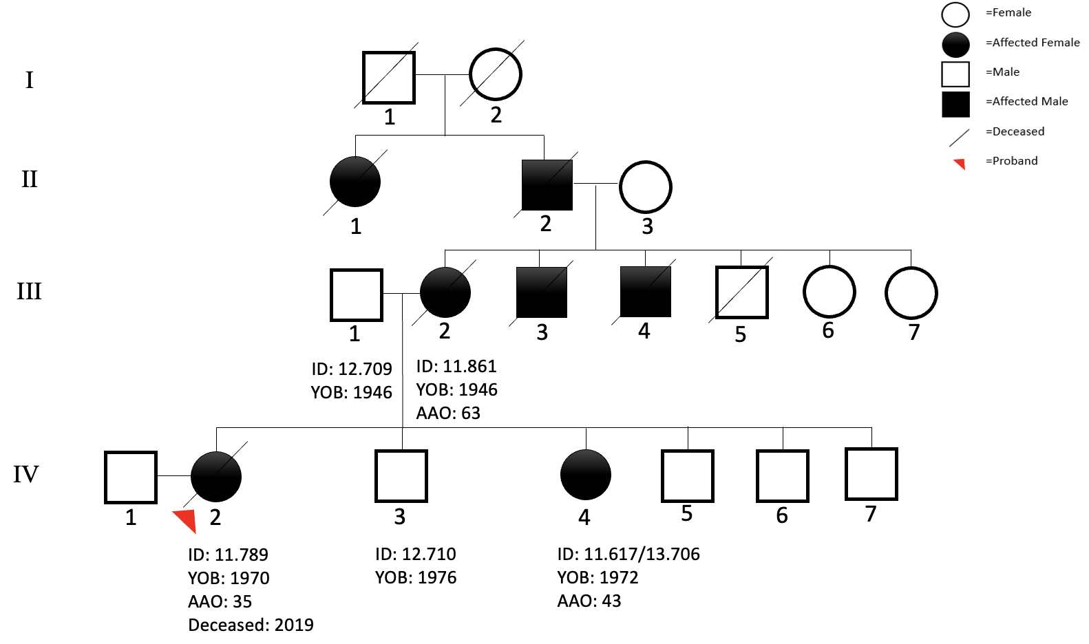
Had undergone DBS

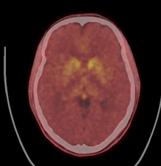
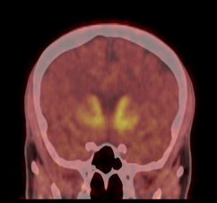
(C)
(C)
(B)

Supplementary Figure S1. (A) Pedigree of family ZA459. The affected individuals are the individual who had undergone DBS (IV-4), her sister (IV-2) and their mother (III-2). All individuals with sample IDs were included in the genetic analysis. (B-C) F-DOPA PET images of individual IV-4 show significant asymmetrical reduction in dopamine receptor binding on the (B) coronal and (C) axial images. The right side being more affected corresponds to the clinical picture of left-sided onset and dominant Parkinsonism.
Abbreviations: ID, sample identification; YOB, year of birth; AAO, age at onset.
Supplementary Table S1: Demographic and phenotypic information for family ZA459.

 | Affected |  |  | Unaffected
Individual | IV-2 *  (proband) | IV-4 | III-2 * | III-1 | IV-3
Lab ID | 11.789 | 11.617/13.706 | 11.861 | 12.709 | 12.710
Year of Birth | 1970 | 1972 | 1946 | 1946 | 1976
Sex | Female | Female | Female | Male | Male
Age at Death | 49 | N/A | 70 | N/A | N/A
Deep Brain Stimulation | No | Subthalamic DBS done 20 Nov 2020 | No
Date of Last Clinical Evaluation | 2013 | 2024 | 2013 | N/A | N/A
Age at Onset (years) | 35 | 43 | 63 | N/A | N/A
Resting Tremor | Yes | Yes | Unknown
Postural Tremor | Unknown | No | Yes
Action Tremor | Unknown | No | Unknown
Slow Movements | Unknown | Yes | Unknown
Rigidity/Stiffness | Unknown | Yes | Unknown
Gait Difficulty | Unknown | Yes | Unknown
Gait Freezing | Unknown | No | Unknown
Postural Instability/Falls | Unknown | No | Unknown
Dystonia | Yes | Yes | Yes
Clear, Favourable Response to Dopaminergic Medication | Unknown | Yes | Unknown
Motor Fluctuations (On/Off Periods) | Unknown | Yes | Unknown
Levodopa-induced Dyskinesias | Unknown | Yes | Unknown
Sleep Benefit | Unknown | No | Unknown
Upper Motor Neuron Signs | Unknown | No | Unknown
RBD | Unknown | Yes | Unknown
Insomnia | Unknown | Yes | Unknown
Excessive Daytime Sleepiness | Unknown | No | Unknown
Depression Symptoms | Unknown | Yes | Unknown
Anxiety | Unknown | Yes | Yes
Mild Cognitive Impairment | Unknown | Yes | Unknown
Dementia | Unknown | No | Unknown
Visual Hallucinations | Unknown | No | Unknown
Impulse Control Disorders | Unknown | No | Unknown
Constipation | Yes | Yes | Yes
Urinary Dysfunction | Unknown | No | Unknown
Orthostatic Hypotension | Unknown | No | Unknown
Pain | Unknown | Yes | Unknown
Hyposmia | Unknown | No | Unknown
Underweight | Unknown | No | Unknown
Presence of Atypical Features | Yes  Leg Spasms and Speech Impairments | No | Yes  Scoliosis
Aggressive Behaviour | Unknown | No | Unknown
Childhood Symptoms | Unknown | None | Unknown
Initial Symptoms | Unknown | Unilateral left hand tremor | Unknown
Olfaction (Normal/Impaired) | Unknown | Normal | Unknown
Excessive Sweating | Unknown | No | Unknown
Total Daily Dose of Levodopa (mg) | Unknown | 500mg | Unknown
Blood Pressure (Presence/Absence of Orthostatic Drop) | Unknown | Normal | Unknown
Reflexes (Normal/Hyperreflexia) | Unknown | Normal | Unknown
Brain CT Scan (Done/Not Done & Findings) | Unknown | CT - F-DOPA PET - confirmed diagnosis of PD 26 Jun 2022; MRI brain normal 25 May 2020 | Unknown
UPDRS (Unified Parkinson Disease Rating Scale) part III | Unknown | 22 | Unknown
MOCA (Montreal Cognitive Assessment) | Unknown | 24/30 | Unknown

* Clinical records of 11.789 and 11.861 were destroyed after they died so no clinical information is available

Supplementary Table S2: Pre- and post-deep brain surgical outcomes in the family member (individual IV-4) four years after surgery.

Scale | Pre-STN DBS surgery (2020) | Post-STN DBS surgery (2024) | Percentage change
UPDRS -I | 11 | 7 | 36%
UPDRS -II | 13 | 3 | 77%
UPDRS -III (levodopa-off) | 48 | 22 | 54%
UPDRS -IV | 13 | 4 | 69%
Levodopa equivalent daily dose (LEDD) | 1000 | 500 | 50%
MoCA | 28 | 27 | 3%
STN DBS, subthalamic nucleus deep brain stimulation; UPDRS, Unified Parkinson's Disease Rating Scale

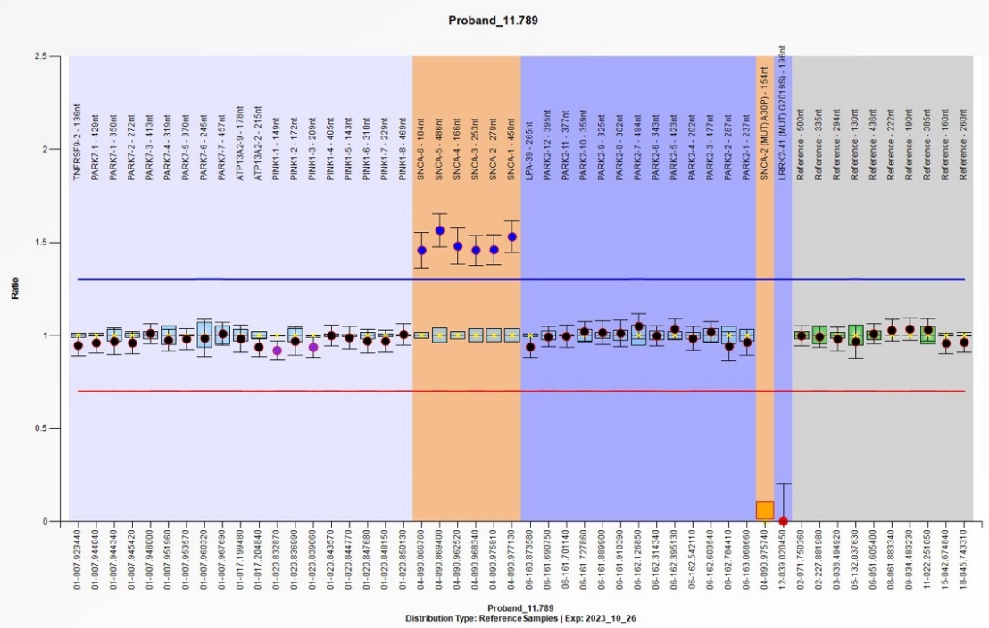
(A)
IV-2 (ID 11.789)

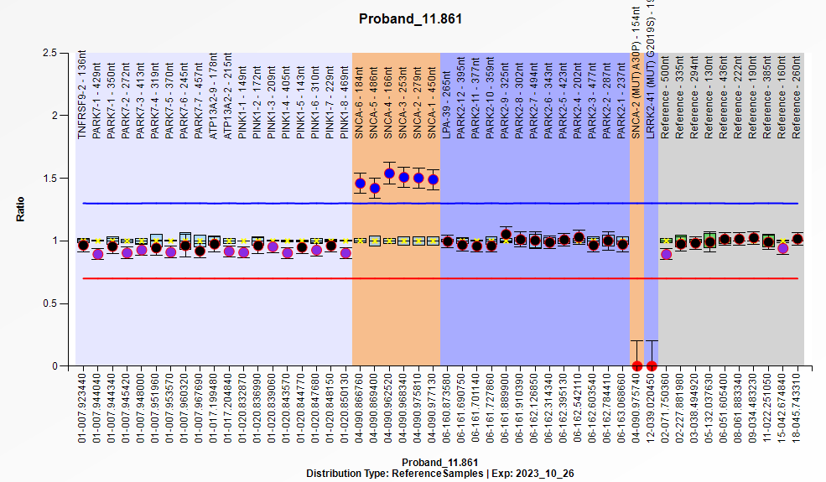
III-2 (ID 11.861)
(B)

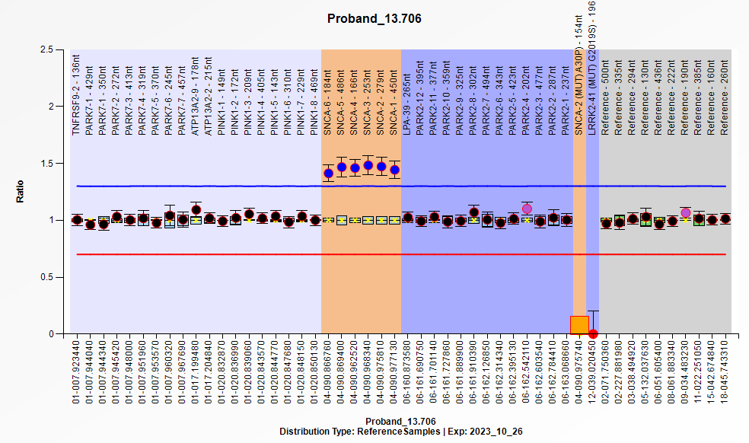
IV-4 (ID 13.706)
(C)

Supplementary Figure S2: MLPA ratio charts. (A-C) Ratio charts for the three affected family members displaying the SNCA gene duplication. The ratio charts depict a ratio of 1.5 (shown in black boxes), signifying the presence of a duplication.

