Supplementary figures
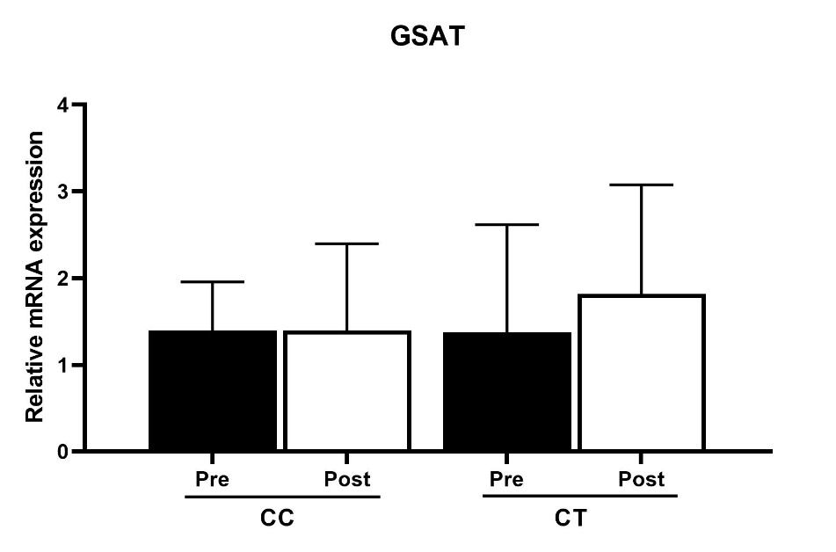
Figure S1. Relative mRNA expression of FKBP5 in gluteal adipose tissue (GSAT) of control participants pre and post exercise intervention and stratified by the rs1360780 genotype. Data represented as mean ± SD (n=6 per group).

Supplementary Tables
Table S1. Correlation between the change (Δ) in FKBP5 methylation levels and Δ cardiometabolic parameters in exercise group.
 | GSAT |  |  |  |  |  | ASAT
 | CpG542 |  |  | CpG543 |  |  | CpG542 |  |  | CpG543
 | r | P | P* | r | P | P* | r | P | P* | r | P | P*
Δ VO_{2Peak} (ml/kg) | -0.498 | 0.030 | 0.100 | -0.191 | 0.433 | 0.806 | -0.188 | 0.273 | 0.485 | -0.311 | 0.195 | 0.393
Body Composition and Fat Distribution
Δ BMI (kg/m²) | 0.405 | 0.085 | 0.203 | 0.344 | 0.149 | 0.322 | -0.196- | 0.421 | 0.231 | -0.115 | 0.639 | 0.393
Δ Weight (kg) | 0.408 | 0.083 | 0.208 | 0.355 | 0.136 | 0.323 | -0.205 | 0.399 | 0.221 | -0.130 | 0.597 | 0.361
Δ WHR | 0.165 | 0.499 | 0.711 | 0.229 | 0.347 | 0.502 | -0.137 | 0.576 | 0.447 | 0.013 | 0.957 | 0.877
ΔWC (cm) | 0.436 | 0.062 | 0.187 | 0.578 | 0.010 | 0.024 | -0.174 | 0.475 | 0.200 | -0.130 | 0.597 | 0.283
Δ FM (%) | 0.399 | 0.091 | 0.362 | 0.329 | 0.170 | 0.628 | 0.446 | 0.056 | 0.143 | 0.389 | 0.100 | 0.247
Δ Android FM (%) | 0.039 | 0.873 | 0.418 | -0.212 | 0.383 | 0.866 | -0.126 | 0.375 | 0.408 | -0.085 | 0.729 | 0.870
Δ Gynoid FM (%) | 0.179 | 0.464 | 0.409 | 0.249 | 0.304 | 0.228 | 0.343 | 0.150 | 0.135 | 0.280 | 0.245 | 0.230
Glucose Regulation
Δ HbA1C (%) | 0.252 | 0.298 | 0.445 | 0.020 | 0.936 | 0.783 | 0.292 | 0.225 | 0.391 | 0.407 | 0.083 | 0.150
Δ HOMA-IR | -0.073 | 0.768 | 0.750 | -0.069 | 0.778 | 0.602 | -0.117 | 0.634 | 0.809 | -0.206 | 0.397 | 0.572
Δ Fasting Glucose (mmol/L) | 0.163 | 0.506 | 0.812 | 0.259 | 0.285 | 0.470 | 0.247 | 0.309 | 0.479 | 0.087 | 0.723 | 0.963
Δ Fasting Insulin (μU/ml) | -0.106 | 0.665 | 0.709 | -0.109 | 0.656 | 0.556 | -0.298 | 0.215 | 0.343 | -0.334 | 0.163 | 0.298
Δ Si (x10⁻⁴min⁻¹/μUmL⁻¹) | 0.242 | 0.318 | 0.086 | 0.024 | 0.924 | 0.418 | -0.022 | 0.928 | 0.898 | 0.022 | 0.930 | 0.729
Lipid profile
Δ LDL (mmol/L) | 0.147 | 0.547 | 0.773 | 0.052 | 0.834 | 0.827 | 0.270 | 0.264 | 0.349 | 0.498 | 0.030 | 0.050
Δ HDL (mmol/L) | 0.089 | 0.718 | 0.555 | 0.093 | 0.706 | 0.441 | 0.234 | 0.336 | 0.338 | 0.174 | 0.477 | 0.453
Δ Triglycerides (mmol/L) | -0.012 | 0.961 | 0.658 | -0.340 | 0.155 | 0.257 | 0.048 | 0.845 | 0.620 | 0.241 | 0.321 | 0.184
Data expressed as the Pearson’s r-coefficient/Spearman’s rho coefficient and p-value. *P-value adjusted for alcohol consumption and employment
Abbreviations: BMI, body mass index; C-peptide; FM, fat mass; HbA1C, haemoglobin A1C ; HDL, high-density lipoprotein; HbA1C, haemoglobin A1C ; HOMA-IR, homeostatic model assessment of insulin resistance; LDL, low-density lipoprotein; Si, insulin sensitivity; WHR, waist-to-hip ratio; WC, waist circumference.

Table S2. Correlation between the change (Δ) in FKBP5 methylation levels and Δ cardiometabolic parameters in control group.
 | GSAT |  |  |  |  |  | ASAT
 | CpG542 |  |  | CpG543 |  |  | CpG542 |  |  | CpG543
 | r | P | P* | r | P | P* | r | P | P* | r | P | P*
Δ VO_{2Peak} (ml/kg) | -0.188 | 0.558 | 0.540 | -0.007 | 0.538 | 0.669 | -0.005 | 0.710 | 0.794 | -0.008 | 0.538 | 0.669
Body Composition and Fat Distribution
Δ BMI (kg/m²) | -4.793 | 0.388 | 0.354 | -6.692 | 0.249 | 0.178 | -5.162 | 0.446 | 0.446 | -6.693 | 0.249 | 0.178
Δ Weight (kg) | -1.602 | 0.473 | 0.426 | -2.372 | 0.311 | 0.223 | -1.977 | 0.467 | 0.461 | -2.373 | 0.311 | 0.223
Δ WHR | -28.316 | 0.738 | 0.711 | -21.292 | 0.813 | 0.600 | -60.546 | 0.553 | 0.491 | -21.292 | 0.813 | 0.600
ΔWC (cm) | -0.719 | 0.381 | 0.389 | -0.208 | 0.516 | 0.396 | -0.627 | 0.534 | 0.515 | -0.169 | 0.847 | 0.751
Δ FM (%) | -0.290 | 0.126 | 0.278 | -0.261 | 0.203 | 0.511 | -0.089 | 0.715 | 0.931 | -0.111 | 0.596 | 0.770
Δ Android FM (%) | -1.878 | 0.116 | 0.255 | -1.806 | 0.159 | 0.411 | -0.742 | 0.629 | 0.820 | -0.851 | 0.519 | 0.678
Δ Gynoid FM (%) | -0.887 | 0.109 | 0.244 | -0.822 | 0.169 | 0.443 | -0.290 | 0.685 | 0.900 | -0.342 | 0.578 | 0.746
Glucose Regulation
Δ HbA1C (%) | -20.228 | 0.020 | 0.036 | -17.862 | 0.065 | 0.082 | 9.878 | 0.406 | 0.302 | 6.763 | 0.513 | 0.457
Δ HOMA-IR | -1.405 | 0.602 | 0.545 | -1.639 | 0.566 | 0.576 | 2.455 | 0.450 | 0.472 | 2.260 | 0.419 | 0.395
Δ Fasting Glucose (mmol/L) | -1.959 | 0.566 | 0.437 | -2.077 | 0.566 | 0.376 | 8.847 | 0.014 | 0.032 | 5.575 | 0.097 | 0.155
Δ Fasting Insulin (μU/ml) | -0.398 | 0.562 | 0.520 | -0.464 | 0.524 | 0.594 | -0.687 | 0.407 | 0.419 | -0.321 | 0.658 | 0.751
Δ Si (x10⁻⁴min⁻¹/μUmL⁻¹) | -2.325 | 0.176 | 0.238 | -2.606 | 0.150 | 0.128 | -0.239 | 0.913 | 0.975 | -0.770 | 0.682 | 0.639
Lipid profile
Δ LDL (mmol/L) | 3.243 | 0.255 | 0.167 | 3.014 | 0.322 | 0.170 | 5.042 | 0.136 | 0.118 | 5.786 | 0.184 | 0.290
Δ HDL (mmol/L) | -5.274 | 0.661 | 0.765 | -3.432 | 0.788 | 0.843 | 22.080 | 0.108 | 0.118 | 22.633 | 0.048 | 0.063
Δ Triglycerides (mmol/L) | -6.455 | 0.506 | 0.663 | -2.924 | 0.779 | 0.960 | 10.107 | 0.388 | 0.346 | 4.399 | 0.668 | 0.581
Data expressed as the Pearson’s r-coefficient/Spearman’s rho coefficient and p-value. *P-value adjusted for alcohol consumption and employment
Abbreviations: BMI, body mass index; C-peptide; FM, fat mass; HbA1C, haemoglobin A1C ; HDL, high-density lipoprotein; HbA1C, haemoglobin A1C ; HOMA-IR, homeostatic model assessment of insulin resistance; LDL, low-density lipoprotein; Si, insulin sensitivity; WHR, waist-to-hip ratio; WC, waist circumference

