E = 91.8% R² = 0.985 Slope = -3.535
B
A
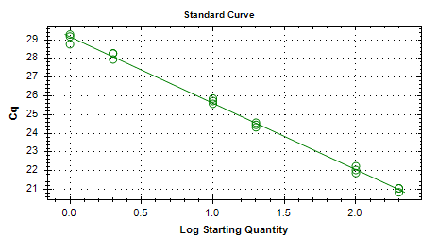
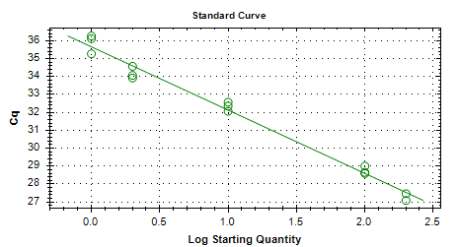
C
E = 91.3% R² = 0.997 Slope = -3.551
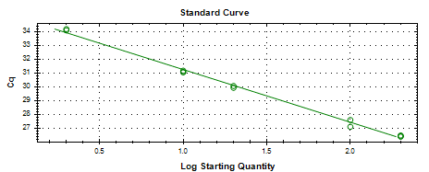

E = 83.0% R² = 0.995 Slope = -3.811
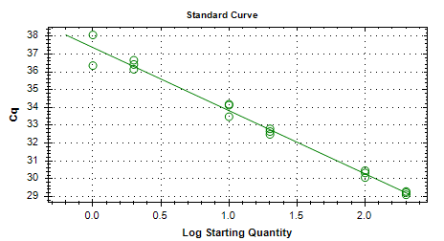
D

E = 91.3% R² = 0.984 Slope = -3.550

Supplementary Figure 6. Standard curves of target PcinCRN genes for RT-qPCR. Standard curves of the reference genes were prepared from a 5-fold dilution series of a cDNA template pool. (A) PcinCRN74, (B) PcinCRN79, (C) PcinCRN90 and (D) PcinCRN95. The log of the starting quantity was plotted against the Cq value for each of the standard wells and a line of best fit was drawn through the data points. The efficiency (E), slope and correlation (R²) values are indicated.

