Performance Evaluation of Gold (III) Bio-Reduction by Bacterial strains and a Consortium Isolated from Gold Mine effluents
Miranda Mpeta*, Job T. Tendenedzai, Shepherd M. Tichapondwa and Evans M.N. Chirwa
Water Utilisation and Environmental Engineering Division, Department of Chemical Engineering, University of Pretoria, Pretoria 0002, South Africa; u24054276@tuks.co.za (M.M.); job.tendenedzai@tuks.co.za (J.T.T.); shepherd.tichapondwa@up.ac.za (S.M.T); evans.chirwa@up.ac.za (E.M.N.C.)
*Corresponding authors: u24054276@tuks.co.za

Supplementary data
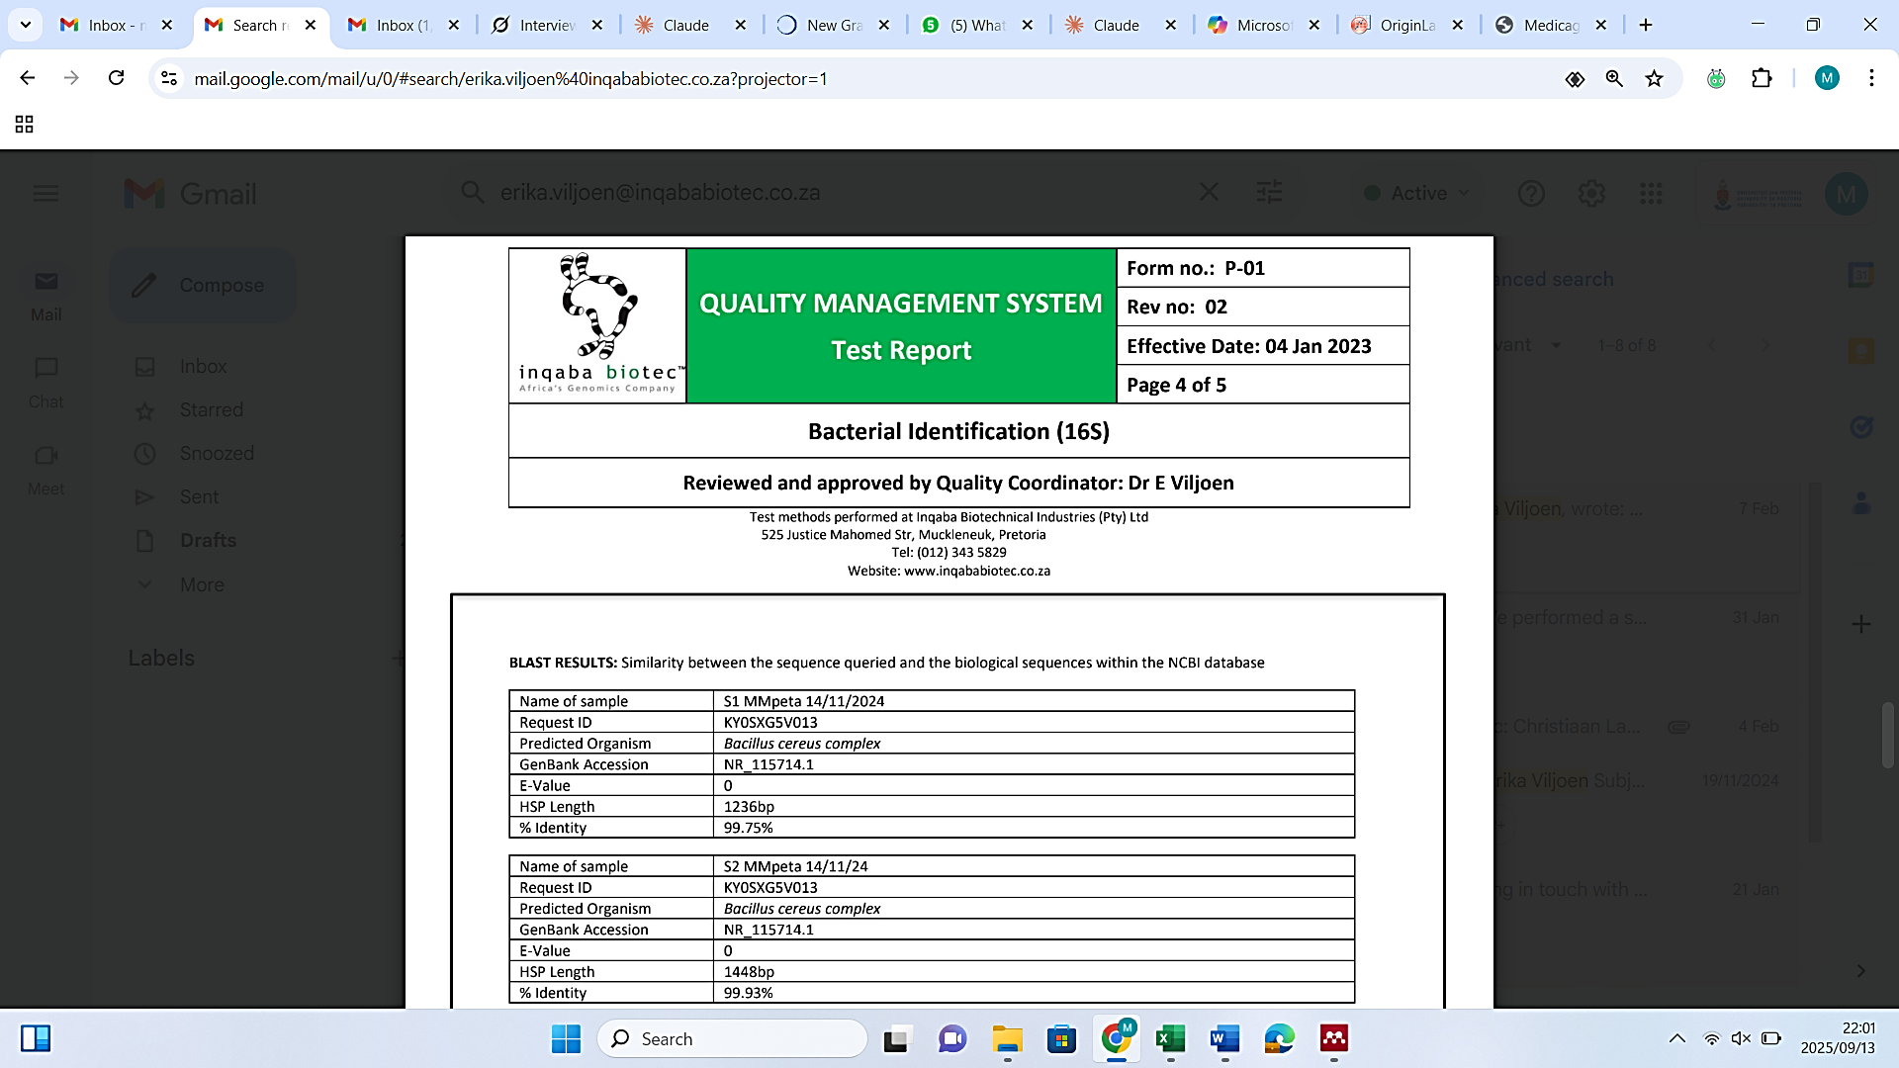

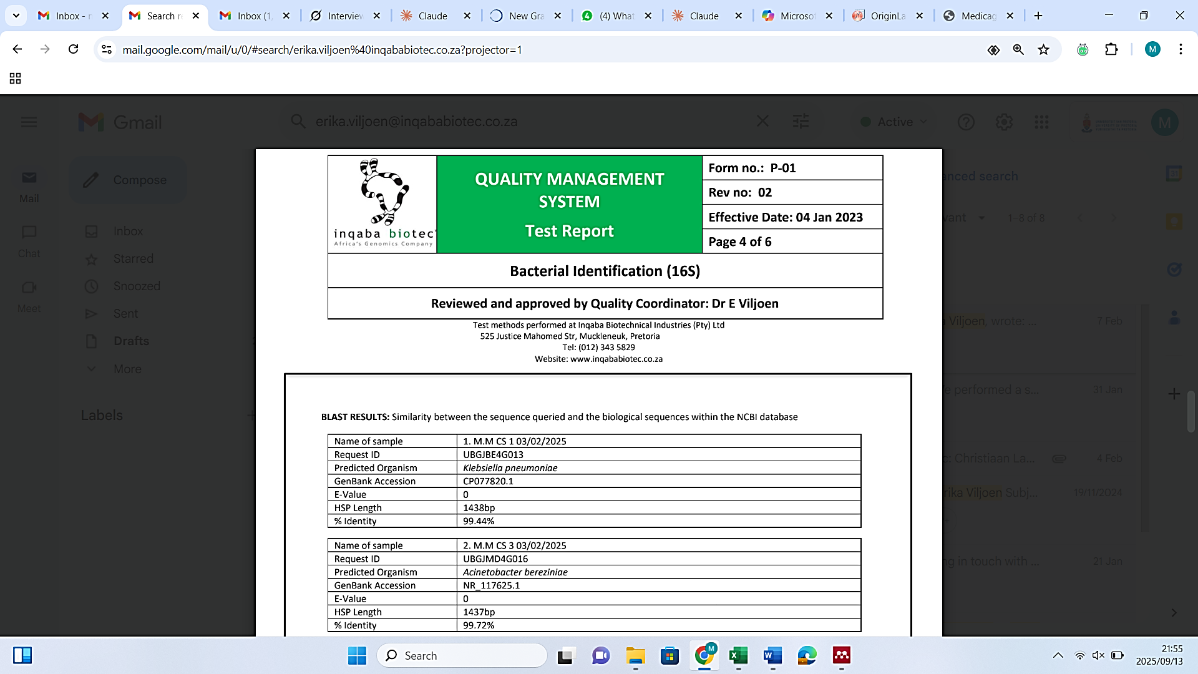
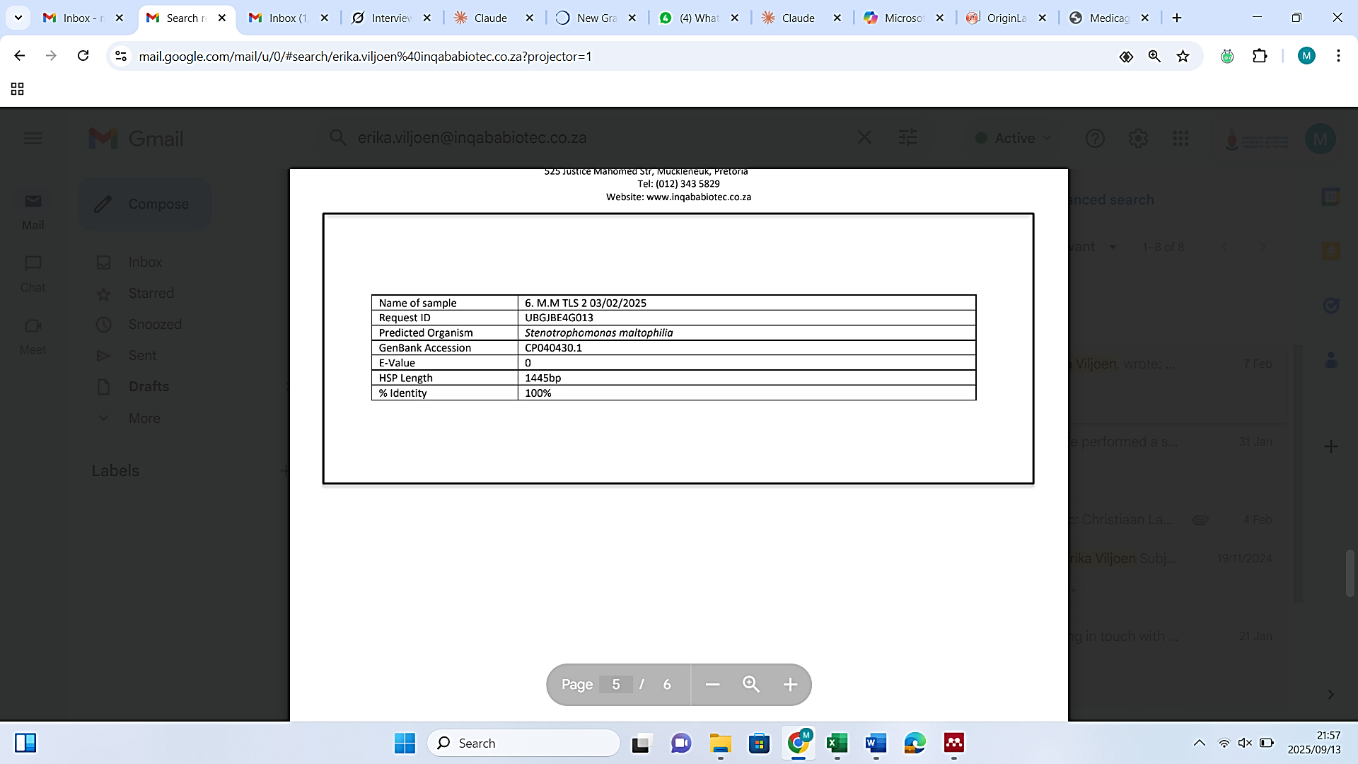

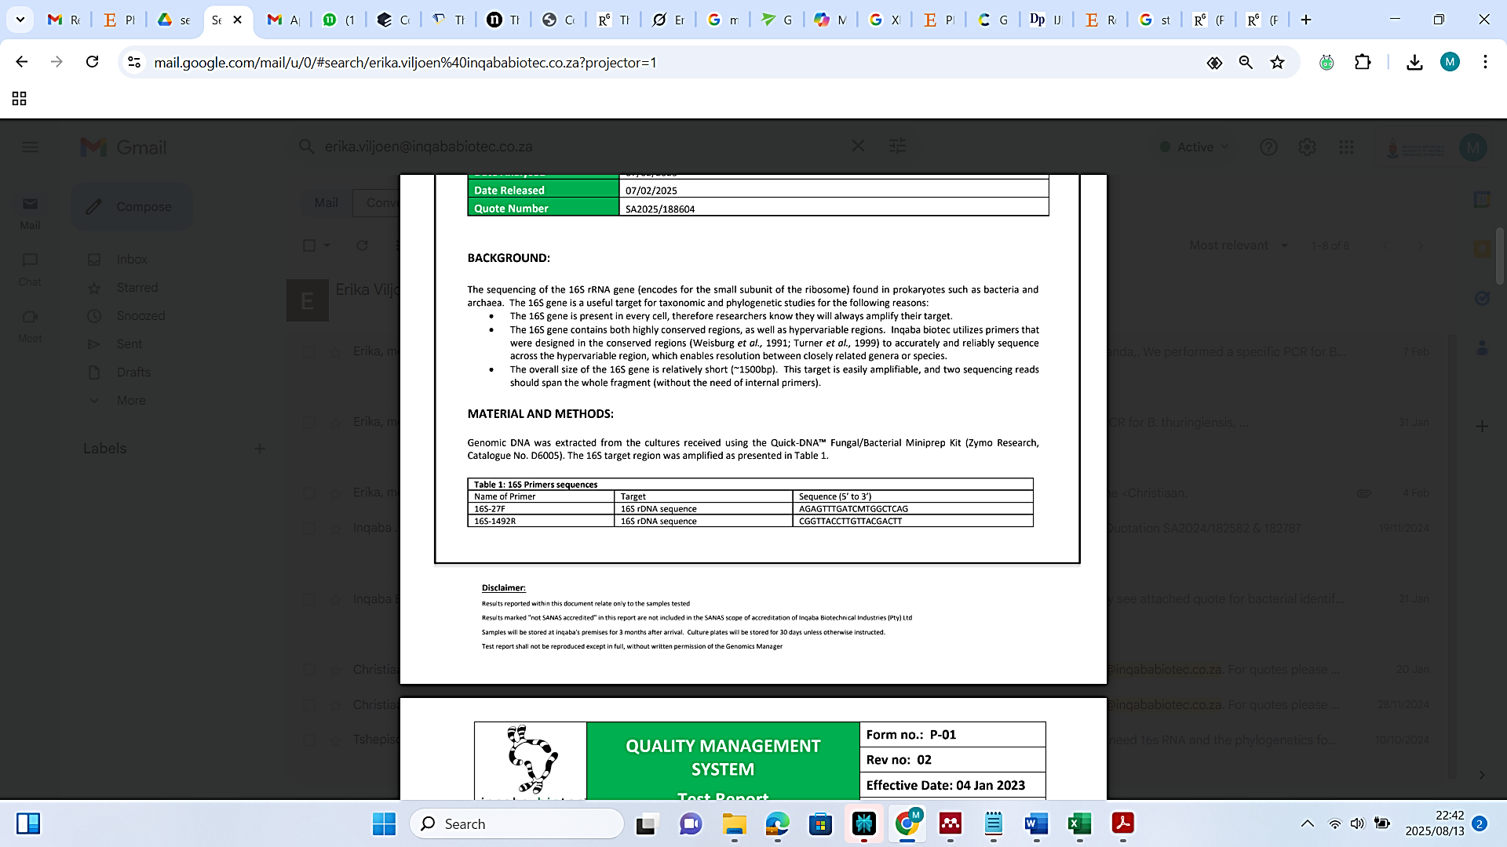
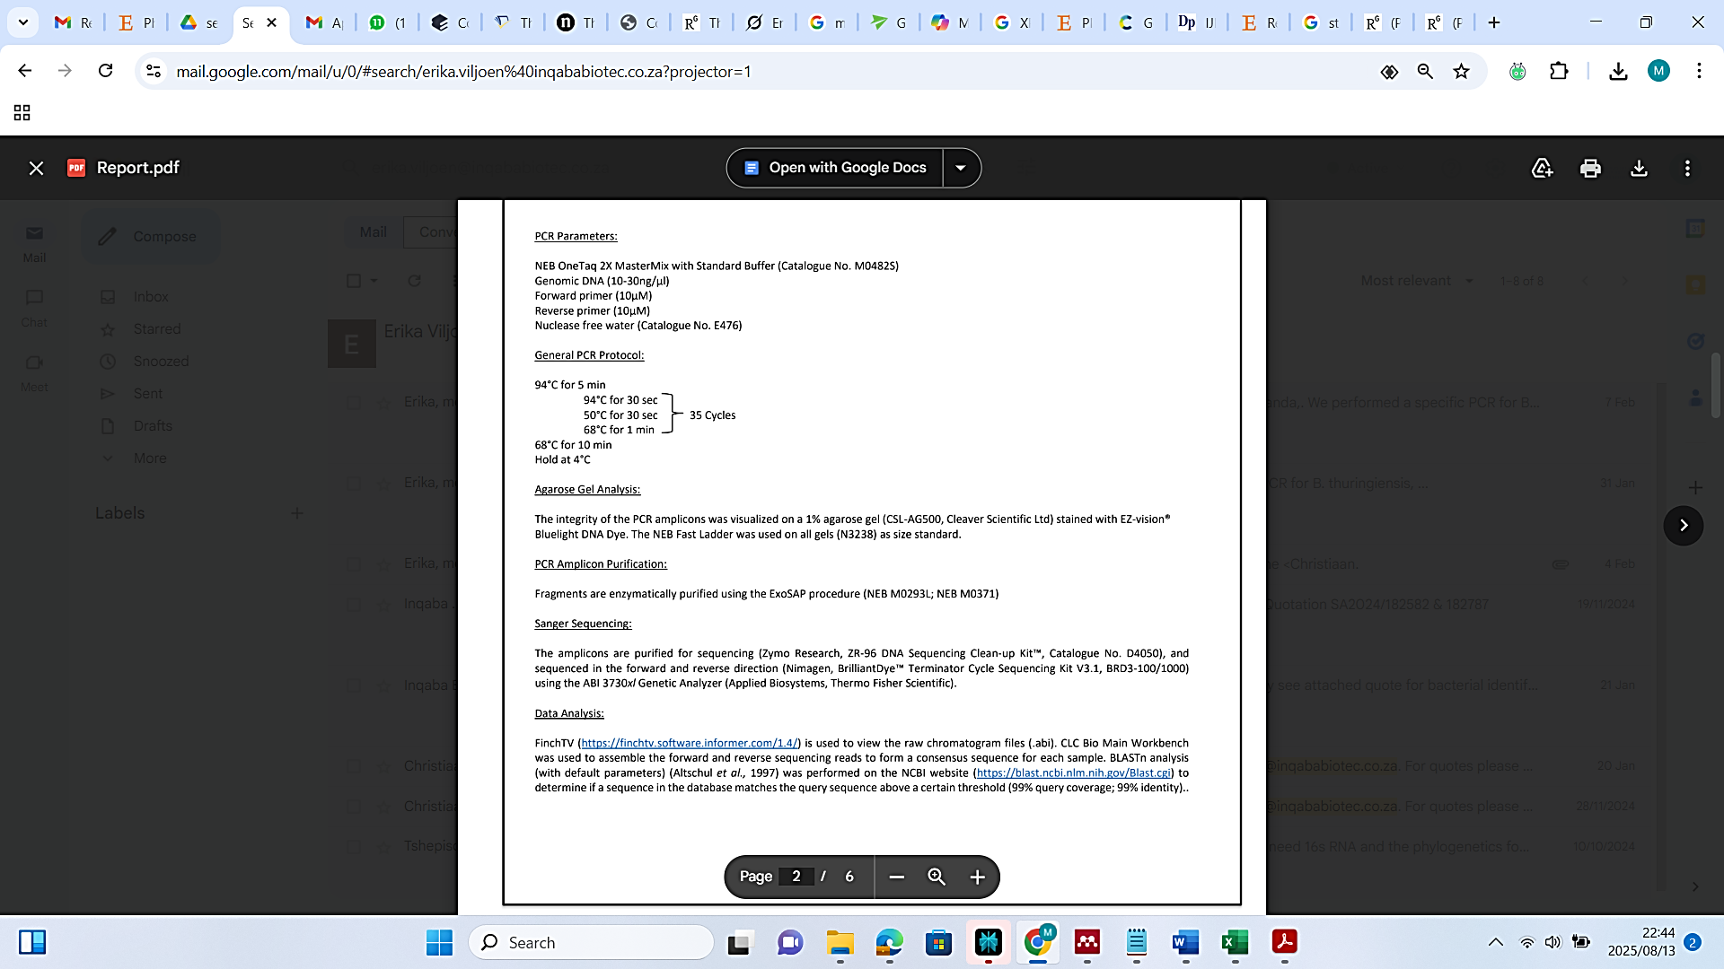
Figure S1- Part of Bacterial identification 16S rRNA gene sequencing report for samples S1, S2, CS1, CS3 and TLS 2 collected at different cyanide- contaminated sites of a gold mine.

Fig. S2. X- ray diffraction spectra of the synthesised gold nano particles at 2θ degrees (horizontal axis), intensity measured in counts (vertical axis) with major constituents being halite (57.8%), sylvine (33.7%) and gold (8.5%)
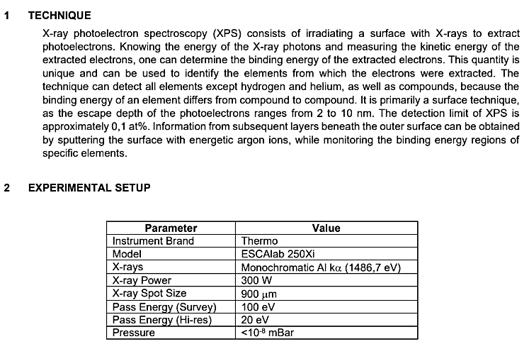
Fig. S3. XPS technique description and experimental setup.

