A
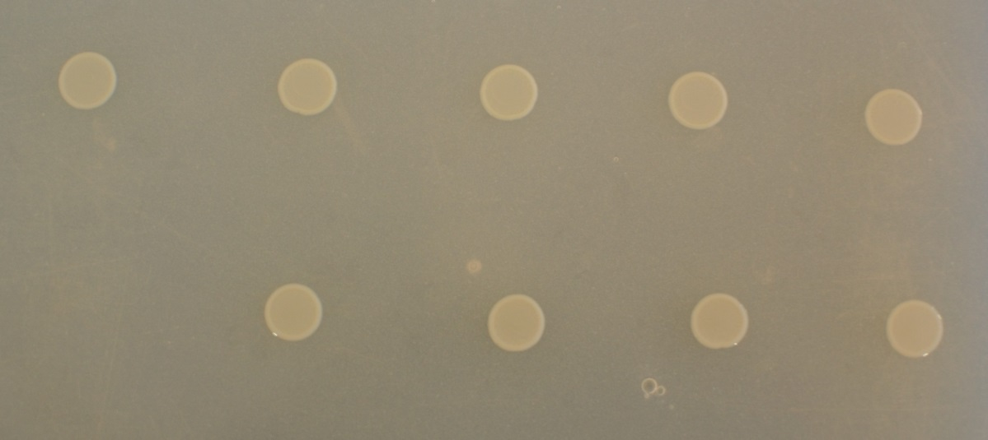
∆expI
∆slyA
∆carC
∆expIpExpI
∆slyApSlyA
∆carCpCarC
∆furpFur
∆fur
Pcb1692

B
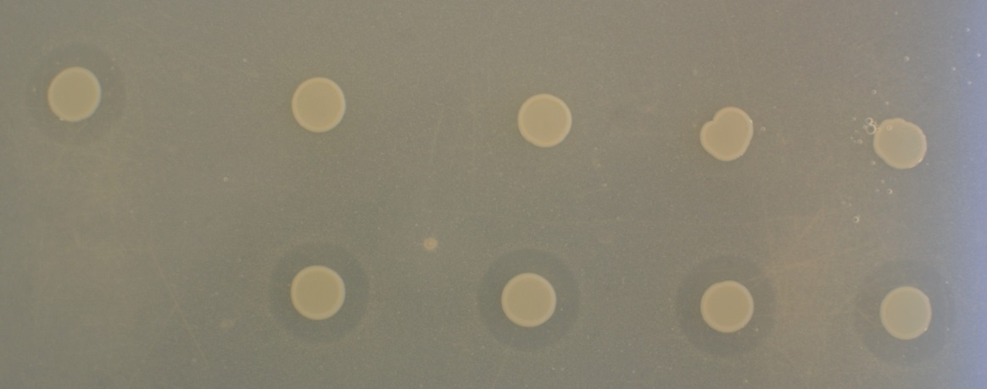
∆expI
∆expIpExpI
∆furpFur
∆carCpCarC
∆slyApSlyA
∆slyA
∆carC
∆fur
Pcb1692

C

Supplementary Data Sheet S3. The effect of iron on carbapenem production Pectobacterium carotovorum subsp. brasiliense 1692 and targeted bacteria. M9 minimal media was supplemented with or without iron (10µM). Pcb1692 and its corresponding mutant and complement strains were spotted on a lawn of Dickeya dadantii and incubated overnight at 28ºC A) No halos were produced by strains Pcb1692 in the absence of iron. B) Halos were observed in wildtype Pcb1692 and complement mutant strains which was indicative of carbapenem production. C) Halo area was measured using ImageJ and data presented as the mean, error bars represent one standard deviation and asterisk represent statistical significant difference (p<0.05) as determined by the two-tailed Student’s t-test. Experiments were performed in triplicates and repeated three independent times.

