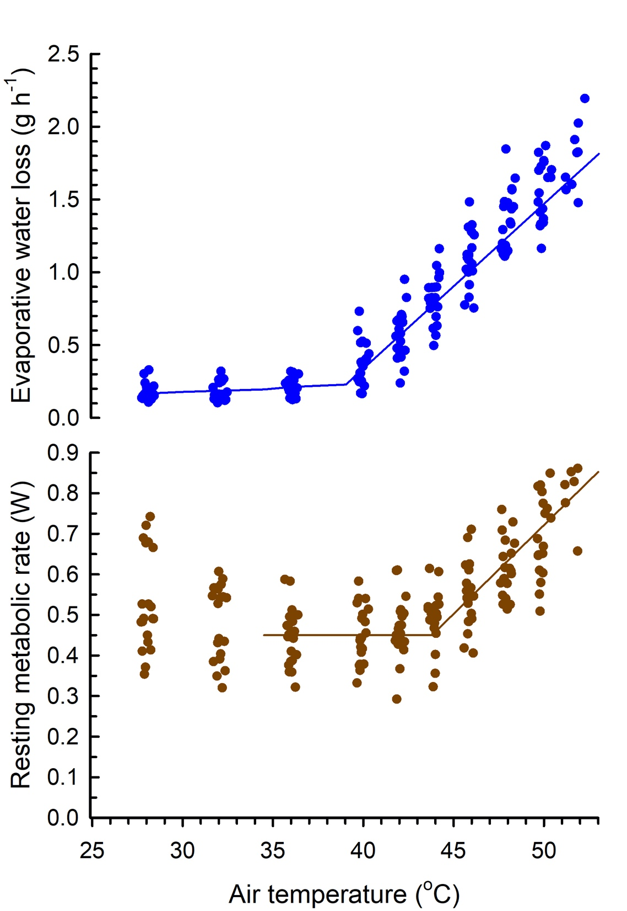

Figure S1. Relationships between air temperature and evaporative water loss (upper panel) and resting metabolic rate (lower panel) during acute heat exposure in red-billed queleas (Quelea quelea; n = 20). The solid lines are the relationships above and below inflection points from linear mixed-effects models that included individual as a random effect to account for multiple measurements per individual.

