Odour information enables patch choice by mammalian herbivores from afar, leading to predictable plant associational effects
Patrick B. Finnerty¹*, Adrian M. Shrader², Peter B. Banks¹, Melissa H. Schmitt³, Clare McArthur¹
¹ School of Life & Environmental Sciences, University of Sydney, Sydney, NSW, 2006, Australia
² Mammal Research Institute, Department of Zoology and Entomology, University of Pretoria, Pretoria, South Africa
³ Department of Biology, University of North Dakota, Grand Forks, ND 58202, USA
* Corresponding author: (E): patrick.finnerty@sydney.edu.au; (T): +61 498 102 984

SUPPLEMENTARY MATERIAL

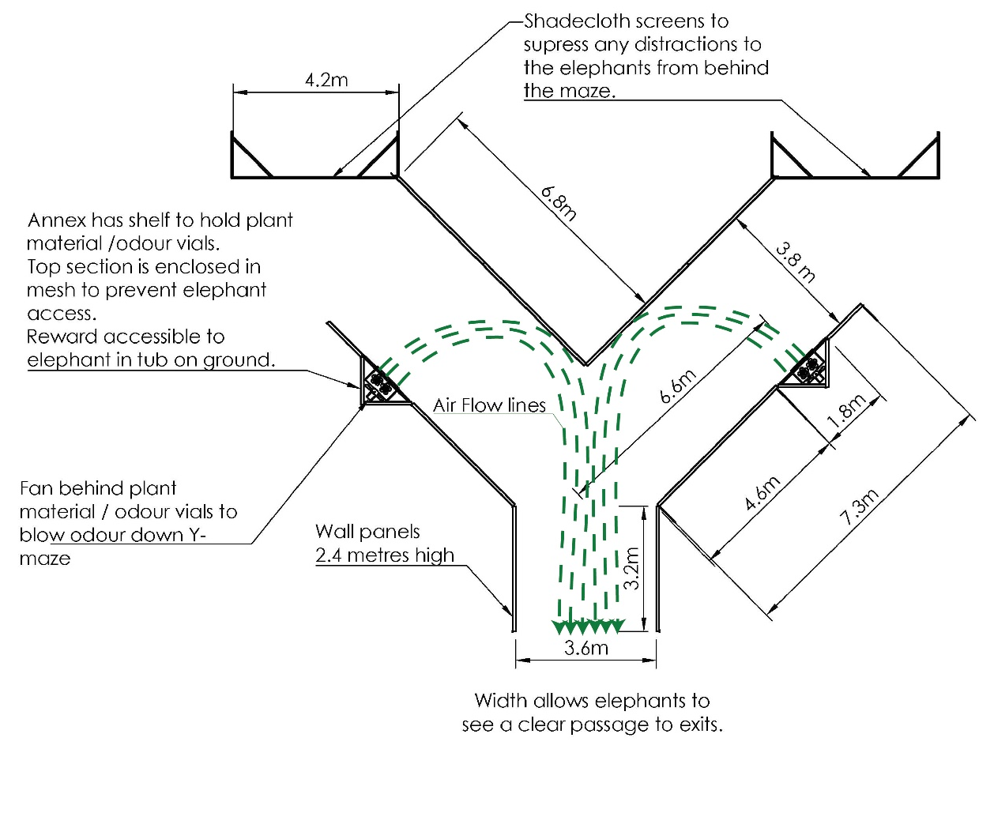
Figure S1. Detailed schematic of the Y-maze.

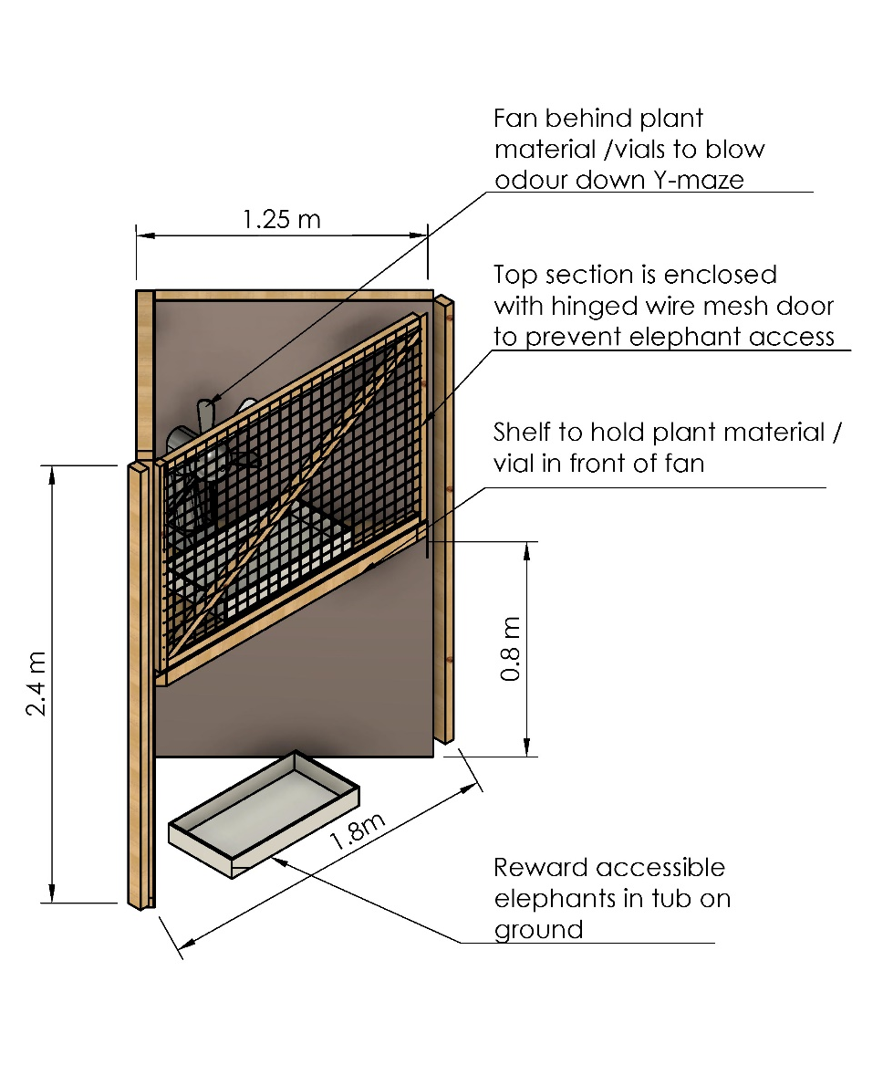
Figure S2. Detailed schematic of an annex

SUPPLEMENTARY NOTES
NOTE 1 Habituation and training
We habituated the six elephants to the experimental setup for a maximum of 17 days before they participated in patch choice trails. The goal of habituation was to ensure that the elephants were comfortable in the Y-maze, and understood the basis of the experiment (i.e., choosing a side of the Y-maze they preferred based on odour). Initially, handlers walked each elephant (via ‘trunk walking’) down each arm of the Y-maze six times respectively. Fans were then turned on and incrementally increased to full speed as handlers walked elephants past the fans. When the handlers were confident that each elephant was comfortable walking past a fan at full speed, we progressed to the next training stage.
Next, we placed a handful of ‘Boskos’ African game feed pellets (WES Enterprises, Thabazimbi, South Africa) (a highly preferred food option provided to the elephants as positive reinforcement) on one side of the Y-maze within the closed off annex, and in the reward tub where elephants could access and consume. Each elephant was asked to stand at the front of the Y-maze and instructed to ‘Smell, Smell, Choose’. Elephants would walk down their selected arm of the Y-maze. Each elephant received three consecutive ‘walk-throughs’. The position of the ‘Boskos’ pellets in the Y-maze was randomized (by coin toss). ‘Boskos’ pellets were never placed on one side of the Y-maze more than twice in a row. Once each elephant could select the position of the ‘Boskos’ pellets over three consecutive ‘walk-throughs’, we moved onto the next training stage.
In the third stage, we trained elephants to selected preferred real plant options. Within the enclosed annexes, 350 g (10 × 35 g ‘trunk-fulls’; (Schmitt, Ward & Shrader 2016)) of high-quality Pappea capensis, (based on elephant foraging data by (Schmitt et al. 2018) was placed down one arm of the Y-maze and 350 g low-quality (avoided) Euclea undulata down the other arm. 140 g (4 × 35 g ‘trunk-fulls’) of either species was placed in the corresponding reward tub below where elephants could access and consume. Each elephant was again asked to stand at the front of the Y-maze and instructed to ‘Smell, Smell, Choose’. Each elephant received three consecutive ‘walk-throughs’. The position of preferred P. capensis in the Y-maze was randomized (by coin toss).
If plants were replaced in a ‘reward’ tub after a choice, plants on the other side of the Y-maze were also lifted and dropped back into the reward tub at the same time to ensure elephants were not using sound as a cue to choose a side. To avoid bias and odour contamination, all observers and handlers stood directly behind the elephant. To replace or swap the position of plants, persons only entered the Y-maze from the end of each arm of the maze.
If the elephants chose the side that contained high-quality P. capensis, they made the ‘good’ choice and received a food item that could act as a reward (i.e., positive reinforcement). Alternatively, choosing the side with low-quality E. undulata resulted in the elephants selecting something they do not like (i.e., a ‘bad’ choice) and resulted in negative reinforcement. However, elephants were not required to eat either reward. This procedure ensured that the elephants understood the ‘you get what you choose’ reward system of the odour-based choice experiments. Elephants were considered to fully understand the experimental procedure once each elephant could select high-quality P. capensis nine times in a row (three periods of three consecutive ‘walk-throughs’). Upon reaching the training criterion, elephant subjects proceeded to plant quality trials and several choice trial tests.
NOTE 2 Plant quality ranking
We ran several choice trials between the three plant species using the Y-maze. We tested the following combinations: (1) P. capensis versus E. undulata, (2) P. capensis versus D. rotundifolia, and (3) D. rotundifolia versus E. undulata. In an arm of the Y-maze, 175 g of a species (5 × 35 g ‘small trunkfuls’) was presented within the annex with 70 g of the same species (2 × 35 g ‘small trunkful’) available for consumption in the plastic tub below. Elephants selected for both P. capensis and D. rotundifolia (termed high-quality). Elephants selected against E. undulata (termed low-quality).
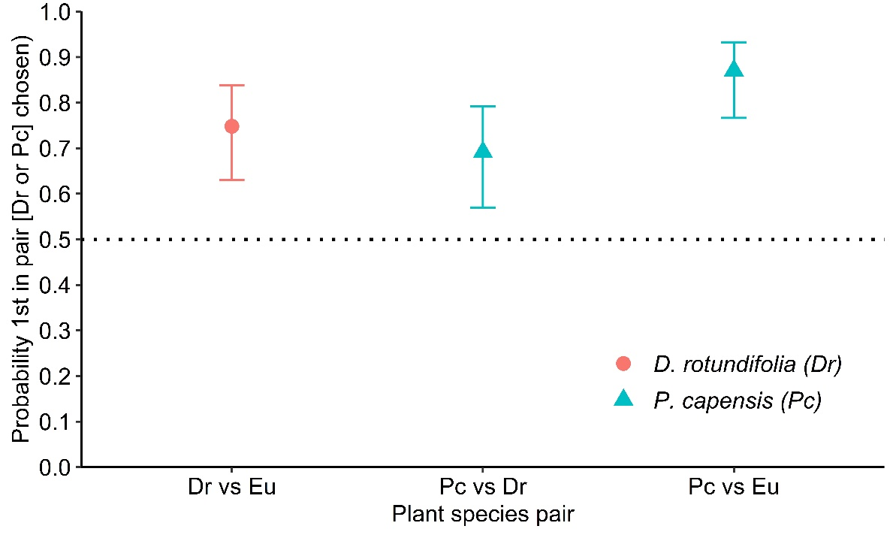
Figure S3. Probability (means ± 95% CI) that the first plant species (i.e., Dr or Pc) listed in the pair is chosen over the second. If error bars do not overlap the dashed line (random choice), the result is significant. Error bars above the dashed line show preference for the treatment. Dr = Dombeya rotundifolia, Pc = Pappea capensis, and Eu = Euclea undulata.
NOTE 3

Trial S.1

S.1.1 MATERIALS AND METHODS
To compare how many artificial odour vials were required to influence plant patch choice by elephants, we compared elephant choice between (i) a high-quality focal plant alone (175 g of the high-quality plant P. capensis) versus (ii) the same (175 g of P. capensis) in one of four patch treatments: (a) no neighbour (focal plant alone as a control), (b) mixed with 875 g of low-quality (avoided) E. undulata (focal plant + low-quality neighbours), or next to (c) five informative odour vials, and (e) one informative odour vial. All informative odour vials were mixed to a total 3 mL volume.

S.1.2 RESULTS
There was a significant effect of Treatment of elephant patch choice (analysis of deviance likelihood ratio LR $χ_{3}^{2}$= 29.67, P < 0.0001, Fig. N3a). Comparing among treatments, elephants were equally likely to choose high-quality focal plants (175 g P. capensis) when mixed with (b) 875 g low-quality E. undulata, and when next to both (c) five, and (d) one informative odour vial (Table N3a, Fig N3a). Elephants were less likely to choose high-quality focal plants when mixed with (b) 875 g low-quality E. undulata, and when next to both (c) five and (d) one informative odour vial than (a) untreated control treatments (high-quality focal plant only) (Table N3a, Fig N3a).
Table N3a. Pairwise comparison between elephant choice among patch treatments. Focal plant = 175 g high-quality P. capensis, untreated control = 175 g P. capensis, low-quality neighbours = 875 g low quality E. undulata.
Pairwise Comparison | Odds ratio | SE | Z-ratio | p-value
(a) Focal plant (untreated control) vs (b) Focal plant + low-quality neighbour | 4.63 | 1.76 | 4.03 | 0.0003
(a) Focal plant (untreated control) vs (c) Focal plant + 5 Informative odour vial | 7.54 | 3.19 | 4.69 | < 0.0001
(a) Focal plant (untreated control) vs (d) Focal plant + 1 Informative odour vial | 3.53 | 1.21 | 3.40 | 0.005
(b) Focal plant + low-quality neighbour vs (c) Focal plant + 5 Informative odour vial | 1.75 | 0.29 | 1.02 | 0.74
(b) Focal plant + low-quality neighbour vs (d) Focal plant + 1 Informative odour vial | 0.73 | 0.56 | 0.80 | 0.85
(c) Focal plant + 5 Informative odour vial vs (d) Focal plant + 1 Informative odour vial | 0.45 | 0.99 | 1.77 | 0.28

Considering patch choice within treatments, elephants chose (a) untreated control treatment randomly (equally to focal plants alone, Table N3b , Fig N3a). However, the probability that elephants selected high-quality focal plants mixed with (b) low-quality neighbours, and when next to both (c) five, and (d) one informative odour vials over high-quality focal plant alone was significantly less than 0.5 (Table N3b, Fig N3a). Irrespective of patch treatment, elephants always consumed all focal plants in reward tubs (285 of 285 ‘walk-throughs’). If chosen, low quality E. undulata in reward tubs was rarely consumed (2 out of 14 ‘walk-throughs’). As elephants were equally likely to choose high-quality focal plants next to both (c) five, and (d) one informative odour vial, we proceeded to only use a single vial in Trial S.2.
Table N3b. Pairwise comparison between elephant choice among patch treatments. Focal plant = 175 g high-quality P. capensis, untreated control = 175 g P. capensis, low-quality neighbours = 875 g low quality E. undulata.
Pairwise Comparison | Probability (first selected) | SE | Z-ratio | p-value
(a) Focal plant (untreated control) vs (i) Focal plant alone | 0.53 | 0.06 | 0.47 | 0.64
(b) Focal plant + low-quality neighbour vs (i) Focal plant alone | 0.19 | 0.05 | -4.77 | < 0.0001
(c) Focal plant + 5 Informative odour vial vs (i) Focal plant alone | 0.13 | 0.04 | -5.31 | < 0.0001
(c) Focal plant + 1 Informative odour vial vs (i) Focal plant alone | 0.25 | 0.05 | -5.31 | < 0.0001

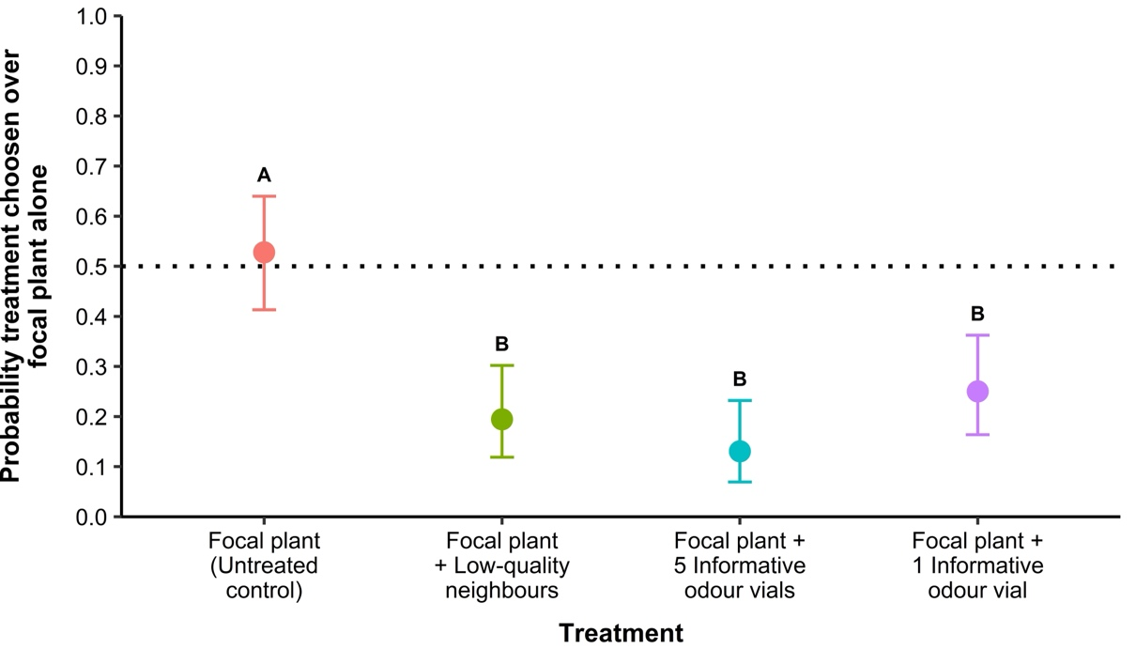
Figure N3a. Probability (means ± 95% CI) that a treatment option is chosen over a fixed option of a high-quality focal plant alone (175 g P. capensis). Untreated control = 175 g P. capensis, low-quality neighbours = 875 g E. undulata. If error bars do not overlap the dashed line (random choice), the preference for a treatment is significant. Error bars below the dashed line show avoidance of the patch treatment. Different letters indicate significant differences in preferences among treatments.

Trial S.2
Before comparing informative, flipped proportion, and uninformative odour vial treatments in Trial 2, we first needed to ensure that the VOC emission rates of informative odour vials were comparable to the real low-quality E. undulata neighbours. This was an essential step to ensure that any elephant responses to odour vials were not just a consequence of VOC emission rates being greater, or lower than real E. undulata VOC emissions presented in a treatment.

S.2.1 MATERIALS AND METHODS
To compare informative odour vial to real E. undulata VOC emission rates, we compared elephant choice between (i) a high-quality focal plant (175 g P. capensis) mixed with 875 g of real low-quality E. undulata, versus (ii) five patch treatments: (a) 175 g P. capensis mixed with 875 g of real E. undulata (control), and 175 g P. capensis next to informative odour vials mixed to volumes of (b) 3 mL, (c) 1.5 mL, (d) 0.5 mL, and (e) 0.1 mL.
Where elephant choice of an informative odour vial treatment reached 0.5 (representing random choice), VOC emission rate between 875 g low-quality E. undulata and the informative odour vial volume was deemed comparable.

S.2.2 RESULTS
There was a significant effect of Treatment of elephant patch choice (analysis of deviance likelihood ratio LR $χ_{4}^{2}$= 54.36, P < 0.0001, Fig. N3b). Comparing among treatments, elephants were equally likely to choose treatments (a) 175 g P. capensis mixed with 875 g of real low-quality E. undulata (control) and (c) 175 g P. capensis next to a 1.5 mL informative odour vial (P = 0.87, Fig N3c). Elephants were more likely to choose treatments (a) control and (c) 175 g P. capensis next to a 1.5 mL informative odour vial over (b) 175 g P. capensis next to a 3 mL informative odour vial (Table N3c, Fig N3b). Elephants were less likely to choose treatments (a) control, (b) 175 g P. capensis next to a 3 mL informative odour vial, and (c) 175 g P. capensis next to a 1.5 mL informative odour vial over (d) 175 g P. capensis next to a 0.5 mL informative odour vial, and (e) 175 g P. capensis next to a 0.1 mL informative odour vial (Table N3c, Fig N3b).

Table N3c. Pairwise comparison between elephant choice among patch treatments. Focal plant = 175 g high-quality P. capensis, low-quality neighbours = 875 g low quality E. undulata.
Pairwise Comparison | Odds ratio | SE | Z-ratio | p-value
(a) Focal plant + low-quality neighbour (control) vs (b) Focal plant + 3mL Informative odour vial | 0.26 | 0.10 | 3.64 | 0.003
(a) Focal plant + low-quality neighbour (control) vs (c) Focal plant + 1.5 mL Informative odour vial | 0.77 | 0.43 | 0.75 | 0.95
(a) Focal plant + low-quality neighbour (control) vs (d) Focal plant + 0.5 mL Informative odour vial | 0.34 | 1.05 | -2.97 | 0.03
(a) Focal plant + low-quality neighbour (control) vs (e) Focal plant + 0.1 mL Informative odour vial | 0.27 | 1.39 | -3.49 | 0.005
(b) Focal plant + 3mL Informative odour vial vs (c) Focal plant + 1.5 mL Informative odour vial | 0.19 | 1.89 | -4.30 | 0.0002
(b) Focal plant + 3mL Informative odour vial vs (d) Focal plant + 0.5 mL Informative odour vial | 0.09 | 4.54 | -6.12 | < 0.0001
(b) Focal plant + 3mL Informative odour vial vs (e) Focal plant + 0.1 mL Informative odour vial | 0.07 | 5.92 | -6.51 | < 0.0001
c) Focal plant + 1.5 mL Informative odour vial vs (d) Focal plant + 0.5 mL Informative odour vial | 0.44 | 0.82 | -2.27 | 0.02
c) Focal plant + 1.5 mL Informative odour vial vs (e) Focal plant + 0.1 mL Informative odour vial | 0.35 | 1.08 | -2.81 | 0.04
(d) Focal plant + 0.5 mL Informative odour vial vs (e) Focal plant + 0.1 mL Informative odour vial | 0.79 | 0.50 | 0.59 | 0.98

Considering patch choice within treatments, elephants chose (a) 175 g P. capensis mixed with 875 g of real low-quality E. undulata (control) (P = 0.91, Table N3d, Fig N3b) and (c) 175 g P. capensis next to a 1.5 mL informative odour vial treatments (P = 0.24, Table N3d, Fig N3b) randomly (equally to the fixed option of 175 g P. capensis mixed with 875 g of E. undulata, Table N3d, Fig N3b). The probability that elephants selected (b) 175 g P. capensis next to a 3 mL informative odour vial over 175 g focal P. capensis mixed with 875 g of E. undulata was significantly less than 0.5 (P < 0.0001, Table N3d, Fig N3b ). The probability that elephants selected (d) 175 g P. capensis next to a 0.5 mL informative odour vial and (e) 175 g P. capensis next to a 0.1 mL informative odour vial over 175 g focal P. capensis mixed with 875 g of E. undulata was significantly greater than 0.5 (P < 0.0001, Table N3d, Fig N3b). Irrespective of patch treatment, elephants always consumed all focal plants in reward tubs (359 of 359 ‘walk-throughs’). If chosen, low quality E. undulata in reward tubs was rarely consumed (3 out of 71 ‘walk-throughs’).

Table N3d. Pairwise comparison between elephant choice among patch treatments. Focal plant = 175 g high-quality P. capensis, untreated control = 175 g P. capensis, low-quality neighbours = 875 g low quality E. undulata.
Pairwise Comparison | Probability (first selected) | SE | Z-ratio | p-value
(a) Focal plant + low-quality neighbour (control) vs (i) Focal plant + low-quality neighbour | 0.51 | 0.06 | 0.12 | 0.91
(b) Focal plant + 3 mL Informative odour vial vs (i) Focal plant + low-quality neighbour | 0.21 | 0.05 | -4.60 | < 0.0001
(c) Focal plant + 1.5 mL Informative odour vial vs (i) Focal plant + low-quality neighbour | 0.56 | 0.06 | 1.18 | 0.24
(d) Focal plant + 0.5 mL Informative odour vial vs (i) Focal plant + low-quality neighbour | 0.75 | 0.05 | 4.04 | 0.0001
(e) Focal plant + 0.1 mL Informative odour vial vs (i) Focal plant + low-quality neighbour | 0.79 | 0.05 | 4.60 | < 0.0001

As choice of treatment (c) was random, this indicates that VOC emission rates of a 1.5 mL informative odour vial and 875 g E. undulata are comparable. We thus proceeded to use 1.5 mL odour vials in Trial 2.
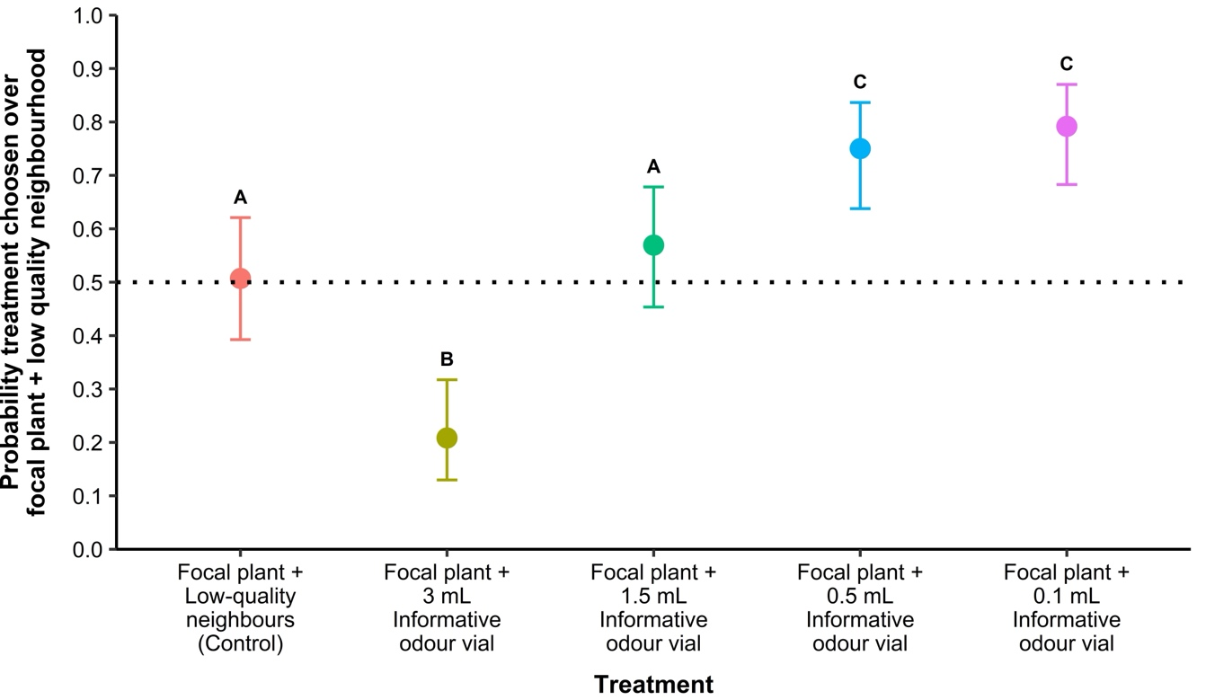
Figure N3b. Probability (means ± 95% CI) treatment is chosen over 175 g focal P. capensis mixed with 875 g of real low-quality E. undulata. Control = 175 g focal P. capensis mixed with 875 g of real E. undulata (low-quality neighbours). Focal plant = 175 g P. capensis. If error bars do not overlap the dashed line (random choice), the preference for a treatment is significant. Error bars above the dashed line show preference for the treatment, error bars below the dashed line show avoidance of the treatment. Different letters indicate significant differences in preferences among treatments.

