Conservation among Apicomplexa for 188 PTPs
Of the 188 PTPs, only seven were restricted to Theileria species, namely EAN31530.1, EAN31807.1, EAN32811.1, EAN33054.1, EAN33784.1, EAN34055.1, and KAF5153161.1. Among the remaining 171 proteins, 166 were found in Babesia, Plasmodium, and the Conoidasida. Eight were restricted to Babesia and two to Plasmodium. One protein was exclusive to Aconoidasida, while four proteins were common between Babesia and the Conoidasida, possibly suggesting deletion from the Plasmodium genus. These results are illustrated in Figure H.1, and detailed in Table H.1.

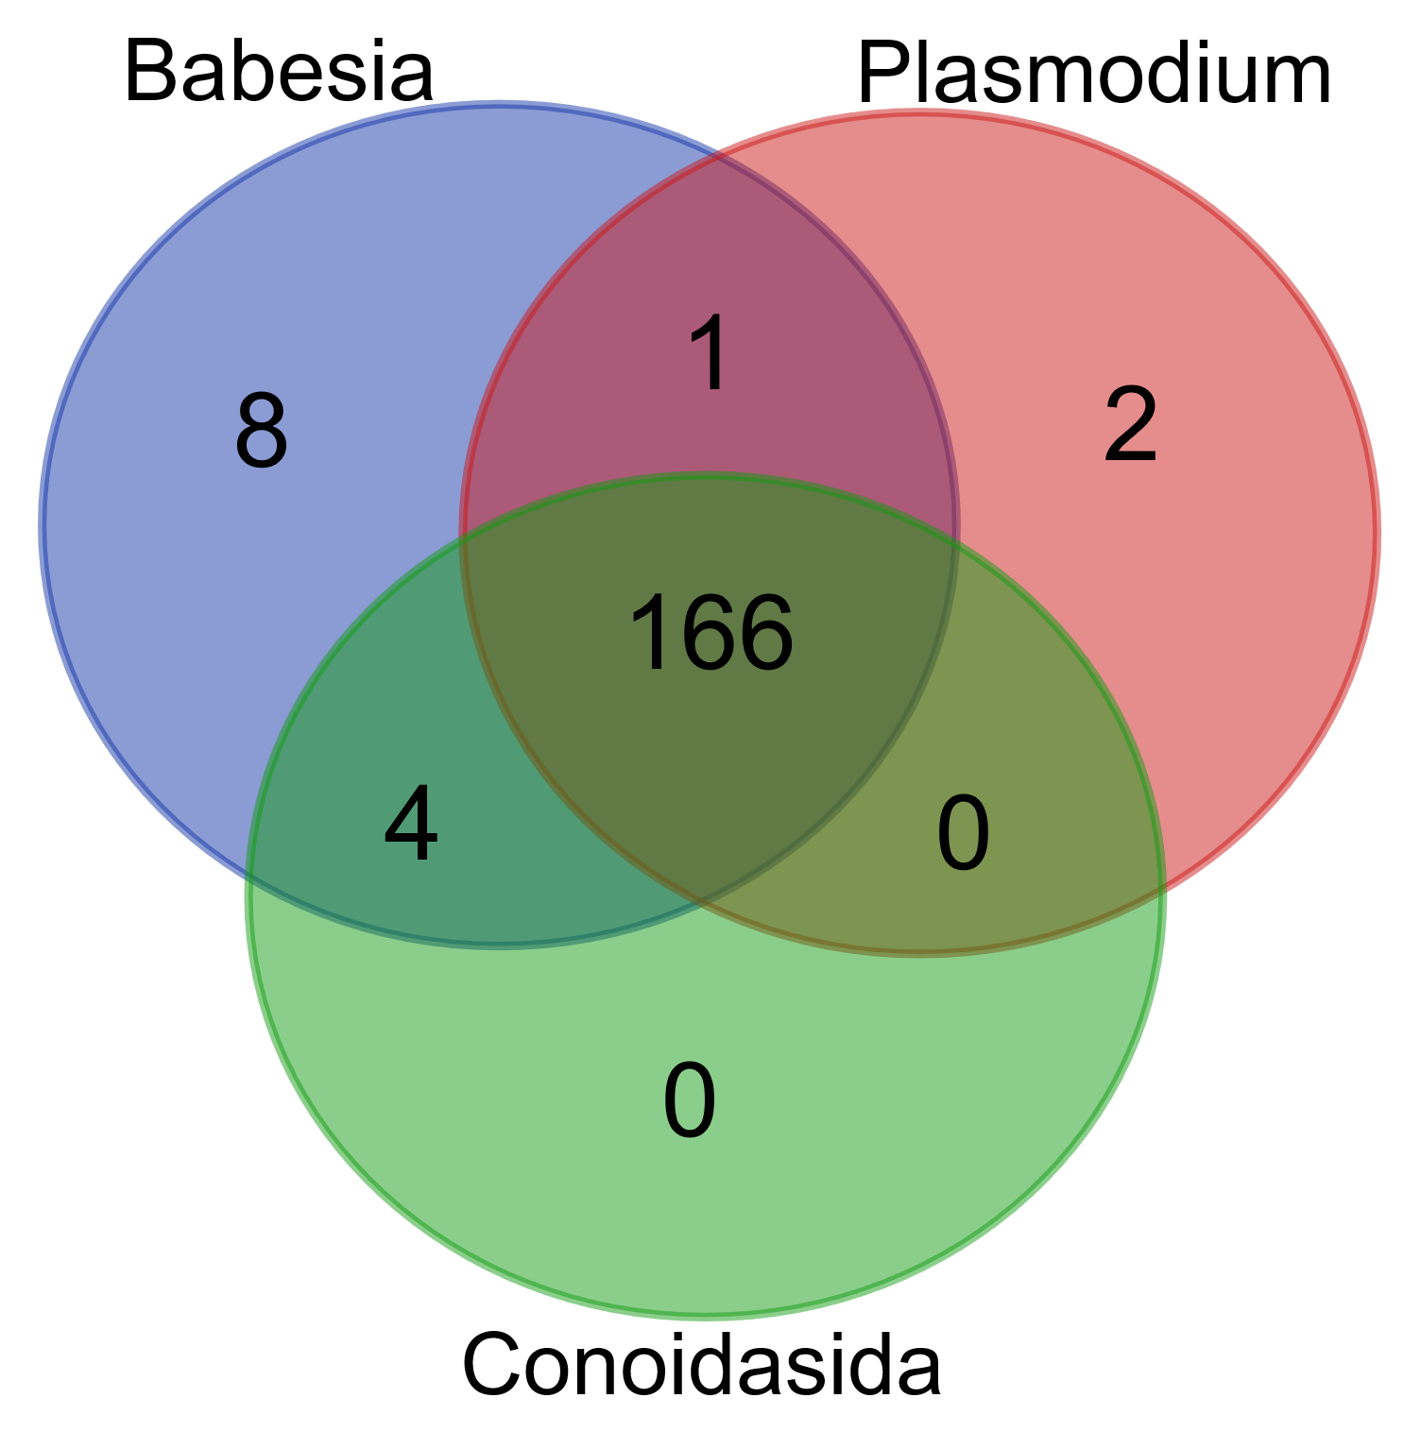
Figure H.1: Distribution of the 188 potential transport-related proteins among different apicomplexan taxonomic groups

Table H.1: Details of the distribution of 188 potential transport-related proteins among different apicomplexan taxonomic groups. Accompanies Figure H.1
Category | Total | Accessions
Babesia Conoidasida Plasmodium | 166 | EAN32984.1 EAN31304.1 EAN32434.1 EAN32601.1 EAN34161.1 EAN33745.1 EAN33316.1 EAN32783.1 EAN31570.1 EAN30800.1 EAN31281.1 EAN33035.1 EAN32507.1 EAN34037.1 EAN33343.1 EAN31553.1 EAN32576.1 EAN31085.1 EAN31883.1 EAN31625.1 EAN33698.1 EAN30992.1 EAN31893.1 EAN33420.1 EAN34401.2 KAF5153135.1 EAN31078.1 EAN33445.1 EAN31793.1 EAN31788.1 EAN34251.1 EAN31111.1 EAN30799.1 EAN31293.2 EAN31223.2 EAN32807.1 EAN32643.2 EAN34042.1 KAF5153138.1 EAN33225.1 EAN32673.1 EAN32639.1 EAN31580.1 EAN31291.1 EAN32706.1 EAN31289.1 EAN32728.1 EAN30877.2 EAN31072.1 EAN31074.1 EAN32773.1 EAN34131.2 EAN34374.1 EAN32067.1 EAN31945.2 EAN30694.1 EAN32036.1 EAN33088.1 EAN32262.1 EAN32084.1 EAN30520.1 EAN30900.1 EAN30853.1 EAN34338.1 EAN33599.1 EAN31314.1 EAN32571.1 EAN34123.2 EAN31258.1 EAN32895.1 EAN33496.2 EAN32209.2 EAN34307.1 KAF5153593.1 EAN30693.1 EAN32427.1 KAF5153653.1 EAN33235.2 EAN31185.1 EAN32157.1 KAF5153216.1 EAN34036.2 EAN32536.2 EAN34448.2 EAN32088.1 EAN32303.1 EAN32743.1 KAF5153531.1 EAN34189.1 EAN32957.1 EAN33037.1 EAN34284.1 EAN31904.1 EAN33970.2 EAN33255.1 EAN32955.1 EAN30993.2 EAN31288.2 EAN33934.2 KAF5153666.1 EAN30743.1 EAN30706.2 EAN31106.1 EAN31347.1 EAN32992.2 EAN33021.1 EAN33646.1 EAN32186.1 EAN33203.1 EAN31084.2 EAN31982.1 EAN31285.1 EAN33971.1 KAF5153605.1 KAF5153237.1 EAN31181.2 EAN30577.1 EAN32674.1 EAN33527.1 EAN34339.2 EAN31107.1 EAN30606.2 KAF5153131.1 KAF5153638.1 EAN32336.1 EAN34090.1 EAN32514.2 EAN32733.1 EAN32596.1 EAN33895.1 EAN31077.1 EAN31694.2 EAN31669.2 EAN31014.1 EAN32894.1 EAN32671.1 EAN32771.1 EAN34245.1 EAN30689.2 EAN31073.1 EAN33761.1 EAN32991.1 EAN32765.1 EAN31373.2 EAN31920.1 EAN32888.1 EAN31076.1 EAN33779.1 EAN31286.1 EAN33155.1 EAN32442.1 EAN32302.1 EAN31075.1 EAN32320.2 EAN33953.1 EAN32956.1 EAN33056.1 EAN31290.2 EAN32268.1 EAN33633.1 EAN32982.1 EAN33958.1 EAN31715.1 EAN33884.1 EAN32573.1 EAN32839.2
Babesia Plasmodium | 1 | EAN31026.2
Babesia Conoidasida | 4 | EAN33749.1 EAN32776.1 EAN34380.1 EAN33647.1
Babesia | 8 | EAN32078.1 EAN31178.1 EAN32009.1 EAN32010.2 EAN32008.1 EAN32006.1 EAN32476.1 EAN31968.1
Plasmodium | 2 | EAN32702.1 EAN33799.1

