Supplementary Material
Phenotypic plasticity in attachment and attachment-related surface properties of Bradyrhizobium diazoefficiens USDA 110 when grown in different soybean root exudate compounds
Armaan Kaur Sandhu¹, McKenzie Rae Brown¹, Senthil Subramanian^{1,2} and Volker S. Brözel^{1,3}*
* Correspondence: Corresponding Author: Volker.brozel@sdstate.edu
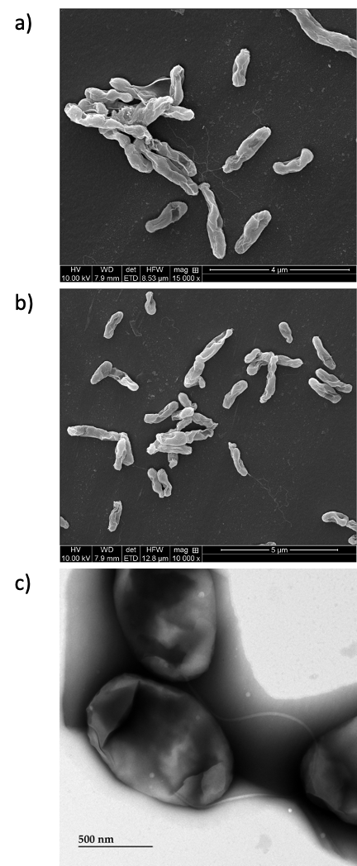

Figure S1: SEM (a, b) and TEM (c) of B. diazoefficiens USDA 110 cultured in raffinose, showing sub-polar flagella.
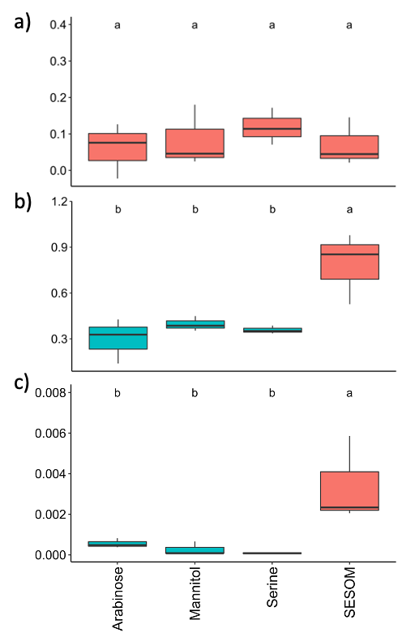

Figure S2: Biofilm formation on polystyrene (a), hydrophobicity determined by the MATH assay using hexadecane (b), and attachment to soybean roots of B. japonicum USDA 20 (c).

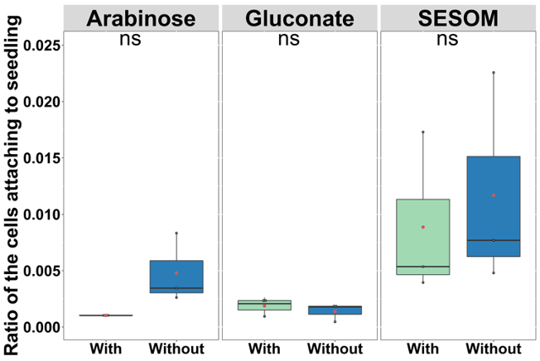

Figure S3: Root attachment of B. diazoefficiens USDA 110 cultured in arabinose, gluconate and SESOM before (with, green columns) and after (without, blue columns) removal of EPS.

