Supporting information

Abundance and trait-matching both shape interaction frequencies between plants and birds in seed-dispersal networks

APPENDIX 1- Morphological traits of fleshy-fruited plants and legitimate avian frugivores of the Cantabrian Range (northern Iberian Peninsula).
Table S1.1. Average values of morphological traits of fleshy-fruited plant species.
Species | Common name | Acronym | Fruit width (mm) | Height (m)
Crataegus monogyna | Hawthorn | Cramon | 9.54 | 9.00
Ilex aquifolium | Holly | Ileaqu | 8.96 | 12.00
Rubus fruticosus/ulmifolius | Bramble/Blackberry | Rubfru | 3.57 | 1.50
Sambucus nigra | Elder | Samnig | 5.01 | 4.00
Sorbus aria | Whitebeam | Sorari | 11.34 | 18.00
Sorbus aucuparia | Rowan | Sorauc | 10.35 | 20.00
Taxus baccata | Yew | Taxbac | 9.37 | 25.00

Table S1.2. Average values of morphological traits of frugivores and legitimate seed dispersers.
Species | Common name | Acronym | Bill width (mm) | Kipp’s index
Erithacus rubecula | European robin | Erirub | 7.28 | 0.22
Garrulus glandarius | Eurasian jay | Gargla | 17.60 | 0.19
Sylvia atricapilla | Eurasian blackcap | Sylatr | 7.48 | 0.27
Turdus iliacus | Redwing | Turili | 10.78 | 0.32
Turdus merula | Common blackbird | Turmer | 12.39 | 0.23
Turdus phillomelos | Song thrush | Turphi | 12.20 | 0.32
Turdus pilaris | Fieldfare | Turpil | 12.90 | 0.33
Turdus torquatus | Ring ouzel | Turtor | 13.37 | 0.31
Turdus viscivorus | Mistle thrush | Turvis | 13.05 | 0.35

APPENDIX 2- Relationship between plant and bird species abundances with their degree of specialization (d’). Plant-bird pairwise interactions of fleshy fruited plants and avian seed dispersers and their abundances.
We estimated the degree of specialization of each plant and bird species, which allows to distinguish between generalist and specialist species. For this, we calculated the standardized Kullback–Leibler divergence (d'; Blüthgen, Menzel, & Blüthgen, 2006). This is a measure of the specialization of a given species and also of the exclusiveness (non-overlap) in interactions relative to other species, representing thus the complementarity in the functional niche of species within the same trophic level (Blüthgen & Klein, 2011). Values of d', which range from 0 to 1, where high values of d′ thus characterize specialist species. We estimated d’ for each species with the Bipartite package in r (Dormann, 2011). For this, we included all plant-bird interactions to build the global network of our community.
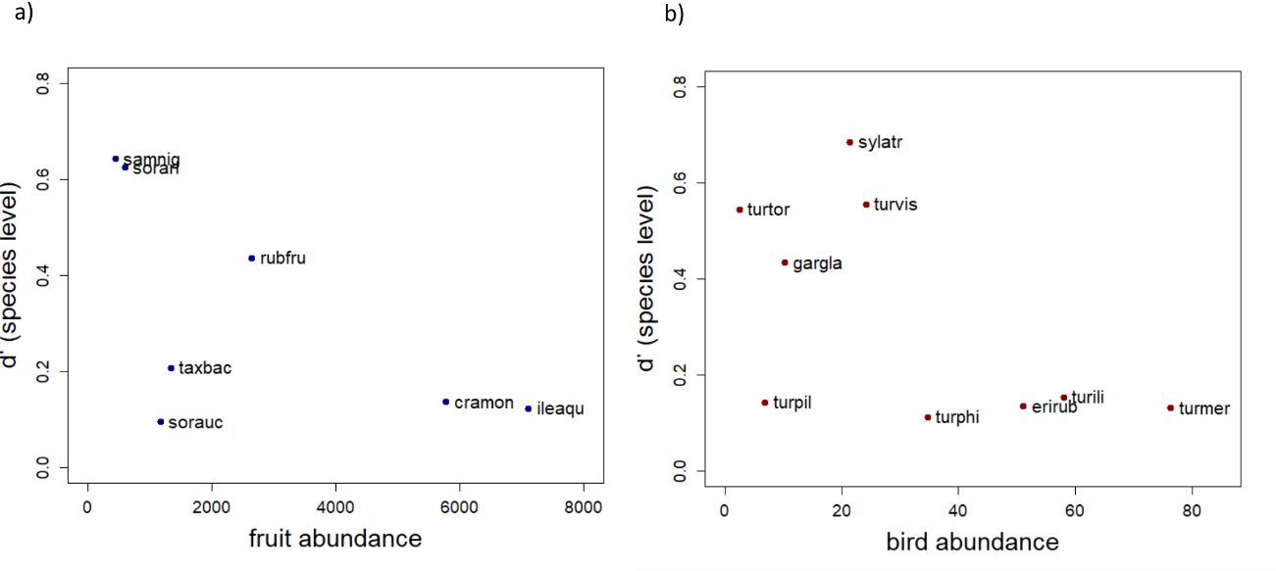
Figure S2. Relationship between the degree of specialization (d’) of each fleshy-fruited plant and bird species —estimated from the plant-frugivore regional network (two pooled years) — and species abundances —as the cumulative number of individuals of each species observed in the two sampled years (squared root-transformed)— for a) plants and b) birds. Points represent each species, and species names are indicated by their acronyms (see tables S1.1 and S1.2).

References:
Blüthgen, N., & Klein, A. M. (2011). Functional complementarity and specialisation: The role of biodiversity in plant-pollinator interactions. Basic and Applied Ecology, 12(4), 282–291. https://doi.org/10.1016/j.baae.2010.11.001
Blüthgen, N., Menzel, F., & Blüthgen, N. (2006). Measuring specialization in species interaction networks. BMC Ecology, 6(1), 9. https://doi.org/10.1186/1472-6785-6-9
Dormann, C. F. (2011). How to be a specialist? Quantifying specialisation in pollination networks. Network Biology, 1(1), 1–20.
Table S2.1 Cumulative and relative abundances and the relative interaction frequency of each fleshy-fruited plant species per sampled year. Species names are indicated by their acronyms (see table S1.1).

Year |  | 2012 |  |  | 2013
Plant  species | Fruit  abundance | Relative abundance | Interaction frequency | Fruit abundance | Relative abundance | Interaction frequency
Cramon | 16804146 | 0.5 | 0.745 | 16590478 | 0.272 | 0.346
Ileaqu | 10627070 | 0.316 | 0.064 | 39833401 | 0.654 | 0.43
Rubfru | 4810249 | 0.143 | 0.053 | 2170409 | 0.036 | 0.042
Samnig | 104060 | 0.003 | 0.001 | 90006 | 0.001 | 0.053
Sorari | 280 | 0 | 0.003 | 354104 | 0.006 | 0.065
Sorauc | 165901 | 0.005 | 0.021 | 1199055 | 0.02 | 0.055
Taxbac | 1130001 | 0.034 | 0.113 | 650543 | 0.011 | 0.008

Table S2.2 Cumulative and relative abundances and the relative interaction frequency of each avian frugivore species per sampled year. Species names are indicated by their acronyms (see table S1.2).

Year |  | 2012 |  |  | 2013
Bird  species | Bird abundance | Relative abundance | Interaction frequency | Bird abundance | Relative abundance | Interaction frequency
Erirub | 889 | 0.136 | 0.021 | 1724 | 0.224 | 0.015
Gargla | 53 | 0.008 | 0.004 | 52 | 0.007 | 0.002
Sylatr | 187 | 0.029 | 0.037 | 273 | 0.035 | 0.08
Turili | 1541 | 0.237 | 0.206 | 1825 | 0.237 | 0.144
Turmer | 2535 | 0.389 | 0.544 | 3304 | 0.429 | 0.625
Turphi | 864 | 0.133 | 0.114 | 342 | 0.044 | 0.072
Turpil | 47 | 0.007 | 0.049 | 0 | 0 | 0
Turvis | 398 | 0.061 | 0.025 | 184 | 0.024 | 0.057
Turtor | 0 | 0 | 0 | 6 | 0.001 | 0.005

Table S2.3 Common pairwise interactions for each sampled year indicating the frequency of each pairwise interaction (IF). Species names are indicated by their acronyms (see tables S1.1 and S1.2).
 |  |  |  |  | 2012 |  |  |  |  |  | 2013
 | Bird species | Plant species | N. Interactions | Relative IF | Bird abundance | Bird relative abundance | Fruit abundance | Fruit relative abundance | N. Interactions | Relative IF | Bird abundance | Bird relative abundance | Fruit abundance | Fruit relative abundance
1 | Erirub | Cramon | 18 | 0.014 | 889 | 0.136 | 16804146 | 0.500 | 11 | 0.007 | 1724 | 0.224 | 16590478 | 0.272
2 | Erirub | Rubfru | 7 | 0.005 | 889 | 0.136 | 4810249 | 0.143 | 8 | 0.005 | 1724 | 0.224 | 2170409 | 0.036
3 | Gargla | Rubfru | 4 | 0.003 | 53 | 0.008 | 4810249 | 0.143 | 3 | 0.002 | 52 | 0.007 | 2170409 | 0.036
4 | Sylatr | Cramon | 1 | 0.001 | 187 | 0.029 | 16804146 | 0.500 | 3 | 0.002 | 273 | 0.035 | 16590478 | 0.272
5 | Sylatr | Rubfru | 38 | 0.029 | 187 | 0.029 | 4810249 | 0.143 | 37 | 0.023 | 273 | 0.035 | 2170409 | 0.036
6 | Sylatr | Samnig | 1 | 0.001 | 187 | 0.029 | 104060 | 0.003 | 76 | 0.047 | 273 | 0.035 | 90006 | 0.001
7 | Turili | Cramon | 195 | 0.150 | 1541 | 0.237 | 16804146 | 0.500 | 46 | 0.029 | 1825 | 0.237 | 16590478 | 0.272
8 | Turili | Ileaqu | 68 | 0.052 | 1541 | 0.237 | 10627070 | 0.316 | 186 | 0.116 | 1825 | 0.237 | 39833401 | 0.654
9 | Turmer | Cramon | 625 | 0.479 | 2535 | 0.389 | 16804146 | 0.500 | 424 | 0.264 | 3304 | 0.429 | 16590478 | 0.272
10 | Turmer | Ileaqu | 10 | 0.008 | 2535 | 0.389 | 10627070 | 0.316 | 457 | 0.284 | 3304 | 0.429 | 39833401 | 0.654
11 | Turmer | Rubfru | 8 | 0.006 | 2535 | 0.389 | 4810249 | 0.143 | 20 | 0.012 | 3304 | 0.429 | 2170409 | 0.036
12 | Turmer | Sorauc | 27 | 0.021 | 2535 | 0.389 | 165901 | 0.005 | 77 | 0.048 | 3304 | 0.429 | 1199055 | 0.020
13 | Turmer | Taxbac | 40 | 0.031 | 2535 | 0.389 | 1130001 | 0.034 | 7 | 0.004 | 3304 | 0.429 | 650543 | 0.011
14 | Turphi | Cramon | 63 | 0.048 | 864 | 0.133 | 16804146 | 0.500 | 68 | 0.042 | 342 | 0.044 | 16590478 | 0.272
15 | Turphi | Ileaqu | 6 | 0.005 | 864 | 0.133 | 10627070 | 0.316 | 34 | 0.021 | 342 | 0.044 | 39833401 | 0.654
16 | Turphi | Taxbac | 68 | 0.052 | 864 | 0.133 | 1130001 | 0.034 | 1 | 0.001 | 342 | 0.044 | 650543 | 0.011
17 | Turvis | Cramon | 10 | 0.008 | 398 | 0.061 | 16804146 | 0.500 | 5 | 0.003 | 184 | 0.024 | 16590478 | 0.272
18 | Turvis | Sorari | 3 | 0.002 | 398 | 0.061 | 280 | 0.000 | 75 | 0.047 | 184 | 0.024 | 354104 | 0.006
19 | Turvis | Taxbac | 20 | 0.015 | 398 | 0.061 | 1130001 | 0.034 | 5 | 0.003 | 184 | 0.024 | 650543 | 0.011
 |  |  |  | 0.929 |  |  |  |  |  | 0.960

Table S2.4 Pairwise interactions that occurred exclusively in a given sampled year and their relative interaction frequencies (IF). Species names are indicated by their acronyms (see tables S1.1 and S1.2).
 |  |  |  |  | 2012 |  |  |  |  |  | 2013
 | Bird species | Plant species | N. Interactions | Relative IF | Bird abundance | Bird relative abundance | Fruit abundance | Fruit relative abundance | N. Interactions | Relative IF | Bird abundance | Bird relative abundance | Fruit abundance | Fruit relative abundance
1 | Turpil | Cramon | 59 | 0.045 | 47 | 0.007 | 16804146 | 0.500 | 0 | 0 | 0 | 0 | 0 | 0
2 | Turpil | Taxbac | 5 | 0.004 | 47 | 0.007 | 1130001 | 0.034 | 0 | 0 | 0 | 0 | 650543 | 0.011
3 | Turphi | Rubfru | 12 | 0.009 | 864 | 0.133 | 4810249 | 0.143 | 0 | 0 | 342 | 0.044 | 2170409 | 0.036
4 | Sylatr | Sorari | 1 | 0.001 | 187 | 0.029 | 280 | 0.000 | 0 | 0 | 273 | 0.035 | 354104 | 0.006
5 | Erirub | Taxbac | 2 | 0.001 | 889 | 0.136 | 1130001 | 0.034 | 0 | 0 | 1724 | 0.224 | 650543 | 0.011
6 | Gargla | Taxbac | 1 | 0.001 | 53 | 0.008 | 1130001 | 0.034 | 0 | 0 | 52 | 0.007 | 650543 | 0.011
7 | Sylatr | Taxbac | 7 | 0.005 | 187 | 0.029 | 1130001 | 0.034 | 0 | 0 | 273 | 0.035 | 650543 | 0.011
8 | Turili | Taxbac | 5 | 0.004 | 1541 | 0.237 | 1130001 | 0.034 | 0 | 0 | 1825 | 0.237 | 650543 | 0.011
9 | Turtor | Sorari | 0 | 0 | 0 | 0 | 280 | 0.000 | 8 | 0.005 | 6 | 0.001 | 354104 | 0.006
10 | erirub | ileaqu | 0 | 0 | 889 | 0.136 | 10627070 | 0.316 | 1 | 0.001 | 1724 | 0.224 | 39833401 | 0.654
11 | Sylatr | ileaqu | 0 | 0 | 187 | 0.029 | 10627070 | 0.316 | 7 | 0.004 | 273 | 0.035 | 39833401 | 0.654
12 | Turvis | ileaqu | 0 | 0 | 398 | 0.061 | 10627070 | 0.316 | 6 | 0.004 | 184 | 0.024 | 39833401 | 0.654
13 | Erirub | samnig | 0 | 0 | 889 | 0.136 | 104060 | 0.003 | 3 | 0.002 | 1724 | 0.224 | 90006 | 0.001
14 | Turmer | samnig | 0 | 0 | 2535 | 0.389 | 104060 | 0.003 | 7 | 0.004 | 3304 | 0.429 | 90006 | 0.001
15 | Turphi | sorari | 0 | 0 | 864 | 0.133 | 280 | 0.000 | 8 | 0.005 | 342 | 0.044 | 354104 | 0.006
16 | erirub | sorauc | 0 | 0 | 889 | 0.136 | 165901 | 0.005 | 1 | 0.001 | 1724 | 0.224 | 1199055 | 0.020
17 | Sylatr | sorauc | 0 | 0 | 187 | 0.029 | 165901 | 0.005 | 5 | 0.003 | 273 | 0.035 | 1199055 | 0.020
18 | Turphi | sorauc | 0 | 0 | 864 | 0.133 | 165901 | 0.005 | 5 | 0.003 | 342 | 0.044 | 1199055 | 0.020
19 | Turvis | soraur | 0 | 0 | 398 | 0.061 | 165901 | 0.005 | 1 | 0.001 | 184 | 0.024 | 1199055 | 0.020

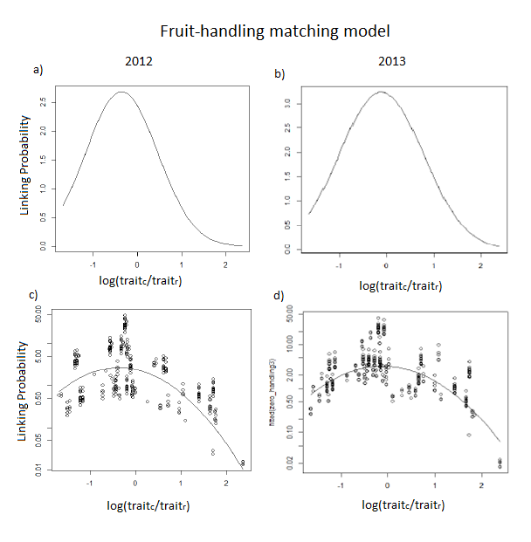
APPENDIX 3- Trait matching and optimal ratio approach.
Figure S3.1 The black curves illustrated the part of the fitted linking probabilities (log-transformed) contributed by the ratio terms of the corresponding fruit-handling model of matching for each sampling year, a) 2012 and b) 2013); c-d) White circles correspond to the observed pairwise interactions between plants and birds (log(trait_{c}/trait_{r}) data was scaled to zero mean and unit variance; max-min (trait_{c}/trait_{r}) = 4.93 - 0.64 ; mean+SD = 1.71 ± 0.50, median=1.36).

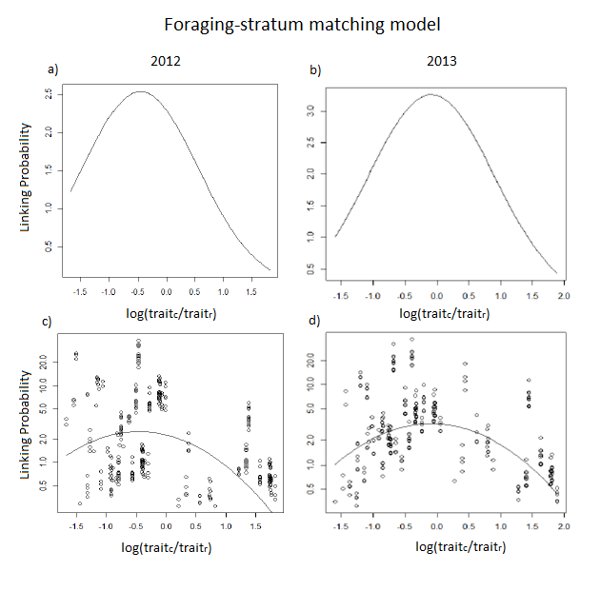
Figure S3.2 The black curves illustrated the part of the fitted linking probabilities (log-transformed) contributed by the ratio terms of the corresponding foraging-stratum model of matching for each sampled year, a) 2012 and b) 2013); c-d) White circles correspond to the observed pairwise interactions between plants and birds (log(trait_{c}/trait_{r}) data was scaled to zero mean and unit variance; max-min (trait_{c}/trait_{r}) = 0.01 - 0.23; mean ± SD = 0.06 ± 0.07, median= 0.03).

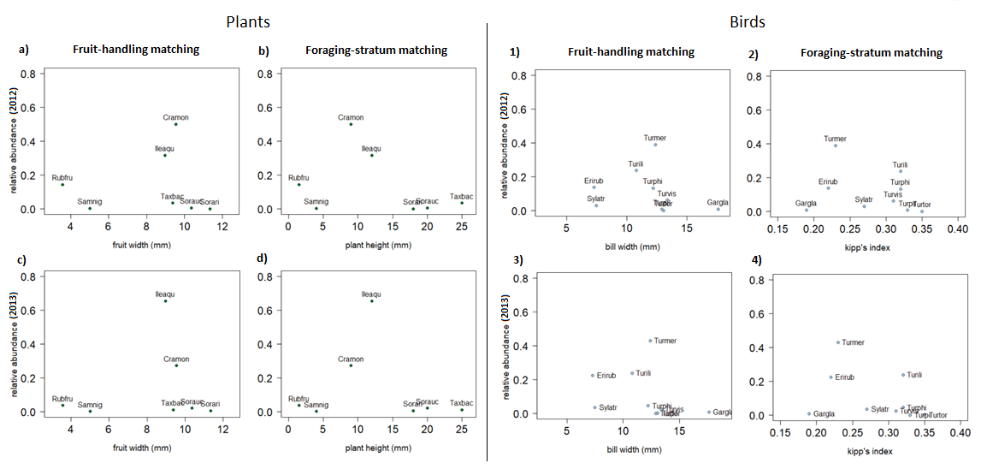
APPENDIX 4- Relationship between species relative abundances and values of matching traits for (a-d) fleshy-fruited plants and (1-4) avian frugivores of the Cantabrian Range (northern Iberian Peninsula).
Figure S4.1 Relationship between relative abundances for each sampled year, 2012 (bottom) and 2013 (down), and values of species functional traits used for estimating fruit-handling and foraging-stratum trait-matching (see Methods) between fleshy fruited plants (a-d) and avian frugivores (1-4). Points represent each species, and species names are indicated by their acronyms (see tables S1.1 and S1.2)
Table S4.1. Values and degrees of significance of Pearson’s coefficient of correlation between the relative interaction frequency of plant and bird (IF) in different sampling years (i.e., 2012 and 2013), and the corresponding plant/bird trait related to handling abilities (i.e. fruit width and bill width) and foraging behavior (i.e. plant height and Kipp’ index). Code for statistical significance: *P ≤ 0.05; ** P ≤ 0.01; *** P ≤ 0.001.
Taxa | Relative interaction frequencies (IF) | Handling traits | Foraging traits
 | IF 2012 | 0.05 | -0.33
Plants | IF 2013 | 0.15 | -0.13
 | IF 2012 | -0.19 | -0.23
Birds | IF 2013 | -0.3 | -0.38

