University of Pretoria: Creative Outputs Declaration Form
The DHET's policy requires that creators submining creative work outputs, submit a number of declarations i.e.: a declaration:of originality; non-plagiarism and creatorship I co-creatorship.

Note: this form is OT for the Academic Annotation/Framework/Motivation, which must be completed in the relevant template Spreadsheet accompanying the submission.

Name of prima ry contributor: Aubrey Lodewyk
UP Staff number: u05051152
Title of Creative output : UP staff and Lunch hour concert
Category (circle one)· -,
Design | Film | Fine Arts | Literary / |  | Music  ) | I  retevision | Theatre, Performance and Dance
Design | Film | Fine Arts | Arts | I | Music  ) | I  retevision | Theatre, Performance and Dance

'-----"

Sub-category (see list in guidelines):

Approval granted by Faculty HOD/Creative This creative output was evaluated by the HOD/Creative o t Outputs committee to submit this CO for committee and approval is granted to submit it for subsidy YES subsidy.
Declaration of originality I /We declare that the creative output has not been published in a
peer reviewed journal or a book and has not been submitted for subsidy before

Declaration that this creative work generated has not been copied from elsewhere and that the ideas are those of the claiming creator/s.
I /We declare that the creative output has not been plagiarized and that the ideas are those of the claiming creator.

Declaration of creator/co-creatorship I I We declare that I I we am/are the sole creator
/co -creator/s of this creative work.
A declaration of creator/co-creatorship and
disclosure of other active part icipants in the Primary
creation of the work Creator Print Name: Aubrey Lodewyk

(use an additionalform ifmorespace needed)
lf co-creator/s, print names: Dr. Hanli Stapela

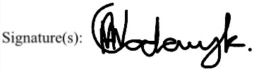
Signatures of all creators:

(use an additionalform ifmorespace needed)

Date: 7 August 2020
Signature HOD/Creative outputs pan el: Print Name: Alexander Johnson

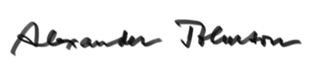Signature: Date: 08-08-2020

