Fungal Ecology Supporting Information
Article title: Deterministic processes have limited impacts on foliar fungal endophyte communities along a savanna-forest successional gradient

Authors: Mathew Andrew Harris; Martin Kemler; Bernard Slippers; Samantha-Leigh Jamison-Daniels; Frederick Witfeld; Monique Botha; Dominik Begerow; Andreas Brachmann & Michelle Greve

The following Supporting Information is available for this article:
Figure S1 Schematic of nested PCR approach
Figure S2 Heat tree for the host Euclea crispa
Figure S3 Heat tree for the host Canthium inerme
Figure S4 Heat tree for the host Searsia chirindensis
Figure S5 Eigenvalue decomposition analysis
Figure S6 α-diversity (effective number of species at the Hill number for Shannon diversity)
Figure S7 α-diversity (effective number of species at the Hill number for Inverse Simpson diversity)
Figure S8 CCA and variation partitioning analysis
Figure S9 Full GDM model fit against raw predictors
Figure S10 Euclea crispa GDM model fit against raw predictors
Figure S11 Canthium inerme GDM model fit against raw predictors
Figure S12 Searsia chirindensis GDM model fit against raw predictors
Table S1 Specific fungal ITS primers used for amplicon library preparation
Table S2 Assignment of unique tag and index combinations for each sample
Table S3 Multi-collinearity analysis.
Table S4 α-diversity (effective number of species at the Hill number for Shannon diversity)
Table S5 α-diversity (effective number of species at the Hill number for Inverse Simpson diversity)
Table S6 Sequence read count information per sample
Table S7 CCA results
Table S8 GDM results for Euclea cripsa endophyte communities
Table S9 GDM results for Canthium inerme endophyte communities
Table S10 GDM results for Searsia chirindensis endophyte communities
Methods S1 Amplicon library preparation.
Methods S2 Amplicon pooling and sequencing.

Figure. S1 Schematic representation of which regions are amplified in the two PCR steps of the nested PCR approach used for sample identification and delineation.

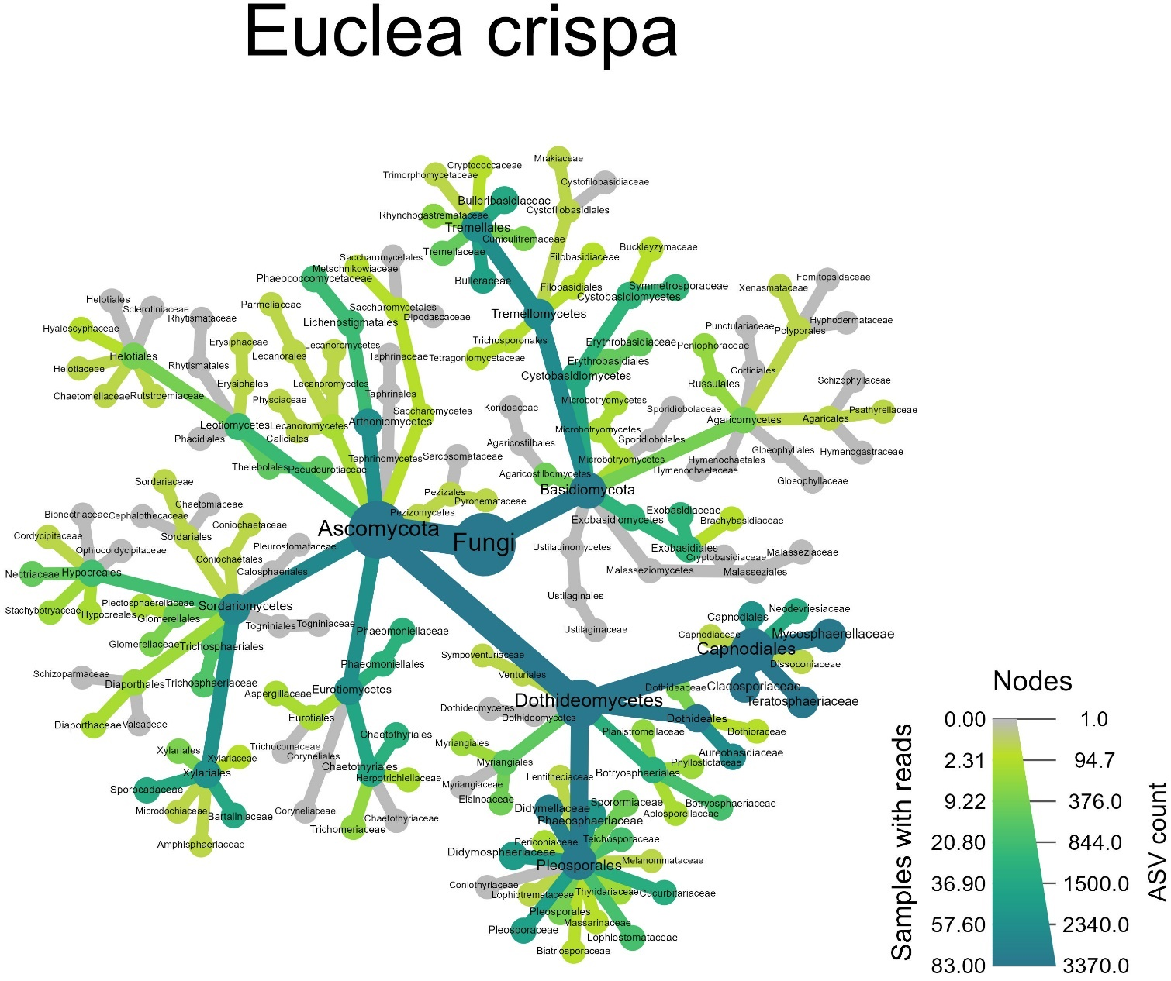
Figure S2 Heat tree for the host E. crispa showing the fungal taxonomic composition. The number of ASV reads per taxonomic lineage is represented by the colour gradient, and the number of samples which contain reads for a particular lineage represented by node size.

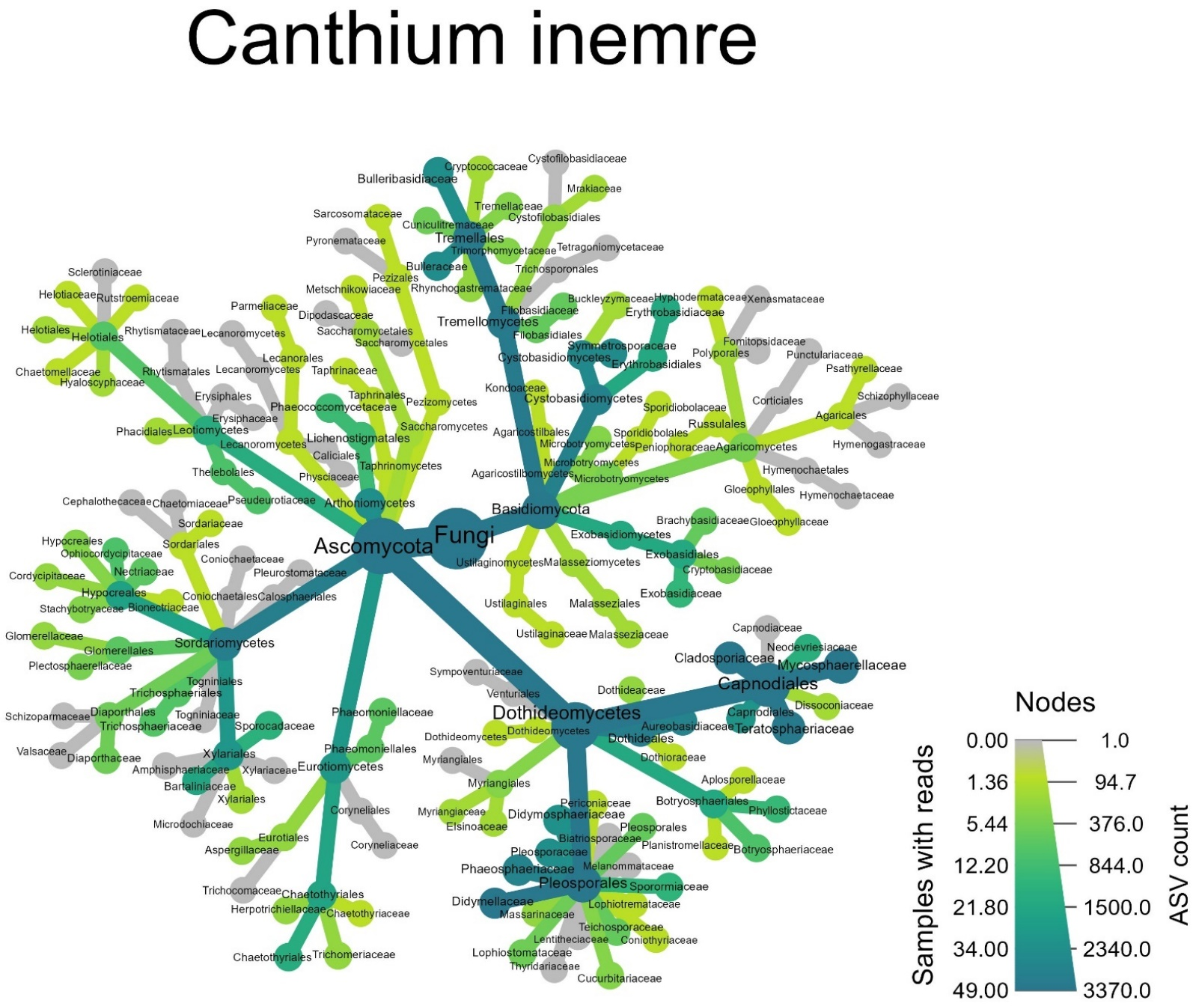

Figure S3 Heat tree for the host C. inerme showing the fungal taxonomic composition. The number of ASV reads per taxonomic lineage represented by the colours, and the number of samples which contain reads for a particular lineage represented by node size.

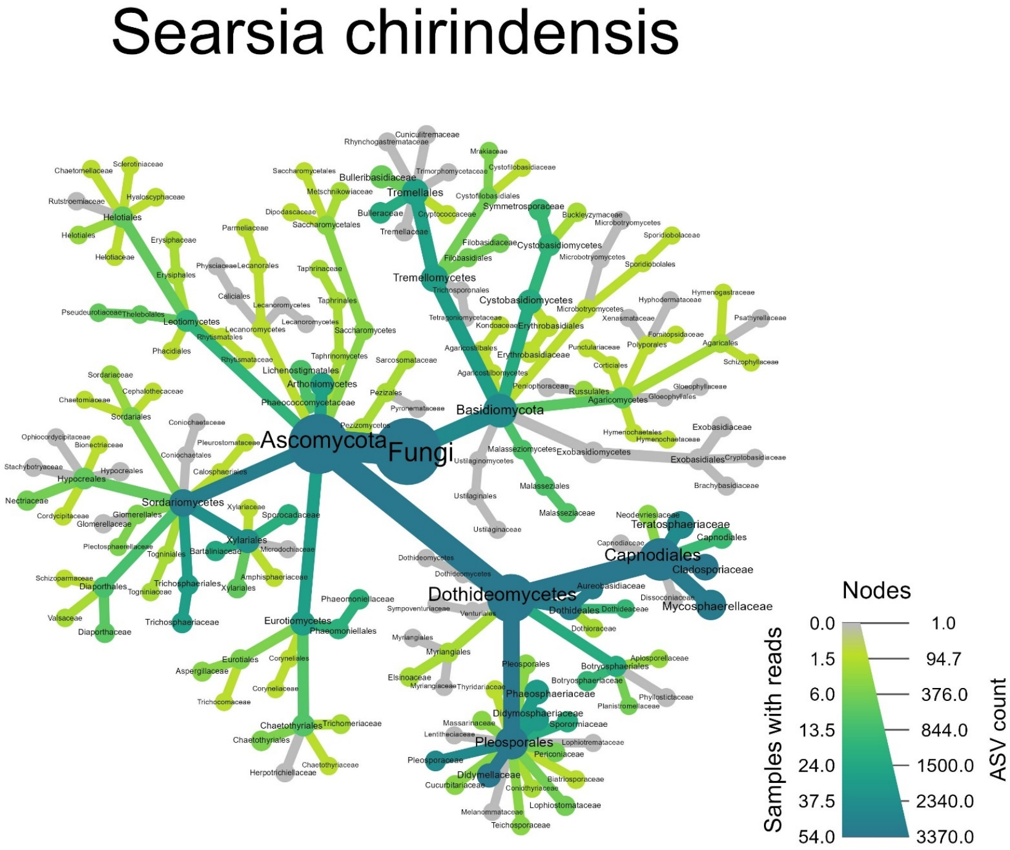

Figure S4 Heat tree for the host S. chirindensis showing the fungal taxonomic composition. The number of ASV reads per taxonomic lineage represented by the colours, and the number of samples which contain reads for a particular lineage represented by node size.

Figure. S5 Eigenvalue decomposition analysis used to determine a break in inertia for each of the first five eigenvalues of the CCA ordination as ASV occurrences were removed. The vertical line represents the break in eigenvalue inertia for eigenvalue 3, when ASVs that occurred in less than 20 samples was removed.

Figure S6 Predictor effect plots for the significant predictors from the best subset GLMM model for the effective number of species at the Hill number for Shannon entropy diversity of foliar fungi. A) The effective number of species remained constant in E.crispa, but increased in C. inerme and S.chirindensis as bush clump tree basal area increased. B) Light intensity experienced within BCs had no effect on the effective number of species in C. inerme, whereas the effective number of species decreased in E. crispa and increased in S. chirindensis with light intensity – x-axis represents inverse light intensity measured as photosynthetic active radiation (PAR) outside a BC minus PAR inside a BC. C) The effective number of species decreased as the distance to the indigenous forest increased. D) Effective number of species decreased with maximum temperature. Light blude shading represents the 95% confidence interval for the fitted model.

Figure S7 Predictor effect plots for the significant predictors from the best subset GLMM model for the effective number of species at the Hill number for Inverse Simpsons diversity of foliar fungi. A) The effective number of species decreased with maximum temperatures. B) The effective number of species decreased with distance to the indigenous forest edge. Light blue shading represents the 95% confidence interval for the fitted model.

Figure S8. a) CCA ordination showing the best fitting model that explains foliar fungal endophyte community composition, based on 1000 permutations and averaged forward and backward stepwise model selection. Spatial eigenvectors are the retained eigenvectors from the PCNM analysis. Shaded convex hulls represents all samples taken from a particular host. b) Variation partitioning between the six retained variables (host identity, four spatial variables, and light intensity) that were identified from the CCA ordination, i.e. the best subset model based on AIC score. The variation partitioning analysis determines the individual portion of the variation that can be explained by each set of variables and the interactions between sets of variables. The results from the CCA and variation partitioning analysis are presented for comparison with the GDM results (Figure 5 and Table 2). The difference here is that the CCA analysis only allowed the inclusion of categorical (i.e. host), linear (e.g. climate) and spatial data (i.e. geographic distance) whereas the GDM analysis additionally allowed the inclusion of tree compositional data into the same analysis.

Figure S9 A) Plot of the observed compositional dissimilarity against the raw predictors from the GDM model on the full ASV dataset. B) The observed compositional dissimilarity against the predicted dissimilarity from the GDM model on the full ASV dataset.

Figure S10 A) Plot of the observed compositional dissimilarity against the raw predictors from the GDM model performed on samples only collected from the host Euclea crispa. B) The observed compositional dissimilarity against the predicted dissimilarity from the GDM model performed on samples only collected from the host Euclea crispa.

Figure S11 A) Plot of the observed compositional dissimilarity against the raw predictors from the GDM model performed on samples only collected from the host Canthium inerme. B) The observed compositional dissimilarity against the predicted dissimilarity from the GDM model performed on samples only collected from the host Canthium inerme.

Figure S12 A) Plot of the observed compositional dissimilarity against the raw predictors from the GDM model performed on samples only collected from the host Searsia chirindensis. B) The observed compositional dissimilarity against the predicted dissimilarity from the GDM model performed on samples only collected from the host Searsia chirindensis.

Table S1 Assignment of unique tag and index combination for each of the samples across the two PCR plates for all 189 samples. The two samples highlighted in red (BC13 SC4 and BC29 EC1) failed to amplify any fungal DNA and were excluded before DNA pooling. BC = Bush clump, CI = Canthium inerme, EC = Euclea crispa and SC = Searsia chirindensis. The numbers 1-4 represent the replicate of a particular host species individual per bush clump
 | Indices | 504.1-704.1 | 504.2-704.2 | 504.3-704.3 | 504.4-704.4 | 505.1-705.1 | 505.2-705.2 | 505.3-705.3 | 505.4-705.4 | 506.1-706.1 | 506.2-706.2 | 506.3-706.3 | 506.4-706.4
Tag | Plate 2 | 1 | 2 | 3 | 4 | 5 | 6 | 7 | 8 | 9 | 10 | 11 | 12
F1.1-R1.1 | A | BC30 EC2 | BC30 EC4 | BC29 SC3 | BC32 SC1 | BC32 SC4 | BC11 SC1 | BC08 SC1 | BC29 SC1 | BC19 SC1 | BC30 SC1 | BC22 SC1 | BC13 SC1
F1.2-R1.2 | B | BC06 CI2 | BC12 CI1 | BC09 SC1 | BC01 SC1 | BC28 SC1 | BC32 SC3 | BC22 SC2 | BC35 SC1 | BC25 SC3 | BC27 SC3 | BC18 SC4 | BC18 SC1
F2.2-R2.2 | C | BC01 CI1 | BC32 CI1 | BC36 EC3 | BC21 EC2 | BC39 EC2 | BC23 EC3 | BC22 EC2 | BC25 EC2 | BC28 SC2 | BC36 SC1 | BC33 SC2 | BC36 SC2
F2.3-R2.3 | D | BC29 EC2 | BC13 EC2 | BC27 EC2 | BC17 EC1 | BC30 EC3 | BC25 EC1 | BC23 EC1 | BC29 SC1 | BC23 SC1 | BC02 SC1 | BC33 SC1 | BC38 SC1
F3.3-R3.3 | E | BC15 EC2 | BC18 EC2 | BC39 SC1 | BC17 SC2 | BC13 SC4 | BC31 SC1 | BC27 SC1 | BC20 SC1 | BC33 SC3 | BC36 SC3 | BC37 SC1
F3.4-R3.4 | F | BC18 CI2 | BC37 CI2 | BC13 SC1 | BC37 SC2 | BC13 SC2 | BC10 SC1 | BC41 SC1 | BC06 SC1 | BC27 SC4 | BC18 SC3 | BC27 SC2
F4.4-R4.4 | G | BC40 CI4 | BC22 EC1 | BC26 EC1 | BC37 EC1 | BC14 EC2 | BC36 EC1 | BC17 EC3 | BC18 SC2 | BC17 SC1 | BC25 SC3 | BC32 SC2
F4.1-R4.1 | H | BC22 EC4 | BC25 EC3 | BC31 EC4 | BC18 EC4 | BC19 EC4 | BC39 EC1 | BC29 EC1 | BC41 SC2 | BC23 SC2 | BC08 SC2 | BC25 SC1

 | Indices | 501.1-701.1 | 501.2-701.2 | 501.3-701.3 | 501.4-701.4 | 502.1-702.1 | 502.2-702.2 | 502.3-702.3 | 502.4-702.4 | 503.1-703.1 | 503.2-703.2 | 503.3-703.3 | 503.4-703.4
Tag | Plate 1 | 1 | 2 | 3 | 4 | 5 | 6 | 7 | 8 | 9 | 10 | 11 | 12
F1.1-R1.1 | A | BC35 EC1 | BC34 EC1 | BC14 EC4 | BC20 CI3 | BC19 EC3 | BC15 EC1 | BC40 EC2 | BC06 EC2 | BC06 EC1 | BC22 EC3 | BC16 EC1 | BC15 EC4
F1.2-R1.2 | B | BC25 EC4 | BC03 EC2 | BC23 EC4 | BC31 CI4 | BC31 EC3 | BC31 CI3 | BC27 CI4 | BC22 CI4 | BC25 CI2 | BC25 CI1 | BC22 CI1 | BC12 CI2
F2.2-R2.2 | C | BC40 EC3 | BC33 CI1 | BC14 EC1 | BC40 EC4 | BC17 EC4 | BC27 CI2 | BC13 CI1 | BC27 CI1 | BC16 CI2 | BC31 CI2 | BC10 CI2 | BC30 CI2
F2.3-R2.3 | D | BC36 EC4 | BC32 CI2 | BC20 EC1 | BC23 CI2 | BC37 CI1 | BC45 EC2 | BC40 EC1 | BC29 EC3 | BC32 EC3 | BC18 EC3 | BC31 EC2 | BC16 EC3
F3.3-R3.3 | E | BC40 CI3 | BC06 EC3 | BC37 CI3 | BC23 EC2 | BC19 EC2 | BC31 EC1 | BC13 EC1 | BC36 EC2 | BC27 EC4 | BC16 EC4 | BC32 EC2 | BC32 EC1
F3.4-R3.4 | F | BC40 CI1 | BC17 EC2 | BC22 CI3 | BC21 EC1 | BC26 CI1 | BC31 CI1 | BC18 CI1 | BC33 CI3 | BC33 CI2 | BC33 CI3 | BC40 CI2 | BC23 CI1
F4.4-R4.4 | G | BC30 CI1 | BC32 EC4 | BC01 EC1 | BC30 CI3 | BC20 CI1 | BC30 EC1 | BC10 CI1 | BC20 CI2 | BC04 CI1 | BC27 CI3 | BC03 CI1 | BC16 CI1
F4.1-R4.1 | H | BC22 CI2 | BC26 EC2 | BC14 EC3 | BC06 CI1 | BC03 EC3 | BC16 EC2 | BC03 EC1 | BC19 EC1 | BC18 EC2 | BC13 EC3 | BC27 EC1 | BC15 EC3
Table S2 Specific ITS1-F and ITS4 primers and barcode tag sequences which were used for the first PCR step of the amplicon library preparation.

Name | Length | Full sequence | Overlap | Barcode tag sequence | Primer sequence
ITS1F_1.1 | 47 | TACACGACGCTCTTCCGATCTTCATCTTGGTCATTTAGAGGAAGTAA | TACACGACGCTCTTCCGATCT | TCAT | CTTGGTCATTTAGAGGAAGTAA
ITS1F_1.2 | 47 | TACACGACGCTCTTCCGATCTGACGCTTGGTCATTTAGAGGAAGTAA | TACACGACGCTCTTCCGATCT | GACG | CTTGGTCATTTAGAGGAAGTAA
ITS1F_2.3 | 49 | TACACGACGCTCTTCCGATCTCATGGCCTTGGTCATTTAGAGGAAGTAA | TACACGACGCTCTTCCGATCT | CATGGC | CTTGGTCATTTAGAGGAAGTAA
ITS1F_2.4 | 49 | TACACGACGCTCTTCCGATCTAATGTACTTGGTCATTTAGAGGAAGTAA | TACACGACGCTCTTCCGATCT | AATGTA | CTTGGTCATTTAGAGGAAGTAA
ITS1F_3.3 | 50 | TACACGACGCTCTTCCGATCTGGATCGACTTGGTCATTTAGAGGAAGTAA | TACACGACGCTCTTCCGATCT | GGATCGA | CTTGGTCATTTAGAGGAAGTAA
ITS1F_3.4 | 50 | TACACGACGCTCTTCCGATCTTGCTATCCTTGGTCATTTAGAGGAAGTAA | TACACGACGCTCTTCCGATCT | TGCTATC | CTTGGTCATTTAGAGGAAGTAA
ITS1F_4.1 | 51 | TACACGACGCTCTTCCGATCTGACATCCACTTGGTCATTTAGAGGAAGTAA | TACACGACGCTCTTCCGATCT | GACATCCA | CTTGGTCATTTAGAGGAAGTAA
ITS1F_4.4 | 51 | TACACGACGCTCTTCCGATCTGACAGAACCTTGGTCATTTAGAGGAAGTAA | TACACGACGCTCTTCCGATCT | GACAGAAC | CTTGGTCATTTAGAGGAAGTAA
ITS4_1.1 | 47 | CAGACGTGTGCTCTTCCGATCTAGGAGTCCTCCGCTTATTGATATGC | CAGACGTGTGCTCTTCCGATCT | AGGAG | TCCTCCGCTTATTGATATGC
ITS4_1.2 | 47 | CAGACGTGTGCTCTTCCGATCTCTGCTTCCTCCGCTTATTGATATGC | CAGACGTGTGCTCTTCCGATCT | CTGCT | TCCTCCGCTTATTGATATGC
ITS4_2.2 | 48 | CAGACGTGTGCTCTTCCGATCTATATCATCCTCCGCTTATTGATATGC | CAGACGTGTGCTCTTCCGATCT | ATATCA | TCCTCCGCTTATTGATATGC
ITS4_2.3 | 48 | CAGACGTGTGCTCTTCCGATCTCGAGACTCCTCCGCTTATTGATATGC | CAGACGTGTGCTCTTCCGATCT | CGAGAC | TCCTCCGCTTATTGATATGC
ITS4_3.3 | 49 | CAGACGTGTGCTCTTCCGATCTGAGAACCTCCTCCGCTTATTGATATGC | CAGACGTGTGCTCTTCCGATCT | GAGAACC | TCCTCCGCTTATTGATATGC
ITS4_3.4 | 49 | CAGACGTGTGCTCTTCCGATCTGCTCCAATCCTCCGCTTATTGATATGC | CAGACGTGTGCTCTTCCGATCT | GCTCCAA | TCCTCCGCTTATTGATATGC
ITS4_4.1 | 50 | CAGACGTGTGCTCTTCCGATCTTTGACCAGTCCTCCGCTTATTGATATGC | CAGACGTGTGCTCTTCCGATCT | TTGACCAG | TCCTCCGCTTATTGATATGC
ITS4_4.4 | 50 | CAGACGTGTGCTCTTCCGATCTTTGCAACTTCCTCCGCTTATTGATATGC | CAGACGTGTGCTCTTCCGATCT | TTGCAACT | TCCTCCGCTTATTGATATGC

 | Elevation | Tree Height | Bush clump area | Mean soil moisture | Max temp | Min temp | Temp SD | Difference in light intensity | Relative humidity min | Bush clump tree species richness | Bush clump tree diversity | Bush clump tree basal Area | Forest distance
Elevation | 1.000 | 0.232 | -0.176 | 0.203 | -0.197 | -0.078 | -0.403 | 0.238 | 0.382 | -0.225 | -0.183 | -0.097 | 0.462
Tree Height | 0.232 | 1.000 | 0.085 | 0.108 | -0.187 | 0.054 | -0.223 | 0.165 | 0.319 | 0.061 | -0.203 | 0.105 | 0.136
Bush clump area | -0.176 | 0.085 | 1.000 | 0.133 | -0.431 | 0.623 | -0.395 | 0.490 | 0.173 | 0.835 | -0.691 | 0.898 | 0.234
Mean soil moisture | 0.203 | 0.108 | 0.133 | 1.000 | 0.020 | 0.186 | 0.003 | 0.249 | 0.447 | 0.059 | -0.214 | 0.023 | -0.185
Max temp | -0.197 | -0.187 | -0.431 | 0.020 | 1.000 | -0.392 | 0.764 | -0.150 | -0.658 | -0.421 | 0.551 | -0.469 | -0.371
Min temp | -0.078 | 0.054 | 0.623 | 0.186 | -0.392 | 1.000 | -0.476 | 0.456 | 0.014 | 0.552 | -0.498 | 0.562 | -0.008
Temp SD | -0.403 | -0.223 | -0.395 | 0.003 | 0.764 | -0.476 | 1.000 | -0.311 | -0.642 | -0.346 | 0.497 | -0.432 | -0.343
Difference in light intensity | 0.238 | 0.165 | 0.490 | 0.249 | -0.150 | 0.456 | -0.311 | 1.000 | 0.118 | 0.395 | -0.550 | 0.551 | 0.247
Relative humidity min | 0.382 | 0.319 | 0.173 | 0.447 | -0.658 | 0.014 | -0.642 | 0.118 | 1.000 | 0.327 | -0.360 | 0.304 | 0.357
Bush clump tree species richness | -0.225 | 0.061 | 0.835 | 0.059 | -0.421 | 0.552 | -0.346 | 0.395 | 0.327 | 1.000 | -0.567 | 0.860 | 0.331
Bush clump tree diversity | -0.183 | -0.203 | -0.691 | -0.214 | 0.551 | -0.498 | 0.497 | -0.550 | -0.360 | -0.567 | 1.000 | -0.575 | -0.239
Bush clump tree basal Area | -0.097 | 0.105 | 0.898 | 0.023 | -0.469 | 0.562 | -0.432 | 0.551 | 0.304 | 0.860 | -0.575 | 1.000 | 0.400
Forest distance | 0.462 | 0.136 | 0.234 | -0.185 | -0.371 | -0.008 | -0.343 | 0.247 | 0.357 | 0.331 | -0.239 | 0.400 | 1.000
Table S3 Multi-collinearity analysis between all continuous variables considered as predictor variables for analyses. In the case of two highly correlated variables, i.e. r > |0.75|, one variable was removed. Variables which have been removed prior to analyses are highlighted in yellow.

Table S4 Type III Wald chi-square test of the best subset GLMM assessing which factors affect the effective number of foliar fungal ASVs at the hill number for Shannon’s diversity across the bush clump tree successional gradient. The retained variables from the best subset model, and their interactions between each other are fixed effects. Bold p-values represent significant effects at p > 0.05. Bush clump identity and sample identity were included as random variables.

Fixed Effects | Df | Chi-square | p-value | Marginal R²
Host | 2 | 6.3941 | 0.0409 | 0.3225
Maximum temperature | 1 | 4.951 | 0.0261 | 0.3225
Distance to forest edge | 1 | 9.2923 | 0.0026 | 0.3225
Inverse light intensity | 1 | 0.0822 | 0.7744 | 0.3225
Bush clump basal area | 1 | 1.9179 | 0.1661 | 0.3225
Host X Bush clump tree basal area | 2 | 6.9843 | 0.0304 | 0.3225
Host X Tree height | 2 | 13.0369 | 0.0015 | 0.3225
Random Effects | Variance | Standard deviation | AIC | Conditional R²
(1|Bush clump ID) | 0.0082 | 0.0904 | 1655.7 | 0.9354
(1|Sample ID) | 01812 | 0.4257

Table S5 Type II Wald chi-square test of the best subset GLMM assessing which factors affect the effective number of foliar fungal ASVs at the hill number for inverse Simpson diversity across the bush clump tree successional gradient. The retained variables from the best subset model, and their interactions between each other are fixed effects. Bold p-values represent significant effects at p > 0.05. Bush clump identity and sample identity were included as random variables.

Fixed Effects | Df | Chi-square | p-value | Marginal R²
Maximum temperature | 1 | 3.5912 | 0.0581 | 0.0863
Distance to the forest edge | 1 | 10.4428 | 0.0012 | 0.0863
Random Effects | Variance | Standard deviation | AIC | Conditional R²
(1|Bush clump ID) | 0.033 | 0.1816 | 1407.4 | 0.8744
(1|Sample ID) | 0.2549 | 0.5049

Table S6 Sequence read counts for each of the 186 samples collected. The three discarded samples due to low (>10 000) sequence read counts are highlighted in yellow. BC = bush clump, CI = Canthium inerme, EC = Euclea crispa and SC = Searsia chirindensis.

Sample code | Sequence read count |  | Sample code | Sequence read count
BC18 EC2 | 103727 |  | BC25 EC2 | 35903
BC33 CI2 | 100082 |  | BC10 SC1 | 35882
BC27 EC4 | 97811 |  | BC27 SC2 | 35843
BC35 EC1 | 92916 |  | BC06 CI1 | 35344
BC25 CI2 | 91865 |  | BC14 EC3 | 35336
BC30 EC3 | 88323 |  | BC32 SC2 | 35074
BC40 CI1 | 78049 |  | BC23 EC1 | 35033
BC39 EC2 | 75541 |  | BC37 SC2 | 34953
BC06 EC1 | 74851 |  | BC19 SC1 | 34804
BC32 EC3 | 73589 |  | BC30 EC1 | 34443
BC14 EC2 | 72291 |  | BC33 CI4 | 34284
BC16 CI2 | 71557 |  | BC31 CI2 | 34033
BC18 CI2 | 71202 |  | BC06 SC1 | 33933
BC40 CI3 | 70222 |  | BC25 EC1 | 33903
BC40 EC3 | 69818 |  | BC41 SC2 | 33660
BC36 EC4 | 69324 |  | BC41 SC1 | 33647
BC30 CI1 | 67735 |  | BC08 SC1 | 33624
BC22 EC4 | 67009 |  | BC23 SC2 | 33586
BC19 EC4 | 65411 |  | BC36 SC1 | 33523
BC32 SC1 | 62892 |  | BC31 SC1 | 32908
BC40 CI4 | 62660 |  | BC31 CI1 | 32933
BC22 CI2 | 62110 |  | BC22 SC2 | 32853
BC29 EC2 | 59692 |  | BC17 EC3 | 32699
BC32 SC4 | 59363 |  | BC36 SC2 | 32467
BC20 CI1 | 59266 |  | BC33 SC3 | 32249
BC01 CI1 | 58970 |  | BC32 SC3 | 32023
BC19 EC3 | 58544 |  | BC20 EC2 | 23015
BC14 EC3 | 57642 |  | BC35 SC1 | 31988
BC17 EC4 | 57306 |  | BC15 EC4 | 31925
BC15 EC2 | 56219 |  | BC27 SC1 | 31790
BC06 CI2 | 54571 |  | BC37 SC1 | 31697
BC03 EC3 | 53808 |  | BC16 EC4 | 31693
BC04 CI1 | 53023 |  | BC13 EC3 | 31253
BC37 CI1 | 52837 |  | BC32 EC4 | 30780
BC26 CI1 | 52409 |  | BC16 EC2 | 30733
BC12 SC2 | 52063 |  | BC18 EC3 | 30719
BC31 EC3 | 50407 |  | BC20 SC1 | 30644
BC19 EC2 | 49423 |  | BC27 CI3 | 30604
BC30 EC2 | 49418 |  | BC02 SC1 | 30591
BC36 EC3 | 49407 |  | BC38 SC1 | 30478
BC21 EC1 | 47855 |  | BC31 EC2 | 30205
BC25 EC4 | 47704 |  | BC23 SC1 | 30203
BC40 EC4 | 47685 |  | BC22 CI3 | 29907
BC25 EC3 | 46643 |  | BC17 SC1 | 29865
BC28 SC1 | 46478 |  | BC31 EC1 | 29377
BC29 SC3 | 46478 |  | BC27 SC4 | 28971
BC31 EC4 | 46276 |  | BC15 EC1 | 28916
BC23 EC3 | 45785 |  | BC36 EC2 | 28683
BC37 CI2 | 45748 |  | BC16 EC3 | 28206
BC20 CI3 | 45331 |  | BC30 SC1 | 28092
BC32 CI1 | 44858 |  | BC26 EC2 | 27956
BC22 EC1 | 44854 |  | BC33 SC2 | 27692
BC31 CI4 | 44832 |  | BC16 CI1 | 27613
BC39 EC1 | 44685 |  | BC33 SC1 | 27141
BC16 EC1 | 44189 |  | BC22 EC3 | 26941
BC23 CI1 | 44159 |  | BC17 EC2 | 26801
BC30 CI3 | 43286 |  | BC32 EC1 | 26336
BC30 EC4 | 42568 |  | BC27 SC3 | 26268
BC26 EC1 | 42297 |  | BC31 CI3 | 26065
BC27 EC2 | 42273 |  | BC39 SC1 | 25925
BC40 CI2 | 42084 |  | BC29 SC1 | 25785
BC22 EC2 | 41780 |  | BC18 SC3 | 25725
BC12 CI1 | 41594 |  | BC08 SC2 | 25532
BC18 EC2 | 40978 |  | BC25 SC1 | 25530
BC37 CI3 | 40830 |  | BC40 EC2 | 25530
BC09 SC1 | 40346 |  | BC25 SC3 | 24997
BC23 EC4 | 40318 |  | BC06 EC2 | 24963
BC14 EC1 | 40140 |  | BC34 EC1 | 24591
BC30 CI2 | 39944 |  | BC20 CI2 | 23881
BC20 EC1 | 39721 |  | BC22 CI1 | 23618
BC13 EC2 | 39710 |  | BC19 EC1 | 23234
BC36 EC1 | 39319 |  | BC01 EC1 | 22437
BC13 SC1 | 39298 |  | BC10 CI2 | 21456
BC01 SC1 | 39031 |  | BC13 SC1 | 20955
BC27 EC1 | 38926 |  | BC36 SC3 | 20229
BC29 SC1 | 38514 |  | BC32 CI2 | 20019
BC23 EC2 | 38409 |  | BC06 EC3 | 19565
BC33 CI1 | 38268 |  | BC18 CI1 | 19040
BC11 SC1 | 37937 |  | BC27 CI1 | 18636
BC28 SC2 | 37883 |  | BC10 CI1 | 18145
BC32 EC2 | 37789 |  | BC33 CI3 | 17534
BC25 CI1 | 37760 |  | BC22 CI4 | 17517
BC18 SC2 | 37748 |  | BC03 EC2 | 17063
BC17 EC1 | 37518 |  | BC29 EC3 | 16632
BC18 EC4 | 37224 |  | BC13 EC1 | 16588
BC03 CI1 | 37045 |  | BC25 SC2 | 14471
BC15 EC3 | 36977 |  | BC27 EC4 | 14430
BC21 EC2 | 36541 |  | BC03 EC1 | 14066
BC12 CI2 | 36518 |  | BC13 CI1 | 13672
BC27 CI2 | 36219 |  | BC40 EC4 | 12533
BC17 SC2 | 36168 |  | BC18 SC4 | 5622
BC23 CI2 | 36076 |  | BC18 SC1 | 5500
BC37 EC1 | 35903 |  | BC22 SC1 | 5323

Table S7. Results of the ANOVA performed on the retained variables of the final CCA ordination.
Variable | Df | Chi-Square | F | p-value
Host | 2 | 0.5345 | 5.5526 | 0.001
Light intensity | 1 | 0.1074 | 2.2312 | 0.001
PCNM 1 | 1 | 0.1538 | 3.1953 | 0.001
PCNM 2 | 1 | 0.1104 | 2.2939 | 0.004
PCNM 13 | 1 | 0.1263 | 2.6247 | 0.001
PCNM 17 | 1 | 0.0994 | 2.0656 | 0.027
Residual | 175 | 8.5672

Table S8 Relative importance of the retained predictor variables for the GDM of Euclea crispa endophyte communities.

Gradient | estimate | p-value
Distance to forest edge | 0.450405 | <0.001
Geographic distance | 0.347727 | <0.001
Tree basal area per BC | 0.273931 | 0.011
Tree composition per BC | 0.174349 | 0.145
Temperature standard deviation | 0.108372 | 0.269

Table S9 Relative importance of the retained predictor variables for the GDM of Canthium inerme endophyte communities.
Gradient | estimate | p-value
Inverse light intensity | 0.341691 | 0.061
Minimum temperature | 0.319279 | 0.045
Tree composition per BC | 0.298149 | 0.113
Tree height | 0.245841 | 0.165
Geographic distance | 0.220483 | <0.001

Table S10 Relative importance of the retained predictor variables for the GDM of Searsia chirindensis endophyte communities.
Gradient | estimate | p-value
Temperature standard deviation | 0.273021 | 0.265
Tree composition per BC | 0.219133 | 0.145
Distance to forest edge | 0.197599 | 0.163
Inverse light intensity | 0.157009 | 0.262
Geographic distance | 0.079578 | 0.013

Methods S1 ITS amplicon library preparation

Preparation of the amplicon library for next-generation sequencing consisted of two PCRs separated by a cleaning step and resulted in a unique barcode-index combination for each sample. The first PCR was conducted to amplify the fungal ITS1-F and ITS4 regions and to add the unique tag sequence and overlap region (Supporting Information Fig. S1, Table S2). Each reaction had a total volume of 12.5 μl, 6.25 μl GoTaq® G2 Hot Start Colourless Master Mix (Promega, Madison, WI, USA), 5.25 μl ddH₂O, 0.5 μl primer mix and 0.5 μl extracted DNA. The PCR program for the first PCR was initiated with a denaturation step at 95°C for three minutes. It then cycled through a denaturation at 94°C for 27 s, an annealing step at 56°C for 60 s and an elongation step at 72°C for 90 s, repeated 27 times. A final elongation step at 72°C for seven minutes took place and the samples were subsequently stored at 10°C.
To remove any leftover primers and dNTPs from the PCR products produced in the first PCR, the PCR products were subjected to an enzymatic clean-up utilizing the ExoSap-IT® enzyme mixture (Affymetrix Pte Ltd, Santa Clara, CA, USA). Preparation of the ExoSap-IT® mixture and PCR reaction mixture took place on ice to avoid denaturation of the enzymes. The clean-up reaction had a final volume of 7 μl: 5 μl PCR product from the first PCR and 2 μl of the ExoSap-IT® (diluted 1:5 in ddH₂O). There were two reaction steps: the first at 37°C for 30 minutes to remove excess primers and dNTPs and the second at 80°C for 15 minutes to denature the enzymes. Subsequently the samples were store at 10°C.
The second PCR utilized the PCR products from the clean-up reaction and added indices such that each sample could be identified by its unique tag and index combination (Supporting Information Fig. S1; Table S1). Additionally, the P5 and P7 adapters for the Illumina sequencing were attached to the amplicons in the second PCR (Supporting Information Fig. S1). Each reaction had a total volume of 25 μl; 12.5 μl GoTaq® G2 Hot Start Colorless Master Mix, 6.5 μl ddH₂O, 5 μl PCR product from the clean-up PCR and 1 μl primer mix. Since the main aim of the second PCR was an elongation of the amplicons and not further amplification of new amplicons, the PCR program for the second PCR has fewer cycles. The PCR program was as follows. An initial denaturation step at 95°C for three minutes, followed by five cycles of denaturation at 94°C for 27 seconds, an annealing step at 57°C for 60 s, an elongation step at 72°C for 90 s, and a final elongation step at 72°C for seven minutes, before being stored at 10°C.
The PCR products from the second PCR were subjected to gel electrophoresis. The gel was loaded with 5 μl PCR product from the second PCR with 2 μl of 6x loading buffer. The gel was a 0.8% (w/v) agarose gel dissolved in TBE-buffer (88 mM Tris, 88mM boric acid, 2% (v/v) 0.1M EDTA pH 8.0) with added ethidium bromide (1 μl per 20 ml agarose). The first, middle and last lanes of a 25-comb gel were loaded with 3 μl of 2:3 diluted 1kb ladder. Each gel underwent electrophoresis for 30 minutes at 130 V and 300 mA. After electrophoresis, the gels were photographed in a UV-chamber and images analysed for the concentration of DNA. Relative concentration of each sample was determined in ImageJ. The intensity (concentration) of bands present in each lane (both samples and the ladders – the ladder represents the DNA standard) was calculated as an area value in ImageJ. The relative DNA concentration was calculated as its area value divided by the average of the ladder (the DNA standard) to the left and right of each sample. According to the relative concentration values of each sample, pools of approximately 15 samples with similar relative concentration values were grouped together. Two samples, one E. crispa and one S. chirindensis sample, had extremely low concentrations of DNA (bands were not visible) and were excluded before pooling. In total the remaining 186 samples were pooled into 12 initial pools.

Methods S2 Amplicon pooling and sequencing

The volume of pooled DNA that was used for cleaning depended on the average pool concentration. Concentrations of individual pools were equalised through dilution with ddH₂O and combined into one final pool. To get to the stage where all samples were contained within one pooled sample, several intermediate pools needed to go through several rounds of pooling and cleaning steps.
Pools were cleaned using the CleanNA CleanPCR – 96-well plate protocol (CleanNA, Waddinxveen, Nertherlands), whereby the volume of CleanPCR reagent used was 70% of the volume of the pooled DNA used. The magnetic beads with the bound DNA underwent two washing steps with 70% EtOH. Subsequently, the beads were dried for 15 minutes and then eluted with ddH₂O and the adjusted DNA concentration for each pool was removed.
The final pooled amplicon library was sequenced at the Genomics Service Unit of the Ludwig Maximilians University (LMU) Biocenter on an Illumina MiSeq® sequencer (Illumina Inc., San Diego, CA, USA) using the MiSeq Reagent Kit v3 Chemistry for 2 × 250 bp paired-end sequencing.

