Supplementary Material

Dual suppression of Glossina pallidipes populations using entomopathogenic fungal-based biopesticides and sterile insect technique
Fidelis L.O. Ombura^{1,2}, Adly M.M. Abd-alla³, Komivi S. Akutse^{1,4}, Steven Runo², Paul O. Mireji^{5,6}, Rosemary Bateta⁵, Joseck O. Esikuri¹, Inusa J. Ajene¹, and Fathiya M Khamis^{1,β}
¹International Centre of Insect Physiology and Ecology (icipe), P.O. Box 30772-00100, Nairobi, Kenya
²Kenyatta University, Department of Biochemistry and Biotechnology, P.O. Box 43844 – 00100, Nairobi
³Insect Pest Control Laboratory, Joint FAO/IAEA Centre of Nuclear Techniques in Food and Agriculture, International Atomic Energy Agency, Wagramerstraße 5, A-1400 Vienna, Austria
⁴Unit of Environmental Sciences and Management, North-West University, Private Bag X6001, Potchefstroom 2520, South Africa
⁵Biotechnology Research Institute, Kenya Agricultural and Livestock Research Organization, P.O. Box 362-00902, Kikuyu, Kenya
⁶Centre for Geographic Medicine Research Coast, Kenya Medical Research Institute, P.O. Box 428, Kilifi, Kenya
^{β}Author for correspondence: Fathiya M Khamis, Fax: +254 (20) 8632001, E-mail: fkhamis@icipe.org

Supplementary Figures and Tables

Supplementary Figures
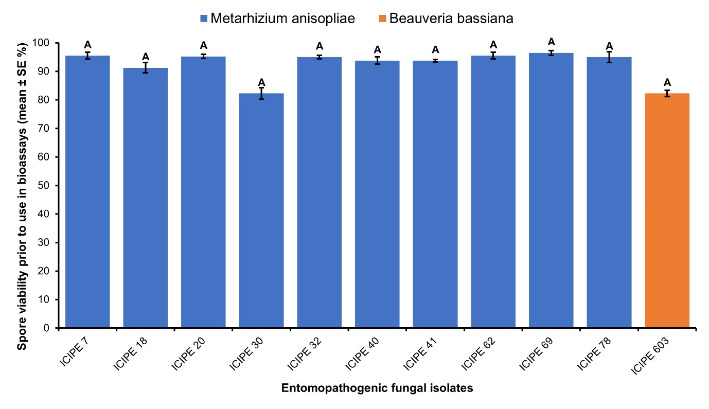
Supplementary Figure 1: Bar graph illustrating the mean percentage germination/spore viability rates of the 10 M. anisopliae strains (ICIPE 07, ICIPE 18, ICIPE 20, ICIPE 30, ICIPE 32, ICIPE 40, ICIPE 41, ICIPE 62, ICIPE 69, ICIPE 78) and the single Beauveria bassiana strain ICIPE 603 used in this study. Error bars indicate the standard error of the mean, and the means separation is depicted by the lowercase letters (similar lowercase letters indicate the means are not statistically significant from each other).

Supplementary Tables
Supplementary Table 1: Mycosis rates of Glossina pallidipes cadavers infected by the entomopathogenic fungal (EPF) isolates.
 | Mycosis rates of EPF-challenged Glossina pallidipes (% ± SE)
Treatment | Unirradiated G. pallidipes | Irradiated G. pallidipes
ICIPE 7 | 86.11 ± 2.76 a | 95.56 ± 0.91 A
ICIPE 18 | 96.30 ± 3.02 ab | 94.44 ± 1.81 A
ICIPE 20 | 92.93 ± 2.56 bc | 96.47 ± 1.68 A
ICIPE 30 | 96.67 ± 2.72 c | 100 ± 0.0 A
ICIPE 32 | 84.92 ± 0.65 abc | 95.16 ± 0.06 A
ICIPE 40 | 96.67 ± 2.72 c | 94.44 ± 0.91 A
ICIPE 41 | 84.13 ± 0.65 abc | 98.89 ± 0.91 A
ICIPE 62 | 95.31 ± 0.81 bc | 91.48 ± 1.42 A
ICIPE 69 | 96.54 ± 1.57 bc | 93.26 ± 0.06 A
ICIPE 78 | 86.11 ± 2.76 abc | 94.25 ± 0.95 A
ICIPE 603 | 91.67 ± 3.40 abc | 94.20 ± 1.02 A
The values represent mean ± SE. Means within a column followed by the same letters are not significantly different (ANOVA followed by Student–Newman–Keuls (SNK) post hoc test, P < 0.05).

