Supplementary material
Maize yield response to nitrate leaching at early growth stage under crop-and site specific biosolid application.

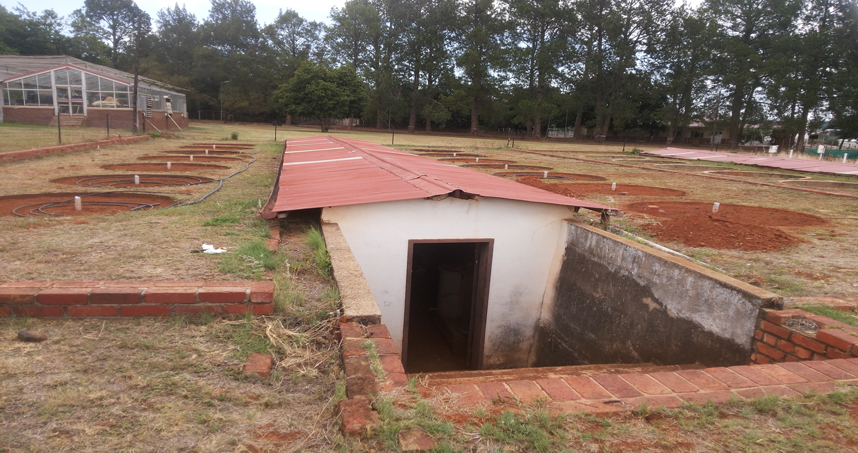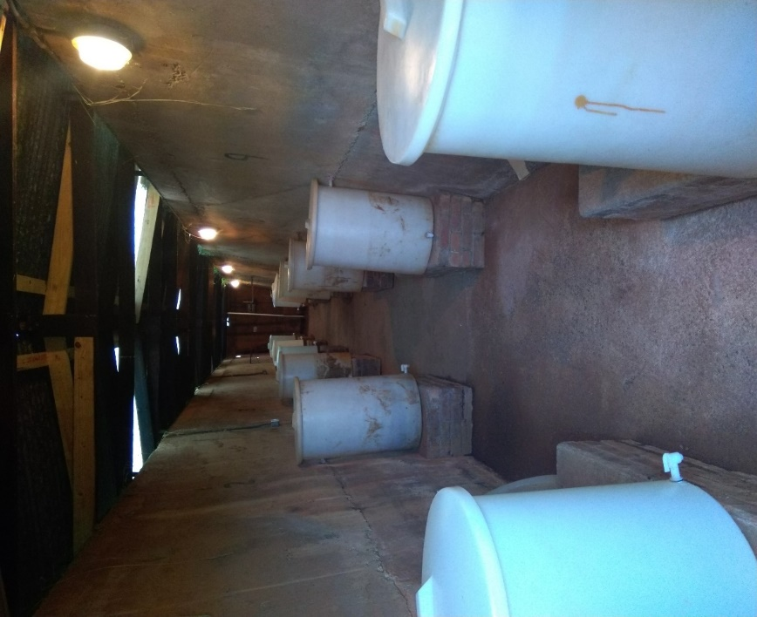
Fig. S2: Underground housing of the lysimeter facility.
Fig. S1: Lysimeter facility at land preparation.
Table S1: Mean minimum, maximum, and average temperatures, and total rainfall of sub-humid and humid agro-ecological zones during the field trial.
 | First year |  |  |  |  |  |  |  |  |  | Second year
 |  | Sub-humid (Pretoria) |  |  |  | Humid (Durban) |  |  |  |  | Sub-humid (Pretoria) |  |  |  | Humid (Durban)
Month | Week | Temperature ºC |  |  | Rainfall mm | Temperature ºC |  |  | Rainfall mm |  | Temperature ºC |  |  | Rainfall mm | Temperature ºC |  |  | Rainfall mm
 |  | max. | min. | ave. | total | max. | min. | ave. | total |  | max. | min. | ave. | total | max. | min. | ave. | total
Dec. | 3-4 | * | * | * | 10.9⁺ | 29.2 | 20.9 | 25.1 | 32.1 |  | - | - | - | - | - | - | - | -
Jan. | 1-2 | 28.9 | 17.2 | 23.0 | 114.5 | 29.1 | 19.6 | 23.7 | 23.4 |  | - | - | - | - | - | - | - | -
 | 3-4 | 30.8 | 16.4 | 23.6 | 54.8 | 27.9 | 19.6 | 23.7 | 91.7 |  | - | - | - | - | - | - | - | -
Feb. | 1-2 | 27.7 | 17.6 | 22.6 | 106.0 | 30.4 | 21.2 | 25.8 | 74.1 |  | 28.7 | 15.7 | 22.2 | 14.7 | 30.0 | 21.5 | 25.8 | 44.4
 | 3-4 | 29.7 | 15.5 | 22.6 | 41.5 | 30.2 | 21.2 | 25.7 | 65.8 |  | 28.2 | 16.0 | 22.1 | 12 | 28.1 | 20.0 | 24.0 | 118.3
Mar. | 1-2 | 30.8 | 17.4 | 24.1 | 0.6 | 30.2 | 22.2 | 26.2 | 104.6 |  | 26.6 | 13.4 | 20.0 | 28.4 | 29.0 | 19.6 | 24.3 | 48.1
 | 3-4 | 31.0 | 15.9 | 23.4 | 7.5 | 30.9 | 22.8 | 26.8 | 68.1 |  | 25.3 | 16.2 | 20.8 | 37.9 | 27.9 | 19.6 | 23.8 | 43.2
April | 1-2 | 24.8 | 13.5 | 19.2 | 47.0 | 29.3 | 20.5 | 24.9 | 47.0 |  | 22.3 | 15.2 | 18.7 | 95.8 | 26.3 | 17.1 | 21.7 | 50.8
 | 3-4 | 25.2 | 12.3 | 18.8 | 17.7 | 29.3 | 20.8 | 25.0 | 191.8 |  | 20.3 | 12.51 | 16.4 | 40.1 | 25.9 | 14.5 | 21.5 | 88.7
May | 1-2 | 26.2 | 10.7 | 18.4 | 0 | 30.2 | 19.8 | 25.0 | 1.1 |  | 21.3 | 9.9 | 15.6 | 0 | 26.6 | 12.4 | 20.5 | 1.8
 | 3-4 | 24.1 | 7.8 | 15.9 | 0 | 28.2 | 17.7 | 22.9 | 5.4 |  | 19.2 | 7.8 | 13.5 | 0 | 25.5 | 10.8 | 18.9 | 2.7
June | 1-2 | 22.0 | 5.0 | 13.5 | 0 | 27.4 | 14.8 | 21.1 | 8.4 |  | - | - | - | - | - | - | - | -
* No data found ⁺ Incomplete data
Sources: SASRI weatherweb station Mt Edgecombe - SASRI [MET-29] [29º42'15"S] [31º2'45"E] [96 m] (Durban)
Pretoria University Proefplaas weather station 0513435A4 (Pretoria)
Table S2: Some physiochemical characteristics of the bed dried anaerobically digested biosolids used for the study (n = 3).

 |  | First year | Second year
Parameter | Unit | Value | Value
Moisture | % | 25 | 27
pH | - | 6.5 | 6.9
EC | ms m⁻¹ | 998 | 1127
Total Nitrogen | % | 2.71 | 3.4
NO₃⁻ - N | mg kg⁻¹ | 21.98 | 22.08
NH₄⁺ - N | mg kg⁻¹ | 24.13 | 26.91
Organic Carbon | % | 15.69 | 19.6
Total Phosphorus | % | 0.37 | 3.0
Potassium | mg kg⁻¹ | 180.86 | 3145.5
Magnesium | mg kg⁻¹ | 494.0 | 1122.3
Sodium | mg kg⁻¹ | 155.89 | 2650.6
Calcium | mg kg⁻¹ | 3703.67 | 6940.8
As | mg kg⁻¹ | 6.7 | 4.5
Cd | mg kg⁻¹ | 4.5 | 6.6
Cr | mg kg⁻¹ | 165.0 | 218.0
Cu | mg kg⁻¹ | 283.7 | 364.0
Hg | mg kg⁻¹ | 1.7 | 0.6
Mn | mg kg⁻¹ | 767.7 | 1091.0
Ni | mg kg⁻¹ | 124.0 | 156.0
Pb | mg kg⁻¹ | 63.4 | 81.9
Zn | mg kg⁻¹ | 1717.7 | 1695.0
Fe | mg kg⁻¹ | 18000.0 | 38500.0

Fig. S3: Year effect on maize grain and biomass yield in (a) inorganic fertilizer + humid rainfall, (b) Biosolid + humid rainfall, (c) Inorganic fertilizer + subhumid rainfall, and (d) Biosolid + subhumid rainfall treatments. Uppercase letters are grain yield while lowercase letters are biomass yield. Different letters of a yield type are significantly different (p<0.05) according to Tukey test.

Table S3: Least significant difference values for two-way ANOVA showing main and interaction effects of factors.
 |  | Yield
 | Nitrate leaching | Maize grain | Maize biomass
Year | ns | < 0.001 | 0.043
(Fertilization + Rainfall) | ns | < 0.001 | < 0.001
Year x (Fertilization + Rainfall) | ns | ns | < 0.001
ns is non-significant.
Fig. S4: Year effect on the cumulative nitrate leaching in (a) Inorganic fertilizer + humid rainfall, (b) Biosolid + humid rainfall, (c) Inorganic fertilizer + Subhumid rainfall, (d) Biosolid + Subhumid rainfall. Similar letters between years are significantly the same (P<0.05) according to Tukey test.

Table S4: Maize nitrogen uptake (kg ha⁻¹): Inorganic fertilizer versus biosolid under humid and sub-humid rainfall regimes.
 |  | First year |  | Second year
 |  | Leaf | Grain | Leaf | Grain
Humid rainfall | Inorganic fertilizer | 65.18 ± 5.9 | 215.33 ± 14.0 | 80.45 ± 7.2 | 135.34 ± 24.7
 | Biosolid | 55.83 ± 6.0 | 149.45 ± 9.7 | 66.22 ± 10.5 | 118.47 ± 34.5
Sub-humid rainfall | Inorganic fertilizer | 51.72 ± 5.1 | 123.03 ± 7.9 | 42.31 ± 3.3 | 100.52 ± 14.1
 | Biosolid | 40.66 ± 2.2 | 112.03 ± 22.5 | 21.23 ± 2.2 | 23.00 ± 1.3
± error of means

Table S5: Relationship between nitrate leaching and maize yield. In-H used as reference level.
 | Term | Estimate | S.E | t | t. pr.
Grain yield | Constant | 12289 | 579 | 21.24 | <0.001
 | Bio-H × year | -1957 | 641 | -3.05 | 0.007
 | In-S × year | -2616 | 644 | -4.06 | <0.001
 | Bio-S × year | -5467 | 656 | -8.33 | <0.001
Biomass yield | Constant | 9878 | 625 | 15.79 | <0.001
 | Bio-H × year | -3209 | 1327 | -2.42 | 0.029
 | In-S × year | -3836 | 1327 | -2.89 | 0.011
 | Bio-S × year | -8006 | 1327 | -6.03 | <0.001
Bio = biosolid, In = inorganic fertilizer, H = humid rainfall, S = subhumid rainfall

Fig. S5: Nitrogen mineralization for incubated biosolid under biosolid treatments alone. Bio-H = biosolid + humid rainfall, Bio-S = biosolid + subhumid rainfall.

B

Fig. S6: Soil residual total N for (A) first year and (B) second year. Bio = biosolid, In = inorganic fertilizer, H = humid rainfall, S = subhumid rainfall. Error bars represent error of mean.

Table S6: Natural rainfall and irrigation of the humid and subhumid rainfall treatments during the trial.
First year – Humid rainfall |  | First – Subhumid rainfall |  | Second year – Humid rainfall |  | Second – year Subhumid rainfall
Date | Rainfall/irrigation (mm) | Date | Rainfall/irrigation (mm) | Date | Rainfall/irrigation (mm) | Date | Rainfall/irrigation (mm)
28/12/2018 | 2 | 28/12/2018 | 2 | 06/02/2020 | 0 | 06/02/2020 | 0
29/12/2018 | 7.2 | 29/12/2018 | 7.2 | 07/02/2020 | 0 | 07/02/2020 | 0
01/01/2019 | 58 | 01/01/2019 | 58 | 08/02/2020 | 2.4 | 08/02/2020 | 2.4
02/01/2019 | 10.5 | 02/01/2019 | 10.5 | 09/02/2020 | 5.5 | 09/02/2020 | 5.5
03/01/2019 | 7 | 03/01/2019 | 7 | 11/02/2020 | 6.8 | 11/02/2020 | 6.8
06/01/2019 | 17 | 06/01/2019 | 17 | 14/02/2020 | 10 | 14/02/2020 | 10
07/01/2019 | 4.5 | 07/01/2019 | 4.5 | 15/02/2020 | 20 | 18/02/2020 | 10
09/01/2019 | 21.5 | 09/01/2019 | 21.5 | 18/02/2020 | 10 | 22/02/2020 | 6
11/01/2019 | 2 | 11/01/2019 | 2 | 20/02/2020 | 20 | 23/02/2020 | 5.5
12/01/2019 | 14 | 12/01/2019 | 14 | 22/02/2020 | 6 | 27/02/2020 | 10
16/01/2019 | 10 | 16/01/2019 | 10 | 23/02/2020 | 5.5 | 29/02/2020 | 0.5
20/01/2019 | 10 | 20/01/2019 | 10 | 27/02/2020 | 10 | 02/03/2020 | 2.2
22/01/2019 | 10 | 24/01/2019 | 10 | 28/02/2020 | 20 | 03/03/2020 | 5.2
24/01/2019 | 10 | 26/01/2019 | 1.8 | 29/02/2020 | 0.5 | 07/03/2020 | 10
26/01/2019 | 1.8 | 28/01/2019 | 13 | 02/03/2020 | 2.2 | 13/03/2020 | 14
27/01/2019 | 10 | 29/01/2019 | 18 | 03/03/2020 | 5.2 | 14/03/2020 | 7
28/01/2019 | 13 | 30/01/2019 | 22 | 07/03/2020 | 10 | 15/03/2020 | 5
29/01/2019 | 18 | 01/02/2019 | 5.5 | 13/03/2020 | 14 | 18/03/2020 | 4.5
30/01/2019 | 22 | 02/02/2019 | 10 | 14/03/2020 | 7 | 22/03/2020 | 21.9
01/02/2019 | 5.5 | 04/02/2019 | 24.5 | 15/03/2020 | 5 | 24/03/2020 | 3
02/02/2019 | 10 | 07/02/2019 | 10 | 16/03/2020 | 20 | 25/03/2020 | 2
04/02/2019 | 24.5 | 11/02/2019 | 10 | 18/03/2020 | 4.5 | 26/03/2020 | 2
07/02/2019 | 10 | 12/02/2019 | 29 | 22/03/2020 | 21.9 | 27/03/2020 | 4.5
08/02/2019 | 10 | 13/02/2019 | 22 | 24/03/2020 | 3 | 04/04/2020 | 55
11/02/2019 | 10 | 14/02/2019 | 15 | 25/03/2020 | 2 | 05/04/2020 | 17.8
12/02/2019 | 29 | 15/02/2019 | 19.5 | 26/03/2020 | 2 | 15/04/2020 | 23
13/02/2019 | 22 | 16/02/2019 | 6.5 | 27/03/2020 | 4.5 | 26/04/2020 | 1.1
14/02/2019 | 15 | 17/02/2019 | 1 | 31/03/2020 | 10 | 27/04/2020 | 19
15/02/2019 | 19.5 | 22/02/2019 | 5 | 03/04/2020 | 5 | 28/04/2020 | 19
16/02/2019 | 6.5 | 23/02/2019 | 14.5 | 04/04/2020 | 55 | 29/04/2020 | 1
17/02/2019 | 1 | 08/03/2019 | 0.6 | 05/04/2020 | 17.8
19/02/2019 | 10 | 26/03/2019 | 6 | 12/04/2020 | 5
22/02/2019 | 15 | 29/03/2019 | 1.5 | 15/04/2020 | 23
23/02/2019 | 14.5 | 05/04/2019 | 22 | 20/04/2020 | 5
24/02/2019 | 10 | 07/04/2019 | 21 | 25/04/2020 | 5
26/02/2019 | 10 | 12/04/2019 | 4 | 26/04/2020 | 1.1
01/03/2019 | 10 | 22/04/2019 | 8.7 | 27/04/2020 | 19
08/03/2019 | 0.6 | 24/04/2019 | 6.1 | 28/04/2020 | 19
12/03/2019 | 20 | 25/04/2019 | 2.9 | 29/04/2020 | 1
16/03/2019 | 10 |  |  | 03/05/2020 | 5
20/03/2019 | 10 |  |  | 10/05/2020 | 5
24/03/2019 | 10
26/03/2019 | 6
29/03/2019 | 1.5
01/04/2019 | 5
05/04/2019 | 22
07/04/2019 | 21
12/04/2019 | 4
22/04/2019 | 8.7
24/04/2019 | 6.1
25/04/2019 | 2.9

