Supplementary Figure to: Visualisation of in vivo protein synthesis during mycobacterial infection through [⁶⁸Ga]Ga-DOTA-puromycin µPET/MRI

Sebastian Eigner ^{1,2}, Janke Kleynhans³, Denis R. Beckford Vera¹, Mike M. Sathekge ^{3,4}, Katerina Eigner Henke^{2,5} , and Thomas Ebenhan^{3,6#}
¹Department of Radiopharmaceuticals, Nuclear Physics Institute, Academy of Science of the Czech Republic, Rez near Prague, Czech Republic
²Department of Radiopharmacy, Charles University Prague, Czech Republic;
³Nuclear Medicine Research Infrastructure NPC, Pretoria, South Africa,
⁴Department of Nuclear Medicine and Steve Biko Academic Hospital, University of Pretoria, Pretoria, South Africa
⁵ Clinic for Nuclear Medicine, University Hospital RWTH Aachen, Aachen, Germany;
⁶Department of Nuclear Medicine University of Pretoria, Pretoria, South Africa;

SUPPLEMENT FIGURE S1. Correlation plot for NUV values from image guided analysis for 68Ga-Pur versus 18F-FDG (y=7.51x; N=16). The linear regression (r²) analysis returned a value of 0.651.

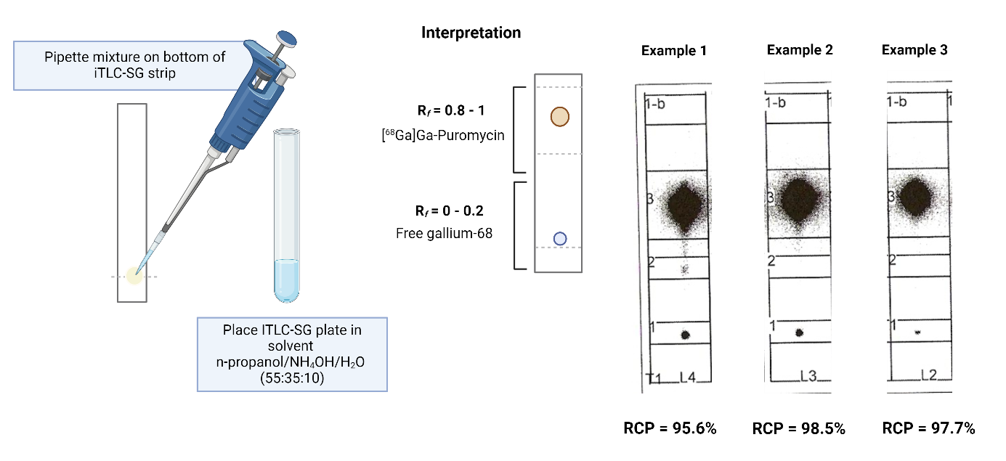

Supplementary Figure S2: Autoradiography images of 3 synthesis of [68Ga]Ga-DOTA-Puromycin. Radio-TLC analysis shows free gallium-68 retaining at the origin (Rf = 0.05) whilst [⁶⁸Ga]Ga-DOTA-puromycin migrates with the solvent front (Rf =0.85 – 1.00). ITLC was cross-validated with HPLC during previous work – as described in Eigner et al., (2013).

Supplementary Figure S3: Ex-vivo biodistribution studies on [⁶⁸Ga]Ga-DOTA-puromycin performed previously in xenograft (PC3 cells) animal models. Tumour data is not included. These measurements are done in animals euthanized 2 hours post-injection and there are 4 animals in the test group.
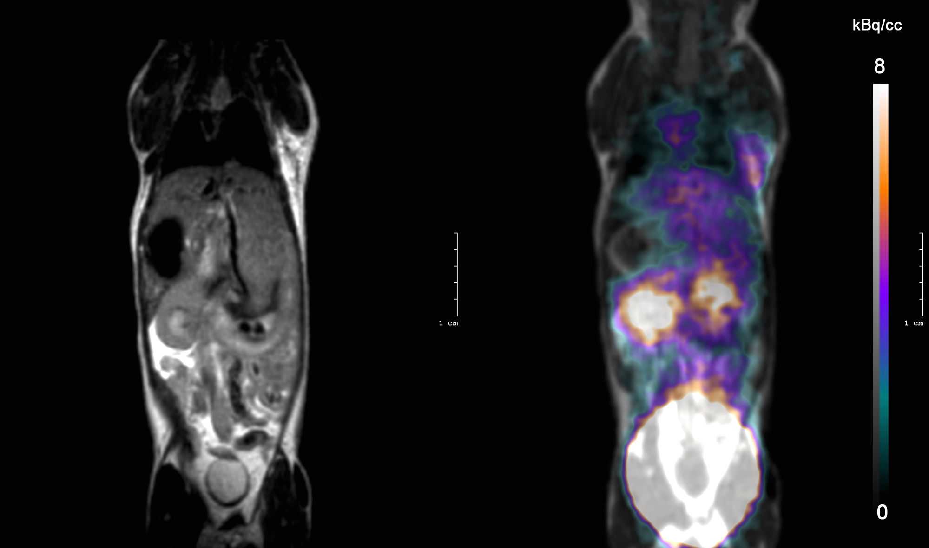
Supplementary Figure S4: Whole-body [⁶⁸Ga]Ga-DOTA-puromycin-µPET/MRI (representative posterior, coronal whole-body image slice), the full scanner field of view of 6.7 cm including MRI (left) and fused PET/MRI (right) projection from neck – pelvis. Unwanted high bladder activity (bottom right) is limiting the image quality.

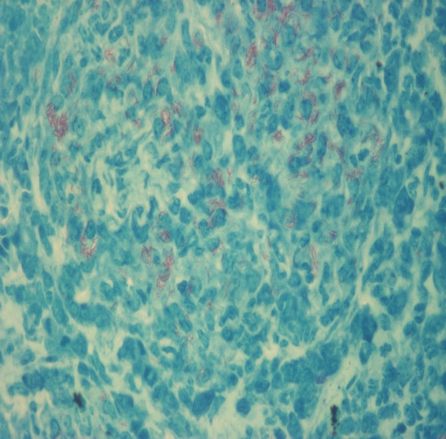
+3 Ziehl Neelsen grading
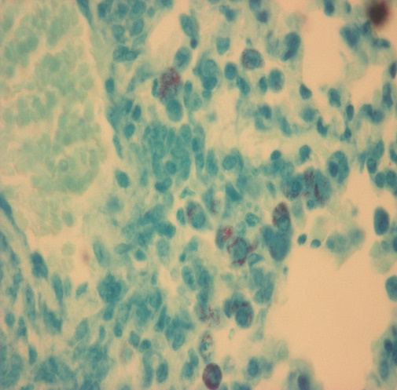
+1 Ziehl Neelsen grading
Supplementary Figures S5: Representative images of the Ziehl Neelsen staining

