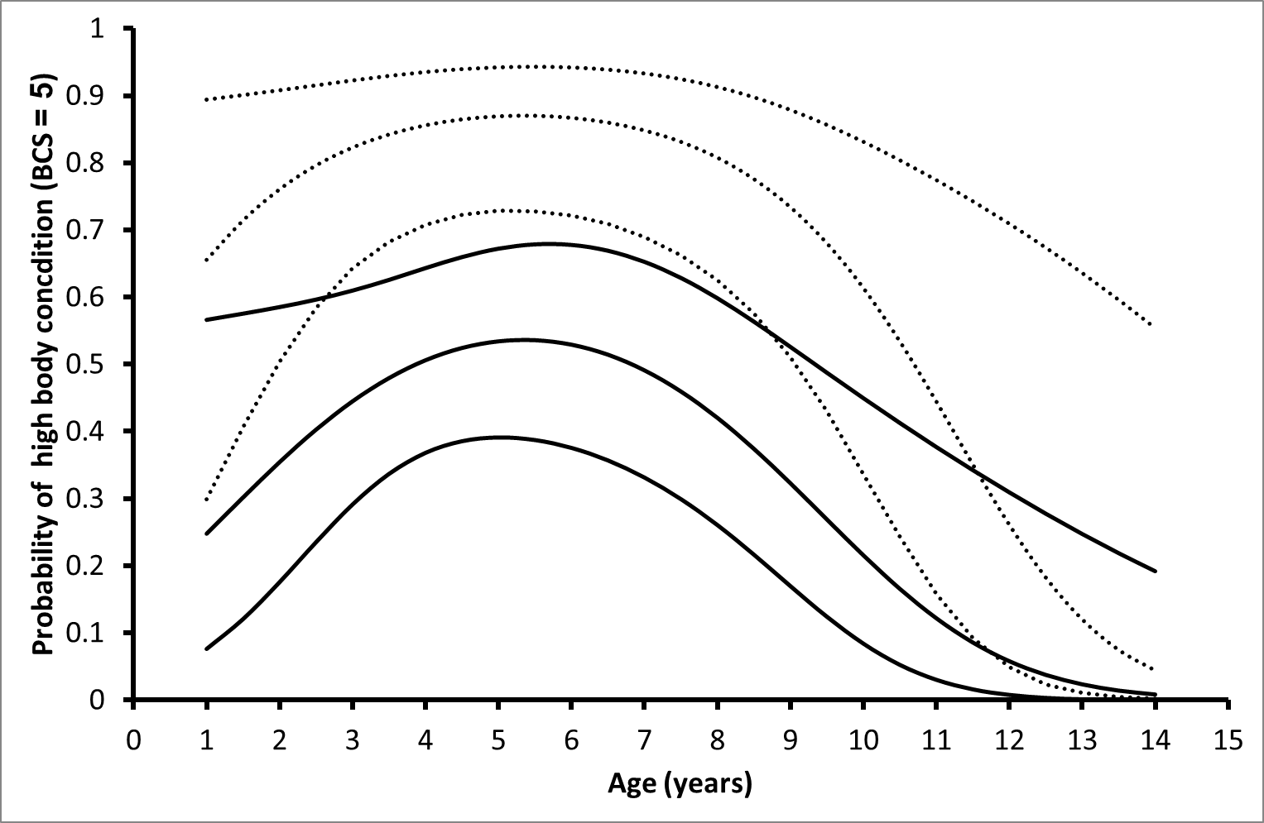
Relationship between body condition and age per locality (logistic regression). Regression lines: probability of having a high body condition (BCS = 5), upper and lower lines: upper and lower limit of the 95% confidence interval of the regression lines, dotted lines: northern Kruger, solid lines: southern Kruger.
Dependent variable: body condition (BCS): 0: BCS ≤ 4, 1: BCS = 5. χ²-value model = 24.47, d.f. = 3, P_{model} < 0.0001, P_{age} = 0.037, P_{age}² = 0.014, P_{north-south} = 0.00039 (higher body condition in the north). Sex was not significant when added to the regression model (P_{sex} = 0.12). Northern individual with body condition = 0: n_{individuals} = 10, northern individual with body condition = 1: n_{individuals} = 34, southern individual with body condition = 0: n_{individuals} = 35, southern individual with body condition = 1: n_{individuals} = 27.

