Properties of infrared heat-moisture treated amylose-lipid complex nanomaterials

By

Njabulo Gladman Maphumulo

Submitted in partial fulfilment of the requirements of the degree

Master of Science (MSc): Food Science
In the

Department of Consumer and Food Sciences

Faculty of Natural and Agricultural Science

University of Pretoria

South Africa

November 2020

Declaration
I declare that the dissertation, herewith submitted for the degree MSc Food Science at the University of Pretoria has not previously been submitted for a degree at any other tertiary institution.

Njabulo Gladman Maphumulo
November 2020

Acknowledgment
I would like to express my sincere appreciation to my supervisor, Prof M.N. Emmambux for his guidance, patience and inspiration during my course of study
I also extend my appreciation to the academic, colleagues, the administrative and support staff of Department of Consumer and Food Sciences, University of Pretoria for their assistance and support.
I would like to thank Prof SS Ray as my co-supervisor from the Council for Science and Industrial Research (CSIR) centre for nanostructured materials and for giving me the opportunity to use their research instruments
My heartfelt thanks to the University of Pretoria, DSI-NRF Centre of Excellence in Food Security for financially supporting my study under project ID number 91490.
My deepest gratitude to my family and friends for the love and support they shown to me during my studies

Abstract
Properties of infrared heat moisture treated amylose lipid complex nanomaterials
By
Njabulo Gladman Maphumulo
Supervisor: Prof MN Emmambux
Co-supervisor: Prof SS Ray
Degree: MSc in Food Science

Nanotechnology involves the study and use of materials at nanoscale dimensions of $≤$ 100 nm. This nanoscale length results in materials exhibiting physical and chemical properties that are significantly different from the properties of macroscale materials composed of the same substances. However, there are limited food compatible nanomaterials to be used in foods, or most of them are not considered as an edible or clean label. Current consumers’ trends are more towards ‘clean label’ food and food ingredients. This has prompted the development of ‘clean label’ starch with principles of green chemistry, for example using naturally occurring substances such as fatty acids. Amylose lipid complexes (ALC) has been produced at nanoscale when maize starch is wet heat processed with stearic acid at lab scale. The material is semi-crystalline and dispersed in aqueous system to form hydrocolloids, and this limits the use as nanofiller in biodegradable packaging systems. Heat moisture treatment using infrared energy can increase the crystallinity of starch. The aim of this project was to produce ALC nanomaterials at a pilot scale and to evaluate the effects of infrared energy heat moisture treatment on the properties of the isolated nanomaterials. It is anticipated that HMT will result in more crystalline material to be used as nanofillers.
The nanomaterials were produced using maize starch with added stearic acid (1.5% w/w) pasted for a prolonged period of 130 min at 91$℃$ using Rheometer (lab scale) and Reactor (pilot scale). The nanomaterial was infrared heat moisture treated for 1, 2 and 3 hours at 110$℃$with 25% moisture content as a continuous method. Repeated infrared heat moisture treatment was carried out for three days at 1 hour each day with 25% moisture content at 110$℃$ using different cooling systems after the daily infrared treatments (room temperature, refrigeration temperature and liquid nitrogen) for 24 hours. The nanomaterial was analysed for thermal properties using differential scanning calorimetry (DSC), wide angle x-ray diffraction scattering (WAXS), thermogravimetric analysis (TGA) and dynamic mechanical thermal analysis (DMTA). The morphology (using scanning electron microscopy), flow properties and water absorption and solubility index were also determined.
The lab scale synthesis had a significantly (p<0.05) higher yield compared to the pilot scale, with the yield percentage of 41% and 38% respectively. Both the lab scale and pilot scale isolated materials had an average size of ±45 nm and DSC endothermic peak at about 103$℃$, showing that the isolated nanomaterials contained amylose lipid complexes. Thus, ALC nanomaterials were scaled up successfully.
The DSC for ALC nanomaterials treated with heat moisture followed by cooling showed higher endothermic peak temperature and hence the presence of type II ALC when compared to untreated ALC (control), that only had type I ALC. Wide angle X-ray scattering (WAXS) showed that the moisture treated ALC nanomaterials showed relatively higher crystallinity as compared to untreated ALC and the increase in crystallinity was correlated to the transformation of type I to type II ALC as evidenced by DSC and WAXS results.
Infrared heat moisture treatment followed by cooling changed the structural, flow and morphological properties of isolated amylose lipid complex at nano level. SEM of the treated ALC nanomaterials showed more closely packed particles and protrusion on the surface which resulted in significantly (p<0.05) reduced water solubility and water absorption index compared to untreated isolated ALC nanomaterials. DMTA showed similar grass transition temperature, increased storage modulus and decreased tan delta peak broadness as opposed to that of untreated ALC nanomaterials. Treated isolated ALC nanomaterial resulted in significantly (p<0.05) reduced zero shear viscosity and hysteresis during flow property analyses at different shear rates. These changes were related to the formation of type II ALC observed in XRD and DSC; as well as the nanostructure.
The crystallinity of isolated amylose lipid complex nanomaterials can be increased with infrared heat moisture treatment by structural transformation of type I of ALC to type II. This was because during infrared HMT, the helices acquired enough mobility to align around the remaining helices acting as nuclei. This leads into more ordered type II ALC crystals. They was also increased in crystallinity from type IIa into type IIb. The molecular re-ordering reduced the viscosity.
Heat moisture treatment resulted in increased crystallinity of isolated amylose lipid complex nanomaterials. Therefore, ALC nanomaterials with increased crystallinity can be produced from infrared HMT that can be used in biodegradable packaging systems. Moreover, the reduced viscosity suggest that infrared HMT treated ALC can be used for encapsulation of flavours to be used in emulsion at higher solid content for higher encapsulation efficiency.

Table of Contents
1.0 Introduction 12
2.0 Literature review 14
2.1 Amylose lipid complexes 14
2.1.1 Chemistry of amylose lipid complexes 14
2.1.2 Formation of amylose lipid complexes 17
2.1.3 Micro and nano-structure of amylose lipid complexes 19
2.1.4 Preparation of amylose lipid complexes 21
2.1.5 Factors affecting formation of amylose lipid complexes 23
2.1.6 Isolation of amylose lipid complexes 24
2.1.7 Application of amylose lipid complexes 25
2.2 Heat moisture treatment 27
2.2.1 Hydrothermal treatments 28
2.2.2 Infrared heat moisture treatment 32
2.2.4 Repeated heat moisture treatment 35
2.2.5 cooling 37
2.3 concluding remarks 38
3.0 Hypothesis and objectives 40
3.1 Hypothesis 40
3.2 Objectives 40
4.0 EXPERIMENTAL 41
4.1 Experimental design 41
4.2 Materials 42
4.3 Methods 42
4.3.1 Stearic acid incorporation 42
4.3.2 Preparation of amylose lipid complexes nanomaterials 42
4.3.3 Infrared heat moisture treatment with cooling systems 43
4.4 Analyses 44
4.4.1 Water Absorption Index (WAI) and Water Solubility Index (WSI) 44
4.4.2 Flow properties 44
4.4.3 Nanostructure by Scanning Electron Microscopy (SEM) 45
4.4.4 Thermal properties by Differential scanning calorimetry (DSC) 45
4.4.5 Wide angle X-ray diffraction scattering (WAXS) 45
4.4.6 Thermal gravimetric anaylsis (TGA) 45
4.4.7 Dynamic mechanical thermal analysis (DMTA) 46
4.5 Statistical analysis 46
5. Results 47
5.1 Upscaling amylose lipid complex nanomaterials 47
5.1.1 Pasting and yield of isolated nanomaterials 47
5.1.2 DSC and SEM of isolated materials 47
5.2 Infrared heat moisture treatment with different cooling rate of isolated amylose lipid complex nanomaterials 52
5.2.1 Water absorption and solubility properties 52
5.2.2 Flow properties 53
5.2.3 Morphology 55
5.2.4 Differential scanning calorimetry (DSC) 58
5.2.5 Wide angle X-ray diffraction scattering of amylose lipid complex nanomaterials 60
5.2.6 Thermogravimetric analysis of amylose lipid complexes nanomaterials 62
5.2.7 Dynamic mechanical thermal analysis (DMTA) 64
6.0 Discussion 67
6.1 Methodology 67
6.1.1 Stearic acid incorporation 67
6.1.2 Preparation of Amylose lipid complex nanomaterials 67
6.1.3 Infrared heat moisture treatment 68
6.1.4 Flow properties 68
6.1.5 Morphology 68
6.1.6 Thermal properties 69
6.1.7 Wide angle X-ray diffraction scattering 70
6.1.8 Thermal gravimetric analysis 70
6.1.9 Dynamic mechanical thermal analysis 71
6.2 Results discussion 71
6.2.1 Pasting and yield of isolated nanomaterials 71
6.2.2 Infrared heat moisture treatment with different cooling rate of isolated amylose lipid complex nanomaterials 74
6.3 Application and future studies 82
7.0 Conclusions 84
8.0 References 85

List of tables
Table 1: The chemical structures of the saturated fatty acids commonly used in starch modification (Rustan & Drevon, 2005) 19
Table 2: Starch modification processes and products attributes 28
Table 3: A summary of the impact of heat moisture treatment on the starch functional properties (Ji et al., 2015). 30
Table 4: Frequencies and wavelengths corresponding with different categories of infrared radiation regions (Sakai & Hanzawa, 1994) 34
Table 5: Applications of infrared heating on different starch and flours 35
Table 6: A summary of different repeated heat moisture treatment on various starch 37
Table 7: Effect of upscaling from lab (Rheometer) to pilot (Reactor) scale on the yield of amylose lipid complexes nanomaterials 48
Table 8: Effects of heat moisture treatment and cooling systems on the water absorption index (WAI) and water solubility index (WSI) of isolated amylose lipid complex nanomaterials 54
Table 9: Effects of heat moisture treatment and cooling systems on the flow properties of isolated amylose lipid complex nanomaterials 56
Table 10: Effects of heat moisture treatment and cooling systems on the thermal properties of isolated amylose lipid complex nanomaterials 61
Table 11: Effects of heat moisture treatment and cooling systems using infrared energy on the X-ray diffraction pattern of isolated amylose lipid complex nanomaterials 63

List of figures
Figure 1: A structure of amylose lipid complexes (Putseys et al., 2010). 16
Figure 2: The a, b plane showing associated hydrogen bonding and helix spatial arrangement of Vh-amylose crystal unit cell (Rappenecker & Zugenmaier, 1981). 17
Figure 3: The heating and cooling of amylose lipid complexes in a system as transformation between free amylose, liquid crystalline phase, and type I complexes liquid gel phase (Tufvesson, Wahlgren, & Eliasson, 2003). 18
Figure 4: Schematics representation of the monoglyceride induced conformational changes and organization of amylose chain into a supramolecular structure (adapted from (Biliaderis & Galloway, 1989)) 20
Figure 5: Schematic representation of the lamellae-like structure of amylose-ligand complexes and possible ligand of molecules trapped (Biais, Le Bail, Robert, Pontoire, & Buleon, 2006). 21
Figure 6: Atomic force microscopy of maize starch with 2-dimension phase and height images (Cuthbert et al., 2017). 22
Figure 7: Schematic representation of probable structure of amylose lipid complexes as prepared using bottom-up (left to right) and top-down (right to left) approaches (Obiro et al., 2012). 23
Figure 8: Possible mechanisms for heat moisture treatment at different length scale of starch (Mapengo, 2020) 32
Figure 9: Electromagnetic spectrum ((Krishnamurthy, Khurana, Soojin, Irudayaraj, & Demirci, 2008) 33
Figure 10: The spectrum highlighting infrared wavelength corresponding to near, mid and far infrared 34
Figure 11: Scanning electron microscopy images of gelatinized high amylose starch dispersion produced at fast (A) and slow (B) cooling rate (Nordmark & Ziegler, 2002). 39
Figure 12: Experimental design for production of amylose lipid complexes and modification using infrared heat moisture treatment and different cooling system 42
Figure 13: A- rheometer and B- reactor 44
Figure 14: Effect of solids concentration of 10 and 20% solid on the pasting properties of starch with added stearic acid 50
Figure 15: The DSC thermograms of isolated materials using Rheometer (A) and Reactor (B) 51
Figure 16: Scanning electron microscopy of isolated nanomaterial images produced using Rheometer (A) and Reactor (B), Bar is 100nm 52
Figure 17: The effect of heat moisture treatment and cooling systems on the flow properties of isolated amylose lipid complex nanomaterials 55
Figure 18: Effects of heat moisture treatment and cooling systems on the nanostructure of isolated nanomaterials using scanning electron microscopy 57
Figure 19: Effects of heat moisture treatment and cooling systems on the nanostructure of isolated nanomaterials using scanning electron microscopy 58
Figure 20: Effects of heat moisture treatment and cooling systems on the thermal properties of isolated amylose lipid complex nanomaterials 60
Figure 21: Effects of heat moisture treatment and cooling systems using infrared energy on the X-ray diffraction pattern of isolated amylose lipid complex nanomaterials 62
Figure 22: Effects of heat moisture treatment and cooling systems on the thermal properties of isolated amylose lipid complex nanomaterials by Thermogravimetric analysis (TGA) 64
Figure 23: Effects of heat moisture treatment and cooling systems using infrared energy on the dynamic mechanical properties (tan delta) of isolated amylose lipid complexes nanomaterials 66
Figure 24: Effects of heat moisture treatment and cooling systems using infrared energy on the dynamic mechanical properties (storage modulus) of isolated amylose lipid complexes nanomaterials 67
Figure 25: Formation of amylose lipid complexes adapted from (Chao, Yu, Wang, Copeland, & Wang, 2018) 74
Figure 26: Molecular (a), nano (b) and micro (c) level structures of amylose lipid complexes (S. Wang et al., 2020) 75
Figure 27: sketch of a compatible stacked lamellar of type I, IIa, IIb amylose lipid complexes adapted from (Goderis et al., 2014) 80
Figure 28: schematic diagram of proposed mechanisms of isolated amylose lipid complexes treated with HMT and different cooling systems 83

1.0 Introduction
Nanotechnology involves the study and use of materials at nanoscale dimensions of $≤$ 100 nm. This nanoscale length result in materials exhibiting physical and chemical properties that are significantly different from the properties of macroscale materials composed of the same substances (Duncan, 2011; Valdés, Valdés González, García Calzón, & Díaz-García, 2009). Nanotechnology has been used in construction materials for floors, machines, new devices, and techniques in electronics, medicine, wastewater, water treatment, biology, biochemistry and agriculture, and food processing (Rashidi & Khosravi-Darani, 2011). However, there are limited compatible nanomaterials to be used in foods or most of them are not considered as edible or ‘clean label’. Current consumers’ trends are more towards ‘clean label’ food and food ingredients (Arocas, Sanz, & Fiszman, 2009). This has prompted the development of clean label starch with principles of green chemistry, for example using naturally occurring substances such as fatty acids.
Recently, a clean label nanomaterials made up of amylose lipid nanomaterials has been produced and patented (Cuthbert, Ray, & Emmambux, 2017) with patent number WO2017096411A2. The nanomaterials were produced when starch with stearic acid was wet heat processed for prolonged period (up to 130 min) at 91$℃$. The novel method also involved isolating amylose lipid complexes nanoparticles using thermostable alpha-amylase. Although the isolated amylose lipid complex nanomaterials has potential as a hydrocolloids in food systems for example as a fat replacer, it could replace fat at 25% in margarine type products (Obiro, Sinha Ray, & Emmambux, 2012). Moreover it shows very limited changes as nanofiller in starch plastic films (Moodley, 2017).
However, the isolated materials cannot be used in other systems where hydrophobic or highly crystalline materials are required as nanofiller materials. The possible reason is that the patented method produces low crystallinity of amylose lipid complexes nanomaterials. The patented method also showed some residual alpha amylase activity and the method used to inactivate the enzyme was ineffective. Moreover, the nanomaterials were produced in a lab scale production using about 2.8 g of starch and has not been upscaled. These showed the limitation of the isolated nanomaterials. Thus, there is a need to modify the isolated amylose lipid complex nanomaterials in terms of its crystallinity and inactivating the residual alpha-amylase using alternative methods.
Heat moisture treatment of starch has been shown to enhance the crystalline nature of starch by increasing the interactions between amylose and amylopectin side chains, hence strengthening the intra-molecular hydrogen bonds (da Rosa Zavareze & Dias, 2011; Ratnajothi Hoover & Vasanthan, 1994). Heat moisture treatment is a physical process that involves incubation of starch granules at low moisture levels (below 35% water (w/w)), during a certain period at a temperature above glass transition temperature but below the gelatinization temperature. Heat moisture treatments modify the physico-chemical properties of starch without destroying the granule structure (Chung et al., 2009). It has been noted that heat moisture treatment altered crystalline nature and distorted active site for enzyme hydrolysis (Hoover, Hughes, Chung, & Liu, 2010). This suggest that heat moisture treatment can be used to modify the crystallinity of amylose lipid complex nanomaterials. However the heat moisture treatment method generally uses heat temperature of 80 – 140$℃$ for up to 16 hours and thus the method is also an energy intensive one (Chiu & Solarek, 2009a).
Infrared can be an alternative for heat moisture treatment of maize starch with stearic acid, in order to save the energy. Mapengo and Emmambux (2020) showed that Infrared energy promoted molecular vibrations of maize meal components during heat-moisture treatment resulting in altering the molecular structure of maize starch. During infrared heat moisture treatment, it was noted that amylose-stearic acid complexes were formed, and amylopectin interacted with amylose and/or other amylopectin side chains to increase crystallinity. It was concluded that infrared heat moisture treatment changes the functional and nutritional properties of maize meal with stearic acid. The aim of this project was to produced ALC nanomaterials at a pilot scale and evaluate the effects of infrared energy heat moisture treatment on the properties of the isolated nanomaterials. It is anticipated that HMT will result in more crystalline material to be used as nanofillers in packaging materials.

2.0 Literature review
The contents of this literature cover relevant information about amylose lipid complexes, its chemistry, structural characterisation, formation and effect of heat moisture treatment on amylose lipid complexes.

2.1 Amylose lipid complexes
Amylose lipid complexes are defined as the inclusion of lipid molecules in amylose characterised by single, left-handed helices with an internal cavity (Carlson, Larsson, Dinh-Nguyen, & Krog, 1979). The chemistry, structural characterisation and formation of amylose lipid complexes is well documented in literature from reviews by (Obiro et al., 2012; Panyoo & Emmambux, 2017; Putseys, Lamberts, & Delcour, 2010)

2.1.1 Brief chemistry of amylose lipid complexes
A hydrophobic ligand containing an aliphatic hydrocarbon tail can form amylose lipid complexes as the hydrocarbon tail can fit in the hydrophobic core of amylose helices (figure 1). Each ligand can impose its own specific helix dimensions, as described for amylose complexation with iodine, potassium hydroxide (KOH) (Putseys et al., 2010) and stearic acid (D’Silva, Taylor, & Emmambux, 2011; Wokadala, Ray, & Emmambux, 2012a). Therefore, the amount of water bound to the glucose units and the complexing agent should be determines helix diameter and dimensions (Putseys et al., 2010).
Van der Waals forces and hydrogen bonding (Intramolecular bonds) are forces that support the amylose-lipid complex helix formation. These bonds occur between the turns along the helix and stabilize a single chain helix (figure 1). Differential Scanning Calorimetry (DSC) of the amylose lipid complexes shows an endotherm during heating and an exotherm during cooling (Rappenecker & Zugenmaier, 1981), since the heat can dissociate the amylose lipid complexes (between amylose and its ligand) and reformed during cooling. Amylose lipid complexes favour hydrophobic interactions because helix core is hydrophobic. The intramolecular bonds (van der Waals) occurs between the turns along the helix and stabilize a single chain helix while hydrophobic interaction between the hydrophobic tail and helix interior stabilize the interaction between amylose and its ligand (figure 2) (Karkalas, Ma, Morrison, & Pethrick, 1995). There is also intrahelical hydrogen bonding inside the helix between water molecules and there are inter hydrogen between helices and water molecules are also involved here due to numerous hydrogen bonds.

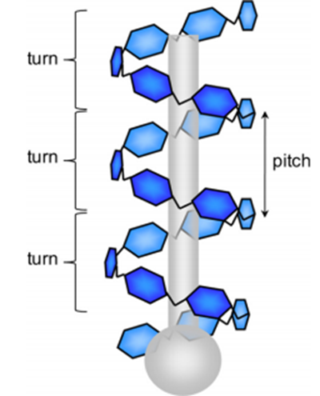
Figure 1: A structure of amylose lipid complexes (Putseys et al., 2010).
The complexing agent controls the helix diameter of amylose lipid complexes, resulting in helices with six, seven and eight glucosyl residues per turn (Buléon, Colonna, Planchot, & Ball, 1998; Rappenecker & Zugenmaier, 1981). The six glycosyl residues per turn are mostly for linear lipids or linear alcohols, seven for branched chain alkyl compounds for example tert-butyl alcohol and eight for more bulky compounds for example 1- naphthol (Lalush, Bar, Zakaria, Eichler, & Shimoni, 2005;Linko,Linko, &Olkku, 1983). Amylose-lipid complexes with six glycosyl residues per turn and a ligand molecule inside the helix, which can exist in dry and hydrated forms (Rappenecker & Zugenmaier, 1981), are widely studied.

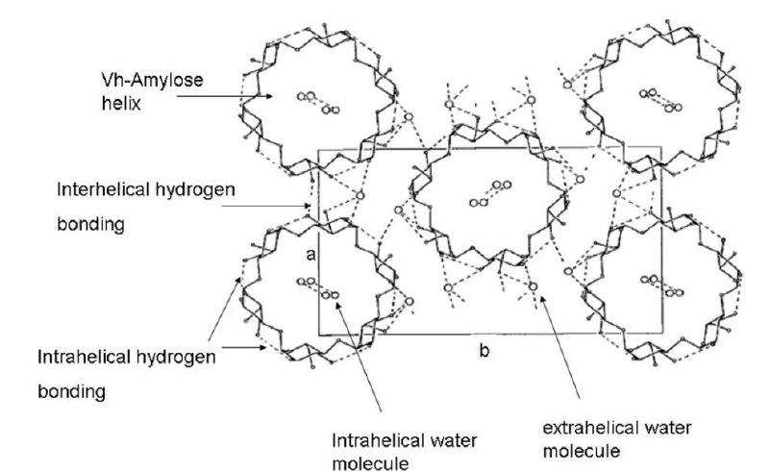
Figure 2: The a, b plane showing associated hydrogen bonding and helix spatial arrangement of hydrated Vh-amylose crystal unit cell (Rappenecker & Zugenmaier, 1981).
There are two type of amylose lipid complexes, namely type I and type II differentiated based on the forming temperature and also melting of the crystalline regions. Type I normally has melting temperatures in the range of 94 and 104$℃$, while type II melts between 115 and 121$℃$. Type I complexes consist of a partially ordered structure with no distinct crystalline regions, while type II complexes are composed of distinct crystalline structures. Type II can be subdivided into type IIa and type IIb, they differ slightly in terms of the degree of crystallinity and melting temperatures. The type IIa complexes melts approximately at 115$℃$ , while type IIb complexes melts approximately at 121$℃$ (Lalush et al., 2005).
Type I complexes nucleate at high temperatures (90$℃$) to transform into type II complexes (figure 3). They first transform into a liquid crystalline phase and then change to type II complexes during heating (Biliaderis & Galloway, 1989; Lalush et al., 2005). Rappenecker and Zugenmaier (1981) proposed that the most stable form of the amylose lipid complexes is type IIb complexes. The type II complexes are aggregates (superstructures) of many type I complexes crystallized together and non-dissociated type I complexes serve as the nuclei for crystallization (Biliaderis & Galloway, 1989). Amylose lipid complexes form two endothermic peaks on the Differential Scanning Calorimetry (DSC), a peak in the range of 90-104$℃$ (type I) and a peak at >104$℃$ (type II) (Karkalas et al., 1995).
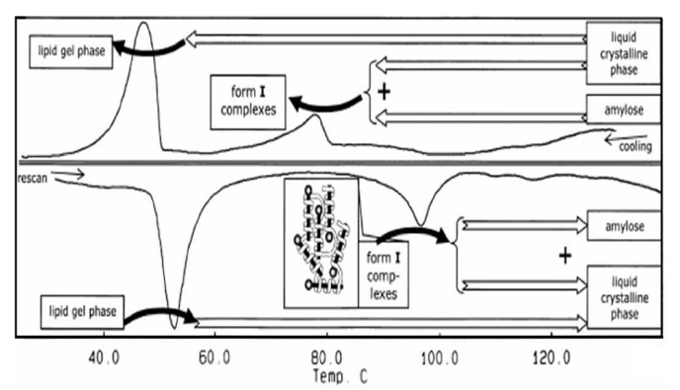
Figure 3: The heating and cooling of amylose lipid complexes in a system as transformation between free amylose, liquid crystalline phase, and type I complexes liquid gel phase (Tufvesson, Wahlgren, & Eliasson, 2003).

2.1.2 Formation of amylose lipid complexes
There are different methods for formation of amylose lipid complex, which can be sub-divided into three main categories: (i) starting from amylose and ligands, or (ii) starting from starch and ligands, or (iii) synthesizing amylose in the presence of the ligands. The characteristics of the obtained amylose lipid complexes differ depending on the method (Putseys et al., 2010). Amylose can form complexes with various guest molecules such as fatty acids, phenolics, protein and triglycerides (Zhu, 2015). The fatty acids can be either be endogenous lipids (native lipid) or exogenous lipids (lipids added to defatted starch) (Karkalas et al., 1995). A number of common saturated fatty acids found in edible oil such as myristic acid, palmitic acid, stearic acid and oleic acid can be used to produce amylose lipid complexes. Saturated fatty acids are slightly more effective in forming complexes than their unsaturated fatty acids counterparts, because of steric hindrance (Karkalas & Raphaelides, 1986). Saturated fatty acids usually have straight hydrocarbon chains with an even number of carbon atoms ranging between 12-22 carbon atoms (Rustan & Drevon, 2005) (table 1).

Table 1: The chemical structures of the saturated fatty acids commonly used in starch modification (Rustan & Drevon, 2005)
Chemical formula | Fatty acid name
CH₃(CH₂)₁₀CO₂H | Lauric acid (C-12)
CH₃(CH₂)₁₂CO₂H | Myristic acid (C-14)
CH₃(CH₂)₁₄CO₂H | Palmitic acid (C-16)
CH₃(CH₂)₁₆CO₂H | Stearic acid (C-18)

Biliaderis et al., (1986) proposed a 2-step amylose lipid complexes using a monoacyl lipids. The first step involves the formation of a single helix between amylose and monoacyl lipids with the second step involving the formation of a supramolecular semi-crystalline structure (figure 4). The pitch is the distance between identical points in sequential turns. The presence of a ligand molecule in dilute amylose solution leads to formation of single helix conformation, with the ligand molecule embedded inside the amylose. The single helix amylose-ligand segments tend to reorganise to form a supramolecular structure by helix-helix association (Biliaderis & Galloway, 1989). The formation of amylose lipid complexes requires heating in order for the amylose to acquire enough mobility to interact with ligands.

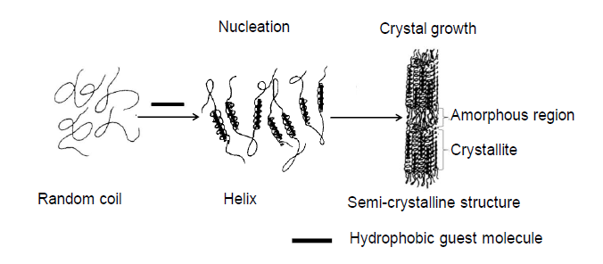
Figure 4: Schematics representation of the monoglyceride induced conformational changes and organization of amylose chain into a supramolecular structure (adapted from (Biliaderis & Galloway, 1989))

2.1.3 Micro and nano-structure of amylose lipid complexes
It has been proposed that amylose lipid complexes have about 10 nm of lamellae folding length, amylose chain length and lesser extent of fatty acids chain length determine the strength of crystalline lamellar thickness (figure 5) (Biliaderis & Galloway, 1989; Lalush et al., 2005). Hence the degree of amylose polymerization might be a huge factor in determining the structural organization of amylose lipid complexes at nanoscale. Amylose lipid complexes are reported to consist of supramolecular structures (aggregates) of nanosized structure of at least 100 nm in one dimension (Cuthbert et al., 2017).
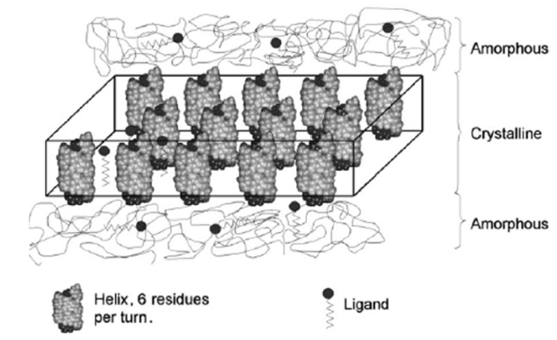
Figure 5: Schematic representation of the lamellae-like structure of amylose-ligand complexes and possible ligand of molecules trapped (Biais, Le Bail, Robert, Pontoire, & Buleon, 2006).
The size and shape of nano-scale supramolecular structures formed could be influenced by the method used in the production of amylose lipid complexes. Lalush et al. (2005) produced spherical shapes of amylose lipid complexes with distinct nanoscale, elongated structures with a width of 43-160 nm and diameter of 150 nm using two different methods involving KOH/ligand heating with pH reduction (HCI), and water/dimethyl sulfoxide (DMSO)/ligand heating. Transmission electron microscopy (TEM) and atomic force microscopy (AFM) have been used to investigate amylose lipid complexes at the nanoscale (Lalush et al., 2005). According to Cuthbert et al. (2017), teff and maize nanomaterial isolated at 10 min had approximately particle sizes in the range of about 5-22 nm with a height of about 4 nm and 5-31 nm with a height of about 4 nm for teff and maize nanomaterials respectively (figure 6).
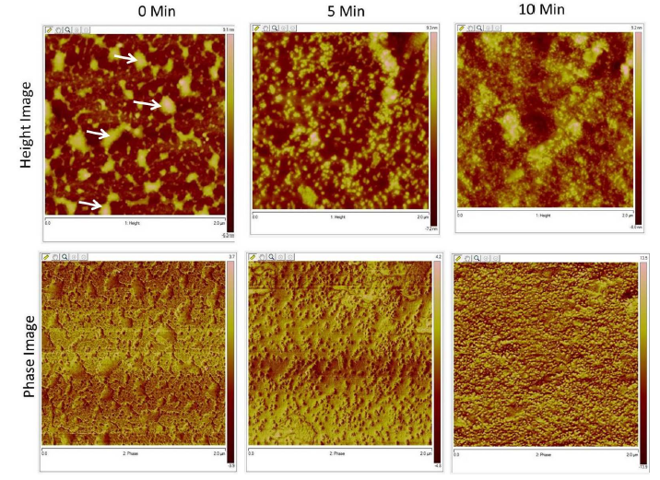
Figure 6: Atomic force microscopy of maize starch with 2-dimension phase and height images (Cuthbert et al., 2017).

2.1.4 Preparation of amylose lipid complexes
Classical, thermo-mechanical and enzymatic are methods for producing amylose lipid complexes. These methods produce amylose lipid complexes structures of different sizes at micro and nano scale.
Classical methods
The classical methods involve mixing of amylose with ligand molecule under shear-less heating or moisture conditions. In this procedure, amylose is dissolved in a diluent such as water, DMSO, and KOH solution, followed by adding the ligand and incubating at 60-90$℃$ to allow for amylose lipid complexes formation (Biliaderis & Galloway, 1989). Amylose lipid complexes are isolated by cooling or reducing the pH (from 12 to 4.6) of the mixture using hydrochloric acid (HCI) to allow crystallization, in order for centrifugation (Karkalas et al., 1995).
Enzymatic methods
The enzymatic methods can be divided into two main forms which are entirely enzymatic and partially enzymatic methods. The entirely enzymatic uses a bottom-up approach (figure 7), using glucose phosphorylase. The entirely enzymatic process can control the sizes of resultant amylose lipid complexes and has large scale production, therefore this method shows more potential for commercial application (Putseys et al., 2010).The partially enzymatic method utilizes a top-bottom approach (figure 7), mainly involves modification of amylose lipid complexes synthesis by addiction of an enzyme catalysed starch/amylose depolymerization step before or after complex formation. The entirely and partially enzymatic methods can produce amylose lipid complex structures of nano-scale dimensions.
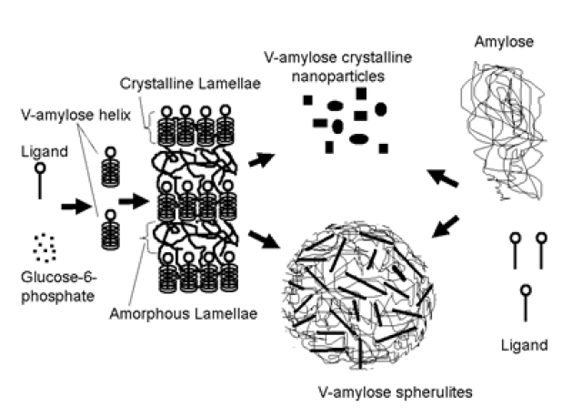
Figure 7: Schematic representation of probable structure of amylose lipid complexes as prepared using bottom-up (left to right) and top-down (right to left) approaches (Obiro et al., 2012).
Thermo-mechanical methods
In the thermomechanical methods, amylose lipid complexes are produced by involving simultaneous use of heating and shearing effects. Rapid visco-analyser (RVA) pasting, dual feed homogenization, extrusion cooking and steam jet cooking have been used. These methods accelerate gelatinization (pasting) and starch granule degradation, which free amylose to interact with ligands, thus formation of amylose lipid complexes. Steam jet, extrusion and homogenization results in the formation of micron range structures (Fanta, Felker, Shogren, & Salch, 2008). Pasting of amylose with ligands in RVA and visco-amylograph for the formation of amylose lipid complexes at nanoscale have been reported (Nelles, Dewar, Bason, & Taylor, 2000; Wokadala et al., 2012a). The use of prolonged pasting time (30-90min) in RVA resulted in the formation of amylose lipid complexes at nano-scale (Cuthbert et al., 2017).

2.1.5 Factors affecting formation of amylose lipid complexes
Amylose lipid complex formation is affected by reactant and the experimental factors. The reactant factors include starch/ligand concentration ratio, starch type, starch degree of polymerization, water content of the starch and the structure of the included molecule. The experimental factors include the complexation time, medium pH and complexation temperature. This chapter will only focus on the three main factors: amylose chain length, ligand and concentration.
Amylose chain length
The degree of polymerization of amylose affects the properties of amylose lipid complexes. Therefore, amylose molecular weight plays huge role in the yield of amylose lipid complexes compare to the number of carbons of the fatty acids(Godet, Bizot, & Buléon, 1995). Amylose lipid complexes yield and crystallinity increased with degree of amylose polymerization below DP 400, but decrease at higher DP of 950 (Gelders, Vanderstukken, Goesaert, & Delcour, 2004). The increase of amylose solubility, and the ability to form complexes that can precipitate in the crystallization medium in the study explain the increase in crystallization yields with amylose chain length (Godet et al., 1995).
The excess of amylose chain length (presence of more amylose chain than that required for complexing the ligand) will be used for amorphous amylose lipid complexes component, resulting in a decrease in crystallization yield at higher DP. Glucose chain length with low degree of polymerization (DP 20) could not form stable amylose lipid complexes with a fatty acid. However, amylose with longer chain length form stable complexes with increased yield, melting temperature and crystal thickness of amylose lipid complexes (Godet et al., 1995).

Ligand characteristics
Identity of the polar head, degree of unsaturation and lipid chain length affect the amylose lipid complexes properties. As the length of aliphatic chain of the lipid increases, so does the dissociation temperatures of amylose lipid complexes. It has been attributed to the resulting stronger preference to reside within the hydrophobic helix cavity and lower hydrophilicity of longer lipid chains. Long hydrocarbon chain requires higher temperatures to break the bonds since there are more hydrophobic interactions within the interior of the helix (Gelders et al., 2004; Godet et al., 1995).
Lipids of chain length of about 10 or less carbon atoms have been considered too short to influence amylose lipid complex formation (Godet et al., 1995), presumably because they are too soluble in the aqueous environment to be retained properly in the hydrophobic helix cavity (Putseys et al., 2010). The thermal properties of the amylose lipid complexes are affected by the number of double bonds in the aliphatic lipid chain. Increasing level of unsaturation leads to the formation of less crystalline complexes compared to fully saturated fatty acids (Karkalas et al., 1995), because of their low thermal stability or steric hindrance. The type of lipid also affects the characteristics of the amylose lipid complexes, since fatty acids, mono and diacyl glycerol can complex with amylose whereas triacyl lipids are most unlikely to complex (Gelders et al., 2004).
Ligand concentration and solubility
The ligand concentration and solubility affect the degree of amylose lipid complex formation, since the complexes will only precipitates when the amylose chain is saturated. The ratio of ligand to amylose is, thus, a decisive factor in the formation of amylose lipid complexes. Wokadala et al., (2012) reported that 1.5% (w/w) of stearic acid was optimum to induce an amylose lipid complex conformation. The ligand seems to only interact with amylose in aqueous medium; therefore, its solubility is a decisive factor in the formation of amylose lipid complexes.

2.1.6 Isolation of amylose lipid complexes
Hydrolysis of amylose lipid complexes can be classified as a two-step process (Putseys et al., 2010). First step process involves a rapid hydrolysis of the amorphous areas while the second step process is about the degradation of amylose lipid complexes (which is a slower process) (Biliaderis & Galloway, 1989; Godet et al., 1995). Lipid chain length and amylose influences the hydrolysis of amylose lipid complexes. Resistance to enzyme (e.g. thermostable and pancreatic alpha amylase) increases with the degree of polymerisation of amylose and lipid chain length in the complex (Gelders et al., 2004).
The lipid properties affect the digestibility of amylose lipid complexes, since their hydrolysis depends on degree of unsaturation and lipid chain lengths. The structural characteristic of the amylose also strongly influences their degradability, with more highly crystalline amylose lipid complexes having lower digestibility. Type IIa and IIb of amylose lipid complexes are considered as part of the resistant starch fraction (RS type III or V). Amylose lipid complexes have compact structure where α-(1-4) bonds are protected from hydrolysis and result in a dense packing of starch chains, this protect the glycosidic linkages from attack by digestive enzymes. Therefore, result in a reduced starch hydrolysis (Mapengo & Emmambux, 2020).
Wokadala et al., (2017) isolated amylose lipid complexes from teff and maize starch modified with stearic acid using thermostable alpha amylase. With thermostable alpha amylase, a faster hydrolysis of 10 minutes was enabled compared to using porcine pancreatic alpha amylase with hydrolysis of 60 minutes (Kim & Lim, 2010). This was due to higher hydrolysis temperature of 75$℃$ for thermostable alpha amylase compared to hydrolysis of 25$℃$ using porcine pancreatic amylase. The challenge with using thermostable alpha amylase are enzyme residue since it requires a temperature of 120$℃$ to be inactivated.

2.1.7 Application of amylose lipid complexes
Amylose lipid complexes as functional ingredient in other foods
The amylose lipid complexes have physiological benefits and distinctive functional properties which yield high quality food products, when compared to the traditional dietary fibres. Having bland flavour, nano particle size, lower calorific value and white appearance provide unique properties for amylose lipid complexes. The desirable physicochemical properties (water holding capacity, non-gel formation, swelling index and viscosity increase) of amylose lipid complexes has made it useful in a wide range of food products. Amylose lipid complexes will not only replace dietary fibre, but also imparts certain unique characteristics which are not attainable in high-fibre foods (Ashwar, Gani, Shah, Wani, & Masoodi, 2016).
Amylose lipid complexes can be used to enrich bread instead of bran as a source of dietary fibre. Addition of bran can have some negative attributes such as dark colour, poor mouthfeel, masking of flavour and reduced loaf volume (Ashwar et al.,2016). These negative attributes caused by dietary fibre can be solved by using amylose lipid complexes. A wide range of baked foods such as cakes, brownies and muffins can incorporate amylose lipid complexes in order to act as texture modifier by imparting favourable tenderness/crispness to the crumb and producing low-calorie baked food products. Amylose lipid complexes can be used in extruded products such as extruded cereal and snacks to improve expansion (Ashwar et al., 2016).
Encapsulation of bioactive and flavour substances
Encapsulation involves the incorporation of enzymes, food ingredients, cells or other materials in small capsules, the encapsulated materials can be protected from heat, moisture, and other extreme conditions (Gibbs, 1999). Starch can form amylose lipid complexes with a wide variety of molecule compounds that serve as pharmaceutical (bioactive substances), flavour components, and nutraceutical. Nontoxicity, relatively low cost, ready availability, biodegradability, and capacity for targeted delivery at particular gastrointestinal tract (GIT) locations are advantages of using amylose to form the complexes (Shimoni, Lesmes, Cohen, & Ades, 2007). The ligand is released only where it is needed or absorbed, therefore the targeted delivery allows for the application of reduced active ingredient dosages (Conde-Petit, Escher, & Nuessli, 2006; Lalush et al., 2005). Bamidele, Duodu, and Emmambux (2019), encapsulated ascorbyl palmitate using maize starch by forming both entrapment of the ascorbyl palmitate within the starch matrix and amylose lipid complexes. They concluded that the encapsulation of ascorbyl palmitate in starch significantly reduced the release of ascorbyl palmitate during enzymatic hydrolysis of starch. The amylose lipid complexes can act as an agent during encapsulation process to protect unsaturated fatty acids (e.g. conjugated linoleic acid) which are oxygen-sensitive molecules (Lalush et al., 2005) or vitamins against oxidation. Oxidation can negatively influence the flavour of starch containing products. Volatile flavour compounds (aromatic molecules) can be stabilized by encapsulation using amylose lipid complexes, therefore increasing their retention (Putseys et al., 2010). According to Lalush et al. (2005) the complexation of conjugated linoleic acid not only stabilises the ligand against oxidation, but also creates a vehicle for the controlled release of the ligand in the stomach (intestine).

The amylose lipid complexes produced had it shortcomings such as low crystallinity of the materials (Obiro et al., 2012) when used in food packaging systems. Therefore, amylose lipid complexes with low crystallinity of the material cannot be used as nanofiller. Since the materials must be hydrophobic or highly crystalline. To increase the crystallinity of the material one can suggest heat moisture treatment and heat moisture treatment followed by different cooling systems.

2.2 Heat moisture treatment
Heat moisture treatment are generally used to improve physico-chemical properties of native starch. Chemical modification of native starch is generally achieved through derivatization, involving etherification, esterification, or oxidation of the available hydroxyl groups on the $α$-D-glucopyranosyl units that make up the starch polymers (Chiu & Solarek, 2009a). Physical modification has been used as a safe process which is responsible for changing the granular structure of the native starch such as hydrothermal treatment, pre-gelatinisation and retrogradation (Xie, Liu, & Cui, 2005). Some of the processes of starch modification are summarised in table 2.
Table 2: Starch modification processes and products attributes (Chung, 2009)
Category of modification | Type of modification | Properties enhanced
Chemical | Crosslinking by using difunctional chemicals such as orthophosphoric acid and POCl₃ | Improved the integrity of the granule and prevented loss of viscosity and resistance to shear and high temperatures
Chemical | Substitution (esterification and etherification) using chemicals such as propylene hydroxide, acetic anhydride and vinyl acetate | It promoted non-gelling tendencies, and improved the process tolerance of starch, that is, increased thermal, shear and freeze thaw stability
Physical | Pre-gelatinised | Improved the texture of the starch yielding smooth slurries due to instant hydration and swelling of starch granules
Physical | Hydrothermal treatment | Improved the integrity of the granule and prevented loss of viscosity and resistance to shear

2.2.1 Hydrothermal treatments
The modification of starch using hydrothermal treatments can be considered as environmentally friendly (green chemistry and clean label) and a relatively lower-cost method for starch modification. Starch modified using hydrothermal treatments can improve their functionality. According to our knowledge, it seems like the has been no work done on hydrothermal treatment for amylose lipid complexes in literature, the science behind HMT is thus reviewed for starch in this section.
Heat moisture treatment (HMT) and annealing (ANN) are the two types of hydrothermal treatments that modify the physico-chemical properties of starch without disruption of granular structure (Jacobs & Delcour, 1998a). HMT and ANNT both require that the heating time, temperature, and starch-to-moisture ratio are controlled (Chung, Liu, & Hoover, 2009). However, these two process differ in the temperature used and amount of water (Zavareze & Dias, 2011). In HMT, starch is heated to higher temperatures (80-140$℃$) for a period of time (15min-16h) but with insufficient moisture (10-30%) to prevent starch gelatinization, but above the glass transition. Annealing, starch is exposed to intermediate water (40-55% w/w) or excess water (<65% w/w) for an extended period of time (24 hours) at a temperature above the glass transition but below the gelatinization temperature (Chung, Hoover, & Liu, 2009).
HMT conditions of temperature and moisture have often been chosen without consideration of the exact gelatinisation temperature of starch at the moisture level investigated. Therefore, the results of HMT can be influenced by partial gelatinisation (Eerlingen, Jacobs, Block, & Delcour, 1997). HMT causes structural changes in the amorphous and crystalline domains of the starch granules which induce changes in solubility and swelling power, crystallinity, gelatinization characteristics, amylose leaching, retrogradation, pasting properties, thermal stability and X-ray pattern (Huang, Zhou, Jin, Xu, & Chen, 2016). The changes occurred during HMT of structural and physicochemical properties may affect the susceptibility of starch to enzymatic hydrolysis (Mapengo & Emmambux, 2020).
Chung et al., (2009) reported that heat moisture treatment of maize starch with lauric acid favoured the formation of amylose lipid complexes. HMT promotes the interaction of polymer chains by disrupting the crystalline structure and dissociating the double helical structure in the amorphous region, followed by the rearrangement of the disrupted crystals (Gunaratne & Hoover, 2002). Zavareze and Dias (2011) stated that HMT promotes an increase in thermal stability, increase in gelatinisation transition temperature, widening of the gelatinization temperature range, amylose leaching, and a decrease in granular swelling regardless of the starch’s origin.
Changes in the X-ray pattern, the disruption of crystallinity and formation of amylose-lipid complexes depends on the botanical origin of the starch and HMT conditions (Chung, Liu, et al., 2009). Starch source, composition, the ratio of amylose to amylopectin, arrangement of the starch chains within the crystalline and amorphous domains of the native starch granules influenced the extent of modification by HMT (Zavareze & Dias, 2011). The physical modification by HMT is consistent with clean label trends towards natural products and offers the potential to change starch functionality in an environmentally friendly way and at a low cost (Zavareze & Dias, 2011). The impact of heat moisture treatment on the starch functional properties is summarised in table 3.
Table 3: A summary of the impact of heat moisture treatment on the starch functional properties (Ji et al., 2015).
Category | Properties influenced by HMT
Gel properties | Increase gel hardness
Granule morphology | No change in shape and size of starch granules
Relative crystallinity | Increase in crystallinity
Gelatinisation characteristics | Increase in gelatinisation temperature, increase gelatinisation temperature range and increase enthalpy of gelatinisation
Susceptibility to enzymatic hydrolysis | Increase in susceptibility
Susceptibility to acid hydrolysis | Reduces susceptibility
Swelling power and solubility | Reduction in swelling power, reduced hydration
Pasting properties | Increased pasting temperature, reduced initial peak viscosity, reduced amylose leaching, reduced breakdown viscosity and retrogradation

The starch’s source and the treatment conditions determine the effects of HMT on the crystallinity. HMT result in the change of crystallinity, it could be attributed to the following reasoning: crystallite growth or perfection of already existing crystallites. HMT changes the packing arrangement of double helices from B- to A-type crystallinity in the starch crystallites (Ji et al., 2015). Development of new crystallites in the amorphous regions by partial melting and realignment of polymer chains (Jacobs & Delcour, 1998b). HMT results in the transformation of the stable B-polymorphic structure (less thermodynamically) to a more stable monoclinic structure of A-type polymorphs. An increase in the X-ray intensity of heat moisture treated starches is due to the displacement of the double helical chains within the starch crystals, resulting in a crystalline matrix that is more orderly than in the native starch (da Rosa Zavareze & Dias, 2011). Liu, Laohasongkram, and Chaiwanichsiri (2016) reported that HMT causes double helices to shift within the crystallites and to assume a crystalline array that is more closely packed and ordered.
During HMT, starch granules absorb water through the pores and channels and result in the molecular changes. The sufficient water absorbed has been reported to facilitate hydrogen bonding between starch chains (Vermeylen, Goderis, & Delcour, 2006). Heat-moisture treatment disrupts the radial orientation of amylopectin double helices that are loosely organised, thereby increasing the starch chain flexibility. The thermal energy imparted to the outmost short-chain (A chains) of densely packed amylopectin in the presence of limited water during HMT has been reported to influence the disruption of hydrogen bonds (Chung, Hoover, et al., 2009).
However, Chung et al. (2009) also reported that prolonged HMT might also increase the mobility of double helices, thereby contributing to the increase in amorphous areas. The interior of starch granules has a lamellar organisation (Szymońska & Krok, 2003). There is limited work that has proposed the mechanism of HMT in starch granules on this nano level. Possible mechanisms for heat moisture treatment at different length scale of starch shown in figure 8. It is evident that HMT can cause some structural changes at molecular level, thus it may be suggested that a similar impact can happen for isolated amylose lipid complexes.
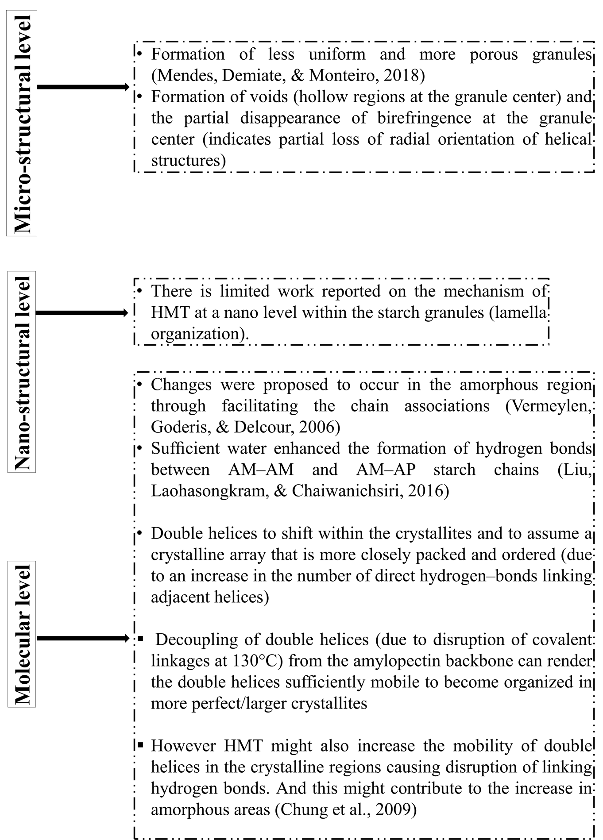
Figure 8: Possible mechanisms for heat moisture treatment at different length scale of starch (Mapengo, 2020)

2.2.2 Infrared heat moisture treatment
The use of conventional heating for heat-moisture treatment has its disadvantages such as higher energy consumption and relatively long processing time which makes it less favourable at commercial scale (Puligundla et al., 2013). Infrared can be an alternative for heat moisture treatment of starch, in order to save the energy and time. With infrared energy being precisely controllable and can be turned on or off instantly, it eliminates the need for warming up or cooling down, provides more uniform energy distribution. The energy used by infrared heat moisture treatment at 3 hours is 17.39 KJ while conventional heat moisture treatment uses 92.83 KJ (Mapengo, Ray, & Emmambux, 2019). Mapengo et al. (2019), conducted the experiment using both the conventional heating and infrared heating for heat moisture treatment to compare the two methods and found that infrared heat moisture treatment can show similar effects to conventional heat moisture treatment at molecular, nanostructure and microstructure of starch.
Infrared is an electromagnetic radiation that can transfer thermal energy in the form of electromagnetic waves (Figure 9). It has three categories based on its wavelength: the near- infrared (NIR; 0.78-1.4mm), middle-infrared (MIR;1.4-3mm), and far-infrared (FIR; 3-1000mm) (figure 10). The short waves appear when temperatures are above 1000$℃$ while long waves appear below 400$℃$ and the medium waves between these temperatures. The application of different infrared wavelength regions affects the amount of transmitted energy, rate of temperature increase and penetration depth, Infrared heating has a limited penetration depth, about 0.31-4.76 mm dependent on food product and applied wavelengths, and therefore infrared is mainly considered a surface heating technology (Eliasson, Isaksson, Lövenklev, & Ahrné, 2015).

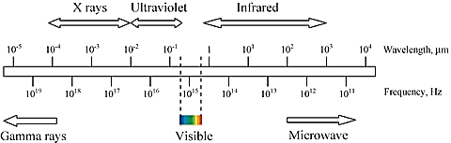
Figure 9: Electromagnetic spectrum ((Krishnamurthy, Khurana, Soojin, Irudayaraj, & Demirci, 2008)

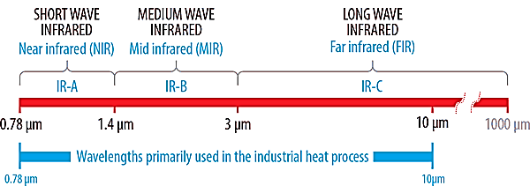
Figure 10: The spectrum highlighting infrared wavelength corresponding to near, mid and far infrared
The three different regions (NIR, MIR and FIR) have different applications, the FIR region is best for food processing as the components that are found in food (hydroxyl groups on water and sugars, carbonyl groups on lipids and proteins, etc) absorb the radiative energy in the FIR region (Sandu, 1986). Thicker materials tend to dry quicker when using IR that uses NIR region due to the shorter wavelengths of the NIR region penetrating deeper than FIR region (Sakai & Hanzawa, 1994). Therefore, NIR may be better for the drying of materials but FIR will be more effective in processing food materials. Frequencies and wavelengths corresponding with different categories of infrared radiation regions shown on table 4.
Table 4: Frequencies and wavelengths corresponding with different categories of infrared radiation regions (Sakai & Hanzawa, 1994)
Class | Frequency (GHz) | Wavelength (µm)
Near infrared radiation | 3.8 x 10⁵ – 2.1 x 10⁵ | 0.78 – 1.4
Mid infrared radiation | 2.1 x 10⁵ – 1 x 10⁵ | 1.4 – 3
Far infrared radiation | 1 x 10⁵ – 300 | 3 – 1000

The infrared absorption mechanism includes changes in the molecular vibrational state. Infrared penetration causes vibratory movement of water molecules at a frequency of 60,000–150,000 MHz and thereby causes heat by molecular friction (Krishnamurthy et al., 2008). When a material is exposed to the radiation, it is heated intensely, and the temperature gradient in the material reduces within a short period (Rastogi, 2012). When the radiant electromagnetic energy penetrates food and it may induce changes in the vibrational states of atoms and molecules. The vibratory mechanism is responsible for the heat transference to all the molecules within a sample (Skjöldebrand, 2001). During IR heating, heat is transferred by radiation, the temperature of the emitting body determines the wavelength, that is, the higher the temperature, the shorter the wavelength (Rastogi, 2012).
Utilization of infrared (IR) in food industry has seen an increasing trend in the recent years, mainly in reducing the cooking time of legumes and drying of food samples (grains, fruits and vegetables). Sample heated directly and uniformly, high quality product, high drying rate, reduced processing time and high energy efficiency are advantages of infrared heating over conventional heating (Ismailoglu & Basman, 2015). The moisture content (20 or 30%), treatment time (30 or 60 min) and infrared power (550 or 750 W) are the most important parameters in order to observe the effect of infrared heat moisture treatment. Infrared heat moisture treatment alters physicochemical properties of starch according to the parameters used (table 5). According to Mapengo and Emmambux (2020), and Ismailoglu and Basman (2015) birefringence of starch can be retained upon the infrared heat-moisture treatment depending on the energy inputs.
Table 5: Applications of infrared heating on different starch and flours
Infrared heating conditions | Cereal or starch type | Properties altered
Using 1000W at 25% moisture content for 1, 2 and 3 hours (Mapengo & Emmambux, 2020) | Maize meal with stearic acid | Reduced in vitro starch digestibility and reduced final viscosity
22% moisture content, periods (15, 30, and 45 s) (Shah et al., 2016) | Indian horse chestnut starch | Peak, trough, final, and setback viscosities were significantly reduced with an increase in treatment time; phenolic content gets increased
17, 31, or 41% moisture content, surface temperatures (100, 120, or  140°C) (Emami, Meda, Pickard, & Tyler, 2010) | Barley starch | Lower in resistant starch (RS) and slowly digestible starch (SDS) and, therefore, higher in rapidly digestible starch (RDS); reductions in the gelatinization enthalpy
0, 10, 20 and 40 Hz using 900 W for 212, 103 and 51 s (Arce-Arce et al., 2014) | Common bean flour | Formation of amylose–lipid complex; power absorbed (20 Hz) show the highest values of water absorption capacity (WAC) and water absorption index (WAI) and the lowest value of viscosity. The content of RS was highest at medium absorbed power (10 Hz).
time (180 s), temperature (130 °C); moisture content (20%); 1.1–1.2 μm (Deepa & Hebbar, 2014) | Maize flour | Inactivation of lipase activity by 66.9-68.2%; Increase in RDS content

Heat moisture treatment has been carried out using the microwave energy, this increasing trend is due to the fact that microwave energy is more efficient than the traditional heating process since it ensures homogenous operation in the whole volume of substance, selective absorption, and greater penetrating depth. The unique heating ability makes microwave energy advantageous for both industrial and home food applications (Anderson & Guraya, 2006). Infrared heating has gained popularity because of fast response time and its superior thermal efficiency compared to the conventional heating (Riadh, Ahmad, Marhaban, & Soh, 2015).
Mapengo and Emmambux, (2019) used infrared followed by pasting to promote formation of amylose lipid complexes and more crystalline structure using maize meal with stearic acid as a sample. In order to compare infrared with conventional heat moisture treatment. They found that the thermal properties of pasted maize meal after HMT of infrared for 2 and 3 hrs showed type IIa and type IIb ALCs while conventionally HMT showed only type IIa ALCs. And also the enthalpies of pasted maize meal were considerably higher for the infrared HMT compared to conventional HMT. Infrared HMT showed higher increase of crystallinity compared to conventional HMT since type IIb ALCs are more crystalline than type I and IIa.

2.2.4 Repeated heat moisture treatment
The repeated heat moisture treatment is a process of repeated heating and cooling of starch, in order to exert great effect on the properties of starch samples. The difference between heat moisture treatment and repeated heat moisture treatment is a cooling process, which explain the superiority of repeated heat moisture treatment. Gong et al. (2017) explained the superiority of repeated heat moisture treatment by suggesting that the rearrangement of starch molecules and the redistribution of water molecules during cooling process stabilize the structure in a greater extent. To our best knowledge, the repeated heat moisture treatment seems to have been done by using the mostly room temperature as a cooling process shown in table 6 (Gong et al., 2017; Huang et al., 2016; Li, Zhang, Xie, & Chen, 2019; Y. Xie, Li, Chen, & Zhang, 2019).
Table 6: A summary of different repeated heat moisture treatment on various starch
HMT conditions | Cooling process | Cycle of HMT | Starch type | Aim of the study | Findings
100$℃$ at 30% moisture content for 5 hours (Xie et al., 2019) | Room temperature for 24 hours | 4 cycles | Wheat starch | Preparing of porous wheat starch | Increased surface area and total pore volume of the wheat starch
100$℃$ at 30% moisture content for 2 hours (Huang et al., 2016) | No cooling process | 5 cycles | Sweet potato starch | In vitro digestibility, physicochemical and structural properties | SDS and thermo-stable SDS content of starch increased, while swelling power and solubility decreased
120$℃$ at 30% moisture content for 2hrs (Zhao et al., 2020) | Naturally cooled | 5 cycles | Mung bean starch | Structural, physicochemical, and digestibility properties | Relative crystallinity, and slow digestible starch increased, while swelling power and viscosities decreased
100$℃$ at 30% moisture content for 3 hours (Li et al., 2019) | Room temperature | 3 cycles | Wheat starch | Structural, physicochemical properties, and in vitro digestibility | Resistant starch formation
110$℃$ at 35% moisture content for 5 hours (Niu et al., 2020) | No cooling process | 4 cycles | Waxy maize starch | Structural characteristics | Change crystalline pattern from A-type to B-type
120$℃$ at 30% moisture content for 2 hours(Gong et al., 2017) | Room temperature for 60 minutes | 6 cycles | Red adzuki bean starch | Structural, physicochemical, and digestibility properties | Change crystalline pattern from C-type to A-type

2.2.5 Cooling
The main focus on using different cooling systems in terms of the effect of cooling rate on the crystalline structure of starch in terms of size and growth has been reported (Creek, Ziegler, & Runt, 2006). Spherulites of 4.5-24µm (small and large particles) are formed (from helical inclusion complexes of amylose with the native lipids) when starch and lipids are heated and slowly cooled (Shogren, Fanta, & Felker, 2006). Spherulitic amylose lipid crystals has two distinct types, which are large lobed/spherical particles and smaller torus-shaped particles. The large particles consist of 7₁ helices while smaller particles has 6₁ helices, typically >90% are large particle while the remainder are smaller particle (Fanta, Felker, & Shogren, 2002). Spherical/lobed spherulites are formed at the slow cooling rates while torus/disc spherulites are formed fast cooling rates (Fanta et al., 2008). Fanta et al. (2008) suggested that slowly- cooled dispersions allows for growth of spherical/lobed spherulites, since the complexation occur at relatively higher cooling temperatures. During rapid cooling more torus/disc spherulites will be formed, because they will be more amylose and fatty acids complex available. Therefore, explains the change in morphology from spherical/lobed to torus/ disc as it rapidly cooled.
It has been noted that cooling rate affect the particle size, the rapid cooling produces smaller particles compare to slow cool (Fanta, Kenar, & Felker, 2015). The spherulite diameter dependent on the cooling rate, small particles are formed during fast cooling as shown in figure 11. According to Fanta et al. (2015) the cooling time of 10 seconds produced nanoparticles with mean diameters of ±63 nm while cooling time of 110 minutes had nanoparticles in a range of 143-375 nm. Purohit and Rao (2017) conducted a study to increase starch crystallinity in parboiled rice, and one of the independent factors were different cooling temperatures and cooling times. They found that cooling temperatures had a significant effect on the starch crystallinity, attributed due to low molecular weight starch chain might had undergone reassociation with corresponding starch chain or short amylose chain during low temperatures forming B-type polymorphs.

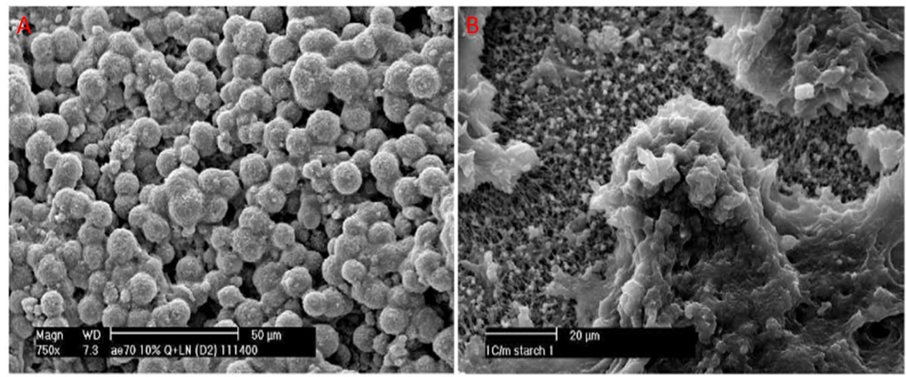
Figure 11: Scanning electron microscopy images of gelatinized high amylose starch dispersion produced at fast (A) and slow (B) cooling rate (Nordmark & Ziegler, 2002).

2.3 concluding remarks
- Amylose lipid complex nanomaterials can be produced using clean label method with principles of green chemistry
- Amylose lipid complex nanomaterial has not been fully utilized to it potential due to physicochemical properties such as low crystallinity and high-water dispersibility
- The nanomaterial has only been produced in a lab scale; it has not been upscaled
- Heat moisture treatment of starch has been shown to enhance the crystalline nature of starch, suggesting that heat moisture treatment can be used to modify the crystallinity of amylose lipid complex nanomaterials
- Infrared energy can be alternative for heat moisture treatment, in order to save the energy

3.0 Hypothesis and objectives

3.1 Hypothesis
Infrared heat-moisture (HMT) treatment will change the functional, nanostructure and molecular properties of isolated amylose lipid complex (ALC) nanomaterials. HMT can modify the structural attributes of starch at the granular surface and the molecules within the starch granules (Chung, Hoover, et al., 2009). Infrared energy will induce changes in the electronic, vibrational, and rotational states of atoms and molecules in the starch components (Skjöldebrand, 2001). These molecular vibrations generate enough thermal energy to increase the mobility of starch chains and lipids, thereby promoting more bonding between starch chains and lipids. Thus, modification of amylose lipid complexes nanomaterials (ALC) using heat moisture treatment can potentially lead into structural transformation of type I of ALC to type II. There will also be an increase of crystallinity of type II ALC, from type IIa into type IIb. Thus, the crystallinity of HMT of isolated ALC nanomaterials will increase and this will impact on the nanostructure as well as functional properties.

3.2 Objectives
To determine the effects of infrared heat moisture treatment and different cooling systems on the modification of amylose lipid complex nanomaterials with the aim of improving crystallinity for potential use as nanofiller in biodegradable packaging systems.

4.0 EXPERIMENTAL

4.1 Experimental design
Figure 12 shows the experimental design of the research. Maize starch and stearic acid were mixed. The mixture was heat moisture treated for 1, 2, and 3 hours using infrared energy, followed by cooling with different systems (room temperature, refrigeration temperature and liquid nitrogen) for 24 hours.
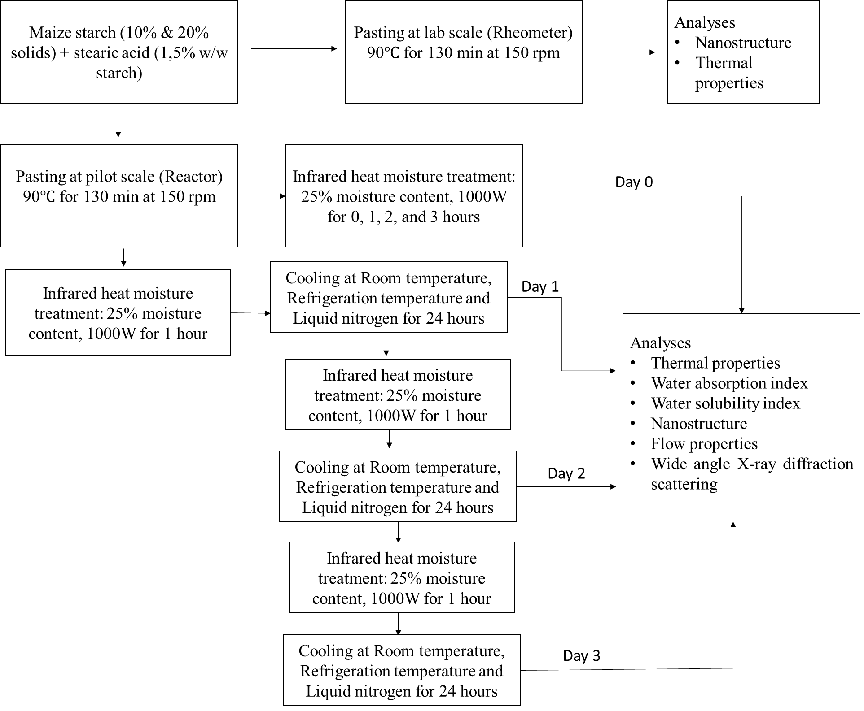
Figure 12: Experimental design for production of amylose lipid complexes and modification using infrared heat moisture treatment and different cooling system

4.2 Materials
Commercial white normal maize starch was obtained from Tongaat Hulett® (Edenvale, South Africa). Stearic acid was obtained from Sigma Aldrich (St. Louis, USA). The moisture, ash, crude fat and protein contents of maize starch were 9%, 0.1%, 0.2% and 0.6% respectively. Thermally stable alpha-amylase from Bacillus Licheniformis (EC.3.2.1.1, 3000 U/ml) was obtained from Megazyme Ltd (Bray, Ireland). All the chemicals and reagents used were of analytical grade.

4.3 Methods

4.3.1 Stearic acid incorporation
Stearic acid (1,5% w/w) was incorporated into commercial normal white maize starch according to the method by D’Silva et al. (2011). The stearic acid was first dissolved in absolute ethanol followed by starch addition and the samples were covered with parafilm and aluminium foil, placed in a shaking water bath at 50$℃$for 30 min. The ethanol was then evaporated off in a forced draught oven at 40$℃$.

4.3.2 Preparation of amylose lipid complex nanomaterials
4.3.2.1 Lab and pilot scale
The maize starch (10 and 20% w/v solids) added with stearic acid was pasted in water for prolonged period of 130 min using the rheometer (Physica MCR 101, Ostildern, Germany) and reactor (IKA® LR 1000 control, Staufen, Germany) shown on the figure 13a and 13b respectively. The rheometer conditions were 90$℃$ at 150 rpm stirring then hold it for the required time of 130 min and cooling it from 90$℃$ to 75$℃$. The probe used for rheometer was a stirrer with 6 blades (ST24-2D/2V/2V-30). The reactor conditions were 90$℃$ at 150 rpm stirring then holding it for the required time of 130 min and cooling it from 90$℃$ to 75$℃$. The material was hydrolysed by adding thermostable alpha-amylase from Bacillus Licheniformis (EC.3.2.1.1) to the paste, according to the method by Wokadala et al., (2012). The thermostable alpha-amylase of 0.29 ml in Tris-HCl (0.05 M, pH 8.2) buffer was added at 75$℃$ for 10 minutes. The unhydrolyzed isolated materials were freeze dried and analysed by differential scanning calorimeter and high-resolution scanning electron microscopy.
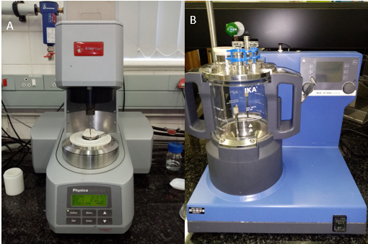
Figure 13: a- rheometer and b- reactor

4.3.3 Infrared heat moisture treatment with cooling systems
Only the isolated materials from pilot scale were heat moisture treated with infrared. The materials were mixed with distilled water to achieve the desired moisture content of approximately 25% for the heat moisture treatment. The samples were equilibrated for 24 h by sealing the containers and leaving them at 21$℃$ before being treated.
The isolated materials were infrared heat moisture treated for the modification using Microwave/Infrared Hot air tunnel oven (MW 180, Olifantsfontein, South Africa). The equilibrated ALC nanomaterials (30 g) were weighed into glass petri dishes and the sample thickness were approximately 3mm. The 1000 W was applied and the temperature at the surface was detected by an IR thermometer. The IR oven was used with halogen lamp (0.2–4 μm), and the samples were placed at a height 25 cm away from the IR lamps. The set temperature for the infrared oven was set at 110°C. Conditions were as follows:
- Heat moisture treated amylose lipid complexes at 110℃ for 1, 2, 3 hours respectively as a continuous method
- Heat moisture treated amylose lipid complexes at 110℃ for 1 hour; cooled and stored at room temperatures (23$℃$) for 24 hours, then HMT at day 2 for one hour followed by cooling (23$℃$) for 24 hours, and then again HMT at day 3 for one hour followed by cooling (23$℃$) for 24 hours.
- Heat moisture treated amylose lipid complexes at 110℃ for 1 hour; cooled and stored at refrigeration temperatures (4$℃$) for 24 hours, then HMT at day 2 for one hour followed by cooling/storage (4$℃$) for 24 hours, and then again HMT at day 3 for one hour followed by cooling/storage (4$℃$) for 24 hours.
- Heat moisture treated amylose lipid complexes at 110℃ for 1 hour and cooled using liquid nitrogen for 10 minutes and stored in the freeze (-20$℃$) for 24 hours, this is repeated for two another two days, i.e. HMT at day 2 for one hour followed by cooling for 24 hours, and then again HMT at day 3 for one hour followed by cooling for 24 hours.
The HMT followed by different cooling systems were then analysed.

4.4 Analyses

4.4.1 Water Absorption Index (WAI) and Water Solubility Index (WSI)
Both treated and untreated isolated materials samples solubility properties were determined by WAI and WSI using the method described by Clarity R. Mapengo et al. (2019). The samples (~1g, dry basis) were heated in 10 mL of distilled water at 50°C and 95°C in a water bath (rpm of 150) for 30 min while vortexing the mixture every 5 min interval. The sample solution was centrifuged at 3000 x g for 15 min. The supernatant was decanted and evaporated at 100°C for 24 h in a forced draught oven. The water solubility index was determined as the ratio in weight of dried supernatant to the weight of the dry sample and expressed as a percentage (%). The residue obtained after centrifugation was weighed to obtain the absorption index. The water absorption index was expressed as the weight of pellet(g) obtained per gram of dry ground sample.
Formulas: WAI = (CT_{o} – CT)/W_{o}
WSI = W_{d} x 100/W_{o}
Where:
W_{o} = weight of dry solids
W_{d} = weight of dissolved solids in supernatant (weight of supernatant after drying)
CT = centrifuge tube
CT_{o} = weight of centrifuge tube containing the gel/pellet.

4.4.2 Flow properties
The flow properties of both treated and untreated materials samples were measured using the plate-to-plate method with rheometer (Physica MCR 101, Ostildern, Germany). A serrated plate was utilized to measure the flow properties of the sample pastes with a 1mm gap. The sample pastes were equilibrated at 25 °C for 1 min before the start of the test. Flow properties were determined at different shear rates from 0.001 to 1000 s⁻¹. The Power law model: σ =K γ̇ ^{n} where K is the consistency coefficient (Pa.s^{n}) and n is the flow behaviour index was used to describe the flow properties.

4.4.3 Nanostructure by Scanning Electron Microscopy (SEM)
Both treated and untreated isolated materials samples were submersed in liquid nitrogen and allowed to freeze. Samples were then freeze fractured in half and mounted onto aluminium stubs with the aid of double-sided carbon tape and carbon paste to help orientate sample powder. Aluminium stubs were coated six times with carbon to about 20 nm in thickness before analysed by SEM. SEM micrographs were obtained using Cryo-SEM, JOEL 840 (Tokyo, Japan) at an accelerated voltage of 3.00 kV. Observations were done at 2500x magnifications.

4.4.4 Thermal properties by Differential scanning calorimetry (DSC)
Thermal properties of both treated and untreated isolated materials samples were measured using a differential scanning calorimeter (DSC) system (HP DSC827e, Mettler Toledo, Greifensee, Switzerland). The method used for this analysis was as described by Wokadala et al. (2012). The sample powder (10 mg, db) was weighed into aluminium pans and thoroughly mixed with distilled water at a 1:3 (w/w) starch-to-water ratio to make homogeneous slurry. The pans were sealed. An empty aluminium crucible was used as a reference. The pans were equilibrated for 24 h at room temperature before scanning. Scanning was done from 25°C to 180°C under high pressure (4 MPa using N₂) at a rate of 10°C/min. Indium (Tp = 156.6°C, 28.45 J/g) was used as a standard to calibrate the DSC.

4.4.5 Wide angle X-ray diffraction scattering (WAXS)
Wide angle X-ray diffraction scattering (WAXS) was conducted using X’Pert PANalytical diffractometer (Eindhoven, Netherlands) on both treated and untreated isolated materials. The samples were equilibrated for 5 days at 65% ERH (estimated relative humidity) at room temperature using a saturated sodium chloride solution. The operating conditions for the WAXS were 45 kV, 40 mA, CuKα (0.154 nm). The scanning was done from 5° - 30° (2θ) and the exposure was 16 min and 14 s, step size was 0.026° and time/step ratio was 229.5 s. The relative degree of crystallinity was determined as the percentage integrated area of crystalline peaks to the total integrated area above a straight baseline using Originpro software (Wokadala et al., 2012).

4.4.6 Thermal gravimetric anaylsis (TGA)
Thermogravimetric analysis was performed on TGA Q500 (TA Instruments), USA, using ~10mg of both treated and untreated isolated materials samples. TGA was used to evaluate the thermal stability of ALC nanomaterials. The analysis was performed at a heating rate of 10°C/min under air and ramped from 25°C to 900°C under a nitrogen gas flow 50 mL/min. The plot of the weight loss against temperature was achieved from the analysis.

4.4.7 Dynamic mechanical thermal analysis (DMTA)
The DMTA property measurements were performed on a Perkin Elmer DMA 8000 (USA) instrument within a temperature range of −100 to 200°C at a heating rate of 2°C/min heating rate and 1 Hz constant frequency on both the treated and untreated isolated materials. The instrument was operated in dynamic mode, using single cantilever geometry, at a strain of 0.02%.

4.5 Statistical analysis
The statistical design of the pilot scale material was a 4 X 4 factorial design (heat moisture treatment of 0, 1, 2 and 3 hours and cooling system of no cooling, room temperature (slow cooling rate), Refrigeration temperature (fast cooling rate) and liquid nitrogen (fastest cooling rate). The experiments were done in triplicate. Multivariate analysis of variance (MANOVA) was used to determine significant differences due to the heat moisture treatment and cooling systems for amylose lipid complex nanomaterials. Means were compared using the Fischer’s Least Significant Difference Test (LSD) at P≤0.05.

5. Results

5.1 Upscaling amylose lipid complex nanomaterials

5.1.1 Pasting and yield of isolated nanomaterials
Figure 14 shows viscous properties of 10 and 20% starch with stearic acid pasted using pasting cell in a Rheometer. The 10% starch had a maximum viscosity of about 3 000 Pa.s while 20% had 14 000 Pa.s maximum first peak viscosity. The viscosity further increased after the first peak viscosity. It seems that starch with stearic acid at 20% solids was too viscous, it did not mix the content efficiently as the pasted material collected around the stirrer. Thus, the machine was not measuring the resistance to flow by the stirrer, the Rheometer continue to run while giving false results (figure 14).
The yield of isolated materials from lab (rheometer) scale and pilot (reactor) scale is shown in table 7. The lab scale had a significantly (p<0.05) higher yield compared to the pilot scale, with the yield percentage of 41% and 38% respectively for the 10% paste. The Reactor was able to upscale the production of isolated materials from 10 to 20% with no significance difference (p>0.05) in yield.
Table 7: Effect of upscaling from lab (Rheometer) to pilot (Reactor) scale on the yield of amylose lipid complexes nanomaterials
Scale | Starch concentration (w/v in water) | Instrument used | Yield (%)
Lab | 10% | Rheometer | 40.63 ± 0.3a
Lab | 20% | Rheometer | -
Pilot | 10% | Reactor | 37.74 ± 0.1b
Pilot | 20% | Reactor | 37.60 ± 0.2b
Values are means ± SD. Different letters represent significant differences (p ≤ 0.05). (-) is too viscous, prohibited the stirring (failed)

5.1.2 DSC and SEM of isolated materials
Differential scanning calorimetry (DSC) and scanning electron microscopy (SEM) of isolated materials are shown on figure 15 and 16 respectively. The onset (T_{o}), peak (T_{p}) and endset (T_{e}) transition temperatures values of isolated materials produced using Rheometer and Reactor were 99.0$℃$, 103.$7℃$ and 111.$6℃$ and 98.$0℃$, 103.9$℃$ and 111.1$℃$ respectively and showed no significantly difference (p>0.05). The SEM image showed nanoparticles with an average size of ±45nm and ±48nm, manufactured from rheometer and reactor respectively. The SEM also seem to show that the particles is made up of several nanomaterials of less than 10nm together to average size of about 40-50 nm, suggesting lamella organisation of the nanomaterials. The melting temperature of isolated materials from rheometer and reactor showed presence of amylose lipid complexes (Cuthbert et al., 2017) and SEM showed nanomaterials. Thus, the isolated materials can be referred as amylose lipid complex nanomaterials.

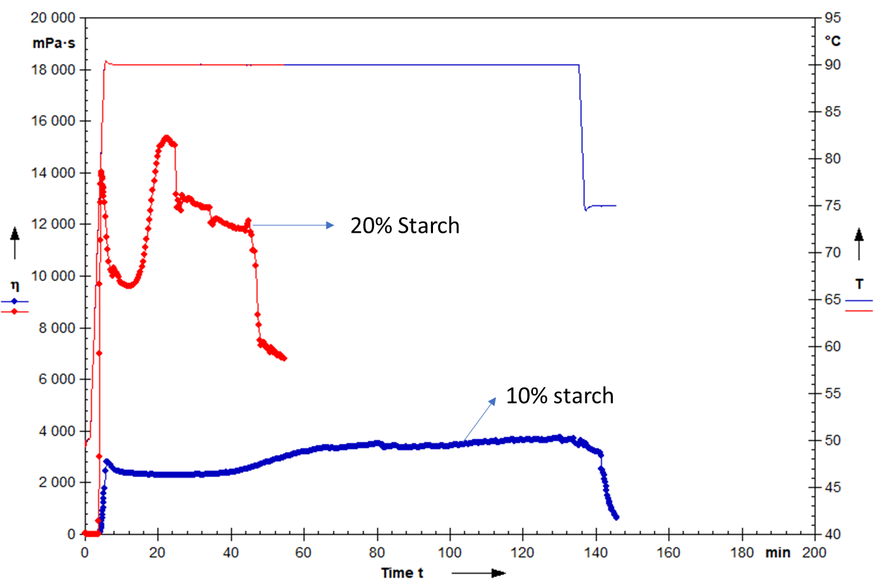
Figure 14: Effect of solids concentration of 10 and 20% solid on the pasting properties of starch with added stearic acid
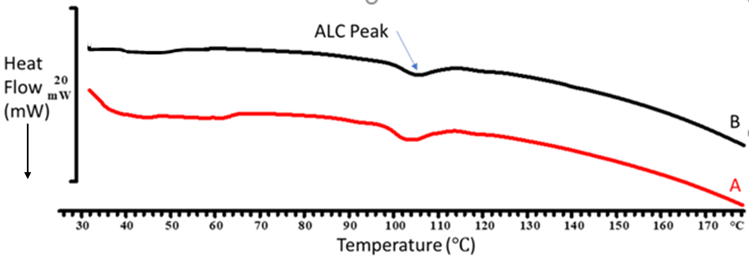
Figure 15: The DSC thermograms of isolated materials using Rheometer (A) and Reactor (B)
ALC- isolated amylose lipid complex nanomaterial
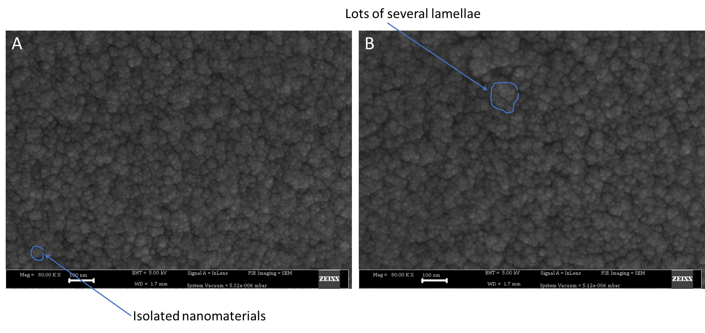
Figure 16: Scanning electron microscopy of isolated nanomaterial images produced using Rheometer (A) and Reactor (B), Scale bar is 100nm

5.2 Infrared heat moisture treatment with different cooling rate of isolated amylose lipid complex nanomaterials

5.2.1 Water absorption and solubility properties
The effects of heat moisture treatment with infrared and cooling systems on the water solubility and absorption index of treated and untreated ALC nanomaterials at different temperatures (50$℃$ and 95$℃$) are shown in table 8. It is also noted that cooling with liquid nitrogen is the fastest followed by refrigeration and room temperature. For all the isolated nanomaterials, the water absorption and solubility index increased with increasing measuring temperatures from 50$℃$ to 95$℃$ during the analyses. As the time of HMT (more energy) increased from one to three hours, water absorption and water solubility index both at 50$℃$ and 95$℃$ showed significant (p<0.05) decrease. However, there was no significant (p>0.05) difference when the rate of cooling increased from room temperature to liquid nitrogen. Therefore, cooling systems seems to have minimal effects compared to infrared HMT. Water absorption and solubility index at 50$℃$ showed a statistically significant (p<0.05) interactive between cooling systems and heat moisture treatment, while had no significant (p >0.05) effect at 95$℃$.
Table 8: Effects of heat moisture treatment and cooling systems on the water absorption index (WAI) and water solubility index (WSI) of isolated amylose lipid complex nanomaterials
Cooling system | Time of HMT (hours) | WAI at 50$℃$ (g/g) | WAI at 95$℃$  (g/g) | WSI at 50$℃$  (%) | WSI at 95$℃$  (%)
No cooling | 0  1  2  3 | 9.6 ±0.6e  8.3 ±0.3d  8.2 ±0.3d  6.4 ±0.3a | 20.3 ±0.2e  19.8 ±0.2abcde  19.6 ±0.1abcd  19.15 ±0.2a | 5.3 ±0.3f  4.3 ±0.4cd  4.0 ±0.2bcd  3.6 ±0.1abc | 9.8 ±0.1efg  9.5 ±0.1cde  9.2 ±0.1bcd  8.9 ±0.1 ab
Room temperature | 0  1  2  3 | 10.1 ±0.1e  8.3 ±0.2d  7.3 ±0.3bc  6.1 ±0.1a | 20.2 ±0.1de  19.9 ±0.1bcde  19.6 ±0.1abcd  19.5 ±0.1 abc | 5.2 ±0.1f  4.5 ±0.4de  4.1 ±0.1bcd  3.9 ±0.2bcd | 9.9 ±0.1efg  9.5 ±0.2cde  9.1 ±0.1abc  8.8 ±0.1a
Refrigeration temperatures | 0  1  2  3 | 10.1 ±0.2e  7.3 ±0.1bc  6.3 ±0.2a  6.5 ±0.1ab | 20.1 ±0.1cde  19.8 ±0.2bcde  19.5 ±0.3ab  18.9 ±0.1a | 5.1 ±0.2ef  4.8 ±0.1e  4.3 ±0.1cd  4.0 ±0.2bcd | 9.9 ±0.1fg  9.6 ±0.1def  9.2 ±0.2bcd  9.0 ±0.1ab
Liquid nitrogen | 0  1  2  3 | 10.0 ±0.2e  7.9 ±0.1cd  7.3 ±0.2bc  8.3 ±0.3d | 20.3 ±0.3e  19.8 ±0.2abcde  19.6 ±0.2abcd  19.2 ±0.1ab | 5.4 ±0.3f  4.5 ±0.1de  3.4 ±0.2a  3.2 ±0.2 bc | 9.9 ±0.2g  9.6 ±0.1defg  9.5 ±0.1def  9.1 ±0.2abc
Values are mean ± standard deviation of triplicate experiments. Values of different letters a-g in the column are significantly different at P˂ 0.05.

5.2.2 Flow properties
As expected, the apparent viscosity decreased with increasing shear rates for the treated and untreated isolated nanomaterials (figure 17), showing that the isolate nanomaterials were shear thinning. The zero shear viscosity was calculated, and the flow properties of isolated ALC nanomaterials followed the Power law model with the correlation coefficient (r²≥0.99) close to 1, for the shear rate range of 0.001 to 1000 1/s (table 9). The consistency index, zero shear, viscosity and hysteresis of the treated isolated ALC nanomaterials decreased significantly (p<0.05) compare to the untreated isolated ALC nanomaterials. The flow behaviour index ‘n’ of the treated ALC nanomaterials increased significantly (p<0.05) compared to untreated isolated ALC nanomaterials, suggesting less shear thinning behaviour (moving toward Newtonian regime) with Infrared HMT treatments. As the time of HMT (more energy) increased from one to three hours, the flow properties showed significantly (p<0.05) lower viscosity parameters; while as the rate of cooling increased from room temperature to liquid nitrogen, a higher significant (p<0.05) decrease was observed. Therefore, it seems like cooling systems seems to have a greater effect compared to HMT in decreasing the viscosity of the isolated nanomaterials at different shear rates. Flow properties also showed a statistically significant interactive effect between cooling systems and infrared heat moisture treatment at p<0.05. It is also noted that when amylose lipid nanomaterials were treated for longer time, there seems to have a minimal or less shear thinning behaviour as ‘n’ from the power law model increased from 0.16 to about a maximum of about 0,86. There was also a decrease in the hysteresis area with increase in infrared HMT time and increase in cooling rate.

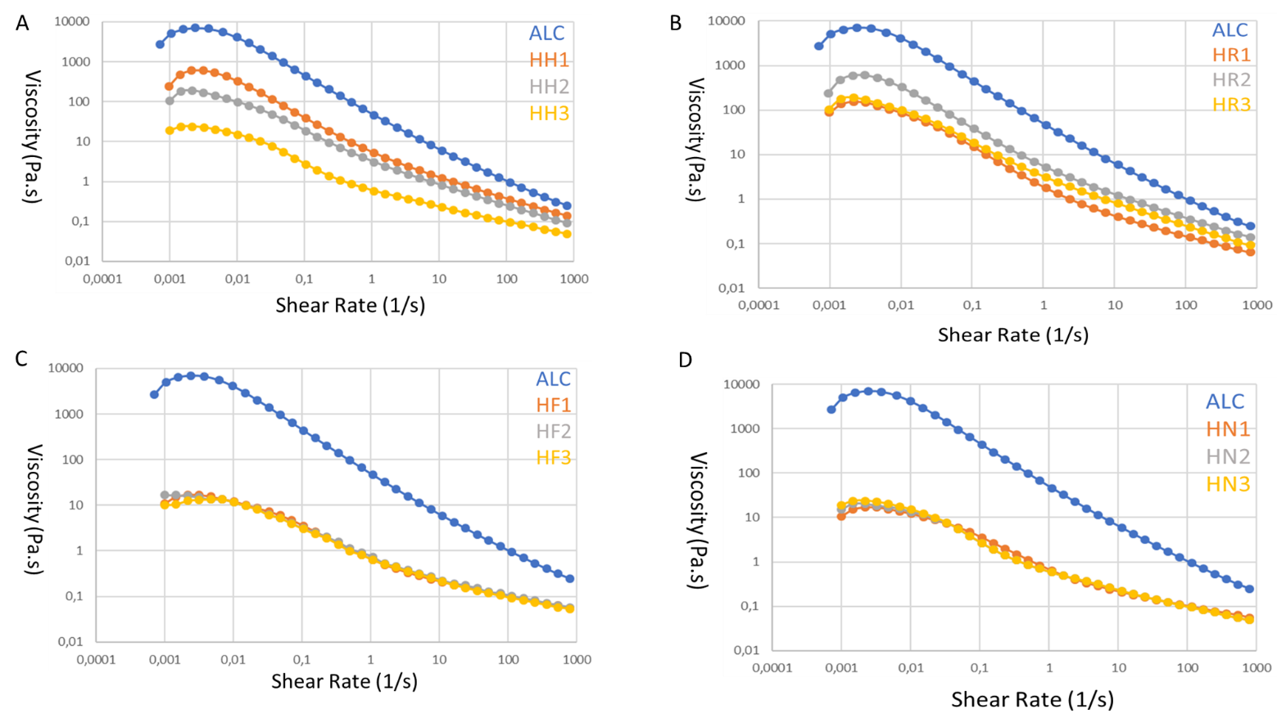
Figure 17: The effect of heat moisture treatment and cooling systems on the flow properties of isolated amylose lipid complex nanomaterials
A - Heat moisture treated amylose lipid complexes at 110℃ for 1,2,3 hours respectively as a continuous method
B - Heat moisture treated amylose lipid complexes at 110℃ for 1 hour and cooled at room temperatures (23$℃$) for 24 hours, then HMT at day 2 for one hour followed by cooling (23$℃$) for 24 hours, and then again HMT at day 3 for one hour followed by cooling (23$℃$) for 24 hours.
C - Heat moisture treated amylose lipid complexes at 110℃ for 1 hour and cooled at refrigeration temperatures (4$℃$) for 24 hours, then HMT at day 2 for one hour followed by cooling (4$℃$) for 24 hours, and then again HMT at day 3 for one hour followed by cooling (4$℃$) for 24 hours.
D - Heat moisture treated amylose lipid complexes at 110℃ for 1 hour and cooled using liquid nitrogen for 10 minutes and stored in the freeze (-20$℃$) for 24 hours, then HMT at day 2 for one hour followed by cooling for 24 hours, and then again HMT at day 3 for one hour followed by cooling for 24 hours.

Table 9: Effects of heat moisture treatment and cooling systems on the flow properties of isolated amylose lipid complex nanomaterials
Cooling system | Time of HMT (hours) | K (Pa.s^{n}) | n | R2 | Zero shear (Pa.s) | Hysteresis (Pa/s)
No cooling | 0  1  2  3 | 46.5 ±0.5f  5.3 ±0.2e  3.3 ±0.1d  2.3 ±0.1c | 0.16 ±0.1a  0.45 ±0.4b  0.44 ±0.1b  0.45 ±0.1b | 0.99  0.99  0.99  0.99 | 6724 ±0.7e  593 ±0.9d  194 ±0.2c  161 ±0.5bc | 13796 ±0.5i  33378 ±0.6h  3157 ±0.2g  2925 ±0.9f
Room temperature | 0  1  2  3 | 46.7 ±0.2f  1.7 ±0.1b  1.6 ±0.1b  1.5 ±0.1b | 0.16 ±0.1a  0.44 ±0.1b  0.45 ±0.1b  0.45 ±0.1b | 0.99  0.99  0.99  0.99 | 6742 ±0.8e  155 ±0.2bc  143 ±0.6b  135 ±0.4b | 13817 ±0.3i  1672 ±0.7c  1845 ±0.5d  2045 ±0.4e
Refrigeration temperatures | 0  1  2  3 | 46.6 ±0.1f  0.4 ±0.1a  0.4 ±0.1a  0.6 ±0.1a | 0.16 ±0.1a  0.68 ±0.1c  0.68 ±0.1c  0.62 ±0.1c | 0.99  0.99  0.99  0.99 | 6776 ±0.9e  11 ±0.3a  17 ±0.4a  13 ±0.4a | 13790 ±0.2i  665 ±0.3b  628 ±0.5ab  598 ±0.6a
Liquid nitrogen | 0  1  2  3 | 46.8 ±0.2f  0.1 ±0.1a  0.2 ±0.1a  0.2 ±0.1a | 0.16 ±0.1a  0.83 ±0.1e  0.75 ±0.1d  0.74 ±0.1d | 0.99  0.99  0.99  0.99 | 6723 ±0.2e  17 ±0.2a  22 ±1.5a  23 ±0.4a | 13784 ±0.3i  690 ±0.4b  601 ±0.1a  571 ±0.8a
Values are mean ± standard deviation of triplicate experiments. Values of different letters a-i in the column are significantly different at P˂ 0.05. ‘n’ is the flow index; K is the consistency index and r² is the correlation coefficient.

5.2.3 Morphology
The Scanning electron micrographs shows images of both treated and untreated isolated ALC nanomaterials (figure 19 and 18). All the images showed that particles had an average size of less than 100 nm, therefore all the particles were at nanoscale. The nanostructure of untreated ALC nanomaterial seems to change with IR HMT and the cooling systems. The untreated ALC had finely arranged structure while the treated (IR HMT followed by cooling) ALC showed disrupted structure with some nanoparticles projected up (vertical). As the HMT time increased from one to three hours (more energy), more protruded nanoparticles were observed. HMT followed by cooling using refrigeration temperatures had more protruded nanoparticles compared to other treatments. The infrared treatment with cooling systems, especially with refrigeration and liquid nitrogen also produced images also showed less spaces between the nanoparticles. This may suggest that there may be some structural changes of the nanomaterials as a result of infrared HMT and cooling rate.
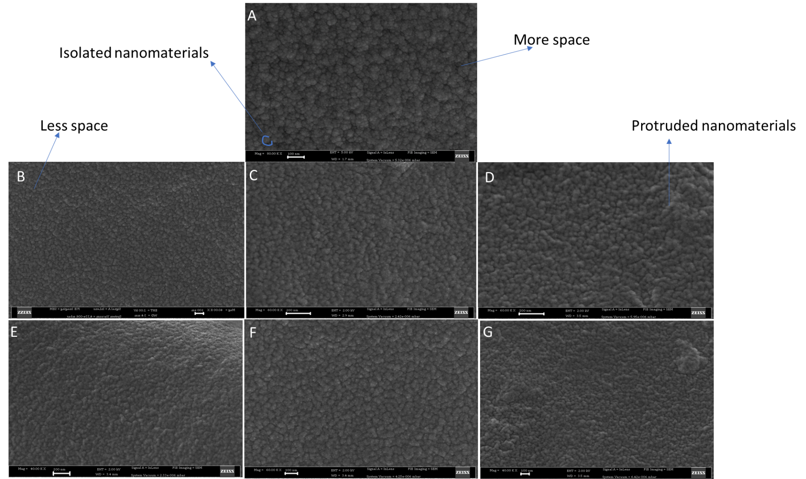
Figure 18: Effects of heat moisture treatment and cooling systems on the nanostructure of isolated nanomaterials using scanning electron microscopy
A is ALC (control)
B, C, D is heat moisture treated amylose lipid complexes at 110℃ for 1,2,3 hours respectively as a continuous method
E, F, G is heat moisture treated amylose lipid complexes at 110℃ for 1 hour and cooled at room temperatures (23$℃$) for 24 hours, then HMT at day 2 for one hour followed by cooling (23$℃$) for 24 hours, and then again HMT at day 3 for one hour followed by cooling (23$℃$) for 24 hours
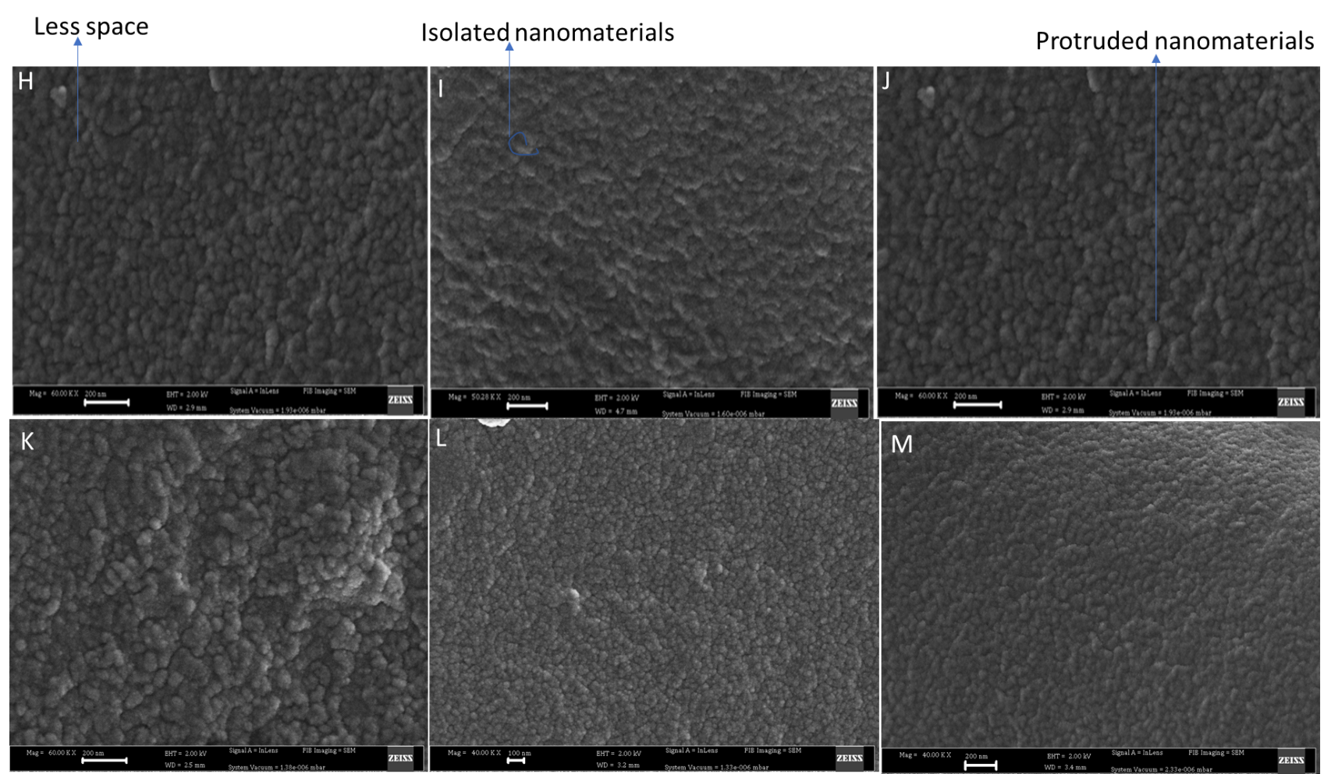

Figure 19: Effects of heat moisture treatment and cooling systems on the nanostructure of isolated nanomaterials using scanning electron microscopy
H, I, J is heat moisture treated amylose lipid complexes at 110℃ for 1 hour and cooled at refrigeration temperatures (4$℃$) for 24 hours, then HMT at day 2 for one hour followed by cooling (4$℃$) for 24 hours, and then again HMT at day 3 for one hour followed by cooling (4$℃$) for 24 hours.
K, L, M is heat moisture treated amylose lipid complexes at 110℃ for 1 hour and cooled using liquid nitrogen for 10 minutes and stored in the freeze (-20$℃$) for 24 hours, then HMT at day 2 for one hour followed by cooling for 24 hours, and then again HMT at day 3 for one hour followed by cooling for 24 hours

5.2.4 Differential scanning calorimetry (DSC)
The differential scanning calorimetry of treated and untreated isolated ALC nanomaterials are shown in figure 20 and table 10. The untreated isolated ALC nanomaterials (control) had an onset temperature (T_{o}), peak temperature (T_{p}) and conclusion temperature (T_{c}) of 97.1$℃$, 103.9$℃$ and 111.3$℃$ respectively (table 10). The endothermic temperatures of treated ALC nanomaterials showed a significant (p < 0.05) increase in the peak temperatures compared to the control, except for the treated isolated ALC nanomaterial with HMT for 1 hour. The treated ALC nanomaterials cooled using refrigeration temperatures at one day and cooled using liquid nitrogen at 3 days recorded the highest values of T_{o}, T_{p} and T_{c} of 103.8$℃$, 110.7$℃$ and 117.0$℃$, and 104.6$℃$, 112.3$℃$ and 117.7$℃$ respectively. Both treated and untreated ALC nanomaterials only showed one endothermic peak. As the time of HMT (more energy) and cooling rate increased, thermal properties of isolated nanomaterials showed significant (p<0.05) increase. However, it seems that the HMT showed a greater effect than the cooling rate. DSC patterns for onset and peak temperatures showed a statistically significant interactive between cooling systems and heat moisture treatment at p<0.05, while the endset temperatures had no significant (p >0.05) effect.

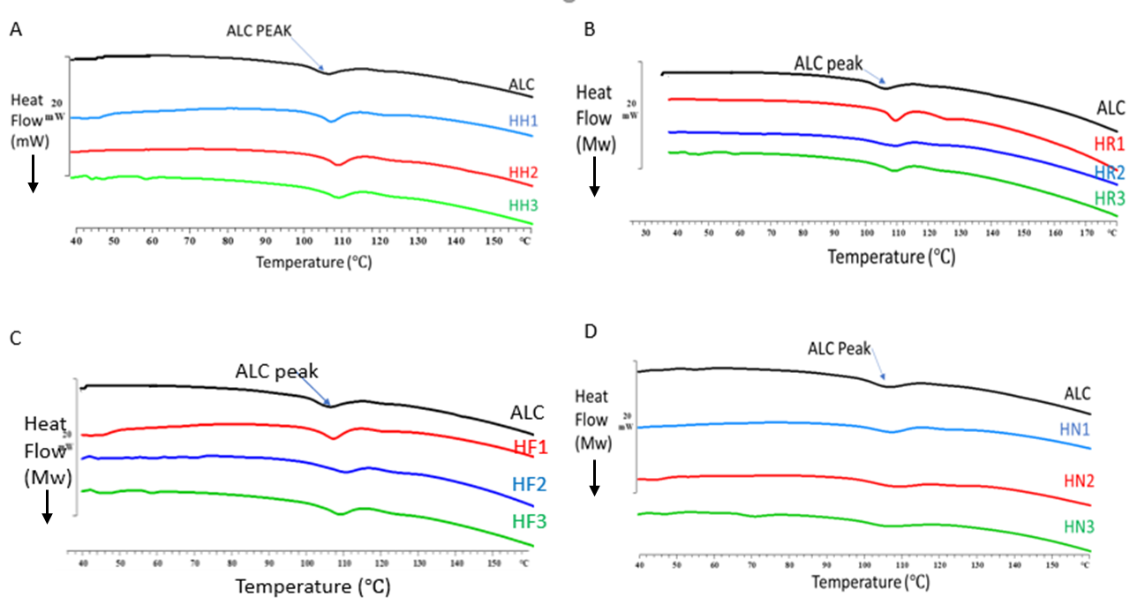
Figure 20: Effects of heat moisture treatment and cooling systems on the thermal properties of isolated amylose lipid complex nanomaterials
A - Heat moisture treated amylose lipid complexes at 110℃ for 1,2,3 hours respectively as a continuous method
B - Heat moisture treated amylose lipid complexes at 110℃ for 1 hour and cooled at room temperatures (23$℃$) for 24 hours, then HMT at day 2 for one hour followed by cooling (23$℃$) for 24 hours, and then again HMT at day 3 for one hour followed by cooling (23$℃$) for 24 hours.
C - Heat moisture treated amylose lipid complexes at 110℃ for 1 hour and cooled at refrigeration temperatures (4$℃$) for 24 hours, then HMT at day 2 for one hour followed by cooling (4$℃$) for 24 hours, and then again HMT at day 3 for one hour followed by cooling (4$℃$) for 24 hours.
D - Heat moisture treated amylose lipid complexes at 110℃ for 1 hour and cooled using liquid nitrogen for 10 minutes and stored in the freeze (-20$℃$) for 24 hours, then HMT at day 2 for one hour followed by cooling for 24 hours, and then again HMT at day 3 for one hour followed by cooling for 24 hours.
Table 10: Effects of heat moisture treatment and cooling systems on the thermal properties of isolated amylose lipid complex nanomaterials
Cooling systems | Time of HMT (hours) | Onset ($℃$) | Peak ($℃$) | Endset ($℃$)
No cooling | 0  1  2  3 | 97.1 ± 0.3a  97.4 ± 0.2a  99.9 ± 0.2b  99.9 ± 0.1b | 103.3 ± 0.8a  105.2 ± 0.7b  108.9 ± 0.3de  108.5 ± 0.5cd | 110.8 ± 0.2a  112.3 ± 0.4a  115.5 ± 06e  115.1 ± 0.1d
Room temperatures | 0  1  2  3 | 97.2 ± 0.4a  103.8 ± 0.3cd  99.2 ± 0.2b  104.5 ± 0.2d | 103.5 ± 0.6a  109.1 ± 0.2de  107.7 ± 0.1c  109.7 ± 0.2ef | 110.8 ± 0.2a  113.5 ± 0.4c  113.7 ± 0.3c  113.9 ± 0.4c
Refrigeration temperatures | 0  1  2  3 | 97.5 ± 0.7a  104.0 ± 0.1d  101.9 ± 0.1c  101.1 ± 0.1c | 103.4 ± 0.6a  110.7 ± 0.1f  109.9 ± 0.9ef  110.9 ± 0.2f | 110.6 ± 0.3a  117.0 ± 0.1f  117.8 ± 0.3g  117.2 ± 0.2fg
Liquid nitrogen | 0  1  2  3 | 97.3 ± 0.2a  102.4 ± 0.2c  100.4 ± 0.2b  104.7 ± 0.2d | 103.4 ± 0.5a  109.9 ± 0.1ef  108.2 ± 0.2cd  112.3 ± 0.1g | 110.9 ± 0.2a  115.5 ± 0.1de  115.3 ± 0.1de  117.7 ± 0.3g
Values are mean ± standard deviation of triplicate experiments. Values of different letters a-g in the column are significantly different at P˂ 0.05.

5.2.5 Wide angle X-ray diffraction scattering of amylose lipid complex nanomaterials
The X-ray diffraction showed three peaks for both treated and untreated isolated ALC nanomaterials (figure 21 and table 11). The three peaks were in the range of 7-8$°$, 12-13$°$ and 19-20$°$. The relative crystallinity increased significantly (p < 0.05) for treated isolated ALC nanomaterials compare to untreated isolated ALC nanomaterials (control), except for the treated isolated ALC nanomaterial with HMT for 1 hour shown in table 11. The interplanar spacing (d) decreased significantly (p<0.05) as the 2$θ$ degrees increase for both the treated and untreated isolated ALC nanomaterials (table 11). The interplanar spacing (d) for untreated isolated ALC nanomaterials (control) at 7-8$°$, 12-13$°$ and 19-20$°$ were 1.15, 0.66 and 0.44Å, respectively, but did not change with the infrared and cooling treatments. However, the area and relative area of the peaks changed with the treatments. Increase in infrared treatment time resulted in increased diffractogram peaks at 7-8$°$, 12-13$°$ and 19-20$°$, and the relative area also increased from diffractogram peaks at 7-8$°$ to 19-20$°$. The area and relative area of the peaks for untreated isolated ALC nanomaterials (control) at 7-8$°$, 12-13$°$ and 19-20$°$ were 82.73, 544.02 and 886.58, and 0.06, 0.36 and 0.59 respectively. The relative crystallinity of untreated isolated ALC nanomaterials (control) was 13.7%, and the treated isolated ALC nanomaterial with HMT for 1 hour recorded the lowest of 10.6%. The relative crystallinity was highest at 21.1% and 21.7% for treated isolated ALC nanomaterials with cooling for three days using of refrigeration temperatures and liquid nitrogen respectively. As the time of HMT (more energy) increased from one to three hours and the rate of cooling increased from room temperature to liquid nitrogen, a significant (p<0.05) increase in crystallinity was observed. The X-ray diffraction of relative crystallinity showed a statistically significant interactive between cooling systems and heat moisture treatment at p<0.05.

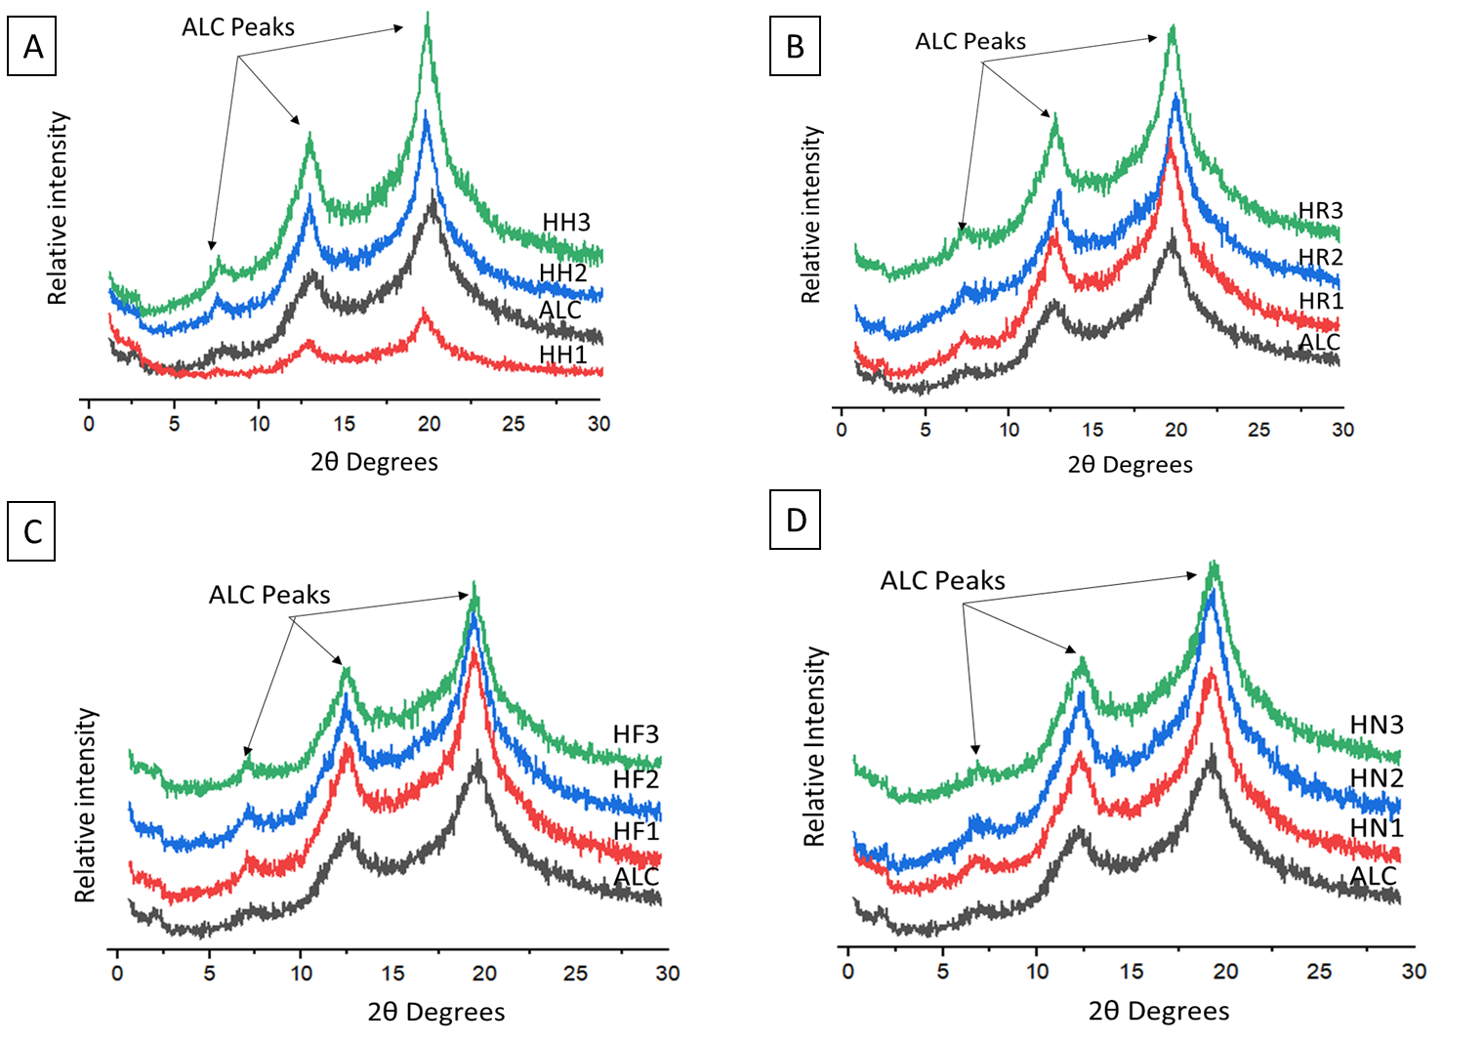
Figure 21: Effects of heat moisture treatment and cooling systems using infrared energy on the X-ray diffraction pattern of isolated amylose lipid complex nanomaterials
A - Heat moisture treated amylose lipid complexes at 110℃ for 1,2,3 hours respectively as a continuous method
B - Heat moisture treated amylose lipid complexes at 110℃ for 1 hour and cooled at room temperatures (23$℃$) for 24 hours, then HMT at day 2 for one hour followed by cooling (23$℃$) for 24 hours, and then again HMT at day 3 for one hour followed by cooling (23$℃$) for 24 hours.
C - Heat moisture treated amylose lipid complexes at 110℃ for 1 hour and cooled at refrigeration temperatures (4$℃$) for 24 hours, then HMT at day 2 for one hour followed by cooling (4$℃$) for 24 hours, and then again HMT at day 3 for one hour followed by cooling (4$℃$) for 24 hours.
D - Heat moisture treated amylose lipid complexes at 110℃ for 1 hour and cooled using liquid nitrogen for 10 minutes and stored in the freeze (-20$℃$) for 24 hours, then HMT at day 2 for one hour followed by cooling for 24 hours, and then again HMT at day 3 for one hour followed by cooling for 24 hours.
Table 11: Effects of heat moisture treatment and cooling systems using infrared energy on the X-ray diffraction pattern of isolated amylose lipid complex nanomaterials
Cooling systems | Time of HMT (hours) | Interplanar spacing (Å) with the area and relative area of the peak in bracket |  |  | Relative crystallinity (%)
Cooling systems | Time of HMT (hours) | 7°-8° | 12°-13° | 19°-20° | Relative crystallinity (%)
No cooling | 0  1  2  3 | 1.15 (82.73, 0.06)  1.21 (75.78, 0.18)  1.20 (72.31, 0.04)  1.19 (110.09, 0.04) | 0.68 (544.02, 0.36)  0.70 (118.79, 0.29)  0.69 (512.97, 0.31)  0.69 (797.96, 0.30) | 0.44 (886.58, 0.59)  0.46 (221.88, 0.53)  0.45 (1077.58, 0.65)  0.44 (1735.90, 0.66) | 13.7 ± 2.2ab  11.5 ± 1.7a  16.8 ± 0.5bcd  16.0 ± 0.6bc
Room temperatures | 0  1  2  3 | 1.15 (82.73, 0.06)  1.17 (95.01, 0.04)  1.22 (101.56, 0.05)  1.12 (181.28, 0.06) | 0.68 (544.02, 0.36)  0.69 (695.73, 0.31)  0.71 (514.35, 0.25)  0.69 (790.53, 0.27) | 0.44 (886.58, 0.59)  0.45 (1450.85, 0.65)  0.45 (1403.90, 0.70)  0.45 (1995.23, 0.67) | 14.1 ± 1.9ab  15.2 ± 0.1b  13.7 ± 1.2ab  18.7 ± 1.4cde
Refrigeration temperatures | 0  1  2  3 | 1.15 (82.73, 0.06)  1.19 (193.13, 0.06)  1.18 (173.62, 0.05)  1.22 (98.71, 0.04) | 0.68 (544.02, 0.36)  0.69 (1072.04, 0.35)  0.69 (940.94, 0.29)  0.69 (811.52, 0.30) | 0.44 (886.58, 0.59)  0.45 (1812.42, 0.59)  0.45 (2102.16, 0.65)  0.45 (1753.38, 0.66) | 13.7 ± 2.2ab  20.5 ± 1.1e  21.7 ± 1.20e  20.9 ± 0.9e
Liquid nitrogen | 0  1  2  3 | 1.15 (82.73, 0.06)  1.19 (105.98, 0.04)  1.17 (155.29, 0.07)  1.16 (106.08, 0.04) | 0.68 (544.02, 0.36)  0.70 (769.95, 0.32)  0.67 (865.02, 0.36)  0.68 (804.07, 0.30) | 0.44 (886.58, 0.59)  0.45 (1523.49, 0.63)  0.45 (1352.66, 0.57)  0.45 (1768.33, 0.66) | 13.9 ± 2.1ab  19.8 ± 1.1e  15.9 ± 0.9bc  21.1 ± 0.3e
Values are mean ± standard deviation of triplicate experiments. Values of different letters a-e in the relative crystallinity column are significantly different at P˂ 0.05.

5.2.6 Thermogravimetric analysis of amylose lipid complexes nanomaterials
The TGA curve of both treated and untreated isolated ALC nanomaterials showed three major weight loss regions, that were in the range of 10 – 100$℃$, 250 – 350$℃$ and 350 – 550$℃$ with main peak at $±$330$℃$(figure 22 and table 12). In those three regions, both treated and untreated isolated ALC nanomaterials had a mass loss of approximately 5%, 65% and 7% respectively. There was an increase, although non-significant (P<0.05) in main peak temperature for the treated isolated nanomaterials compared with control. There was no statistically significant (p>0.05) difference between the weight loss in the three TGA curve regions of both treated and untreated isolated ALC nanomaterials. However, the residual weight after 600$℃$ for untreated isolated ALC nanomaterial was 6.6% while the treated isolated ALC nanomaterial cooled for three days using liquid nitrogen had 7.9% which was the highest. As the hours of HMT (more energy) increased from one to three hours and the rate of cooling increased from room temperature to liquid nitrogen no significantly (p>0.05) difference effects was observed. They were a no significantly different (p>0.05) for HMT with cooling compared with HMT without cooling.

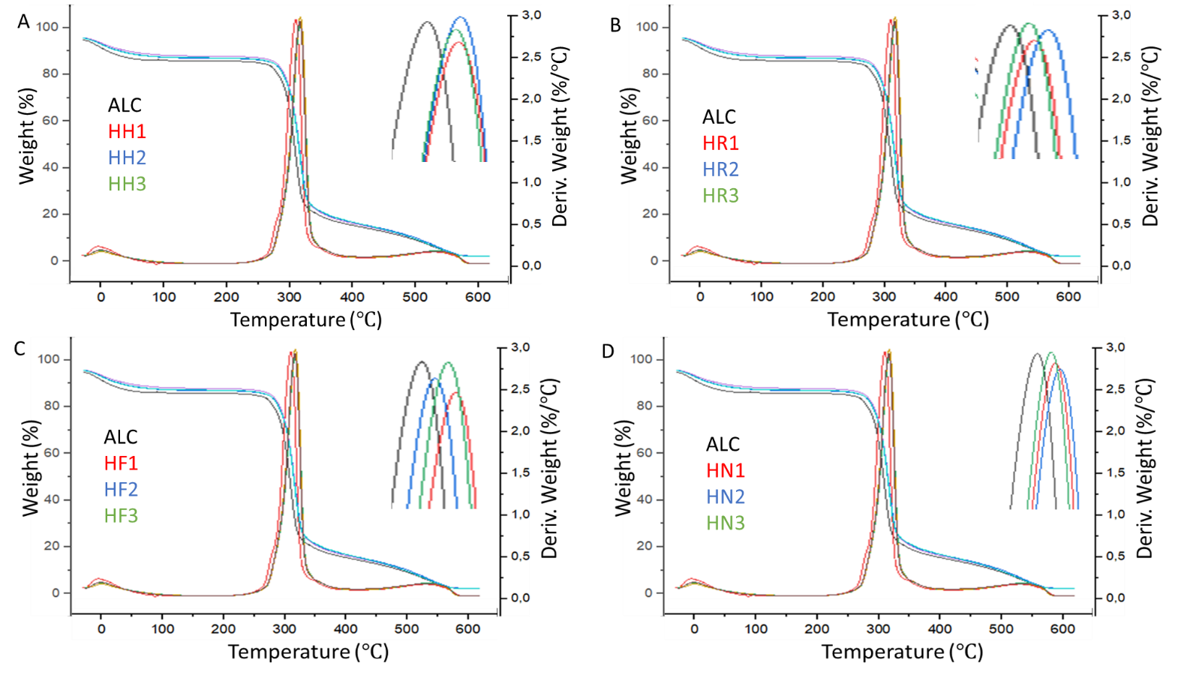
Figure 22: Effects of heat moisture treatment and cooling systems on the thermal properties of isolated amylose lipid complex nanomaterials by Thermogravimetric analysis (TGA)
A - Heat moisture treated amylose lipid complexes at 110℃ for 1,2,3 hours respectively as a continuous method
B - Heat moisture treated amylose lipid complexes at 110℃ for 1 hour and cooled at room temperatures (23$℃$) for 24 hours, then HMT at day 2 for one hour followed by cooling (23$℃$) for 24 hours, and then again HMT at day 3 for one hour followed by cooling (23$℃$) for 24 hours.
C - Heat moisture treated amylose lipid complexes at 110℃ for 1 hour and cooled at refrigeration temperatures (4$℃$) for 24 hours, then HMT at day 2 for one hour followed by cooling (4$℃$) for 24 hours, and then again HMT at day 3 for one hour followed by cooling (4$℃$) for 24 hours.
D - Heat moisture treated amylose lipid complexes at 110℃ for 1 hour and cooled using liquid nitrogen for 10 minutes and stored in the freeze (-20$℃$) for 24 hours, then HMT at day 2 for one hour followed by cooling for 24 hours, and then again HMT at day 3 for one hour followed by cooling for 24 hours.

Table 12: Effects of heat moisture treatment and cooling systems on the thermal properties of isolated amylose lipid complex nanomaterials by Thermogravimetric analysis (TGA)
Cooling systems | Time of HMT (hours) | Temperature onset ($℃$) | Temperature peak ($℃$) | ∆ weight (%)
No cooling | 0  1  2  3 | 252.1 $±$0.3ab  249.8$±$0.4ab  250.9$±$0.1ab  250.4$±$0.2ab | 328.6 $±0.3$a  329.8 $±0.3$ab  330.9 $±0.1$b  330.3 $±0.3$ab | 6.6 $±0.2$a  7.3 $±0.2$a  7.0 $±0.3$a  7.2 $±0.2$a
Room temperature | 0  1  2  3 | 252.5$±$0.2ab  246.4$±0.2$ab  250.4 $±$0.3ab  256.6 $±0.1$ab | 328.9 $±0.2$a  328.6 $±0.1$ab  329.8 $±0.1$ab  330.3 $±0.1$ab | 6.5 $±0.1$a  7.6 $±0.1$a  7.5 $±0.3$a  7.4 $±0.1$a
Refrigeration temperature | 0  1  2  3 | 252.3 $±0.2$ab  253.2 $±0.2$ab  261.7 $±0.1$b  250.9 $±0.2$ab | 328.7 $±0.1$a  330.9 $±0.2$b  329.2 $±0.2$ab  329.8 $±0.4$ab | 6.6 $±0.6$a  7.4 $±0.4$a  7.3 $±0.1$a  7.3 $±0.1$a
Liquid nitrogen | 0  1  2  3 | 252.3 $±0.4$ab  248.7 $±$0.5ab  273.6 $±0.1$ab  245.8 $±0.2$a | 328.4 $±0.5$a  329.2 $±0.1$ab  332.1 $±0.4$b  328.6 $±0.1$ab | 6.5 $±$0.2a  7.2 $±0.3$a  7.9 $±0.1$a  7.9 $±0.2$a
Values are mean ± standard deviation of triplicate experiments. Values of different letters a-b in the column are significantly different at P˂ 0.05.

5.2.7 Dynamic mechanical thermal analysis (DMTA)
The tan delta showed one peak for both the treated and untreated isolated ALC nanomaterials (figure 23). As the time of HMT (more energy) increased from one to three hours and the rate of cooling increased from room temperature to liquid nitrogen, there was a significantly (p<0.05) higher storage modulus (E´) (Figure 24), and a broader tan delta peak. The peak broadness increased and height decreased significantly (p<0.05) for all the treated isolated ALC nanomaterials compared with untreated isolated ALC nanomaterials (control) (figure 10). The glass transition temperature as indicated by peak tan delta had a range of ±100$℃$ for untreated isolated ALC nanomaterials, but the broader peak for treated ALC suggest a range of values for the glass tarnsition. The E’ was significantly (p<0.05) higher for all the treated isolated ALC nanomaterials compared with untreated isolated ALC nanomaterials (control) exemption for treated isolated ALC nanomaterials cooled for 2 days using room temperature (figure 24).

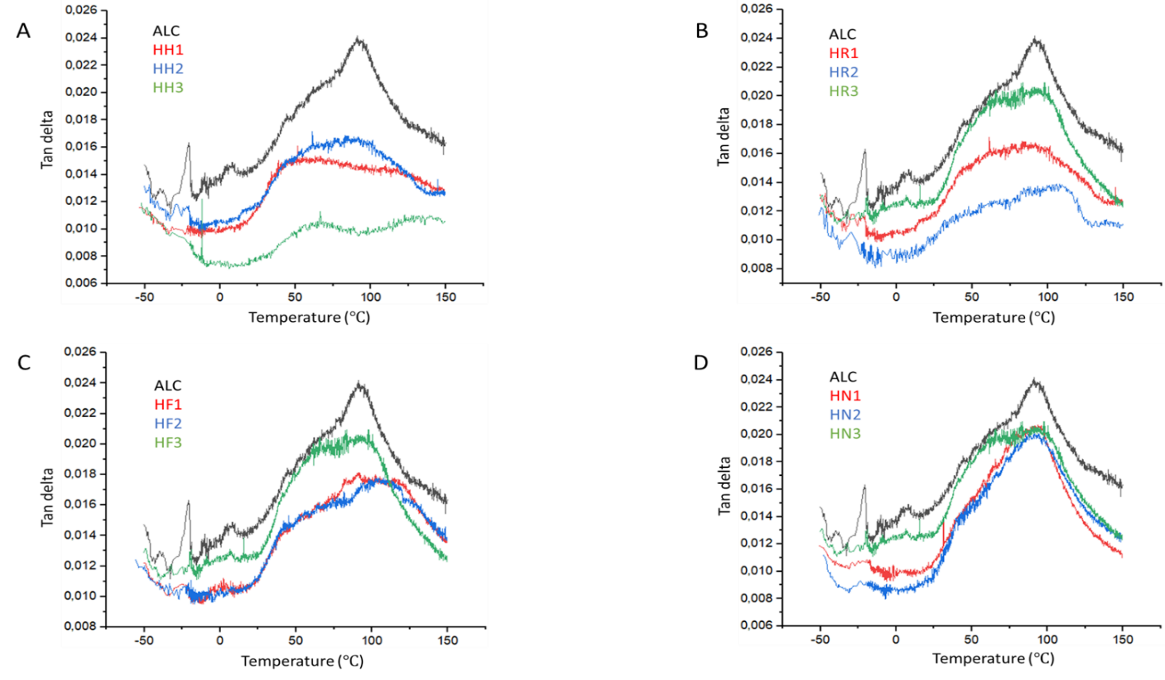
Figure 23: Effects of heat moisture treatment and cooling systems using infrared energy on the dynamic mechanical properties (tan delta) of isolated amylose lipid complexes nanomaterials
A - Heat moisture treated amylose lipid complexes at 110℃ for 1,2,3 hours respectively as a continuous method
B - Heat moisture treated amylose lipid complexes at 110℃ for 1 hour and cooled at room temperatures (23$℃$) for 24 hours, then HMT at day 2 for one hour followed by cooling (23$℃$) for 24 hours, and then again HMT at day 3 for one hour followed by cooling (23$℃$) for 24 hours.
C - Heat moisture treated amylose lipid complexes at 110℃ for 1 hour and cooled at refrigeration temperatures (4$℃$) for 24 hours, then HMT at day 2 for one hour followed by cooling (4$℃$) for 24 hours, and then again HMT at day 3 for one hour followed by cooling (4$℃$) for 24 hours.
D - Heat moisture treated amylose lipid complexes at 110℃ for 1 hour and cooled using liquid nitrogen for 10 minutes and stored in the freeze (-20$℃$) for 24 hours, then HMT at day 2 for one hour followed by cooling for 24 hours, and then again HMT at day 3 for one hour followed by cooling for 24 hours.

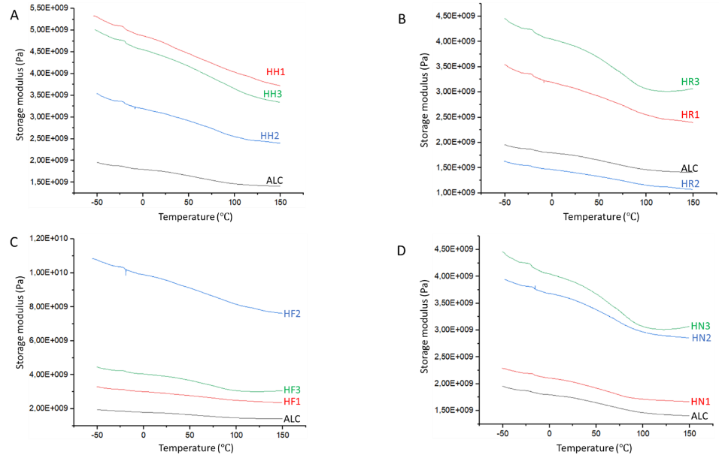
Figure 24: Effects of heat moisture treatment and cooling systems using infrared energy on the dynamic mechanical properties (storage modulus) of isolated amylose lipid complexes nanomaterials
A - Heat moisture treated amylose lipid complexes at 110℃ for 1,2,3 hours respectively as a continuous method
B - Heat moisture treated amylose lipid complexes at 110℃ for 1 hour and cooled at room temperatures (23$℃$) for 24 hours, then HMT at day 2 for one hour followed by cooling (23$℃$) for 24 hours, and then again HMT at day 3 for one hour followed by cooling (23$℃$) for 24 hours.
C - Heat moisture treated amylose lipid complexes at 110℃ for 1 hour and cooled at refrigeration temperatures (4$℃$) for 24 hours, then HMT at day 2 for one hour followed by cooling (4$℃$) for 24 hours, and then again HMT at day 3 for one hour followed by cooling (4$℃$) for 24 hours.
D - Heat moisture treated amylose lipid complexes at 110℃ for 1 hour and cooled using liquid nitrogen for 10 minutes and stored in the freeze (-20$℃$) for 24 hours, then HMT at day 2 for one hour followed by cooling for 24 hours, and then again HMT at day 3 for one hour followed by cooling for 24 hours.

6.0 Discussion
This discussion is presented in three sections. The first section gives a critical evaluation of the principal methodologies used in the modification of isolated amylose lipid complex nanomaterials. The second section discusses the research findings and proposed possible mechanisms for the increased crystallinity of isolated amylose lipid complex nanomaterials. The third section briefly discusses possible application and future research.

6.1 Methodology

6.1.1 Stearic acid incorporation
Stearic acid was used as a complexing agent in the formation of amylose-lipid complexes from maize starch. The same complexing agent has been used by other researchers (Cuthbert et al., 2017; D’Silva, Taylor, & Emmambux, 2011; Mapengo et al., 2019; Maphalla & Emmambux, 2016). Stearic acid (1.5% w/w) was dissolved in ethanol solution and then added to maize starch to form a homogeneous mixture. Ethanol was used because it is an organic solvent that has adequate non-polar characteristics to allow the dissolution of fatty acids and promote the diffusion of stearic acid into the pores of the maize starch granules. D’Silva et al. (2011) suggested that 1.5% stearic acid promoted optimum amylose-lipid complexing during pasting.

6.1.2 Preparation of Amylose lipid complex nanomaterials
Maize starch with added stearic acid was long pasted using rheometer and reactor. Rheometer was used for lab scale production while reactor was used for pilot scale production. The pilot scale production had a lower yield compared to the lab scale, this could be related to the heating of the two equipment’s since rheometer heat from the bottom and sideways while reactor only heat from the bottom. The material suspension was increased from 10% to 20 % for production of amylose-lipid complex, the reactor was able to upscale by using the 20%.
Isolation of amylose-lipid complex nanomaterials was done using thermostable alpha-amylase hydrolysis at 75 °C for 10 mins. Thermostable alpha-amylase has also been used to isolate amylose-lipid complexes from tef and maize starch pastes at 75 °C for 10 mins (Cuthbert et al., 2017). The activity of the thermostable alpha-amylase after the hydrolysis process requires quenching. However, this has not been done in the present study. It can be suggested that high temperatures during heat moisture treatment can terminate the enzyme activity. Ice cold 0.1 M NaOH has been used to stop the activity of alpha-amylase (Park et al., 2014). Linko, Linko, and Olkku (1983) and (Wokadala et al., 2012) also reported the use of boiling 0.2 M acetate buffer to stop reaction of the enzyme.

6.1.3 Infrared heat moisture treatment
Isolated amylose lipid complex nanomaterials were incubated in 25% w/w moisture at room temperature for 24 hours, to allow the moisture to be equilibrated. The moisture content of 25% and a high temperature of ±110°C was used and these conditions ensured that the temperature was below the gelatinisation temperature (Zeleznak & Hoseney, 1987). Glass Petri dishes were used for the infrared heat-moisture treatment of isolated amylose lipid complex nanomaterials. Eliasson, Isaksson, Lövenklev, and Ahrné (2015) have used glass Petri dishes for infrared heating of Paprika powder. Therefore, it can be suggested that glass Petri dishes can transmit Near and Mid-IR radiation (Niemoller & Behmer, 2008).
A microwave/Infrared Hot air tunnel oven (MW180, Olifantsfontein, South Africa) was used in this study. Although the set temperature was 110°C, the surface temperature for all samples was ranging between 108 -115°C. Since the dishes were placed ~25 cm away from the infrared emitter. Eliasson et al. (2015) suggested the application of hot-air circulation will also promote a more uniform surface temperature.

6.1.4 Flow properties
During flow property measurements of isolated amylose lipid complex nanomaterials, water evaporation may occur. Silicon (Singh, Kaur, & McCarthy, 2007), paraffin oil (D’Silva et al., 2011) and solvent trap (Lagarrigue & Alvarez, 2001) can be used to minimise water evaporation at high temperatures. In the current study, paraffin oil was used to minimise water evaporation. Measurement of flow properties may provide information on the behaviour of isolated amylose lipid complex nanomaterials pastes under shear. During processing (end use), isolated amylose lipid complex nanomaterials dispersions will be subjected to both high heating and shear rates. These will affect their rheological behaviour as well as the final characteristics of the product (Lagarrigue & Alvarez, 2001). The serrated plate was used to avoid slippage of the material during shear.

6.1.5 Morphology
Microscopic techniques are used for examination of starch granule morphology to characterise these granules based on their size and shape (Allen, et al., 1997). Scanning electron microscopy was used in this research to characterise the isolated amylose lipid complex nanomaterials structure. The principle of SEM is based on the electron beam impinges on the specimen and generation of electrons. In order to observed the information about the surface structure and morphology, also the three-dimensional structure of starch granules (Jackson, 2003). The advantages are as follows: The depth of focus is much larger; excellent contrast (Ratner, 2013); three-dimensional quality; maximum magnification of about ×100000. At very high magnifications, the texture of the metal coat and not the surface may be under observation, also expensive to operate (Singh, 2016) are disadvantages of SEM. Given the limitations of SEM, one can use atomic force microscopy (AFM) and high-resolution transmission microscopy (HRTEM) to overcome them.

6.1.6 Thermal properties
DSC was used in the present study to determine the thermal properties of isolated amylose lipid complex nanomaterials. The results from the Differential scanning calorimetry can give an indication of the type of amylose-lipid complexes being formed. It can distinguish between type I and type IIa or type IIb amylose lipid complexes (Biliaderis & Galloway, 1989). The method is based on measurement of heat flow of materials that accompany heat induced transitions in material. The difference in heat flow between a sample and an inert reference (such as an empty pan in the present research) is constantly measured and recorded as a function of time and temperature in a controlled atmosphere (Biliaderis & Galloway, 1989). Advantages of using the DSC include simplicity, easy to use, easy sample preparation, fast analysis with regard to time and it uses a wide temperature range (Verdonck, Schaap, & Thomas, 1999).
The limitation with the use of the DSC for the determination of amylose-lipid complexes is that the analysis is moisture dependent. The moisture content of a sample affects the magnitude of the melting enthalpies observed with the DSC. Water acts as a plasticiser, thus in excess water, the melting of the crystallite occurs at lower temperatures (Biliaderis et al., 1986). Thus, a constant water in a ratio of 1:3 (material: water) was used. High pressure system DSC was used as it provides the high temperature range required with no water evaporation from the sample. High pressure suppresses vaporization of water and shifts it to higher temperature since pressure pushes down the water molecules and prevents them from escaping. Other authors have used this ratio and pressure mode for determining the thermal properties of modified starch-containing ALCs (Mapengo & Emmambux, 2020; Maphalla & Emmambux, 2016; Wokadala, Ray, & Emmambux, 2012b).
Yu and Christie (2001) reported that inadequate equilibration of moisture could result in a heterogeneous sample, thereby introducing multiple transition endotherms. Inadequate equilibration can also affect the magnitude of the melting enthalpies observed with the DSC using non-isothermal methods for starch samples. Therefore, in this study, the samples were equilibrated for 24 h before running DSC in this study. DSC can also result in endotherms with poor resolution when using heating rates <5°C/min or above 10°C/min (Biliaderis, Page, Maurice, & Juliano, 1986), therefore a heating rate of 10°C/min was used in this study.

6.1.7 Wide angle X-ray diffraction scattering
Wide angle X-ray diffraction scattering has been previously used to show the presence of amylose-lipid complex formation (Cuthbert et al., 2017; Mapengo & Emmambux, 2020; Maphalla & Emmambux, 2016). The principle of WAXS is based on the fact that when a crystal is irradiated with X-rays, a distinct pattern of the crystal structure is formed as a result of X-rays scattering from the sample. A scattering profile produced then gives details on the crystalline and amorphous information of the sample, which is used as a fingerprint WAXS pattern ( Liu, Donner, Tarn, Singh, & Chung, 2009).
One of the limitation with the use of WAXS is that it cannot differentiate between types of amylose-lipid complexes formed. Another disadvantage with WAXS is that it gives an estimation of the degree of crystallinity, referred to as the relative degree of crystallinity. This is because the ratio of the upper area to the total diffraction is taken as the relative degree of crystallinity (Cheetham & Tao, 1998). The upper area separated with a smooth curve correspond to the crystalline portion and the lower area is regarded as the background containing the amorphous portion (Nara & Komiya, 1983).

6.1.8 Thermal gravimetric analysis
Thermogravimetry analysis (TGA) was used to evaluate the thermal degradation and stability of the modified isolated amylose lipid complex nanomaterials. TGA measures a sample’s weight as it is heated or cooled in a furnace by quantifying the loss of water, loss of solvent, loss of plasticiser, decarboxylation, pyrolysis, oxidation and decomposition. The TGA operating variables that contribute to reproducibility and include calibration, sample preparation and temperature scanning rate (Soudais, Moga, Blazek, & Lemort, 2007). The use of the same sample weight during the experiment helps promote data reproducibility and repeatability; hence this study used a constant sample weight (Elmer, 2010).
Although it has strengths such as the analysis of multiple overlapping mass loss events, the TGA cannot identify the evolved products. TGA can, therefore, be connected to an evolved gas analyser (for example, Thermogravimetric Analysis/Mass Spectrometry (TGA-MS): (TGA/MS) or Thermogravimetric Analysis (TGA) coupled to Fourier Transform Infrared Spectroscopy (TGA/FTIR)) (Soudais et al., 2007). Also, data interpretation is limited without further modifications and deconvolution of the overlapping peaks may be required (Elmer, 2010).

6.1.9 Dynamic mechanical thermal analysis
DMTA works by applying a sinusoidal deformation to a sample of known geometry to measure stiffness or dampness (Ebnesajjad, 2014). The sample can be subjected by controlled stress or a controlled strain sinusoidally. Under tension/compression deformations the measured viscous component is referred to as the loss modulus (E″/G″), while the measured elastic component is referred to as the storage modulus (E′/G′) (Ebnesajjad, 2006). The ratio of the loss modulus to the storage modulus is referred to as the loss tangent (G″/E′), or tan delta (Brent Jr, Mulvaney, Cohen, & Bartsch, 1997).
The dynamic mechanical analysis was used as a preferred method of measurement for glass transition temperature, and other minor phases/structure changes of the starch (Bergström, 2015). It is more sensitive to glass transition than DSC and resolves other more localised transitions such as side-chain movements that are not detected in the DSC (Menard & Menard, 2002). However, DMTA cannot separate overlapping thermal transitions in samples, and this limitation could have been combated by using modulated DSC (Bier, Verbeek, & Lay, 2014). Modulated DSC provides separation of overlapping thermal transitions through modulated cycles over the temperature region and allows interpretation of complex transitions. It improves interpretation of thermal transition data by separating the volume relaxation endotherm (a non-reversing phenomenon) from the reversing heat capacity change at the glass transition (Reading, Luget, & Wilson, 1994).

6.2 Results discussion

6.2.1 Pasting and yield of isolated nanomaterials
Isolated amylose lipid complex nanomaterials production can be upscaled from lab (Rheometer) to pilot scale (Reactor). The pilot scale production had a reduction in yield by 3% compare to the lab scale. This could be related to the heating of the two equipment since Rheometer heat from the bottom and sideways while Reactor only heat from the bottom. Thus at lab scale this could have higher rate of reaction to enable amylose to interact with stearic acid to form complexes that are resistant to amylolysis (D’Silva et al., 2011). Rudjito, Ruthes, Jiménez-Quero, and Vilaplana (2019) also noted a lower yield of 15% when upscaling extraction of feruloylated arabinoxylan from wheat bran. The upscaling was done by using rotary autoclave, while the lab scale they used a solvent extractor.
The isolated amylose lipid complex nanomaterials produced from the two equipment’s (Rheometer and Reactor) analysed by DSC and SEM showed similar findings already reported by Cuthbert et al. (2017). They produced nanoparticles isolated from maize and tef starch with added stearic acid after pasting at 90$℃$ for 130 minutes using Rapid Visco Analyzer (RVA) followed by hydrolysis of the paste using thermo-stable alpha-amylase.
Amylose lipid complexes are classified as type I and type II based on the crystalline melting temperatures. Type I melting temperatures are 94-104$℃$, while type melting temperatures are 115-121$℃$ (Biliaderis, 1990). The isolated amylose lipid complex nanomaterials produced from the two methods were type I complexes since they showed a peak at 103$℃$ in DSC thermogram. The isolated amylose lipid complex nanomaterials had several particles of less than 10 nm in size as observed from the SEM micrographs. Cuthbert et al. (2017) obtained similar results of teff and maize starch with distinct nanoparticles of less than 10nm isolated after formation during pasting of starches with stearic acid using RVA.
Amylose lipid complex nanomaterials were formed during extended pasting, due to amylose chains forming inclusion complexes with lipids. Therefore, amylose interact with stearic acid to form ALC (figure 25). The ALC were formed when starch was heated with added stearic acid during pasting and subsequently cooled, causing modifications in its crystalline structure. Therefore, amylose undergoes conformation change, giving a single, left handed helix with stearic acid to form the complex (Putseys et al., 2010).

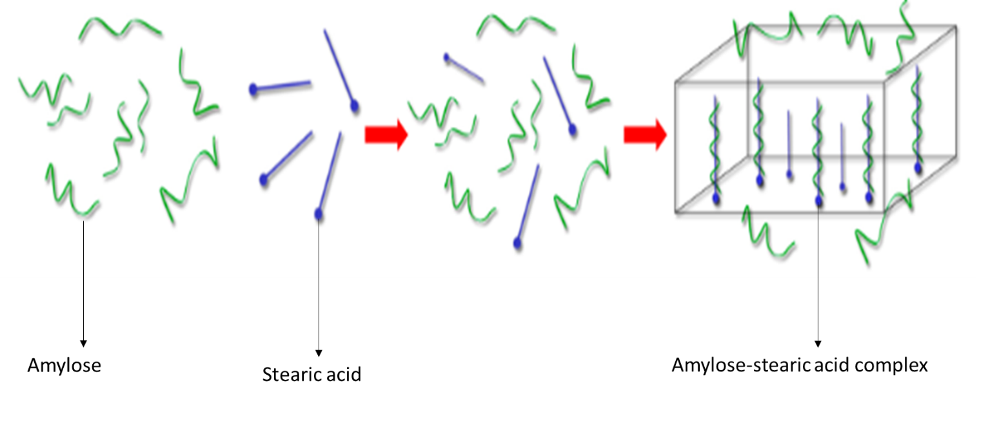
Figure 25: Formation of amylose lipid complexes adapted from (Chao, Yu, Wang, Copeland, & Wang, 2018)
Wang et al (2020) showed different structural levels of amylose lipid complexes at molecular, nano and micro level (Figure 26). The aliphatic chain of stearic acid is inside the internal cavity of amylose helix, while the stearic acid carboxyl group remains outside of the amylose helix due to electrostatic repulsions and steric hindrance (figure 26a). Amylose lipid complexes stacked themselves into crystalline lamellae (figure 26b) and reorganized the crystalline lamellae with interspacing amorphous regions into nano-sized packed (figure 26c). However, it is noted that the amylose-lipid complexes formed during production in our study was only at nanoscale and did not produce micron size structure.
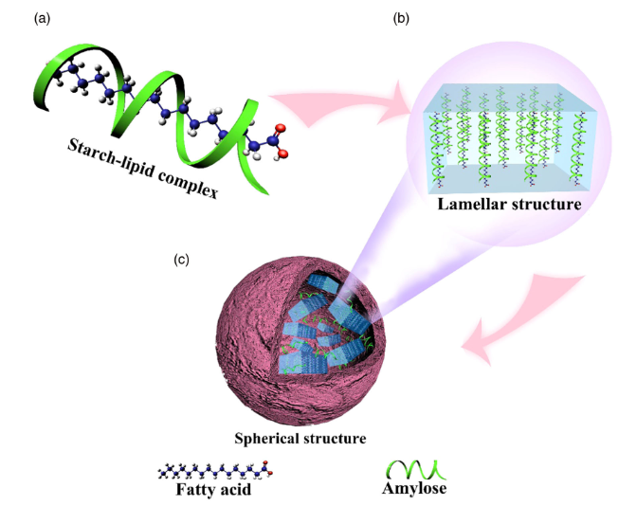
Figure 26: Molecular (a), nano (b) and micro (c) level structures of amylose lipid complexes (S. Wang et al., 2020)

6.2.2 Infrared heat moisture treatment with different cooling rate of isolated amylose lipid complex nanomaterials

The functional properties as affect by infrared HMT and cooling systems will be discussed first followed by molecular and nano properties, and the possible mechanism that caused the changes at nano and molecular level influencing functional properties. It is worth noting that there is limited literature available on HMT of isolated amylose lipid complex nanomaterials and the effects on its structure, thus results obtained in terms of infrared HMT will be compared with starch.

The summarised results of the effects of infrared HMT and cooling rate seems to suggest that infrared HMT (Table 13) has more effects than cooling rates.
Table 13: Summary of nano and molecular changes and their impact on the functional properties of isolated ALC nanomaterials as affected by Infrared HMT and cooling systems
Treatments | Main findings
Treatments | Nano level | Molecular level | Functional properties
Heat moisture treatment | Less space between nanoparticle  More lamellae formation | Increased crystallinity and  thermal stability | Decreased viscosity, water absorption and solubility indexes
Cooling rates | Less space between nanoparticle  Protruded nanoparticles  More lamellae formation | Increased crystallinity  Thermal stable nanomaterials | Decreased viscosity  Not much effects on the absorption and solubility indexes

As such there is no report found in literature on the reduction of viscosity of infrared HMT treatment starch amylose lipid nanomaterials, but several researchers have shown this effect for starch in general. HMT decreased starch solubility, amylose leaching, peak viscosity and swelling power, and increases the pasting temperature (Chung, Hoover, et al., 2009; Pinto et al., 2012; Sui et al., 2015). Mapengo and Emmambux (2020) also reported that infrared HMT increased relative crystallinity and reduced in vitro starch digestibility in maize meal with added stearic acid.
The decreased viscosity of infrared heat moisture treatment of isolate ALC nanomaterials with the different cooling systems suggests that there may be changes such as hydrodynamic volume of the nanomaterials as well the molecular interactions between the nanomaterials. Lower viscosity suggest a lower hydrodynamic volume of the treated nanomaterials (Tosh, Wood, Wang, & Weisz, 2004) and this may be related to the lower water absorption properties. The trend of decreasing water absorption and water solubility indexes after HMT observed were similar to that reported by Mapengo et al. (2019). The lower absorption also suggests that perhaps there are molecular interaction between the nanomaterials rather than nanomaterials with water molecules. The lower interaction with water can be due to the highly crystalline materials that suggest change in molecular conformation of the nanomaterials (discussed later).
The flow behaviour index of n<1 suggest that both the treated and untreated isolated ALC nanomaterials were shear thinning. This may be because with an increase in shear rate, the ALC nanomaterials disentanglement can occur as a result of molecules begin to orientate in the direction of shear (Chen et al., 2017). However, the nanomaterials after heat moisture treatment and cooling system were less shear thinning as the flow behaviour index ‘n’ increase and this is possibly due to less alignment in the shear and less disentanglement (Sajjan & Rao, 1987).
The clockwise hysteresis loop of untreated isolated ALC nanomaterials is referred to as thixotropic behaviour, since the clockwise loop indicate the structural breakdown by the shear resulting in formation of new structure or changes in the structure (Achayuthakan & Suphantharika, 2008). Heat moisture treatment and cooling systems decreased hysteresis loop, suggesting a more stable nanomaterial. The decrease in hysteresis may be attributed to rearrangement of amorphous region into more compact crystalline region as well as formation of cross-linkages (Sharma, Yadav, Singh, & Tomar, 2015). Therefore, more energy is required for structural disintegration. Hoover and Vasanthan (1994) obtained similar results while working on different gelatinized starch pastes on the effect of HMT on the flow behaviour. The lower viscosity, less shear thinning, and the lower hysteresis suggest that there have been some molecular changes of the HMT treated ALC nanomaterials.

This changes in water absorption and water solubility indexes indicates that there was modification in functional properties. Klein et al. (2013) suggested that reduced starch granular swelling is due to limited hydration of amorphous lamellae. The decrease in water absorption and water solubility indexes can probably due to an increase in crystallinity (as shown by the XRD diffractogram) during infrared HMT treatment, where starch had a stronger and denser structure, making it more difficult to absorb water (Subroto, Indiarto, Marta, & Shalihah, 2019). In fact, the isolated nanomaterials in the current research were more crystalline after the HMT as observed by XRD as well as formation of type II from type I ALC. Water solubility indicates the extent to which the component of amylose lipid complexes dissolves in water (Pratama, 2018). HMT can change the conformation of amylose lipid complexes, and it seems like the molecular chains became less flexible, and therefore, water molecules do not easily penetrate amylose lipid complexes, and thus less solubility. The increase in water absorption and water solubility indexes of isolated ALC nanomaterials at higher temperature is due to the fact that there is higher kinetic energy at higher temperature, resulting in water molecules interacting with hydroxyl groups of amylose lipid complexes easily (Pratama, 2018). Thus, from the above it looks like the changes at the molecular and nanostructure level lead to changes in functional properties (viscosity and water absorption and solubility indexes).
Treated ALC nanomaterials by HMT showed disrupted structure with less space in between the particles and this suggest that infrared HMT alters the nanostructure. Starch granules can become tight and compact after HMT (Tan et al., 2017). Mapengo and Emmambux (2020) reported that infrared heat moisture treated maize starch at nanostructure showed less molecular spaces between starch blocklets, and this resulted in of higher glass transition temperature of the starch materials and changes of functional properties. Thus, the nano structural changes observed in this study suggest greater interaction between the nanomaterials and this can decrease viscosity, water absorption and solubility indexes, and less interaction with water.
The increase in peak temperatures obtained from DSC as the time of HMT (from one to three hours) and cooling rate (room temperatures to liquid nitrogen) also showed structural changes of the nanomaterials. Mapengo et al. (2019) showed similar increase in starch melting temperature of HMT treated maize meal and maize starch. According to Biliaderis and Galloway (1989), ALCs can be type I (96−104°C), IIa (105−110°C) and IIb (109−120°C) based on the melting temperatures. Thus increase in the endothermic temperatures has been associated with presence of stable crystallites and the presence of type II ALC (Chiu & Solarek, 2009b; Lewandowicz, Jankowski, & Fornal, 2000; Sun, Han, Wang, & Xiong, 2014). The untreated isolated amylose lipid complex nanomaterials (control) had type I ALC as there was a melting endotherm between 96 -104$℃$ (Biliaderis, 1990; Karkalas et al., 1995).
HMT and cooling using room temperatures produced type IIa ALC while cooling with refrigeration temperatures and liquid nitrogen produced type IIb ALC. Similarly, there was an increase in relative crystallinity. Su et al. (2020) conducted a study to compare repeated versus continuous heat moisture treatment on wheat starch, they noted that repeated heat moisture treatment had higher relative crystallinity compared to continuous heat moisture treatment. This was due to the cooling process during repeated heat moisture treatment which strengthened the bonds and allow for the redistribution of water molecules, resulting in recrystalized starch granule forming more stable crystal structure (Gong et al., 2017). Therefore, the redistribution of most likely H-bonds and perhaps water molecules can transform type I ALC into the formation of type IIa and IIb ALCs for HMT treated sample. This transformation is also supported by the higher relative crystallinity observed from XRD.
Infrared heat-moisture treatment modified the structural attributes of starch at the granular surface and the molecules within the starch granules (Chung, Hoover, et al., 2009). HMT involves the initial disruption of the crystalline structure of starch granule and dissociation of double helix structure followed by the rearrangement of the disrupted crystals (Ma, Hu, & Boye, 2020). Infrared HMT results in forming more ordered crystals from disordered crystalline structures. Thus, in our study, HMT changed type I into type II ALC as type I ALC melt and recrystallize partially into type IIa ALC, as well as from type IIa into type IIb probably due melting of type I crystalline structures and then formation of more stable crystalline structures.
The treated and untreated isolated ALC nanomaterials XRD showed three peaks at 2θ in the range of 7-8$°$, 12-13$°$ and 19-20$°$. The three peaks from XRD of the nanomaterials peaks at 2θ of 7-8$°$, 12-13$°$ and 19-20° have been assigned to ALC (Cervantes-Ramírez et al., 2020). Our findings were similar with the findings of Cuthbert et al. (2017). The relative crystallinity of isolated ALC nanomaterials increased to the maximum of 3% by HMT while HMT followed by cooling systems recorded maximum of 8% increase compared to untreated isolated ALC nanomaterials. The increased in relative crystallinity corresponds to the presence of type IIa and IIb ALC on the treated ALC nanomaterials. Since type II ALC are more thermally stable, requires more thermal energy to melt due to higher crystalline order compared to type I ALC.
A higher 2θ peaks for treated nanomaterials imply that larger crystallites (1.20 Å) were observed at 2θ in the range of 7-8$°$ while smaller crystallites were observed at 2θ in the range 19-20$°$ (0.45 Å). This shows that HMT and cooling systems increased the lamellar thickness of the isolated ALC nanomaterials as observed by XRD. Therefore, resulting in a higher ordering degree of lamellae and increasing peak visibility (broadness) (Wang, Zhang, Chen, & Li, 2016). This also mostly due to the change from type I into type II ALC after treatment (HMT and cooling systems). As the area of peaks increased, it suggests that more lamellae were stacked together to increase crystallinity (became thicker). Therefore, higher degree of orientation between crystallites resulting in thermal stability seen on type II ALC. The complex melting points are proportional to the thickness of the lamellae shown in figure 27 (Goderis, Putseys, Gommes, Bosmans, & Delcour, 2014). Smaller crystallites had thicker lamellae compared to larger crystallites. The increase in lamella thickness and high thermally stable type II ALC formed during HMT showed more molecular interaction between nanomaterials and this is related to the lower water absorption and solubility index, and lower viscosity as already discussed.
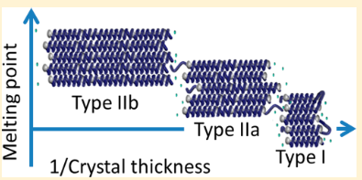
Figure 27: sketch of a compatible stacked lamellar of type I, IIa, IIb amylose lipid complexes adapted from (Goderis et al., 2014)
This first weight loss region from the three main region of TGA of ALC nanomaterials (figure 8) has been attributed to the evaporation of physically and chemically bound water (Zhang, Xie, Zhao, Liu, & Gao, 2009) as well as other compounds of low molecular weight present in the samples (Merci, Mali, & Carvalho, 2019).. The second weight loss region is due to breaking down of amylose lipid complexes (Thakur et al., 2017). Lacerda et al. (2008) highlighted that the last weight loss region could be attributed to thermal degradation of starch polymeric chain after which a carbonaceous residue remains. Four major weight loss regions have been noted by Thakur et al. (2017) for amylose lipid complexes, thus there was one missing weight loss region in our study. This missing region of 250-275$℃$ is responsible for the decomposition of unbounded fatty acids. This suggests that there was no unbound stearic acid in our nanomaterials (all the stearic acid was involved in the complex formation). This also correlated with the DSC results since there were no stearic acid peaks at about 69$℃$ from DSC (Biliaderis, Page, & Maurice, 1986).
The TGA showed that treated isolated ALC nanomaterials had non-significant higher main peak temperatures compared to untreated isolated ALC nanomaterials. This could be the results of the increased crystallinity and formation of type II ALCs for the treated isolated ALC nanomaterials shown by XRD and DSC respectively. The treated isolated ALC nanomaterials had lower weight loss percentage compared to untreated isolated ALC nanomaterials. Therefore, the treated isolated ALC nanomaterials had higher thermal resistance which correlated with other results (DSC and XRD). Since DSC and XRD showed that the treated isolated ALC nanomaterials had higher thermal resistance compared to untreated isolated ALC nanomaterials. Mapengo and Emmambux (2020) noted similar results of the main peak temperatures and weight loss, while working on maize meal with stearic acid treated with both conventional and infrared heat moisture treatment.
The higher E’ of treated ALC compared to untreated ALC nanomaterials shown by DMTA suggest that infrared HMT and cooling systems resulted in increased ALC inter and intra molecular association. Mizuno, Mitsuiki, and Motoki (1998) suggested that inter molecular bonds in starch could be responsible for a higher storage modulus. A higher E´ indicates that isolated ALC nanomaterials showed more elastic energy and a more stable structure of isolated ALC nanomaterials as observed by TGA and XRD. The derived tan delta values of both treated and untreated isolated ALC nanomaterials showed one thermal transitions. This tan delta peak could correspond to the melting of amylose lipid complexes. Since a melting transitions at a temperature above 90$℃$ were as a results of amylose lipid complexes (Biliaderis & Galloway, 1989; Cuthbert et al., 2017). A tan delta is due to the stability of the network, since higher energy will be required to disrupt it. Therefore, indicating an increase in thermal stability for the treated isolated ALC nanomaterials compared to the untreated isolated ALC nanomaterials (control).
Changes at molecular and nano level resulted in changes in the functional properties. It seems that infrared HMT and cooling systems resulted in an increased crystallinity of isolated nanomaterials becoming more thermally stable. This was due to the change in the nanostructure, hence decreased in viscosity and water absorption and solubility indexes. Thus, one possible mechanism to explain and relate the changes is based on the increase lamellae thickness of isolated ALC nanomaterials after treated with HMT and cooling systems. Infrared HMT increased the crystalline lamellae thickness and decreased the amorphous lamellae thickness (figure 28). The decrease in amorphous lamellae thickness might have resulted in non-swelling amorphous lamellae. Meaning that the amorphous lamellae was converted to crystalline lamellae. The increase of crystalline lamellae thickness is induced by water and thermal energy resulting in the dissociation and crystallization from type I to type II ALC. This happens after the dissociation of type I complexes; the helices will acquire enough mobility to align around the remaining helices acting as nuclei. This will lead into ordered crystals (type II ALC) (Putseys et al., 2010), increase of crystallinity of type II ALC, from type IIa into type IIb.
Rapid cooling systems also facilitated the increasing ordering degree of the crystalline lamellae by rearranging the structure and redistribution of water molecules in the system, but to a lesser extent. It is well known that a semi crystalline polymer will crystallize when cooled from the melt or heated from the amorphous state to the temperature region between glass transition temperature and melt temperature. Liu, Mo, Wang, and Zhang (1997) reported that during cold crystallization the peak temperatures increased as the cooling rate increased. At faster cooling rate, the activation of nuclei occurs at lower temperatures while at slow cooling rates the activation of nuclei occurs at higher temperatures. Because of sufficient time to activate the nuclei at higher temperatures. Therefore, crystallization nucleates at lower temperatures during faster cooling rates (López & Wilkes, 1989).
The lamella thickening is due to the lengthening of double helices by additional intertwining of loose double helix ends (Vermeylen et al., 2006). Since double helices are linked by hydrate water bridges and direct hydrogen bonding (Ratnajothi Hoover, 2010). Lamellae coming together could possibly explain by the rupture of hydrate water bridges and hydrogen bonds, which causes the lamellae to move closely together.

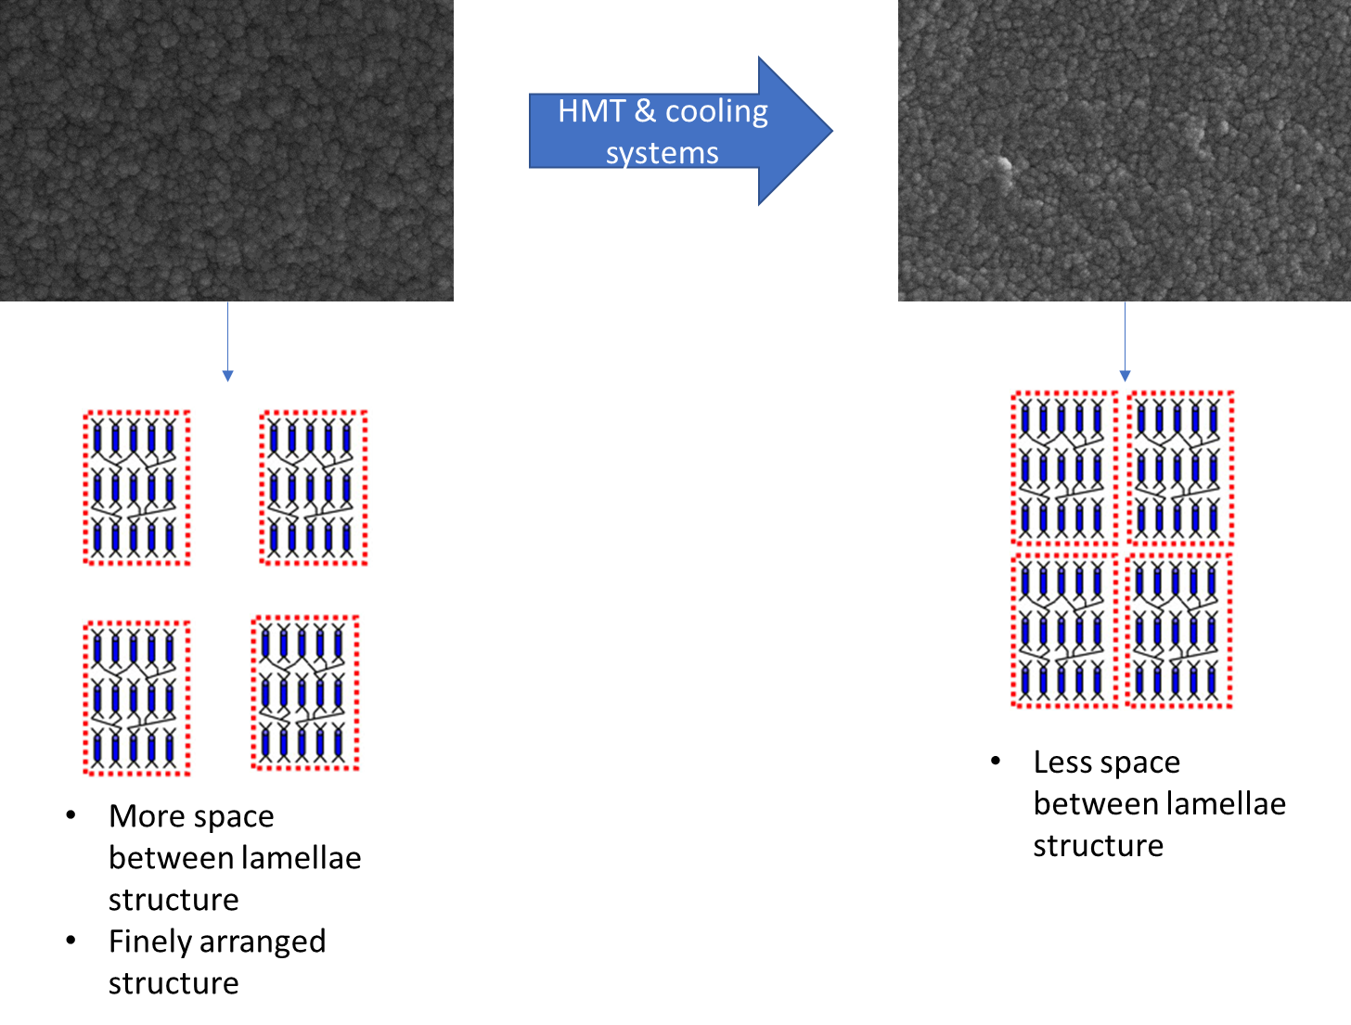
Figure 28: schematic diagram of proposed mechanisms of isolated amylose lipid complexes treated with HMT and different cooling systems

6.3 Application and future studies
Application and future studies of our work involves using the isolated nanomaterials as an encapsulating agent due to it low viscosity and as nano filler because of improved crystallinity. Encapsulation is a technique by which a material (active or core material) is coated within another material (shell or wall materials) (Madene, Jacquot, Scher, & Desobry, 2006). For many years, gum Arabic has been preferential choice as the encapsulating agent (wall material) of choice for flavour encapsulation for beverages due to it excellent emulsifier, volatiles retention and bland flavour (Rascón, Beristain, García, & Salgado, 2011). One of the main reasons gum Arabic has been used as a wall material is because of it low viscosity (Shaddel et al., 2018), thus easy to produce concentrates with higher encapsulation efficiency.
The wall material for encapsulation must have a low viscosity at a high solid ratio (Madene et al., 2006). Muhammad et al. (2020) reported incorporating a minimum of 0.3% of xanthan gum into anti-solvent phase to stabilise the shellac colloidal particles, since shellac tends to aggregate at an acidic pH. The issue was the formation of agglomerates of nanoparticles caused by higher viscosity, since higher concentration of xanthan gum caused a higher apparent viscosity. Thus, the ALC nanomaterials treated by infrared HMT has potential to be used as a replacement of xanthan gum, but this required further research.
The total solids content of the emulsion plays an important role in determining the efficiency of encapsulation and retention of volatiles during spray drying of foods oil. High solids content reduced the required time to form a semi-permeable membrane at the surface of the drying particle. The challenge is that high total solids leads to the increase emulsion viscosity, resulting in rapid skin formation by preventing circulation movement inside the droplets (Jafari, Assadpoor, He, & Bhandari, 2008).
Amylose inclusion complexes have been used for encapsulation, for delivery composition of bioactive guest molecules. For instance, amylose complexed with surfactant (Kong, Bhosale, & Ziegler, 2018) and ascorbyl palmitate (Bamidele et al., 2019) for the controlled release of β- carotene. Therefore, amylose lipid complex nanomaterials have the potential to be used as an encapsulating agent due to it low viscosity similar to gum Arabic (table 14). This can be a good subject for future research.

Table 14: The flow properties of isolated amylose lipid complex nanomaterials and gum arabic
Samples | Concentration (w/v,%) | Consistency index (Pa.s^{n}) | Flow behaviour index | R² | Source
Gum Arabic | 10 | 0.131 | 0.035 | 0.95 | (Mothé & Rao, 1999)
Untreated ALC nanomaterials | 10 | 46.5 | 0.16 | 0.99 | Our work
Treated ALC nanomaterials | 10 | 0.1 | 0.83 | 0.99 | Our work

Many researchers have attempted to improve the functionality of starch films by using filler materials. Nanocomposite films are combination of bio-based polymer and fillers. Films representing a new generation of packing materials, that must have at least one nanometer scale dimension. The biopolymer acts as a matrix and nanofillers are dispersed therein to improve the functional properties for example thermal stability (Jamróz, Kulawik, & Kopel, 2019). Moodley (2017) reported that amylose-lipid nanomaterial can act as a nano filler material in wheat starch films. (Cuthbert et al., 2017) reported that amylose lipid complexes had low crystallinity, thereby producing films with low thermal properties. Hence the treated isolated nanomaterials with increased crystallinity has potential to produce films that have improved thermal properties.

7.0 Conclusions
Isolated amylose lipid complex (ALC) nanomaterials can be upscaled from the lab scale to the pilot scale. SEM and DSC confirm that upscaling can still produce ALC at nanoscale. However, more work is required to improve the yield during the pilot scale isolation of ALC nanomaterials.
Infrared heat moisture treatment and cooling systems changes the molecular structure of isolated ALC nanomaterials, resulting in the change in the functional properties. ALC nanomaterials change from type I into type II ALC during infrared heat moisture treatment as shown by DSC and WAXS. The combined effects of infrared heat moisture treatment with rapid cooling produce more crystalline type IIb ALC materials, further reduce viscosity, water solubility and absorption indexes.
The treated isolated ALC nanomaterial is more thermo stable and can be used as a nanofiller because of it increase crystallinity. The isolated nanomaterials have the potential to replace hydrocolloids such as gum Arabic as an encapsulating agent due to it low viscosity. More research is needed for the application of isolated ALC nanomaterials with it improve thermal and functional properties.

8.0 References

Achayuthakan, P., & Suphantharika, M. (2008). Pasting and rheological properties of waxy corn starch as affected by guar gum and xanthan gum. Carbohydrate Polymers, 71(1), 9-17.
Anderson, A. K., & Guraya, H. S. (2006). Effects of microwave heat-moisture treatment on properties of waxy and non-waxy rice starches. Food Chemistry, 97(2), 318-323.
Arce-Arce, E. E., Gallegos-Infante, J. A., Rocha-Guzmán, N. E., González-Laredo, R. F., Moreno-Jiménez, R., Figueroa-Cárdenas, J. d. D., & Montelongo-Montelongo, A. N. (2014). Effect of infrared heating on the physicochemical properties of common bean (Phaseolus vulgaris L.) flour. CyTA - Journal of Food, 12(3), 242-248. doi:10.1080/19476337.2013.834978
Arocas, A., Sanz, T., & Fiszman, S. M. (2009). Improving effect of xanthan and locust bean gums on the freeze-thaw stability of white sauces made with different native starches. Food Hydrocolloids, 23(8), 2478-2484. doi:https://doi.org/10.1016/j.foodhyd.2009.08.001
Ashwar, B. A., Gani, A., Shah, A., Wani, I. A., & Masoodi, F. A. (2016). Preparation, health benefits and applications of resistant starch—a review. Starch - Stärke, 68(3-4), 287-301. doi:10.1002/star.201500064
Bamidele, O. P., Duodu, K. G., & Emmambux, M. N. (2019). Encapsulation and antioxidant activity of ascorbyl palmitate with normal and high amylose maize starch by spray drying. Food Hydrocolloids, 86, 124-133. doi:https://doi.org/10.1016/j.foodhyd.2018.03.008
Bergström, J. (2015). 2 - Experimental Characterization Techniques. In J. Bergström (Ed.), Mechanics of Solid Polymers (pp. 19-114): William Andrew Publishing.
Biais, B., Le Bail, P., Robert, P., Pontoire, B., & Buleon, A. (2006). Structural and stoichiometric studies of complexes between aroma compounds and amylose. Polymorphic transitions and quantification in amorphous and crystalline areas. Carbohydrate Polymers, 66(3), 306-315.
Bier, J. M., Verbeek, C. J., & Lay, M. C. (2014). Thermal transitions and structural relaxations in protein‐based thermoplastics. Macromolecular Materials and Engineering, 299(5), 524-539.
Biliaderis, C. (1990). On the supermolecular structure and metastability of glycerol monostearate-amylose complex. Carbohydrate Polymers, 13(2), 185-206. doi:10.1016/0144-8617(90)90083-5
Biliaderis, C., Page, C., & Maurice, T. (1986). Non-equilibrium melting of amylose-V complexes. Carbohydrate Polymers, 6(4), 269-288.
Biliaderis, C. G., & Galloway, G. (1989). Crystallization behavior of amylose-V complexes: structure-property relationships. Carbohydrate Research, 189, 31-48. doi:10.1016/0008-6215(89)84084-4
Biliaderis, C. G., Page, C. M., Maurice, T. J., & Juliano, B. O. (1986). Thermal characterization of rice starches: A polymeric approach to phase transitions of granular starch. Journal of Agricultural and Food Chemistry, 34(1), 6-14.
Brent Jr, J., Mulvaney, S., Cohen, C., & Bartsch, J. (1997). Viscoelastic properties of extruded cereal melts. Journal of Cereal Science, 26(3), 313-328.
Buléon, A., Colonna, P., Planchot, V., & Ball, S. (1998). Starch granules: structure and biosynthesis. International Journal of Biological Macromolecules, 23(2), 85-112. doi:10.1016/S0141-8130(98)00040-3
Carlson, T. L. G., Larsson, K., Dinh-Nguyen, N., & Krog, N. (1979). A study of the amylose-monoglyceride complex by Raman spectroscopy. Starch - Stärke, 31(7), 222-224. doi:10.1002/star.19790310703
Cervantes-Ramírez, J. E., Cabrera-Ramirez, A. H., Morales-Sánchez, E., Rodriguez-García, M. E., Reyes-Vega, M. L., Ramírez-Jiménez, A. K., Gaytán-Martínez, M. (2020). Amylose-lipid complex formation from extruded maize starch mixed with fatty acids. Carbohydrate Polymers, 246, 116555. doi:https://doi.org/10.1016/j.carbpol.2020.116555
Chao, C., Yu, J., Wang, S., Copeland, L., & Wang, S. (2018). Mechanisms Underlying the Formation of Complexes between Maize Starch and Lipids. Journal of Agricultural and Food Chemistry, 66(1), 272-278. doi:10.1021/acs.jafc.7b05025
Cheetham, N. W., & Tao, L. (1998). Solid state NMR studies on the structural and conformational properties of natural maize starches. Carbohydrate Polymers, 36(4), 285-292.
Chen, X., Liu, P., Shang, X., Xie, F., Jiang, H., & Wang, J. (2017). Investigation of rheological properties and conformation of cassava starch in zinc chloride solution. Starch‐Stärke, 69(9-10), 1600384.
Chiu, C.-w., & Solarek, D. (2009a). Chapter 17 - Modification of Starches. In J. BeMiller & R. Whistler (Eds.), Starch (Third Edition) (pp. 629-655). San Diego: Academic Press.
Chiu, C. & Solarek, D. (2009b). Modification of starches. Starch: Chemistry and Technology, 629-655.
Chung, H.-J., Hoover, R., & Liu, Q. (2009). The impact of single and dual hydrothermal modifications on the molecular structure and physicochemical properties of normal corn starch. International Journal of Biological Macromolecules, 44(2), 203-210.
Chung, H.-J., Liu, Q., & Hoover, R. (2009). Impact of annealing and heat-moisture treatment on rapidly digestible, slowly digestible and resistant starch levels in native and gelatinized corn, pea and lentil starches. Carbohydrate Polymers, 75(3), 436-447. doi:10.1016/j.carbpol.2008.08.006
Conde-Petit, B., Escher, F., & Nuessli, J. (2006). Structural features of starch-flavor complexation in food model systems. Trends in Food Science & Technology, 17(5), 227-235. doi:https://doi.org/10.1016/j.tifs.2005.11.007
Creek, J. A., Ziegler, G. R., & Runt, J. (2006). Amylose Crystallization from Concentrated Aqueous Solution. Biomacromolecules, 7(3), 761-770. doi:10.1021/bm050766x
Cuthbert, W. O., Ray, S. S., & Emmambux, N. M. (2017). Isolation and characterisation of nanoparticles from tef and maize starch modified with stearic acid. Carbohydrate Polymers, 168, 86-93.
D’Silva, T. V., Taylor, J. R., & Emmambux, M. N. (2011). Enhancement of the pasting properties of teff and maize starches through wet–heat processing with added stearic acid. Journal of Cereal Science, 53(2), 192-197.
da Rosa Zavareze, E., & Dias, A. R. G. (2011). Impact of heat-moisture treatment and annealing in starches: A review. Carbohydrate Polymers, 83(2), 317-328.
Deepa, C., & Hebbar, H. U. (2014). Micronization of maize flour: Process optimization and product quality. Journal of Cereal Science, 60(3), 569-575.
Duncan, T. V. (2011). Applications of nanotechnology in food packaging and food safety: Barrier materials, antimicrobials and sensors. Journal of Colloid and Interface Science, 363(1), 1-24. doi:https://doi.org/10.1016/j.jcis.2011.07.017
Ebnesajjad, S. (2014). Chapter 4 - Surface and Material Characterization Techniques. In S. Ebnesajjad (Ed.), Surface Treatment of Materials for Adhesive Bonding (Second Edition) (pp. 39-75). Oxford: William Andrew Publishing.
Eerlingen, R. C., Jacobs, H., Block, K., & Delcour, J. A. (1997). Effects of hydrothermal treatments on the rheological properties of potato starch. Carbohydrate research, 297(4), 347-356. doi:https://doi.org/10.1016/S0008-6215(96)00279-0
Eliasson, L., Isaksson, S., Lövenklev, M., & Ahrné, L. (2015). A comparative study of infrared and microwave heating for microbial decontamination of paprika powder. Frontiers in microbiology, 6, 1071.
Eliasson, L., Isaksson, S., Lövenklev, M., & Ahrné, L. (2015). A comparative study of infrared and microwave heating for microbial decontamination of paprika powder. Frontiers in microbiology, 6, 1071. doi:10.3389/fmicb.2015.01071
Elmer, P. (2010). Thermogravimetric Analysis A Beginner Guide. Perkin Elmer Inc., 1-19.
Emami, S., Meda, V., Pickard, M. D., & Tyler, R. T. (2010). Impact of micronization on rapidly digestible, slowly digestible, and resistant starch concentrations in normal, high-amylose, and waxy barley. Journal of aAgricultural and Food Chemistry, 58(17), 9793-9799. doi:10.1021/jf101702e
F. Gibbs, S. K. I. A. C. N. M. B. (1999). Encapsulation in the food industry: a review. International Journal of Food Sciences and Nutrition, 50(3), 213-224. doi:10.1080/096374899101256
Fanta, G. F., Felker, F. C., & Shogren, R. L. (2002). Formation of crystalline aggregates in slowly-cooled starch solutions prepared by steam jet cooking. Carbohydrate Polymers, 48(2), 161-170. doi:https://doi.org/10.1016/S0144-8617(01)00230-2
Fanta, G. F., Felker, F. C., Shogren, R. L., & Salch, J. H. (2008). Preparation of spherulites from jet cooked mixtures of high amylose starch and fatty acids. Effect of preparative conditions on spherulite morphology and yield. Carbohydrate Polymers, 71(2), 253-262. doi:10.1016/j.carbpol.2007.05.034
Fanta, G. F., Kenar, J. A., & Felker, F. C. (2015). Nanoparticle formation from amylose-fatty acid inclusion complexes prepared by steam jet cooking. Industrial Crops and Products, 74, 36-44. doi:https://doi.org/10.1016/j.indcrop.2015.04.046
Gelders, G. G., Vanderstukken, T. C., Goesaert, H., & Delcour, J. A. (2004). Amylose-lipid complexation: a new fractionation method. Carbohydrate Polymers, 56(4), 447-458. doi:10.1016/j.carbpol.2004.03.012
Goderis, B., Putseys, J. A., Gommes, C. d. J., Bosmans, G. M., & Delcour, J. A. (2014). The structure and thermal stability of amylose–lipid complexes: A case study on amylose–glycerol monostearate. Crystal Growth & Design, 14(7), 3221-3233.
Godet, M. C., Bizot, H., & Buléon, A. (1995). Crystallization of amylose—fatty acid complexes prepared with different amylose chain lengths. Carbohydrate Polymers, 27(1), 47-52. doi:10.1016/0144-8617(95)00034-5
Gong, B., Xu, M., Li, B., Wu, H., Liu, Y., Zhang, G., Li, W. (2017). Repeated heat-moisture treatment exhibits superiorities in modification of structural, physicochemical and digestibility properties of red adzuki bean starch compared to continuous heat-moisture way. Food Research International, 102, 776-784.
Gunaratne, A., & Hoover, R. (2002). Effect of heat-moisture treatment on the structure and physicochemical properties of tuber and root starches. Carbohydrate Polymers, 49(4), 425-437. doi:10.1016/S0144-8617(01)00354-X
Hoover, R. (2010). The impact of heat-moisture treatment on molecular structures and properties of starches isolated from different botanical sources. Critical Reviews in Food Science and Nutrition, 50(9), 835-847.
Hoover, R., Hughes, T., Chung, H. J., & Liu, Q. (2010). Composition, molecular structure, properties, and modification of pulse starches: A review. Food Research International, 43(2), 399-413. doi:https://doi.org/10.1016/j.foodres.2009.09.001
Hoover, R., & Vasanthan, T. (1994). Effect of heat-moisture treatment on the structure and physicochemical properties of cereal, legume, and tuber starches. Carbohydrate Research, 252, 33-53.
Huang, T.-T., Zhou, D.-N., Jin, Z.-Y., Xu, X.-M., & Chen, H.-Q. (2016). Effect of repeated heat-moisture treatments on digestibility, physicochemical and structural properties of sweet potato starch. Food Hydrocolloids, 54, 202-210.
Ismailoglu, S. O., & Basman, A. (2015). Effects of infrared heat-moisture treatment on physicochemical properties of corn starch. Starch - Stärke, 67(5-6), 528-539. doi:10.1002/star.201400266
Jackson, D. S. (2003). STARCH | Structure, Properties, and Determination. In B. Caballero (Ed.), Encyclopedia of Food Sciences and Nutrition (Second Edition) (pp. 5561-5567). Oxford: Academic Press.
Jacobs, H., & Delcour, J. A. (1998a). Hydrothermal Modifications of Granular Starch, with Retention of the Granular Structure: A Review. Journal of Agricultural and Food Chemistry, 46(8), 2895-2905. doi:10.1021/jf980169k
Jafari, S. M., Assadpoor, E., He, Y., & Bhandari, B. (2008). Encapsulation efficiency of food flavours and oils during spray drying. Drying Technology, 26(7), 816-835.
Jamróz, E., Kulawik, P., & Kopel, P. (2019). The effect of nanofillers on the functional properties of biopolymer-based films: A review. Polymers, 11(4), 675.
Ji, N., Li, X., Qiu, C., Li, G., Sun, Q., & Xiong, L. (2015). Effects of heat moisture treatment on the physicochemical properties of starch nanoparticles. Carbohydrate polymers, 117, 605-609.
Karkalas, J., Ma, S., Morrison, W. R., & Pethrick, R. A. (1995). Some factors determining the thermal properties of amylose inclusion complexes with fatty acids. Carbohydrate Research, 268(2), 233-247. doi:10.1016/0008-6215(94)00336-E
Karkalas, J., & Raphaelides, S. (1986). Quantitative aspects of amylose-lipid interactions. Carbohydrate research, 157, 215-234. doi:https://doi.org/10.1016/0008-6215(86)85070-4
Kim, J.-Y., & Lim, S.-T. (2010). Complex formation between amylomaize dextrin and <b>n</b>-butanol by phase separation system. Carbohydrate Polymers, 82(2), 264-269. doi:10.1016/j.carbpol.2010.04.050
Klein, B., Pinto, V. Z., Vanier, N. L., da Rosa Zavareze, E., Colussi, R., do Evangelho, J. A., Dias, A. R. G. (2013). Effect of single and dual heat–moisture treatments on properties of rice, cassava, and pinhao starches. Carbohydrate Polymers, 98(2), 1578-1584.
Kong, L., Bhosale, R., & Ziegler, G. R. (2018). Encapsulation and stabilization of β-carotene by amylose inclusion complexes. Food Research International, 105, 446-452. doi:https://doi.org/10.1016/j.foodres.2017.11.058
Krishnamurthy, K., Khurana, H. K., Soojin, J., Irudayaraj, J., & Demirci, A. (2008). Infrared heating in food processing: an overview. Comprehensive Reviews in Food Science and Food Safety, 7(1), 2-13.
Lacerda, L., da Silva Carvalho Filho, M., Demiate, I., Bannach, G., Ionashiro, M., & Schnitzler, E. (2008). Thermal behaviour of corn starch granules under action of fungal α-amylase. Journal of Thermal Analysis and Calorimetry, 93(2), 445-449.
Lagarrigue, S., & Alvarez, G. (2001). The rheology of starch dispersions at high temperatures and high shear rates: a review. Journal of Food Engineering, 50(4), 189-202.
Lalush, I., Bar, H., Zakaria, I., Eichler, S., & Shimoni, E. (2005). Utilization of amylose-lipid complexes as molecular nanocapsules for conjugated linoleic Acid. Biomacromolecules, 6(1), 121-130.
Lewandowicz, G., Jankowski, T., & Fornal, J. (2000). Effect of microwave radiation on physico-chemical properties and structure of cereal starches. Carbohydrate Polymers, 42(2), 193-199. doi:https://doi.org/10.1016/S0144-8617(99)00155-1
Li, M.-N., Zhang, B., Xie, Y., & Chen, H.-Q. (2019). Effects of debranching and repeated heat-moisture treatments on structure, physicochemical properties and in vitro digestibility of wheat starch. Food Chemistry, 294, 440-447.
Linko, P., Linko, Y.-Y., & Olkku, J. (1983). Extrusion cooking and bioconversions. Journal of Food Engineering, 2(4), 243-257.
Linko, P., Linko, Y. Y., & Olkku, J. (1983). Extrusion cooking and bioconversions. Journal of Food Engineering, 2(4), 243-257. doi:10.1016/0260-8774(83)90014-6
Liu, Q., Donner, E., Tarn, R., Singh, J., & Chung, H.-J. (2009). Advanced analytical techniques to evaluate the quality of potato and potato starch. In Advances in Potato Chemistry and Technology (pp. 221-248): Elsevier.
Liu, T., Mo, Z., Wang, S., & Zhang, H. (1997). Nonisothermal melt and cold crystallization kinetics of poly (aryl ether ether ketone ketone). Polymer Engineering & Science, 37(3), 568-575.
Liu, Y., Laohasongkram, K., & Chaiwanichsiri, S. (2016). Effects of heat-moisture treatment on molecular interactions and physicochemical properties of tapioca starch. MOJ Food Processing & Technology, 3(3), 304-311.
López, L. C., & Wilkes, G. L. (1989). Non-isothermal crystallization kinetics of poly(p-phenylene sulphide). Polymer, 30(5), 882-887. doi:https://doi.org/10.1016/0032-3861(89)90186-9
Ma, Z., Hu, X., & Boye, J. I. (2020). Research advances on the formation mechanism of resistant starch type III: A review. Critical Reviews in Food Science and Nutrition, 60(2), 276-297.
Madene, A., Jacquot, M., Scher, J., & Desobry, S. (2006). Flavour encapsulation and controlled release–a review. International Journal of Food science & Technology, 41(1), 1-21.
Mapengo, C. R., & Emmambux, M. N. (2020). Functional properties of heat-moisture treated maize meal with added stearic acid by infrared energy. Food Chemistry, 126846. doi:https://doi.org/10.1016/j.foodchem.2020.126846
Mapengo, C. R., Ray, S. S., & Emmambux, M. N. (2019). Pasting properties of hydrothermally treated maize starch with added stearic acid. Food Chemistry, 289, 396-403. doi:10.1016/j.foodchem.2019.02.130
Maphalla, T. G., & Emmambux, M. N. (2016). Functionality of maize, wheat, teff and cassava starches with stearic acid and xanthan gum. Carbohydrate Polymers, 136, 970-978.
Menard, K. P., & Menard, N. R. (2002). Dynamic mechanical analysis in the analysis of polymers and rubbers. Encyclopedia of Polymer Science and Technology, 1-33.
Merci, A., Mali, S., & Carvalho, G. M. D. (2019). Waxy maize, corn and cassava starch: Thermal degradation kinetics. Semina: Ciências Exatas e Tecnológicas, 40(1), 13. doi:10.5433/1679-0375.2019v40n1p13
Mizuno, A., Mitsuiki, M., & Motoki, M. (1998). Effect of Crystallinity on the Glass Transition Temperature of Starch. Journal of Agricultural and Food Chemistry, 46(1), 98-103. doi:10.1021/jf970612b
Moodley, P. (2017). Quality of wheat starch films with amylose-lipid nanomaterials. (MSc Dissertation ). University of Pretoria Pretoria. Retrieved from https://repository.up.ac.za/handle/2263/63283?show=full
Mothé, C. G., & Rao, M. A. (1999). Rheological behavior of aqueous dispersions of cashew gum and gum arabic: effect of concentration and blending. Food Hydrocolloids, 13(6), 501-506. doi:https://doi.org/10.1016/S0268-005X(99)00035-1
Muhammad, D. R. A., Sedaghat Doost, A., Gupta, V., bin Sintang, M. D., Van de Walle, D., Van der Meeren, P., & Dewettinck, K. (2020). Stability and functionality of xanthan gum–shellac nanoparticles for the encapsulation of cinnamon bark extract. Food Hydrocolloids, 100, 105377. doi:https://doi.org/10.1016/j.foodhyd.2019.105377
Nara, S., & Komiya, T. (1983). Studies on the relationship between water‐saturated state and crystallinity by the diffraction method for moistened potato starch. Starch‐Stärke, 35(12), 407-410.
Nelles, E. M., Dewar, J., Bason, M. L., & Taylor, J. R. N. (2000). Maize Starch Biphasic Pasting Curves. Journal of Cereal Science, 31(3), 287-294. doi:10.1006/jcrs.2000.0311
Niemoller, A., & Behmer, D. (2008). Use of near infrared spectroscopy in the food industry. Nondestructive Testing of Food Quality, 67-118.
Niu, W., Pu, H., Liu, G., Fang, C., Yang, Q., Chen, Z., & Huang, J. (2020). Effect of repeated heat-moisture treatments on the structural characteristics of nanocrystals from waxy maize starch. International Journal of Biological Macromolecules.
Nordmark, T. S., & Ziegler, G. R. (2002). Spherulitic crystallization of gelatinized maize starch and its fractions. Carbohydrate Polymers, 49(4), 439-448. doi:https://doi.org/10.1016/S0144-8617(01)00353-8
Obiro, W. C., Sinha Ray, S., & Emmambux, M. N. (2012). V-amylose structural characteristics, methods of preparation, significance, and potential applications. Food Reviews International, 28(4), 412-438.
Panyoo, A. E., & Emmambux, M. N. (2017). Amylose–lipid complex production and potential health benefits: A mini‐review. Starch‐Stärke, 69(7-8), 1600203.
Park, J.-T., Suwanto, A., Tan, I., Nuryanto, T., Lukman, R., Wang, K., & Jane, J.-l. (2014). Molecular cloning and characterization of a thermostable α-amylase exhibiting an unusually high activity. Food Science and Biotechnology, 23(1), 125-132.
Pinto, V. Z., Vanier, N. L., Klein, B., Zavareze, E. d. R., Elias, M. C., Gutkoski, L. C., Dias, A. R. G. (2012). Physicochemical, crystallinity, pasting and thermal properties of heat‐moisture‐treated pinhão starch. Starch‐Stärke, 64(11), 855-863.
Pratama, F. (2018). Impact of dry-and hydro-thermal treatments on swelling power, water absorption and water solubility on red-rice flours. Agricultural Engineering International: CIGR Journal, 20(3), 227-232.
Puligundla, P., Abdullah, S., Choi, W., Jun, S., Oh, S., & Ko, S. (2013). Potentials of microwave heating technology for select food processing applications–a brief overview and update. Journal of Food Processing & Technology, 4(11).
Purohit, S. R., & Rao, P. S. (2017). Optimization of paddy parboiling process for higher starch crystallinity by response surface methodology. International Journal of Biological Macromolecules, 104, 1091-1098. doi:https://doi.org/10.1016/j.ijbiomac.2017.06.089
Putseys, J. A., Lamberts, L., & Delcour, J. A. (2010). Amylose-inclusion complexes: Formation, identity and physico-chemical properties. Journal of Cereal Science, 51(3), 238-247. doi:https://doi.org/10.1016/j.jcs.2010.01.011
Qiu, C., Wang, J., Zhang, H., Qin, Y., Xu, X., & Jin, Z. (2018). Novel approach with controlled nucleation and growth for green synthesis of size-controlled cyclodextrin-based metal–organic frameworks based on short-chain starch nanoparticles. Journal of Agricultural and Food Chemistry, 66(37), 9785-9793.
Rappenecker, G., & Zugenmaier, P. (1981). Detailed refinement of the crystal structure of Vh-amylose. Carbohydrate Research, 89(1), 11-19. doi:10.1016/S0008-6215(00)85225-8
Rascón, M. P., Beristain, C. I., García, H. S., & Salgado, M. A. (2011). Carotenoid retention and storage stability of spray-dried encapsulated paprika oleoresin using gum Arabic and Soy protein isolate as wall materials. LWT - Food Science and Technology, 44(2), 549-557. doi:https://doi.org/10.1016/j.lwt.2010.08.021
Rashidi, L., & Khosravi-Darani, K. (2011). The Applications of Nanotechnology in Food Industry. Critical Reviews in Food Science and Nutrition, 51(8), 723-730. doi:10.1080/10408391003785417
Rastogi, N. K. (2012). Recent trends and developments in infrared heating in food processing. Critical Reviews in Food Science and Nutrition, 52(9), 737-760. doi:10.1080/10408398.2010.508138
Ratner, B. D. (2013). Chapter I.1.5 - Surface Properties and Surface Characterization of Biomaterials. In B. D. Ratner, A. S. Hoffman, F. J. Schoen, & J. E. Lemons (Eds.), Biomaterials Science (Third Edition) (pp. 34-55): Academic Press.
Reading, M., Luget, A., & Wilson, R. (1994). Modulated differential scanning calorimetry. Thermochimica Acta, 238, 295-307. doi:https://doi.org/10.1016/S0040-6031(94)85215-4
Riadh, M. H., Ahmad, S. A. B., Marhaban, M. H., & Soh, A. C. (2015). Infrared heating in food drying: An overview. Drying Technology, 33(3), 322-335.
Rudjito, R. C., Ruthes, A. C., Jiménez-Quero, A., & Vilaplana, F. (2019). Feruloylated arabinoxylans from wheat bran: optimization of extraction process and validation at pilot scale. ACS Sustainable Chemistry & Engineering, 7(15), 13167-13177.
Rustan, A., & Drevon, C. (2005). Fatty acids: structures and properties. London: Encyclopedia of Life Sciences. In: Nature Publishing.
Sakai, N., & Hanzawa, T. (1994). Applications and advances in far-infrared heating in Japan. Trends in Food Science & Technology, 5(11), 357-362.
Sandu, C. (1986). Infrared radiative drying in food engineering: a process analysis. Biotechnology progress, 2(3), 109-119.
Shaddel, R., Hesari, J., Azadmard-Damirchi, S., Hamishehkar, H., Fathi-Achachlouei, B., & Huang, Q. (2018). Use of gelatin and gum Arabic for encapsulation of black raspberry anthocyanins by complex coacervation. International Journal of Biological Macromolecules, 107, 1800-1810.
Shah, U., Gani, A., Ashwar, B. A., Shah, A., Wani, I. A., & Masoodi, F. A. (2016). Effect of infrared and microwave radiations on properties of Indian horse chestnut starch. International Journal of Biological Macromolecules, 84, 166-173. doi:https://doi.org/10.1016/j.ijbiomac.2015.12.020
Sharma, M., Yadav, D. N., Singh, A. K., & Tomar, S. K. (2015). Rheological and functional properties of heat moisture treated pearl millet starch. Journal of food Science and Technology, 52(10), 6502-6510.
Shimoni, E., Lesmes, U., Cohen, R., & Ades, H. (2007). Using starch molecular complexes as carriers for therapeutics and nutrients. Paper presented at the International Workshop on Bioencapsulation.
Shogren, R. L., Fanta, G. F., & Felker, F. C. (2006). X-ray diffraction study of crystal transformations in spherulitic amylose/lipid complexes from jet-cooked starch. Carbohydrate Polymers, 64(3), 444-451. doi:https://doi.org/10.1016/j.carbpol.2005.12.018
Singh, J., Kaur, L., & McCarthy, O. (2007). Factors influencing the physico-chemical, morphological, thermal and rheological properties of some chemically modified starches for food applications—A review. Food Hydrocolloids, 21(1), 1-22.
Skjöldebrand, C. (2001). Infrared heating. In Thermal technologies in food processing (pp. 208-228): Elsevier.
Soudais, Y., Moga, L., Blazek, J., & Lemort, F. (2007). Coupled DTA–TGA–FT-IR investigation of pyrolytic decomposition of EVA, PVC and cellulose. Journal of Analytical and Applied Pyrolysis, 78(1), 46-57.
Su, C., Zhao, K., Zhang, B., Liu, Y., Jing, L., Wu, H., Li, W. (2020). The molecular mechanism for morphological, crystal, physicochemical and digestible property modification of wheat starch after repeated versus continuous heat-moisture treatment. LWT- Food Science and Technology, 129, 109399. doi:https://doi.org/10.1016/j.lwt.2020.109399
Subroto, E., Indiarto, R., Marta, H., & Shalihah, S. (2019). Effect of heat-moisture treatment on functional and pasting properties of potato (Solanum tuberosum L. var. Granola) starch. Food Research, 3(5), 469-476.
Sui, Z., Yao, T., Zhao, Y., Ye, X., Kong, X., & Ai, L. (2015). Effects of heat–moisture treatment reaction conditions on the physicochemical and structural properties of maize starch: Moisture and length of heating. Food Chemistry, 173, 1125-1132.
Sun, Q., Han, Z., Wang, L., & Xiong, L. (2014). Physicochemical differences between sorghum starch and sorghum flour modified by heat-moisture treatment. Food Chemistry, 145, 756-764.
Szymońska, J., & Krok, F. (2003). Potato starch granule nanostructure studied by high resolution non-contact AFM. International Journal of Biological Macromolecules, 33(1-3), 1-7.
Tan, X., Li, X., Chen, L., Xie, F., Li, L., & Huang, J. (2017). Effect of heat-moisture treatment on multi-scale structures and physicochemical properties of breadfruit starch. Carbohydrate Polymers, 161, 286-294. doi:https://doi.org/10.1016/j.carbpol.2017.01.029
Thakur, R., Pristijono, P., Golding, J. B., Stathopoulos, C. E., Scarlett, C. J., Bowyer, M., Vuong, Q. V. (2017). Amylose-lipid complex as a measure of variations in physical, mechanical and barrier attributes of rice starch-ι-carrageenan biodegradable edible film. Food Packaging and Shelf Life, 14, 108-115.
Tosh, S. M., Wood, P. J., Wang, Q., & Weisz, J. (2004). Structural characteristics and rheological properties of partially hydrolyzed oat β-glucan: the effects of molecular weight and hydrolysis method. Carbohydrate Polymers, 55(4), 425-436. doi:https://doi.org/10.1016/j.carbpol.2003.11.004
Tufvesson, F., Wahlgren, M., & Eliasson, A. C. (2003). Formation of amylose‐lipid complexes and effects of temperature treatment. Part 2. Fatty acids. Starch‐Stärke, 55(3‐4), 138-149.
Umadevi Sajjan, S., & Raghavendra Rao, M. R. (1987). Effect of hydrocolloids on the rheological properties of wheat starch. Carbohydrate Polymers, 7(5), 395-402. doi:https://doi.org/10.1016/0144-8617(87)90005-1
Valdés, M. G., Valdés González, A. s. C., García Calzón, J. A., & Díaz-García, M. E. (2009). Analytical nanotechnology for food analysis. Microchimica Acta : An International Journal on Micro and Trace Chemistry, 166(1-2), 1-19. doi:10.1007/s00604-009-0165-z
Verdonck, E., Schaap, K., & Thomas, L. C. (1999). A discussion of the principles and applications of modulated temperature DSC (MTDSC). International Journal of Pharmaceutics, 192(1), 3-20.
Vermeylen, R., Goderis, B., & Delcour, J. A. (2006). An X-ray study of hydrothermally treated potato starch. Carbohydrate Polymers, 64(2), 364-375. doi:https://doi.org/10.1016/j.carbpol.2005.12.024
Wang, H., Zhang, B., Chen, L., & Li, X. (2016). Understanding the structure and digestibility of heat-moisture treated starch. International Journal of Biological Macromolecules, 88, 1-8. doi:https://doi.org/10.1016/j.ijbiomac.2016.03.046
Wang, S., Chao, C., Cai, J., Niu, B., Copeland, L., & Wang, S. (2020). Starch–lipid and starch–lipid–protein complexes: A comprehensive review. Comprehensive Reviews in Food Science and Food Safety, 19(3), 1056-1079.
Wokadala, O. C., Ray, S. S., & Emmambux, M. N. (2012a). Occurrence of amylose-lipid complexes in teff and maize starch biphasic pastes. Carbohydrate Polymers, 90(1), 616-622. doi:10.1016/j.carbpol.2012.05.086
Wokadala, O. C., Ray, S. S., & Emmambux, M. N. (2012b). Occurrence of amylose–lipid complexes in teff and maize starch biphasic pastes. Carbohydrate Polymers, 90(1), 616-622.
Xie, S., Liu, Q., & Cui, S. (2005). Starch Modification and Applications: Cui SW. Food Carbohydrate, Che-mistry, Physical Properties, and Applications. In: CRC Press.
Xie, Y., Li, M.-N., Chen, H.-Q., & Zhang, B. (2019). Effects of the combination of repeated heat-moisture treatment and compound enzymes hydrolysis on the structural and physicochemical properties of porous wheat starch. Food Chemistry, 274, 351-359.
Yu, L., & Christie, G. (2001). Measurement of starch thermal transitions using differential scanning calorimetry. Carbohydrate Polymers, 46(2), 179-184.
Zavareze, E. d. R., & Dias, A. R. G. (2011). Impact of heat-moisture treatment and annealing in starches: A review. Carbohydrate Polymers, 83(2), 317-328. doi:10.1016/j.carbpol.2010.08.064
Zeleznak, K., & Hoseney, R. (1987). The glass transition in starch. Cereal Chemistry, 64(2), 121-124.
Zhang, L., Xie, W., Zhao, X., Liu, Y., & Gao, W. (2009). Study on the morphology, crystalline structure and thermal properties of yellow ginger starch acetates with different degrees of substitution. Thermochimica Acta, 495(1-2), 57-62.
Zhao, K., Zhang, B., Su, C., Gong, B., Zheng, J., Jiang, H., Li, W. (2020). Repeated Heat-Moisture Treatment: a more EffectiveWay for Structural and Physicochemical Modification of Mung Bean Starch Compared with Continuous Way. Food and Bioprocess Technology, 13(3), 452-461.
Zhu, F. (2015). Interactions between starch and phenolic compound. Trends in Food Science & Technology, 43(2), 129-143. doi:https://doi.org/10.1016/j.tifs.2015.02.003

