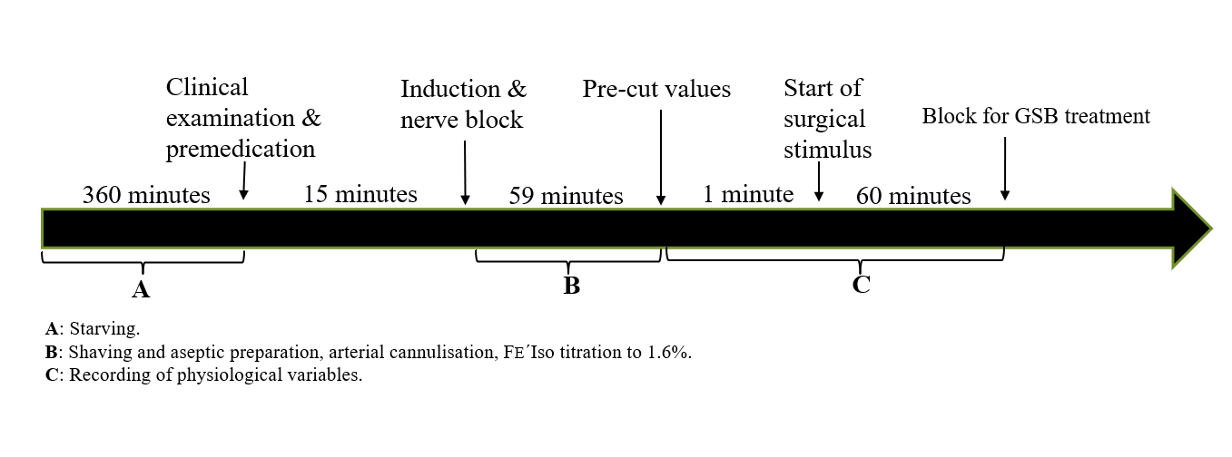
Supplementary Figure S2 Order and timing of procedures during data collection. Indicating time points for clinical evaluation, premedication, anaesthetic induction, nerve blocks, recording of the pre-cut physiological variables, the start of surgery and additional intervention for guided saline block (GSB ) group. Time intervals for starving (A), patient preparation (B) and data recording(C).

