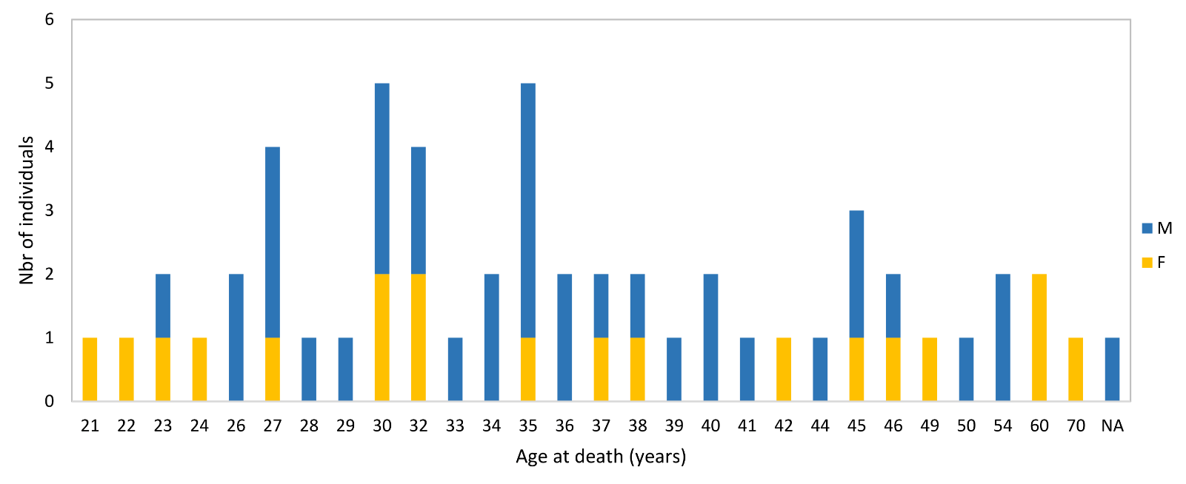
Figure S1. Age distribution of the South African modern human sample.
Abbreviations: F, female; M, male

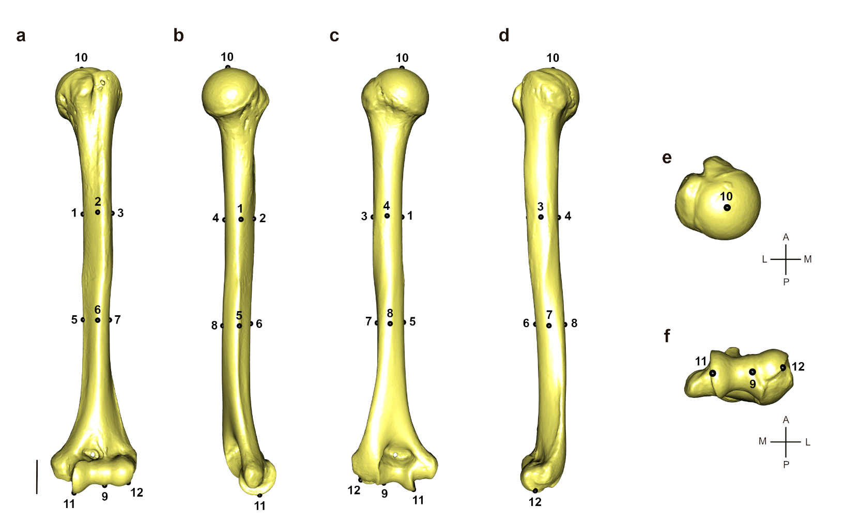
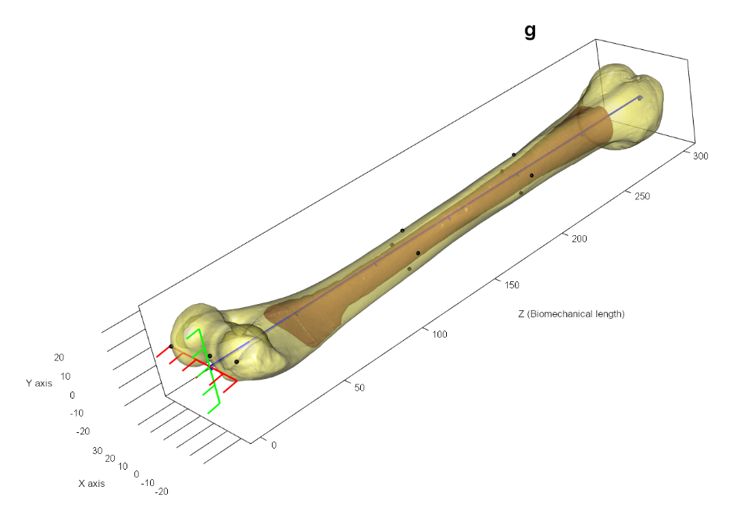
Figure S2. Landmarks positions on the 3D mesh of the humerus outer surface in anterior (a), medial (b), posterior (c), lateral (d), proximal (e), and distal (f) views, and the resulting virtual alignment (g) obtained with morphomap R package.
Scalebar = 25mm. For landmark definitions, see Table S4

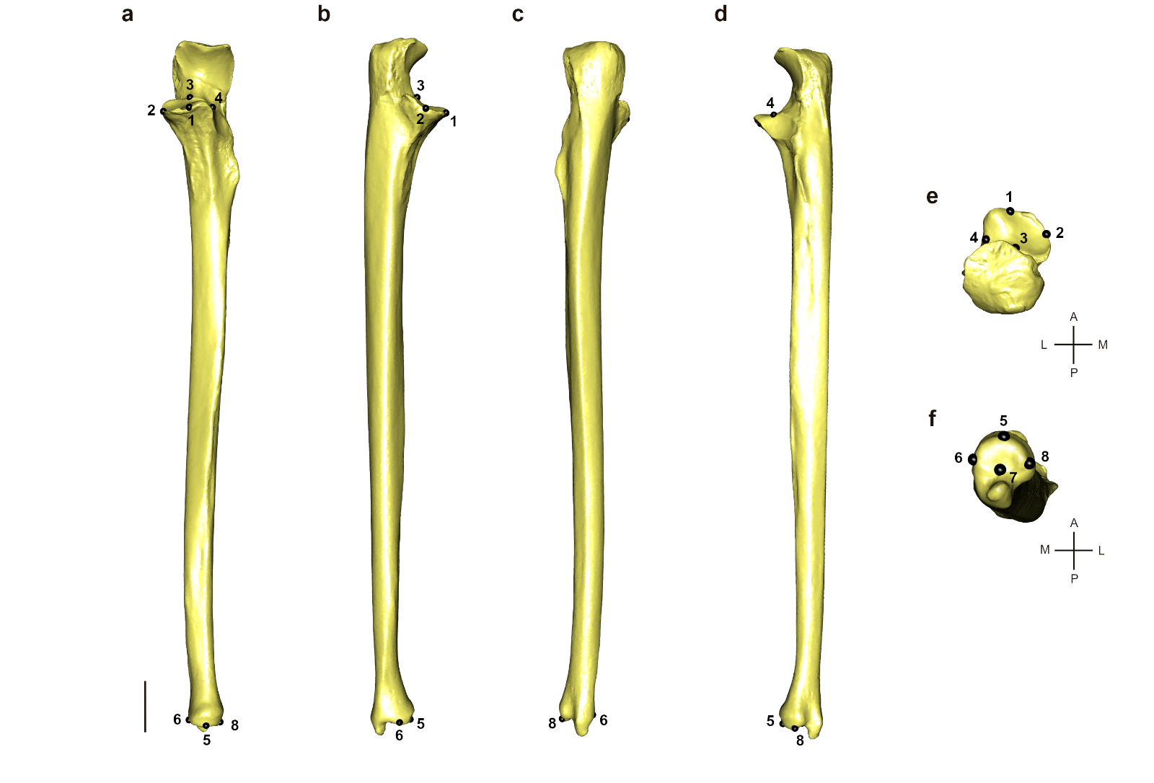
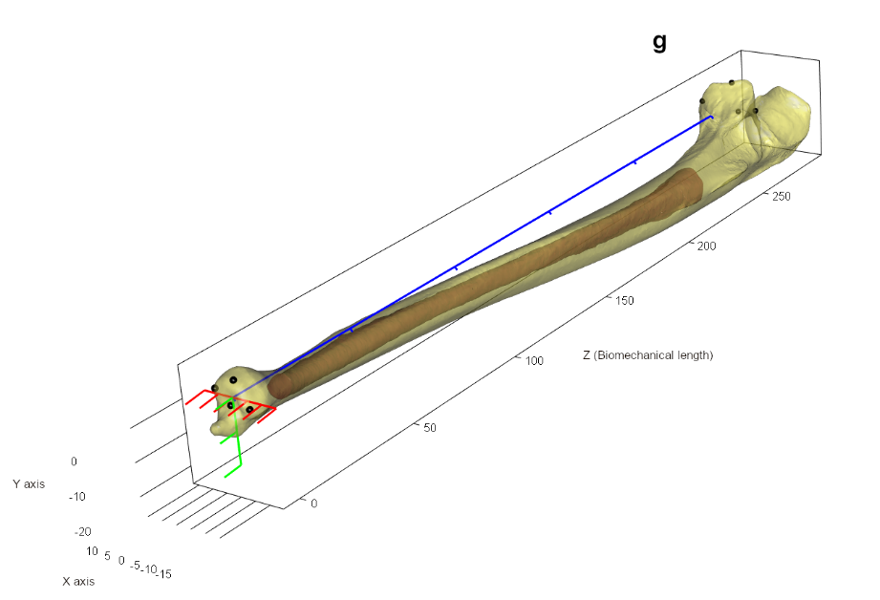
Figure S3. Landmarks positions on the 3D mesh of the ulna outer surface in anterior (a), medial (b), posterior (c), lateral (d), proximal (e), and distal (f) views, and the resulting virtual alignment (g) obtained with morphomap R package.
Scalebar = 25mm. For landmark definitions, see Table S4

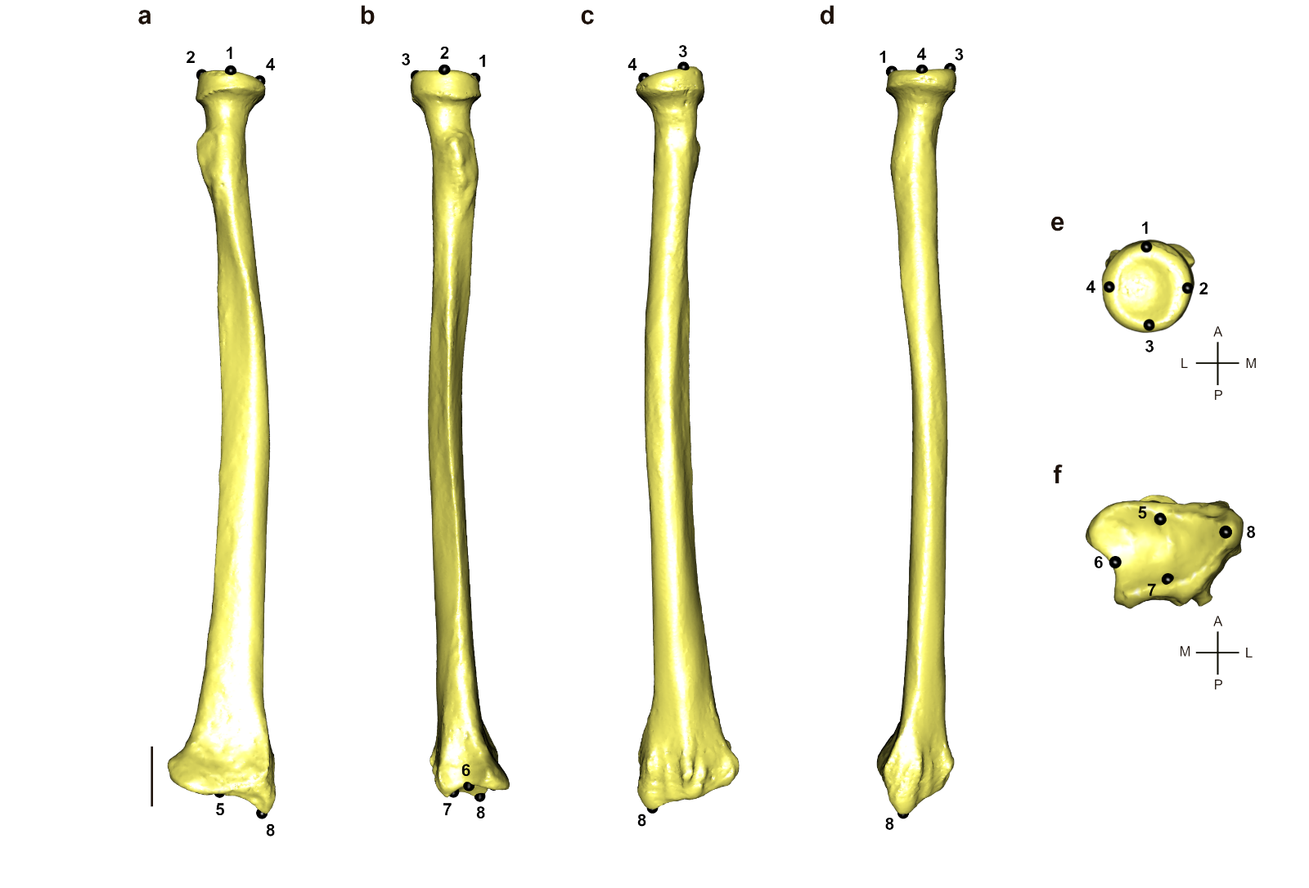
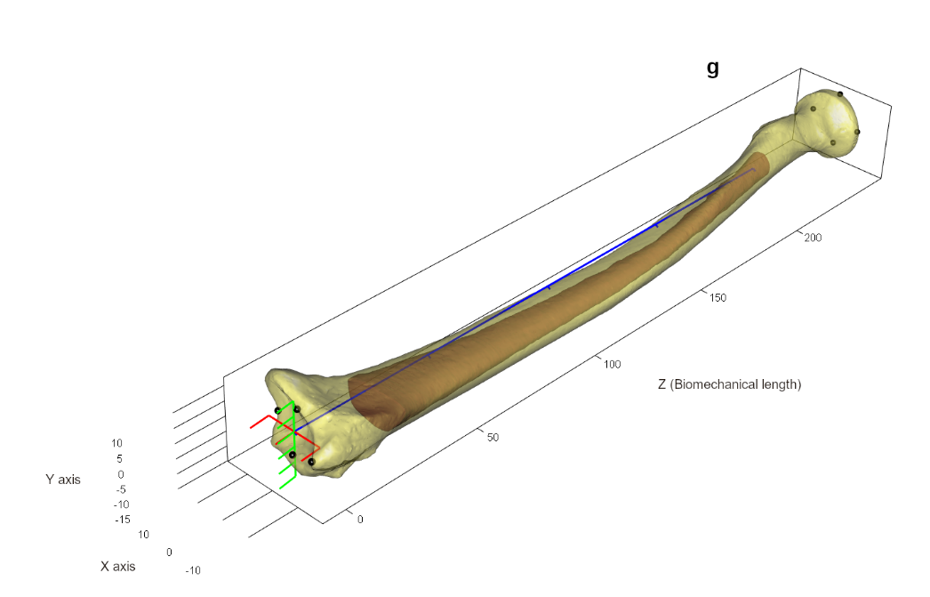
Figure S4. Landmarks positions on the 3D mesh of the radius outer surface in anterior (a), medial (b), posterior (c), lateral (d), proximal (e), and distal (f) views, and the resulting virtual alignment (g) obtained with morphomap R package.
Scalebar = 25mm. For landmark definitions, see Table S4

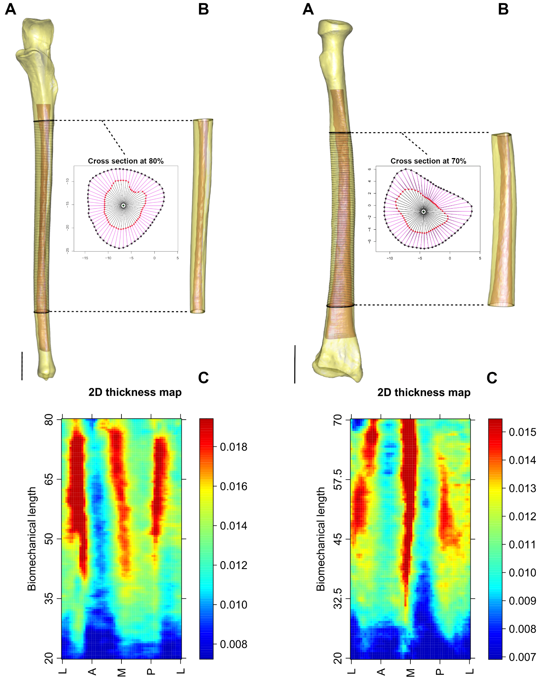
Figure S5. Data processing for the ulnae and radii in morphomap. (A) Position of the 120 cross-sections on outer surface (in yellow) and medullary cavity (in red) meshes of the 20-80% bone region of the ulna, and 100 cross-sections on outer surface and medullary cavity meshes of the 20-70% bone region of the radius. At each cross-section, 60 paired equiangular semilandmarks were set on the external (black spheres) and internal (red spheres) outlines, centered at the center of the cortical area (green dot). (B) Cortical bone volume computable from the 3D coordinates of the internal and external semilandmarks. (C) Two-dimensional morphometric map of scaled cortical thickness variation along the 20-80% region of the ulna shaft, and along the 20-70% region of the radius shaft.
X axis of the 2D morphometric map: unfolded projection starting and ending at the lateral (L) border, passing through the anterior (A), medial (M), and posterior (P) borders of the ulna and radius. Y axis: the percentage of the ulna and radius biomechanical lengths. The colors indicate the cortical thickness and range from dark red (thickest) to dark blue (thinnest). Scalebar = 25mm.
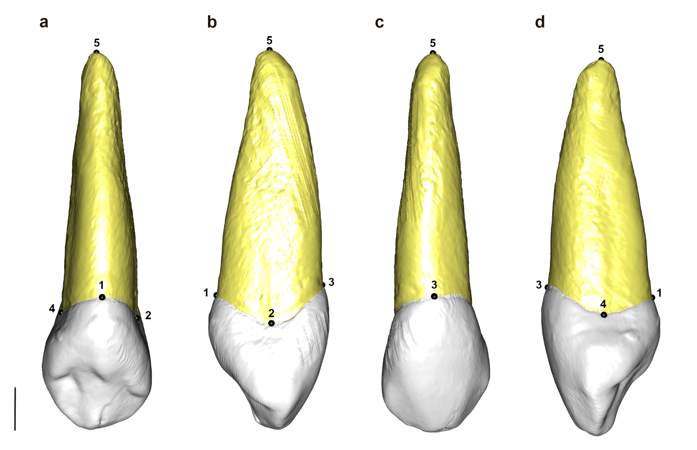
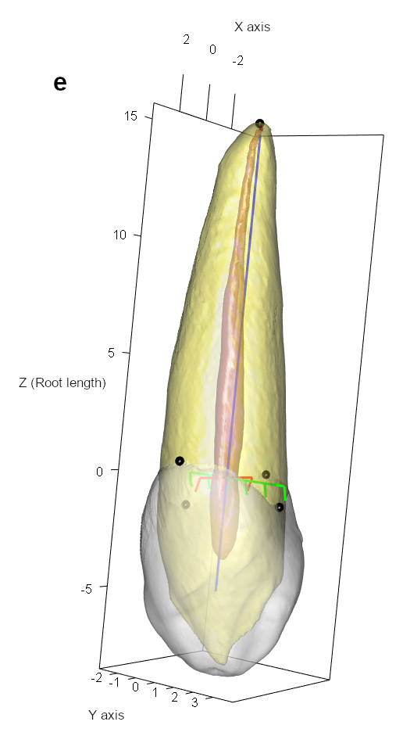
Figure S6. Landmarks positions on the 3D mesh of dentine of the upper canine in lingual (a), mesial (b), buccal (c), and distal (d) views, and the associated virtual alignment (e) with Toothnroll R package. The landmarks positions and alignment are similar for central and lateral incisors.
Scalebar = 2.5mm. For landmark definitions, see Table S4
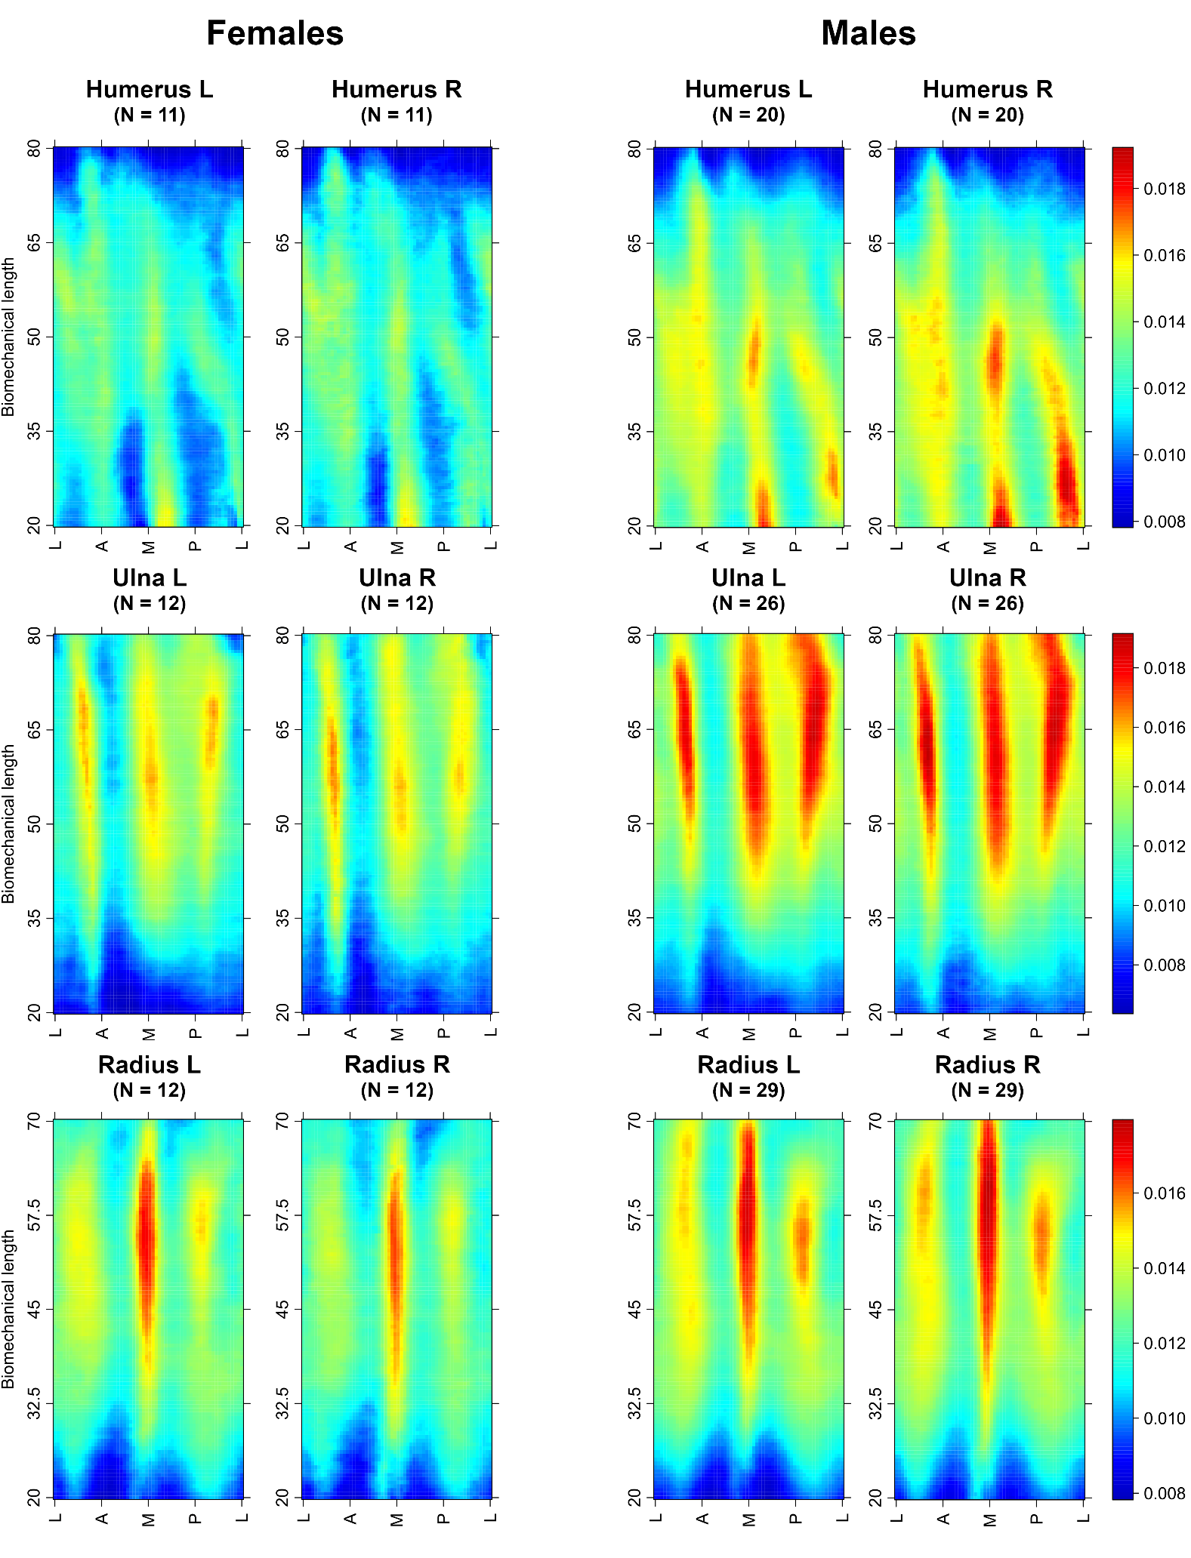
Figure S7. 2D morphometric maps of the mean cortical thickness variation across the entire shaft of left and right bones: the 20-80% humerus region (first row), the 20-80% ulna region (second row), and the 20-70% radius region (third row) for female and male individuals.
Abbreviations: L, left; R, right
X axis of the 2D morphometric map: unfolded projection starting and ending at the lateral (L) border, passing through the anterior (A), medial (M), and posterior (P) borders of the bone. Y axis: the percentage of the bone biomechanical length. The colors indicate the scaled cortical thickness and range from dark red (thickest) to dark blue (thinnest), using a global scale, such that all samples are shown on one scale.
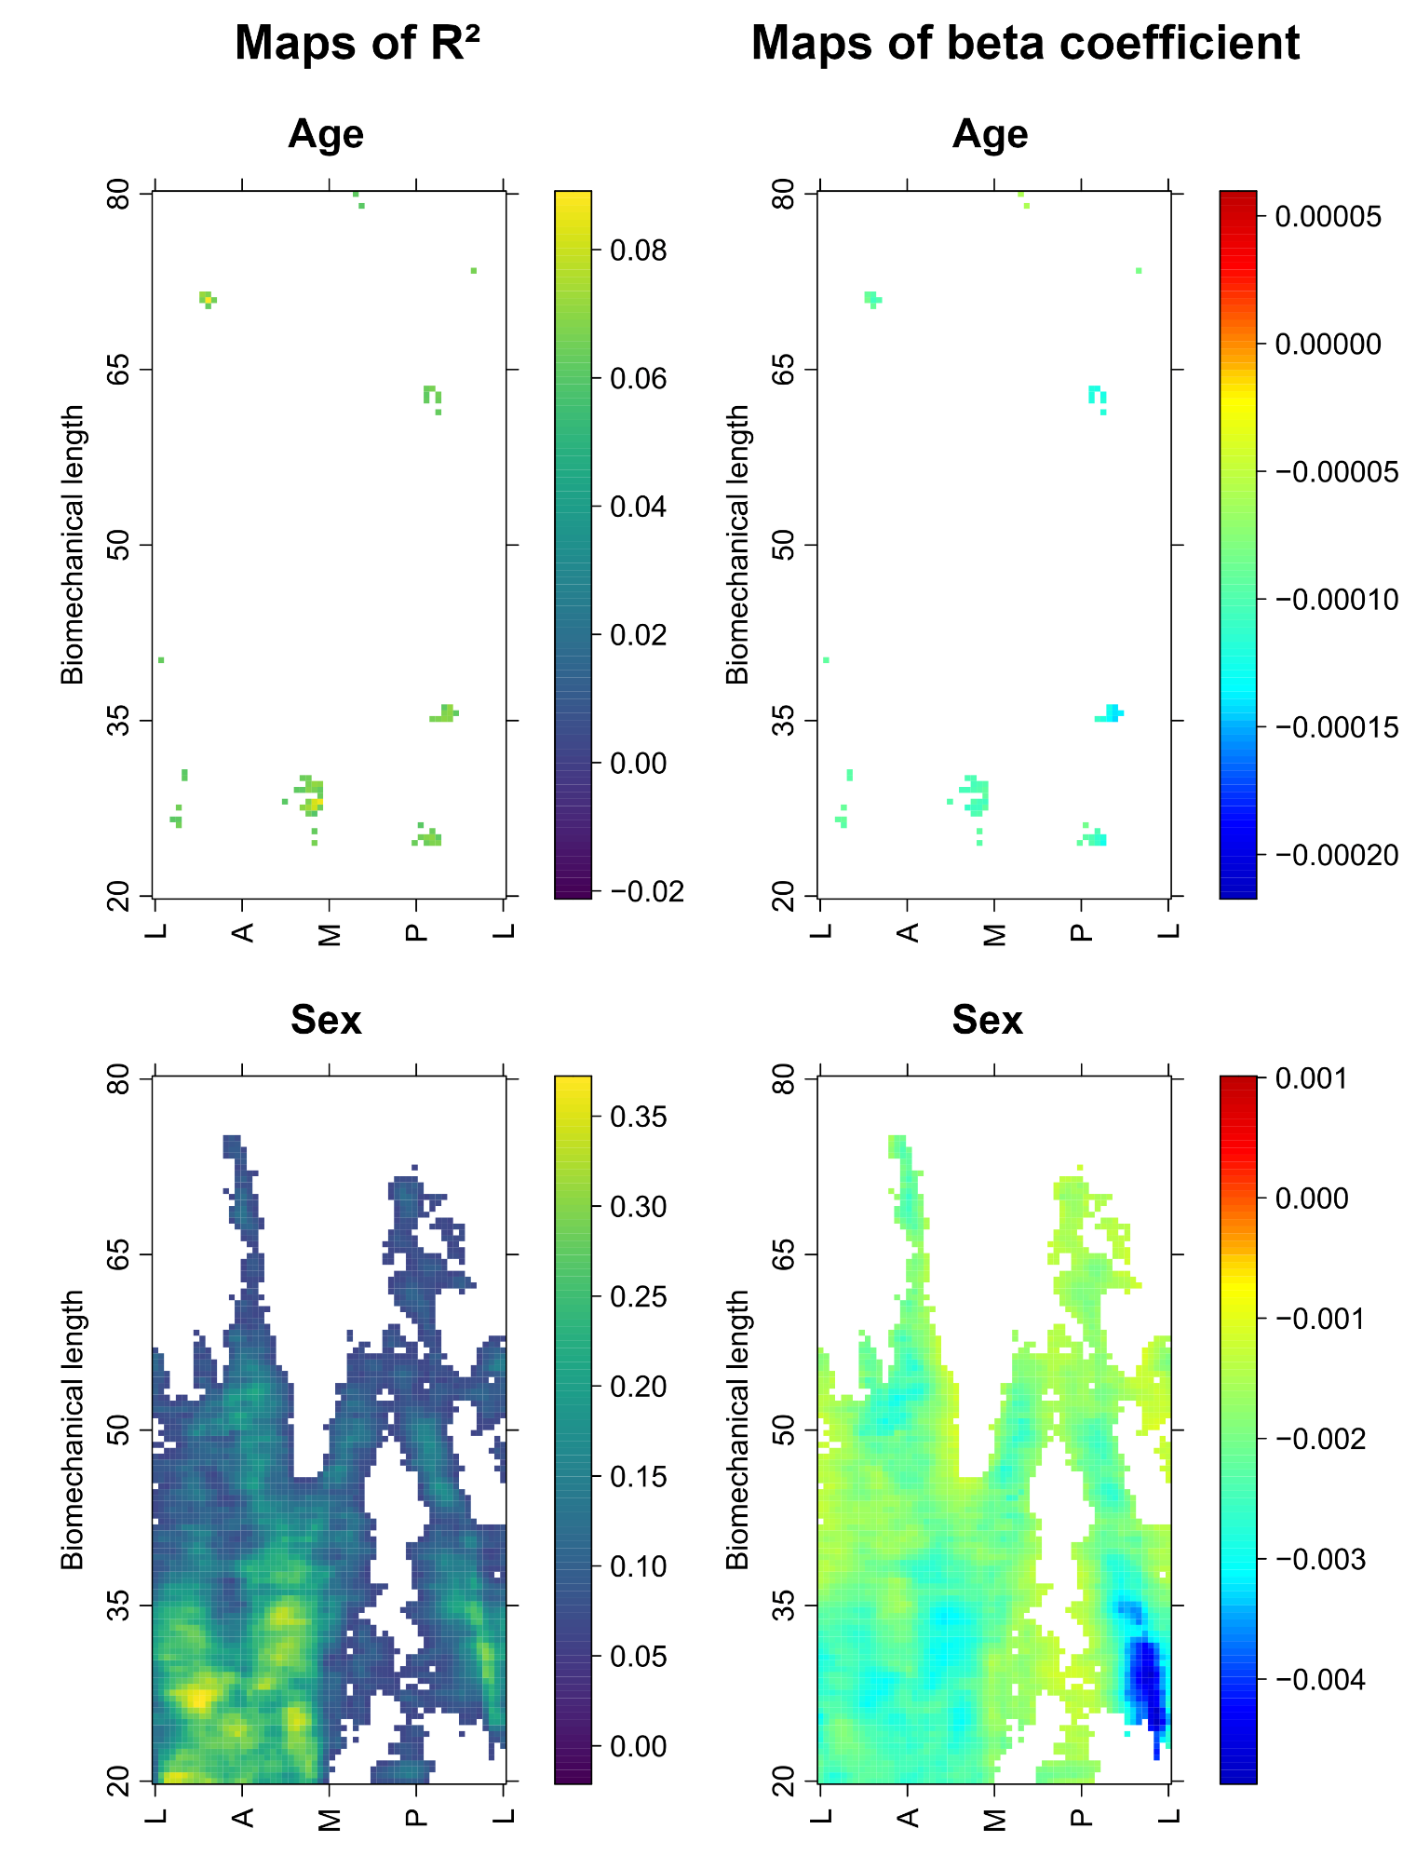
Figure S8. Map of R² (first column) and beta coefficients (second column) obtained from multiple regression of scaled cortical bone thickness variation according to individual age and sex for the 49 left humeri. R² highlights shaft regions showing cortical thickness variation relative to age and sex, and range is reported using the viridis palette. Beta coefficient indicates the rate of change in cortical bone thickness for changing age and sex, and range is reported using a rainbow palette. For the age variable, warm colors indicate significantly thicker cortical thickness, while cool colors indicate significantly thinner thickness with increasing age. For the sex variable, warm colors indicate significant increase in cortical thickness in the female humerus compared to the male humerus, while cool colors indicate significantly thinner thickness. White cells indicate statistically insignificant relationships.
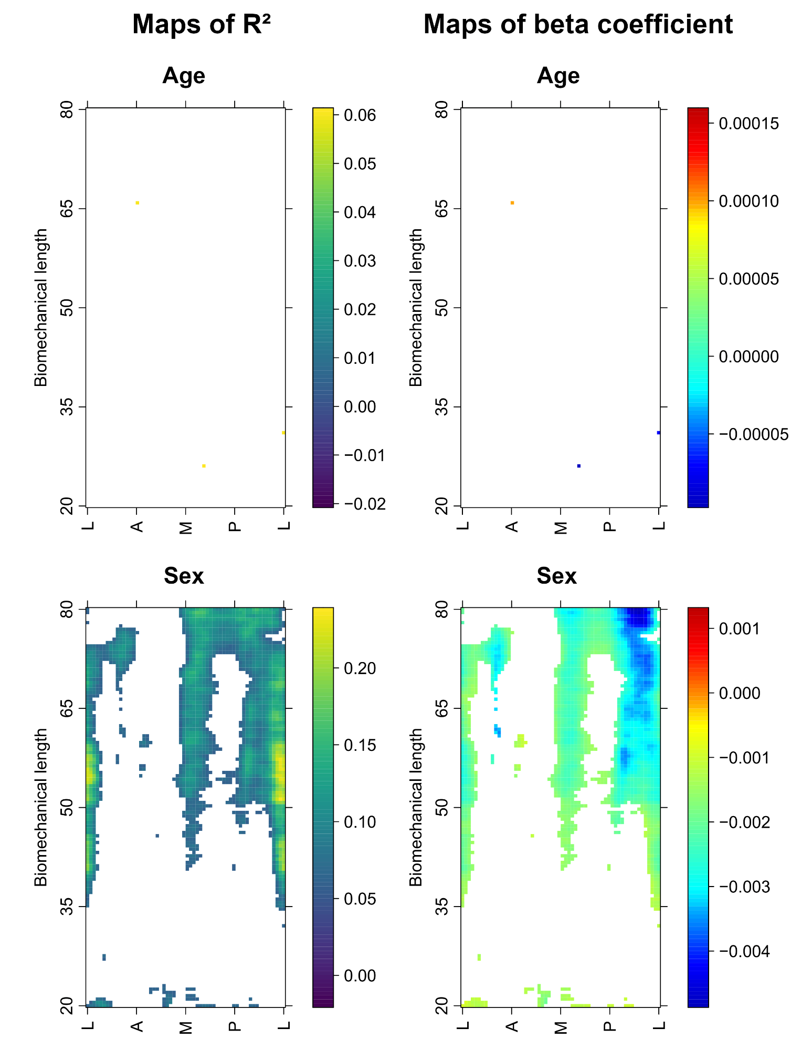
Figure S9. Map of R² (first column) and beta coefficients (second column) obtained from multiple regression of scaled cortical bone thickness variation according to individual age and sex for the 50 left ulnae. R² highlights shaft regions showing cortical thickness variation relative to age and sex, and range is reported using the viridis palette. Beta coefficient indicates the rate of change in cortical bone thickness for changing age and sex, and range is reported using a rainbow palette. For the age variable, warm colors indicate significantly thicker cortical thickness, while cool colors indicate significantly thinner thickness with increasing age. For the sex variable, warm colors indicate significant increase in cortical thickness in the female humerus compared to the male humerus, while cool colors indicate significantly thinner thickness. White cells indicate statistically insignificant relationships.
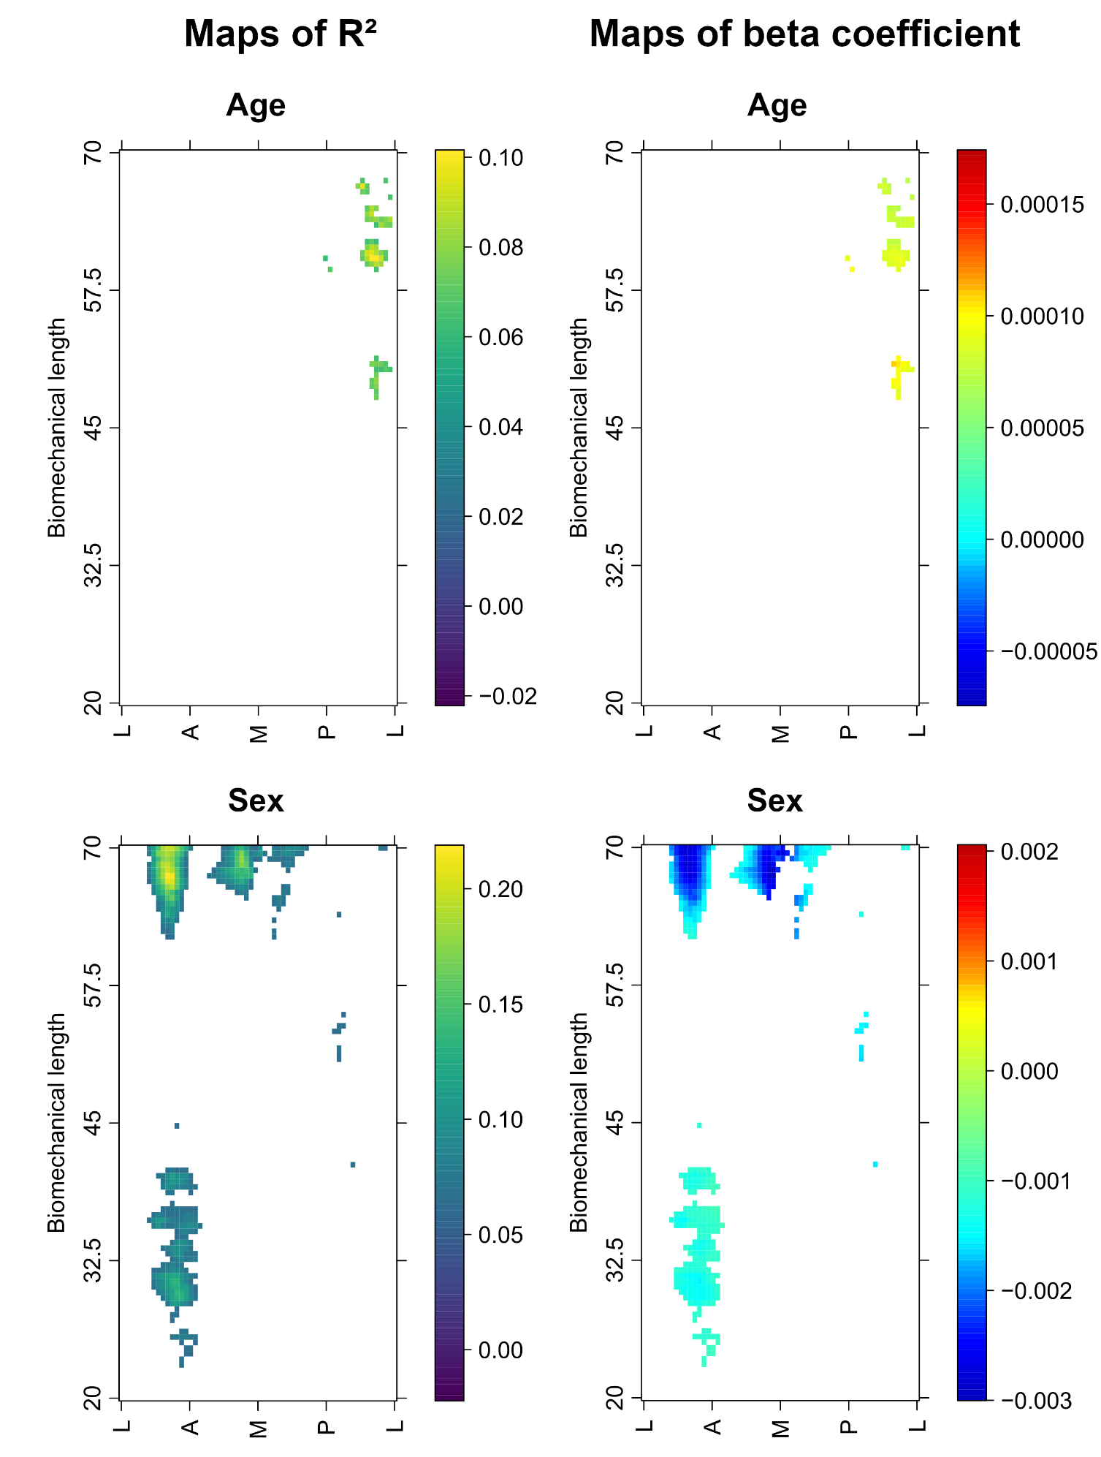
Figure S10. Map of R² (first column) and beta coefficients (second column) obtained from multiple regression of scaled cortical bone thickness variation according to individual age and sex for the 47 left radii. R² highlights shaft regions showing cortical thickness variation relative to age and sex, and range is reported using the viridis palette. Beta coefficient indicates the rate of change in cortical bone thickness for changing age and sex, and range is reported using a rainbow palette. For the age variable, warm colors indicate significantly thicker cortical thickness, while cool colors indicate significantly thinner thickness with increasing age. For the sex variable, warm colors indicate significant increase in cortical thickness in the female humerus compared to the male humerus, while cool colors indicate significantly thinner thickness. White cells indicate statistically insignificant relationships.

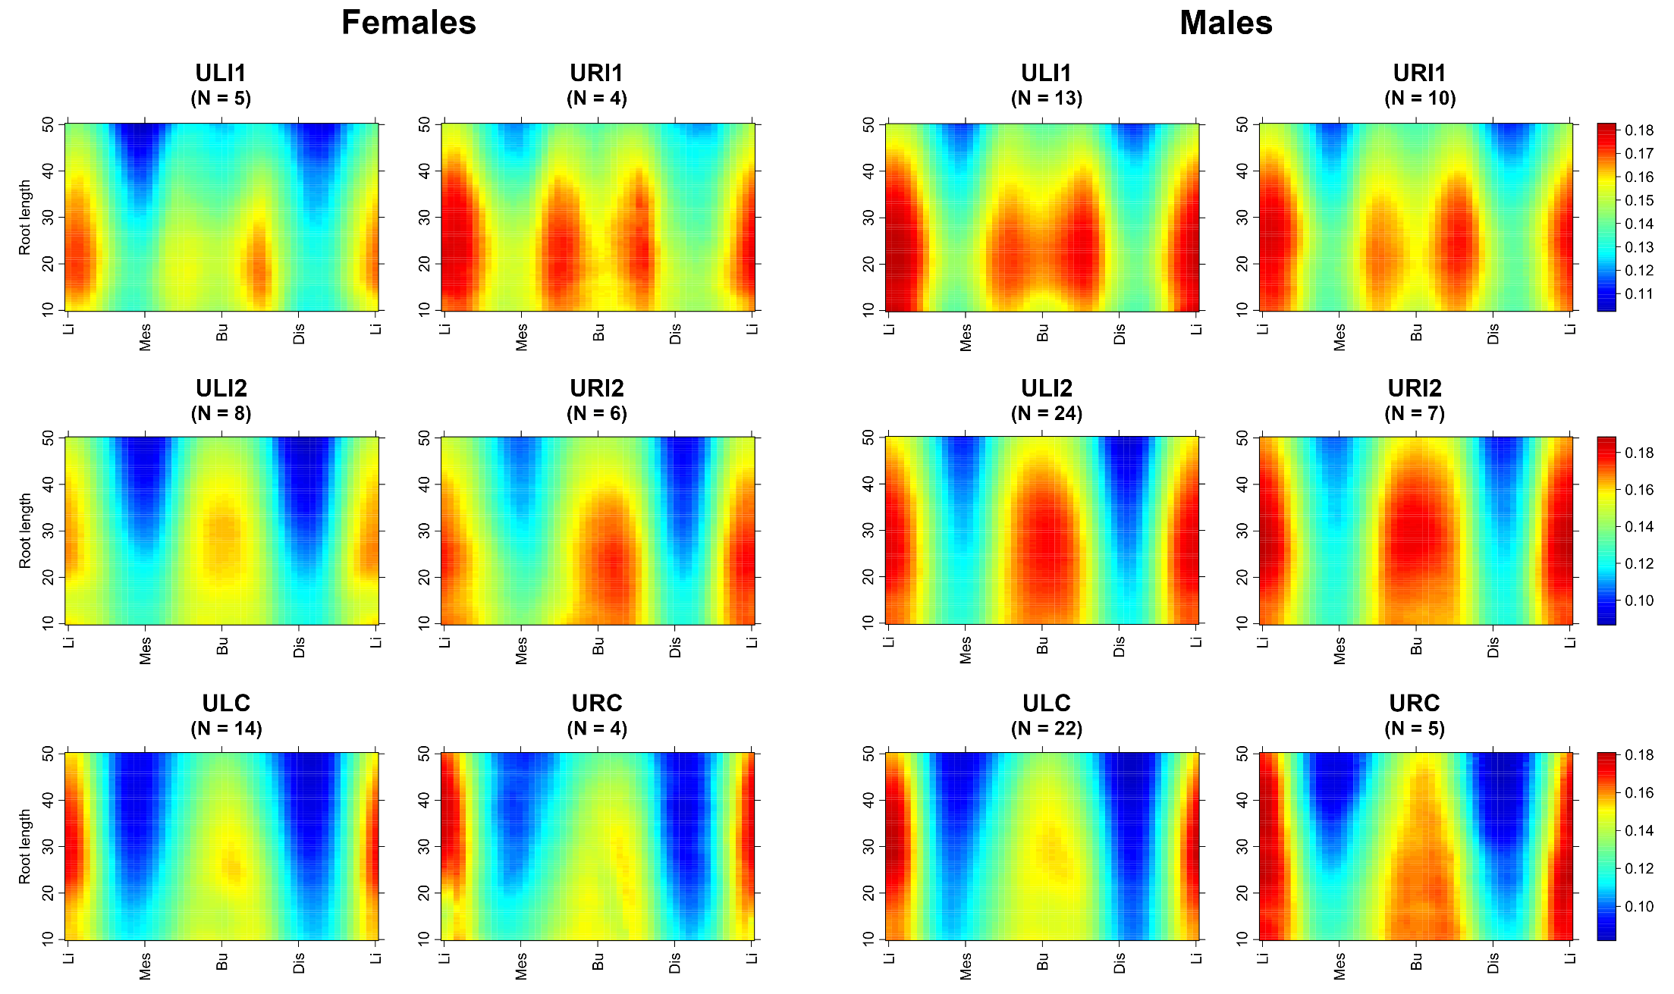
Figure S11. 2D morphometric maps of the mean dentine thickness variation across the 10-50% root region of left and right upper central incisors (first row), lateral incisors (second row), and canines (third row) for female and male individuals.
Abbreviations: ULI1, upper left central incisor; URI1, upper right central incisor; ULI2, upper left lateral incisor; URI2, upper right lateral incisor; ULC, upper left canine; URC, upper right canine
X axis of the 2D thickness map: unfolded projection starting and ending at the lingual (Li) border, passing through the mesial (Mes), buccal (Bu), and distal (D) borders. Y axis: the percentage of the total root length. The colors indicate the scaled dentine thickness and range from dark red (thickest) to dark blue (thinnest), using a global scale, such that all samples are shown on one scale.
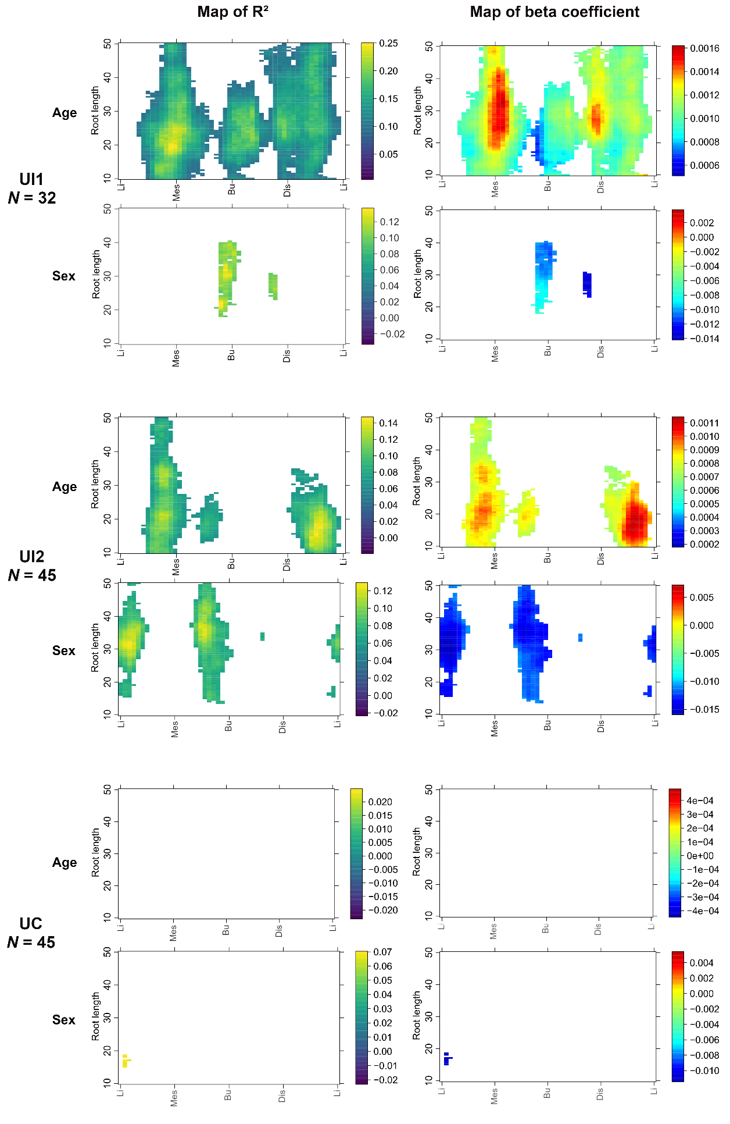
Figure S12. Map of R² (first column) and beta coefficients (second column) obtained from multiple regression of scaled dentine thickness variation for the 10-50% root region, according to individual age class and sex for the 32 upper central incisors, 45 lateral incisors, and 45 canines. R² highlights root regions showing dentine thickness variation relative to age and sex, and range is reported using the viridis palette. Beta coefficient indicates the rate of change in dentine thickness for changing age and sex, and range is reported using a rainbow palette. For the age variable, warm colors indicate significantly thicker dentine thickness, while cool colors indicate significantly thinner thickness with increasing age. For the sex variable, warm colors indicate significant increase in dentine thickness in the female anterior tooth compared to the male anterior tooth, while cool colors indicate significantly thinner thickness. White cells indicate statistically insignificant. Abbreviations: UI1, permanent upper central incisor; UI2, permanent upper lateral incisor; UC, permanent upper canine
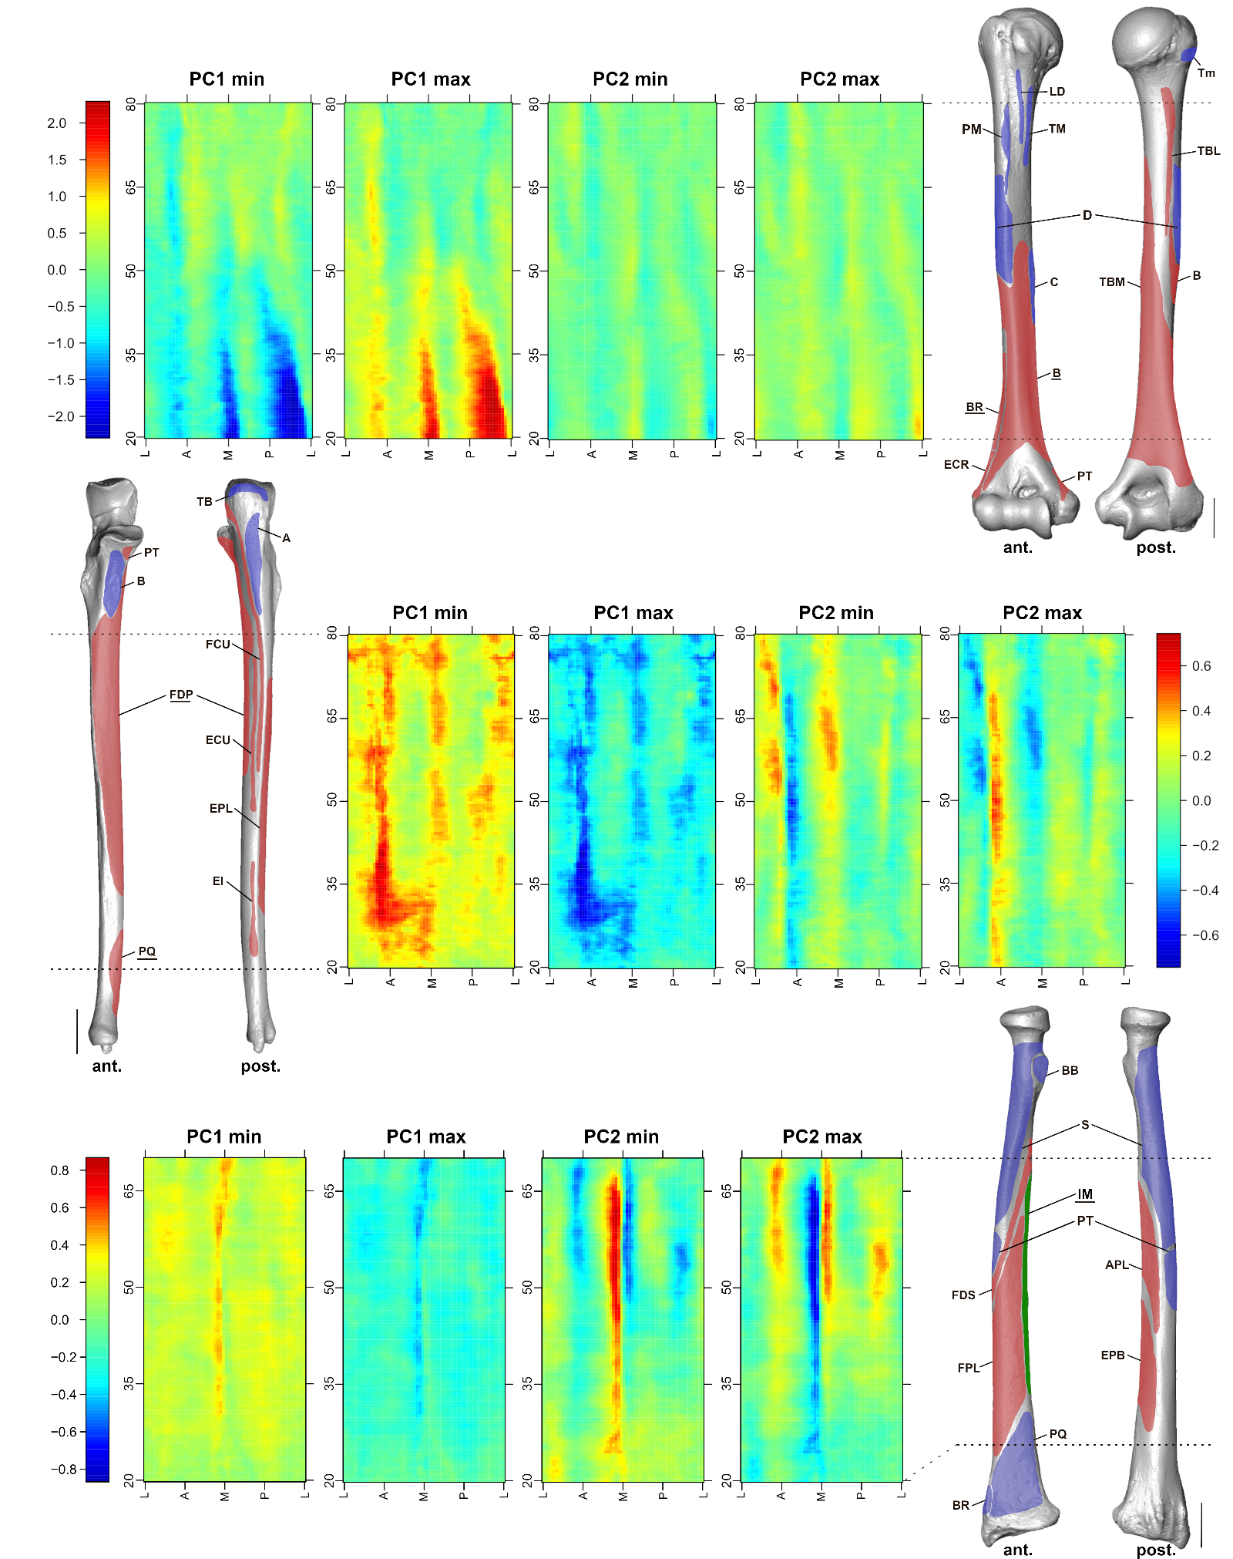
Figure S13. Maps of extreme conformation obtained from PCA of cortical thickness variation along the shafts of paired humeri (1st row), ulnae (2nd row), and radii (3rd row). The origins (in red) and insertions (in blue) of muscles of the humerus, ulna, and radius are indicated. Muscles potentially aligning with areas of cortical bone asymmetry are highlighted. For muscle abbreviations, see Table S11.
The X-axis represents the unrolled view from the lateral (L), anterior (A), medial (M), and posterior (P) aspects of the shaft. The Y-axis represents the percentage of the bone biomechanical length. The colors indicate the cortical bone thickness and range from dark blue (thinnest) to dark red (thickest).
Supplementary Discussion
Both males and females exhibited a similar pattern of radicular dentine distribution in their antimeric central incisors. Morphometric maps of mean dentine thickness revealed a single vertical strip along the lingual aspect and two dentine thickenings on the buccal aspect of the 10-50% root region (Figure S11). In females, these reinforcements tend to be thicker in the right central incisors, whereas in males, maximum thickness is observed in the left incisors. This asymmetry is also reflected in radicular dentine volumes, with Wilcoxon tests indicating statistical differences in absolute and scaled volumes between the antimeric central incisors in males and females (Table S5).
In lateral incisors, the dentine distribution pattern is similar to that of the central incisors, but with a single strip of dentine along the buccal aspect (Figure S11). Females exhibited greater buccal thickening in the right lateral incisors compared to the left, whereas males showed the reverse asymmetry. However, the comparison of radicular dentine volumes between the left and right lateral incisors revealed no significant differences in either sex (Table S5).
The dentine distribution in canines closely resembles that of the lateral incisors. However, there is no distinct asymmetry in dentine thickness, aside from a minor lingual thickening observed in the right canines of females (Figure S11). Again, no significant differences emerged from radicular volume comparisons between antimeres (Table S5).
If dental asymmetry in posterior teeth may preserve a developmental signature (Garn et al., 1967; Scott & Turner, 1997), it has also been interpreted as a consequence of chewing side preference in individuals during mastication (e.g., Martinez-Gomis et al., 2009; Oxilia et al., 2018). During the chewing cycle, the anterior teeth are responsible for food incision (Hylander, 2006), and the forces exerted on incisors are minimal compared to those applied on posterior teeth (Helkimo et al., 1977). Consequently, there is limited evidence regarding the effect of chewing side preference on the external or internal morphology of antimeric anterior teeth. In our study, radicular dentine distribution patterns were consistent between antimeric teeth. Furthermore, variations in dentine thickness and volume seem to randomly affect either the right or left side of central and lateral incisors and canines. These patterns could be linked to fluctuating asymmetry, which is known to influence overall tooth size as well as crown and root traits (rev. in Scott & Turner, 1997). Alternatively, these differences might result from the small sample size for each tooth type in our study.

References:
Garn, S.M., Lewis, A.B. & Kerewsky, R.S. (1967) Buccolingual Size Asymmetry and Its Developmental Meaning. The Angle Orthodontist, 37(3), 186–193.
Helkimo, E., Carlsson, G.E. & Helkimo, M. (1977) Bite force and state of dentition. Acta Odontologica Scandinavica, 35(6), 297–303. Available from: https://doi.org/10.3109/00016357709064128.
Hylander, W.L. (2006) Functional Anatomy and Biomechanics of the Masticatory Apparatus. In: D. M. Laskin, C. S. Greene, & W. L. Hylander eds. Temporomandibular Disorders: An Evidenced-Based Approach to Diagnosis And Treatment. Chicago: Quintessence, 3–34.
Martinez-Gomis, J., Lujan-Climent, M., Palau, S., Bizar, J., Salsench, J. & Peraire, M. (2009) Relationship between chewing side preference and handedness and lateral asymmetry of peripheral factors. Archives of Oral Biology, 54(2), 101–107. Available from: https://doi.org/10.1016/j.archoralbio.2008.09.006.
Oxilia, G., Bortolini, E., Martini, S., Papini, A., Boggioni, M., Buti, L., et al. (2018) The physiological linkage between molar inclination and dental macrowear pattern. American Journal of Physical Anthropology, 166(4), 941–951. Available from: https://doi.org/10.1002/ajpa.23476.
Scott, G.R. & Turner, C.G. (1997) The Anthropology of Modern Human Teeth: Dental Morphology and its Variation in Recent Human Populations. Cambridge University Press.

