Additional file 1
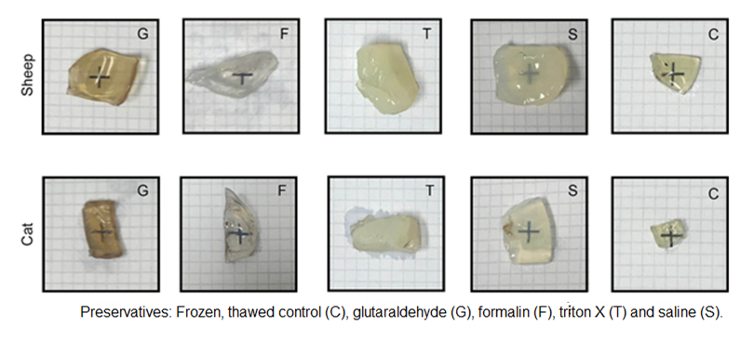
Figure S1. Images for subjective assessment of the transparency of sheep and cats’ preserved corneas on a 2 mm grid.

