Supplementary Data for “Comparative genomics reveals adaptive traits in novel Antarctic lithic cyanobacteria”
Marc W. Van Goethem^{1,2}, Surendra Vikram¹, Don A. Cowan¹, and Thulani P. Makhalanyane^{3,4}
¹Centre for Microbial Ecology and Genomics, Department of Biochemistry, Genetics and Microbiology, University of Pretoria, Lynnwood Road, Pretoria 0028, South Africa
²Biological and Environmental Sciences and Engineering Division, King Abdullah University of Science and Technology (KAUST), Thuwal 23955-6900, Kingdom of Saudi Arabia
³Department of Microbiology, Faculty of Science, Stellenbosch University, Stellenbosch 7600, South Africa
⁴The School for Data Science and Computational Thinking, Stellenbosch University, Stellenbosch 7600, South Africa
Supplementary Figure 1. Genome comparison between Coleofasciculus caryii H7-2 (inner ring, contigs indicated as grey bars) and the closest available reference strain Coleofasciculus sp. FACHB-T130 (outer ring, sequence similarities are indicated by red colours).
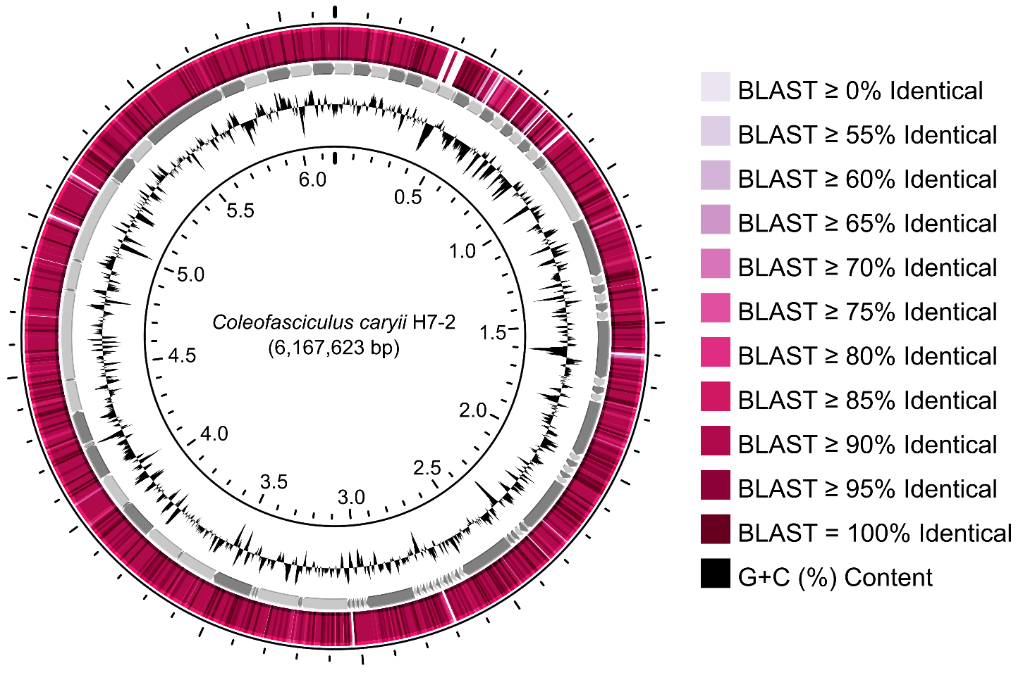
Supplementary Figure 2. Dot plot showing a genome-wide comparison between Coleofasciculus caryii H7-2 and the closest available reference strain Coleofasciculus sp. FACHB-T130. The alignments are coloured according to their sequence similarity.
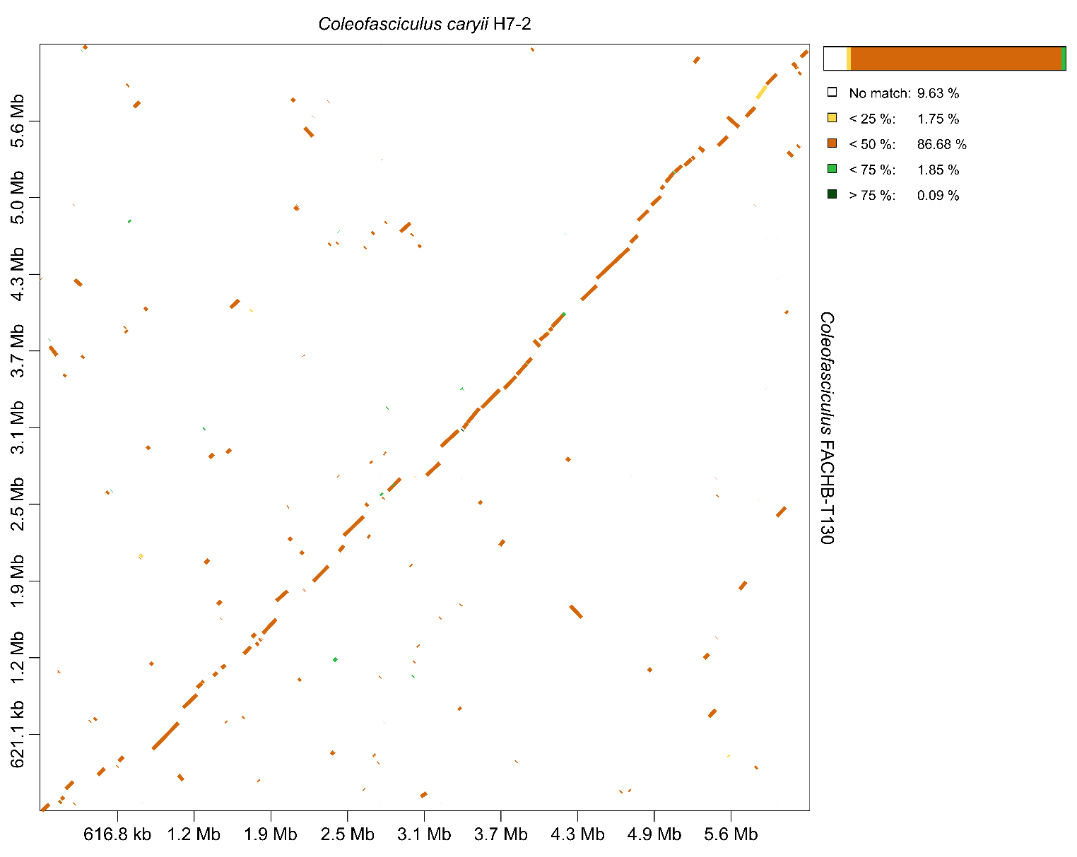
Supplementary Figure 3. Supplementary Figure 1. Genome comparison between Aliterella bergstromii E5.1 (inner ring, contigs indicated as grey bars) and the closest available reference strain Aliterella sp. RAGGC 92 (outer ring, sequence similarities are indicated by red colours).
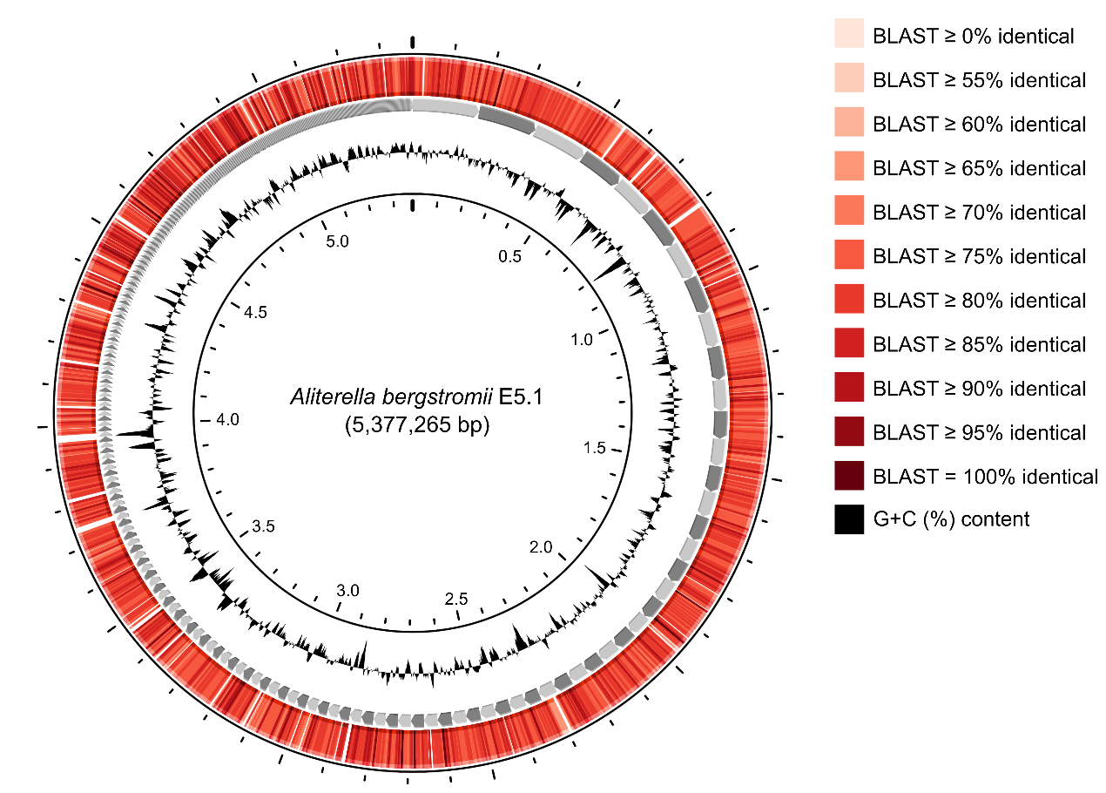
Supplementary Figure 4. Dot plot showing a genome-wide comparison between Aliterella bergstromii E5.1 and the closest available reference strain Aliterella sp. RAGGC 92. The alignments are coloured according to their sequence similarity.
