Supplementary tables and figures
Table S1: Search strategy and terms
Search engine | Terms
PubMed | (((((((((prevalence[MeSH Terms]) OR (epidemiology[MeSH Terms])) AND (colistin[MeSH Terms])) OR (Polymyxins[MeSH Terms])) OR (Polymyxin B[MeSH Terms])) ) AND (colistin-resistant)) OR (enterobacteriaceae[MeSH Terms])) OR (enterobacteriaceae infections[MeSH Terms])) AND (Africa[MeSH Terms]) Filters: Humans, English, from 2010/1/30 - 2023/12/31  (((((("prevalence"[MeSH Terms] OR "epidemiology"[MeSH Terms]) AND "colistin"[MeSH Terms]) OR "polymyxins"[MeSH Terms] OR "polymyxin b"[MeSH Terms]) AND "colistin-resistant"[All Fields]) OR "enterobacteriaceae"[MeSH Terms] OR "enterobacteriaceae infections"[MeSH Terms] OR "gram negative bacteria"[MeSH Terms]) AND "africa"[MeSH Terms]) AND ((humans[Filter]) AND (2010/1/30:2023/12/31[pdat]) AND (english[Filter]))
Science Direct | (Prevalence OR epidemiology) AND (colistin OR polymyxin) AND (colistin-resistant OR enterobacteriaceae) AND Africa
Scopus | prevalence* OR epidemiology* AND colistin* OR polymyxin* AND colistin-resistant* OR enterobacteriaceae* AND Africa*
Google Scholar | Prevalence OR epidemiology AND colistin OR polymyxin AND colistin-resistant OR enterobacteriaceae AND Africa
Filters | Human, English language, date 2010/1/30-2023/12/31

Table S2: Quality score of the included studies
Authors | 1. Was the sample frame appropriate to address the target population? | 2. Were study participants sampled in an appropriate way? | 3. Was the sample size adequate? | 4. Were the study subjects and the setting described in detail? | 5. Was the data analysis conducted with sufficient coverage of the identified sample? | 6. Were valid methods used for the identification of the condition? | 7. Was the condition measured in a standard, reliable way for all participants? | 8. Was there appropriate statistical analysis? | 9. Was the response rate adequate, and if not, was the low response rate managed appropriately? | Quality score
1.Abozahara | Yes | Yes | yes | yes | yes | No | Yes | yes | yes | 8/9
2.Abdil F | N0n-applicable | Yes | yes | yes | yes | Yes | Yes | yes | yes | 8
3.Adeosum | N0n-applicable | Yes | yes | yes | yes | Yes | Yes | yes | yes | 8
4.Azzab | Yes | Yes | yes | yes | yes | Yes | Yes | yes | Yes | 9
5.Carrol et al | Yes | Yes | yes | yes | yes | Yes | No | yes | yes | 8
6.El-kholy et al | Yes | Yes | yes | yes | yes | Yes | Yes | yes | yes | 9
7.Elbaradei et al | Yes | Yes | yes | yes | yes | Yes | Yes | yes | yes | 9
8.Hasanin | Yes | Yes | yes | yes | yes | No | Yes | yes | yes | 8
9.Irenge | Yes | Yes | yes | yes | yes | Yes | Yes | yes | yes | 9
10.Jalal et al | Yes | Yes | No | yes | yes | Yes | Yes | yes | Yes | 8
11.Mbelle et al | Unclear | Yes | yes | yes | yes | No | Yes | yes | yes | 7
12.Romandan | Yes | Yes | yes | yes | yes | Yes | Yes | yes | yes | 9
13.Zafer et al | Yes | Yes | yes | yes | yes | Yes | Yes | yes | yes | 9
14.Gizachew et a | Yes | Yes | yes | yes | yes | Yes | Yes | yes | No | 8
15.Yousfi et al | Yes | Yes | yes | yes | No | No | Yes | yes | yes | 7
16.Abdelmagid | Yes | Yes | yes | yes | No | Yes | No | yes | yes | 7
17.Aminata et al | Yes | Yes | No | yes | yes | No | Yes | yes | yes | 7
18.Sarr et al | Yes | Yes | yes | yes | yes | Yes | Yes | yes | yes | 9
19.Mohammed | Yes | Yes | yes | yes | yes | Yes | No | yes | yes | 8
20.El-Mahallawy | Yes | Yes | yes | yes | yes | Yes | Yes | yes | yes | 9
21.Abdel salam | Yes | Yes | yes | yes | yes | No | Yes | yes | yes | 8
22.Synman et al | Yes | Yes | yes | yes | yes | No | yes | No | yes | 7
23.Kieffer et a | Yes | Yes | yes | yes | yes | No | yes | No | yes | 7
24.Mezghani | Yes | Yes | yes | yes | yes | No | yes | yes | yes | 8
25.Battikh et al | Yes | Yes | yes | yes | yes | Yes | yes | yes | yes | 9
26.Ayandele | Yes | Yes | yes | yes | yes | No | yes | No | yes | 7
27.Budel et al | Yes | Yes | yes | yes | yes | No | yes | yes | yes | 8
28.Newton-Foot | Yes | Yes | yes | yes | yes | Yes | yes | yes | yes | 9
29.Messaoudi | Yes | Yes | yes | yes | yes | No | yes | No | yes | 7
30.Aworh et al | Yes | Yes | yes | yes | yes | No | yes | No | yes | 7
31.Deku et al | Yes | Yes | yes | yes | yes | No | yes | Yes | yes | 8
32.El-Mokhtar | Yes | Yes | yes | yes | yes | Ye | yes | yes | yes | 9
33.Maina et al | Yes | Yes | yes | yes | yes | No | yes | No | yes | 7
34.Zakkaria et al | Yes | Yes | yes | yes | yes | Yes | yes | yes | yes | 9
35.Afolayan et al | Yes | Yes | yes | yes | yes | No | yes | No | yes | 7
36.Poirel et al | Yes | Yes | yes | yes | yes | No | yes | No | yes | 7
37.Nabti et al | Yes | Yes | yes | yes | yes | No | yes | yes | yes | 8
38.Konate et al | Yes | Yes | yes | yes | yes | No | yes | No | yes | 7
39.Sumbana et al | Yes | Yes | yes | yes | yes | No | yes | yes | yes | 8
40.Otokunefor | Yes | Yes | yes | yes | yes | No | yes | No | yes | 7
41.Mohammed | Yes | Yes | yes | yes | yes | Yes | yes | yes | yes | 9

Table S3: Trim-and-fill analysis for the pooled prevalence of colistin resistance among Enterobacteriaceae
Studies | Prevalence | 95% CI
Observed (41) | 26.744 | 16.685-36.804
Observed + imputed (41+7) | 32.305 | 22.928-41.682

Table S4: Pooled prevalence of colistin resistance in Klebsiella pneumoniae after trim and fill analysis
Studies | Effect-size | (95% CI)
Observed | 28.844 | 16.636-41.053
Observed +imputed (30+3) | 32.101 | 20.475-43.727

Table S5: Pooled prevalence of colistin resistance in E. coli after trim and fill analysis
Studies | Prevalence | 95% (CI)
Observed | 24.498 | 11.681-37.315
Observed +imputed (26+2) | 26.539 | 14.342-38.736

Table S6: Pooled prevalence of colistin resistance after trim and fill analysis in proteus species
Studies | Effect-size | (95% CI)
Observed | 50.015 | 5.998 106.029
Observed + Imputed (4+1) | 66.584 | 12.420 120.748

Figure S1: Funnel plot showing the presence of publication bias in studies on colistin-resistant Enterobacteriaceae
Figure S2: Funnel plot depicting publication bias in the pooled prevalence of colistin resistance among Klebsiella pneumoniae isolates
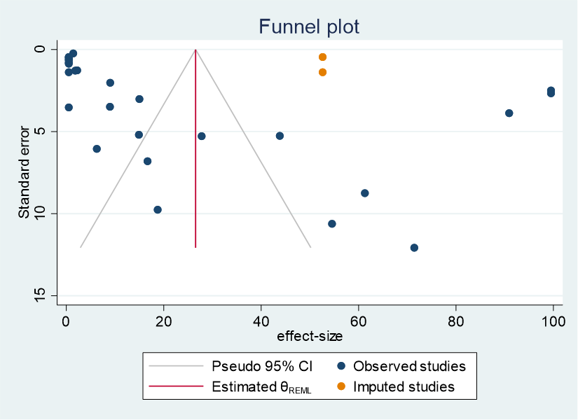

Figure S3: Funnel plot for publication bias of pooled prevalence of colistin resistance among E. coli isolates in Africa from 2010 to 2023 G.C.

Figure S4: Funnel plot for publication bias of pooled prevalence of colistin resistance among Enterobacter species isolates in Africa from 2010 to 2023 G.C.
Figure S5: Funnel plot for publication bias of pooled prevalence of colistin resistance among Proteus species isolates in Africa from 2010 to 2023 G.C.

