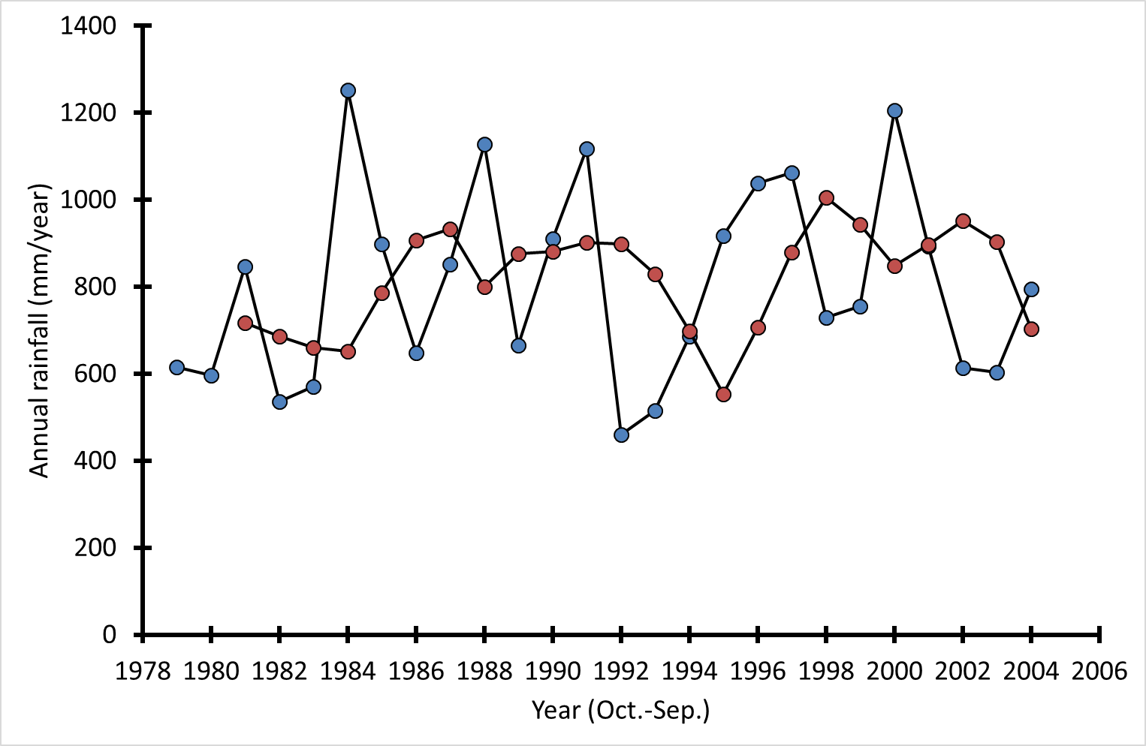
S3 Fig. Annual rainfall in HiP in the period 1979-2004.
Blue data points: annual rainfall (years running from October to September), red data points: average annual rainfall in the three years before the year of birth

