Supplementary information file 3

Native-alien populations—-an apparent oxymoron that requires specific conservation attention
Method for testing whether native-alien populations are particularly prevalent in large, ecologically diverse countries
The environmental heterogeneity of countries was quantified by calculating the number of ecoregions and biomes per country. Spatial ecoregion and biome data from Olson et al. (2001) were used for this purpose (https://databasin.org/datasets). Data on country size, which were obtained from the World Bank (https://data.worldbank.orghttps://datacatalog.worldbank.org), and the spatial terrestrial ecoregion and biome data were used to determine the relationship between environmental heterogeneity (i.e. number of ecoregions and biomes per country), and country size.
Within a country, there may be two or more patches of the same environment that are separated by a biogeographical barrier. Although the environment is similar in these patches, some species may only occupy a single patch and may not have dispersed to all patches. To assess if larger countries tend to have a higher number of suitable but unoccupied habitats, the spatial data for the world’s terrestrial ecoregions and biomes discussed above were used to calculate the number of ecoregions and biomes with separate patches per country. Patches of the same habitat (ecoregions or biomes) were considered separate if there was a spatial gap between them. The results of this analysis along with the country size data discussed above were used to determine the relationship between the country size and the number of ecoregions and biomes (habitats) with separate patches.

The data were analysed using R statistical software (version 3.4.4, R Core Team 2018). Generalized linear models (Poisson error distribution and log link) were used to determine the relationship between: 1) country size and number of ecoregions; 2) country size and number of biomes; 3) country size and number of ecoregions with separate patches; and 4) country size and number of biomes with separate patches (Crawley, 2013). Overdispersion was checked by dividing the residual deviance by residual degrees of freedom (Crawley 2013). Overdispersion was identified in the analysis of the relationship between country size and number of ecoregions and ecoregions with separate patches. A quasipoisson model was fitted to deal with overdispersion.

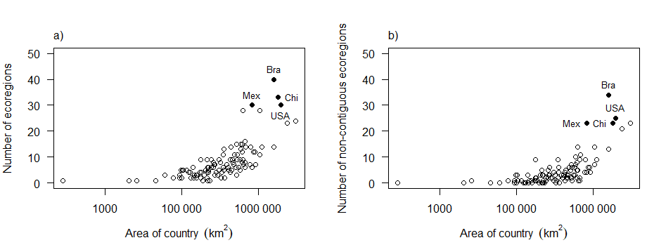
Supplementary file Figure 1 The relationship between the size (log) of the country and a) the number of ecoregions and b) the number of ecoregions with non-contiguous patches in the country
The analyses discussed above test whether large countries are ecologically diverse, however, they do not test whether native-alien populations are particularly prevalent in large, ecologically diverse countries. We did attempt to test this relationship using global data on bird introductions, but the quality of the data available on native-alien populations, even for this well-studied group, was poor, and consequently no conclusions on these relationships could be drawn. See below for the methods and results for this work.
Methods
In order to determine if larger countries have more native-alien populations than smaller countries, bird introduction data were used to calculate, per country, the number of bird species with native-alien populations. These data were used as birds are a well-studied group globally, and as this is the only group for which a global dataset is available that includes native-alien populations. The Global Avian Invasions Atlas (GAVIA) as described in Dyer et al. (2017) was used for the analysis. The GAVIA database contains introduction data for alien bird species introduced to 230 countries and administrative areas spanning the period 6000 BCE to AD 2014 (Dyer et al. 2017). GAVIA database includes all introductions, both of species that are alien to a country and native-alien populations. Records from all of the stages of invasion process, including introductions that have failed, are included in GAVIA but only records of the within-country introductions were used for this analysis (Dyer et al. 2017). Spatial data of the ranges of the bird species included in GAVIA were obtained from Birdlife International (https://www.birdlife.org). The species range data from Birdlife includes information on where the species are native and alien. The GAVIA database (Dyer et al. 2017) was used to generate a list of bird species and countries where introductions were recorded, excluding introductions that occurred on islands. The Birdlife dataset was used to generate a list of countries where each species is native. This was done by intersecting the species range maps with a map of the country boundaries of the world. The country boundaries from Thematic Mapping were used (https://thematicmapping.orghttp://thematicmapping.org/downloads/world_borders.php) for this analysis. For each species, we intersected the list of countries where the species is introduced from GAVIA with the list from Birdlife of countries where the species is native. In so doing we identified for each species the countries where the species is both native and introduced (i.e. those with native-alien populations). The number of species with native-alien populations per country was calculated, and the results of this analysis along with the country size data and the data on the number of ecoregions and biomes per country were used to determine the relationship between the country size, the number of species with native-alien populations, and environmental heterogeneity.

Results
A total of 164 countries, excluding islands, were used to examine the relationship between country size and the number of native-alien populations. Of the 164 countries, 99 countries (60%) had records of native-alien populations of birds while 65 countries (40%) had no records of native-alien populations of birds (Fig. S2). Although there are more countries with native-alien populations than countries without native-alien populations, most of these countries (74%) had fewer than five native-alien populations of birds, and almost half (47%) have only one native-alien population (Fig. S2). Some large countries had no records or low numbers of native-alien populations, while some smaller countries had high numbers of native-alien populations (Fig. S2). We suspect that the quality of the dataset is questionable. Therefore, this dataset presents a challenge for analysis and therefore we could not use this dataset to statistically test whether native-alien populations are more prevalent in large than smaller countries. An issue of concern is that the amount of effort that has been put into recording native-alien populations is not likely to be the same across countries. We also hypothesize that the native-alien population phenomenon will be prominent in taxa with low dispersal rates. However, we could not test this hypothesis because we did not find a suitable dataset. In addition, some European countries (e.g. Belgium and Greece) are environmentally homogenous (no biogeographical barriers), but based on our results have a higher number of native-alien bird populations than would be expected (Fig S2. This is likely to have occurred as GAVIA is implementing a different definition for native-alien populations than we have proposed. Native-alien populations have largely been neglected in the literature (Vitule et al. 2019), and research on these populations is vital if we are to better understand them and inform their management. The hypotheses suggested here require further testing and more data are required on native-alien populations globally. There is broad overlap between our map and the one produced by Early et al. (2016) on response capacity for biological invasions. The low numbers of recorded native-alien populations are more likely to be an artefact of capacity and available systems to record such phenomena than due to true patterns (Early et al. 2016).
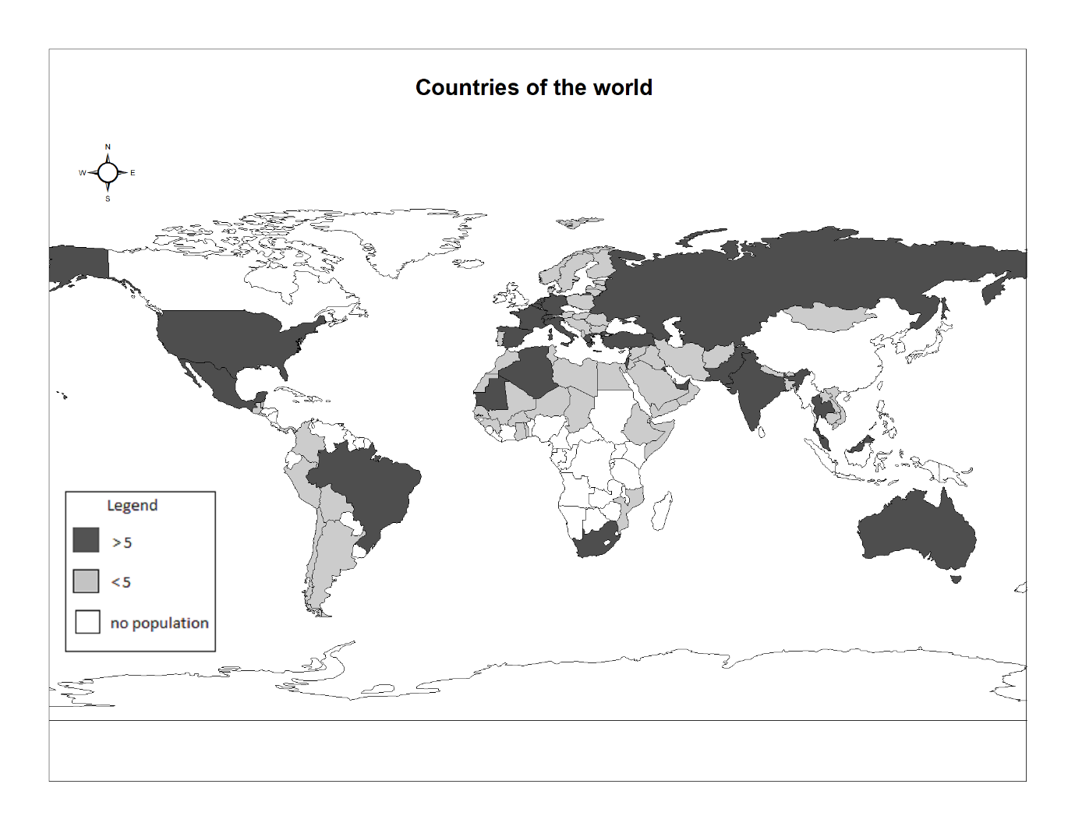
Supplementary file Figure 2 Countries of the world with native-alien populations of birds from GAVIA database. White colour represents countries without any record of native-alien populations, light grey represents countries with fewer than five native-alien populations and in dark grey are countries with more than five native-alien populations of birds
Reference
Crawley MJ (2013) The R book. Wiley, United Kingdom
Dyer EE, Redding DW, Blackburn TM (2017) Data Descriptor : The global avian invasions atlas , a database of alien bird distributions worldwide. 1–12. https://doi.org/10.1038/sdata.2017.41
Early R, Bradley BA, Dukes JS, Lawler JJ, Olden JD, Blumenthal DM, Gonzalez P, Grosholz ED, Ibañez I, Miller LP, Sorte CJ (2016) Global threats from invasive alien species in the twenty-first century and national response capacities. Nature communications 7:1-9. https://doi.org/10.1038/ncomms12485
Olson DM, Dinerstein E, Wikramanayake ED, Burgess ND, Powell GVN, Underwood EC, Amico JAD, Itoua I, Strand HE, Morrison JC, Loucks J, Allnutt TF, Ricketts TH, Kura Y, Lamoreux JF, Wesley W, Hedao P, Kassem KR (2001) Terrestrial Ecoregions of the World: A New Map of Life on Earth. 51: 933–938. https://doi.org/10.1641/0006-3568(2001)051[0933:TEOTWA]2.0.CO;2
Vitule JRS, Occhi TVT, Kang B, Matsuzaki S, Bezerra LA, Daga VS, Faria L, Frehse FA, Walter F, Padial AA (2019) Intra-country introductions unraveling global hotspots of alien fish species. Biodiversity and Conservation 28(11): 3037–3043. https://doi.org/10.1007/s10531-019-01815-7
https://www.birdlife.org. Accessed 23 March 2020
https://www.databasin.org/datasets. Accessed 23 March 2020
https://www.data.worldbank.org. Accessed 25 March 2020
https://www.thematicmapping.org. Accessed 25 March 2020

