Appendix C
The Intra-Operative Sedation Form
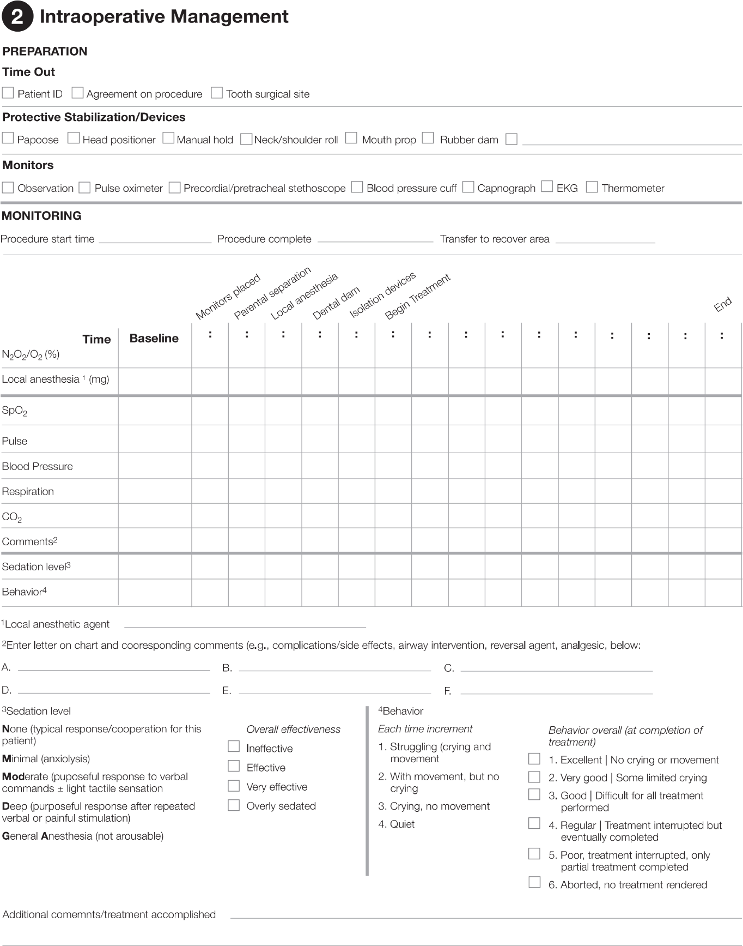
Figure 1: We enhanced the existing clinical form by adding a section to document the patient’s behavioral reactions across the sedation appointment, as well as their overall behavior (see highlighted areas)

