Supplemental files
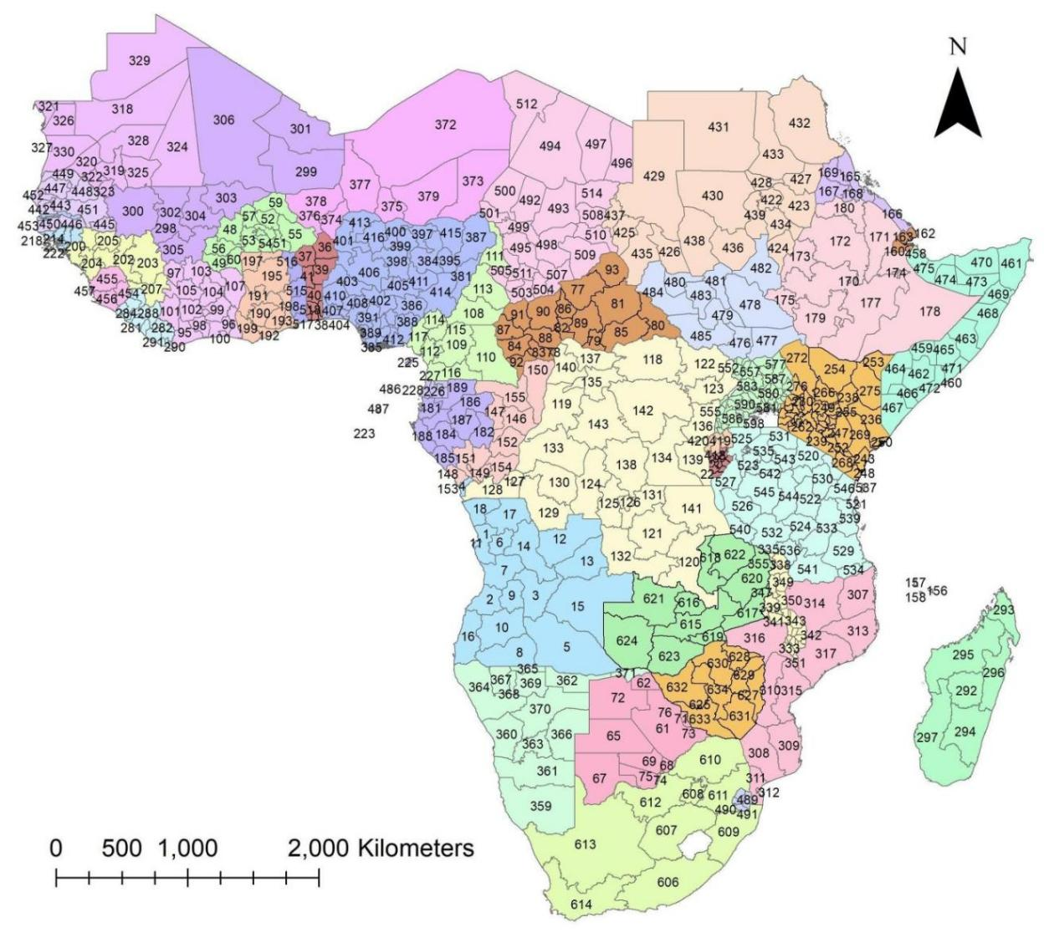
Fig. S1. Map of the study area at regional level and identification number. Source of shapefile: Database of Global Administrative Areas v.4.1 (www.gadm.org), own map output from ArcGIS v.10.8 (https://desktop.arcgis.com).
Table S1. The list of states identification number (SID) and states in the Sub-Saharan Africa corresponding with countries.
SID | State | Country | SID | State | Country
1 | Bengo | Angola | 264 | Nyandarua | Kenya
2 | Benguela | Angola | 265 | Nyeri | Kenya
3 | Bié | Angola | 266 | Samburu | Kenya
4 | Cabinda | Angola | 267 | Siaya | Kenya
5 | Cuando Cubango | Angola | 268 | Taita Taveta | Kenya
6 | Cuanza Norte | Angola | 269 | Tana River | Kenya
7 | Cuanza Sul | Angola | 270 | Tharaka-Nithi | Kenya
8 | Cunene | Angola | 271 | Trans Nzoia | Kenya
9 | Huambo | Angola | 272 | Turkana | Kenya
10 | Huíla | Angola | 273 | Uasin Gishu | Kenya
11 | Luanda | Angola | 274 | Vihiga | Kenya
12 | Lunda Norte | Angola | 275 | Wajir | Kenya
13 | Lunda Sul | Angola | 276 | West Pokot | Kenya
14 | Malanje | Angola | 277 | Bomi | Liberia
15 | Moxico | Angola | 278 | Bong | Liberia
16 | Namibe | Angola | 279 | Gbapolu | Liberia
17 | Uíge | Angola | 280 | Grand Cape Mount | Liberia
18 | Zaire | Angola | 281 | GrandBassa | Liberia
36 | Alibori | Benin | 282 | GrandGedeh | Liberia
37 | Atakora | Benin | 283 | GrandKru | Liberia
38 | Atlantique | Benin | 284 | Lofa | Liberia
39 | Borgou | Benin | 285 | Margibi | Liberia
40 | Collines | Benin | 286 | Maryland | Liberia
41 | Donga | Benin | 287 | Montserrado | Liberia
42 | Kouffo | Benin | 288 | Nimba | Liberia
43 | Littoral | Benin | 289 | River Cess | Liberia
44 | Mono | Benin | 290 | River Gee | Liberia
45 | Ouémé | Benin | 291 | Sinoe | Liberia
46 | Plateau | Benin | 292 | Antananarivo | Madagascar
47 | Zou | Benin | 293 | Antsiranana | Madagascar
61 | Central | Botswana | 294 | Fianarantsoa | Madagascar
62 | Chobe | Botswana | 295 | Mahajanga | Madagascar
63 | Francistown | Botswana | 296 | Toamasina | Madagascar
64 | Gaborone | Botswana | 297 | Toliary | Madagascar
65 | Ghanzi | Botswana | 331 | Balaka | Malawi
66 | Jwaneng | Botswana | 332 | Blantyre | Malawi
67 | Kgalagadi | Botswana | 333 | Chikwawa | Malawi
68 | Kgatleng | Botswana | 334 | Chiradzulu | Malawi
69 | Kweneng | Botswana | 335 | Chitipa | Malawi
70 | Lobatse | Botswana | 336 | Dedza | Malawi
71 | North-East | Botswana | 337 | Dowa | Malawi
72 | North-West | Botswana | 338 | Karonga | Malawi
73 | Selibe Phikwe | Botswana | 339 | Kasungu | Malawi
74 | South-East | Botswana | 340 | Likoma | Malawi
75 | Southern | Botswana | 341 | Lilongwe | Malawi
76 | Sowa | Botswana | 342 | Machinga | Malawi
48 | Boucle du Mouhoun | Burkina Faso | 343 | Mangochi | Malawi
49 | Cascades | Burkina Faso | 344 | Mchinji | Malawi
50 | Centre | Burkina Faso | 345 | Mulanje | Malawi
51 | Centre-Est | Burkina Faso | 346 | Mwanza | Malawi
52 | Centre-Nord | Burkina Faso | 347 | Mzimba | Malawi
53 | Centre-Ouest | Burkina Faso | 348 | Neno | Malawi
54 | Centre-Sud | Burkina Faso | 349 | Nkhata Bay | Malawi
55 | Est | Burkina Faso | 350 | Nkhotakota | Malawi
56 | Haut-Bassins | Burkina Faso | 351 | Nsanje | Malawi
57 | Nord | Burkina Faso | 352 | Ntcheu | Malawi
58 | Plateau-Central | Burkina Faso | 353 | Ntchisi | Malawi
59 | Sahel | Burkina Faso | 354 | Phalombe | Malawi
60 | Sud-Ouest | Burkina Faso | 355 | Rumphi | Malawi
19 | Bubanza | Burundi | 356 | Salima | Malawi
20 | Bujumbura Mairie | Burundi | 357 | Thyolo | Malawi
21 | Bujumbura Rural | Burundi | 358 | Zomba | Malawi
22 | Bururi | Burundi | 298 | Bamako | Mali
23 | Cankuzo | Burundi | 299 | Gao | Mali
24 | Cibitoke | Burundi | 300 | Kayes | Mali
25 | Gitega | Burundi | 301 | Kidal | Mali
26 | Karuzi | Burundi | 302 | Koulikoro | Mali
27 | Kayanza | Burundi | 303 | Mopti | Mali
28 | Kirundo | Burundi | 304 | Ségou | Mali
29 | Makamba | Burundi | 305 | Sikasso | Mali
30 | Muramvya | Burundi | 306 | Timbuktu | Mali
31 | Muyinga | Burundi | 318 | Adrar | Mauritania
32 | Mwaro | Burundi | 319 | Assaba | Mauritania
33 | Ngozi | Burundi | 320 | Brakna | Mauritania
34 | Rutana | Burundi | 321 | Dakhlet Nouadhibou | Mauritania
35 | Ruyigi | Burundi | 322 | Gorgol | Mauritania
108 | Adamaoua | Cameroon | 323 | Guidimaka | Mauritania
109 | Centre | Cameroon | 324 | Hodh ech Chargui | Mauritania
110 | Est | Cameroon | 325 | Hodh el Gharbi | Mauritania
111 | Extrême-Nord | Cameroon | 326 | Inchiri | Mauritania
112 | Littoral | Cameroon | 327 | Nouakchott | Mauritania
113 | Nord | Cameroon | 328 | Tagant | Mauritania
114 | Nord-Ouest | Cameroon | 329 | Tiris Zemmour | Mauritania
115 | Ouest | Cameroon | 330 | Trarza | Mauritania
116 | Sud | Cameroon | 307 | Cabo Delgado | Mozambique
117 | Sud-Ouest | Cameroon | 308 | Gaza | Mozambique
77 | Bamingui-Bangoran | Central African Republic | 309 | Inhambane | Mozambique
78 | Bangui | Central African Republic | 310 | Manica | Mozambique
79 | Basse-Kotto | Central African Republic | 311 | Maputo | Mozambique
80 | Haute-Kotto | Central African Republic | 312 | Maputo City | Mozambique
81 | Haut-Mbomou | Central African Republic | 313 | Nampula | Mozambique
82 | Kémo | Central African Republic | 314 | Nassa | Mozambique
83 | Lobaye | Central African Republic | 315 | Sofala | Mozambique
84 | Mambéré-Kadéï | Central African Republic | 316 | Tete | Mozambique
85 | Mbomou | Central African Republic | 317 | Zambezia | Mozambique
86 | Nana-Grébizi | Central African Republic | 359 | !Karas | Namibia
87 | Nana-Mambéré | Central African Republic | 360 | Erongo | Namibia
88 | Ombella-M'Poko | Central African Republic | 361 | Hardap | Namibia
89 | Ouaka | Central African Republic | 362 | Kavango | Namibia
90 | Ouham | Central African Republic | 363 | Khomas | Namibia
91 | Ouham-Pendé | Central African Republic | 364 | Kunene | Namibia
92 | Sangha-Mbaéré | Central African Republic | 365 | Ohangwena | Namibia
93 | Vakaga | Central African Republic | 366 | Omaheke | Namibia
492 | Barh el Ghazel | Chad | 367 | Omusati | Namibia
493 | Batha | Chad | 368 | Oshana | Namibia
494 | Borkou | Chad | 369 | Oshikoto | Namibia
495 | Chari-Baguirmi | Chad | 370 | Otjozondjupa | Namibia
496 | Ennedi Est | Chad | 371 | Zambezi | Namibia
497 | Ennedi Ouest | Chad | 372 | Agadez | Niger
498 | Guéra | Chad | 373 | Diffa | Niger
499 | Hadjer-Lamis | Chad | 374 | Dosso | Niger
500 | Kanem | Chad | 375 | Maradi | Niger
501 | Lac | Chad | 376 | Niamey | Niger
502 | Logone Occidental | Chad | 377 | Tahoua | Niger
503 | Logone Oriental | Chad | 378 | Tillabéry | Niger
504 | Mandoul | Chad | 379 | Zinder | Niger
505 | Mayo-Kebbi Est | Chad | 417 | Amajyaruguru | Rwanda
506 | Mayo-Kebbi Ouest | Chad | 418 | Amajyepfo | Rwanda
507 | Moyen-Chari | Chad | 419 | Iburasirazuba | Rwanda
508 | Ouaddaï | Chad | 420 | Iburengerazuba | Rwanda
509 | Salamat | Chad | 421 | Umujyi wa Kigali | Rwanda
510 | Sila | Chad | 486 | Príncipe | Sao Tome and Principe
511 | Tandjilé | Chad | 487 | São Tomé | Sao Tome and Principe
512 | Tibesti | Chad | 440 | Dakar | Senegal
513 | Ville de N'Djamena | Chad | 441 | Diourbel | Senegal
514 | Wadi Fira | Chad | 442 | Fatick | Senegal
156 | Mwali | Comoros | 443 | Kaffrine | Senegal
157 | Njazídja | Comoros | 444 | Kaolack | Senegal
158 | Nzwani | Comoros | 445 | Kédougou | Senegal
380 | Abia | Nigeria | 446 | Kolda | Senegal
381 | Adamawa | Nigeria | 447 | Louga | Senegal
382 | Akwa Ibom | Nigeria | 448 | Matam | Senegal
383 | Anambra | Nigeria | 449 | Saint-Louis | Senegal
384 | Bauchi | Nigeria | 450 | Sédhiou | Senegal
385 | Bayelsa | Nigeria | 451 | Tambacounda | Senegal
386 | Benue | Nigeria | 452 | Thiès | Senegal
387 | Borno | Nigeria | 453 | Ziguinchor | Senegal
388 | Cross River | Nigeria | 454 | Eastern | Sierra Leone
389 | Delta | Nigeria | 455 | Northern | Sierra Leone
390 | Ebonyi | Nigeria | 456 | Southern | Sierra Leone
391 | Edo | Nigeria | 457 | Western | Sierra Leone
392 | Ekiti | Nigeria | 458 | Awdal | Somalia
393 | Enugu | Nigeria | 459 | Bakool | Somalia
394 | Federal Capital Territory | Nigeria | 460 | Banaadir | Somalia
395 | Gombe | Nigeria | 461 | Bari | Somalia
396 | Imo | Nigeria | 462 | Bay | Somalia
397 | Jigawa | Nigeria | 463 | Galguduud | Somalia
398 | Kaduna | Nigeria | 464 | Gedo | Somalia
399 | Kano | Nigeria | 465 | Hiiraan | Somalia
400 | Katsina | Nigeria | 466 | Jubbada Dhexe | Somalia
401 | Kebbi | Nigeria | 467 | Jubbada Hoose | Somalia
402 | Kogi | Nigeria | 468 | Mudug | Somalia
403 | Kwara | Nigeria | 469 | Nugaal | Somalia
404 | Lagos | Nigeria | 470 | Sanaag | Somalia
405 | Nassarawa | Nigeria | 471 | Shabeellaha Dhexe | Somalia
406 | Niger | Nigeria | 472 | Shabeellaha Hoose | Somalia
407 | Ogun | Nigeria | 473 | Sool | Somalia
408 | Ondo | Nigeria | 474 | Togdheer | Somalia
409 | Osun | Nigeria | 475 | Woqooyi Galbeed | Somalia
410 | Oyo | Nigeria | 422 | Al Jazirah | Sudan
411 | Plateau | Nigeria | 423 | Al Qadarif | Sudan
412 | Rivers | Nigeria | 424 | Blue Nile | Sudan
413 | Sokoto | Nigeria | 425 | Central Darfur | Sudan
414 | Taraba | Nigeria | 426 | East Darfur | Sudan
415 | Yobe | Nigeria | 427 | Kassala | Sudan
416 | Zamfara | Nigeria | 428 | Khartoum | Sudan
144 | Bouenza | Congo | 429 | North Darfur | Sudan
145 | Brazzaville | Congo | 430 | North Kurdufan | Sudan
146 | Cuvette | Congo | 431 | Northern | Sudan
147 | Cuvette-Ouest | Congo | 432 | Red Sea | Sudan
148 | Kouilou | Congo | 433 | River Nile | Sudan
149 | Lékoumou | Congo | 434 | Sennar | Sudan
150 | Likouala | Congo | 435 | South Darfur | Sudan
151 | Niari | Congo | 436 | South Kurdufan | Sudan
152 | Plateaux | Congo | 437 | West Darfur | Sudan
153 | Pointe Noire | Congo | 438 | West Kurdufan | Sudan
154 | Pool | Congo | 439 | White Nile | Sudan
155 | Sangha | Congo | 520 | Arusha | Tanzania
118 | Bas-Uélé | DR Congo | 521 | Dar es Salaam | Tanzania
119 | Équateur | DR Congo | 522 | Dodoma | Tanzania
120 | Haut-Katanga | DR Congo | 523 | Geita | Tanzania
121 | Haut-Lomami | DR Congo | 524 | Iringa | Tanzania
122 | Haut-Uélé | DR Congo | 525 | Kagera | Tanzania
123 | Ituri | DR Congo | 526 | Katavi | Tanzania
124 | Kasaï | DR Congo | 527 | Kigoma | Tanzania
125 | Kasaï-Central | DR Congo | 528 | Kilimanjaro | Tanzania
126 | Kasaï-Oriental | DR Congo | 529 | Lindi | Tanzania
127 | Kinshasa | DR Congo | 530 | Manyara | Tanzania
128 | Kongo-Central | DR Congo | 531 | Mara | Tanzania
129 | Kwango | DR Congo | 532 | Mbeya | Tanzania
130 | Kwilu | DR Congo | 533 | Morogoro | Tanzania
131 | Lomami | DR Congo | 534 | Mtwara | Tanzania
132 | Lualaba | DR Congo | 535 | Mwanza | Tanzania
133 | Maï-Ndombe | DR Congo | 536 | Njombe | Tanzania
134 | Maniema | DR Congo | 537 | Pemba North | Tanzania
135 | Mongala | DR Congo | 538 | Pemba South | Tanzania
136 | Nord-Kivu | DR Congo | 539 | Pwani | Tanzania
137 | Nord-Ubangi | DR Congo | 540 | Rukwa | Tanzania
138 | Sankuru | DR Congo | 541 | Ruvuma | Tanzania
139 | Sud-Kivu | DR Congo | 542 | Shinyanga | Tanzania
140 | Sud-Ubangi | DR Congo | 543 | Simiyu | Tanzania
141 | Tanganyika | DR Congo | 544 | Singida | Tanzania
142 | Tshopo | DR Congo | 545 | Tabora | Tanzania
143 | Tshuapa | DR Congo | 546 | Tanga | Tanzania
94 | Abidjan | Côte d'Ivoire | 547 | Zanzibar North | Tanzania
95 | Bas-Sassandra | Côte d'Ivoire | 548 | Zanzibar South and Central | Tanzania
96 | Comoé | Côte d'Ivoire | 549 | Zanzibar West | Tanzania
97 | Denguélé | Côte d'Ivoire | 606 | Eastern Cape | South Africa
98 | Gôh-Djiboua | Côte d'Ivoire | 607 | Free State | South Africa
99 | Lacs | Côte d'Ivoire | 608 | Gauteng | South Africa
100 | Lagunes | Côte d'Ivoire | 609 | KwaZulu-Natal | South Africa
101 | Montagnes | Côte d'Ivoire | 610 | Limpopo | South Africa
102 | Sassandra-Marahoué | Côte d'Ivoire | 611 | Mpumalanga | South Africa
103 | Savanes | Côte d'Ivoire | 612 | North West | South Africa
104 | Vallée du Bandama | Côte d'Ivoire | 613 | Northern Cape | South Africa
105 | Woroba | Côte d'Ivoire | 614 | Western Cape | South Africa
106 | Yamoussoukro | Côte d'Ivoire | 476 | Central Equatoria | South Sudan
107 | Zanzan | Côte d'Ivoire | 477 | Eastern Equatoria | South Sudan
159 | Ali Sabieh | Djibouti | 478 | Jungoli | South Sudan
160 | Dikhil | Djibouti | 479 | Lakes | South Sudan
161 | Djibouti | Djibouti | 480 | North Bahr-al-Ghazal | South Sudan
162 | Obock | Djibouti | 481 | Unity | South Sudan
163 | Tadjourah | Djibouti | 482 | Upper Nile | South Sudan
223 | Annobón | Equatorial Guinea | 483 | Warap | South Sudan
224 | Bioko Norte | Equatorial Guinea | 484 | West Bahr-al-Ghazal | South Sudan
225 | Bioko Sur | Equatorial Guinea | 485 | West Equatoria | South Sudan
226 | Centro Sur | Equatorial Guinea | 488 | Hhohho | eSwatini
227 | Kié-Ntem | Equatorial Guinea | 489 | Lubombo | eSwatini
228 | Litoral | Equatorial Guinea | 490 | Manzini | eSwatini
229 | Wele-Nzas | Equatorial Guinea | 491 | Shiselweni | eSwatini
164 | Anseba | Eritrea | 208 | Banjul | Gambia
165 | Debub | Eritrea | 209 | Lower River | Gambia
166 | Debubawi Keyih Bahri | Eritrea | 210 | Maccarthy Island | Gambia
167 | Gash Barka | Eritrea | 211 | North Bank | Gambia
168 | Maekel | Eritrea | 212 | Upper River | Gambia
169 | Semenawi Keyih Bahri | Eritrea | 213 | Western | Gambia
170 | Addis Abeba | Ethiopia | 515 | Centre | Togo
171 | Afar | Ethiopia | 516 | Kara | Togo
172 | Amhara | Ethiopia | 517 | Maritime | Togo
173 | Benshangul-Gumaz | Ethiopia | 518 | Plateaux | Togo
174 | Dire Dawa | Ethiopia | 519 | Savanes | Togo
175 | Gambela Peoples | Ethiopia | 550 | Adjumani | Uganda
176 | Harari People | Ethiopia | 551 | Apac | Uganda
177 | Oromia | Ethiopia | 552 | Arua | Uganda
178 | Somali | Ethiopia | 553 | Bugiri | Uganda
179 | SNNP | Ethiopia | 554 | Bundibugyo | Uganda
180 | Tigray | Ethiopia | 555 | Bushenyi | Uganda
181 | Estuaire | Gabon | 556 | Busia | Uganda
182 | Haut-Ogooué | Gabon | 557 | Gulu | Uganda
183 | Moyen-Ogooué | Gabon | 558 | Hoima | Uganda
184 | Ngounié | Gabon | 559 | Iganga | Uganda
185 | Nyanga | Gabon | 560 | Jinja | Uganda
186 | Ogooué-Ivindo | Gabon | 561 | Kabale | Uganda
187 | Ogooué-Lolo | Gabon | 562 | Kabarole | Uganda
188 | Ogooué-Maritime | Gabon | 563 | Kaberamaido | Uganda
189 | Wouleu-Ntem | Gabon | 564 | Kalangala | Uganda
190 | Ashanti | Ghana | 565 | Kampala | Uganda
191 | Brong Ahafo | Ghana | 566 | Kamuli | Uganda
192 | Central | Ghana | 567 | Kamwenge | Uganda
193 | Eastern | Ghana | 568 | Kanungu | Uganda
194 | Greater Accra | Ghana | 569 | Kapchorwa | Uganda
195 | Northern | Ghana | 570 | Kasese | Uganda
196 | Upper East | Ghana | 571 | Katakwi | Uganda
197 | Upper West | Ghana | 572 | Kayunga | Uganda
198 | Volta | Ghana | 573 | Kibale | Uganda
199 | Western | Ghana | 574 | Kiboga | Uganda
200 | Boké | Guinea | 575 | Kisoro | Uganda
201 | Conakry | Guinea | 576 | Kitgum | Uganda
202 | Faranah | Guinea | 577 | Kotido | Uganda
203 | Kankan | Guinea | 578 | Kumi | Uganda
204 | Kindia | Guinea | 579 | Kyenjojo | Uganda
205 | Labé | Guinea | 580 | Lira | Uganda
206 | Mamou | Guinea | 581 | Luwero | Uganda
207 | Nzérékoré | Guinea | 582 | Masaka | Uganda
214 | Bafatá | Guinea-Bissau | 583 | Masindi | Uganda
215 | Biombo | Guinea-Bissau | 584 | Mayuge | Uganda
216 | Bissau | Guinea-Bissau | 585 | Mbale | Uganda
217 | Bolama | Guinea-Bissau | 586 | Mbarara | Uganda
218 | Cacheu | Guinea-Bissau | 587 | Moroto | Uganda
219 | Gabú | Guinea-Bissau | 588 | Moyo | Uganda
220 | Oio | Guinea-Bissau | 589 | Mpigi | Uganda
221 | Quinara | Guinea-Bissau | 590 | Mubende | Uganda
222 | Tombali | Guinea-Bissau | 591 | Mukono | Uganda
230 | Baringo | Kenya | 592 | Nakapiripirit | Uganda
231 | Bomet | Kenya | 593 | Nakasongola | Uganda
232 | Bungoma | Kenya | 594 | Nebbi | Uganda
233 | Busia | Kenya | 595 | Ntungamo | Uganda
234 | Elgeyo-Marakwet | Kenya | 596 | Pader | Uganda
235 | Embu | Kenya | 597 | Pallisa | Uganda
236 | Garissa | Kenya | 598 | Rakai | Uganda
237 | Homa Bay | Kenya | 599 | Rukungiri | Uganda
238 | Isiolo | Kenya | 600 | Sembabule | Uganda
239 | Kajiado | Kenya | 601 | Sironko | Uganda
240 | Kakamega | Kenya | 602 | Soroti | Uganda
241 | Kericho | Kenya | 603 | Tororo | Uganda
242 | Kiambu | Kenya | 604 | Wakiso | Uganda
243 | Kilifi | Kenya | 605 | Yumbe | Uganda
244 | Kirinyaga | Kenya | 615 | Central | Zambia
245 | Kisii | Kenya | 616 | Copperbelt | Zambia
246 | Kisumu | Kenya | 617 | Eastern | Zambia
247 | Kitui | Kenya | 618 | Luapula | Zambia
248 | Kwale | Kenya | 619 | Lusaka | Zambia
249 | Laikipia | Kenya | 620 | Muchinga | Zambia
250 | Lamu | Kenya | 621 | North-Western | Zambia
251 | Machakos | Kenya | 622 | Northern | Zambia
252 | Makueni | Kenya | 623 | Southern | Zambia
253 | Mandera | Kenya | 624 | Western | Zambia
254 | Marsabit | Kenya | 625 | Bulawayo | Zimbabwe
255 | Meru | Kenya | 626 | Harare | Zimbabwe
256 | Migori | Kenya | 627 | Manicaland | Zimbabwe
257 | Mombasa | Kenya | 628 | Mashonaland Central | Zimbabwe
258 | Murang'a | Kenya | 629 | Mashonaland East | Zimbabwe
259 | Nairobi | Kenya | 630 | Mashonaland West | Zimbabwe
260 | Nakuru | Kenya | 631 | Masvingo | Zimbabwe
261 | Nandi | Kenya | 632 | Matabeleland North | Zimbabwe
262 | Narok | Kenya | 633 | Matabeleland South | Zimbabwe
263 | Nyamira | Kenya | 634 | Midlands | Zimbabwe
SID: it’s the states identification number
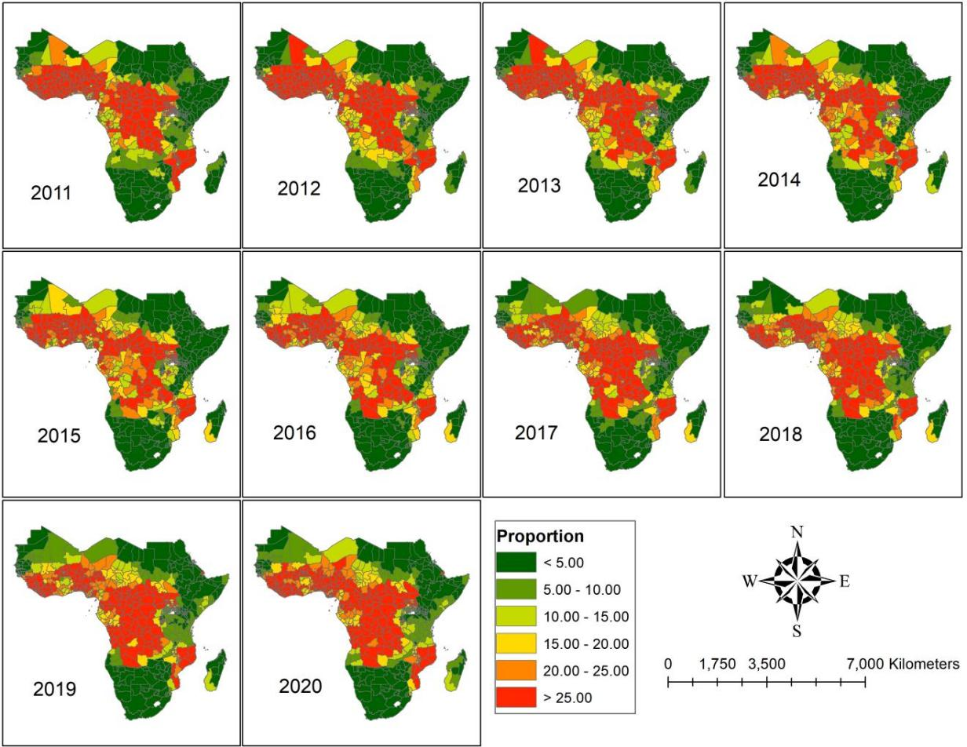
Fig. S2 Spatiotemporal of the proportion of malaria infection for ${PfPR}_{2−10}$ in the SSA from 2011 to 2020. Source of shapefile: Database of Global Administrative Areas v.4.1 (www.gadm.org), own map output from ArcGIS v.10.8 (https://desktop.arcgis.com).

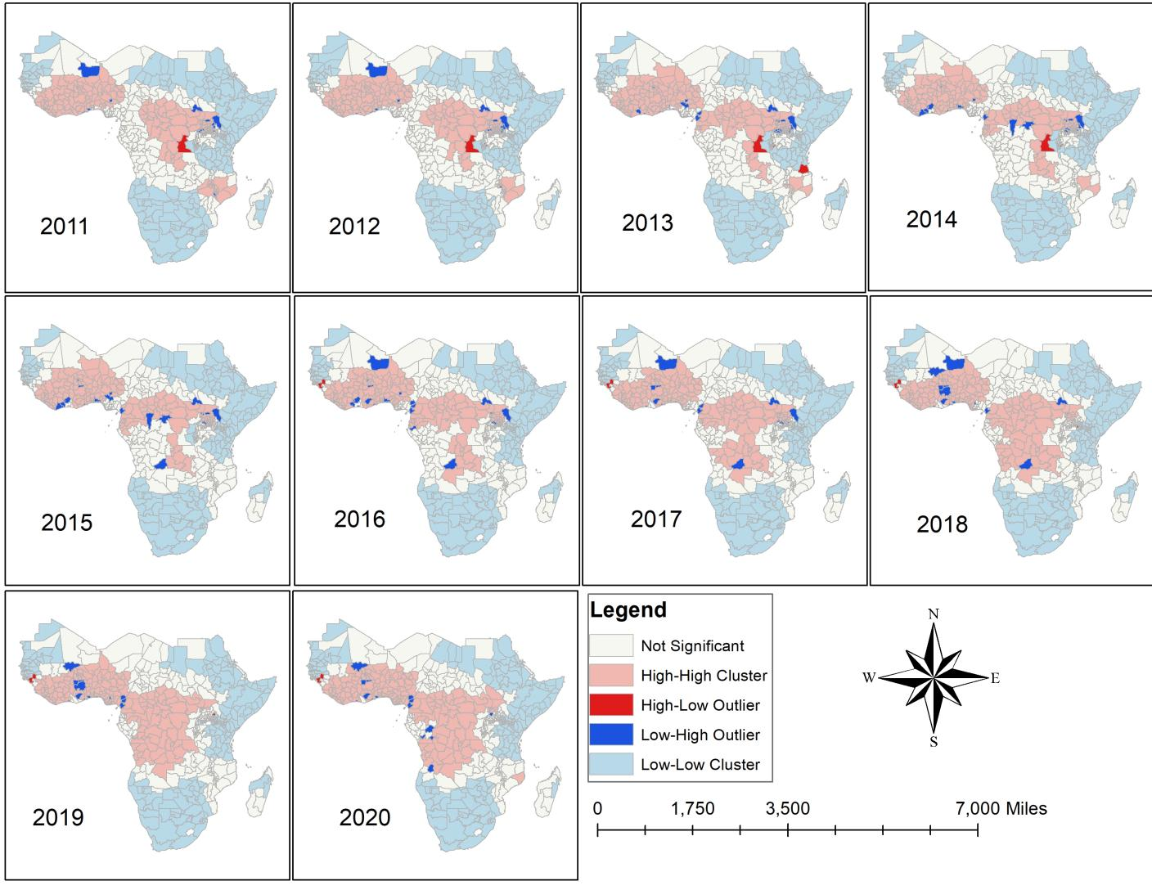
Fig. S3. Cluster and outlier analysis malaria infection for ${PfPR}_{2−10}$ in the SSA from 2011 to 2020. Source of shapefile: Database of Global Administrative Areas v.4.1 (www.gadm.org), own map output from ArcGIS v.10.8 (https://desktop.arcgis.com).

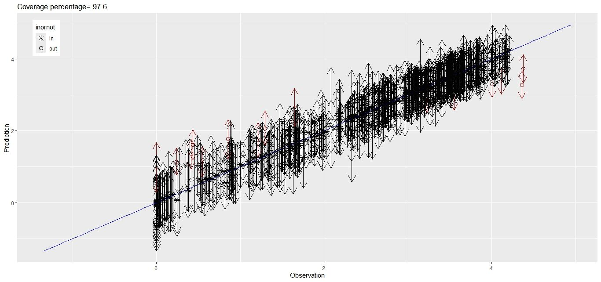
Fig. S4. Observed versus predicted plot for validations performed using the AR(1) model fitted
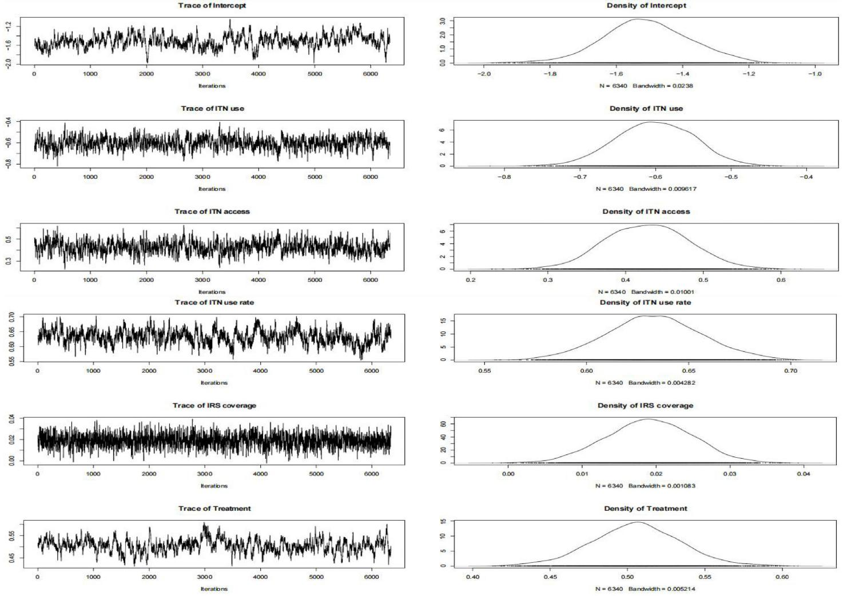
Fig. S5. Posterior distributions of the regression parameters ($β$)
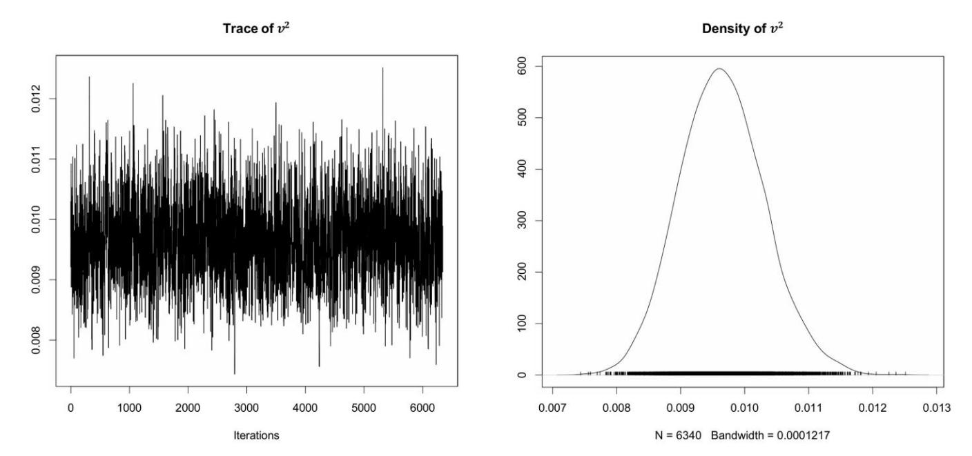
Fig. S6. Posterior distributions of the independent error variance
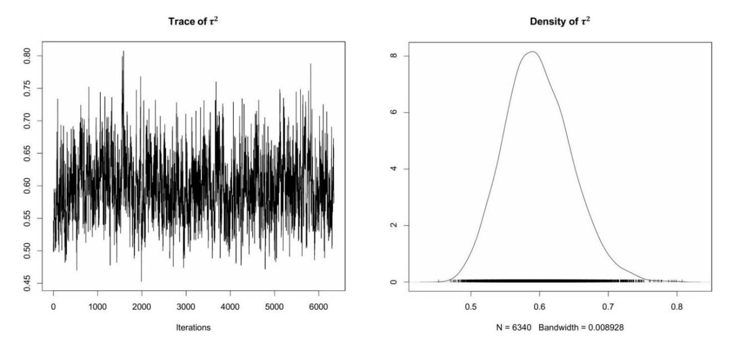
Fig. S7. Posterior distributions of the spatial variance
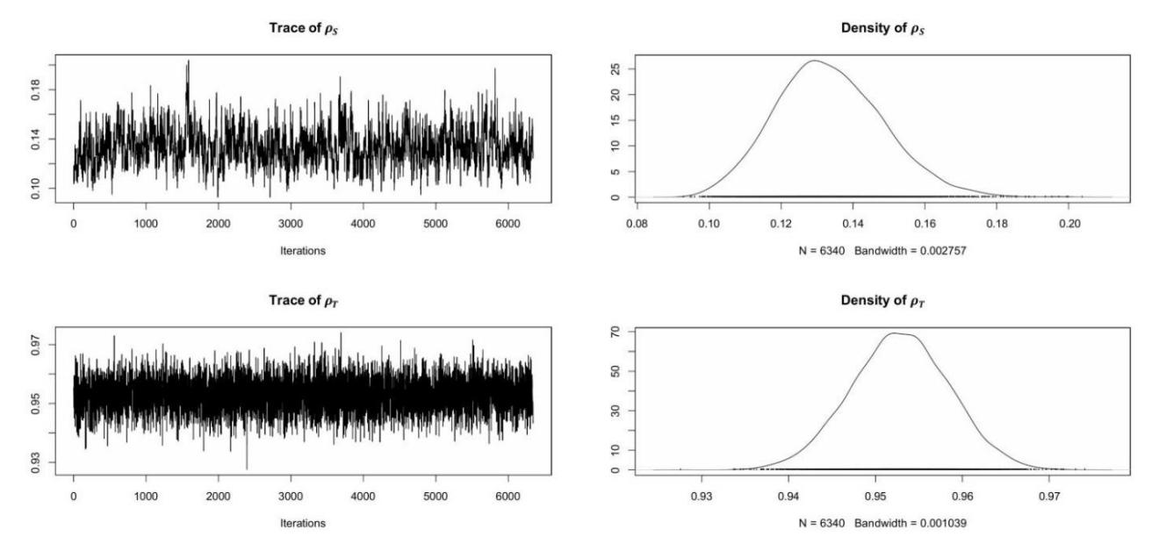
Fig. S8. Posterior distributions of the dependence parameters

