SUPPLEMENTARY FILE 4 FIGURE 1: PARITY
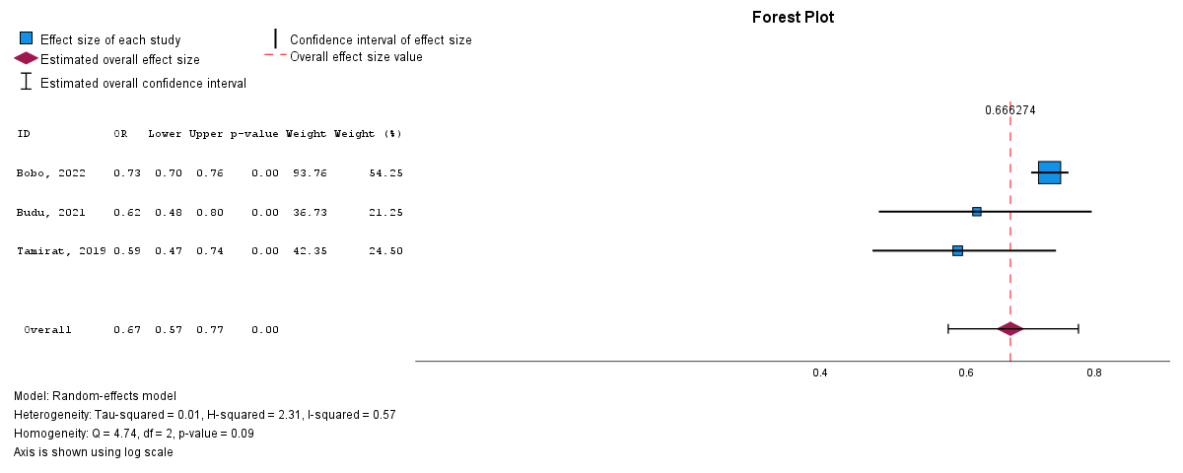

SUPPLEMENTARY FILE 4 FIGURE 2: MOTHER’S EDUCATIONAL LEVEL
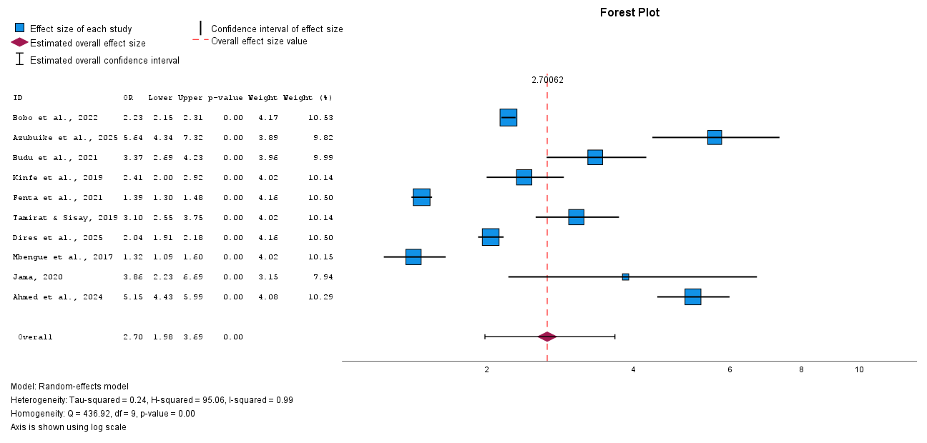

SUPPLEMENTARY FILE 4 FIGURE 3: MOTHER’S EMPLOYMENT STATUS
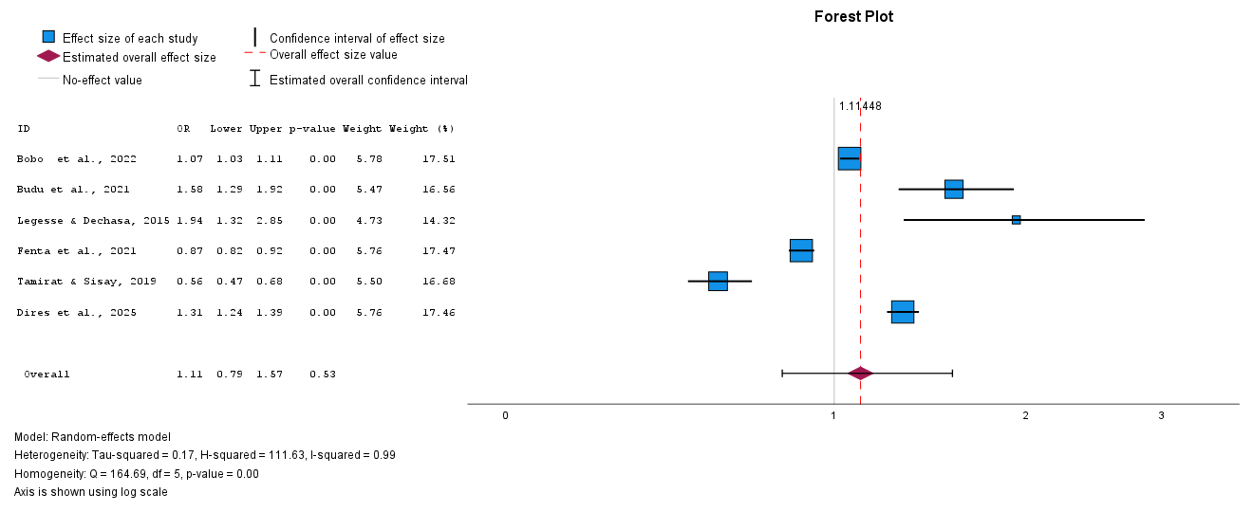

SUPPLEMENTARY FILE 4 FIGURE 4: MOTHER’S AGE

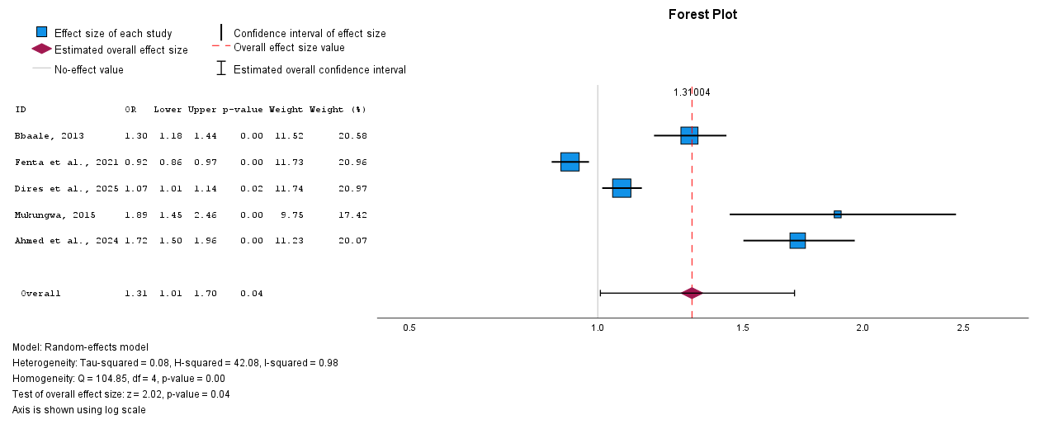

SUPPLEMENTARY FILE 4 FIGURE 5: MOTHER’S RELIGION

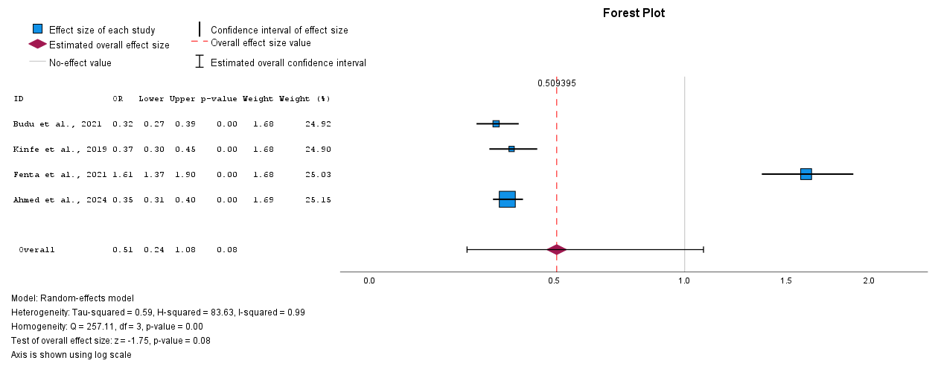

SUPPLEMENTARY FILE 4 FIGURE 6: MOTHER LISTENS TO THE RADIO
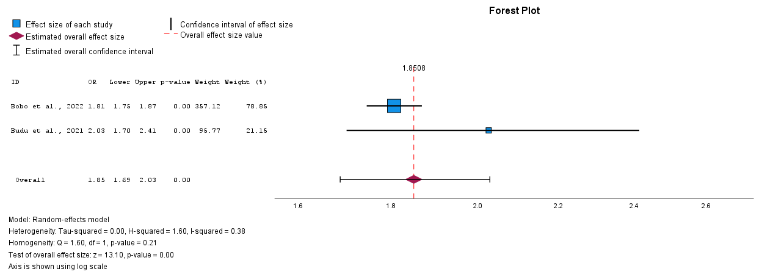

SUPPLEMENTARY FILE 4 FIGURE 7: MOTHER WATCHES TELEVISION
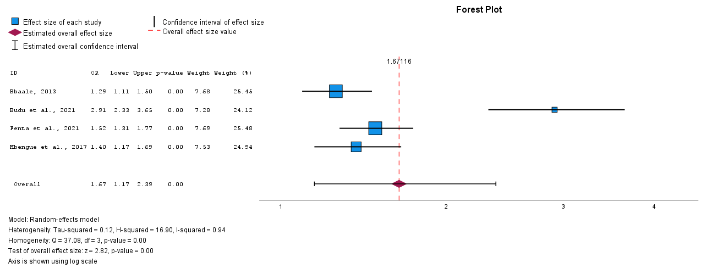

SUPPLEMENTARY FILE 4 FIGURE 8: MOTHER EXPOSED TO MEDIA
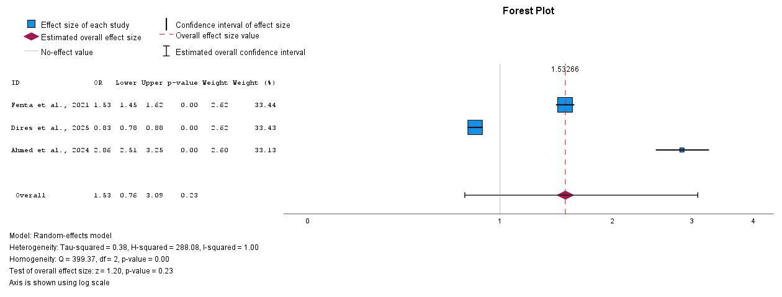

SUPPLEMENTARY FILE 4 FIGURE 9: FATHER’S OCCUPATION
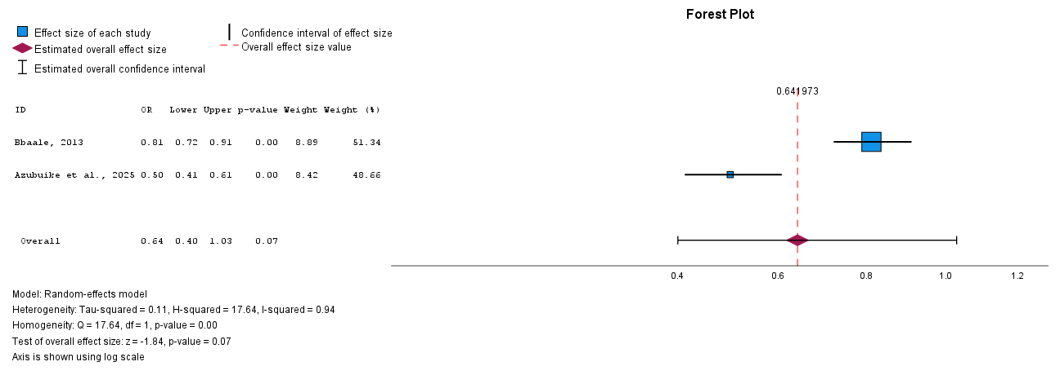

SUPPLEMENTARY FILE 4 FIGURE 10: FATHER’S EMPLOYMENT STATUS

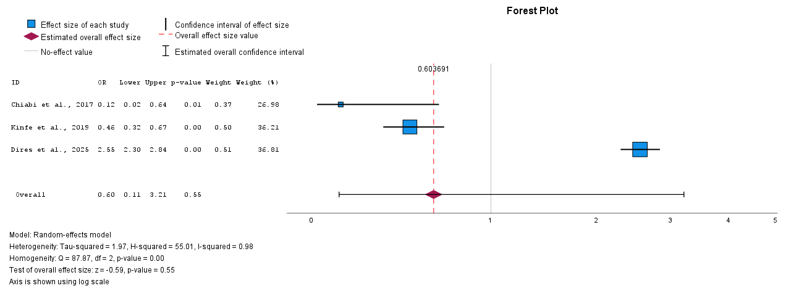

SUPPLEMENTARY FILE 4 FIGURE 11: FATHER’S EDUCATIONAL LEVEL

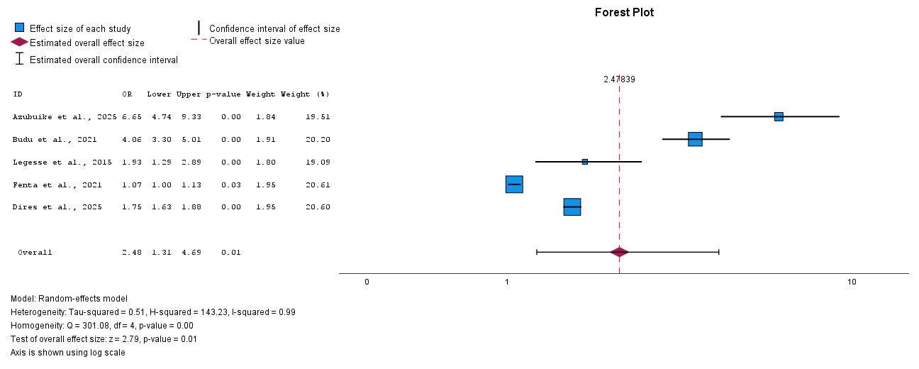

SUPPLEMENTARY FILE 4 FIGURE 12: HOUSEHOLD WEALTH INDEX

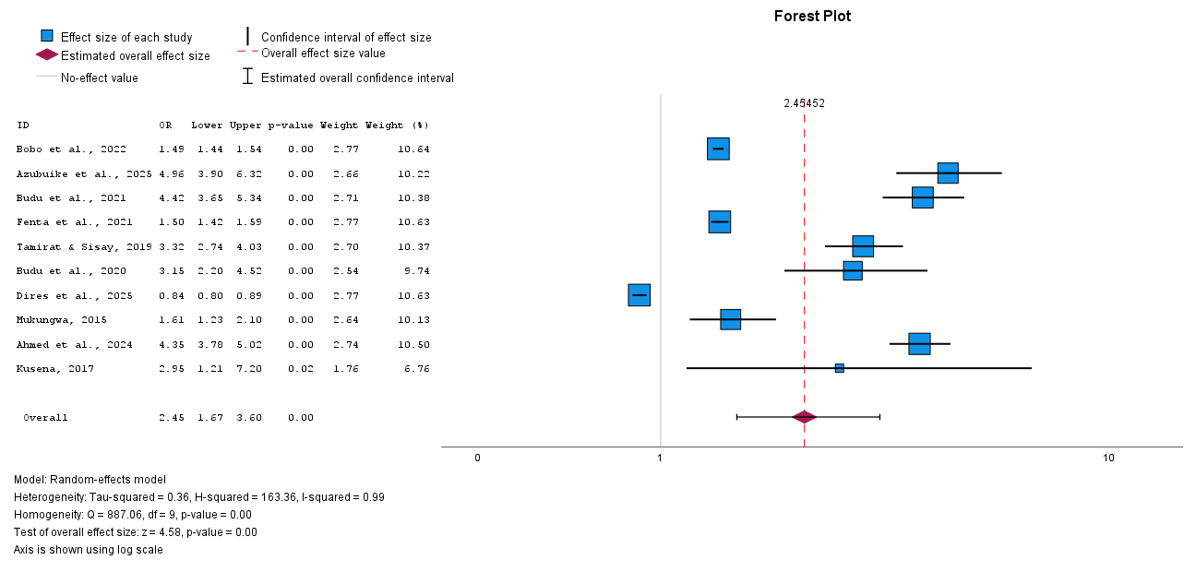

SUPPLEMENTARY FILE 4 FIGURE 13: MARITAL STATUS

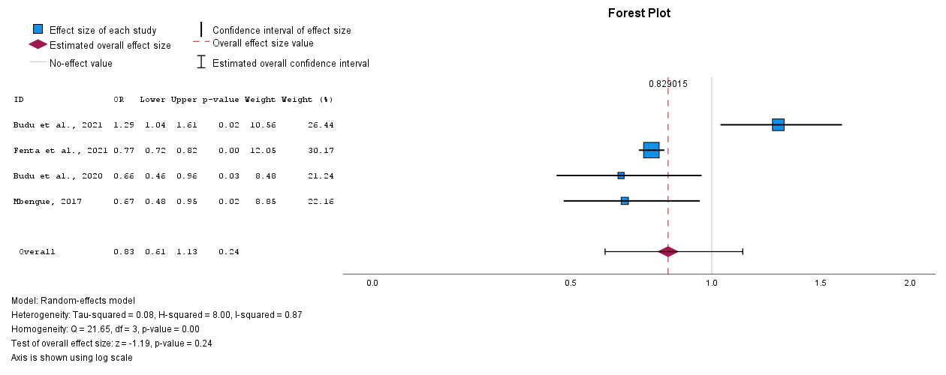

SUPPLEMENTARY FILE 4 FIGURE 14: HOUSEHOLD HEAD

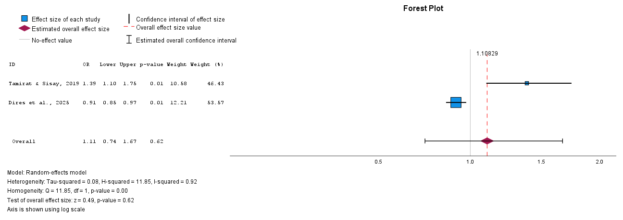

SUPPLEMENTARY FILE 4 FIGURE 15: PLACE OF RESIDENCE

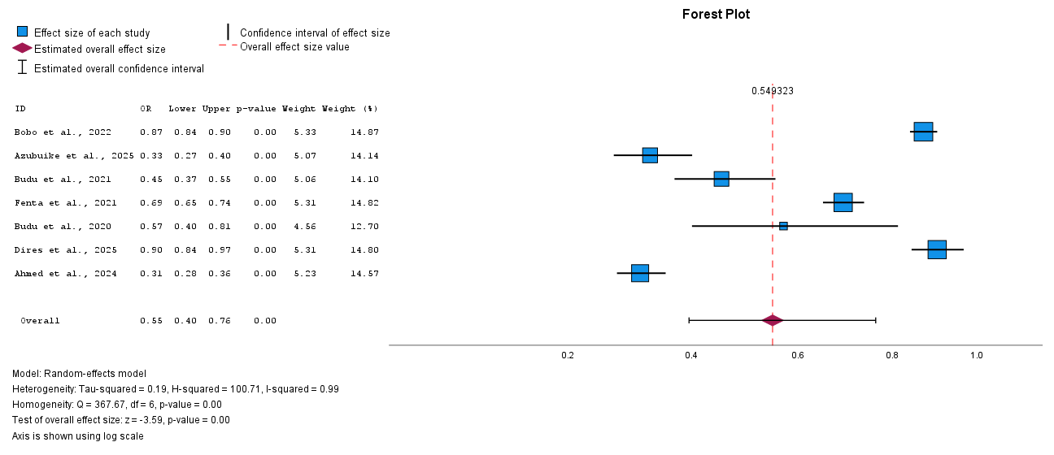

SUPPLEMENTARY FILE 4 FIGURE 16: PLACE OF DELIVERY

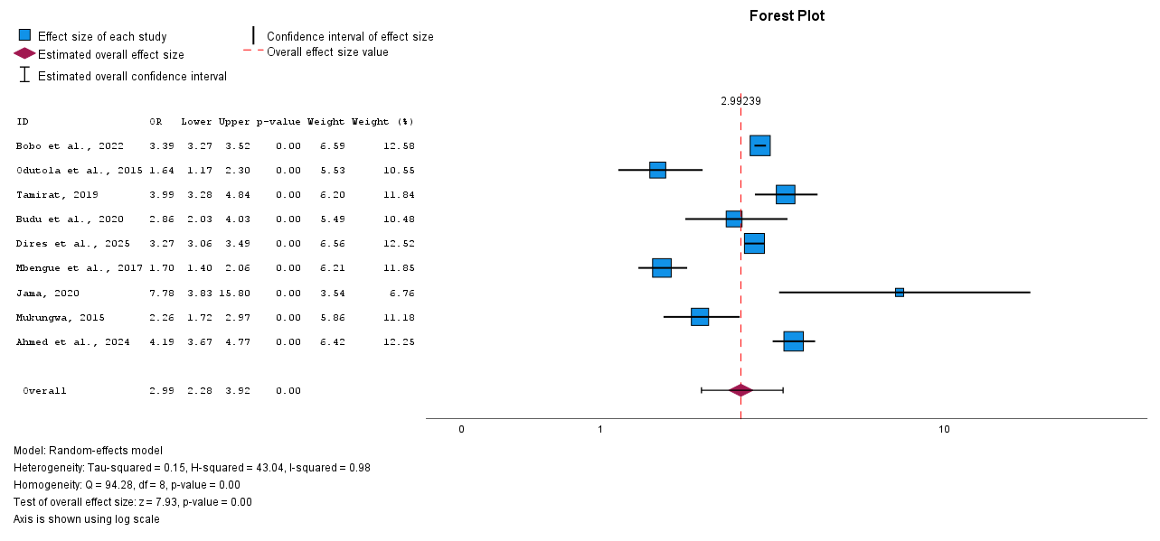

SUPPLEMENTARY FILE 4 FIGURE 17: ANTENATAL ATTENDANCE

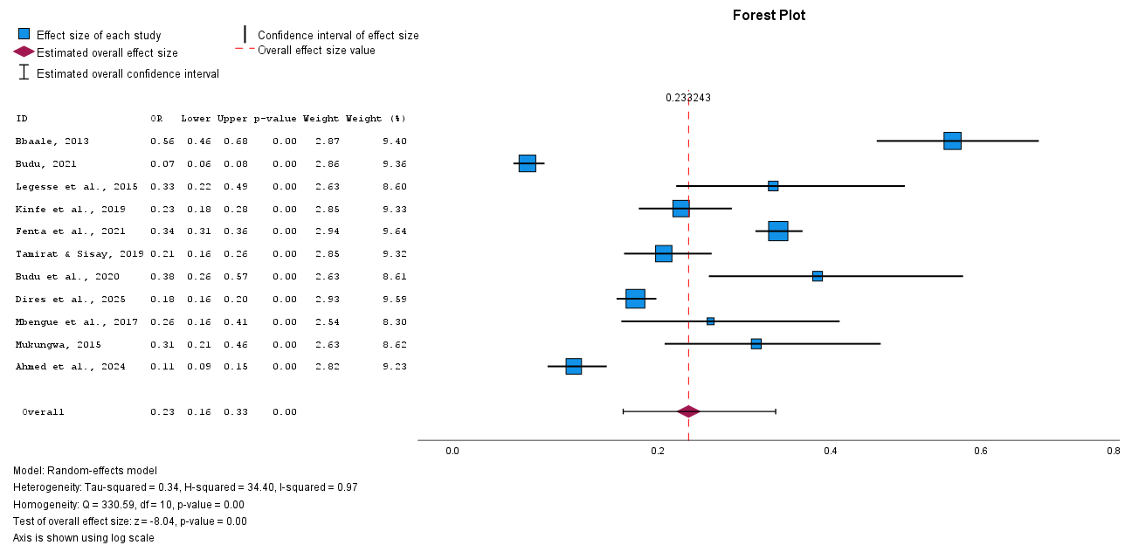

SUPPLEMENTARY FILE 4 FIGURE 18: POSTNATAL CARE ATTENDANCE

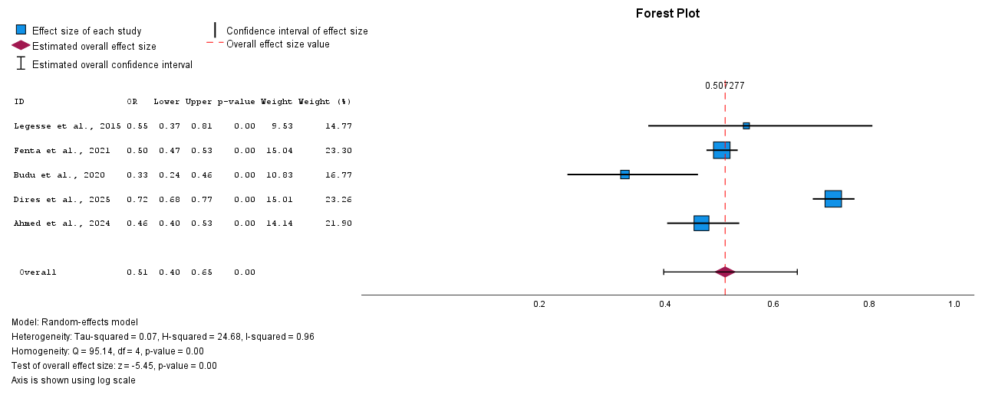

SUPPLEMENTARY FILE 4 FIGURE 19: POSSESSION OF VACCINATION CARD
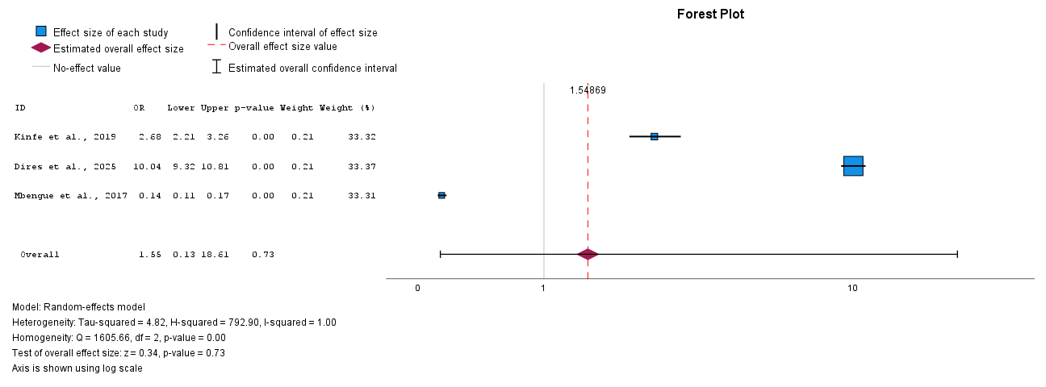

SUPPLEMENTARY FILE 4 FIGURE 20: DISTANCE TO HEALTHCARE FACILITY

