Supplementary material
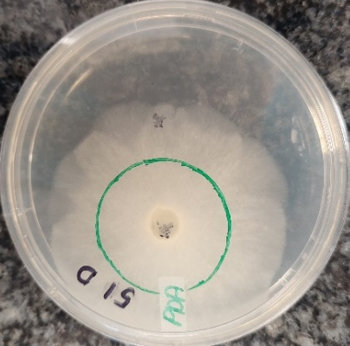A. R. microsporus (W2-51) Control | 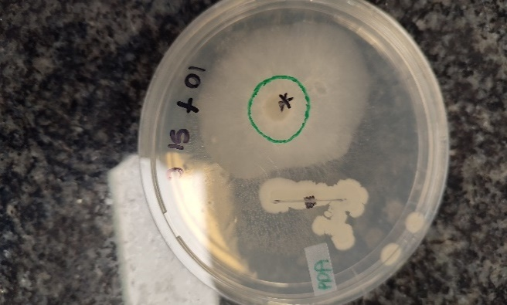B. R. microsporus (W2-51) with Bacillus velezensis KV10 | 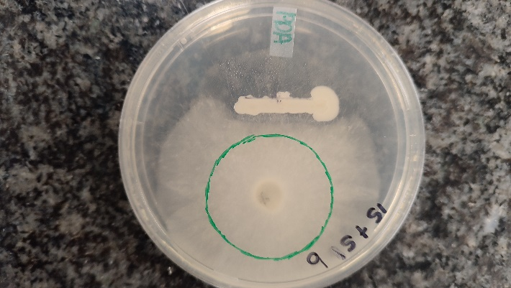  C. R. microsporus (W2-51) with Bacillus velezensis KV15
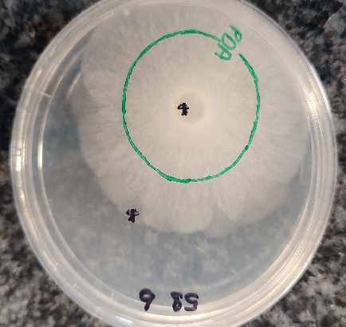D. R. microsporus (W2- 58) Control | 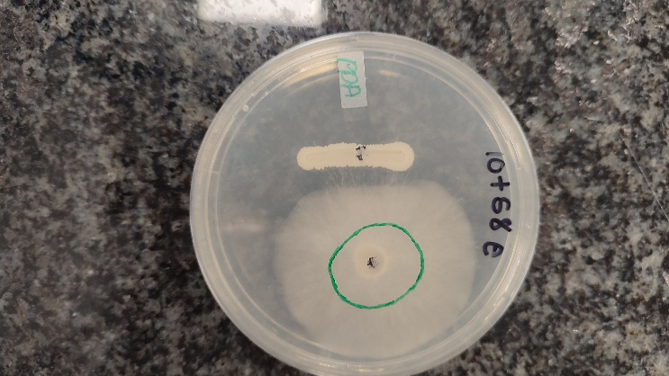E. R. microsporus (W2-58) with Bacillus velezensis KV10 | 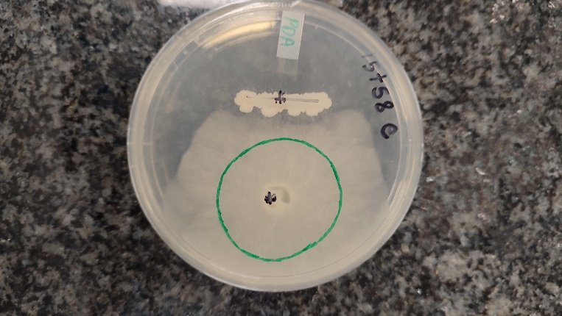  F. R. microsporus (W2-58) with Bacillus velezensis KV15
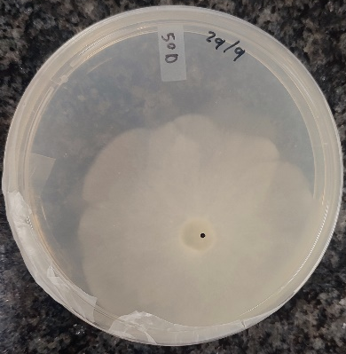  G. R. microsporus (W2-50) Control | 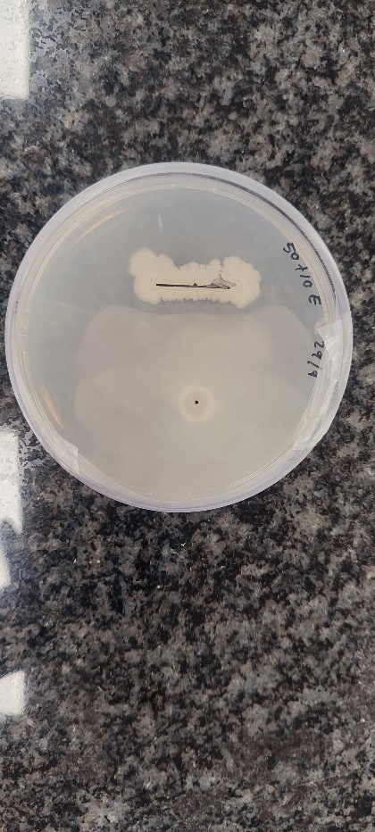  H. R. microsporus (W2- 50) with Bacillus velezensis KV10 | 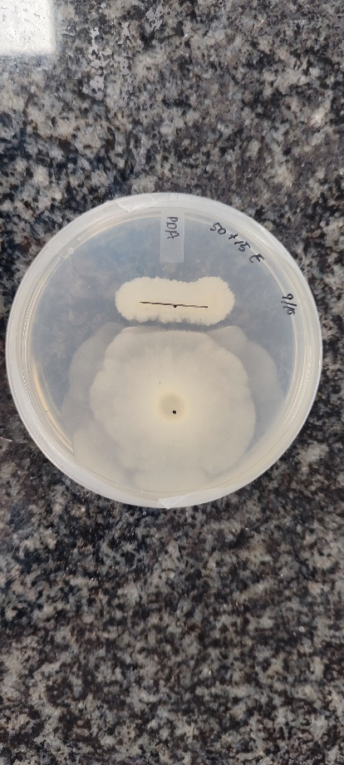  I. R. microsporus (W2-50) with Bacillus velezensis KV15
S.Figure 1: Inhibition of radial growth after 48h incubation for three R. microsporus strains against two Bacillus velezensis strains KV10 and KV15 respectively.

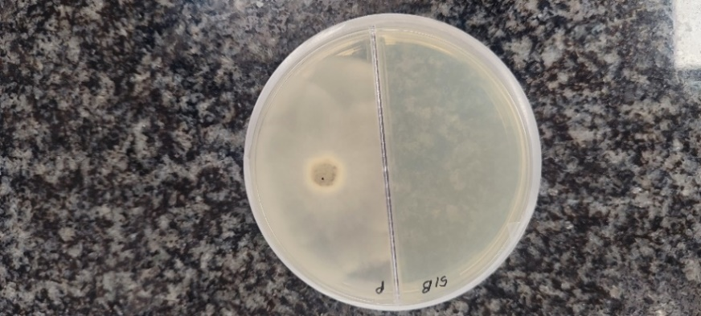  A. R. microsporus (W2-51) Control | 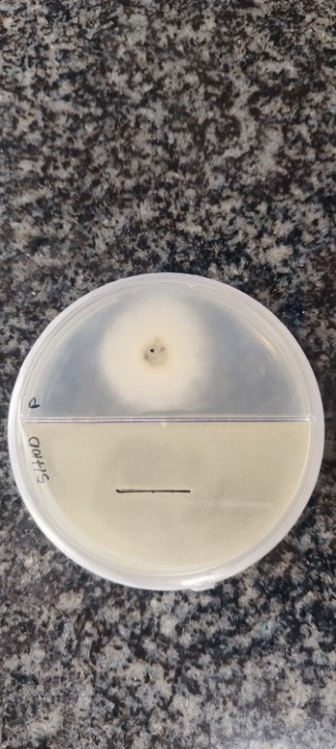B. R. microsporus (W2-51) with Bacillus velezensis KV10 | 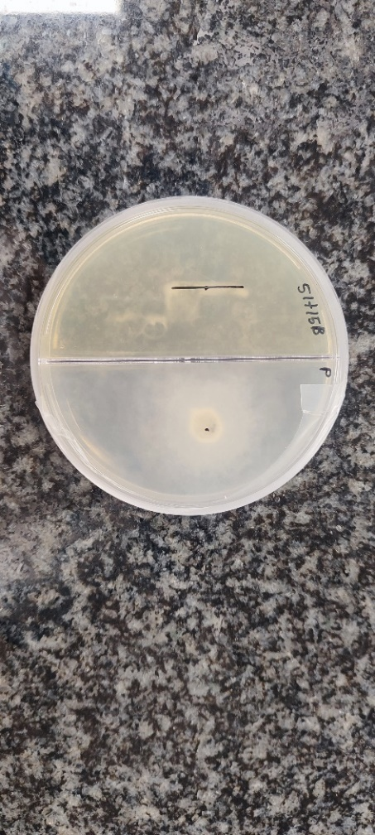  C. R. microsporus (W2-51) with Bacillus velezensis KV15
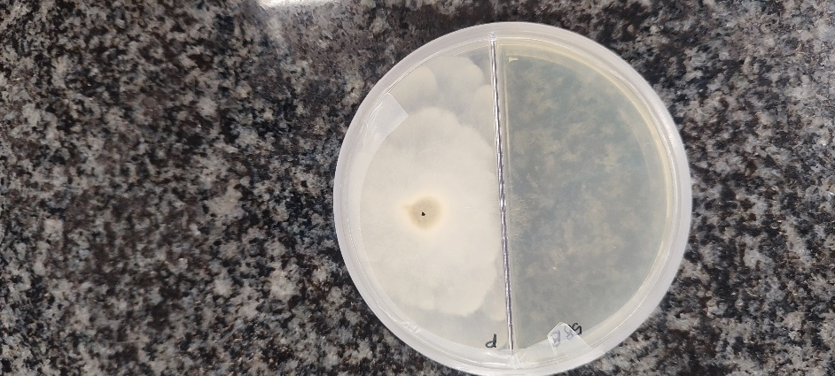D. R. microsporus (W2- 58) Control | 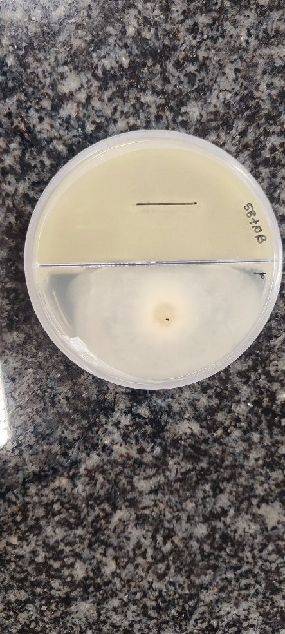E. R. microsporus (W2-58) with Bacillus velezensis KV10 | 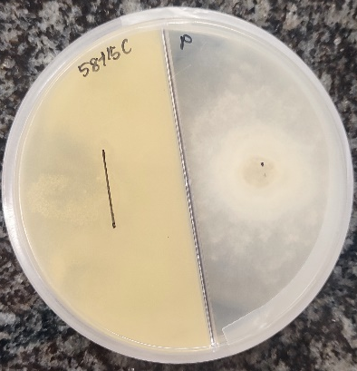  F. R. microsporus (W2-58) with Bacillus velezensis KV15
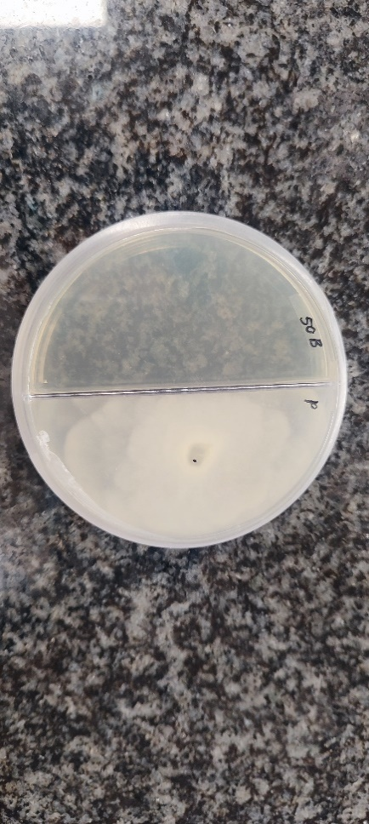G. R. microsporus (W2-50) Control | 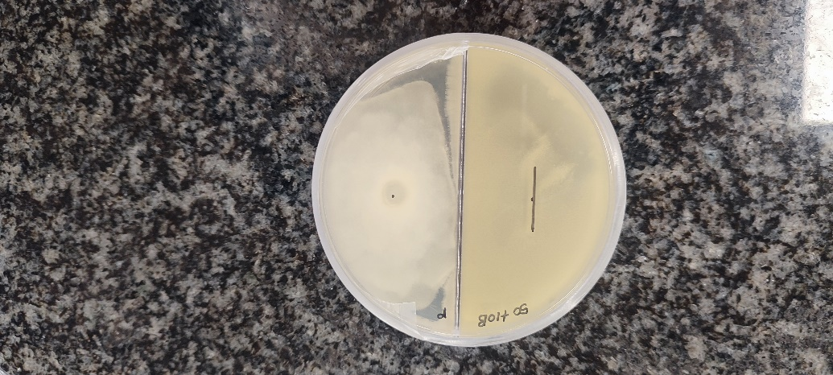H. R. microsporus (W2- 50) with Bacillus velezensis KV10 | 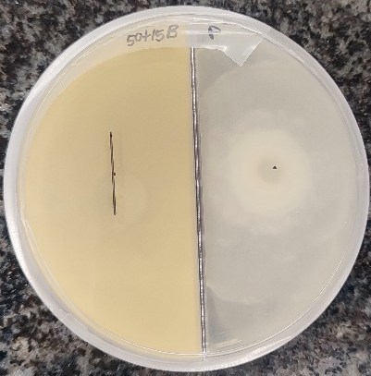  I. R. microsporus (W2-50) with Bacillus velezensis KV15
S.Figure 2: Inhibition of radial growth after 48h incubation for three R. microsporus strains against the VOCs of two B. velezensis strains KV10 and KV15 respectively.
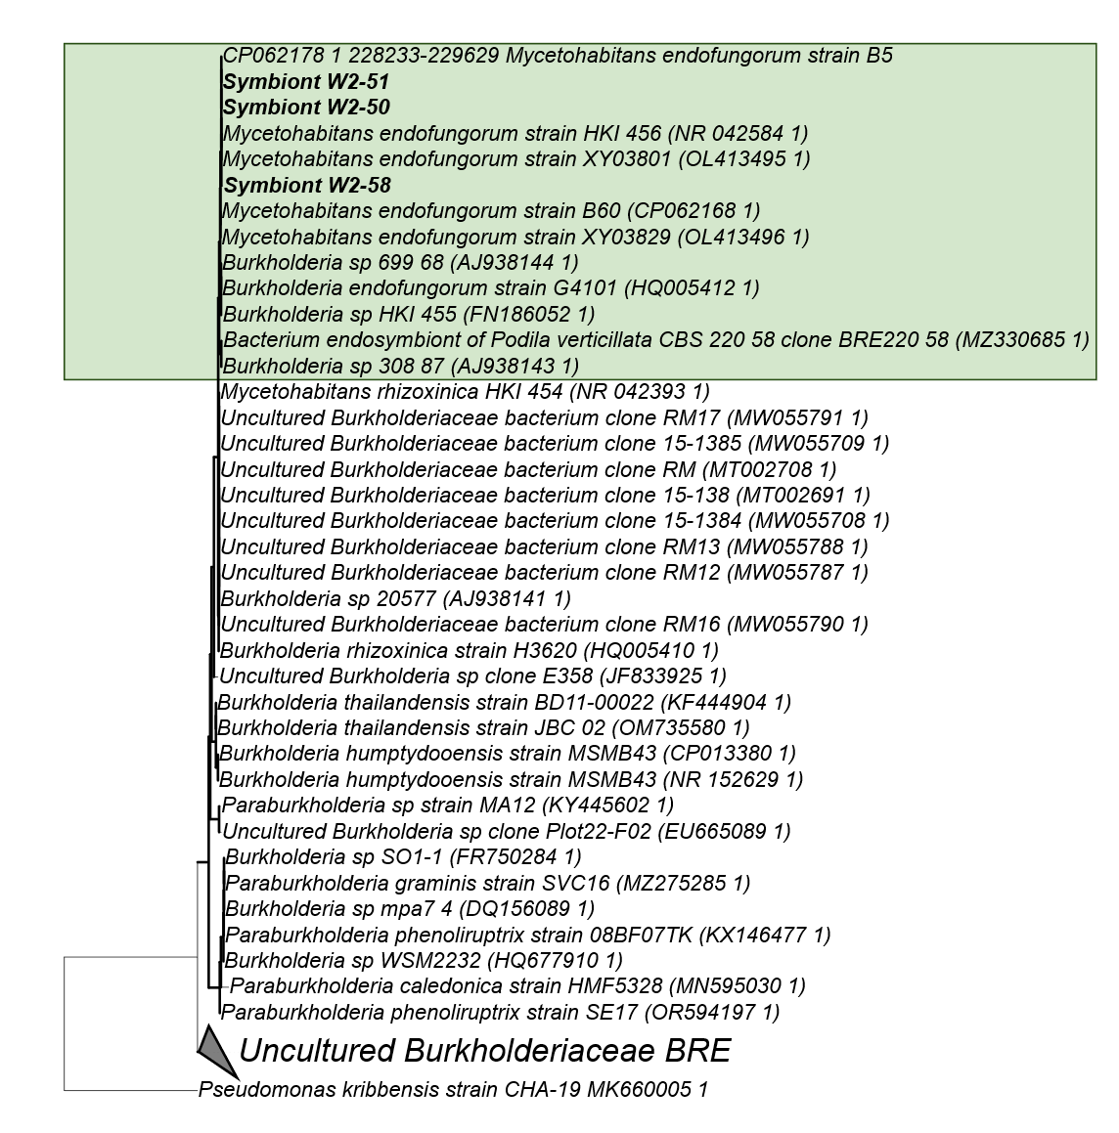
S. Figure 3: Phylogenetic tree based on the 16S rRNA gene sequence data from selected Rhizopus microsporus isolates using RAxML-GUI and applying the GTR Gamma substitution model with 1000 bootstraps. Bold branches represent bootstrap values >70%. Pseudomonas kribbensis strain CHA-19 was selected as outgroup for the phylogenetic inference.
S.Table 1: Incidence (%) of fungal growth observed in tomatoes inoculated with R. microsporus strains after they were treated with B. velezensis strains.
Treatment | Number of infected tomatoes (n=5) | Incidence (%) | Re-isolation of Rhizopus spp.
Wounded uninoculated control | 3/5 | 60% | None
Inoculated with KV10 | 3/5 | 60% | None
Inoculated with KV15 | 0/5 | No spoilage | None
Inoculated with W2-50 | 2/5 | 40% | R. microsporus & R. stolonifer
Inoculated with W2-51 | 1/5 | 20% | None
Inoculated with W2-58 | 1/5 | 20% | None
Inoculated with W2-50 and KV10 | 5/5 | 100% | R. microsporus
Inoculated with W2-50 and KV15 | 1/5 | 20% | R. microsporus
Inoculated with W2-51 and KV10 | 1/5 | 20% | None
Inoculated with W2-51 and KV15 | 2/5 | 40% | None
Inoculated with W2-58 and KV10 | 1/5 | 20% | None
Inoculated with W2-58 and KV15 | 0/5 | No spoilage | None

S.Table 2: Incidence (%) of fungal growth observed in tomatoes inoculated with R. microsporus W2-50 after they were treated with B. velezensis strains.
Treatment | Number of infected tomatoes (n=5) | Incidence (%) | Re-isolation of Rhizopus spp.
Wounded uninoculated control | 3/5 | 60% | None
Inoculated with KV10 | 4/5 | 80% | None
Inoculated with KV15 | 3/5 | 60% | R. stolonifer
Inoculated with W1-50 | 4/5 | 80% | R. microsporus &  R. stolonifer
Inoculated with W1-50 and KV10 | 3/5 | 60% | R. microsporus
Inoculated with W1-50 and KV15 | 3/5 | 60% | R. microsporus

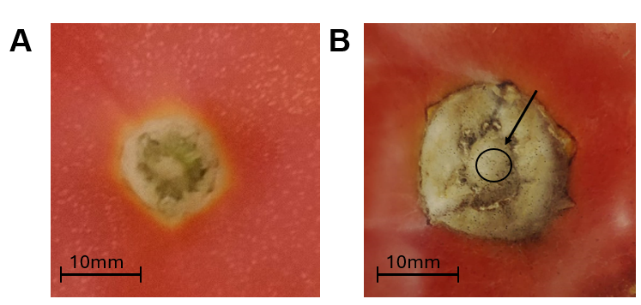
S.Figure 4: A) Image showing a healthy stem with no fungal establishment. B) Image indicating the establishment of R. microsporus W1-50 on the stem-scar of the treated tomato fruit. Visible sporangium can be seen on the surface of the stem-scar.

