Supporting Information

Multifactorial optimization enables the identification of a greener method to produce (+)-nootkatone

Ida M. Makhubela ¹, Alexander Zawaira ², Dean Brady ¹, and Daniel P. Pienaar* ^{1,3}

Affiliations: ¹ Molecular Sciences Institute, School of Chemistry, University of the Witwatersrand, Johannesburg, PO Wits 2050, South Africa; Physical address: 1 Jan Smuts Avenue, Braamfontein, Johannesburg, 2000, South Africa.
² Applied Protein Biotechnologies (Pty) Ltd, 530 Jessie Collins Street, Garsfontein, Pretoria, 0081, South Africa.
³ Department of Chemistry, Faculty of Natural and Agricultural Sciences, University of Pretoria, South Africa; Physical address: Lynnwood Road, Pretoria, 0002, South Africa.

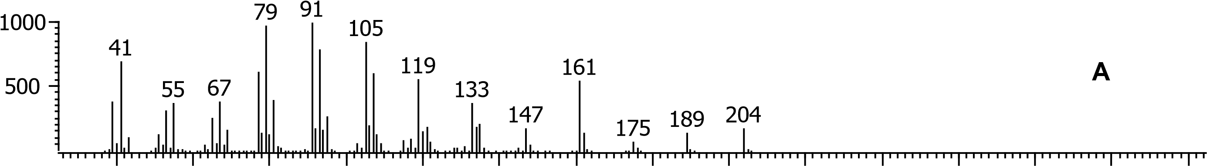
40 60 80 100 120 140 160 180 200 220 240 260 280 300 320
Library Hit - similarity 904, "Naphthalene, 1,2,3,5,6,7,8,8a-octahydro-1,8a-dimethyl-7-(1-methylethenyl)-, [1R-(1à,7á,8aà)]-" 161
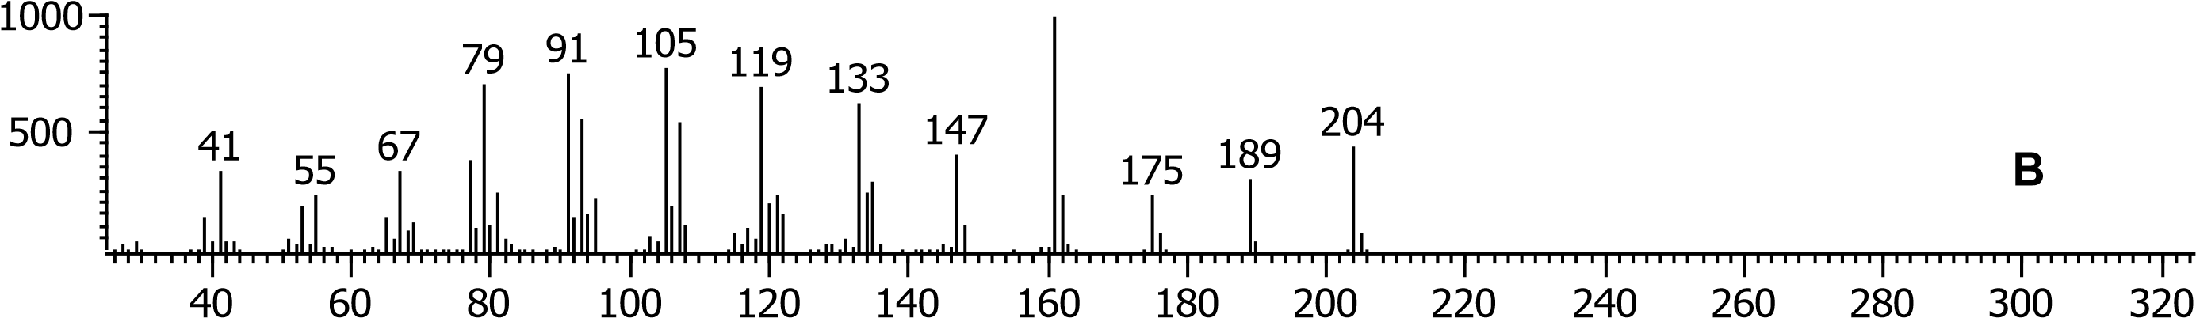

Figure S1: MS spectra (A) valencene present in substrate used and (B) the NIST MS library match of valencene.

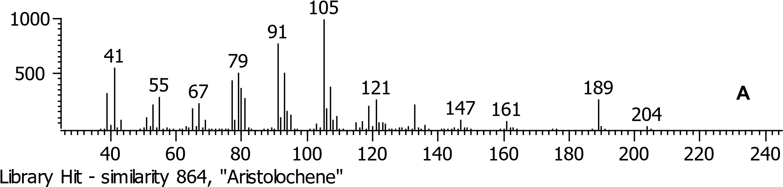
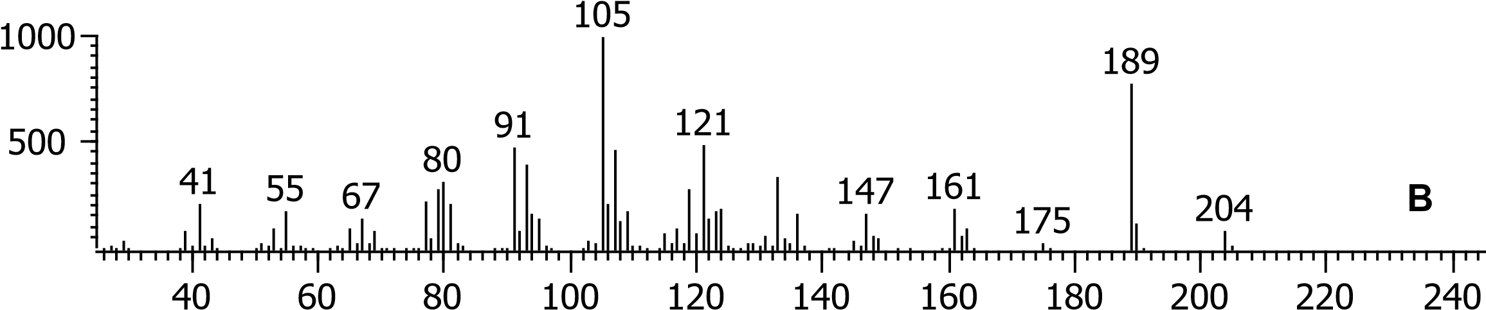

Figure S2: MS spectra of (A) aristolochene present in substrate used and (B) the NIST MS library match of aristolochene.

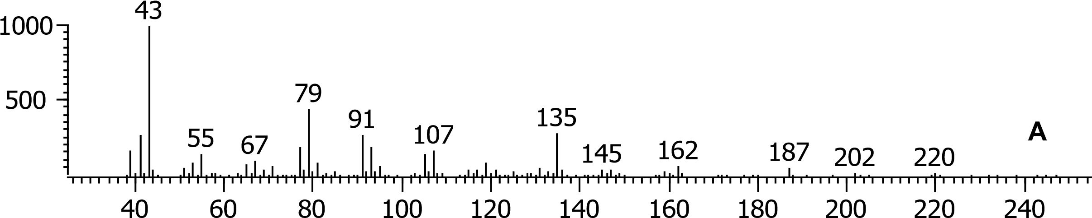

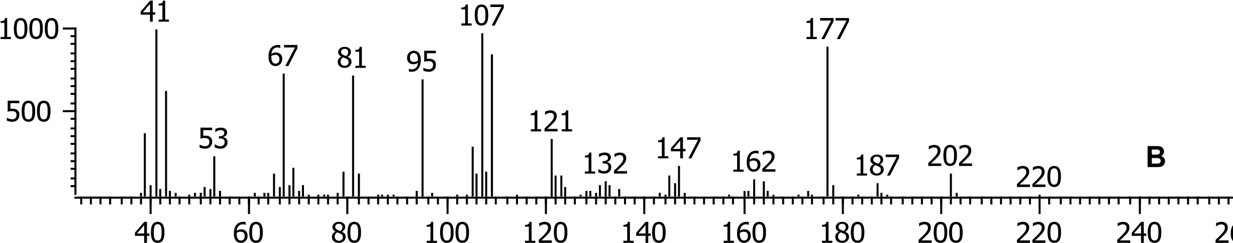

Figure S3: Obtained MS spectra of (A) β-nootkatol and (B) α-nootkatol, verified by comparison with NIST library MS spectra.

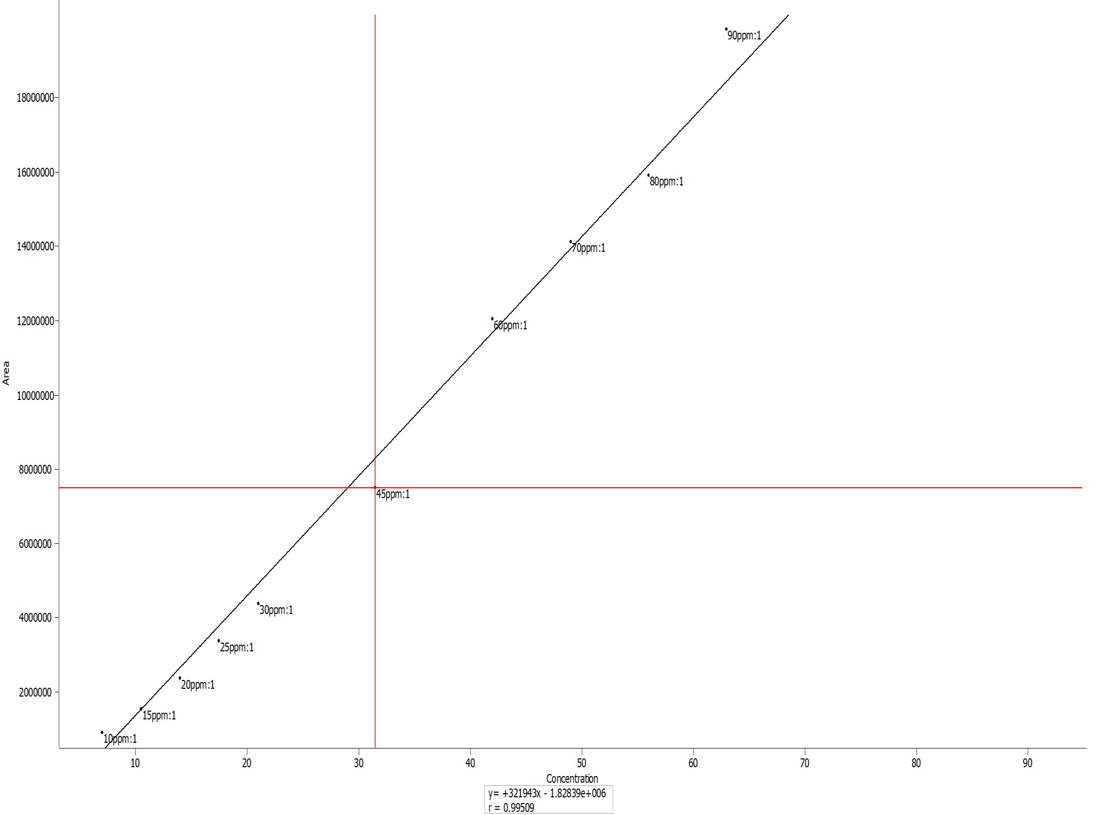

Figure S4: GC calibration curve of VL.

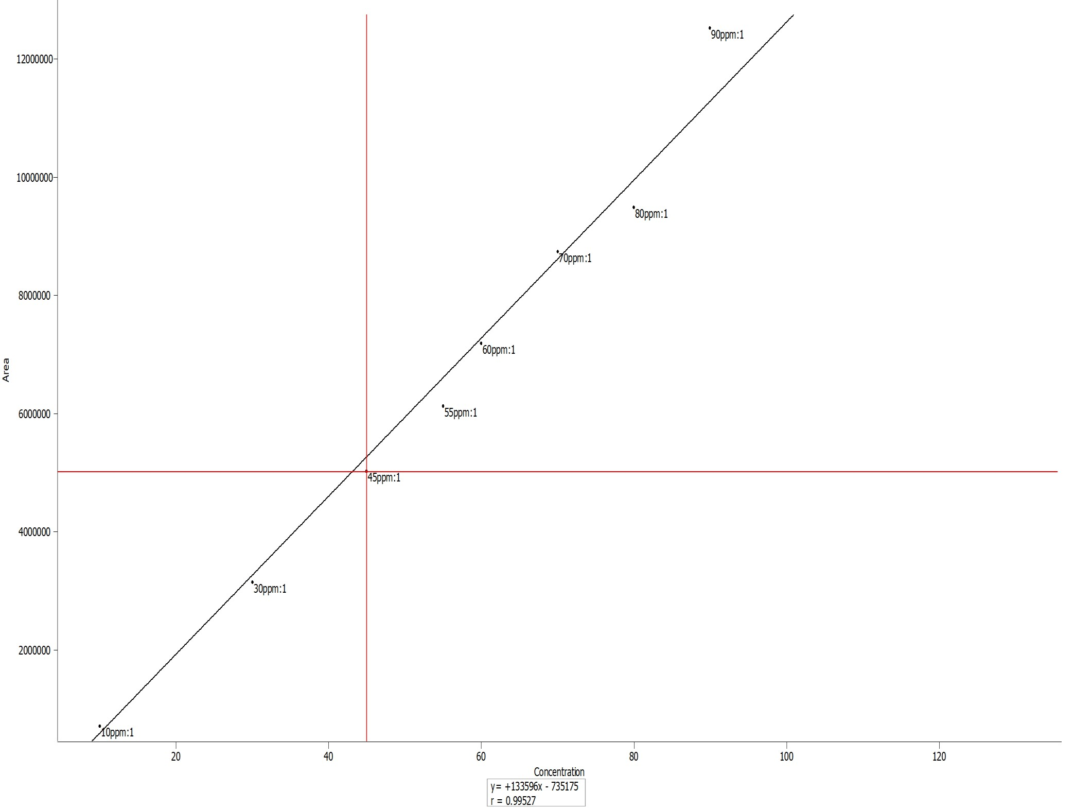

Figure S5: GC calibration curve of NK.

y = 0,0275x + 0,0047
R² = 0,9899
0
02
,
0
04
,
0
,
06
0
,
0
08
1
,
0
12
,
0
0
,
14
0
,
16
0
1
2
3
4
5
6
Absorbance
Concentration (µmol/L)

Figure S6: UV-VIS calibration curve of Methylene Blue, at 664 nm.

Table S1: Reactions at different conditions with crude LOX in sodium borate buffer at pH 7.5 and the mole percentage (mol%) of the recovered valence (VL), mol% of valencene converted into nootkatone (NK), and mol% of valencene converted into other side-products.

Entry | Sodium borate buffer pH | Buffer  Molarity  (mM) | Reaction Temp.  (°C) | Reaction duration  (h) | Reaction pH | Recovered  VL  (mol%) | VL converted into  NK  (mol%) | VL  converted  into  other  products  (mol%)
1 | 7.5 | 150 | 30 | 24 | 5 | 7 | 46 | 47
 |  |  |  | 48 | 5 | 7 | 44 | 49
 |  |  |  | 72 | 5 | 7 | 43 | 50
 |  |  |  | 96 | 4 | 7 | 15 | 78
2 | 7.5 | 100 | 30 | 24 | 5 | 8 | 59 | 33
 |  |  |  | 48 | 4 | 8 | 61 | 31
 |  |  |  | 72 | 4 | 8 | 62 | 30
 |  |  |  | 96 | 4 | 8 | 19 | 73
3 | 7.5 | 150 | 21 | 24 | 6 | 7 | 66 | 27
 |  |  |  | 48 | 6 | 7 | 62 | 31
 |  |  |  | 72 | 5 | 7 | 60 | 33
 |  |  |  | 96 | 5 | 7 | 16 | 77
4 | 7.5 | 100 | 21 | 24 | 5 | 8 | 63 | 29
 |  |  |  | 48 | 4 | 7 | 67 | 26
 |  |  |  | 72 | 4 | 7 | 69 | 24
 |  |  |  | 96 | 4 | 7 | 12 | 81
5 | 7.5 | 15 | 30 | 24 | 3 | 11 | 61 | 28
 |  |  |  | 48 | 3 | 8 | 61 | 31
 |  |  |  | 72 | 3 | 8 | 62 | 30
 |  |  |  | 96 | 3 | 8 | 18 | 74
6 | 7.5 | 10 | 30 | 24 | 2 | 10 | 49 | 41
 |  |  |  | 48 | 2 | 8 | 50 | 42
 |  |  |  | 72 | 2 | 8 | 50 | 42
 |  |  |  | 96 | 2 | 7 | 19 | 74

Table S2: Reactions at different conditions with crude LOX in sodium borate buffer at pH 8.1 and the mole percentage (mol%) of the recovered valence (VL), mol% of valencene converted into nootkatone (NK), and mol% of valencene converted into other side-products.
Entry | Sodium borate buffer pH | Buffer  Molarity  (mM) | Reaction Temp.  (°C) | Reaction duration  (h) | Reaction pH | Recovered  VL  (mol%) | VL converted into  NK  (mol%) | VL  converted  into  other  products  (mol%)
1 | 8.1 | 150 | 30 | 24 | 6 | 8 | 68 | 24
 |  |  |  | 48 | 6 | 8 | 69 | 23
 |  |  |  | 72 | 6 | 8 | 70 | 24
 |  |  |  | 96 | 5 | 8 | 17 | 75
2 | 8.1 | 150 | 35 | 24 | 6 | 7 | 67 | 26
 |  |  |  | 48 | 5 | 7 | 69 | 24
 |  |  |  | 72 | 4 | 7 | 71 | 22
 |  |  |  | 96 | 4 | 7 | 11 | 80
3 | 8.1 | 150 | 21 | 24 | 6 | 8 | 64 | 28
 |  |  |  | 48 | 5 | 8 | 71 | 21
 |  |  |  | 72 | 5 | 8 | 74 | 18
 |  |  |  | 96 | 4 | 8 | 10 | 82
4 | 8.1 | 100 | 35 | 24 | 5 | 7 | 56 | 37
 |  |  |  | 48 | 4 | 7 | 54 | 39
 |  |  |  | 72 | 4 | 7 | 50 | 43
5 | 8.1 | 100 | 30 | 24 | 5 | 7 | 73 | 20
 |  |  |  | 48 | 4 | 7 | 66 | 27
 |  |  |  | 72 | 4 | 7 | 58 | 35

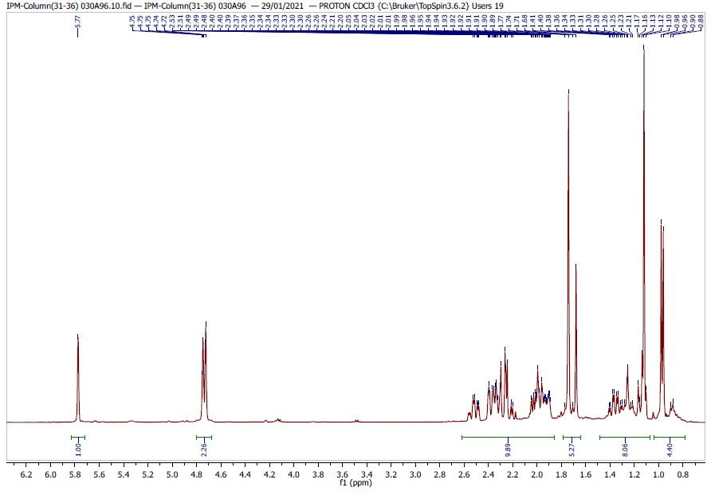

Figure S7: ¹H NMR spectrum of nootkatone.
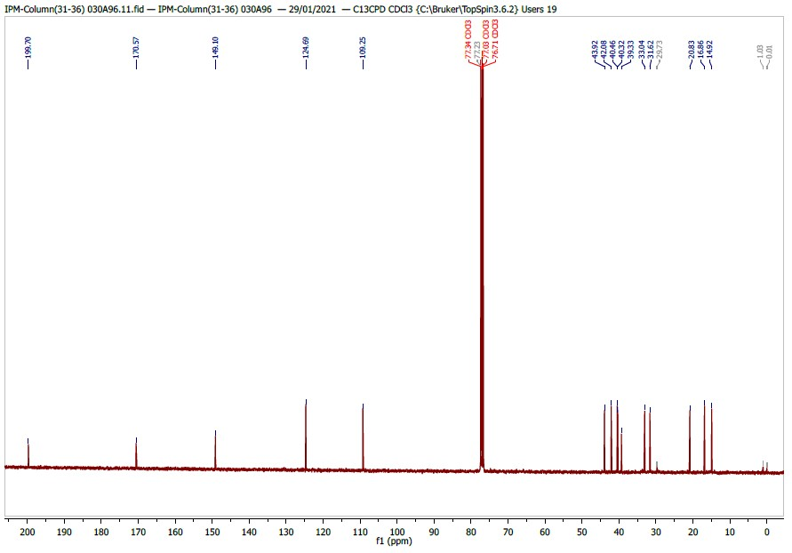

Figure S8: ¹³C NMR spectrum of nootkatone
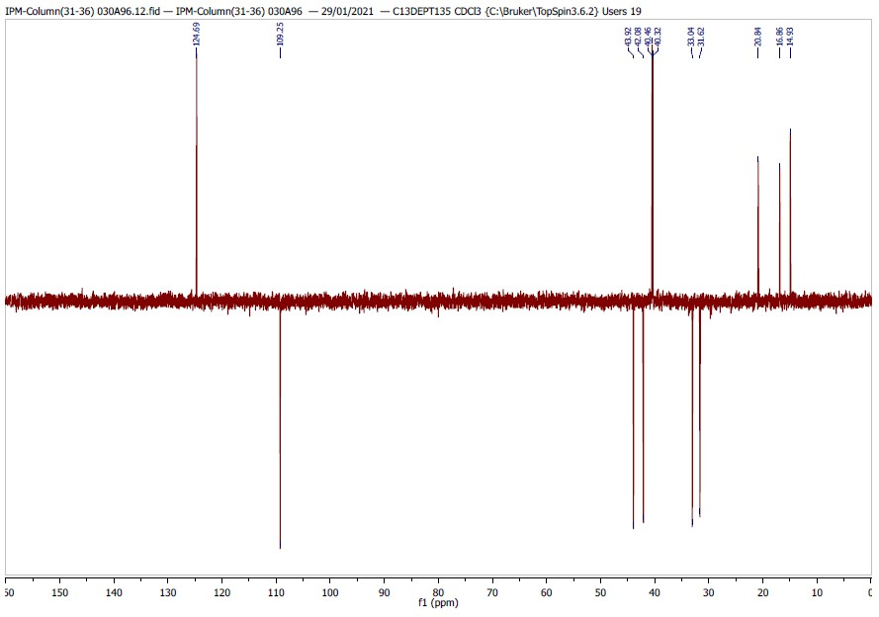

13

Figure S9: ¹³C DEPT135 NMR spectrum of nootkatone.
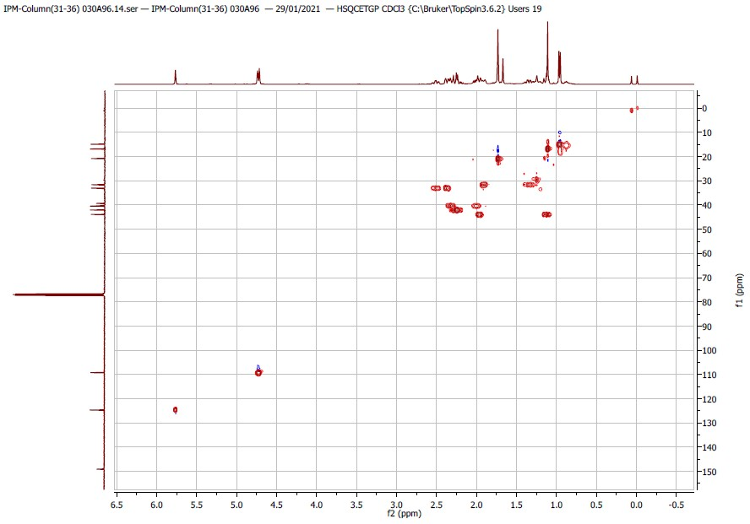

Figure S10: HSQC NMR spectrum of nootkatone.

