Supplementary Figure 1. Heatmap indicating the relative abundance of compounds in the sex pheromone of female S. frugiperda moths of the R (n = 50) and C (n = 50) mitotypes
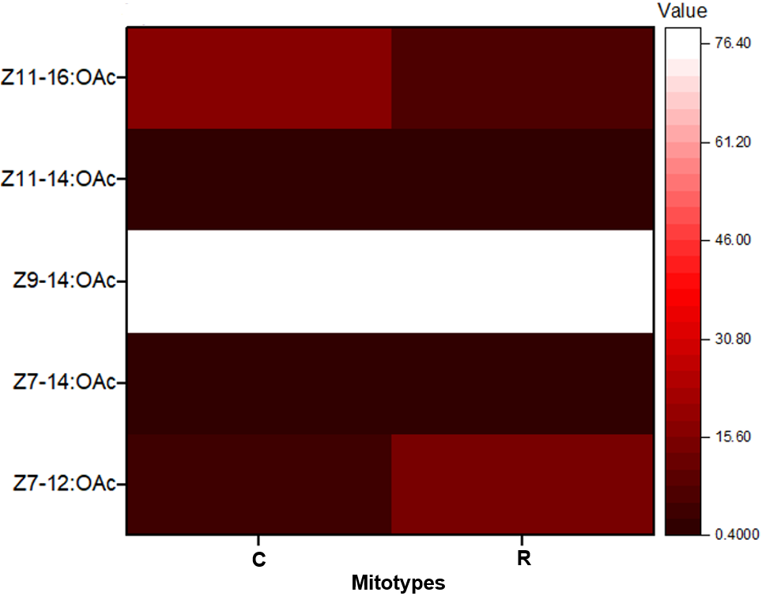

Supplementary Figure 2: Gas chromatography mass spectrometry (GC-MS) chromatograms of pheromone compounds. Peak 1 represents Z7-12:OAc, Peak 2 corresponds to Z7-14:OAc, Peak 3 to Z9-14:OAc, Peak 4 to Z11-14:OAc, and Peak 5 to Z11-16:OAc
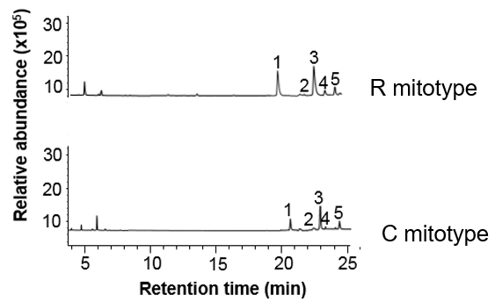

Supplementary Figure 3. Phylogenetic analysis of S. frugiperda adult pairs that produced eggs, based on mtCOI sequences obtained from the GenBank (https://blast.ncbi.nlm.nih.gov/Blast.cgi). An out-group sequence from Spodoptera exigua (KX580621) was included. The USA C (U72974) and R (U72977) strains were used as reference sequences (a). The female and male moths are indicated as FM and MM, respectively, and each pair of moths is represented by similar numbers.
